The Various Cell Types and Functions in the Three Tissue Systems in Strelitzia Reginae and Pinus Strobus
Shay Clancy
100977609
BIOL 2002: Plants Form and Function
Thursday pm
Bench 3
Claudia Buttera

Introduction
There are three different tissue systems in plants, including the vascular system, the ground tissue system and dermal tissue. Dermal tissue is very important for protection of the plant and its organs. Similar to skin on humans, the epidermis on leaves have pores that allow water and gases in and out of the leaves, controlled by the guard cells on either side of the stomata. Vascular tissue consists of mainly phloem and xylem, which transport water and nutrients to different areas of the plant. The vascular system is similar to the circulatory system in animals in that both transport vital substances to areas of the organism in order to survive. Phloem transports sugars and nutrients down from the leaves to the roots, while xylem transports water from the roots up to the leaves. Primary vascular tissue is made by the procambium in the shoot apical meristem and the root apical meristem. Ground tissue includes essentially everything in between vascular tissue and dermal tissue. The ground tissue consists of parenchyma cells throughout the plant used for storage, respiration, photosynthesis, and regeneration (Evert RF, 2006). The collenchyma cells have unevenly thickened cell walls that support the plant, located toward the outside close to the dermal tissue. The sclerenchyma cells have secondary cell walls and are used for storage, support, and protection, located throughout the plant.
The purpose of this assignment is to identify and discuss the functions of various parts of all three systems in two different specimens. The specimens used are Pinus strobus and Strelitzia reginae. Pinus Strobus, also known as Eastern White Pine, grows primarily in Eastern Canada and United States (Guyette and Williams,1999). The Pinus Strobus needle is examined as a cross section and a longitudinal section stained in toluidine blue pH 4.4 under a microscope. Strelitzia reginae is indigenous to South Africa and Cape Province. Strelitzia reginae is examined using a microscope to study a cross section and a longitudinal section stained in toluidine blue pH 4.4.

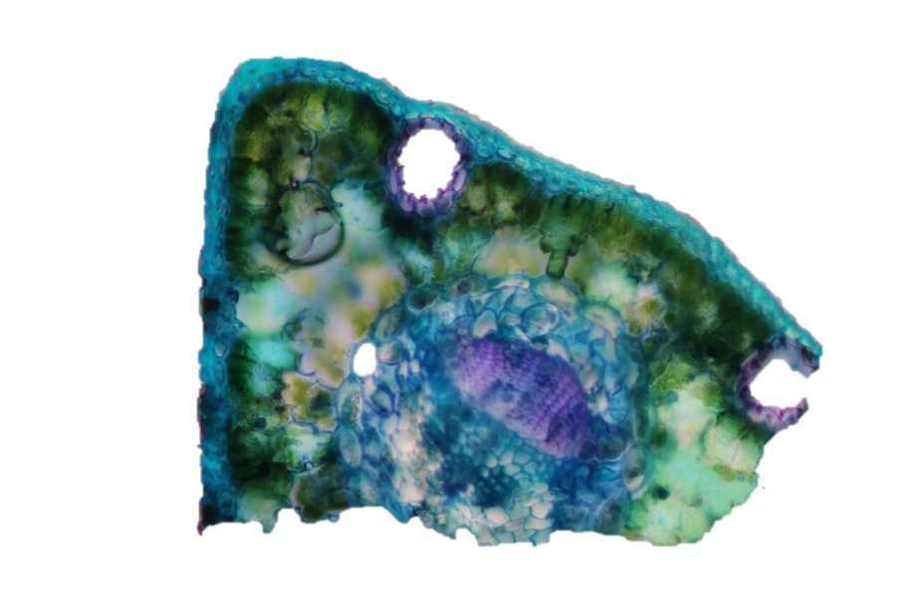
Collenchyma
Undifferentiated mesophyll
Lipid bodies
Resin duct

Figure 2: cross section of Pinus strobus needle stained in toluidine blue pH 4.4 showing the various parts of ground tissue present with a magnification of

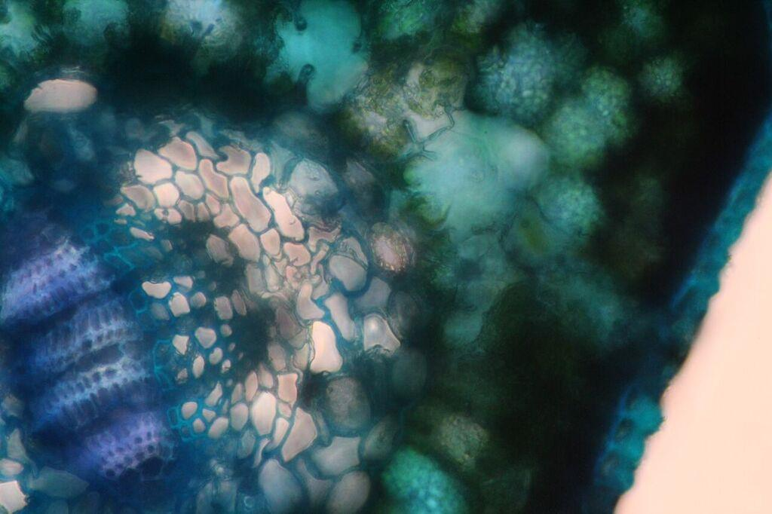 A1
Xylem
Phloem
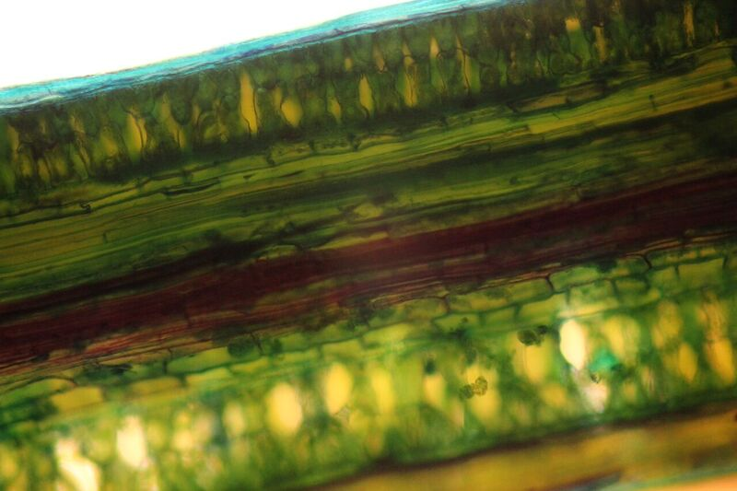 A2
Sieve tube
Companion cell
Annular protoxylem

Figure 3: Pinus strobus needle cross section stained in toluidine blue pH 4.4 showing the cell types present in the vascular tissue with a magnification of (A1) and (A2)

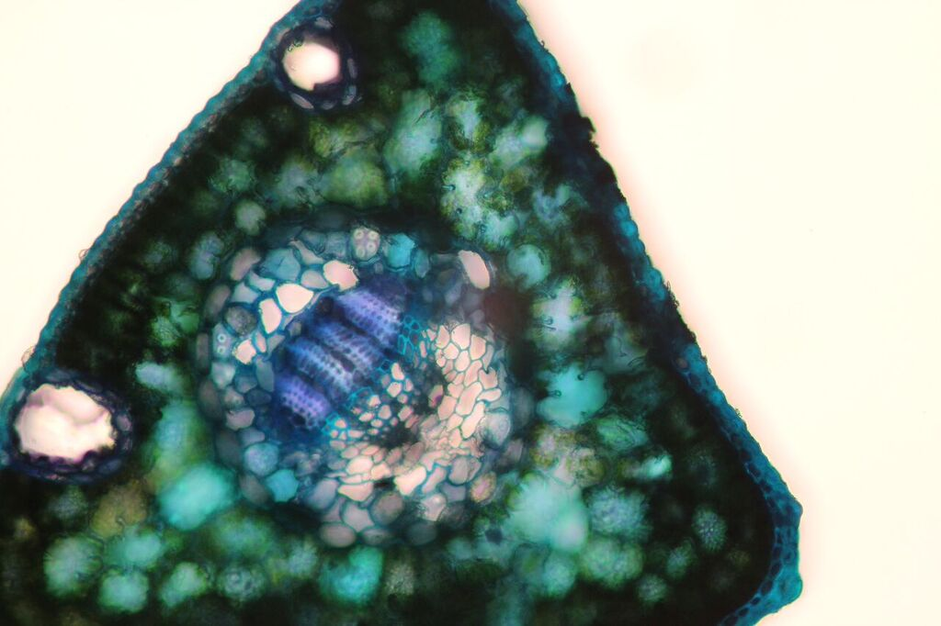 A1
Epidermis
Cuticle
Glandular trichome
Stomatal chamber

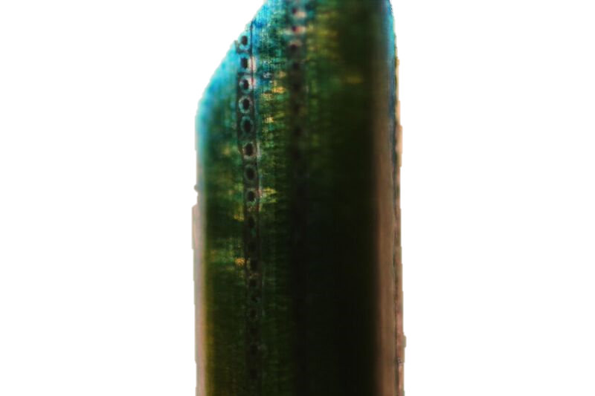A2
Stomata

Figure 4: cross section and longitudinal section of Pinus strobus needle stained in toluidine blue pH 4.4 showing the various parts of dermal tissue with a magnification of (A1) and (A2)

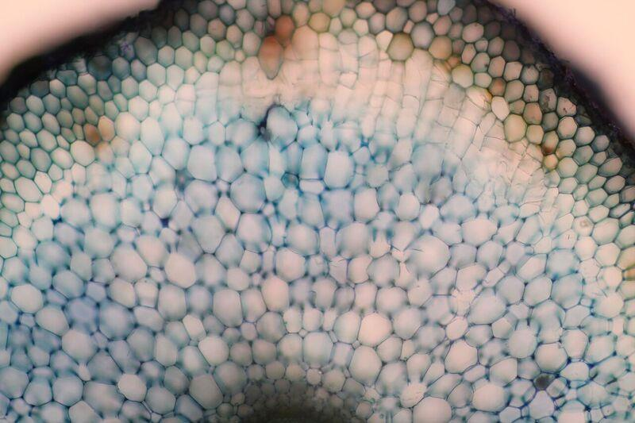
Parenchyma
Lipid bodies
Lacunar collenchyma
Raphide crystals (grouped together)
Anthocyanins
Figure 5: cross section of Strelitzia reginae root stained in toluidine blue pH 4.4 showing the cell types present in the ground tissue with a magnification of
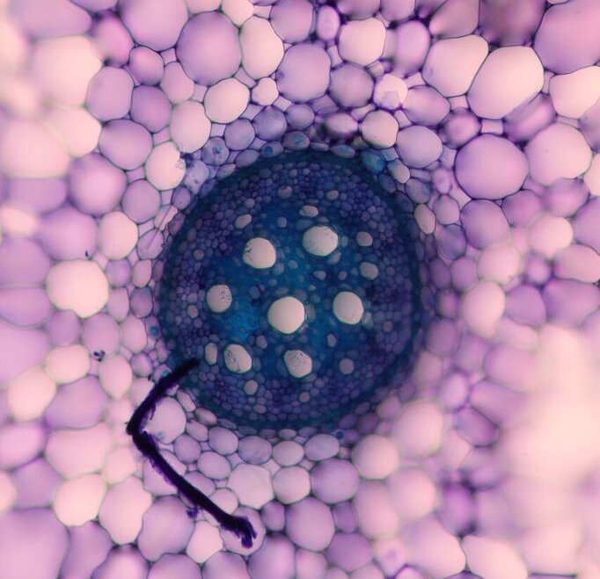 A1
Companion cell
Sieve tube
Metaxylem vessel

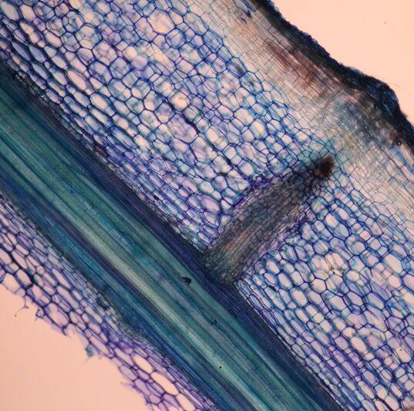 A2
Annular protoxylem
Spiral protoxylem

Figure 6: Cross section and longitudinal section of Strelitzia reginae stained in toluidine blue pH 4.4 showing the various aspects of the vascular tissue with magnifications of (A1) and

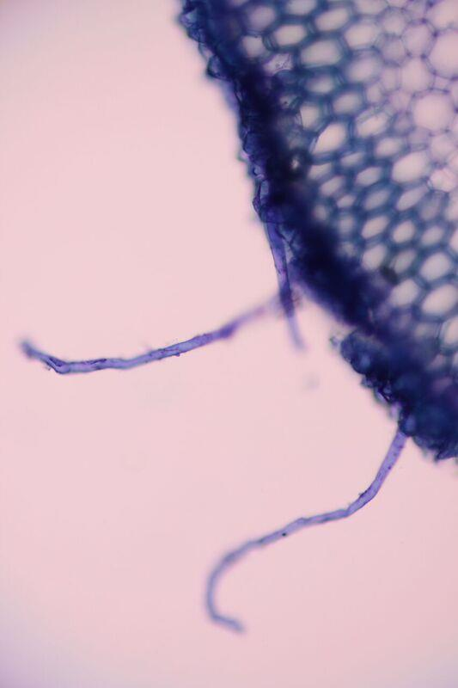
Epidermis
Root hair

Figure 7: cross section of Strelitzia reginae root stained I toluidine blue pH 4.4 showing the different parts of the dermal tissue with a magnification of

Analysis
Pinus strobus is a gymnosperm native to Eastern Canada and United States. Being native to Northeastern land, Pinus strobus must be able to survive harsh conditions such as temperature and weather. Keeping its needles all year round is beneficial for photosynthesis throughout all seasons, where most trees lose their leaves for the harsh winter months. Strelitzia reginae, however, is native to South Africa and has large green leaves and bright orange flowers. The Strelitzia reginae cross section is the root of the plant, while the sections of Pinus strobus are the leaf (needle), therefore making it difficult to compare functions. Leaves and roots have different functions since they are in completely different areas. Roots absorb nutrients and water from the earth while leaves are mainly responsible for capturing sunlight energy used for photosynthesis. This is clear in the sections due to the abundance of mesophyll in Pinus strobus and the lack of mesophyll in the Strelitzia reginae sections and the abundance of parenchyma cells in Strelitzia reginae while Pinus strobus had virtually none.
Figure 1 shows the ground tissue in Pinus strobus needle, there was a lot of undifferentiated mesophyll around the edges of the cross section. The needles are very thin, so the mesophyll fills almost the entire cross section apart from the vascular tissue in the centre. The root section does not have any mesophyll since there is no sunlight underground, but does have a large amount of parenchyma cells. Parenchyma cells are used for storage, in this case the storage of water since the plant lives in such a dry, hot environment. The storage of water in the roots is important because it is cooler underground allowing for less evaporation through pores. Similar to the way camels store water in their humps, the roots must absorb and store as much water as possible since there are long periods with no rainfall. Figure 5 shows the abundance of parenchyma storage cells in the root section, while also showing anthocyanins. Anthocyanins are pigments that appear different colours depending on factors such as pH and temperature. Because of their colours and popularity in plants, anthocyanins can be extracted and used as colouring, but can be relatively unpredictable due to their instability (Lemos et al., 2012). Figure 5 also shows lipid bodies around the vascular tissue in the centre of the section. Lipid bodies are thought to come from the endoplasmic reticulum containing lipid-biosynthesis enzymes (Murphy and Vance, 1999). Lipid bodies are spherical in shape and lack a membrane. Lipid bodies are important for the storage and transport of energy, and since parenchyma cells are used for storage lipid bodies are often found within (Murphy and Vance, 1999). The Strelitzia reginae root is full of parenchyma cells; therefore, it is logical for there to be many lipid bodies present. There are groupings of raphide crystals present in figure 5 as well. A raphide crystal is an ergastic substance that contains toxins as a means of protection for the plant. Raphide crystals are long, thin and sharp at the ends, and have toxins inside so when a predator ingests them it burns. This is a defense mechanism from the plant to try to protect itself from being eaten by predators. There is also lacunar collenchyma present in figure 5. Collenchyma cells ae elongated with thickened cell walls, yet remain flexible and are not lignified like sclerenchyma (Baran and Ozdemir, 2006). Lacunar collenchyma cells are collenchyma cells with cell wall thickening in the corners where there are intercellular spaces. Collenchyma tissue is unique in that it supports the plant while remaining flexible and able to bend. This is useful in roots because they need to remain strong enough to push through the dirt when growing, but must also bend around rocks and such. Figure 2 shows a ring of collenchyma cells surrounding the vascular bundle. This provides enough support for the lightweight Pinus strobus needle to stay stiff and rigid in order to survive the harsh conditions of winter.
Vascular tissue is responsible for the transportation of water and sugars throughout the organism. Figure 3 A1 shows the vascular bundle located in the middle of the cross section with the phloem toward the outside and xylem inward. The xylem is a bright blue with thick cell walls because it is sclerified. Xylem is dead when functional and using lignin for support. Xylem transports water upward from the roots to the leaves. Figure 3 A2 shows a longitudinal section with annular protoxylem. Protoxylem vessels such as annular protoxylem provide some structural support for transportation of small volumes of water (Department of biology, 2015). Since the Pinus strobus needle is very thin, xylem does not have to transport large quantities of water to the few surrounding cells. Figure 3 A2 also shows sieve tube and companion cell, which are part of phloem tissue. The sieve tube is where the transportation of sugars and nutrients takes place, while the companion cell is “the brains of the operation”. Since phloem is alive when functional, it needs organelles to survive. If there were organelles in the sieve tube, they would be moved around and likely would not survive, which is why there is a separate companion cell attached to the sieve tube as a means of protection for the organelles. Figure 6 A2 shows both annular protoxylem and spiral protoxylem. Spiral (or helical) protoxylem, as well as annular protoxylem, allows for growth and expansion while also providing support to move small quantities of water. Helical protoxylem is present in the Strelitzia reginae root but not the Pinus strobus leaf because the root has to move a larger quantity of water than the xylem in the needle. Roots provide the water for the entire plant, so more water must be transported through the roots. Figure 6 A1 shows metaxylem vessels as large openings in the cross section. Metaxylem vessels are more lignified than protoxylem and are able to transport larger quantities of water due to their increased strength. Figure 6 also shows sieve tubes and companion cells. The function is the same in both specimen, but it is very important in the roots because that is how the roots get their energy to grow and obtain water.
Figure 4 shows the various tissues present in the dermal tissue. The dermal tissue in Pinus strobus is complex due to having multiple types of cells. Figure 4 A1 shows a stomatal chamber with glandular trichomes inside. Dermal tissue is mainly responsible for the protection of the plant from all kinds of threats such as herbivores and weather. Glandular trichomes are “involved in chemical defense and can be found on leaves” (department of biology, 2015). Glandular trichomes contain ergastic substances that hurt an animal when ingested. These trichomes are a first line of defense with phytotoxic oils (Wagner, 1991). No trichomes were present on the Strelitzia reginae root because herbivores are not much of a threat to roots underground. Figure 4 also shows the cuticle on the outermost edge of the Pinus strobus needle cross section. Cuticle is a protective covering of cutin and wax (Department of biology, 2015). The cuticle does not cover the stomata, but rather covers around it. This is because the guard cells need to be able to open and close without obstruction in order to perform proper gas exchange. The guard cells and stomatal pores are responsible for water control, meaning they open when they have an abundance of water, or are obtaining water from the atmosphere, but remain closed when the environment is dry as not to lose water. Figure 4 A2 show many stomata lined along the outside of the needle. No stomata were visible on the Strelitzia reginae root. However, figure 7 shows a root hair in the dermal tissue of the cross section. Root hairs greatly increase the surface area of the root, and are thought to play a very important role in the absorption of water (Schiefelbein and Somerville, 1990). Schiefelbein and Somerville also explain that root hairs serve as excellent attachment sites for soil-borne microbes such as nitrogen-fixing bacteria (1990).
There are many similarities between Pinus strobus and Strelitzia reginae, especially in the vascular system and ground tissue. The dermal tissue of each plant has more differences mainly due to the location of the parts of each plant that were sectioned. Neither section shows any sign of secondary growth. Strelitzia reginae is a monocot and therefore does not undergo secondary growth, therefore does not have secondary tissue. Pinus strobus has not shown any signs of having secondary growth in the leaves (Brown, 1915) however would have secondary growth and secondary tissue in other areas.

References
Baran, Pelin, and Canan, Ozdemir. (2006) “The morphological and anatomical characters of Salvia napifolia Jacq. In Turkey. BANGLADESH JOURNAL OF BOTANY35.1: 77-84
Brown, H. P. (1915). Growth Studies in Forest Trees. 2. Pinus strobus L.Botanical gazette, 197-241.
Guyette, Richard P., and William G. Cole. (1999) "Age characteristics of coarse woody debris (Pinus strobus) in a lake littoral zone." Canadian Journal of Fisheries and Aquatic Sciences 56.3: 496-505.
Lemos, M. Adília, Maryam M. Aliyu, and Graham Hungerford.(2012) "Observation of the location and form of anthocyanin in purple potato using time-resolved fluorescence." Innovative Food Science & Emerging Technologies 16: 61-68.
Murphy, D. J., & Vance, J. (1999). Mechanisms of lipid-body formation. Trends in biochemical sciences, 24(3), 109-115.
Schiefelbein, J. W., & Somerville, C. (1990). Genetic control of root hair development in Arabidopsis thaliana. The Plant Cell, 2(3), 235-243.
Wagner, G. J. (1991). Secreting glandular trichomes: more than just hairs.Plant Physiology, 96(3), 675-679.

