The Various Functions of Ground Tissue Cells in Different Plants
Shaylyn Clancy
100977609
BIOL 2002, Plants: Form and Function
Lab: Thursday PM
Bench 3
Claudia Buttera

Introduction
There are three different tissue systems in plants, including the vascular system, the ground tissue system and dermal tissue. Dermal tissue is very important for protection of the plant and its organs. Similar to skin on humans, the epidermis on leaves have pores that allow water and gases in and out of the leaves, controlled by the guard cells on either side of the stomata (the opening). Vascular tissue consists of mainly phloem and xylem, which transport water and nutrients to different areas of the plant. The vascular system is similar to the circulatory system in animals in that both transport vital substances to areas of the organism in order to survive. Phloem transports sugars and nutrients down from the leaves to the roots, while xylem transports water from the roots up to the leaves. Primary vascular tissue is made by the procambium in the shoot apical meristem and the root apical meristem. Ground tissue includes essentially everything in between vascular tissue and dermal tissue. The ground tissue consists of parenchyma cells throughout the plant used for storage, respiration, photosynthesis, and regeneration (Evert RF, 2006). The collenchyma cells have unevenly thickened cell walls that support the plant, located toward the outside close to the dermal tissue. The sclerenchyma cells have secondary cell walls and are used for storage, support, and protection, located throughout the plant.
The purpose of this assignment is to identify and discuss the functions of various parts of the ground tissue system in two different specimens. The specimens used are Ficus benjamina and Sansevieria cylindrica. Ficus benjamina is a type of tree that is an ornamental decoration indoors, mostly in South-East Asia, and is a dicotyledonous plant since the vascular bundles are arranged in a ring around the outer edges of the plant (Veneklaas et al., 2002). The ficus benjamina leaf blade was examined as a cross section stained in toluidine blue pH 4.4 under a microscope. Sansevieria cylindrica is a succulent plant, that stores water in its leaves, native to central Africa (Koller and Rost, 1988), and is a monocot since its vascular bundles are more randomly dispersed. Sansevieria cylindrica was examined using a microscope to study a cross section and a longitudinal section stained in toluidine blue pH 4.4.

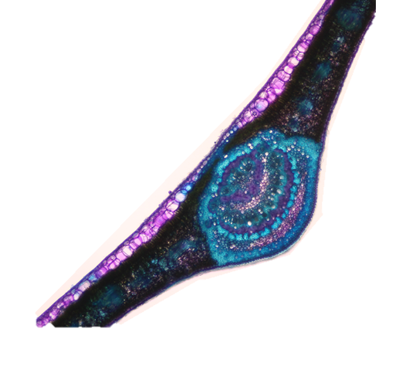

Spongy mesophyll
Palisade mesophyll

Sclerenchyma cells

Figure 1: Cross section of a Ficus benjamina leaf stained in toluidine blue pH 4.4 showing various cell types and their organization within the leaf with a magnification of
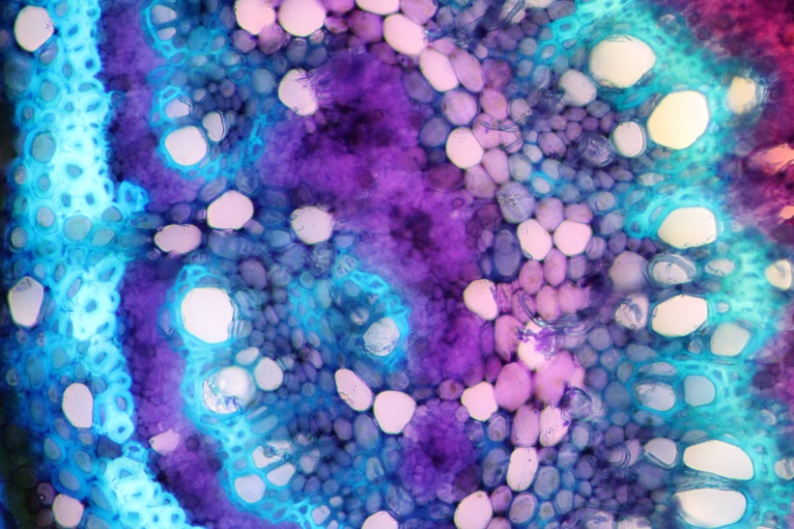
Lipid bodies
Lacunar collenchyma
Sclereid

Sclereids/fibres

Figure 2: Ficus benjamina midrib cross section stained in toluidine blue pH 4.4 showing various cell types and ergastic substances present with a magnification of

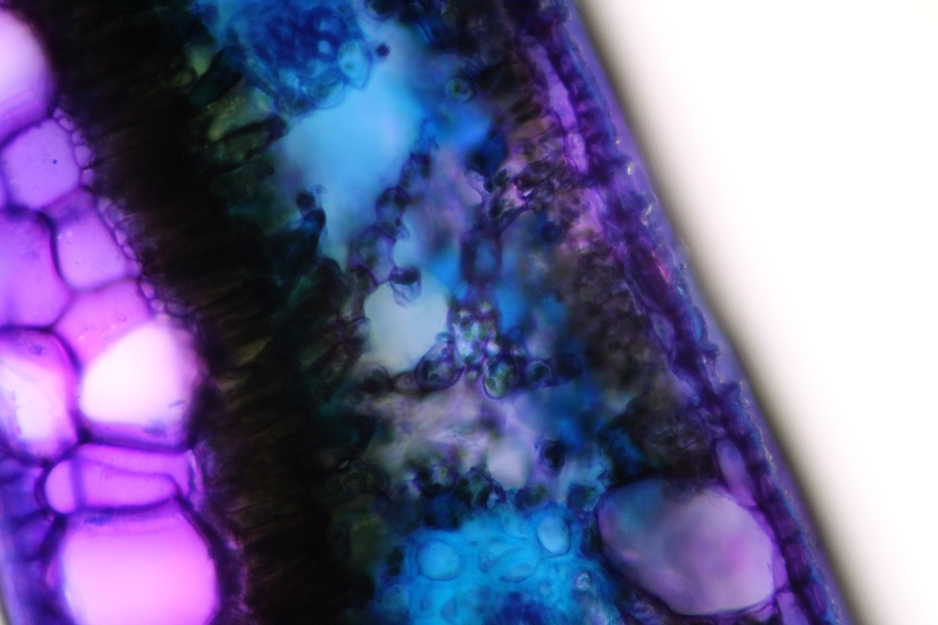

Spongy mesophyll

Palisade mesophyll

Figure 3: Leaf blade cross section of Ficus benjamina stained in toluidine blue pH 4.4 showing the different cell types and organization with a magnification of

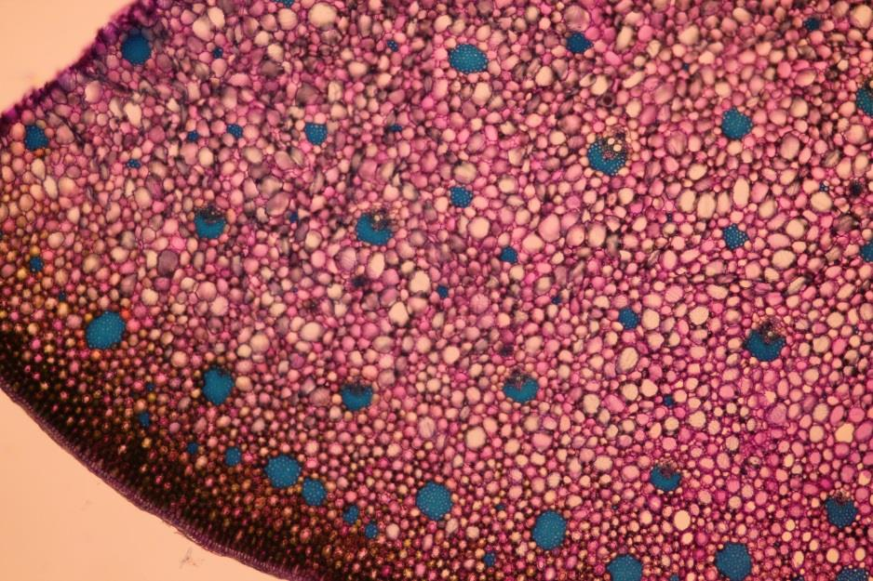
Parenchyma cells
Fibers

Figure 4: Cross section of Sansevieria cylindrica stained in toluidine blue pH 4.4 showing the organization of ground tissue throughout the organism with a magnification of

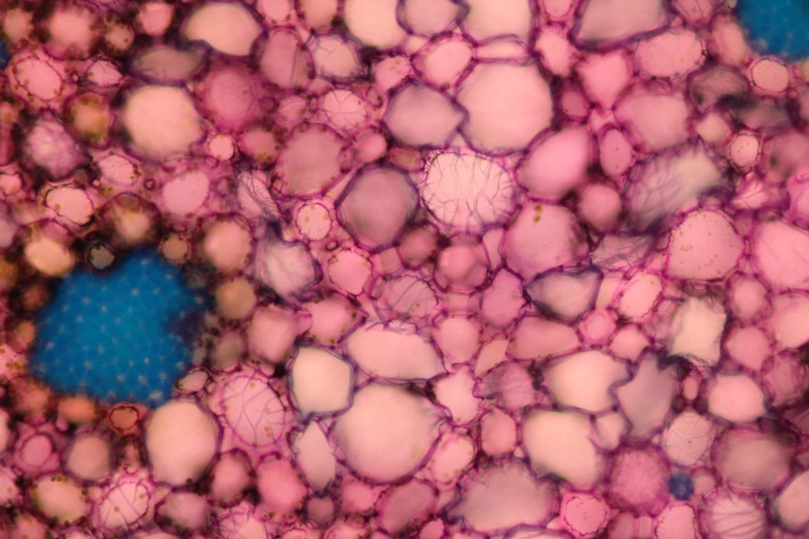
Sclerified parenchyma cell
Fibers

Figure 5: Cross section of Sansevieria cylindrica stained in toluidine blue pH 4.4 showing different cell types and ergastic substances present in the ground tissue with a magnification of

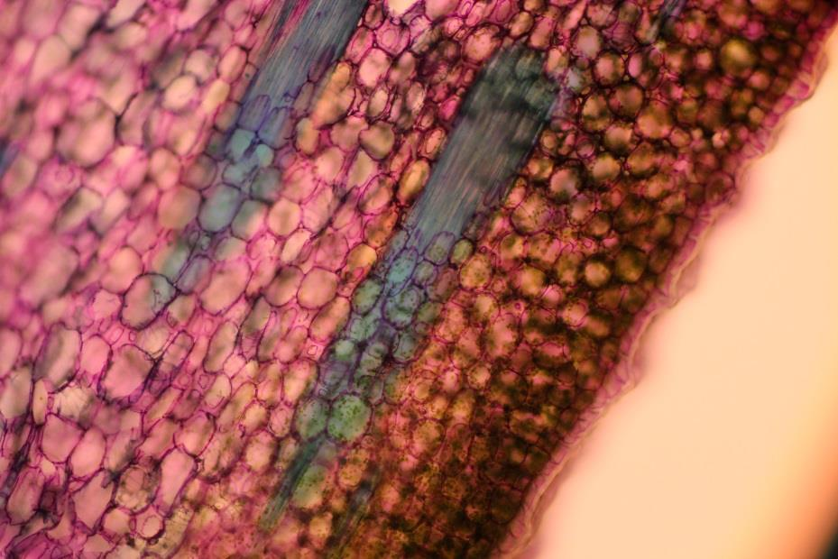
Parenchyma cell
Undifferentiated mesophyll
Fibers
Figure 6: Longitudinal section of Sansevieria cylindrica stained in toluidine blue pH 4.4 showing various cell types of the ground tissue system with a magnification of

Analysis
Both of the Sansevieria cylindrica and of Ficus benjamina sections are the leaves of the plant, yet look completely different. The F. benjamina has wide, thin leaf blade on a relatively short petiole, whereas the S. cylindrica has long, tubular leaves with very little stem. Therefore, the cross sections of each specimen are shaped differently and have different cell types to maximize their benefits. For example, since the F. benjamina has wide, thin leaf blade that contain palisade mesophyll and spongy mesophyll to maximize the amount of sunlight obtained for photosynthesis. The palisade mesophyll is long and in line with the upper epidermis making it the most efficient way to absorb sunlight. The S. cylindrica, being long and round has undifferentiated mesophyll around the outer edges of the cross section because no sunlight reaches the middle of the plant, therefore making it useless in the centre. The undifferentiated mesophyll goes all the way around in order to absorb the most sunlight possible no matter what time of day.
Both specimens have sclereids and fibers present for support. The groups of fibers were much more frequent and spread out in the Sansevieria cylindrica most likely because of the leaves being quite long, therefore needing more support to stand up. The Ficus benjamina had fewer groups of fibers, and were only present in the midrib of the leaf because it holds and supports the leaf blade. The leaf blade is quite thin and lightweight making it easier to support without fibers or sclereids, solely using collenchyma cells. This difference is clear when comparing figure 1 and figure 4. In Figure 6, there are blue streaks running through the section that are fibers due to their length and small width. There are no sclereids visible, but they would be much shorter and wider. Figure 2 shows lacunar collenchyma near the outer edge of the cross section. Lacunar collenchyma is a cell with cell wall thickening in the corners where there are intercellular spaces. Collenchyma cells are elongated and have thickened cell walls, but are flexible and not lignified like sclerenchyma cells (Baran and Ozdemir, 2006). Collenchyma tissue is a means of support while also having the ability to bend, which is likely why there was more in F. benjamina than in S. cylindrica, since S. cylindrica leaves are far more rigid and tall therefore need more support and strength.
Figure 2 shows lipid bodies which are more or less spherical in shape and lack a membrane. Lipid bodies are found in the cytoplasm of various cell types (Dvorak et al., 1983). Lipid bodies are very important for the storage and transport of energy (Murphy and Vance, 1999). Since parenchyma cells are often used for storage, many lipid bodies are found on parenchyma cells in figure 2. Figure 5 shows a sclerified parenchyma cell that looks as though there are multiple veins running across and around the cell. Sclerenchyma cells are cells with a secondary wall and are dead at maturity, whereas parenchyma cells have only a primary wall and are living at maturity (Carleton University press, 2015). Parenchyma can often be sclerified, mean they can become lignified, and remain living at maturity. This is the process visible in figure 5. Lignification, or sclerification, is a defense mechanism in plants in order to protect themselves against a variety of threats (Oven and Torelli, 1999). Since S. cylindrica is a plant native to central Africa, it must endure a harsh environment; therefore, the lignification process is essential in order to protect itself. F. benjamina is native to Asia which tends to have a less drastic environment. This is most likely why F. benjamina does not seem to have sclerified parenchyma in the leaf cross section, since there is little need for defense against environmental threats.

Creative Component

Society Outside vs Society Within
It is common knowledge that the various cell types each have a certain role in the overall performance of an organism. Each cell depends on others in order to effectively perform their own duty, and when one cell fails to complete their task, the whole organism often pays the consequence. Likewise, each person in society has a role, although not as specific as that of a cell, and is important in the community as a whole. There are doctors that help heal and “regenerate” the injured or sick just as parenchyma cells are used for regeneration in a plant. There are also police officers that regulate society and keep everything under control so that the community can run smoothly and effectively, while cells have nuclei that send signals for control. More specifically than society as a whole, a plant’s organization and cells can be compared to the members of an assembly line at a factory.
In a factory, many people have a specific task to complete in order for the final product to be successful. Should one person on an assembly line making dolls fail to properly attach the head or simply not attach the head at all, every person after that will have a very difficult time completely their tasks. The final product will be of very poor quality and not sell well to children. When the head is attached properly, the rest of the assembly line should run smoothly. Children are much more likely to buy a doll with all of its pieces than one without, making it important for every person on the assembly line to do their part. Similarly, should there be no sclerenchyma cells in a plant, the plant will have little to no support and easily fall over making it difficult for the vascular tissue to transport water and nutrients to the appropriate locations. Perhaps the mesophyll in leaves is absent, the plant will have a very difficult time absorbing light for photosynthesis thereby starving the plant of nutrients to survive.
On a much larger scale, if products were continuously being sold broken it would be very difficult to sell anything at all. When products do not sell well, or cost more to make than they are worth, the product stops being made and is discontinued. When a product stops being made, or a company cannot make enough money, they close down causing many people to lose their income. This in turn affects their families and other businesses. Just as the society and businesses rely on each other to stay afloat, cells in a plant or other organism also rely on each other. If the roots stop absorbing water, then it does not matter whether the leaves are absorbing light because the light will not become anything useful without water to complete the reaction.
While cells have very specific jobs and people tend to have jobs that are broader in terms of tasks, both require a team effort to have a final product for which it is worth working. It is the team of cells that work together, yet sometimes indirectly, in a plant to produce the necessary products for survival; it is the team of people that work together to produce the vast array of services and products needed for a society to thrive.

References

Baran, Pelin, and Canan Ozdemir. “The morphological and anatomical characters of Salvia napifolia Jacq. In Turkey. BANGLADESH JOURNAL OF BOTANY 35.1 (2006): 77-84

Department of Biology. 2015. BIOL 2002 Plants: Form and Function Lab manual+ workbook. Carleton University Press, Ottawa, Ontario.

Dvorak, A. M., et al. "Lipid bodies: cytoplasmic organelles important to arachidonate metabolism in macrophages and mast cells." The Journal of immunology 131.6 (1983): 2965-2976.

Koller, Alan L., and Thomas L. Rost. "Leaf anatomy in Sansevieria (Agavaceae)." American Journal of botany (1988): 615-633.

Murphy, Denis J., and Jean Vance. "Mechanisms of lipid-body formation."Trends in biochemical sciences 24.3 (1999): 109-115.

Oven, Primož, and Niko Torelli. "Response of the cambial zone in conifers to wounding." PHYTON-HORN- 39.3 (1999): 133-138.

Veneklaas, E. J., MPRM Santos Silva, and F. Den Ouden. "Determinants of growth rate in Ficus benjamina L. compared to related faster-growing woody and herbaceous species." Scientia Horticulturae 93.1 (2002): 75-84.

