MICROECONOMICS CONCEPT REVIEW
Units 1-4

1. Budget lines
Suppose you won $15 on a lotto ticket at the local 7-Eleven and decided to spend all the winnings on candy bars and bags of peanuts. The price of candy bars is $.75 and the price of peanuts is $1.50.
- Construct a table showing the alternative combinations of the two products that are available. O.K.
- Plot the data in your table as a budget line in a graph. No
- What is the opportunity cost of one more candy bar?1/2 bag of peanuts Of one more bag of peanuts? 2 candy bars Do these opportunity costs rise, fall, or remain constant as each additional unit of the product is purchased? Remain constant
- Suppose that you had won $30 on your ticket, not $15. Show the $30 budget line in your diagram. Why would this budget line be preferable to the old one? You can buy more of each
Peanuts Candy Bars
0 20
1 18
2 16
3 14
4 12
5 10
6 8
7 6
8 4
9 2
10 0

2. Production Possibilities Curves
Below is a production possibilities table for consumer goods (automobiles) and capital goods (forklifts):
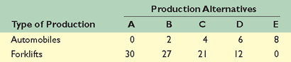
- Show these data graphically. No Upon what specific assumptions is this production possibilities curve based? Only 2 products produced, full utilization of resources
- If the economy is at point C, what is the cost of one more automobile? 2/9 of a forklift Of one more forklift? 3 automobiles Explain how the production possibilities curve reflects the law of increasing opportunity costs. The further you specialize in one product the more of the other you give up for each additional unit produced
- If the economy characterized by this production possibilities table and curve were producing 3 automobiles and 20 fork lifts, what could you conclude about its use of its available resources? Not fully utilized
- What would production at a point outside the production possibilities curve indicate? It is unattainable at this point. What must occur before the economy can attain such a level of production? There musts have been an increase in resources

3. Methods of production
Assume that a business firm finds that its profit is greatest when it produces $40 worth of product A. Suppose that each of the three techniques shown in the table below will produce the desired output:
- With the resource prices shown, which technique will the firm choose? 2 Why? Cost is lowest--$34 Will production using that technique entail profit or loss? Profit What will be the amount of that profit or loss? $6 Will the industry expand or contract? Expand When will that expansion or contraction end? When price equals cost
- Suppose that an increase in the labor supply causes the price of labor to fall to $1.50 per unit, all other resource prices remaining unchanged. Which technique will the producer now choose?1 Explain. It will now be the least costly method
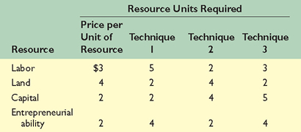

4. Supply and demand
A. Suppose the total demand for wheat and the total supply of wheat per month in the Kansas City grain market are as shown in the accompanying table.
- What is the equilibrium price?$4.00 What is the equilibrium quantity? 75 Fill in the surplus-shortage column and use it to explain why your answers are correct. Surpluses at higher prices, none at $4, shortages at lower prices
- Graph the demand for wheat and the supply of wheat. Be sure to label the axes of your graph correctly. Label equilibrium price P and equilibrium quantity Q.
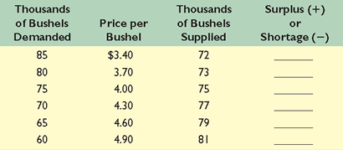
B. How will each of the following changes in demand and/or supply affect equilibrium price and equilibrium quantity in a competitive market; that is, do price and quantity rise, fall, or remain unchanged, or are the answers indeterminate because they depend on the magnitudes of the shifts? Use supply and demand diagrams to verify your answers.
- Supply decreases and demand is constant. Quantity down, price up
- Demand decreases and supply is constant. Quantity down, price down
- Supply increases and demand is constant. Quantity up, price down
- Demand increases and supply increases. Quantity up, price indeterminate
- Demand increases and supply is constant. Quantity up, price up
- Supply increases and demand decreases. Quantity indeterminate, price down
- Demand increases and supply decreases. Quantity indeterminate, price up
- Demand decreases and supply decreases. Quantity down, price indeterminate
C. Refer to the table in question 4A. Suppose that the government establishes a price ceiling of $3.70 for wheat. What might prompt the government to establish this price ceiling? Rapid, unjustified increases in the price of wheat Explain carefully the main effects. Some producers would not be willing or able to supply wheat at that price. Supply would drop, causing a shortage. Rationing would be required. Black markets might emerge. Eventually the government would reverse course.. Demonstrate your answer graphically. No Next, suppose that the government establishes a price floor of $4.60 for wheat. What will be the main effects of this price floor? There will be surpluses as many more suppliers are willing and able to prduce wheat, but people do not want to buy as much at that price Demonstrate your answer graphically.
5. Comparative advantage
The following are production possibilities tables for China and the United States. Assume that before specialization and trade the optimal product mix for China is alternative B and for the United States is alternative U.
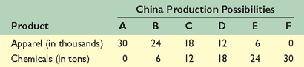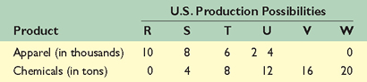
- Are comparative-cost conditions such that the two areas should specialize yes? If so, what product should each produce? China- Apparel; US- Chemicals
- What is the total gain in apparel and chemical output that would result from such specialization? 4 units of apparel (from 24+2 = 26 to 30) and 2 units of chemicals (from 6+12=18 to 20)
- What are the limits of the terms of trade? Anywhere between 1 and 2 units of apparel per unit of chemicals. This is because China could produce 1 unit of chemical at an opportunity cost of 1 unit of apparel, so they would want more than one unit of chemicals to trade apparel. The US would have to give up 2 units of chemicals for a unit of apparel, so they would be willing to trade anything less than two units of chemicals for a unit of apparel. Suppose actual terms of trade are 1 unit of apparel for 1½ units of chemicals and that 4 units of apparel are exchanged for 6 units of chemicals. What are the gains from specialization and trade for each nation? US was originally at 2 A & 12C. They now have 4A & 16C, so they have gained 2A & 4U. China was originally at 24A & 6C, now they are at 26A & 6C, so their gains are 2A & 0C)
6. Price Elasticity
A. Graph the accompanying demand data, and then use the midpoint formula for E_{d} to determine price elasticity of demand for each of the four possible $1 price changes. What can you conclude about the relationship between the slope of a curve and its elasticity? Explain why demand is elastic in the upper left segment of the demand curve and inelastic in the bottom right segment.
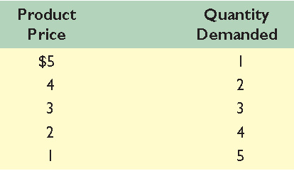
B. Calculate total-revenue data from the demand schedule in question 2. Graph total revenue below your demand curve. Generalize about the relationship between price elasticity and total revenue.
C. How would the following changes in price affect total revenue? That is, would total revenue increase, decline, or remain unchanged?
- Price falls and demand is inelastic. down
- Price rises and demand is elastic. down
- Price rises and demand is inelastic. up
- Price falls and demand is elastic. up
- Price falls and demand is of unit elasticity. same
7. Marginal Utility
A. Complete the following table and answer the questions below:
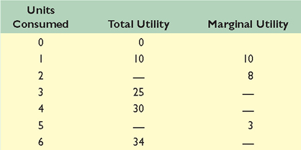
Total utility blanks are 18 and 33; Marginal utility blanks are 7, 5 and 1.
- At which rate is total utility increasing: a constant rate, a decreasing rate, or an increasing rate?
- "A rational consumer will purchase only 1 unit of the product represented by these data since that amount maximizes marginal utility." Do you agree? Explain why or why not. No, we need to know what the marginal utility per dollar is relative to our next best option in order to make this determination.
- "It is possible that a rational consumer will not purchase any units of the product represented by these data." Do you agree? Explain why or why not. Yes, it is possible (but not definite) based on the same logic above.
B. Columns 1 through 4 in the table show the marginal utility, measured in utils, that Ricardo would get by purchasing various amounts of products A, B, C, and D. Column 5 shows the marginal utility Ricardo gets from saving. Assume that the prices of A, B, C, and D are $18, $6, $4, and $24, respectively, and that Ricardo has an income of $106.
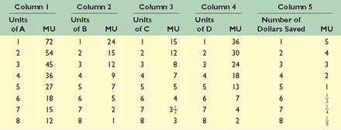
- What quantities of A, B, C, and D will Ricardo purchase in maximizing his utility?
A-4 units; B- 3 units; C- 3 units; D- 0 units
- How many dollars will Ricardo choose to save? 4
8. Costs of Production
A. Complete the table directly below by calculating marginal product and average product. Plot total, marginal, and average product and explain in detail the relationship between each pair of curves. Explain why marginal product first rises, then declines, and ultimately becomes negative. Assume revenue of $10 per unit produced. Plot marginal cost and note the relationship with marginal product.
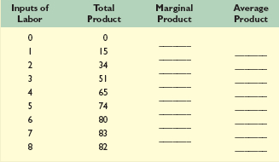
B. A firm has fixed costs of $60 and variable costs as indicated in the table at the bottom of this page. Complete the table.
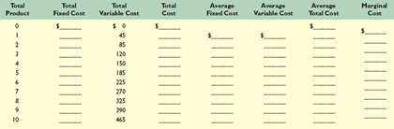
- Graph total fixed cost, total variable cost, and total cost. Explain how the law of diminishing returns influences the shapes of the variable-cost and total-cost curves.
- Graph AFC, AVC, ATC, and MC. Explain the derivation and shape of each of these four curves and their relationships to one another. Specifically, explain in nontechnical terms why the MC curve intersects both the AVC and ATC curves at their minimum points.

