Carleton University

Laboratory Report

Course #: Experiment #: 1

Experiment Title

PURPOSE

The purpose of this experiment is to determine and analyze one’s reaction time with a reasonable error rate.
THEORY

A reaction time is the time taken to react to a trigger, whether it is visually by dodging someone’s slap, or audibly by reacting to a race’s gunshot. In this experiment reaction time will be observed through a series of tests of visual and audible stimulus. The values of the tests are recorded in a program called Logger Pro which takes the mean, standard deviation and number of samples. These values will aid in finding further values, such as statistical error (standard deviation of the mean). Values for both audible and visual stimulus will be then be compared and averaged in an equation to derive an overall reaction time.
𝜎 = Standard Deviation, N= number of samples,
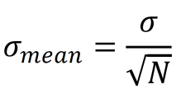
= Equation for standard deviation mean
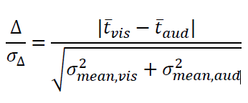

= Equation used for comparison.

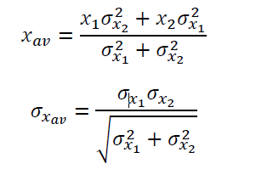
= Equations used to average
and derive overall reaction time.

APPARATUS

Clock- This is used to gage how quickly one is reacting. Range: maximum values are minutes while the smallest are seconds. Times shown on here are visual and auditory reaction times.
The switch- This is used by a partner, pressing down on the clicker switch will make a sound, which the subject has to react to by pressing down on a button to stop the clock. Another component would be a silent switch; it starts the time on the clock. As soon as the clock starts, the subject stops it with another button.
Logger pro- This is used to record time values. It automatically calculates average time, samples and how spread out is the data. Range: number of samples is unlimited, average time depends on the value of samples (for this experiment 0.05 s to 0.33 s)

OBSERVATION
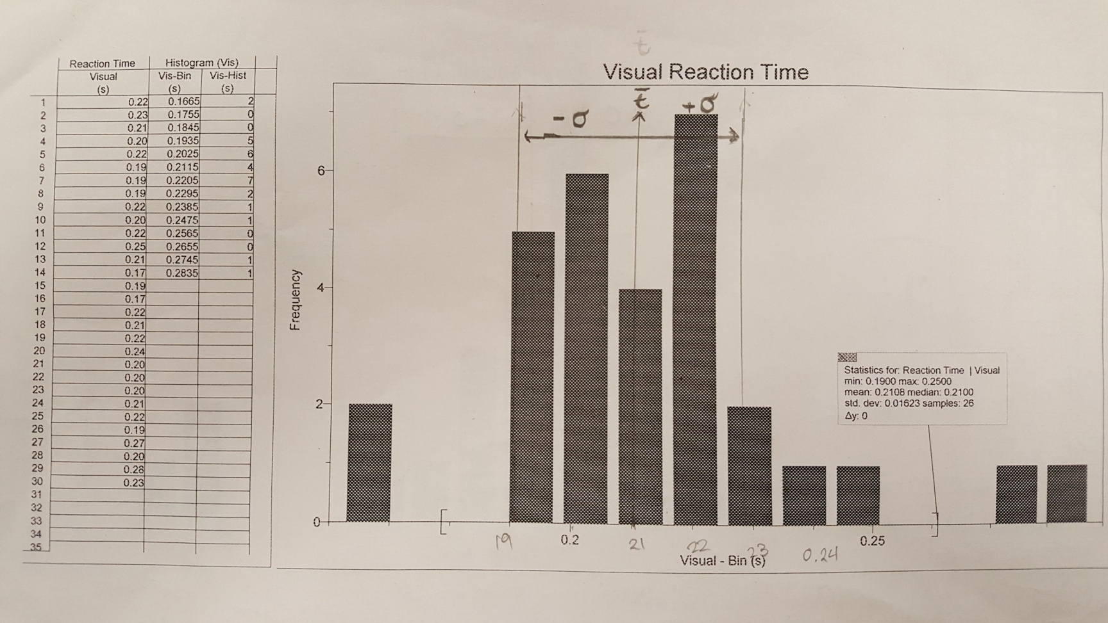

Figure 1
These are samples obtained from doing visual reaction tests. Whenever the clock starts, the subject has to stop it as quickly as possible. As seen in the graph and table, the most frequent value is 0.22 seconds; it makes the mean of 0.2108 seconds reasonable.

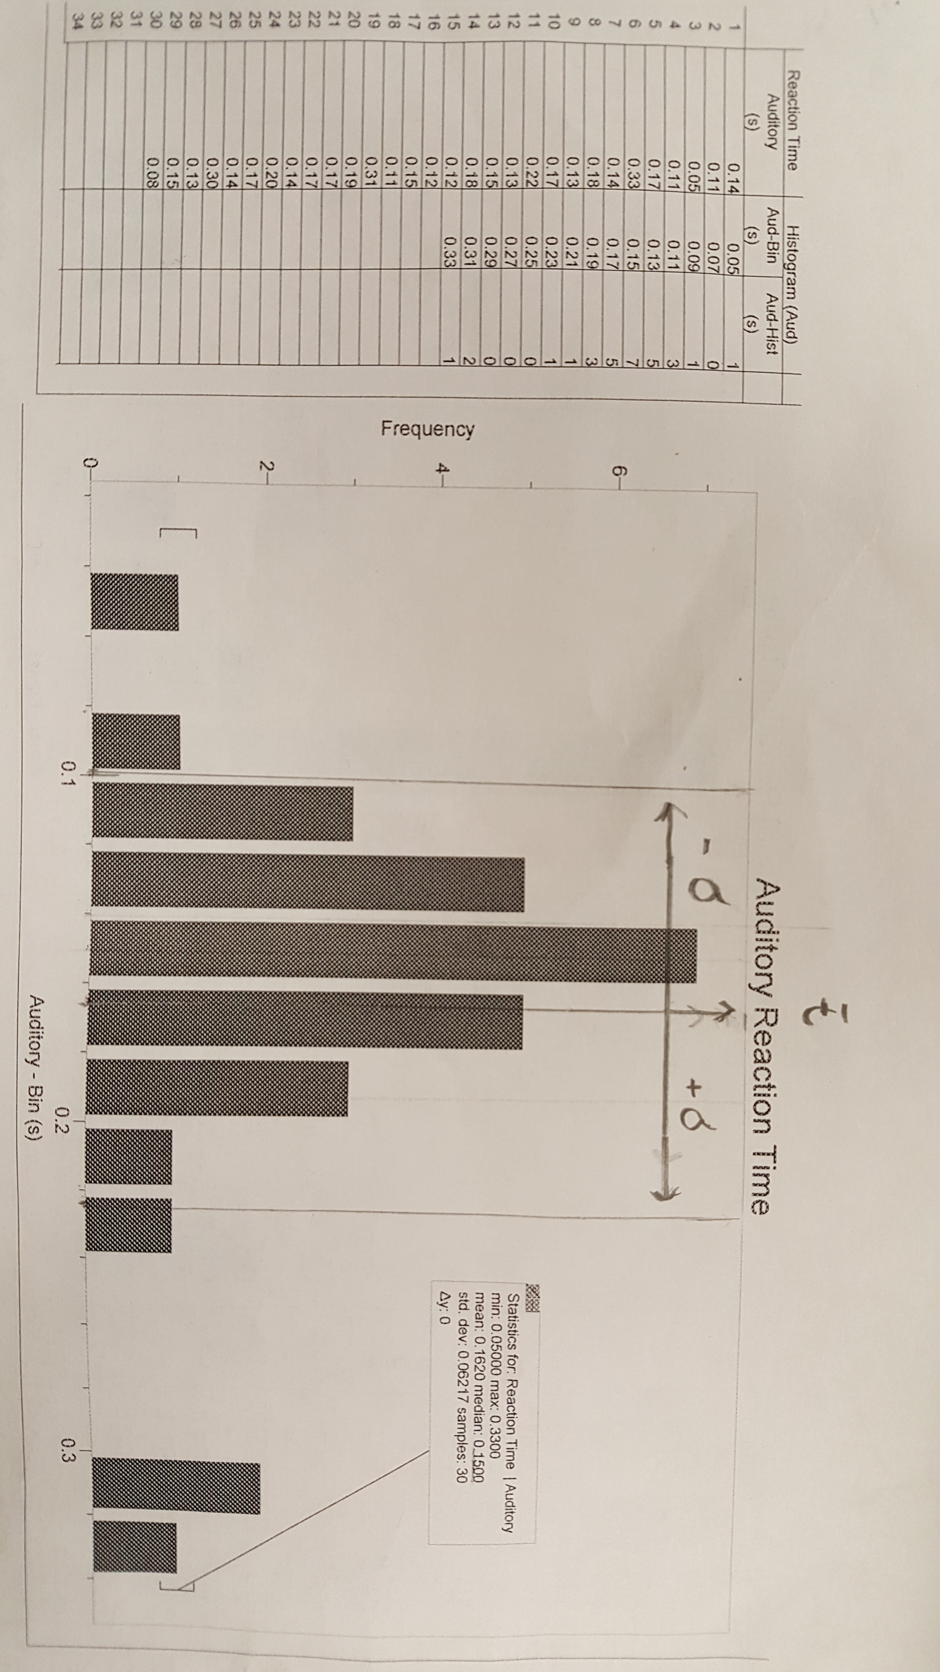

Figure 2
These are samples obtained from auditory reaction tests. Whenever the clicking sound is made, the subject reacts by pressing down on a button that stops the time on the clock. The most frequent value is 0.15 seconds; it makes the mean of 0.1620 seconds reasonable.

CALCULATIONS

Percent of bin inside the interval ($τ$ ±𝜎) = # within the range/Number of Samples times 100
[Auditory Times- Range 0.09983 and 0.22417] = $\frac{25}{30}$ × 100
Percent of bin inside the interval for auditory reaction time = 83 %
[Visual Time range - 0.19457 and 0.22703] = $\frac{22}{26}$ × 100
Percent of bin inside the interval for visual reaction time = 84 %
Auditory Standard deviation mean

= $\frac{0.06217}{\sqrt{30}}$
= 0.011350637 s
0.011 s
Comparison Test - 2× (0.02 s) > 𝜎, therefore I will keep the reading error instead of the statistical error for auditory reaction time.

Visual Standard deviation mean

= $\frac{0.01623}{\sqrt{26}}$
= 0.003182964873 s
= 0.0032 s
Comparison Test - 2× (0.02 s) > 𝜎, therefore I will keep the reading error instead of the statistical error for visual reaction time.

True Auditory Reaction Time = 0.1620 s ± 0.02 s
∴ = 0.162 s ± 0.020 s

True Visual Reaction Time = 0.2108 s ± 0.02 s
∴ = 0.211 s ± 0.020 s

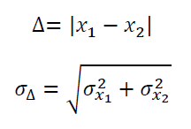
Reaction Time Comparison =

$$=\frac{\left|0.211 s-0.162 s\right|}{\sqrt{{0.020 s }^{2}+{0.020 s }^{2}}}$$
$$=\frac{0.049 s}{0.028284271 s}$$
$\frac{∆}{σ_{∆}}$ = 1.732411614 $≤2$
$\frac{∆}{σ_{∆}}$ = 1.7 $≤2$

∴ Answer is consistent, weighted factor is to be used for calculating the average and error of both reaction times.

Reaction Time Average
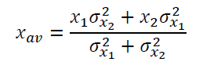

$\frac{0.211 s ×{0.020 s }^{2}+ 0.162 s ×{0.020 s }^{2}}{{0.020 s}^{ 2}+{0.020 s }^{2}}$ = 0.1865$s$

$τ_{av}$= 0.187 s (kept to 3 decimal places to match the errors)

Reaction Time Error
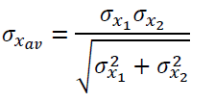

$\frac{0.020 s × 0.020 s}{\sqrt{{0.020 s }^{2}+{0.020 s }^{2}}}$ = 0.014142135 s

$σ_{τ_{av}}$= 0.014 s

Final Overall Reaction Time

($τ_{av}$ ± $σ_{τ_{av}})$

∴ The final overall reaction time is (0.187 s ± 0.014 s)

RESULTS

The first step is to determine whether statistical error or reading error is to be used for each reaction time. For auditory reaction time, the statistical error is smaller than the reading error doubled, so the reading error is taken - 0.011 s vs. 0. 040 s
Similarly, for visual reaction time, the statistical error is smaller than the reading error doubled so it is kept as well –0.0032 vs. 0.040.
Once the error is determined, the average reaction times are rounded and significant digits and decimal places are adjusted for in order to accommodate the errors.
Example
BEFORE | AFTER
$$0.1620 s± 0.02 s$$ | 0.162 s ± 0.020 s
$$0.2108 s±0.02 s$$ | 0.211 s ± 0.020 s

After that the two reaction times are compared and determined whether they are consistent or inconsistent. In this case they are consistent because the answer deduced from the comparison is smaller than 2:$\frac{∆}{σ_{∆}}$ = 1.7$≤2$. This determines that the weighted factor equation is to be used to determine the final overall reaction time and error.
Using the weighted factor, the final overall reaction time is ($τ_{av}$ ± $σ_{τ_{av}})$ = (0.187 s ± 0.014 s)

DISCUSSION

Taking the average of the two means for auditory and visual reaction times, it gives a really close answer to the final overall reaction time: 0.1864 s vs. 0.1865 s – this proves calculations as reasonable. One thing that does stand out is the fact that 83% and 84% of bin is included in the interval ($τ$ ±𝜎) as opposed to the standard 68%. Both reaction times are statistically consistent as seen through calculations but also because 80% of data for both times is between the interval ($τ$ ±𝜎). Statistical error is much lesser than my reading error and by using the comparison factor; it is used as the error rate. Factors that contribute to errors other than the reading errors, are distractions caused by other switch clicks. The subject concentration can be detracted as a cause of other noises caused by other experimenters; this can be distracting for auditory tests where one is listening for one specific amongst many. Stirring of others causes visual distractions, detracting attention from the clock. Another source of error is the interruptions caused by presentations and announcements; it ruins momentum. A method to eliminate the auditory error is simple: instead of using the clicker sound, the subject can react to the moment a sound is produced from a cell phone while wearing headphones, this will cancel all distractions caused by other clicker sounds, and in fact if the whole class uses this method they will no longer be a collection of clicks. The sound from the phone can be easily produced by selecting ringtones in the phone’s settings or downloading applications that reproduce sounds. The visual distraction can be simply solved by the instructor reinforcing that movement should be kept to a minimum, presentation and announcements should all be done prior or after the experiment. The objective of finding has been achieved successfully and a propagated error along with it. According to humanbenchmark.com the average reaction time is 0.276 s $±$ 0.30 s, deeming this experiment’s reaction time 0.089 s faster than the world average. For humans, reaction time is the time it takes for information to travel from your brain to any body part needed in order to react. As an example if someone drops their phone, their reaction time will be dictated by how fast their brain can send information to body in order to move it.

BIBLIOGRAPHY

http://www.humanbenchmark.com/tests/reactiontime/statistics
All other information was obtained from PDFs from cuLearn Phys1003
PDFs :
B_Lab Reports
PHYS 1003 Reaction Time Slides
PHYS 1003 Lab Reports, Sig Figs, Errors
PHYS 1003 Introduction to Physics Labs
PHYS 1003 Reaction Time Manual
C_Errors

