Carleton University

Laboratory Report

Course #: PHYS-1007 L9 Experiment: Density

Density Lab

Jonathan Andre
101008483

Date Performed: September 24, 2015
Date Submitted: October 8, 2015
Lab Period: L9
Partner: Jared
Station #: 2
TA: Rob Hunter
Abstract
The goal of the experiment is to determine the velocity of a metal cylinder using the direct method and Archimedes’ principle as well as to determine the final error on the respective values. Through these values a weighted or an arithmetic average final density will be calculated depending on the consistency and then will be compared to the actual value. To achieve this, a selection of measuring tools will be used such as a micrometer; to determine the length of the cylinder, a Vernier Caliper; to determine the diameter of the cylinder, and an electronic balance; to determine the cylinder weight in both air and water. Once all these values have been found, they will be analyzed using the density equations and error propagation equation to reach a final density. The experimental values were found to be inconsistent with one another however the final calculated density was consistent with accepted value with a slightly higher error value (0.0261, rounded to 1 sig dig is 0.03). This result was achieved by finding the density of the sphere directly through measurements, and through Archimedes’ principle, then taking an arithmetic average of those densities and their errors because they were inconsistent. Finally, a final consistency test was taken. It was found that 2.69 ± 0.03g/cm³ is consistent with the actual value of 2.70 ± 0.01g/cm³.

Theory
The density of an object represents the object’s mass (g) per unit of volume (cm³). The density of an object can be calculated different ways, the most common way of solving it is by using the equation 𝜌 = M/V where 𝜌 represents the density of the object, M represents mass and V represents volume. However, because we are calculating the density of a cylinder, we must account for the cylindrical shape while calculating the density. We therefore use the following equation:
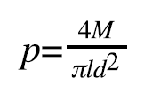 (EQ1)
After calculating the density of the cylinder, we must use the propagation of error equation as there is always an associated error given with any calculated value.
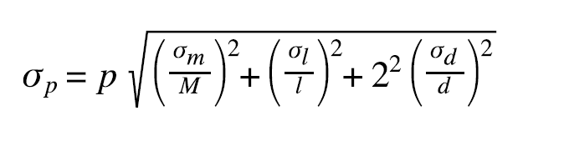(EQ2)
In the propagation of error equation, there are values such as M and l and d. These values also had to be determined using the following equations to ensure the dimensions of the cylinder were as precise as possible.
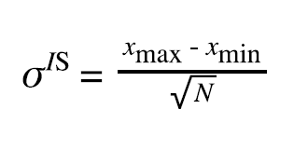 (EQ3)
The equation above is the statistical error where N is the number of trials.
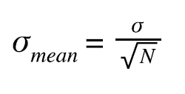(EQ4)
The equation above is the standard deviation of the mean where N is the number of trials.
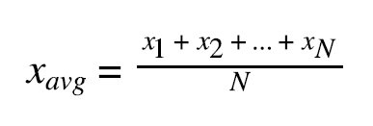(EQ5)
The equation above is the average of values for N number of values.
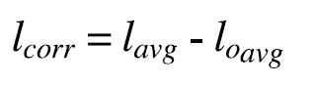 (EQ6)
The equation above is the final length considering micrometer zero.
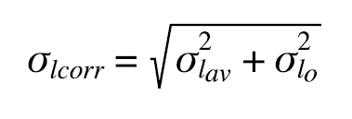 (EQ7)
The equation above is the error propagation for the length of the cylinder.

Then, the density was determined by using Archimede’s Prinicpal. The equation for this principal is the following:
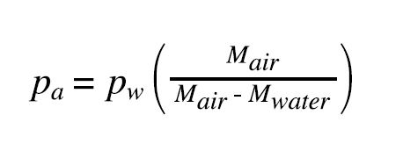(EQ8)
This equation uses the density and the mass of water as well as the mass of air to determine its complete overall density. As mentioned there is always an error value. This can be found in this case using the following equation:
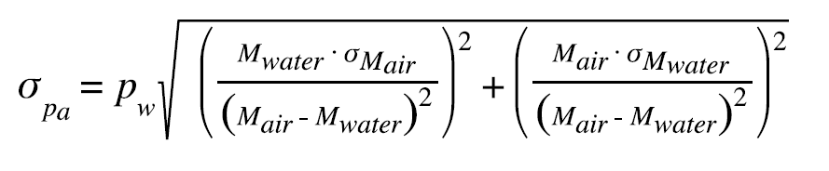(EQ9)

Now since both density values have been calculated (EQ1 and EQ8), we must determine if the calculated values are consistent with the accepted value. We use the following equation:
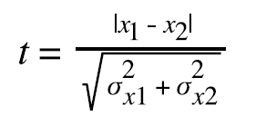(EQ10)
After calculating this value, we must determine if the value is consistent or inconsistent. The value is said to be inconsistent if t > 2, otherwise the value is consistent. Considering that the calculated value was deemed inconsistent (not the final and the actual value), we must use the arithmetic equations:
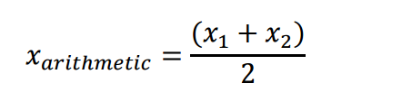 And 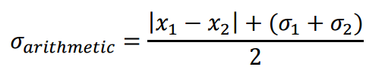

(EQ11) (EQ12)

Apparatus

Observations
Table 1: Observations of the mass, diameter, and length of a small metal cylinder
 | Mass of cylinder in air (g) | Mass of cylinder in water (g) | Diameter of cylinder (Vernier Caliper) (cm) | Length of cylinder (Micrometer)  (mm) | Micrometer Zero  (mm)
Readings  1  2  3  4  5 | 14.17  14.16  14.15  14.14  14.13 | 8.96  8.97  8.96  8.94  8.93 | 1.92  1.91  1.91  1.91  1.91 | 18.52  18.51  18.53  18.52  18.50 | 0.01  0.00  0.0075  0.01  0.01
Average | 14.15 | 8.95 | 1.91 | 18.52 | 0.0075
Reading Error | 0.005 | 0.005 | 0.005 | 0.005 | 0.005
𝝈 | 0.0179 | 0.0179 | 0.0045 | 0.0134 | 0.0045
𝝈𝒎𝒆𝒂𝒏 (stat. error) | 0.008 | 0.008 | 0.0020 | 0.006 | 0.0020
Error Used (Reading or Stat) | Stat Error | Stat Error | Reading Error | Stat Error | Reading Error
Final Values | 14.15±0.008g | 8.95±0.008g | 1.91±0.005cm | 𝒍𝒄𝒐𝒓𝒓 (𝑙 − 𝑙0) = 18.51 | 18.51
 |  |  |  | Error on 𝒍𝒄𝒐𝒓𝒓 = 0.0078 | 0.0078
 |  |  |  | 18.51±0.0078cm | 18.51±0.0078cm

For calculations, please see next page.

Results
The goal of this experiment was to determine the density of a metal cylinder using the direct method and Archimedes’ principle, estimate the final errors on each value, and find a final value to compare to the actual value. The density determined via direct method was 2.67 ± 0.0072 g/cm³ and the density determined via Archimedes’ principle was 2.71 ± 0.0049 g/cm³

These two values were determined to be inconsistent using the consistency test.

Final density determined via arithmetic average: 2.71 ± 0.03 g/cm³

The final density was determined to be consistent with the expected value of 2.70 ± 0.01 g/cm³ by using the consistency test. Ultimately, the goals of the experiment were accomplished making the experiment successful.

Discussion
Over the course of the experiment the density was measured using two different methods (direct method and Archimedes’ principle). The two density values were determined to be very similar, only varying by 0.04 g/cm³ (neglecting error and uncertainty). However, the uncertainty/error values were the contributing factors that made the calculated density inconsistent. The final density was found to be equal to the density determined through Archimedes’ principle. Through this, it can be assumed that though the direct method was able to produce a value close to the actual density, Archimedes’ principle was more accurate by producing a closer value and smaller error. Thus, Archimedes’ principle had a higher contribution to the final value.
The overall experiment was successful, but there are areas in which it could be improved. For example, if the instruments (electronic balance, Vernier Caliper and micrometer) were more precise, the value determined by the direct method may have been closer to the actual value, and measurement errors would be less likely. The possible inaccuracy of the instruments due to their continued and frequent use may have also contributed to this (with the exclusion of the micrometre). The procedure also specified to place the metal cylinder at a different location on the electronic balance each time. A more accurate value may have been achieved by placing the cylinder at the centre for each trial. If the cylinder is placed in a different spot on the balance each time, this will cause a fluctuation in the results, thereby increasing the inaccuracy of the results. There are multiple real-world applications for density, and methods for finding it. One simple application is that of a helium balloon. When a balloon is filled with helium, it eventually begins to float because the density of helium is less than that of air. Another is that of Archimedes himself. When the king asks him to determine if his crown is real gold or not, Archimedes discovers the idea of density as he is in his bathtub. He notices that as he goes in the tub, the water level rises above the rub and spills over because he is denser than the water.

Raw Data
Please see attached sheet for raw data.

