Chapter 10—customer defined service standards
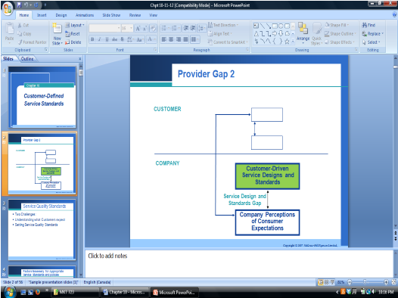
Service quality standards
- Two challenges
  - Understanding customer requirements is the first step in delivering high service quality
  - Using this knowledge to set service quality standards for the organization
- As a service provider you need to figure out what customers want, and how to approach their wants

Factors necessary for appropriate service standards

Standardization of service behaviour and actions
- The translation of customer expectations into specific service standards depends on the degree to which tasks can be standardized
- When should services be standardized?
  - Routine, easy to standardize services
  - If the service is not complicated; it should be standardized →call centre, bank teller o If the service is complicated; it shouldn’t be set to a standard→lawyer
- Standardization of service can take three forms o Substitution of technology for personal contact—automatic car wash, ATM
  - Improvement in work methods –salad bar o Combination of both
- Standardization, whether accomplished by technology or by improvements in work processes reduces gap 2
- Customer defined standardization ensures most critical elements of a service are performed as expected by customer o Call centre standard time to handle a call is tied to customer satisfaction—standard set by customer
▪ Amex call centre—call length determined by customer needs not by company standards

Formal service targets and goal
• Successful companies are noted for establishing formal standards to guide employees o These companies have an accurate sense of how well they are performing and strive to improve by defining goals that lead them to meet or exceed customer expectations
o One type of formal goal setting involves specific targets for individual behaviours
- Ex. call back quickly vs. call back same business day or within the hour o Another type of goal setting involves the overall department or company
- Ex. a department might set as its overall goal “to call the customer back within 4 hours 97% of the time” and collect data over a month time to evaluate the extent to which it meets the target

Customer—not company—defined standards
- Anchoring service standards on customers can save money by identifying what the customer values and eliminates features that the customers will not notice or will pay for
- Customer defined standards: operational standards based on pivotal customer requirements that are visible to and measured by customers o These are chosen to match customer expectations and to be calibrated the way the customer views and expresses them. Visible to the customers rather than the company concerns

Types (3) of customer defined service standards *

Hard customer defined standards
- Hard customer defined standards: things that can be counted, timed, compared or observed through audits o Qualitative standards
- Reliability is the single most important concern of service customers
- Hard service standards for responsiveness are set to ensure the speed or promptness with which companies delivery service or service components.
- Examples:
o
  - Cingular Wireless fewest dropped o % of problems fixed the first time
calls o Time to get your bill - Varies across
  - FedEx on time delivery cultures o Dell- Ship to target, on time first time fix

Soft customer defined standards
- “Not everything that counts can be counted, and not everything that can be counted, counts”
- Soft customer defined standards: those that must be documented using perceptual data o Qualitative standards
- These are opinion based, difficult to measure and observed
- Examples:
o Ritz Carlton- Treated with respect o American Express-Courtesy

One time fixes
- One time fixes: technology, policy, or procedure changes that, when instituted, address customer requirements
- Examples:
o
  - Poka Yokes o Pizza hut central ordering system o City of Toronto one number 311
  - Pizza Hut –centralized order system

Development of customer defined service standards

Basing standards on the service encounter sequence
- A customers overall service quality evaluation is the accumulation of evaluations of multiple service experiences
- Service encounters are the component pieces needed to establish service standards in a company o Therefore, one of the 1st steps in establishing customer-defined standards is to deliante the service encounter sequence
- The best way to develop standards is by blueprinting
- Ex. Marriott found that the first 10 minutes are critical o Research found that consistent performance is not as effective as improving performance that culminates in a strong finish o Strong starts and strong finishes are critical to customer satisfaction

Expressing customer requirements as specific behaviours and actions *
- Effective service standards are defined in very specific ways that enable employees to understand what they are being asked to deliver o These standards are set and measured in terms of specific responses of human behaviours and actions
- What customers expect: getting to actionable steps for airline example
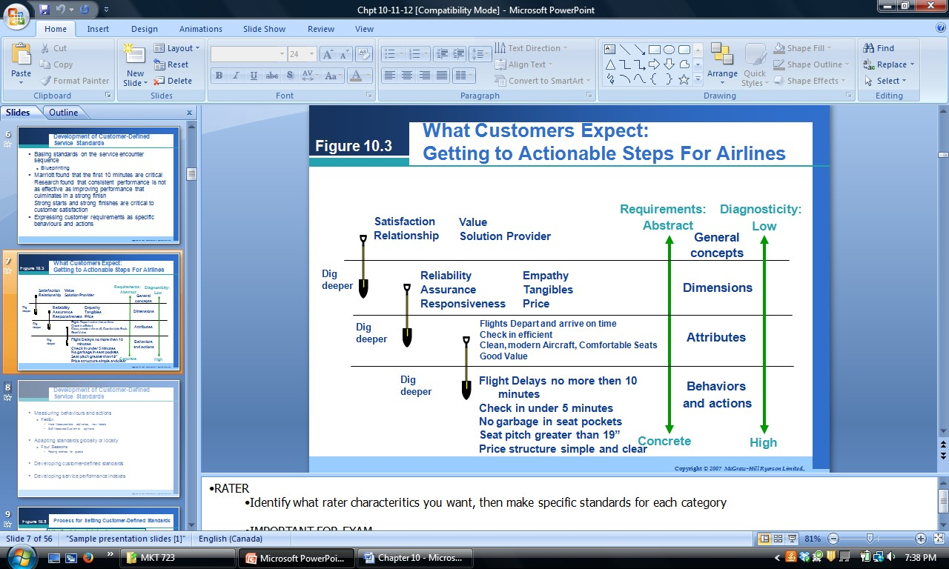
- RATER-- Identify what RATER characteristics you want, then make specific standards for each category

Measuring behaviours and actions
- Hard measurements: consists of counts that provide feedback about the performance of a service standard o Examples: late deliveries, missing labels
o Gauge involves a count of the number and type of actions or behaviours that are correct or incorrect
- Soft measurements: customer’s opinions about whether performance met the standards o Two perceptual measurement types
▪
▪ Trailer calls ▪ Relationship surveys

Adapting standards globally or locally
- Companies with worldwide brands have much to lose if their service standards vary too much across countries, and therefore they must find ways to achieve universally high quality while still allowing for local difference
- Good example: four seasons –7 standards (smile, eye, recognition, voice, informed, clean, everyone)

Process for Developing customer defined standards**
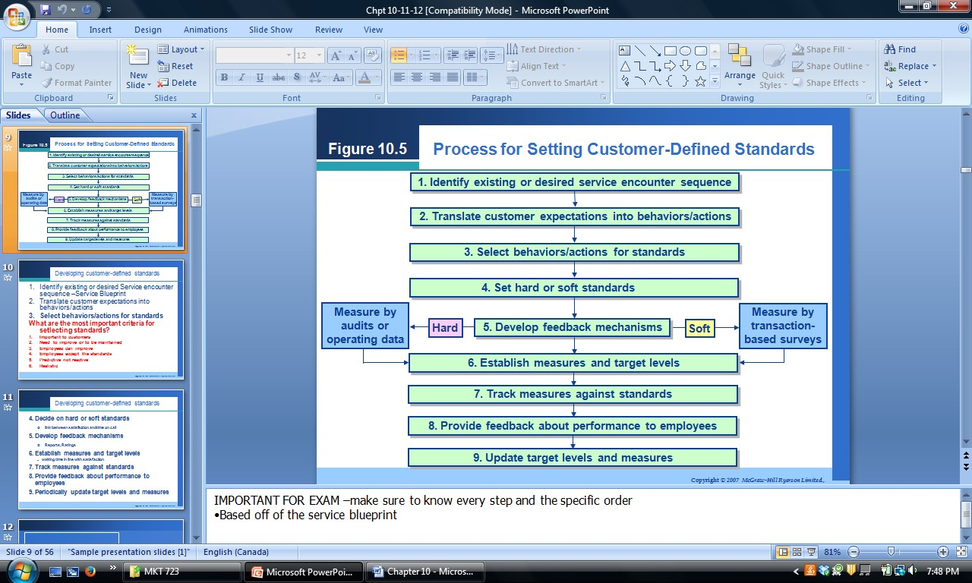
- Identify existing or desired service encounter sequence
  - Delineating the service encounter sequence
  - Service blueprint
- Translate customer expectations into behaviours and actions for each service encounter
  - Research on customer expectations
  - Abstract customer requirements and expectations must be translated into concrete, specific behaviours and actions associated with each service encounter
- Select behaviour and actions for standards
  - The standards are based on behaviours and actions that are very important to customers
    - Predict what customers want, do not just react to what they tell you
  - The standards cover performance that needs to be improved or maintained
  - The standards cover behaviours and actions employees can improve
  - The standards are accepted by employees
    - Employees must have something to do with the standards otherwise it is useless
      - Dependent on employees
    - If employees do not accept the standards and are not happy with, they will not do it
      - Give incentives
      - If they do not agree to standards, or do not see the reason for it they will not do it
a. Incentives are way to get employees to accept standards and strive
for it
  - The standards are predictive rather than reactive
  - The standards are challenging but realistic
- Decide whether hard or soft standards are appropriate
  - Biggest mistake: is to choose a hard standard hastily
  - Ex. Link between satisfaction and time on call
- Develop feedback mechanism for measurement to standards
  - Hard: involve mechanical counts or technology-enabled measurement of time or errors-ratings
  - Soft: require perceptual measurements through the use of trailer surveys or employee monitoring--reports
- Establish measures and target levels
  - Without these the company lacks a way to quantify whether the standards have been met b. Waiting time in line with satisfaction
- Track measures against standards
- Provide feedback about performance to employees
- Periodically update target levels and measures
  - Revising the target levels, measures, and even customer requirements regularly enough to keep up with customer expectations

Developing service performance indexes
- Service performance indexes: are comprehensive composites of the most critical performance standards
- Most companies build these indexes by:
  - Understanding the most important requirements of the customer o Linking these requirements to tangible and measurable aspects of service provision
  - Using feedback from these indexes to identify and improve service problems
Chapter 11—Physical evident and the servicescape

Physical evidence
What is physical evidence?
- Physical evidence includes all aspects of the organization’s physical facility (the servicescape) as well as other forms of tangible communications
- Elements of the servicescape that affect customers include both exterior attributes (such as signage, parking, and the landscape) and interior attributes (design, layout, equipment and decor) o Servicescape=interior location + physical/exterior location
Servicescape | Other tangibles
- Facility exterior:  - Exterior design  - Signage o Parking o Landscape  - Surrounding environment  - Facility interior:  - Interior design  - Equipment | - Business cards  - Stationary  - Billing statements  - Reports  - Employee dress  - Uniforms  - Brochures  - Web pages  - Virtual servicescapes
  - Signage o Layout
  - Air quality/temperature

Types of servicescapes
Typology of service organization based on variations in form and use of the servicescape

Servicescape usage
Self-service
(customer only)
Interpersonal services
(both customer and employee
Remote service
(employee only)

Servicescape usage
Complexity of the servicescape
Elaborate Lean Golf course ATM
eBay Simple internet services

Hotel Bank  Restaurant Airline  Hospital school | Dry cleaner  Retail cart  Hair salon
Telephone company  Insurance company  Utility | Telephone mail order desk  Automated voice  Messaging services

- Self-service: the customer performs most of the activities
- Remote services: little or no customer involvement with the servicescape
- Interpersonal services: represents situations in which both customers and employees are present in the servicescape

Strategic roles of the servicescape
- The servicescape is frequently one of the most important elements used in positioning a service organization
- Package: wrap the service and convey to consumers and external image of what’s inside o Conveys expectations o Influences perceptions
  - Ex. hard rock cafe—you will immediately grasp the packaging role performed by the exterior and interior elements, especially the extensive use of rock and roll memorabilia
- Facilitator: facilitates the flow of the service delivery process o Provides information (how am I to act?)
  - Facilitates the ordering process (how does this work?) o facilitates service delivery o focuses on speed of interaction o ex. Tim Horton’s
- socializer: socialization of both employees and customers in the sense that it helps convey expected roles, behaviours, and relationships o facilitates interaction between:
▪
▪ customers and employees ▪ customers and fellow
customers o
  - ex. Club Med
- differentiator: the design of the physical facility can differentiate a firm from its competitors and signal the market segment that the service is intended for
  - ex. Igloo hotel
•

Framework for understanding servicescape effects on behaviour
- Give people what they expect
- Stimulus-organism-response theory:
o Environment→stimulus o Employees→organism o Behaviours directed at the environment→responses
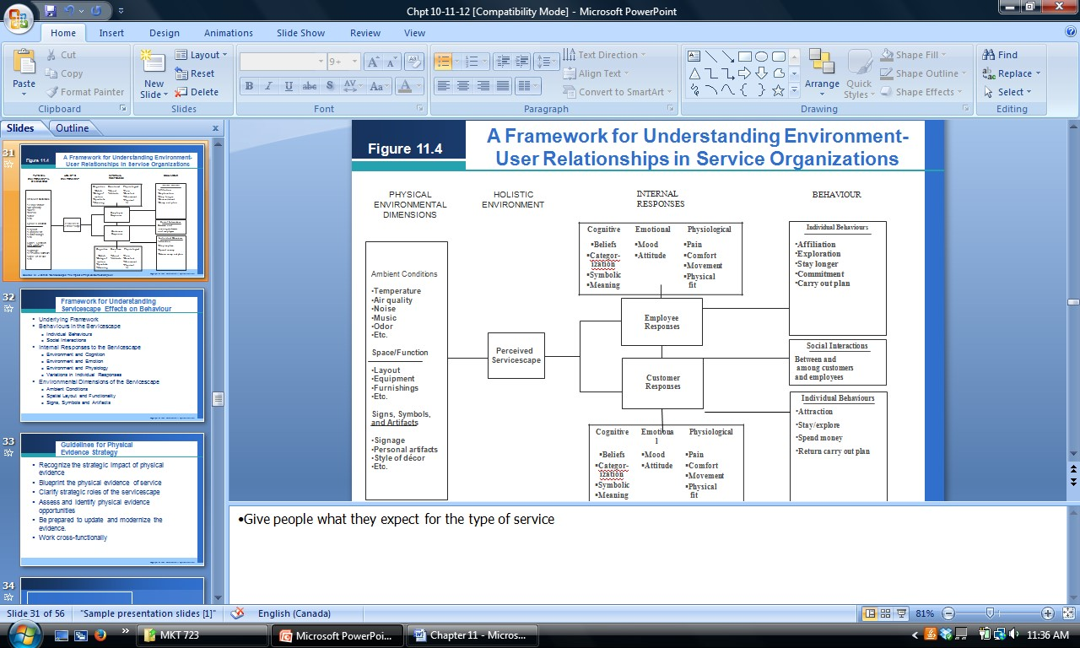

Behaviours in the servicescape
- Individual behaviours o Approach behaviours: all positive behaviours that might be directed at a particular place, such as desire to stay, explore, work and affiliate
o Avoidance behaviours: exact opposite
- Social interactions

Internal responses to the servicescape
•
- Environment and cognition • Variations in individual Reponses
- Environment and emotion
- Environment and physiology

Environmental dimensions of the servicescape
• Hundreds of potential elements have been categorized into three composite dimensions o
o Ambient conditions o Spatial layout and functionality o Signs, symbols, and artifacts

Guidelines for physical evidence strategy
- Recognize the strategic impact of physical evidence
- Blueprint the physical evidence of service
- Clarify strategic roles of the servicescape
- Assess and identify physical evidence opportunities
- Be prepared to update and modernize the evidence

• Work cross-functionality Chapter 12—Employees’ roles in service delivery

- You better have happy employees, because they are who are representing your brand o If your employees are not happy they will not do good for you
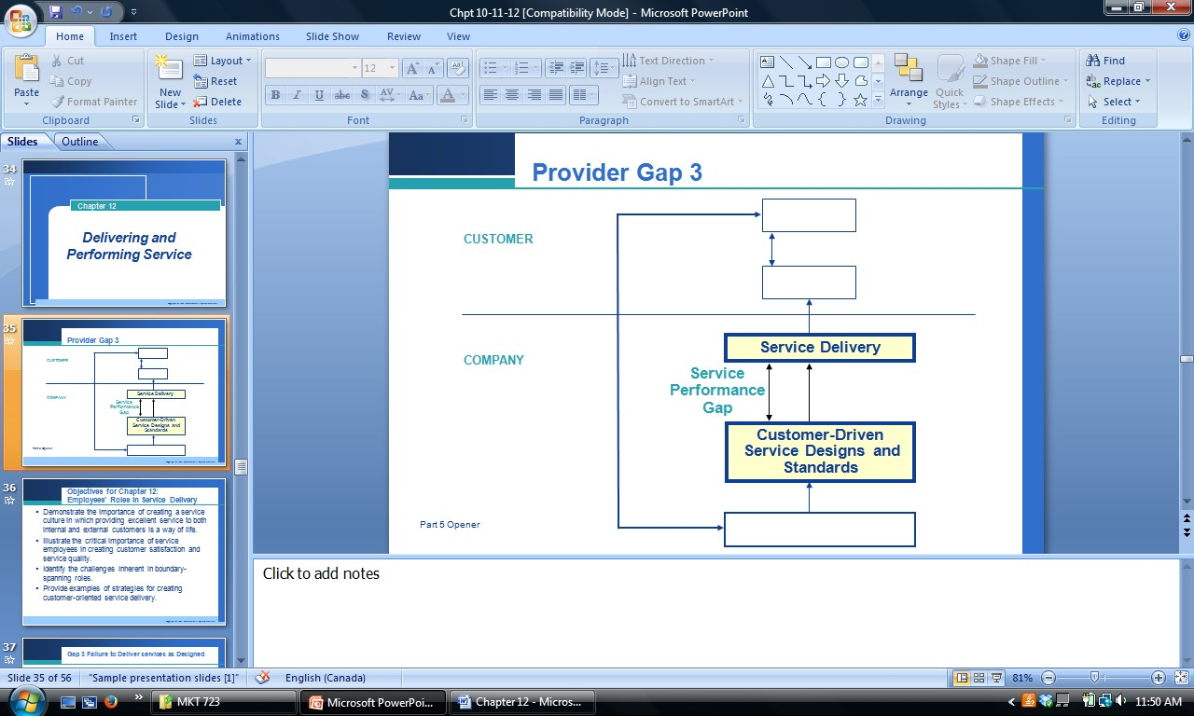
- What contributes to provider gap 3?
  - Ineffective recruitment—you hire the wrong people o Weak or negative corporate culture o Poor employee-technology-job fit
    - Employees do not have the efficient skills needed for the job o Role ambiguity/conflict
  - Inappropriate evaluation and compensations systems
    - Compensation discrepancies o Lack of empowerment, trust, teamwork
    - Not empowered→employees usually want to be independent thinkers

Service culture
- Corporate culture: the pattern of shared values and beliefs that give the members of an organization meaning, and provide them with the rules for behaviour in the organization o Do you have a culture people want to work for, or do people dread o come into work o Do employees know what they are expected to do
- Culture: the way we do things around here
- Service culture: a culture where an appreciation for good service exists, and where giving good service to internal as well as ultimate, external customers is considered a natural way of life and one of the most important norms by everyone
- The biggest factor in corporate culture is unions—unions have a big impact on corporate culture • Make sure to foster cooperation and an enjoyable place to be
- Why is culture so important to an organization?
  - Competitive advantage
  - Subtle efficient and effective form of employee management
  - No large organization can control all employees all the time

The critical important of service employees
- Characteristics of services that increase the importance of employees o Simultaneous production, heterogeneity and intangibility
- Employees:
o They are the service. Provide the entire service
▪ in many cases, the contact employee is the service
- we often DO NOT DISTINGUISH between the person and the firm
▪ Ex. Dental Hygienist, physical trainers, legal services, childcare, counseling, haircutting
o They are the organization in the customer’s eyes.
- employees represent the firm to the client
- may be the ONLY contact they have with the firm
- everything they say and do can influence perceptions of the organization
- even “off-duty” employees can influence perceptions
- Ex. Disney- on stage attitudes and behaviors , Pest control o They are the brand.
- Southwest and West Jet 86% of employees are also shareholders
- Audi and BMW Audi hires employees that are not afraid to develop personal relationships with customers o They are marketers.
- they are walking “billboards”
- they represent the company and influence customer satisfaction
- they are salespersons
- Ex. Banks CSR’s and cross selling, waiters selling desserts o Their importance is evident in:
- the services marketing mix (people)
- the service-profit chain ▪ the services triangle

The services triangle
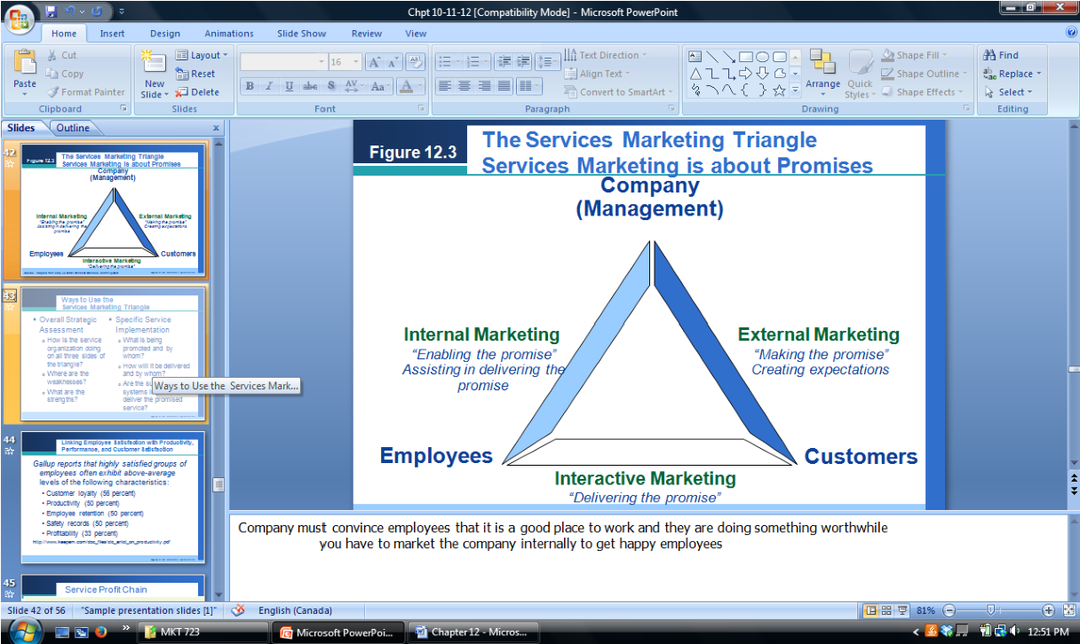
- Company must convince employees that it is a good place to work and they are doing something worthwhile o you have to market the company internally to get happy employees
- external marketing: efforts that the firm engages in to set up its customers expectations and make promises to customers o any communication to customer before service delivery
- interactive/real time marketing: where the promises are kept or broken by the firm
- internal marketing: management aids service providers in their ability to deliver on service promises o recruiting, training, motivating, rewarding
- unless service employees are able and willing to deliver on the promises made, the firm will not be successful and the service triangle will collapse
- ways to use the services marketing triangle o overall strategic assessment
    - how is the service organization on all three sides of the triangle ▪ Where are the weaknesses?
    - What are the strengths?
  - Specific service implementation
    - What is being promoted and by whom?
    - How will it be delivered and by whom? ▪ Are the supporting systems in place to deliver the promised service? Employee satisfaction, customer satisfaction and profits
- Gallup reports that highly satisfied groups of employees often exhibit above average levels of the following characteristics: o
  - Customer loyalty (56%) o Safety records (50%) o Productivity (50%) o Profitability (33%) o Employee retention (50%) •
- Higher retention→happier clients
- Both a climate for service and a climate for employee well-being are highly correlated with overall service quality
- Service profit chain: suggests that there are critical linkages among internal service quality; employee satisfaction/productivity; the value of services provided to the customer; and ultimately customer satisfaction, retention and profits o Happy employeesàproductive employeesèhappy customersàhigher profitability o The reason customers are satisfied is because employees are happy and satisfied
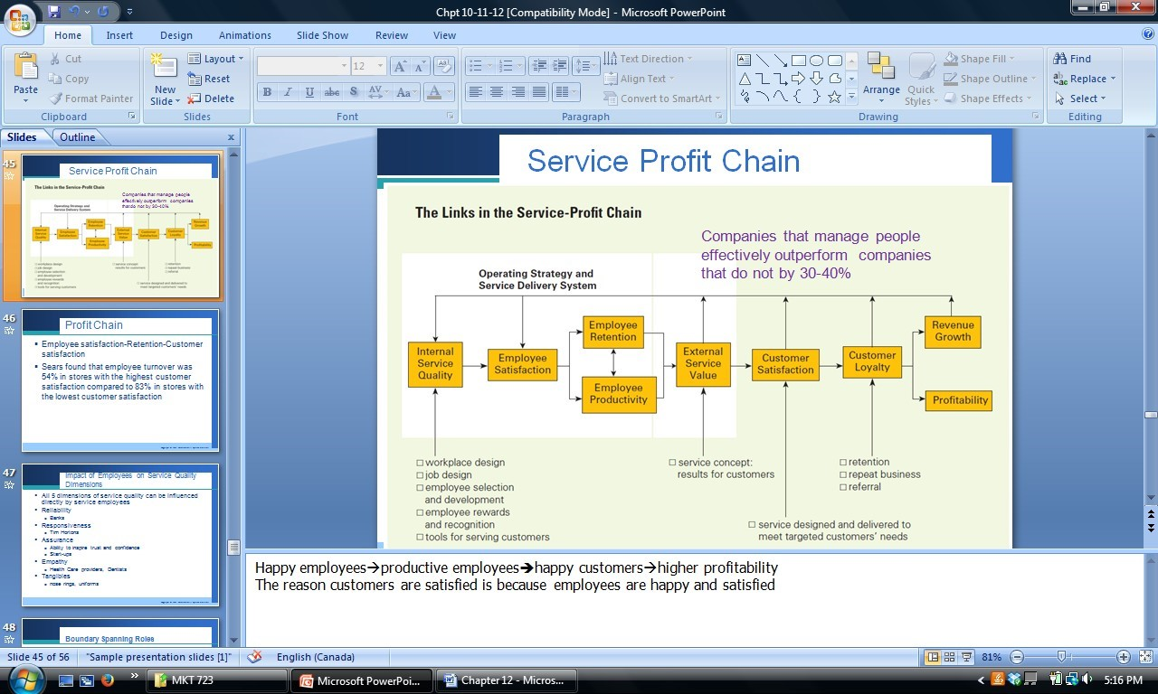
  - Employee satisfaction-retention-customer satisfaction
  - Sears found that employee turnover was 54% in stores with the highest customer satisfaction compared to 83% in stores with the lowest customer satisfaction
    - Employee turnover low→customer satisfaction is high

The effect of employee behaviours on service quality dimensions
- The impact on employees experience at company influences RATER
- All 5 dimensions of service quality can be influenced directly by service employees

Boundary spanning roles
• The front line service employees are referred to as boundary spanners because they operate at the organizations boundary o Boundary spanners provide a link between the external customer and the internal operations of the organization
o They serve a critical function in understanding, filtering, and interpreting information and resources to and from the organization

Emotional labour
- Emotional labour: labour that goes beyond the physical or mental skills needed to deliver quality service o Being friendly with strangers
- Strategies for managing emotional labour:
  - Screening o Teaching
▪
    - Surface ▪ Deep o acting acting
  - Allow employees to vent o Putting management on the frontline
    - Undercover box o Rotations and breaks o Emotional intelligence
  - Give employees a voice and suggest improvements

Sources of conflict for employees
- Person/role conflicts→I don’t want to do it
- Organization/client conflict→greatest when employee believe organization is wrong
- Interclient conflict o University classroom—instructors try to meet student expectations and preferences for content, format and style

Quality/productivity tradeoffs
- Call centres measure number of calls handles and time to handle call may conflict with customer satisfaction
- Technology being used to allow employee to maintain productivity and provide quality service • Benefits vs. costs?

Strategies for delivering service quality through people
- Human resource strategies for delivering service quality through people
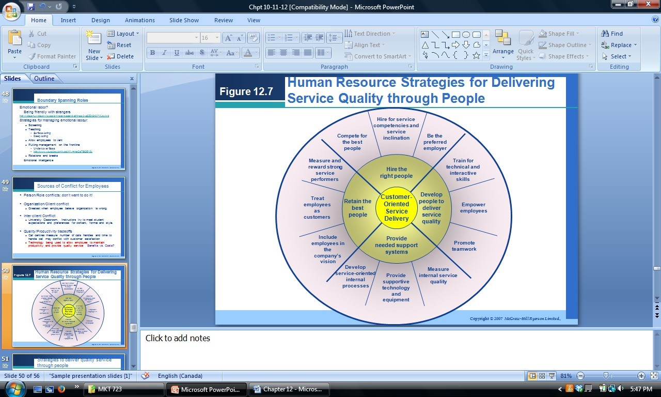
- Hire the right people o Hiringsmart.ca
  - Describes functions to hire right people o Competing for best workers o Service competences
  - Interview questions
- Ask questions that will test if you are well prepared for the job
- Do not ask stupid questions
- Understand that people do lie in interviews
o Be the preferred employer
- Provide needed support systems o What is measured and rewarded
▪ Number of calls vs. Complaints resolved
- Retain the best people o If it looks like the people are planning on leaving or unhappy do what you can to retain them
o Cheaper to hold on to customers and employees, than find and hire more o Rewards
  - Monetary and non monetary ways to motivate employees?
  - What motivates you?
  - Intrinsic and extrinsic motivation

Eight key areas that contribute to employee satisfaction

1.
- Physical workplace
- Work atmosphere and social
- Health, financial & family benefits
- Vacation & time off
- Employee communications
- Performance management

- Training & skills development •
- Community involvement
• These criteria have remained consistent since 2000

Costs and benefits of empowerment
Costs | Benefits
- Greater investments in training and selection  - Higher labour costs  - Violate customers perception of fairness  - Profits | - Response times  - Employee moral  - Source of information  - Great word of mouth advertising from customers
• Slower or inconsistent service delivery

Movie notes
- Scuba display specialist→diving industry
- store planning: designing the store and environment that drives sales
o
  - store layout o use your walls
o Self check out  • Interfering with other customers  o | o Scuba diving | •
o Not boarding the plane on time | o Digging for change | o Paintball  •
  - displays o fixtures o signage o space
  - lasing images you show to • customers

Chapter 13—Customers roles in service delivery­inseparability

Case study: Curves
- Curves: women’s’ gym →distinguished because of its meal plan and exercise plan
- What makes this organization so successful?
- 9500 locations 4 million members
- How does it ensure its members perform their roles?
  - Reasonable expectations—Ads use real women not models o Well defined roles—30 min workout guide; 3 times per week o support
How do customers widen the service performance gap?
- Lack of understanding of their roles
  - Gym equipment
- Not being willing or able to perform their roles
- Rewards for good performance o
- Incompatible market segments o o Kids in starbucks o Paintball o Kids at an adult only vacation resort

Low Moderate | High  Customer co-creates the service product
Low Moderate | • | Active client participation guides the customized service
 | • | Service cannot be created apart from the customer’s purchase and active participation
 | • | Customer inputs are mandatory and co-create the outcome
 | • | University classes
 | • | Personal training
 | • | Surgery
 | • | Management consulting
 | • | Management seminar
 | • | Installation of network

Levels of customer participation across different services

Define Consumer presence required Consumer inputs required for during service delivery service creation
Characteristi • Products are standardized • Clients inputs customize a cs standard service
- Service is provided regardless of any • Provision of service required individual purchase customer purchase
- Payment may be the only • Customer inputs are required customer input necessary for an adequate
outcome, but the service firm provides the service
B2C • Airline travel • Haircut
- Motel stay • Annual physical exam
- Fast-food restaurants • Full service restaurant
B2B • Uniform cleaning • Payroll service
- Pest control • Freight transportation
- Greenery maintenance • Advertising company
- Participation= information, physical effort, or possessions

Fellow customers [importance of other customers in service delivery]
- Other customers can detract from satisfaction:
  - Disruptive behaviours—smoking, delays o Overly demanding behaviours—seat back on airplanes o Excessive crowding—boxing day sales o Incompatible needs
- Other customers can enhance satisfaction:
  - Mere presence—sport events, clubs, vacation resorts, cruise ships o Socialization/friendships—curve camaderie
  - Roles: assistants, teachers, supporters, mentors—diving, paintball, rock climbing

Customer’s roles

Customers as productive resources
- Customers can be thought of as “partial employees” o Contributing effort, time, or other resources to the production process
- Customer inputs can affect organization’s productivity
- Customer inputs should provide benefits to customers o Time, value, savings, quality
- Key issue: Should customers’ roles be expanded or reduced?
  - Due to uncertainty customer roles should be minimized o Efficiency increased if customers are leveraged to co-produce
- Examples:
  - Lower end bargain dress stores: clients find dress, therefore partial employee and resources
  - Home depot
▪ Strategy to serve the Do it yourself home renovator ▪ Service implications of target segments
•
- Contractor
- DIY

Customers as contributors to service quality and satisfaction
- Customers can contribute to:
  - Their own satisfaction with the service ▪ By performing their role effectively
    - By working with the service provider
    - Active students vs. Passive students o The quality of the service they receive
    - By asking questions
    - By taking responsibility for their own satisfaction
    - By complaining when there is a service failure
- Examples: IKEA
  - Differentiated strategy based on customer self service
  - Reduced costs/prices o Customers assemble furniture

Customers as competitors
- Customers may “compete” with the service provider • “internal exchange” vs. “external exchange” • Internal/external decision often based on:
o
- Expertise capacity→DIY disaster o Resource capacity→Tools to fix plumbing leak  - Time capacity o Economic rewards | - Psychic rewards→Do it yourself satisfaction  - Trust o Control  •
- Examples:
o Travel agents
  - The travel agent might not be motivated to continuously work for finding clients better deals
  - Travelers are consuming the products, therefore will be more willing to go and find better deals than the travel agent will o Real estate
  - Selling house by yourself and not through an agent
  - Removes the need for paying commission, and you know you are spending 100% time on doing so
- Disintermediation→cutting out the middleman o Can be risky, or very rewarding

Self­service technologies
• Self serviceàcustomer does everything themselves o Typically online

Strategies for enhancing customer participation—effective customer participation Define customer’s jobs
•
- Clarify level of participation
- Identify specific roles
- Understand implications for productivity /quality
- Helping: oneself, others
- Promoting the company

Recruit, educate, and reward customers
•
- Identify and recruit appropriate segments • Reward customer performance
- Recruit the right customers • Avoid negative outcomes
- Educate/train customers for their roles
- Provide reasons to participate

Manage the customer mix
•
- Assess compatibility of segments • Enhance segment compatibility
- Isolate incompatible segments •

Chapter 14—Delivering service through intermediaries
& electronic channels

Case study: Curves
- Curves: women’s’ gym →distinguished because of its meal plan and exercise plan
- What makes this organization so successful?
- 9500 locations 4 million members
- How does it ensure its members perform their roles?
  - Reasonable expectations—Ads use real women not models o Well defined roles—30 min workout guide; 3 times per week o support
How do customers widen the service performance gap?
- Lack of understanding of their roles
  - Gym equipment
- Not being willing or able to perform their roles
- Rewards for good performance o
o Self check out  • Interfering with other customers  o | o Scuba diving | •
o Not boarding the plane on time  • Incompatible market segments | o Digging for change | o Paintball  •
o
  - Kids in starbucks o Paintball
  - Kids at an adult only vacation resort

Low Moderate | High  Customer co-creates the service product
Low Moderate | • | Active client participation guides the customized service
 | • | Service cannot be created apart from the customer’s purchase and active participation
 | • | Customer inputs are mandatory and co-create the outcome
 | • | University classes
 | • | Personal training
 | • | Surgery
 | • | Management consulting
 | • | Management seminar
 | • | Installation of network

Levels of customer participation across different services

Define Consumer presence required Consumer inputs required for during service delivery service creation
Characteristi • Products are standardized • Clients inputs customize a cs standard service
- Service is provided regardless of any • Provision of service required individual purchase customer purchase
- Payment may be the only • Customer inputs are required customer input necessary for an adequate
outcome, but the service firm provides the service
B2C • Airline travel • Haircut
- Motel stay • Annual physical exam
- Fast-food restaurants • Full service restaurant
B2B • Uniform cleaning • Payroll service
- Pest control • Freight transportation
- Greenery maintenance • Advertising company
- Participation= information, physical effort, or possessions

Fellow customers [importance of other customers in service delivery]
- Other customers can detract from satisfaction:
  - Disruptive behaviours—smoking, delays o Overly demanding behaviours—seat back on airplanes o Excessive crowding—boxing day sales o Incompatible needs
- Other customers can enhance satisfaction:
  - Mere presence—sport events, clubs, vacation resorts, cruise ships o Socialization/friendships—curve camaderie
  - Roles: assistants, teachers, supporters, mentors—diving, paintball, rock climbing

Customer’s roles

Customers as productive resources
- Customers can be thought of as “partial employees” o Contributing effort, time, or other resources to the production process
- Customer inputs can affect organization’s productivity
- Customer inputs should provide benefits to customers o Time, value, savings, quality
- Key issue: Should customers’ roles be expanded or reduced?
  - Due to uncertainty customer roles should be minimized o Efficiency increased if customers are leveraged to co-produce
- Examples:
  - Lower end bargain dress stores: clients find dress, therefore partial employee and resources
  - Home depot
▪ Strategy to serve the Do it yourself home renovator ▪ Service implications of target segments
•
- Contractor
- DIY

Customers as contributors to service quality and satisfaction
- Customers can contribute to:
  - Their own satisfaction with the service ▪ By performing their role effectively
    - By working with the service provider
    - Active students vs. Passive students o The quality of the service they receive
    - By asking questions
    - By taking responsibility for their own satisfaction
    - By complaining when there is a service failure
- Examples: IKEA
  - Differentiated strategy based on customer self service
  - Reduced costs/prices o Customers assemble furniture

Customers as competitors
- Customers may “compete” with the service provider • “internal exchange” vs. “external exchange” • Internal/external decision often based on:
o
- Expertise capacity→DIY disaster o Resource capacity→Tools to fix a plumbing leak  - Time capacity o Economic rewards | - Psychic rewards→Do it yourself satisfaction  - Trust o Control  •
- Examples:
o Travel agents
  - The travel agent might not be motivated to continuously work for finding clients better deals
  - Travelers are consuming the products, therefore will be more willing to go and find better deals than the travel agent will o Real estate
  - Selling house by yourself and not through an agent
  - Removes the need for paying commission, and you know you are spending 100% time on doing so
- Disintermediation→cutting out the middleman o Can be risky, or very rewarding

Self­service technologies
• Self serviceàcustomer does everything themselves o Typically online

Strategies for enhancing customer participation—effective customer participation Define customer’s jobs
•
- Clarify level of participation
- Identify specific roles
- Understand implications for productivity /quality
- Helping: oneself, others
- Promoting the company

Recruit, educate, and reward customers
•
- Identify and recruit appropriate segments • Reward customer performance
- Recruit the right customers • Avoid negative outcomes
- Educate/train customers for their roles
- Provide reasons to participate

Manage the customer mix
•
- Assess compatibility of segments • Enhance segment compatibility
- Isolate incompatible segments •

Chapter 15—Managing demand & capacity—
perishability

- perishability o How to fill up rooms when demand is low, and how to prevent everyone coming at the same time when the demand is high
o What do you have with unfilled rooms
- Delta Demand fluctuations o Seasonal
▪ How to deal with high demand at airport
- More flights
- More people working/more security
▪ How to deal with low demand
- Discounted prices
- Incentive to fly and travel at low periods
o Weekly o Relate to segments Managing capacity
- Why is it so important to manage capacity?
  - To prevent frustrated employees and customers during high times
  - During low times the company is not being optimized in profitability→not making money
- Fixed costs
- Customer satisfaction
- Employee satisfaction

Variations in demand relative to capacity
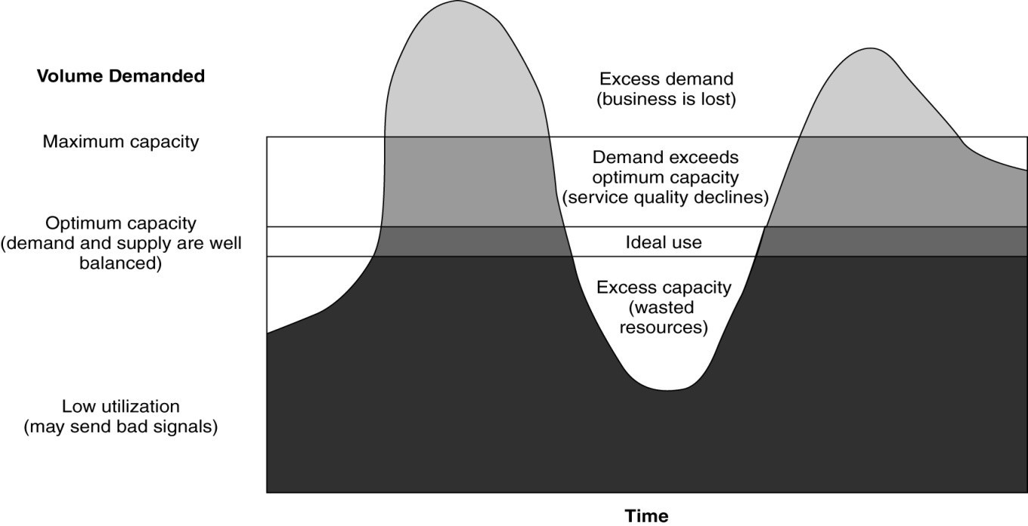
- The area in the middle of the figure are labelled to represent four basic scenarios that can result from different combinations of capacity and demand: o Excess demand
▪ Not everyone will get served or served adequately o Demand exceeds optimum capacity
o Demand and supply are balanced at the level of optimum capacity o Excess capacity
▪ Company resources are being wasted
- The seriousness of the problem will depend on the extent of demand fluctuations over time, and the extent to which supply is constrained

Understanding capacity constraints and demand patterns
Demand patterns
- Charting demand patterns
- Predictable cycles o Travel to the Caribbean o Spring and motorcycle maintenance
  - Reading week—airlines know what university kids want so they will adjust travels to that o March break—families want a completely different type of holiday
- Random demand fluctuation o Weather
- Demand patterns by market segment o Banks commercial accounts
  - Walk in clinics
Capacity constraints
- Time, labour, equipment, and facilities o Because there is not infinitive room and resources
  - You are limited on time, labour, equipment and facilities to service everyone at high demand times
- Optimal versus maximum use of capacity o You want optimal capacity, not maximum capacity
  - You are maximizing profits while maximizing service satisfaction
▪ Focusing on service quality while filling as much to still provide optimal service quality ▪ Avoid over filling and loosing service quality

Demand vs. supply
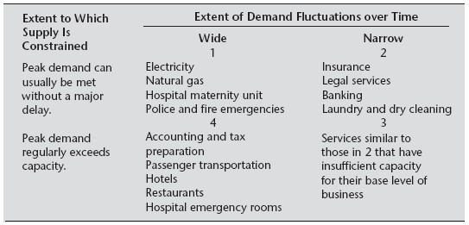

Capacity constraints
Nature of the constraint Type of service
Legal consulting | Accounting medical
Law firm  Accounting firm | Consulting firm  Health clinic
Delivery services  Telecommunication | Network services  Health club
Time
Labour
Equipment
facilities Hotels Airlines
Restaurants Schools
Hospitals Theatres
- Time
o Personal service models o Person-to-person services
- Labour→may not be enough employees to work on temporary basis
- Equipment→capital intensive
- Facilities→supply of services/room

Strategies for matching capacity and demand

Shifting demand to match capacity
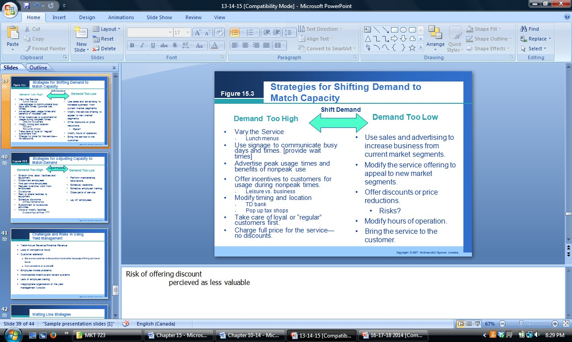

Shifting demand to adjust to capacity
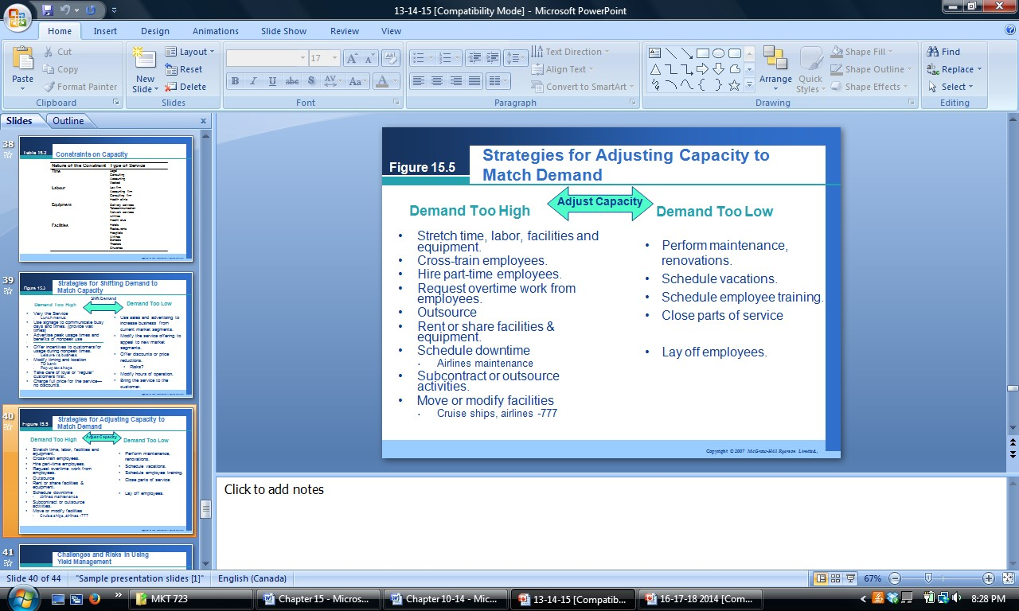

Yield management: Balancing capacity utilization, pricing, market segmentation, and financial return
Yield= actualrevenue
potentialrevenue
¿actualrevenue=actualcapacityused×averageactual price potentialrevenue=totalcapacity×maximum price
• Yield management: balancing act between demand and supply

Challenges and risks in using yield management
- Loss of competitive focus
- Customer alienation o Gave one customer a discount but not another because of timing can be an issue
- Employee morale problems
- Incompatible incentive and reward systems
- Lack of employee training
- Inappropriate organization of the yield management function

Waiting line strategies: when demand and capacity cannot be matched
- Employ operational logic o
o Modify operations  • Establish reservation process o | o Adjust queuing system | •
o Overbook o No shows? | o Reservations o Appointment bookings | •
- Differentiate waiting customers o Importance of the customer –CRM o Urgency of the job
▪ Auto breakdowns—highways vs. Dead battery in driveway o Duration of the service transaction o Payment of a premium price
- Making waiting fun, or at least tolerable o Futureshop—just for laughs o Disney world lines and clowns
o Do something that makes wait seem shorter or entertaining

Issues to consider in making waiting more tolerable
- Unoccupied time feels longer than occupied time
- Pre-process waits feel longer than in-process waits
- Anxiety makes waits seem longer o Did you forget about me?
- Uncertain waits seem longer than known, finite waits o Call centers- your call will be answered in 5 minutes
- Unexplained waits seem longer than explained waits o We are fixing the engine on the plane; emergency care vs. small injury
- Unfair waits feel longer than equitable waits
- The more valuable the service, the longer the customer will wait
- Solo waits feel longer than group waits

Chapter 16—integrated services marketing communications

Communications and services marketing triangle *
• Customers should know what to expect and what’s reasonable to expect from your service, what you are and what you will provide the customer
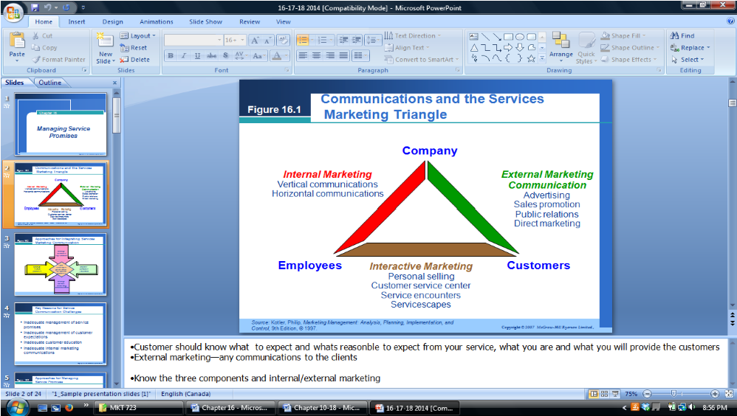

Approaches for integrating services marketing communications
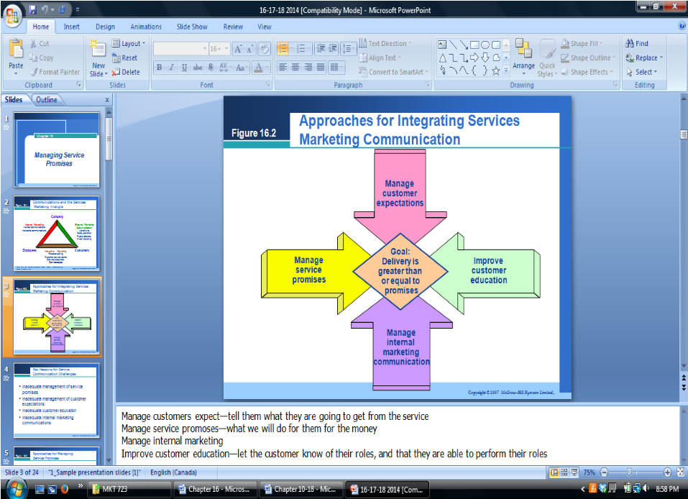
- Manage customers expectations→tell them what they are going to get from the service
- Manage service promises→what we will do for them for the money
- Improve customer education→let the customer know of their roles, and that they able to perform their roles

Key reasons for service communication challenges
- Inadequate management of service promises
- Inadequate management of customer expectations
- Inadequate customer education
- Inadequate internal marketing communications

4 categories of strategies to match service promises with delivery

1. Manage service promises
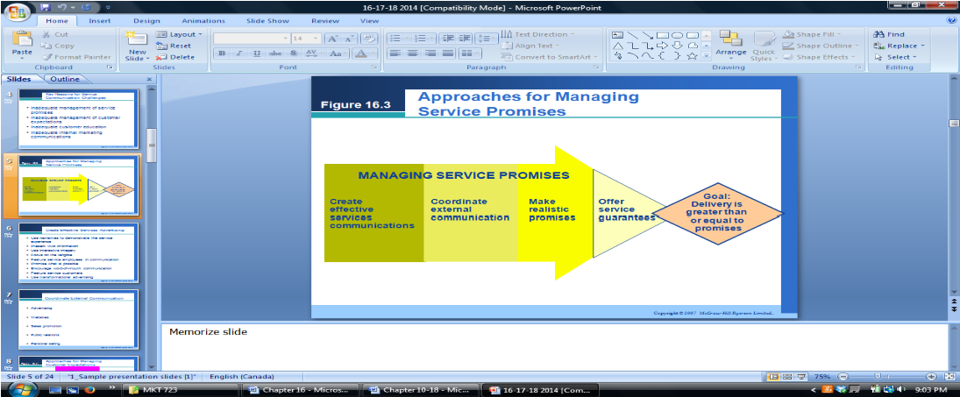
** • Create effective services advertising
o
- Use narratives to demonstrate the o Present vivid information service experience o Use interactive imager
- Focus on the tangibles o Encourage WOM communications o Feature service employees in o Feature service customers
communications o Use transformational advertising
- Promise what is possible •
• Coordinate external communications o
o Advertising o Sales promotion o Personal selling o Websites o Public relations 2.

3. Manage customer expectations
• Tiered value: different classes of service depending on how much spent
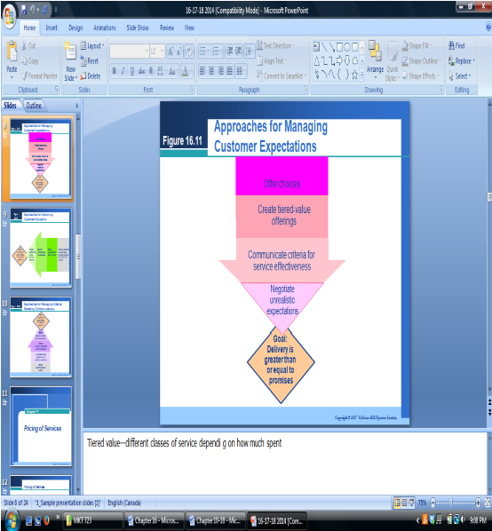

4. Improve customer education
• Make sure to talk to the customer for feedback and after sale. Call them to make sure they are satisfied and address issues or questions
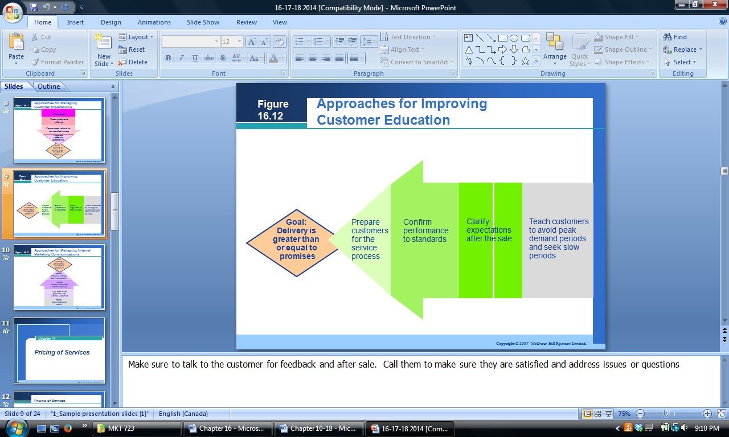

5. Manage internal marketing communications
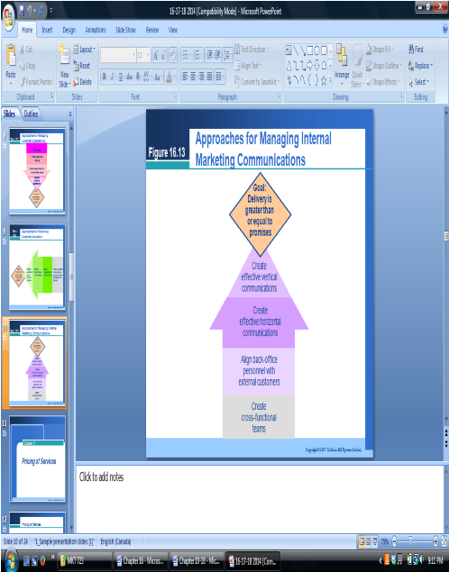
Chapter 17—pricing of services

3 key ways that service prices are different for consumers
- Customers knowledge of service prices o Service variability limits knowledge o Providers are unwilling to estimate prices o Individual customers needs vary
  - Collection of price information is overwhelming in services o Prices are not visible
  - Customers do not know as much about pricing of services than they do about products because it is hard to compare services
- The role of nonmonetary costs o
  - Time costs o Convenience o Psychological o Search costs costs costs
- • Price as an indicator of service quality o You get what you pay for is often the case in the customers mind when it comes to services

Approaches to pricing services **
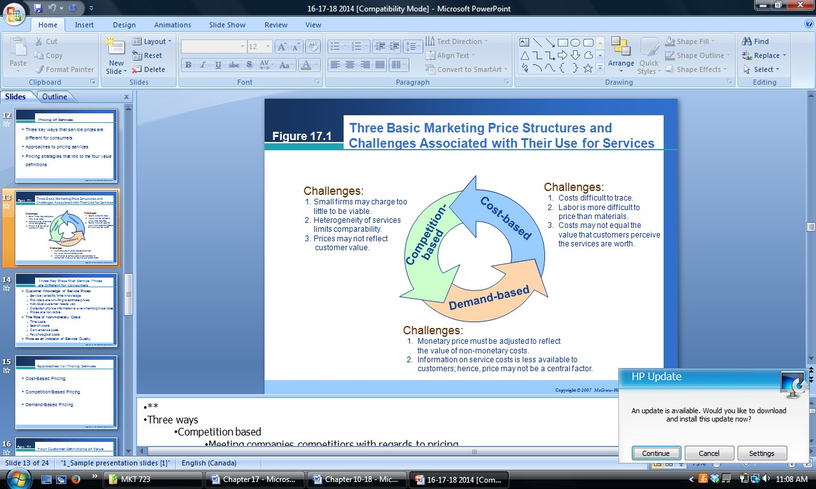

Cost­based pricing
- Price based on cost of providing the service (combo of fixed and overhead costs) o Price = direct costs + overhead costs + profit margin
- Not a good way to price services—difficult to do efficiently
- Typically you do not account for most of the costs of the cost of the service

Competition­based pricing
- Meeting companies competitors with regards to pricing
- Hard for smaller companies to compete with larger companies on price o Larger companies can afford to have lower prices without affecting profitability as much as smaller companies can
▪ Large companies can sell lower than cost to be able to drive smaller companies out of business cause they can afford it
- Good for competing with the same size firm
- Hard competing on price because services are so different
- Can demean quality perception of service
- Use in two situations o When services are standard across providers, such as in the dry cleaning industry o In oligopolies with a few large service providers such as in the airline or rental car industry

Demand­based pricing
- High demandàprice high, low demandàprice low
- Problem is how low can you possibly drop the price o You must have a floor and ceiling price set before
o You can only make demand based adjustments so much to keep customers happy 4 customer definitions of value *

Value is low price • Discounting—offer discounts and price cuts

 | • | Odd pricing—49.97
 | • | Synchro-pricing—low pricing strategy
 | • | Penetration pricing—introduced at low prices to stimulate trial and widespread use
Value is everything I was in a service | • | Prestige pricing—pay a lot of money for the service [say yes to the dress]
 | • | Skimming pricing—new service you charge more to begin with and lower prices later
Value is the quality I get for the price I pay | • | Value pricing—give more for less
 | • | Market segmentation pricing—charges different prices to group of customers
Value is all that I get for all that I give | • | Price framing—compare your services to other companies [progressive]
 | • | Price bundling—combine pricings of services together
 | • | Complementary pricing—if you get more than one service together [mani for x, pedi for y, mani&pedi for z]
 | • | Results-based pricing—contingency fees in law firms [you don’t pay till we recover]

Chapter 18—the financial and economic impact of service

Balanced scorecards*
• Service firms need to keep track of many measures to ensure optimized profitability, customer satisfaction /other customer measures, operational efficiencies and innovation and learning.



