Chapter 1—Introduction to Services

What are Services?
- Services:
  - Deeds, processes, and performances
  - All economic activities whose output is not a physical product or construction, is generally consumed at the same time it is produced, and provides added value in forms that are essentially intangible concerns of its first purchaser
  - Intangible activities, benefits, or satisfactions that an organization provides to consumers in exchange for money or something else of value.
  - A product without physical characteristics; a bundle of performance and symbolic attributes designed to produce consumer want satisfaction.
- Services contributes to approx 70% of the worlds overall economy o In Canada, 71% of service contributed to the countries overall GDP

Service industries, service as products, customer service, and derived service
- Service industries→include those industries and companies typically classified within the service sector whose core product is a service o Ex. Hotels and Airlines
- Services as products→intangible product offerings that customers value and pay for in the marketplace o Service products are sold by service companies and by non-service companies such as manufacturers and technology companies
  - Ex, IBM consulting, Shipping services and pet grooming
- Customer service→the service provided in support of a company’s core products o Ex, retail employee help a customer find a desired item
- Derived Service→all products and phsycial goods are valued for the services they provide o Ex. A razor provides barbering services, pharmasecutivals provide medical services
Why Service Marketing?
- The field of service marketing and management has evolved as a result of these combined forces o Service based economies
    - Service marketing concepts and strategies have developed in response to the growth of service industries and their increased importance to Canadian and other world economies
    - The economic importance of services is that trade in services is growing worldwide
    - Increasing dominance of services in economics worldwide—tremendous growth and economic contributions of the service sector
  - Service as a business imperative in manufacturing and IT
    - Manufacturing and technology industries (automobiles, computers) are recognizing the need to provide quality service and revenue-producing services in order to compete worldwide
  - Deregulated industries and professional service needs
- Service equals profits o Dedication to quality service has been the foundation for success
  - Despite the importance of service and the bottom line profits potential for service, consumers perceive that overall the quality of service is declining. Reasons are:
    - Customers are getting less service that they have in the past
    - Increasing use of self-service and technology based services
- Hard to implement without failures
    - Customer expectations are higher
    - Organizations have cut costs
    - Competitive job market results in less skilled people
    - Failing to provide training and support to employees
    - Delivering consistent service is hard, yet companies promise it
- How is technology advancements influencing technology o Potential for new service offerings o Finding new ways to deliver service
  - Enabling both customers and employees to be more effective o Extending the global reach of services o The internet IS A service
  - The paradox and dark side of technology and service

Characteristics of services compared to goods (HIIP)
- HETEROGENEITY: not all people, even in one service delivery organization do everything the same
  - Service delivery and customer satisfaction depend on employee and customer actions o Service quality depends on many uncontrollable factors
  - There is no sure knowledge that the service delivered matches what was planned and promoted
  - Ex, every professor teaches the same content, but never teaches the same way o Problem: their needs to be a set standard and training to limit the difference/inconsistency
- INTANGIBILITY: not easy to pick up the senses o Services cannot be inventoried o Services cannot be easily patented
  - Services cannot be readily displayed or communicated o Pricing is difficult
- INSEPERABILITY: services are consumed and produced simultaneously, and people don’t differentiate o Mass production is difficult
  - Problem: while the service is being consumed anything can happen that you need to be ready for
  - Ex, having a dinner with wife, and a child starts a food fight→the service is ruined and must be dealt with
- PERISHABILITY: you cannot store/inventory services o It is difficult to synchronize supply and demand with services
  - Services cannot be returned or resold
  - Ex, the way to deal with this is the airline industry that provides discount tickets closer to the flight
Goods Services
Standardized Heterogeneity
Tangible Intangibility
Seperatism Insperability
Non- perishability
perishable
- Services are more difficult to evaluate than goods before a purchase
Feature Marketing problem Marketing strategies
Heterogenity | • | Standardization and quality control difficult to achieve | • | Industrialize service
 |  |  | • | Customer service
Intangiblility | •  •  •  • | Service cannot be stored  Cannot protect service through patents  Cannot readily displau or communicate services  Prices are difficult to set | •  •  •  • | Stress tangible cues  Use personal sources more than nonpersonal sources  Simultate or stimulate WOM communications  Create strong organizational image
 |  |  | • | Use cost accounting to help set prices
 |  |  | • | Engage in postpurchase communications
Inseperability | •  •  • | Consumer involved in production  Other consumers involved in production  Centralized mass production of service difficult | •  •  • | Emphasize selection and training of public contact personnel  Manage consumers  Use multisite locations
Perishability | • | Service cannot be inventoried | • | Use strategies to cope with fluctuating demand
 |  |  | • | Make simulataneous adjustments in demand and capacity to achieve a closer match beyween the two

3 categories or qualities
- Search qualities: physical qualities that enable products to be examined and compared. This eases the task of choosing among them [visual cues]
- Experience qualities: characteristics of products that can be assessed mainly through using them
- Credence qualities: qualities for which, even after purchasing, the buyer must simply trust that the supplier has performed the correct service [trust]

Challenges for services
- Defining and improving quality
- Designing and testing new services
- Communicating and maintaining a consistent image
- Accommodating fluctuating demand
- Motivating and sustaining employee commitment
- Coordinating marketing, operations, and HR efforts
- Setting prices
- Finding a balance between standardization vs personalization
- Ensuring the delivery of consistent quality

Service Marketing Mix
- Service marketing mix is 3 P more than the traditional mix o Traditional 4 P’s : Product, Place, Promotions, Price
  - Service 7ps: Product, Place, Promotions, Price, People, Physical evidence, process
- Expanded mix for services o People: all human actors who play a part in service delivery and thus influences the buyer’s perceptions: namely, the firm’s personnel, the customer, and other customers in the service environment
  - Physical evidence: the environment in which the service is delivered and where the firm and customer interacts, and any tangible components that facilitate performance or communication of the service
  - Process: the actual procedures, mechanism, and flow of activities by which then service is delivered—the service delivery and operating system

- Product:
o Physical goods o Quality/warranty o Accessories  • Place; o | o Packaging o Product lines o Branding | •
o Channel type o Intermediaries o Outlet locations  • Promotion o | o Transportation o Storage | o Managing channels  •
o Promotion blend o Salespeople o Advertising  • Price o | o Sales promotion o Publicity | o Internet/web strategy  •
o Flexibility o Price level o Terms  • People o Employees  ▪ | o Differentiation o Discounts o Allowances | •
- Recruiting  - Training o Customers  ▪ | ▪ Motive/rew ard | ▪ Teamwork o
▪ Education  • Physical evidence o | ▪ Training | •
o Facility design o Equipment  • Process  o Flow of activities ▪ | o Signage o Employee dress | o Other tangibles  •
▪ Standardiz ed  o Number of steps ▪ |  | o
o

▪ Customize d

Simple ▪ Complex o
o Customer involvement

Chapter 2—The Gaps model of service quality

The Customer Gap Expe
- Customer gap: is the difference between customer expectations and perceptions ^{serv}
- Customer expectations: standards or reference points that customers bring into the service experience o Often consist of what a customer believes should or will happen
- Customer perceptions: are subjective assessments of actual service experience
- Closing the gap between what customers expect and what they perceive is critical to delivering quality service; it forms the basis for the gaps model
- First thing with delivering a quality service is knowing and understand your customers
- The sources of customer expectations are marketer-controlled factors as well as factors that the marketer has limited ability to affect

The provider gaps
• To close the customer gap, you must work on closing the 4 provider gaps
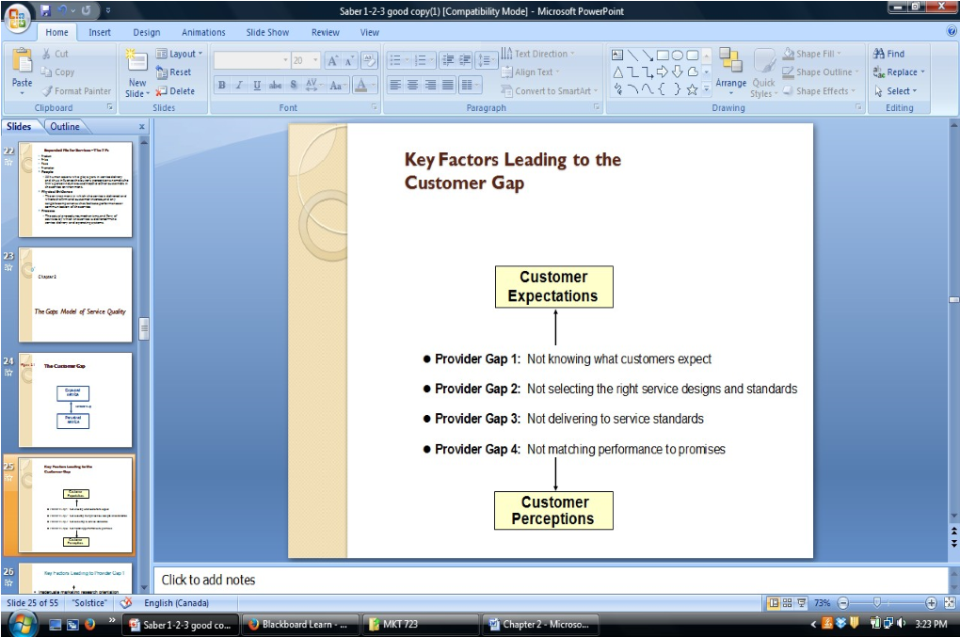

Provider gap 1: not knowing what customer expect
- Provider gap 1: difference between customer expectations of service and company understanding of those expectations. The lack of understandings of what expectations are
- the factors responsible:
o inadequate marketing research orientation
  - insufficient marketing research
  - research not focused on service quality
  - inadequate use of market research o lack of upward communication
  - lack of interaction between management and customers
  - insufficient communication between contact employees and managers
  - too many layers between contact personnel and top management o insufficient relationships focus ▪ lack of market segmentation
  - focus on transactions rather than relationships
  - focus on new customers rather than relationship customers o inadequate service recovery
  - lack of encouragement to listen to customers complaints
  - failure to make amends when things go wrong

▪ no appropriate recovery mechanisms in place to service failures Provider gap 2: not having the right service designs and standards
- provider gap 2: the difference between company understanding of customer expectations and development of customer driven service designs and standards o customer driven standards: different from conventional performance standards that companies establish for service in that they are based on pivotal customer requirements that are visible to and measured by customers
- factors responsible:
o poor service design
  - unsystematic new service development process
  - vague, undefined service designs
  - failure to connect service designs to service positioning o absence of customer driven standards
  - lack of customer driven service standards
  - absence of process management to focus on customer requirements
  - absence of formal process for setting service quality goals o inappropriate physical evidence and service-scape
  - failure to develop tangibles in line with customer expectations
  - service-scape design that does not meet customer and employee needs
  - inadequate maintenance and updating of the service-scape
- service-scape: physical setting where the service is delivered

Provider gap 3: not delivering to service designs and standards
- provider gap 3: the discrepancy between development of customer driven service standards and actual service performance by company employees
- factors responsible:
o deficiencies in human resource policies
  - ineffective recruitment
  - role ambiguity and role conflict
  - poor employee-technology job fit
  - inappropriate evaluation and compensation systems
  - lack of empowerment, perceived control and teamwork o customers who do not fulfil roles
  - customers who lack knowledge of their roles and responsibilities
  - customer who negatively impact each other o problems with service intermediaries
  - channel conflict over objectives and performance
  - difficulty controlling quality and consistency
  - tension between empowerment and control o failure to match supply and demand
  - failure to smooth peaks and valleys of demand
  - inappropriate customer mix
  - overreliance on price to smooth demand

Provider gap 4: not matching performance to promises
- provider gap 4: difference between service delivery and the service provider’s external communications
- key factors:
  - lack of integrated services marketing communications
    - tendency to view each external communication as independent
    - absence of interactive marketing in communications plan
absence of strong internal marketing program
  - ineffective management of customer expectations
    - absence of customer expectation management through all forms of communications
    - lack of adequate education for customers o overpromising
    - overpromising in advertising
    - overpromising in personal selling
    - overpromising through physical evidence cues o inadequate horizontal communications
    - insufficient communication between sales and operations
    - insufficient communications between advertising and operations
    - differences in policies and procedures across branches or units
Expected
CUSTOMER ^{Service}
Customer
Gap
Perceived
Service
COMPANY Service Communications External
Delivery Gap 4 to Customers
Gap 3
Gap 1 Customer-Driven
Service Designs and
Standards
Gap 2
Company Perceptions of Consumer Expectations

Chapter 3—consumer behaviour in services

Search, Experience & Credence Properties
- One framework for isolating differences in evaluation processes between goods and services is a classification proposed by economists (3 types of qualities)
- Search qualities: attributes that a consumer can determine before purchasing a product o Color, style, price, fit, feel, hardness, smell o Ex. Automobile, furniture
- Experience qualities: attributes that can be discerned only after purchase or during consumption o Taste and wearability o Ex. Vacations, restaurants
- Credence qualities: includes characteristics that the consumer may find impossible to evaluate even after purchase and consumption o Ex. Medical treatment, dentist cleaning, automobile brake relining
▪ Few consumers have sufficient skills to evaluate even after these services are necessary or are performed properly, even after they have been prescribed and produced by seller

Consumer behaviour
- Consumer behaviour: The activities of individuals in obtaining, using, and disposing of goods and services, including the decision processes that precede and follow these actions.
- 2 determinants of consumer behaviours:
  - Environmental factors
  - Individual factors and psychological processes
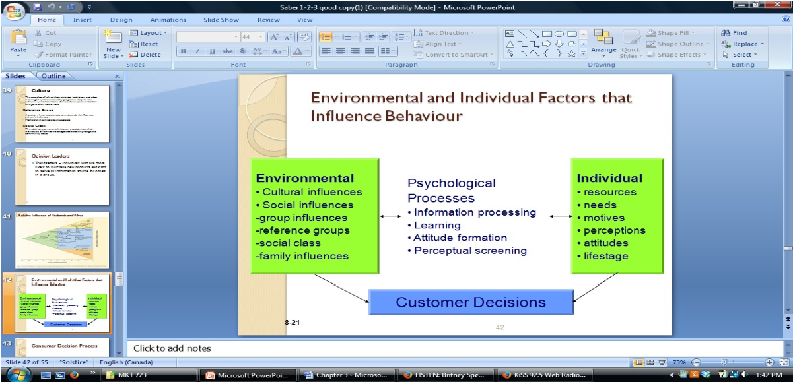
- Reference groups: a group whose value structures and standards influence a person’s behaviour o Membership→ “where I belong now” o Aspirational→ “”where I want to be” aspire to be o Disassociate→ “do not want to be here”
- Opinon leaders: (trendsetters) individuals who are more likely to purchase new products early and to serve as informaion sources for others in a group

Consumer decision process
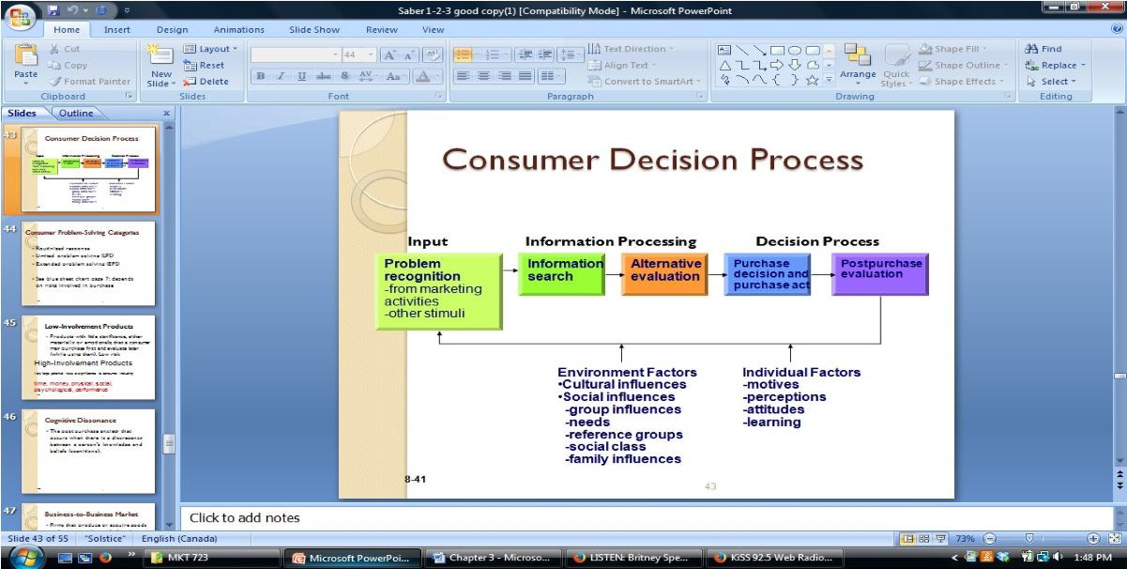
- The first important area of consumer behaviour is how customers choose and make decisions and the steps that lead to the purchase of a particular service
- Consumer choice: need/problem recognition + information search + evaluation of alternative + purchase

Need recognition (problem)
- The recognition that a need or a want exists
- Services can fill all of these needs, and they become increasingly important for higher level social, ego, and self actualization needs o Ex. Teeth whitening is a growing service that is driven by consumer’s ego needs

- Consumer problem solving categories o o Routinized response o Limited problem solving (LPS)

Information Search

o Extended problem solving (EPS)

- Once a need is recognized, consumers obtain information about goods and services that might satisfy this need
- Consumers use both personal sources and nonpersonal sources to gain information about goods and services o Personal sources: friends or experts
When purchasing services, consumers seek and rely to a greater extent on personal sources
o Nonpersonal sources: mass media and websites
- Seeking information is a way of reducing risk, helping consumers feel more confident about their choices

Perceived risk
- More risk appears to be involved in the purchase of services, because services are more intangible, variable and perishable o Must be selected with less prepurchase information o Services can rarely by be returned
- Risk can come in the form of financial risk, time risk, performance risk, social risk or psychological risk
- Risk reduction can be accomplished through tactics that reduce risk (guarantees) or by addressing the factors that contribute to the perception of risk (making the service more tangible)
- Low-involvement products: products with little significance, either materially or emotionally, that a consumer may purchase first and evaluate later (while using them) –Low Risk
- High involvement products: very large potential risks or significance to consumer –high risk

Evaluation of service alternatives
- The evoked set of alternatives is likely to be smaller with services vs. Products. Reasons for this are:
  - Differences in retailing
  - Consumers are unlikely to find more than one-two businesses providing the same services in a given geographical area
  - Difficulty for obtaining adequate prepurchase information about services
- Nonprofessional services→consumers decision often entail the choice between performing the services themselves or hiring someone to perform them o Ex. Cleaning their own house, or hiring housekeepers

Service purchase
- Another difference between services and products is that services are fully produced at the time of consumption
- Cognitive dissonance: the post purchase anxiety that occurs when there is a discrepancy between a person’s knowledge and beliefs (cognitions)

B2B market
- B2B market: firms that produce or acquire goods and services to be used, directly or indirectly, in the production of other goods and services or to be resold
- Distinctive features of the business market 1.
  - Geographic market 3. Small number of 4. Complex purchase concentration buyers decision process
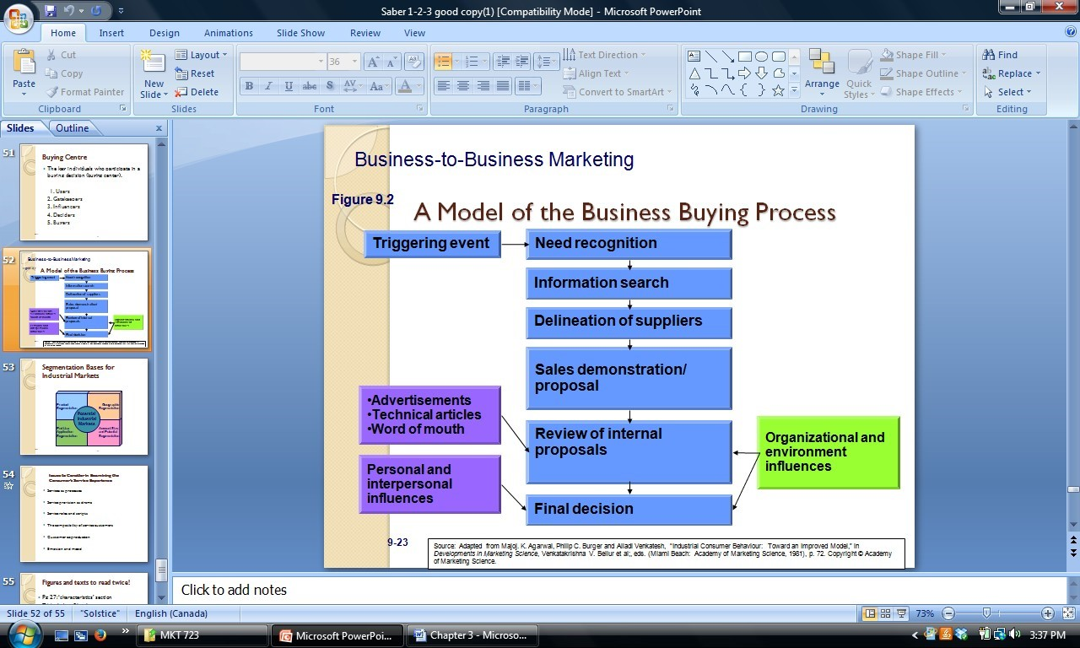
- Buying centre: the group of individuals who participate on the buying decision
o
o User o Influencer o Buyer o Gatekeeper o Decider •
- Basic Categories of business products
1.
  - Capital items →items that depreciate •
  - Expense items→items that are used up
- Business purchasing situations 1.
  - Straight rebuy 4. New task buying •
  - Modified rebuy
- Segmentation bases for potential industrial markets 1.
  - Product segmentation 5. Account size and potential
  - Geographic segmentation segmentation
  - End-use application segmentation

Consumer Experience
- Due to many unknowns, the experience itself often dominates the evaluation process o Services are higher in experience and credence qualities relative to goods; thus, how consumers evaluate the actual experience of the service is very critical in their evaluation process and their decision to repurchase later
- Customer experience: encompassing service processes that span the mundane to the spectacular
- Services as processes
  - Because services are performances done for and with customers, they typically involve a sequence of steps
    - The sequence of steps and other factors constitutes a process o The combo of steps or the experience that is evaluated by the customer
- Service provision as drama
  - The skill of the service “actors” in performing their routines, the way they appear and their commitment to the “show” are all essential to service delivery
  - Service actors’ importance increases in 3 conditions
    - Service actors are critical when the degree of direct personal contact is high
    - Service actors skills are critical is when the services involve repeat customers
The contact personnel are critical is when they have discretion in determining the nature of the service and how it is delivered.
  - The “physical setting” of the service can be likened to the staging of a theatrical production,
    - The setting increases in importance when the environment distinguishes the service
- Downtown law firm has to look prestige not dingy
- Service roles and scripts o Roles are combinations of social cues that guide and direct behaviour in a given setting o The success of any service performance depends in part on how well the role is performed by the service actor and how well the team of players act out their roles
  - Service employees need to perform their roles according to their expectations o Of factor that influences the effectiveness of role performance is the “script”—the logical sequence of events expected by the customer, involving her as either a participant or an observer
  - service scripts→sequences of actions associated with actors and objects that, through repeated involvement, define what the customer expects
    - deviations from the service scrip lead to confusion and dissatisfaction
- the compatibility of service customers o the role of other customers receiving service at the same time
▪ the way other customers behave with many services exerts a similarity of other customers receiving services has a strong impact on the satisfaction and dissatisfaction of any given customer
  - customer capability is a factor that influences customer satisfaction, particularly in high contact services
    - ex, Non smoking in Westin Hotels
- customer coproduction
  - service customers also play a coproduction role that can have profound influence on the service experience
  - ex. Counselling, training and education warrant full participation of the customer
- emotion and mood
  - emotion and mood are feeling states that influence people’s perceptions and evaluations of their experience
  - emotion: intense, stable and pervasive o mood: transient feeling states
  - emotion and mood are critical factors in the experience of service and its perception Post experience evaluation
- following the service experience, customers form an evaluation that determines to a large degree whether they will return or continue to patronize the service organization
- post experience evaluation is captured by companies in measures of satisfaction, service quality, loyalty and sometimes emotional engagement
- word of mouth communications o Post experience evaluations will significantly impact what consumers tell others about the service.
  - Service consumers are strongly influenced by the personal opinion of others, understanding and controlling WOM becomes even more important
  - It is crucial to have an effective service recovery strategy to curb negative WOM
- Attribution of dissatisfaction o When consumers are disappointed with purchases, they may attribute their dissatisfaction to the producers, the retailers, or themselves
  - Because consumers participate a great extent in services, they may feel more responsible for their dissatisfaction when they purchase services over goods
  - The quality of many services depends on the information the customer brings to the service encounter
    - Ex. The quality of the doctors diagnosis depends on a clear history and articulation of symptoms
- Positive or negative biases o Research suggests that people remember negative events and services more than positive, routine or good service experienced
  - People will weigh negative experiences and reviews more heavily than positive ones
- Brand loyalty o The degree to which consumers are committed to particular brands of goods or services depends on a number of factors:
    - The cost of changing brands (switching costs)
    - The availability of substitutes
    - Social ties to the company
    - Perceived risk associated with the purchase
    - Satisfaction obtained in the past o Consumers are more likely to be more brand loyal to services than products o Difficulty of obtaining info about services means that consumers may be unaware of alternatives or substitutes
  - If consumers perceive a greater risk with services, they probably depends on brand names to a greater extent
  - Brand loyalty is a means of economizing decision efforts and relying on repeat purchases o Recognition of the need for repeated usage in order to receive optimum satisfaction for seller (regular customer effect)

Understanding differences among consumers

Global Differences: The role of culture
- Culture: the complex of values, ideas, attitudes, institutions, and other meaningful symbols created by people that shape human behaviour, and the artifacts of that behaviour, transmitted from one generation to the next
- Understanding cultural differences is important in services marketing because of its effects on the ways that customers evaluate and use services
- There are differences in how consumers perceive services across cultures
  - Ex. Taiwan there is a greater emphasis on the interpersonal dimensions
- We all have stereotypes of our own cultures, but actual personalities before cultures are very different
- Languages is also an important cultural differences
- Values and attitudes help determine what members of a culture think is right, important, and/or desirable
  - Because behaviour flow from values and attitudes, services marketers who want their services adopted across cultures must understand these differences
- Manners, customs and habits represent a cultures view of appropriate ways if behaving. It is important to monitor differences in manners and customs because they can have a direct effect on the service encounter
- Material culture consists of the tangible products of culture : cars, homes, clothes etc
- Aesthetics refers to cultural ideas about beauty and good taste
- Culture manifest itself most dramatically in the people to people contact of social institutions (ex classroom interactions)

Chapter 4—customer expectations of service

- Customer expectations: beliefs about service delivery that serve as standards or reference points against which performance is judged.
- Knowing what the customer expects is the first and possibly most critical step in delivering quality service

Meaning and types of service expectations
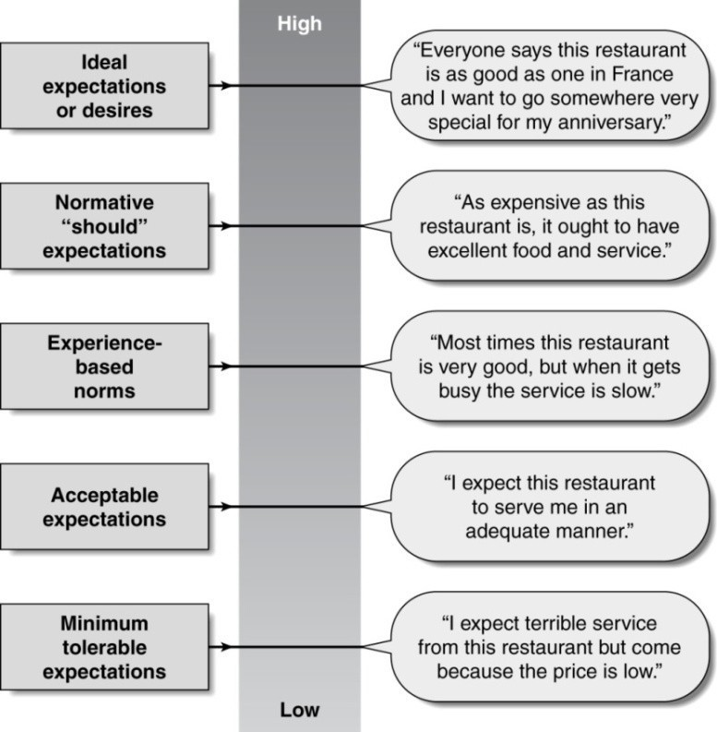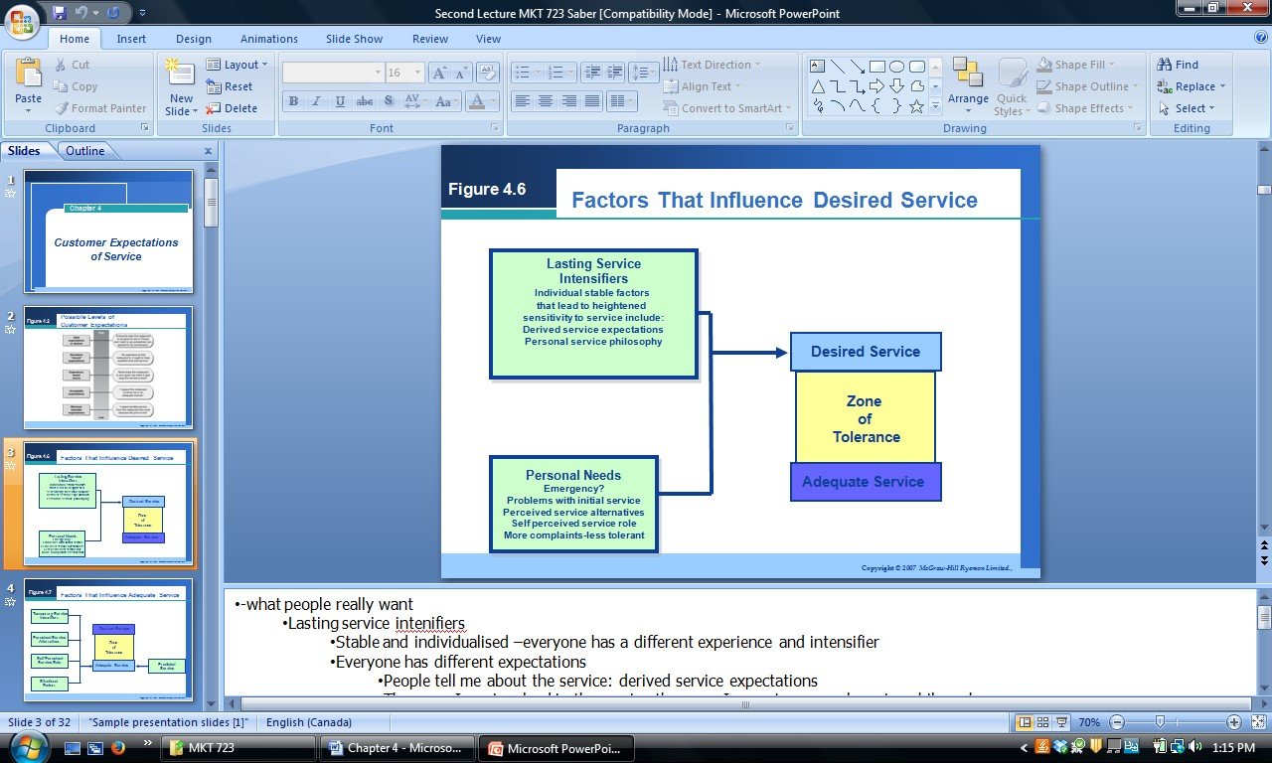
•
The level of expectation can vary widely depending on the reference point the customer holds.
Although most everyone has an intuitive sense of what expectations are, service marketers need a

very clear definition of expectation in order to comprehend, measure and manage them
•
If you are service is met lower than your minimum tolerable expectations you will not go back
Expected service: levels of expectations
Desired service
•
Highest type of expectations is:
desired service
•
The level of service the customer hopes to receive
•
Blend of what the customer believe the service can be and should be
•
The expectation reflects the hopes and wishes of these consumers; without these hopes and
wishes and the belief that they may be fulfilled
•
Desired serviceàtypically never reach the desired service expectation because people have high
expectations
- Lasting service intensifiers→individuals, stable factors that lead the customer to a heightened sensitivity to service o what people really want o Stable and individualized
    - Everyone has a different experience and intensifier
    - Everyone has difference expectations o Derived service expectations—occur when customer expectations are driven by another person or group of people
    - what people tell me about the service I expect to happen o Personal service philosophy—the customers underlying generic attitude about the meaning of service and the proper conduct of service providers
    - the more I am involved in the service the more I expect from it ▪ Costco vs. Holt Renfrew
- Personal needs→pivotal factors that shape what customers desire in service o Physical, social, psychological, and functional categories
  - emergency situations/unexpected needs
  - Problem with initial service so you expect it to be perfect thereafter
  - Perceived service alternatives—if there are other alternatives your expectations are higher o Self perceived service role—how much is the customer expected to do o The more the customer is expected to do, the less the service should cost
    - Costcoàyou are expected to do it all yourself,
    - Real estateàyou expect the agent to do everything, if you are expected to research houses yourself you must pay less or you would be annoyed. If you pay a lot then you do not expect to do work yourself.
  - More complaints-less tolerant: personality attribute

Adequate service
- Adequate service: the level of service the customer will expect o Customers hope to achieve their service desire but recognize that this is not always possible
    - Represents the “minimum tolerable expectations” the bottom level of performance acceptable to the customer
    - what you hope to at least get
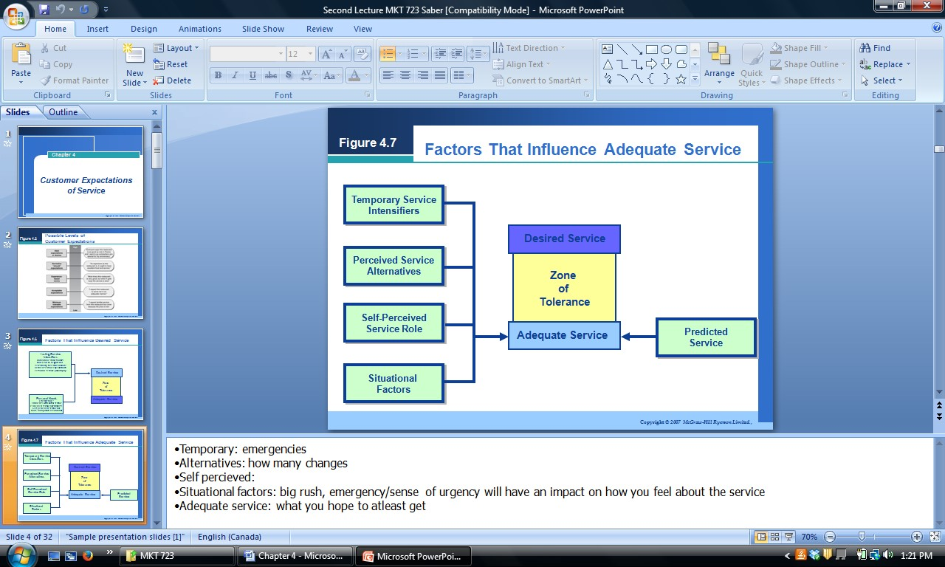
    - Temporary service intensifiers—short terms, individual factors that make a customer more aware of the need for service
      - Personal emergency situations in which service is urgently needed o Perceived service Alternatives—other providers from whom the customer can obtain service
      - how many changes
  - customers self perceived service role—customers perceptions of the degree to which they themselves exert an influence on the level of service they receive
  - Situational factors—service performance conditions that customers view as beyond the control of the service provider
▪ big rush, emergency/sense of urgency will have an impact on how you feel about the service
  - predicted service—the level of service that customers believe they are likely o get The zone of tolerance
- The zone of tolerance; the extent to which customers recognize and are willing to accept this variation
- Zone of toleranceàwhere you will expect the situation
- Range or window in which customers do not particularly notice service performance
- When the service falls outside the range (either higher or lower) the service gets customers attention
- Different customers possess different zones of tolerance o An individual customers zone of tolerance increases or decreases depending on a number of factors, including company controlled factors
o Ex. Price, when price increases, customer tend to be less tolerant or poor service
- Zones of tolerance vary for service dimensions

Factors that influence customer expectations of service
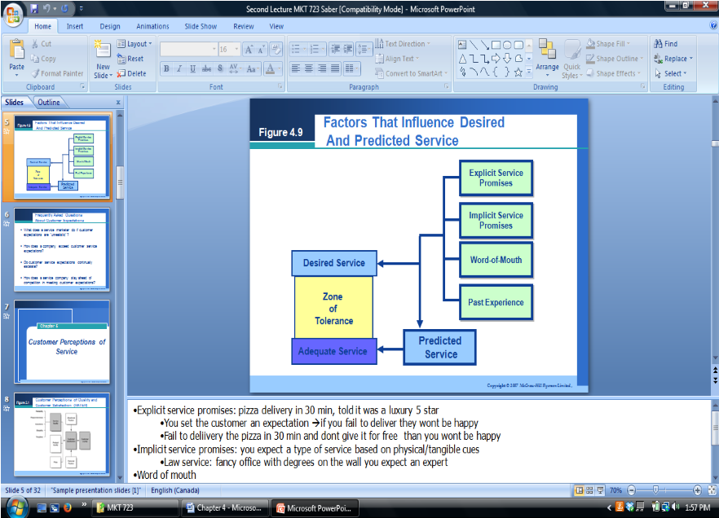
- Explicit service promises: personal and nonpersonal statements about the service made by the organization o Personal when they are communicated by salespeople or service or repair personnel o Nonpersonal when they come from advertising, brochures and other written publications o Completely in control of the service provider o Have a direct effect on desired service expectations o Influence the level of both desired and predicted service
  - Ex. Pizza delivered in 30 mins or its free; if late and not free you won’t be happy
- Implicit service promises: service-related cues other thane explicit promises that lead to inferences about what the service should and will be like o Dominated by price and the tangibles associated with the service
  - Ex. Higher the price, and more impressive the tangibles, the more the customer will expect from the service
  - Ex. Law service must have a fancy office with degrees and expecting of an expert
- Word of mouth communications: conveys to customers what the service will be like and influence both predicted and desired service o Perceived as unbiased, so carries a higher weight
  - Ex. Friend tells you will get a high level of service. So you get a high expectation
- Past experience: another force in shaping predictions and desires o Expectations are set compared to what you received in the past
  - Ex. Comparing your vacation experience to a vacation you had in the past

Issues involving customer service expectations
• 4 of the most frequently asked questions about customer expectations o What does a service marketer do if customer expectations are “unrealistic”?
  - Asking what customers expect and then try to follow through on their expectations
  - Worst thing is to ask about expectations and do nothing about it
  - Inform why the desired expectations are not or cannot be met o How does a company exceed customer service expectations?
  - Essential to recognize that exceeding customer expectations on the basics is virtually impossible
  - Developing a customer relationship→highly personalized and customized approaches
o Do customer service expectations continually escalate?
- Desired service expectations are more stable→driven by enduring factors
- Customer service expectations are dynamic and always changing o How does a service company stay ahead of competition in meeting customer expectations?
- Goal→meeting customer expectations better than its competitors ▪ In the service world gaining brand loyalty is crucial!

Chapter 5—customer perceptions of service

Customer perceptions
• Customer perception: how customers perceive services, how they assess whether they have experienced quality service, and whether they are satisfied

Satisfaction vs. Service Quality
- Satisfaction: is more inclusive: influenced by perceptions of service quality, product quality and price as well as situational factors and personal factors [broad concept]
- Service quality: focused evaluation that reflects the customers perception of: reliability, assurance, responsiveness, empathy and tangibles [focuses specifically on dimension of service]
- Identify factors that enhance of detract from the service quality
- Reliability, assurance, tangibles, empathy and responsiveness Customer Satisfaction
What is Customer Satisfaction?
- Satisfaction: satisfaction is the consumer’s fulfilments response. It is a judgement that a product or service feature, or the product or service itself, provides a pleasurable level of consumptionrelated fulfilment o Satisfaction is the customers evaluation of whether a service has met his/her needs and expectations
▪ failure to meet needs and expectations is assumed to be dissatisfaction
- in addition to a sense of fulfilment in the knowledge that one’s needs have been met • satisfaction = contentment, pleasure, delight, relief, ambivalence What determines customer satisfaction?
- Product/service quality→ price/quality relationships o When it’s cheaper you expect less quality, when its expensive you expect greater quality o Ex. Say yes to the dress; you expect a high level of service
  - Ex, Discount wedding stores; you expect a lower level of service because the dresses are cheap
- Specific product or service features o Did the customer have an expectation that the product would be there and it wasn’t?
  - Did they expect a high level of service and didn’t get it?
- Consumer emotions
  - Ex. Say yes to the dress→if they do not find the dress, they feel like they had a bad service but in actuality it was external factors that influenced experience, (entourage poor feedback)
- Attributions for service success of failure o Who are they blaming for the bad service experience

Ex. Are they blaming the person helping them that they couldn’t find the dress, or are they blaming their own insecurities or their entourage
- Perceptions of equity or fairness o Do they feel they are treated fairly
- Other consumers, family members and coworkers o Word of mouth

Outcomes of customer satisfaction
- Increased customer retention o Loyal customers increases retention, WOM and increased revenues o Generating loyal customers is the goal
- Positive WOM communications o WOM in services is a highly profitable took o The power of WOM was increased by social media
- Increased revenues

Service Quality
- The customer’s judgment of overall excellence of the service provided in relation to the quality that was expected.
- Service quality assessments are formed on judgments of:
o o outcome quality o interaction quality o physical environment quality

RATER: service quality dimensions
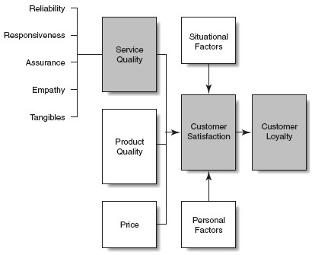
- Reliability: Delivering on Promises o ability to perform the promised service dependability and accurately o The most important determinant of perceptions of service quality o They perform in the way they are expected to
  - Dependable service
  - Ex. FedEx→When it absolutely, positively has to get there overnight
- Assurance: inspiring trust and confidence o employees’ knowledge and courtesy and their ability to inspire trust and confidence o Do you have trust that they will do what they say they will
Do you have the experience and knowledge to do your job right o Do you have the knowledge so I can trust you
  - Trust and confidence may be embodied in the person who links the customers to the company
  - Ex. Banking, insurance, brokerage, medical, legal service
- Tangibles: representing the service physically o appearance of physical facilities, equipment, personnel and written materials
  - HIIP (heterogeneity, intangibility, inseparability, perishability o Used by services to enhance their image, provide continuity and signal quality to customers o Ex. Lawyer using a pretty office, degrees on wall, professional website and professionally dress to signal expertise and quality
  - Look like your role, if you are a lawyer look like an lawyer o Dress, office, website etc
- Empathy: treating customers as individuals o caring, individualized attention given to customers o Do you care about your clients?
  - Ex. Proff that doesn’t care if you are there or not, won’t help and just comes to class to teachàbad service
  - You want a service from people who genuinely care about their clients and the service they provide
  - Developing a relationship with clients
  - Ex. Knowing your customers by name, and trying to customize service to their allergies, or likings
- Responsiveness: being willing to help o willingness to help customers and provide prompt service o Are you willing to help and provide quickly service o Respond to problems quickly are you willing to help
  - Length of time they have to wait for assistance, answers to questions, or attention to problems
 | Reliability | Assurance | Tangibles | Empathy | Responsiveness
Car repair | Problem fixed the 1st time & ready when promised | Knowledgeable mechanics | Repair facility; waiting area; uniforms; equipment | Acknowledges customers by name; remembers previous problems & preferences | Accessible; no waiting; responds to request
Airline | Flights to promised destinations depart & arrive on schedule | Trusted name, good safety record; competent employees | Aircraft; ticketing counters; baggage area; uniforms | Understands special individual needs;  anticipates customer needs | Prompt & speedy system for ticketing, inflight  baggage handling
Medical | Appointments are kept on schedule; diagnoses prove accurate | Knowledge; skills; credentials; reputations | Waiting rooms; exam room; equipment; written materials | Acknowledges patient as a person; remembers previous problems; listens well; has patients | Accessible; no waiting; willingness to listen

E­service quality
- 4 core dimensions that customers use to judge website at which they experience no questions/problems
Efficiency—the ability of customers to get the website, and their desired product and information associated with it, and check with minimal effort
  - Fulfilment—the accuracy of service promises, having products in stock, and delivering the products in the promised time
  - Reliability—the technical functioning of the site, particularly the extent to which it is available and functioning properly
  - Privacy—the assurance that shopping behaviour data are not shared and that credit information is secure
- 3 dimensions that customers use to judge recovery services when they have problems/questions o Responsiveness—the ability if etailers to provide appropriate information to customers when a problem occurs, to have mechanisms for handling returns, and to provide online guarantees
  - Compensation—the degree to which customers are to receive money back and are reimbursed for shipping and handling costs
  - Contact—the ability of live customer service agents online or through the phone

Service Encounters: The building blocks for customer perceptions
• Service encounter=moment of truth o Service encounters occurs any time the customer interacts with the firm o Can potentially be critical in determining customer satisfaction and loyalty o Service encounter is an opportunity to
▪
- Build trust
- Reinforce quality
- Build brand identity
- Increase loyalty

Critical service encounters research
- Critical service encounters research gives feedback on a service o Provides stories of events that stick in your mind either positive or negative o Qualitative research
  - Ex. What we did for our bonus assignment
- Goal→ understanding actual events and behaviours that cause customer dis/satisfaction in service encounters
- Method→critical incident technique
- Data→stores from customers and employees
- Output→identification of themes underlying satisfaction and dissatisfaction with service encounters
- Sample questions for critical incident technique study o Think of a time when, as a customer, you have a particularly satisfying (dissatisfying) interaction with an employee of ___?
  - When did the incident happen?
  - What specific circumstances led up to this situation?
  - Exactly what was said and done? o What resulted that made you feel the interaction was satisfying (dissatisfying)?

Common themes in critical service encounter research
theme Definition Situation Do’s

Recovery | Employee response to service delivery system  failure
Adaptability | Employee response to customer needs and requests
Spontaneity | Unprompted & unsolicited employee actions &
They screwed up, what did they do to fix it
Can they come up satisfying solutions to fix problem
Could they fix it on their own or do they have to get a
- Acknowledge problem
- Explain causes
- Apologize
- Compensate/upgrade
- Lay out options
- Take responsibility
- Recognize the seriousness of the need
- Acknowledge/anticipate
- Attempt to accommodate
- Adjust the system
- Explain rules/policies
- Take responsibility
- Take time
- Be attentive
Don’t
- Ignore customer
- Blame customer
- Leave customer to fend for itself
- Downgrade
- Act as if nothing is wrong
- Pass the buck
- Ignore
- Promise but fail to follow through
- Show unwillingness to try
- Embarrass the customer
- Laugh at customer
- Avoid responsibility
- Pass the buck
- Exhibit impatience
- Ignore

 | attitudes | manager | •  •  • | Anticipate needs  Listen/show empathy  Provide information | •  •  • | Yell/laugh/swear  Steal  Discriminate
Coping | Employee response to problem customers | Did they find out new solutions to respond to problem | •  •  •  • | listen try to accommodate explain let go of the customer | •  • | take customers dissatisfaction personally  let customers dissatisfaction affect others

The Evidence of service from the customers POV
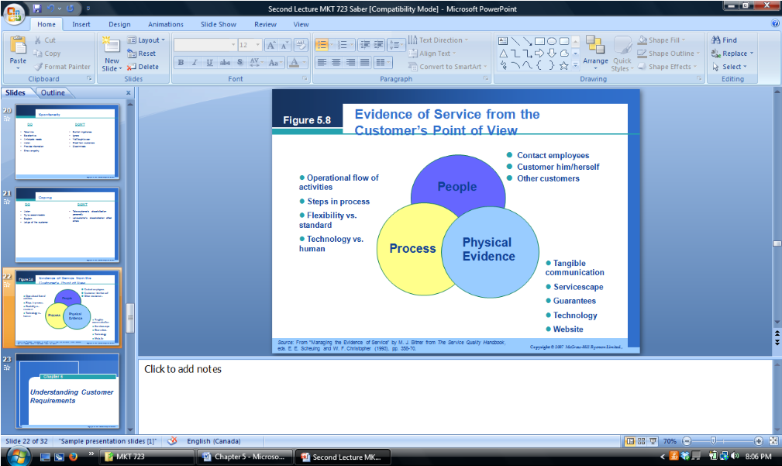

Chapter 6—listening to customers through research

Stages in the research process
- Define problem –most important step—looking at symptoms is not the same as defining the problem itself
- Develop measurement strategy –what are you going to do to measure it?
- Implement research program –do the research
- Collect and tabulate data
- Interpret and analyze findings
- Report findings

The benefits of conducting marketing research on the web
- Speed
- Ability to target hard-to-reach populations
- Ability to target customers with money
- Opportunity to use multimedia to present video and audio
- No interviewers

Listening to customers through research
- Using marketing research to understand customer expectations
- Elements in an effective service marketing research program
- Analyzing and interpreting marketing research findings
- Model services marketing research programs
- Using marketing research information
- Upward communications

Criteria for an effective service research program
- Service research program: composite of all research needed to address the objectives and execute an overall management strategy o Understanding the criteria for an effective services research program will help a company evaluate different types of research and choose the ones most appropriate for its research objectives
- Includes both qualitative and quantitative research
- Includes both expectations and perceptions of customers o You need to figure out the differences and associations and then investigate why
- Balances the cost of the research and the value of the information [research is expensive]
- Includes statistical validity when necessary o The cut off point for statistical decisions for research is : 0.05 or below
- Measures priorities or important of attributes
- Occurs with appropriate frequency
- Includes measures of loyalty, behavioural intentions or actual behaviour

Elements in an effective services research program

Complaint solicitation
- Looking for complaints and feedback
- Good service organizations take complaints seriously o
  - They listen and seek complaints •
  - Learns from complaints tries to improve
- This research has a critical real-time purpose in services o To improve failure points and to improve or correct the performance of contact personnel
- Easiest type of research
- To be effective, complaint solicitation requires rigorous recording of numbers and types of complaints through many channels, and then working o eliminate the most frequent problems o Complaint channels—employees at front line, intermediary organization (retailers), managers, customer advocate groups

Critical incidents studies
- Critical Incident Technique (CIT): a qualitative interview procedure in which customers are asked to provide verbatim stories about satisfying and dissatisfying service encounters they have experienced
- Benefits of CIT o Data is collected from the respondents perspective, usually vivid and express their true feelings
  - Provides concrete information about the way the company and its employees behave and react
▪ Making research easy to translate into action o Research is particularly useful
  - Well suited for assessing perceptions of customers from different cultures

Requirements research
- Requirements research: Involves identifying what customers expect in a service • Qualitative research, quantitative may follow
- An example of requirements research is structured brainstorming o Technique developed by researchers where a sample of customers are assembled and a facilitator leads the group through a series of exercises on creativity and then has the customer describe the ideal provider of the service
▪ Asks what customers want, why they want it, how they will know when they receive
it
- It’s becoming harder to just ask what customers want, cause many times they don’t know what they want

Relationship and SERVQUAL surveys *

Relationship surveys
- Relationship surveys: pose questions about all elements in the customers relationship with the company
- Including service, product, and price
- Typically track performance annually, providing a baseline
- Compares company performance within that of competitors, best competitor as benchmark

SERVQUAL survey
- SERVQUAL survey: one of the 1st measures to be developed specifically to measure service quality
- Involves a survey containing 21 service attributes, grouped into the 5 service quality dimensions of
o
  - Reliability o Assurance o Tangibles o Responsiveness o Empathy •
- Ask customers to provide two ratings o One reflecting the level of service they would expect o One reflecting their perceptions of the service delivered
- Data can be used for:
  - To determine the average gap score
  - To assess a company’s service quality along each of the 5 dimensions o To track customers expectations and perceptions over time o To compare a company’s SERVQUAL scores against those of competitors o To identify and examine customer segments that different in assessments o To asses internal service quality

Trailer calls or post transaction surveys
- Trailer calls: purpose is to compare information about the key service encounters with the customer
- Customers are asked a short list of questions immediately after a particular transaction about their satisfaction
- More effective than complaint solicitation
- Benefit
  - Often appears to customer that the call is a follow up o The call doubles as research and customer service
  - Simple and fresh and provides management with continuous information
  - Serves as an incentive to employees to provide better service

Service expectations meetings and reviews
- B2B situations; research that is highly effective involves eliciting the expectations of the client at a specified time of the year and then following up later to discuss whether the expectations were fulfilled
- The format consists of o Asking clients what they expect in terms of 8-10 basic requirements
  - Inquiring what particular aspects of these requirements the account team performed well and what needs improvement
  - Requesting that the client rank the relative importance of the requirements o Verifying with the client that the account plan will satisfy requirements, and manage expectations

Process checkpoint evaluations
- Areas in service blueprint, and where are the problems in the process?
- Checking in at different points of the service

Market­oriented ethnography
- Assumptions are made based on our own culture
- Goal is to enter the consumers world as much as possible—observing how and when a service is used in an actual home environment
- Observation can also involve entering the experience as a participant observer and watcher what happens rather than asking questions about it

Mystery shopping
- Companies hire outside research organizations to send people into service establishments and experience the service as if they were customers o Deliver objective assessments about service performance by completing questionnaires about service standards
o Provides assessment on the level of service they received
- Mystery shopping keeps workers on their toes

Customer panels
- Customer panels: ongoing groups of customers assembled to provide attitudes & perceptions on a service over time
- Provide company regular and timely customer information
- Often used in the entertainment industry to screen movies before they are released

Lost customer research
- Deliberately seeking customers who have dropped the company’s service to inquire about their reasons for leaving
- Similar to exit interviews with employees
- Identifies failure points and common problems in the service and can help establish an earlywarning system for future defectors
- The research can be used to calculate the cost of lost customers Future expectations research
- What do they expect in the future?
- Different types of future expectations research o Features research—involves environmental scanning and querying of customers about desirable features of possible services
  - Lead user research—brings in customers who are opinion leaders/innovators and asks them what requirements are not currently being met by existing products or services
  - Synectics approach—defines lead users more broadly than in standard lead user research

Analyzing and interpreting research findings
- One of the biggest challenges facing a researcher is converting a complex set of data to a form that can be read and understood quickly by employees who will make decisions
- Types of research data o Tracking of performance, gap scores and competition o Zones of tolerance charts o Importance/performance matrices

Research for Upward communications
•
- Executive visits to customers
- Executive or management listening to customers
- Research on intermediate customers
- Research on internal customers
(employees)
- Executive/management listing approaches to employees
- Employee suggestions

Chapter 7—building customer relationships

Relationship Marketing
- Relationship marketing: a philosophy of doing business that focuses on keeping and improving relationships with current customers rather than on acquiring new customers o Assumes that many customers prefer to have an ongoing relationship with one organization than to switch continually among providers in their search for value
o Does not necessarily emphasize acquiring new customers
- It’s cheaper for the firm to keep customers costs less than attracting a new one o You lose 10-20% of customers a year o It’s easier to keep old ones, than attract new ones
- The focus is less on attraction, and more on retention and enhancement of customer relationships


Customer acquisition Bucket Theory
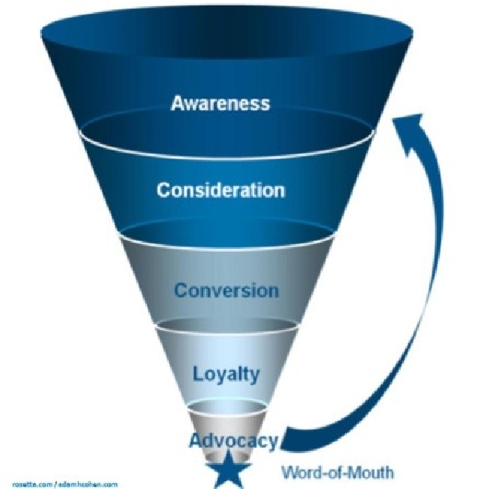
- Many businesses focus on acquisition while ignoring or not understanding defection
- More focus should be on attracting and retaining the best customers
- Bucket theory illustrates why a relationship strategy should be on focuses on plugging holes on the buckets to retain old customers
- Advocacy is where you want customers to be→this is when the consumers start to share the brand and positive experiences with other people

The evolution of customer relationships
- Customers as strangers’→strangers are those customers who are not aware of or, perhaps, those who have not yet had any transaction (interactions) with a firm.
  - The firms primary goal with these customers is to initiate communication with them in order to attract them and acquire their business
- Customers as acquaintances→a trial or awareness was achieved creating the basis for an exchange relationship o Primary goal for the firm is satisfying the customer
  - Give the best feedback that will allow them to be friends and partners in the future
- Customers as friends→customers continue to make purchases, the company begins to acquire specific knowledge of the customers needs, allowing it to create an offering specific to customers o Goal for firm is customer retention o Top level for most consumer services
- Customers as partners→level of trust often depends and the customer may receive more customized product offerings and interactions o More prevalent in B2B relationships o Goal is to enhance the relationship
  - Co-producing service or production and specifying exactly what they need

The goal of relationship marketing
- The primary goal of relationship marketing is to build and maintain a base of committed customers who are profitable for the organization
- The overriding goal is to move customer up the ladder from the point at which they are strangers that need to be attracted through to the point at which they are highly valued, long term customer whose relationship with the firm has been enhanced
- Acquiring new customers is the last resort companies prefer retaining and enhancing old customers→to create brand loyalty

Benefits of relationships marketing
Benefits for customers |  |  |  |  | Benefits for firms
Receipt of greater value | •  • | quality, satisfaction: benefits greater than monetary or non-monetary costs transaction cost theory | Economi  c benefits | •  • | Increased $ over time  More profitable
Confiden ce benefits | •  • | Reduced anxiety switching costs time and $  They are happy and confident with the service | Custome  r  behaviou r benefits | •  •  • | WOM  More voluntary behaviour  Positive social media presence
Social benefits | •  • | Confidants  Get more of what they want | HRM  benefits | •  • | Co-producers (customers know what to do  Employee retention
Special treatment benefits | •  • | They know me  Regular customers
 | • | Customization
 | • | Develop personal relationships
Common market segmentation variables
User Characteristics User Behaviour
- Demographics • When, where, how services used
- Psychographics
- Quantity/value of purchases • Geographic
location • Frequency of use
- Benefits sought • Intention behaviour
- Profitability of relationship
- Sensitivity to marketing variables

Service­relevant segmentation variables
- Timing of service used (hour, day, season) o Ex. Airlines provide cheaper tickets closer to the flight
- Level of skill and experience as co-producer/self server o Some services you need to participate in to get adequate services o Skill is necessary on the service providers level and the consumers o Ex. Scuba diving
- Preferred language in face-to-fact contact o To provide good service you need to ensure you have services in the populations preferred languages
o Ex. Montreal should provide services in English and French
- Access to electronic delivery system (internet, ATM) o Anything that can make it more convenient for the customer is ideal→comparison to brick&mortar stores
- Attitudes toward use of new service technologies

Targeting prospective customers: Basic Segmentation Issues
- Should target segments that fit will with firm’s
o
  - Mission, strategic goals • o Operational capabilities
- Avoid targeting customers who might abuse o
  - Our employees, facilities • o Other customers
- Understand long term value of loyal customers within different segments o A loyal/long term customer is more valuable than one time users
- Choose profitable or potentially profitable segments
o
  - Long term view of customers • o Students and banks
- When choosing targets make sure it fits with who you are, and your expertise and strategic mission

Calculating customer value

Value at acquisition
- Value= Revenues — costs
- Revenues=application fee + initial purchase
- Costs=marketing + credit check + account set up

Annual Value (calculate each year)
- Value= Revenues — costs
- Revenues=annual account fee + sales + service fees + value of referrals
- Costs=account management + cost of sales + write offs

Customer profitability segments

Profitability tiersthe customer pyramid
- It is recommended that companies go through their customer base and categorize them by profitability
  - Think about eliminating the damaging/bad ones
  - Can categorize by pyramid or quadrants (cash cows, stars etc)
- Platinum tier: describes the company’s most profitable customers, typically those who are heavy users of the product, are not price sensitive, willing to invest in and try new offerings, and are committed customers of the firm
- Gold tier: profitability levels is not as high as platinum. Customers want price discounts that limit margins or are not as loyal
- Iron tier: essential customers who provide the volume needed to utilize the firms capacity, but spending levels, loyalty and profitability are not substantial enough for special treatment
- Lead tier: customer who are costing the company money. Demand more attention than they are due given their spending and profitability and are sometimes problem customers
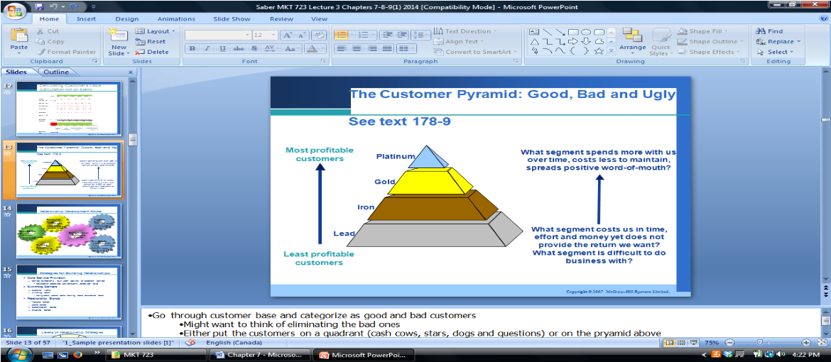

Relationship development strategies
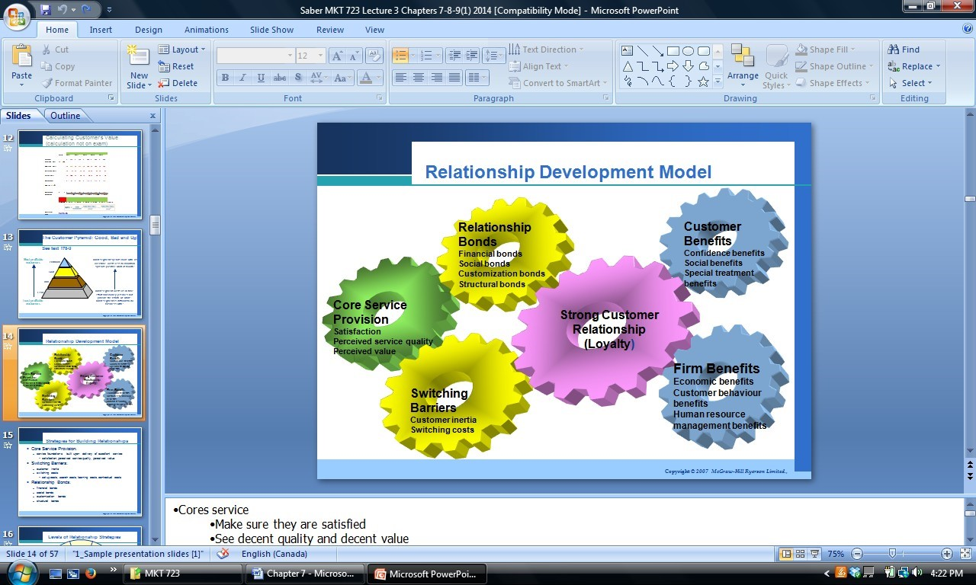
core service provisions | •  • | Must be aligned with efforts to satisfy consumers  Consumers see decent quality and decent value
 | • | Without this, your business means nothing to consumers
 | • | Service foundations built upon delivery of excellent service: satisfaction, perceived service quality, perceived value
Switching barriers | • | Prevent customers from switching to another provider
 | • | Inertia→if it’s hard to switch, and you get decent service they won’t switch
 | • | Switching costs limit the odds of switching
Relationsh • Financial incentives→PC points ip bonds
- Social bonds→develop relationships
- Customization bonds→providing specific services for the customer (special treatment)

Levels of relationship strategies
- Level 1→financial bonds o The first and weakest level of relationship bond, provide some type of economic incentive for a customer to continue a relationship with a company
  - Ex. Frequent shopper or loyalty cards; secured pricing; bundle services as packages
- Level 2→social bonds
  - Provides additional attraction for customers. Service providers use strategies to create social bonds with clients
  - Personal relationship between customer and company, or social among customer
▪ Harley Davidson
- Level 3→customization bonds o May have commonalities with others, but they are stronger
  - Intimate knowledge of customers and personalized services to meet their needs o Customizing product/service→ Amazon providing suggesting products o Mass customization
  - Customer intimacy→making you feel special and customized
- Level 4→structural bonds o Strongest, and most difficult level
  - B2b relationships, where companies become structurally tied to each other but also exhibit customization, social and financial bonds
  - Ex. Wal-Mart and the information system to provide a joint venture with company [just in time]

Relationship challenges

The problem of customer misbehaviour: 6 types of “Jaycustomers”
•
- Thief
- Rule breaker
- Belligerent
- Family feuders
- Vandal
- deadbeat

The customer is NOT always right
- not all customers are good relationship customers:
o
  - wrong segment o difficult customers
  - not profitable in the long term •
- Customers are only “always” right, if they are profitable. If they are bad customers and start abusing the system and are not profitable they are not right and might be easier to cut them loose • But be careful because bad customers are usually the most likely to provide negative reviews

Chapter 8—service recovery—provider gap 1

The impact of service failure and recovery
- Service recovery: refers to the actions taken by an organization in response to a service failure
- Failures occur for all kinds of reasons o The service may be unavailable when promised o May be delivered late or to slowly
  - The outcome may be incorrect or poorly executed o Employees may be rude or uncaring
- Research has shown that resolving customers problem effectively has a strong impact on customer satisfaction, loyalty, WOM communications, and bottom line performance
- The recovery paradox
  - An initially disappointed customer who has experienced good service recovery might be even more satisfied and loyal as a result How customers respond to service failures
- Why do you complain?
  - They expect positive outcomes of complaining o Social obligation to complain o People like to complain
- Why not complain?
o
  - Do not know how to o Emotional risks of complaints o Feel it’s a waste of time •
- Consumers are more likely to complain about services that are expensive, high risk or ego involving o When there is more risk involved, people are more likely to complain o If the customer had more involvement, there is more chances of complaining
- Ways of complaining o
  - Immediately on the spot o Create a website
  - Later by phone, writing, internet o 3rd party—Better Business Bureau
  - Negative word of mouth •
- Types of complainers o Passives—less likely to complain or spread negative WOM
    - Won’t do much, just won’t return o Voicers—actively complain directly
    - Less likely to go to 3rd party of spread negative WOM—won’t tell anyone o Irates—more likely to engage in negative WOM and switch providers
    - Average propensity to complain
    - Complaining has social benefits—will complain a lot, and tell everyone
  - Activist—most likely to complain
▪ Complain to anyone that will listen—enjoys complaining and complain about everything ▪ Avoid disappointing these people, they will voice their complaints in every form Customer recovery expectation
- 7 most common service remedies that customers expect when there is a problem o
  - Fix the service $ o Reimburse all their money $
  - Reimburse part of their money $ o Apology o Explanation
  - Assurance the problem will not be repeated
  - Opportunity to vent

Fair treatment
- Make customers see and feel that you are bending backwards to try to remedy their problem
- 3 specific types of justice that customers are looking for following their complaints o Outcome fairness→make it right
  - Expect outcomes or compensation to reflect level of service failure
  - Punishment should fit the crime o Procedural fairness→was it easy to complain, and were you respected
  - Easy to contact—customers prefer face to face or phone over letter and emails
  - One person handles the complaint
  - Adaptable
  - Quick response to complaints o Interactional fairness→were they nice when you complained
▪
  - Polite ▪ honest
  - Empathic

Switching vs. Staying following service recovery
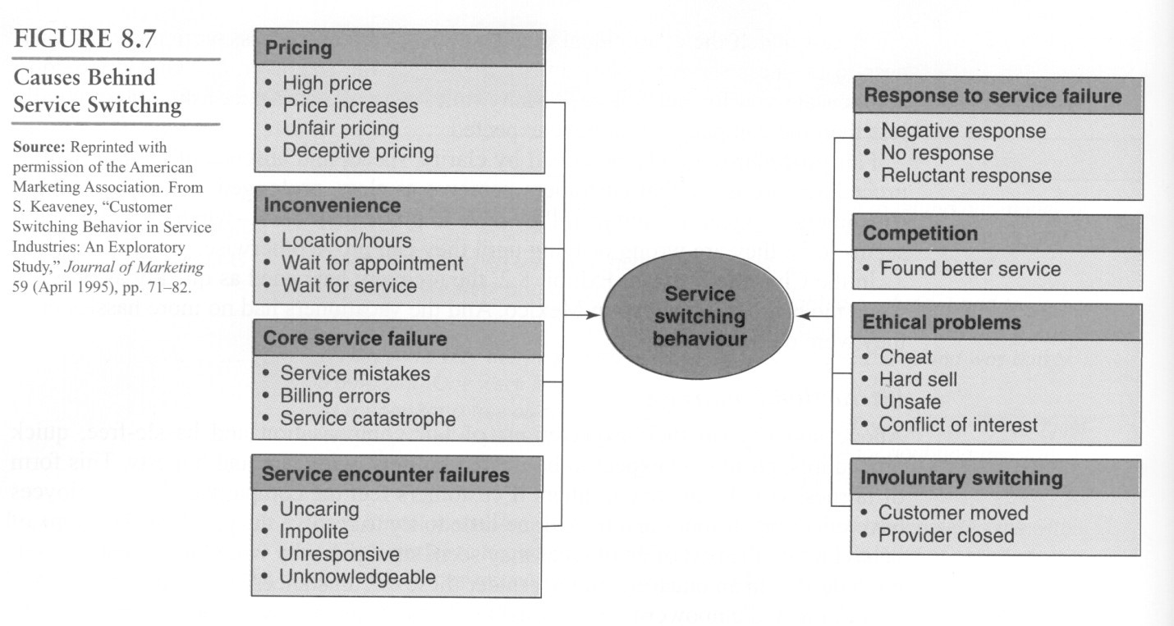

Service recovery strategies
- Act quickly o Take care of problems on the front line o Empower employees
o Allow customers to solve their own problems
- Provide adequate explanations
- Treat customers fairly
- Encourage and track complaints
- Make the service fail-safe—do it right the first time
- Learn from lost customers
- Learn from recovery experiences
- Cultivate relationships with customers

Service guarantees
- Guarantee: an assurance of the fulfillment of a condition o Is a pledge or assurance that a product offered by a firm will perform as promised and, if not, then some form of reparation will be undertaken by the firm
- Tangible products→warranties
- Services are often not guaranteed o Because you cannot return the service
o Service experience is intangible—what can you guarantee
- Ex. Of service guarantee: Pizza arrives in 30 min or its free
- Often conditions to the guarantee apply o If the weather is horrible (crazy snow storm) you expect the pizza to be late so you won’t expect it to be free
- Service guarantees work for companies who are already customer focused
- Effective guarantees can be BIG deals—they put the company at risk in the eyes of customer
- Customer should be involved in the design of service guarantees
- The guarantee should be so stunning that it comes as a surprise—wow factor
- It should be the icing on the cake, not the cake
- Service guarantees are good; but can be detrimental for the service if you don’t follow through with
it

Characteristics of an effective service gaurnatee
- Unconditional o The guarantee should make its promise unconditionally—no strings attached o If you don’t like it; you’ll get your money back
- Meaningful
o The firm should guarantee elements of the service that are important to the customer o The payout should cover fully the customers dissatisfaction
- Easy to understand and communicate o Customers need to understand what to expect o Employees need to understand what to do o Ex. Pizza late and its free, has to be easy to do
- Easy to invoke and collect o The firm should eliminate hoops or red tape in the way of accessing or collecting on the guarantee

Benefits of service gaurantees
- Forces the company to focus on its customers
- Sets clear standards for the organization
- Generated immediate and relevant feedback from customers
- Facilitates service recover, thus satisfying the customer and helping retain loyalty
- Provides information generating opportunity
- Enhances employee morale and loyalty
- Reduces customers sense of risk and builds confidence in the organization
- Forces company to understand why it failed
- Builds marketing muscle

Reasons companies might NOT want to offer a service gaurantee
- Existing service quality is poor
- Guarantee does not fit the company’s image
- Too many uncontrollable external variables (weather for pizza delivery)
- Fears of cheating or abuse by customers
- Costs of the guarantee outweigh the benefits
- Customers perceive little risk in the service
- Customers perceive little variability in service quality among competitors The problem of customer misbehaviour:
•
- Thief
- Rule breaker
- Belligerent
- Family feuders
- Vandal
- deadbeat

The customer is NOT always right
- not all customers are good relationship customers:
o
  - wrong segment o difficult customers
  - not profitable in the long term •
- Customers are only “always” right, if they are profitable. If they are bad customers and start abusing the system and are not profitable they are not right and might be easier to cut them loose • But be careful because bad customers are usually the most likely to provide negative reviews
Chapter 9—service development & design

—provider gap 2

Successful services
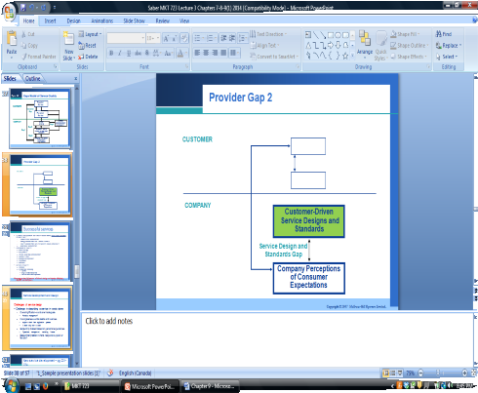
- 60 studies of new products/services should that the most reliable predictors of success were:
  - Product/service characteristics o Strategy characteristics—R&D, HR
  - Process characteristics—pre-development, launch proficiencies o Marketplace characteristics
- Determinants of success o
  - Market synergy o Management capabilities o Well planned o Preparations o Effective marketing communications o innovative
  - Customer service •
- measure of success o financial o relationship enhancing
▪
    - loyalty ▪ effect on other services of
    - image or brand products enhancement •
- many new services fail because of failure to design and develop effectively: only 56% survive 5 years

New service development
- products that are designed and introduced via the steps in a structured planning framework have a greater likelihood of ultimate success than those not developed within a framework
- services are intangible makes them more imperative for a new service development system to have 4 basic characteristics o it must be objective, not subjective o it must be precise, not vague o it must be fact driven, not opinion driven o it must be methodological, not philosophical

Challenges of service design
- oversimplification o
  - words are inadequate •
  - portfolio management
- incompleteness o
  - omits details and nuances •
  - explain a bank loan application process
- subjectivity o
  - biased based on personal o operations, management, marketing, experience finance
- • biased interpretation o What is responsive, quick or flexible?

Types of new services
- major or radical innovation—new services for markets as yet undefined o ex. 1st broadcast TV services
- start-up businesses—new services for a market that is already served by existing products that meet the same generic need o ex. Online banking
- new services for the currently served market—existing customers a service not previously available from the company o ex. Airlines providing internet services
- service line extensions—augmentations of the existing service line o ex. Ryerson offering eMBA
- service improvements—changes in features of services that are already offered o ex. Extended hours of service
- style changes—highly visible modest service changes o changing color scheme at restaurant, changing packaging, redesigning logo

Stages in new service development
- challenges typically lie in defining the concept in the early stages of the development process and again at the prototype development stage
- the stop signs specify requirements that a new service must meet before it can proceed to the next stage of development
- New service development is rarely a linear process. Many companies are finding that to speed up the process, some steps can be worked on simultaneously and in other cases some steps can even be skipped.

Service Blueprinting
- one of the keys to matching service specifications to customer expectations is the ability to describe critical service steps objectively and to depict them so that employees, customers and managers alike know what the service is, can see their role in its delivery, and understand all the steps and flows involved in the service process
- service blueprint: map that accurately portrays the service system o so that different people involved in providing it can understand and deal with it objectively regardless of their roles or their individual points of view
o useful at the design stage of service developments
- A service blueprint visually displays the service by simultaneously depicting the service process, the points of customer contact, and the evidence of service from the customer’s point of view.

Blueprint components *
- customer actions→encompasses the steps, choices, activities, and interactions that the customer performs in the process of purchasing, consuming, and evaluating the service o the total customer experience is apparent in this area of the blueprint
- onstage contact employee actions→steps and activities that the contact employee performs that are visible o the customer
- backstage contact employee actions→employee actions that occur behind the scenes to support the onstage activities o all non-visible contact employee actions are shown in this area of the blueprint
- support processes→covers the internal services, steps, and interactions that take place to support the contact employees in delivering the service
- Physical evidence→the tangible visual cues aligned with the customer actions.
  - Ex. Lawyer→office decor, lawyers outfit, grooming, documents
- Line of interaction→representing direct interactions between the customer and the organization o Anytime a vertical line crosses the horizontal line of interaction, a direct contact between the customer and the organization, or a service encounter has occurred
- Line of visibility→separates all service activities that are visible to the customer from those that are not visible
- Line of internal interaction→separates contact employees activities from those of other service support activities and people o Vertical line cutting across the line of internal interaction represents internal service encounters
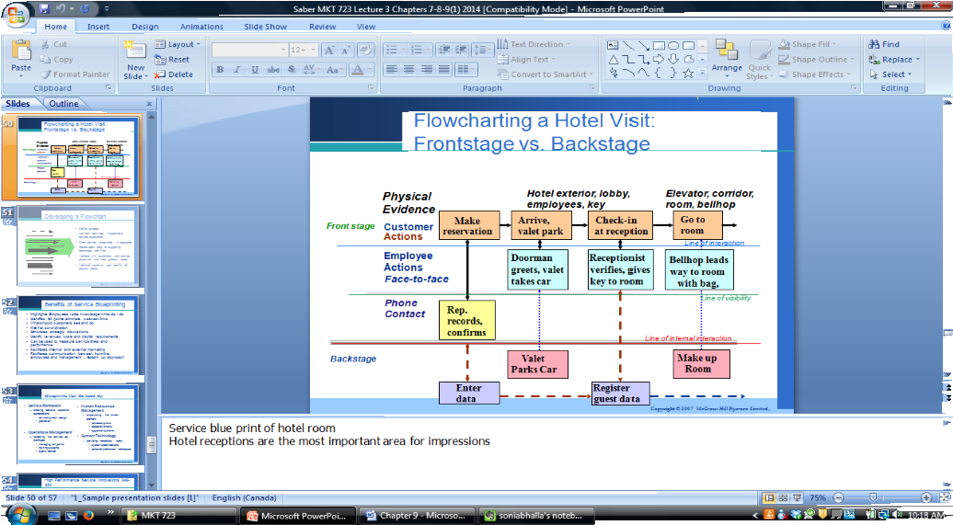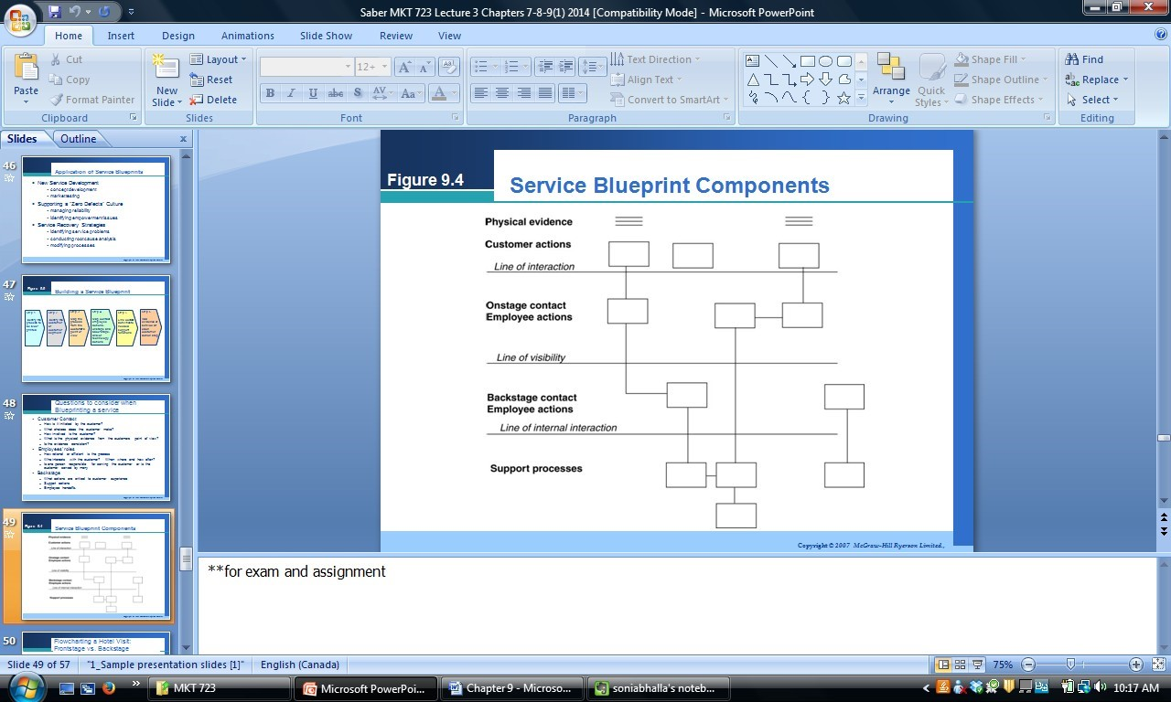
- Developing a flowchart o Define purpose
  - List main activities in customer’s service experience o Chart service encounters in sequence
  - Related each step to supporting backstage activities
  - Validate with customers and service personnel and note problem areas o Add brief narrative and identify all players clearly

Application of service blueprints
- New service development o
  - Concept development o Market testing
•
- Supporting a “zero defects” culture o
  - Managing reliability • o Identifying empowerment issues
- Service recovery strategies o
  - Identifying service problems o Conducting root cause analysis o Modifying process

Building a service blueprint *
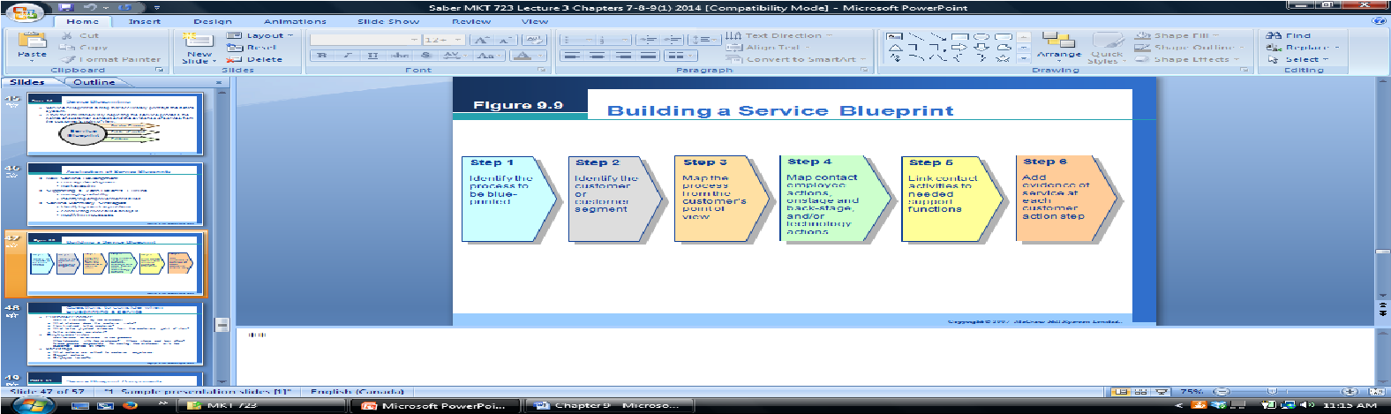
• You must clarify all the steps you need to make to make the services work effortlessly

Questions to consider when blueprinting a service
- Customer contact o How is it initiated by the customer?
  - What choices does the customer make? o How involved is the customer?
  - What is the physical evidence from the customers POV?
  - Is the evidence consistent?
- Employees roles
  - How rational or efficient is the process o What interacts with the customer? When, where, and how often?
  - Is one person responsible for service the customer or is the customer served by many?
- Backstage
  - What actions are critical to customer experience?
  - Support actions o Employee handoffs

Benefits of service blueprinting
- Highlights employees roles knowledge-what do I do
- Identifies fail points—eliminates weakest links o Find out where it is likely to go wrong, find ways to safe-guard the steps o Figuring what could go wrong in the steps of the blueprint
- What should customers see and do
- Internal co-ordination
- Stimulates strategic discussions
- Identify revenues, costs and capital requirements
- Can be used to measure service times and performance
- Facilitates internal and external marketing
- Facilitates communication between front-line employees and management –bottom up approach Blueprints can be used by:
Who? For? Specifics?
-service system design | -promotion
-job descriptions -selection criteria | -appraisal systems
-managing fail -training | -quality control
Service marketers Creating realistic customer expectations
Human resources Empowering the human element management
Operations management Rendering the service as promised
points
systems
System technology Providing necessary tools -system specification -personal preference database

Quality Function Deployment
- QFD: a system for translating customer requirements into appropriate company requirements at every stage, from research through production design and development to manufacture; distribution; installation; and marketing sales and services
- Means of integrating marketing and engineering personnel in the development process

Key success drivers include
•
- Choosing the right projects
- Integrating new services
- Consider multiple measures of success
- Learn from major successes
- Maintain some flexibility

