Chapter 22 Protists

22.1 Evolution of Protists Involved Endosymbiosis

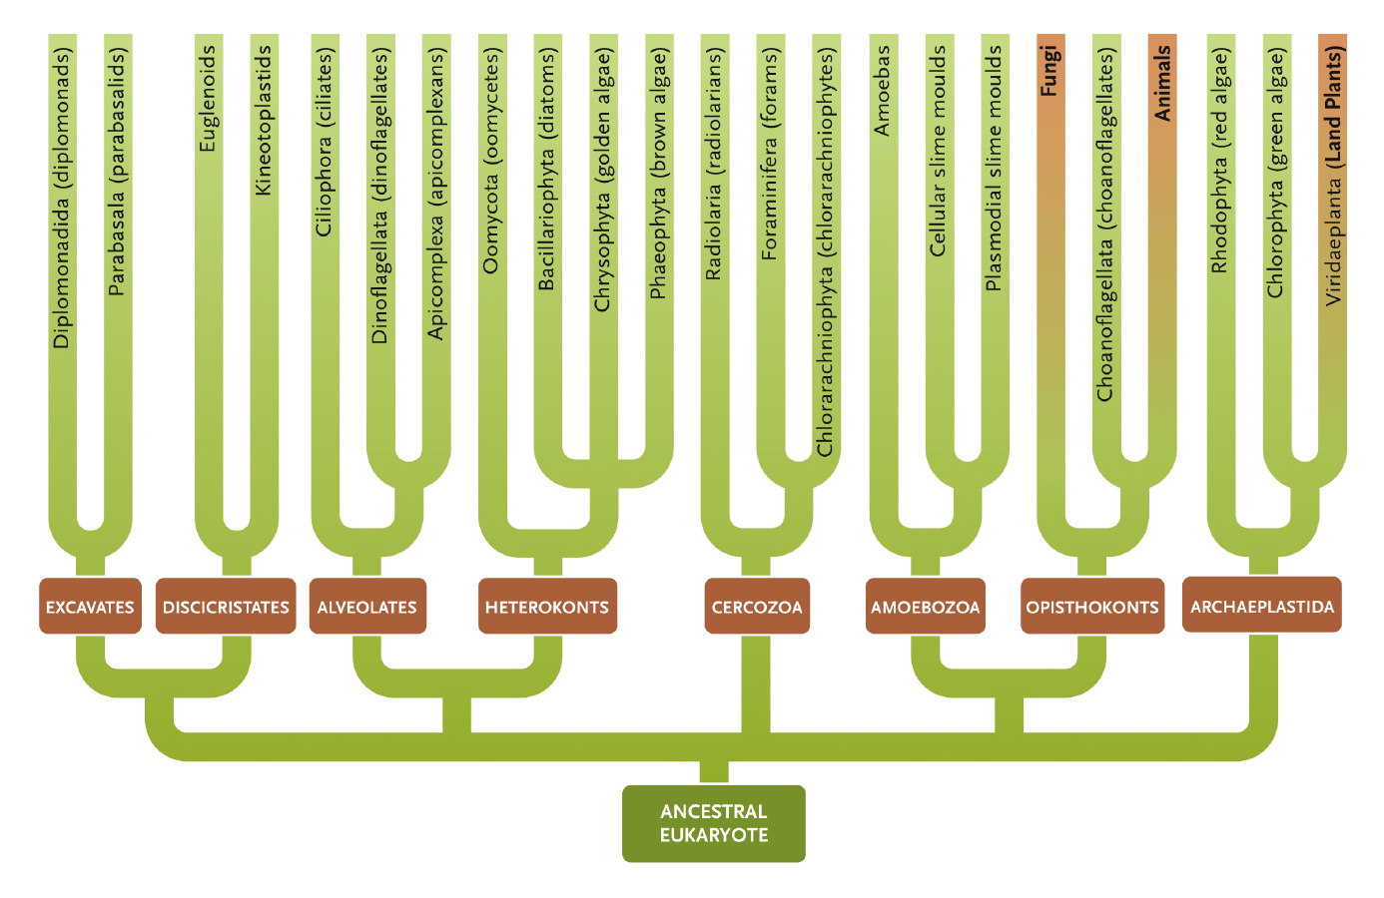
- Evolved 1.5 to 2 billion years ago
- Endosymbiosis played an important role.
  - Contain mitochondria and some contain chloroplasts
  - Earliest eukaryotes acquired mitochondria by engulfing proteobacteria becoming heterotrophic eukaryotes
- Chloroplast endosymbiosis
  - Cyanobacteria ingested by eukaryote that already had mitochondria.
  - Formed symbiotic relationship
  - Over evolutionary time, lost genes no longer required for independent existence and transferred most of its genes to the host’s nuclear genome.
    - Gave the host cell better control of overall cell function
  - Prokaryote became an organelle of an eukaryote
  - Some evolved this way, other: eukaryote engulfed a photosynthetic eukaryote that eventually became a chloroplast.
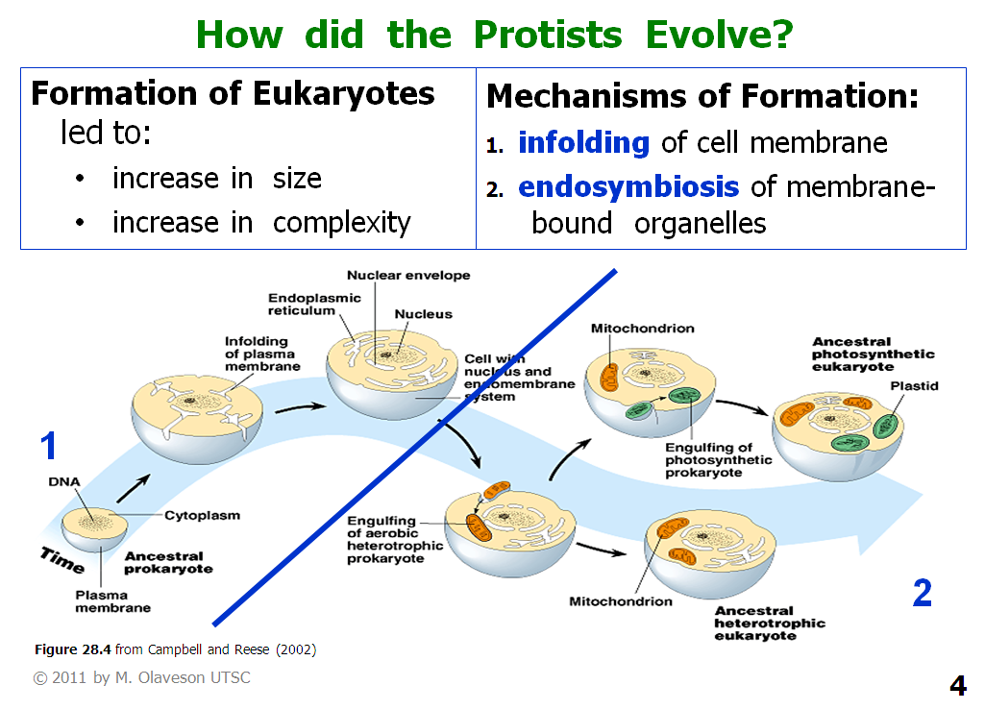

22.2 Characteristics of Protists

- Membrane-bound nucleus
- Multiple linear chromosomes
- Cytoplasmic organelles: mitochondria and chloroplast (in some species)
- Microtubules and microfilaments.
  - Provide motility and cytoskeletal support
- Characteristics of transcription and translation like eukaryotes
- Phylogenetic relationship between protists and eukaryotes are more complex.
  - Over evolutionary time, the eukaryotic family tree branched out in many directions
  - Plants, animals and fungi diverged from protest ancestors.
  - Some features similar, other distinctive.
- Most protists are motile or have motile stages in their life cycle and their cell walls are made of cellulose
  - Fungi cell ways are made of chitin
- Differences from plants:
  - Photoautotrophic protists can also live as heterotrophs
    - Some combine both modes of nutrition
  - Do not retain developing embryos in parental tissue
  - Do not have highly differentiated structures equivalent to roots, stems and leaves
  - Photosynthetic generally referred to as algae
    - Generally aquatic, unicellular and microscopic.
      - Many multicellular
    - Diff groups of algae are not closely related to each other.
- Differences from animals:
  - Unlike protists, all animals are multicellular and have features such as an internal digestive tract and complex developmental stages
  - Protists lack nerve cells, highly differentiated structures such as limbs and a heart and collagen (extracellular support protein)
- Animals in protest are not fungi, plants, animals or prokaryotes
- Extremely diverse
  - Many were grouped into phyla under kingdom according to body form, nutrition modes and movement, forms of meiosis and mitosis. paraphyletic
  - Molecular data show that most protists do not share a common ancestor and the ones grouped together in a phylum are not closely related.
- Some evolutionists believe that Protista kingdom is collection of many kingdoms (as many as 30).

22.3 Protists’ Diversity is reflected in their metabolism, reproduction, structure and habitat

Habitat
  - Live in aqueous habitats
    - Aquatic or moist terrestrial locations
      - Oceans, freshwater lakes, ponds, streams and moist soils and within host organisms
      - Saltwaters
      - Extreme habitats (high/low pH, high/low salt, high/low temperature, high/low nutrients)
      - Aerial habitats
    - Phytoplankton: in bodies of water, small photosynthetic protists collectively make up this
      - Capture light energy
      - Provide organic substance and oxygen for heterotrophic bacteria, other protists and animal larvae
      - Combined with large multicellular protists forming seaweeds, they account for half of the total organic matter produced by photosynthesis
    - Zooplankton: animal larvae that feed of phytoplankton
    - In moist solids of terrestrial environments, protists play important roles among the detritus feeders that recycle matter from organic back to inorganic form
    - Enormously important in world ecosystems
    - Protists that live in host organisms are parasites, obtaining nutrients from the host.
      - Many human parasites are protists causing diseases such as malaria, sleeping sickness and amoebic dysentery.
Structure
  - Most single cells
  - Others live as colonies in which individual cells show little or no differentiation and are potentially independent.
    - Within colonies, individuals use cell signaling to cooperate on tasks such as feeding or movement.
  - Some are large multicellular organisms: giant kelp of coastal waters can rival forest trees in size.
  - Many single celled and colonial protists have complex intracellular structures
    - Reflect key aspects of habitats in which they live.
    - Fresh water protists.
      - Cytoplasm is hypertonic, water flows in.
      - Contractile vacuole gradually fills with fluid, when it reaches its maximum size, it moves to the plasma membrane and forcible contracts, expelling the fluid to the outside through a pore in the membrane.
  - Some are supported by an external cell wall or by an internal or external shell built up from organic or mineral matter
  - Instead of cell wall, other protists have a pellicle: a layer of supportive protein fibers located inside the cell just under the plasma membrane, providing strength and flexibility
  - Almost all protists move sometime during their lives.
    - Some move by amoeboid motion
      - Cell extends one or more lobes of cytoplasm called pseudopodia.
      - Rest of cytoplasm and nucleus then flow into the pseudopodium, completing the movement.
    - Other move by beating of the flagella or cilia.
      - Some protists: cilia are arranged in complex patterns, with an equally complex network of microtubules and other cytoskeletal fibers supporting the cilia under the plasma membrane.
  - Can exist in more than one form
    - As a motile form or nonmotile cyst
      - Survive unfavourable conditions.
    - This morphological variability allows species to live in diff habitats at diff stages in its life
Metabolism
  - Most nutritionally diverse of all eukaryotes
  - All protists are aerobic organisms that live either as
    - Heterotrophs: obtaining carbon from organic molecules produced by other organisms-
      - Some obtain organic molecules by engulfing part or all of other organisms and digesting them internally.
      - Others absorb small organic molecules from the environment by diffusion.
    - Photoautotrophs: producing organic molecules for themselves by photosynthesis.
  - Mixotrophs: Combine heterotroph and photoautotroph
Reproduction
  - Asexual- mitosis
  - Sexual- meiotic cell division and formation of gametes.
  - In protists that reproduce by mitosis and meiosis, the two modes of cell division are often combined info a life cycle that is highly distinctive among the diff protists groups

22.4 The Protist Groups

Excavates lack “typical” mitochondria
  - Flagellated cells
  - Adapted to parasitism
  - Adapted to anaerobic environments (low oxygen)
  - Unique characteristics
    - Hollow (excavated) feeding groove
    - Lack plastids
    - Lack “typical” mitochondria – have modified mitochondria that lack DNA, an electron transport chain, or citric-acid cycle enzymes
      - Glycolysis as ATP source
      - Ancestors had mitochondria but may have lost it as an adaptation to parasitic way of life, O2 is in short supply
  - Diplomonadida
    - Have two equal-sized nuclei and multiple flagella
    - Look like ‘two cells’
    - Two apparently identical nuclei and multiple flagella
    - i.e. Giardia lamblia
    - Some free living, many live in animal intestines
  - Parabasala
    - The sexually transmitted disease trichomoniasis is caused by the parabasalid T. vaginalis
    - Parabasalids take their names from cytoplasmic structures associated with the nucleus, parabasal bodies
    - Also characterized by undulating membrane, formed by a flagellum buried in a fold of the cytoplasm, in addition to freely beating flagella
    - Other parabasalids are symbionts that live in the guts of termites and other wood-eating insects, digesting the cellulose in the wood for their hosts
    - Discovery: protists themselves cannot produce the enzymes necessary to break down cellulose but instead rely on bacterial symbionts to do it
Discicristates include the Euglenoids and Kinetoplastids: highly motile protists
  - Flagellated cells – very motile group
  - Exhibit photosynthesis, heterotrophy, mixotrophy, parasitism
  - Adapted to aerobic environments
  - Unique characteristics
    - Presence of a spiral or crystalline rod inside their flagella
    - Discicristates are named fort heir disc-shaped mitochondrial cristae
  - Euglenoids
    - Important primary producers in freshwater ponds, streams and lakes
    - Most use photosynthesis
    - When light isn’t available heterotrophs (absorbing organic material through the plasma membrane or engulfing small particles)
    - Others lack chloroplasts, thus live entirely as a heterotroph
    - Have a pocket from which one or two flagella emerge
    - Have eyespot – light perception
    - Eyespot contains pigments granules in association with a light-sensitive structure and is part of a sensory mechanism that stimulates cells to swim toward moderately bright light or away from intensively bright light so that the organism finds optimal conditions for PS activity
    - Contain a contractile vacuole
    - Spirally grooved pellicle
    - Can swim by whip-like movements of flagella
    - Have a unique glucose polymer, paramylon, as storage molecule
    - Many species are autotrophic but can be heterotrophic in dark
    - No sexual reproduction reported
  - Kinetoplastids
    - Have a single large mitochondrion associated with a unique organelle, the kinetoplast that houses extranuclear DNA
    - Some kinetoplastids are pathogenic parasites (i.e. sleeping sickness)
Alveolates have complex cytoplasmic structures and move via flagella or cilia
  - Very motile group (use flagella or cilia)
  - Exhibit photosynthesis, heterotrophy, mixotrophy, parasitism
  - Unique characteristics
    - Have small, membrane-bound sac-like vesicles called alveoli in layer under plasma membrane
  - Ciliophora (ciliates)
    - Primarily single-celled but highly complex heterotrophic organisms and move by cilia
    - Have macronuclei and micronuclei
    - Micronucleus is a diploid nucleus that contains a complete complement of genes
    - Macronucleus develops from a micronucleus but loses all genes except those required for basic functions of the cell and for synthesis of ribosomal RNA
    - Unique reproductive processes (e.g. conjugation = a form of sexual reproduction)
    - Feed on bacteria, algae and each other
    - Tetrahymena the organism in which telomeres and telomerase were discovered, the first motor protein, cell cycle control mechanisms, and ribozymes
    - Certain ciliates are animal parasites; other live and reproduce in their hosts as mutually beneficial symbionts
    - Some exude toxins and other defensive materials from the cell surface
  - Dinoflagellata (dinoflagellates)
    - Have two flagella
    - Have cellulose cell wall
    - Responsible for bioluminescence events and “red tides”
    - Live as heterotrophs or autotrophs
  - Apicomplexa
    - Non-motile animal parasites
    - Apical complex attaches to and invades host cells
    - Have both asexual and sexual reproduction
    - i.e. malaria
Heterokonts have two dissimilar flagella at some stage of their life cycles
  - Very motile group (use flagella)
  - Exhibit photosynthesis, heterotrophy, mixotrophy, parasitism
  - Unique characteristics
- Have two dissimilar flagella (one ‘hairy’ and one smooth) at some point in their life cycle (usually on gametes in sexual reproductive stage)
- Oomycota: water moulds. They grow as microscopic, nonmotile filaments called hyphae, forming a network called mycelium. They are heterotrophs, which secrete enzymes that digest the complex molecules of surrounding organic matter or living tissues into simpler molecules that can be absorbed.
- Bacillariophyta (diatoms): single-celled organisms with a glassy silica shell, which is intricately formed. Diatoms are photoautotrophs that carry out PS by pathways similar to those of plants. Asexual reproduction occurs by mitosis followed by a form of cytoplasmic division in which each daughter cell receives either the top or bottom half of the parent shell.
- Chrysophyta (golden algae): most are autotrophs and carry out PS (similar to plants). Golden in colour due to brownish carotenoid pigment.
- Phaeophyta (brown algae): All are photoautotrophs. Kelps are the largest and most complex. They also grow very fast (up to 30cm a day). They contain various tissues. Kelp forests provide food and habitat for many marine organisms. Their cell walls contain cellulose and a mucilaginous polysaccharide, alginic acid.
Cercozoa are amoebas with filamentous pseudopods
  - Single-celled amoeba
  - Exhibit heterotrophy, parasitism
  - Unique characteristics
    - move by stiff, filamentous (thread-like) pseudopodia
    - many produce hard outer shells (tests)
  - Radiolara (radiolarians) – are marine organisms characterized by a glassy internal skeleton and axopods.
  - Foraminifera (forams) – these organisms take their name from the perforations in their shells, through which extend long, slender strands of cytoplasm supported internally by a network of needlelike spines. Forams live in marine environments.
  - Chlorarachniophyta (chlorarachniophytes) – are amoebas that contain chloroplasts and thus use PS.
Amoebozoa include slime moulds and most amoebas
  - Amoebas – single-celled organisms that are abundant in marine and freshwater environments and in the soil. All amoebas are microscopic, some may grow to 5mm. Most are heterotrophs that feed on bacteria, and bits of organic material. Amoebas reproduce asexually, via binary fission. They can survive as a cyst when conditions are unfavourable.
  - Slime Molds (cellular and plasmodial) – slime moulds exists for part of their lives as individuals that move by amoeboid motion. There are two lineages: the cellular slime moulds and the plasmodial slime moulds, which differ in cellular organization. Slime moulds live on moist, rotting plant material such as decaying leaves and bark. The cells engulf particles of dead organic matter, along with bacteria, yeast, and other microorganisms.
Archaeplastida include the red and green algae and land plants
  - Over 1 billion years ago, heterotrophic protists acquired a cyanobacterial endosymbiont - became photosynthetic
  - Descendants evolved into red algae and green algae – ancestors of plants
  - Rhodophyta (Red algae)
    - Most small marine seaweeds
    - Plantlike bodies with stalks and leaflike blades, cell walls
    - Typically multicellular
    - Colour differences due to phycobilins
    - Alternation of generations but no flagellated gametes
    - Produce agar and carrageenan
  - Chlorophyta (Green algae)
    - Same pigments as true plants (chlorophyll a and chlorophyll b)
    - Little differentiation
    - High diversity of body forms/life cycles
    - Symbiotic relationships with fungi (lichen) or animals
    - Genomes most similar to true plants
  - Charophyta
    - Unique structures (e.g. Rosettes for cell wall synthesis)
    - Likely algal ancestors of land plants
Opisthokonts include the Choanoflagellates, which may be the ancestors of animals
  - Most heterotrophic flagellates often colonial
  - Unique characteristics
    - have a single posterior flagellum at some stage in life cycle
  - Choanoflagellata (choanoglagellates)
    - Collar of microvilli surrounds single flagellum
    - May be ancestors of fungi and animals

22.5 Some Protist Groups Arose from Primary Endosymbiosis and Others from Secondary Endosymbiosis
- About 1 Bya, the first chloroplasts evolved from free-living photosynthetic prokaryotic organisms (cyanobacteria) ingested by eukaryotic cells that had already acquired mitochondria
- In some cells, the cyanobacterium was not digested but instead formed a symbiotic relationship with the engulfing host cell – it became an endosymbiont, an independent organism living inside another organism
- Over time, the prokaryotic cell transfers most of its genes to the host
- Endosymbiont became an organelle
- Chloroplasts of red algae, green algae, and land plants from evolutionary divergence of the photosynthetic eukaryotes formed from this primary endosymbiotic event
- Organisms that originated from this event have chloroplasts with two membranes, one from the plasma membrane or the engulfing eukaryote and the other from the plasma membrane of the cyanobacterium
- Resulting in three secondary endosymbiosis events, each time involving different heterotrophic eukaryotes engulfing a photosynthetic eukaryote, producing new evolutionary lineages


