Chapter 20 – Bacteria and Archaea

20.1 – The full extent of prokaryote diversity is unknown
- Identified only 6000 species- less than 1%.
  - We can only do detailed studies on prokaryotes that we can grow in culture.
  - Most cannot grow on the media and condition we can provide: they live in extreme conditions, which cannot be created in a lab.
  - Metagenomics allow us to isolate and clone DNA from an environment and then analyze gene sequences
- Two domains: Archaea and bacteria consist of prokaryotic organisms
  - Bacteria are the most similar to us.

20.2 Prokaryote structure and Function
Prokaryotes:
- Small organisms: 1-2 micro m long.
- Dominate life on earth; estimate of billions of species and total collective mass (biomass) > animals and maybe of all plants.
- Colonize every niche on earth that supports life. Bacteria in and on body outnumber all the cells.
- Why is it so diverse?
- Reason: for 3 billion years – only organism on earth and had time to diversify and expand into every habitats before eukaryotes appeared.
Cell shapes:
- Spiral
- Spherical (or coccoid)
- Cylindrical (rods) - bacilli
- Some archaea even have square cells
Cell
- Much simpler than eukaryotic
- Cell wall and plasma membrane surrounding a cytoplasm
- DNA concentrated in one region and ribosomes scattered
- Chromosome packed into an area called nucleoid
- No cytoplasmic organelles like mitochondria or ER or Golgi complex
- Functions of above organelles take place in cytoplasm and folding of plasma membrane
- Have cytoskeleton
- Greatest metabolic diversity
Internal structure
- Most contain a single circular DNA molecule
- Contains plasmids, which replicates independently and contain genes for beneficial functions. (i.e. antibiotic resistance)
  - Can be transferred from one cell to another.
  - Horizontal gene transfer allows antibiotic resistance
  - Helps traits spread quickly in a population.
  - Also take up DNA from environment or virus transfer DNA.
- Ribosomes
  - Smaller than eukaryotic
  - Function: protein synthesis similar to eukaryotes
  - Archaea – protein synthesis is a combination of bacterial and eukaryotic processes with unique archaeal features.
    - Antibiotics that stop infections by targeting ribosome activity do not work with archaeas.
- Prokaryotic Cell walls
  - Cell wall outside plasma membrane.
  - Protects the cell from lysing if subject to hypotonic conditions
  - Made of peptidoglycan
    - Linear chain polymer of sugars and amino acids
    - Cross linkages = strength and rigidity
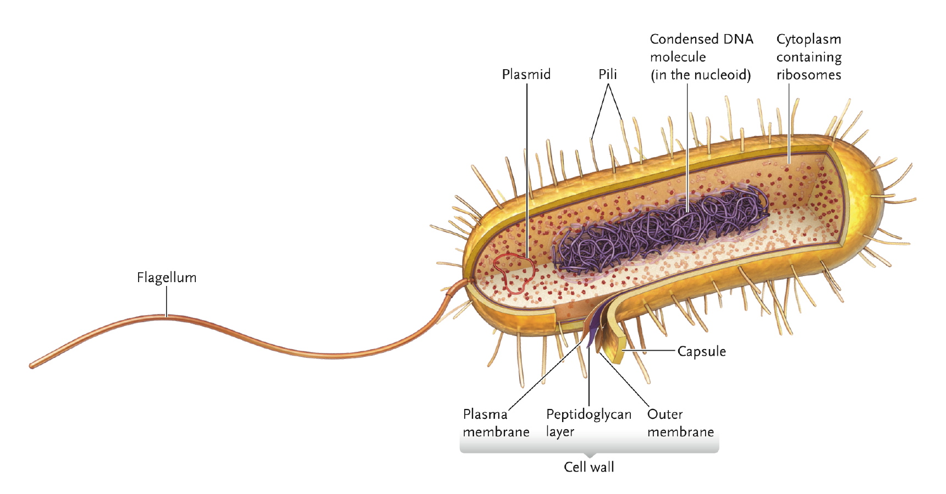
      - Antibiotic penicillin prevents formation of cross linkages weak cell and killed.
      - Penicillin prevents the formation of these cross-linkages resulting in a weak cell wall that is easily ruptured, killing the cell

- Bacteria
  - Gram-positive and gram negative.
  - Gram- positive:
    - Cell walls of only peptidoglycan layer
  - Gram-negative:
    - Cell walls of 2 layers: thin peptidoglycan outside plasma membrane
    - Outer membrane contains lipopolysaccharides(LPS)
      - Protect from harmful substances in the env.
      - Less sensitive to penicillin than gram positive.
  - Gram stain procedure.
    - Cells stained with crystal violet, rinsed with ethanol and counterstained with safranin
    - Gram positive: retain crystal violet and appear purple
    - Gram negative: colourless until stained with safranin and appear pink.

- Archaea:
  - Some have cell walls are assembled from a molecule related to peptidoglycan but with different molecular components and bonding structures.
  - Others have walls from proteins or polysaccharides.
  - Variable response to gram stain.
- The cell wall of many prokaryotes surrounded by layer of polysaccharides = capsule.
  - Sticky
  - Important role in protecting cells in diff environment.
    - From desiccation (drying =dehydrating thoroughly), extreme temp., bacterial viruses and harmful molecules (antibiotics and antibodies)
  - In many, presence or absence differentiates infective from noninfective forms.
- Flagella and Pili
  - Flagella
    - Allows movement via flagella
    - Prokaryotic-bacteria
      - Rigid helical proteins and rotate like propeller of boat.
    - Archaean flagella
      - Similar to bacterial and carry out the same function
      - But contain diff components, develop differently and coded by different genes.
  - Pili
    - Rigid shafts of protein extending from cell walls
    - Helps adhere (stick fast to) to other cells
    - Sex pilus
      - Adhere and act as channel for transfer of plasmids.
    - Other types enable bacteria to bind to animal cells.
- Metabolic Diversity
  - Autotrophs: organisms that synthesize C molecules using inorganic CO₂
  - Heterotrophs: obtain C from organic molecules, either from living hosts or from organic molecules in the products, wastes, or remains of dead organisms
  - Four modes of nutrition based on sources of energy and carbon
  - Photoautotrophs: light as energy source and CO₂ as their carbon source (plants)
  - Chemoheterotrophs: organic molecules as source of energy and carbon (humans, animals, fungi)
  - Photoheterotrophs: use light as energy source and obtain carbon from organic molecules
  - Chemoautotrophs: “lithotrophs” – rock eaters.
    - Obtain energy by oxidizing inorganic substances such as hydrogen, iron, sulphur, ammonia, nitrites and use CO₂ as carbon source
    - Thrive in habitats such as deep-sea hydrothermal vents where lots of inorganic compounds found.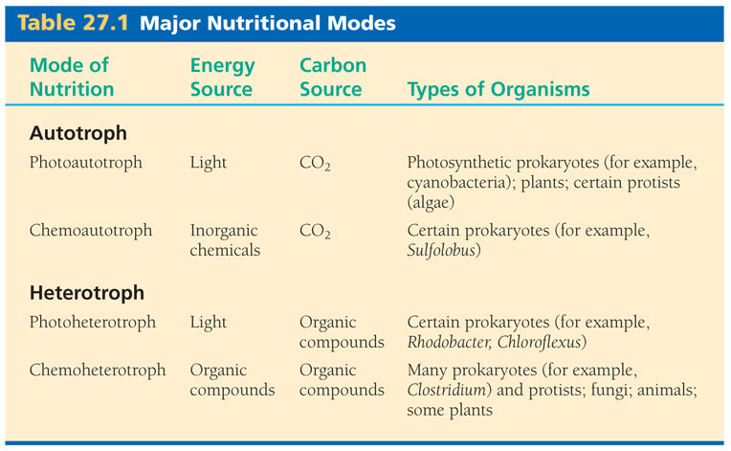
  - Aerobic respiration (oxygen as final electron acceptor) - aerobes
    - Obligate: cannot survive without oxygen
  - Anaerobic respiration – inorganic molecules such as nitrate/sulfate as final electron acceptor.
    - Obligate anaerobes: poisoned by oxygen and survive by fermentation (organic molecule is the final electron acceptor) or by anaerobic respiration (electron acceptors other than oxygen).
    - Facultative respiration: use O₂ when it is present; when not, live by fermentation or anaerobic respiration.
- Biogeochemical cycles
  - Pathway by which a chemical element moves through an ecosystem
  - Element flows: transformed from one form to another.
  - Prokaryotes: Key players in life sustaining cycles
    - Recycling of elements: Carbon, oxygen, and nitrogen.
  - Nitrogen cycle
    - Cant use from air since unable to break triple bond
    - Use nitrogen fixation
    - Bacteria convert nitrogen gas into ammonia to ammonium and then into nitrogen containing molecules such as amino acids and nucleic acids.
    - Only means of replenishing nitrogen sources used by most organisms.
    - Some use nitrification
    - Some bacteria convert ammonium into nitrate, which is taken up by plants and fungi and incorporated into their organic molecules.
    - Animals get N in organic form by eating other organisms.
- Asexual reproduction
  - Parent cells divides by binary fission into two daughter cells (exact genetic copies)
  - Can reproduce very quickly.
  - Small genomes
    - High mutation rates
    - Genetic variability is basis for their diversity, which comes from mutation and to a lesser degree from horizontal gene transfer.
    - Enormous capacity to adapt
- Pathogenic bacteria
  - Exotoxins: toxic proteins leak from or are secreted from bacterium
  - Endotoxins: natural components of outer membrane of gram-negative bacteria.
    - When it lyses, the lipopolysaccharides of outer membrane are released.
    - Exposure to lipid A component of the layer causes endotoxic shock.
      - It over stimulates the host’s immune system, triggering inflammation and an often lethal immune response.
- Resistance to antibiotics
  - Some can pump antibiotics out of the cell using membrane-bound pumps
  - Produce molecule that bind to the antibiotic or enzymes that break it down.
  - Simple mutation can result in a change in the structure of antibiotic’s target and so antibiotic cannot bind to it.
  - Develop new enzymes or pathways not inhibited by the antibiotic.
  - Develop resistance through mutation or acquire by horizontal gene transfer (eg plasmid transfer).
- Where they live
  - Many live in communities where they interact in a variety of ways.
  - Biofilm: prokaryotic community: complex aggregation of microorganisms attached to a surface and surrounded by a film of polymers.
    - Gene transfer within species
    - Organisms can adhere to hospitable surfaces
    - Protects from harmful env.al conditions
    - Form on any substance with sufficient water and nutrients
    - Prokaryotes here become very diff organisms due to gene transfer from a variety of organisms.
    - Communicate by quorum sensing
      - Quorum sensing is a system of stimulus and response correlated to population density. Many species of bacteria use quorum sensing to coordinate gene expression according to the density of their local population.

20.3 The Domain Bacteria
Proteobacteria
- Gram-negative bacteria evolved from purple, photosynthetic ancestor.
  - Purple color from photosynthetic pigment
- Photoautotrophs or photoheterotrophs
- Does not use water as electron donor
Green Bacteria
- Gram-negative and photosynthetic-chlorophyll
Cyanobacteria
- Gram negative photoautotrophs- blue green in color
- Same photosynthesis as eukaryotic algae and plants
- Allowed for evolutionary development of aerobic organisms
- Help fix nitrogen into organic compounds in aquatic habitats.
Gram-positive Bacteria
- Chemoheterotrophs
- Some cause human disease
- Some beneficial (e.g. lactic acid fermentation)
Spirochetes
- Helically spiraled flagella embedded in cytoplasm, cell moves in twisting corkscrew pattern.
Chlamydia
- Gram negative with cell wall but lack peptidoglycan.
- Intracellular parasites causing diseases in animals

20.4 The Domain Archaea
- Extremophiles – extreme lovers.
- Share some features with eukaryotes, some with bacteria and some unique
- Unique
  - Diff linkage btw glycerol and hydrophobic tails in lipid molecules in archaeal plasma membranes.
  - Some lipids have polar at both ends
    - Membrane more resistant to disruption
    - Better suited to extreme environments.
- Many chemoautotrophs, other chemoheterotrophs
- Classified into three groups
  - Euryarchaeota: methanogens, extreme halophiles(salt) and some extreme thermophiles(high temp)
  - Crenarchaeota: most extreme thermophiles, as well as psychrophiles (colder temp) and mesophiles (moderate temp)
  - Korarchaeota: known only from DNA samples

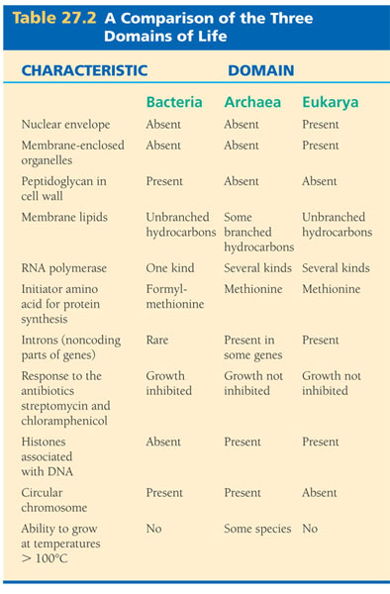

Histones: Any of a group of basic proteins found in chromatin.

