Chapter 17: Darwin, Fossils, and Developmental Biology

17.1 Recognition of Evolutionary Change
- Aristotle was a keen observer of nature and natural history, the branch of biology that examines the form and variety of organisms in their natural environment
  - Began by classifying living/nonliving
- Minerals<plants<animals<humans<gods
- 14th century Europeans: all of the different kinds of organisms had been specifically created by God, that species could never change or become extinct, and that new species could never arise
- He believed that both inanimate objects and living species had fixed characteristics
  - Careful study of diff and similarities enabled him to create a ladder like classification of nature from simplest to most complex
- Natural theology: sought to name and catalogue all of god’s creation.
- Investigated living organisms, giving rise to ideas that species had changed since their creation
- Francis Bacon (1561-1626) established the importance of observation, experimentation, and inductive reasoning
- Buffon proposed that some animals must have changed since their creation
- He proposed that vestigial structures: useless body parts we observe today, must have functioned in ancestral organisms
- Georges Cuvier realized that the layers of fossils represented organisms that had lived at successive times in the past
- Suggested that abrupt changes between geologic strata marked dramatic shifts in ancient environments
- Developed the theory of catastrophism
- Catastrophism: reasoning that each layer of fossils represented the remains of organisms that had died in a local catastrophe such as flood
- Jean Baptiste de Lamarck proposed the theory of biological evolution based on specific mechanism
  - Proposed that metaphysical “perfecting principle” caused organisms to become better suited to their environments
  - Simple organisms evolved into more complex ones, moving up the ladder of life
  - Microscopic organisms were replaced at the bottom by spontaneous generation
  - Two mechanisms fostered evolutionary change
- Principle of use and disuse
    - Body parts grow in proportion to how much they are used
    - Unused structures get weaker and shrink
- Principle of inheritance of acquired characteristics
    - Changes than an animal acquires during its lifetime are inherited by its offspring
- However, now we know that structural changes acquired during an organisms lifetime are not inherited by the next generation
- Lamarck made 4 important contributions to development of an evolutionary world-view
- All species change through time
- Changes are passed from one generation to next
- Organisms change in response to their environment
- Hypothesized existence of specific mechanisms that caused evolutionary change
- First 3 ideas became cornerstones of Darwin’s evolutionary theory.
- He fostered discussion about evolution

17.2 Changes in Earth
- James Hutton argued that slow and continuous physical processes, acting over long periods of time, produced Earth’s major geologic features
- Gradualism: view that earth changed slowly over its history
  - Movement of water in a river slowly erodes the land and deposits sediments near the river’s mouth.
  - Over time erosion create deep canyons and sedimentation creates thick topsoil on flood plains
  - Contrasted Cuvier’s catastrophism
- Charles Lyell argued for uniformitarianism: geologic processes that sculpted Earth’s surface such as volcanic eruptions, earthquakes, erosion and formation and movement of glaciers are exactly the same as the processes we observe today.
  - They occur very slowly and so it must have taken millions of years to mould the landscape into its current configuration

17.3 Charles Darwin
- HMS Beagle: Darwin’s voyage
- Observed fascinating patterns in the distributions of species on the Galapagos islands
  - Animals on different islands varied slightly in form
  - Some similar to South American ancestors
  - He hypothesized that each species had changed after being isolated on a particular island
In selective breeding and hereditary, like begets like
- Offspring resemble their parents
- Artificial selection: selectively breeding individuals with favourable characteristics, breeders enhanced these traits in future generations
In the struggle for existence, the fittest survive
- Thomas Malthus observed that England’s population was growing much faster than its agricultural capacity
- Individuals competed for food and some would inevitably starve
- Species typically produce more offspring than are needed to replace the parent generation
- Some survive and reproduce and others die without reproducing
- Natural selection
  - If one with specific traits reproduced more, more offspring with same genes (traits) and increase in the next gen and so on
- 4 characteristics distinguish Darwin’s theory
  - Provided purely physical rather than spiritual explanations about the origins of biological diversity
  - Recognized that evolutionary change occurs in groups of organisms rather than in individuals. Some members of a group survive and reproduce more successfully than others do
  - Described evolution as a multistage process. Variations arise within groups, natural selection eliminates unsuccessful variations and the next gen inherits successful variants
  - Like Lamarck, Darwin understood that evolution occurs because some organisms function better than others in a particular environment
- Darwin’s impact on biological thought and society
  - Darwin’s Theory – published in “The Origin of Species through Natural Selection” (1859)
    - Shook deepest roots of Western culture
    - Challenged worldview that was prevalent for centuries
  - Argued that all the organisms that have ever lived arose through descent with modification, the evolutionary alteration and diversification of ancestral species
  - Natural selection acted on the variability within groups of organisms, preserving favourable traits and eliminating unfavourable ones

17.4 Evidence for Evolution: The Fossil Record
- Paleontology (discover, describe and name species of fossils) = primary source of data about evolutionary history of many organisms
- Fossils preserved the details of hard structures – bones, teeth and shells or wood, leaves and pollen of plants
  - Formed by buried organisms over time
  - Can be preserved in bottom of ocean, glacial ice, coal, tar pits or highly acidic water of peat bogs.
  - Rarely form where sediments do not accumulate such as mountain forest or where solids are acidic (many forests)
  - May be deformed by pressure from overlying rocks or destroyed by geologic processes (erosion) or disturbances such as volcanic eruptions.
    - Effects of erosion: fossils from older rocks are less common than those in younger rocks, younger been around for less time and therefore exposed to less erosion
- During fossilization, dissolved minerals replace some of an organism’s parts molecule by molecule
- If oxygen is scarce, decomposition does not occur and even soft-bodied organisms may be preserved
- Other fossils are moulds, casts, or impressions
- Amber is the fossilized resin of coniferous trees, can include the remains of insects, plants, tiny lizards, and frogs
- Dating
  - Scientists can assign relative and absolute dates to geologic strata and the fossils they contain.
  - To establish relative dates, sediments found in any one place form distinctive strata (layers) that usually differ in colour, mineral composition, particle size and thickness.
    - Arranged in order in which they are formed, younger at top.
    - But sometimes can be uplifted, warped or even uplifted by geologic processes.
  - Sequences of fossils in different strata give relative ages
    - Geologic time scale = relative dating for sedimentary strata
  - Radiometric dating involves the use of isotopes and sometimes allows actual ages (with error bars) to be associated with diff rock strata
    - Exploits the fact that isotopes begin to decay from the moment they form
    - Isotopes decay at steady rates; rocks containing isotopes can be dated when the amounts of isotopes can be measured and the rates of decay are known
    - Limited to half-life of the isotope
    - Radiometric dating works best with volcanic rocks, which form when lava cools and solidifies
    - Most are found in sedimentary rocks
    - To date sedimentary fossils, scientists determine the age of volcanic rocks from the same strata
    - If fossils contain organic matter such as remains of bones or wood
      - Use carbon-14 dating
      - Living organisms absorb traces of C-14 and large quantities of C-12 from environment and incorporate them into biological molecules
      - C-14 to C-12 ratio remain constant if alive as it is replenished when decayed
      - Once dies, C-14 decays and can use C-14 / C-12 ratio to determine its age

17.5 Earth History, Biogeography, and Convergent Evolution
- Continental Drift
  - Plate tectonics
  - Earth’s crust is broken into irregularly shaped plates of rock that float on its semisolid mantle
  - Continental drift: Currents in the mantle cause the plates and the continents embedded in them to move
  - 250 million years ago = single continent Pangea.
  - Continental drift separated it into current configurations
  - Drifting continents induced global changes in Earth’s climate.
    - Movement towards pole encouraged formation of glaciers which cause temperature and rainfall to decrease worldwide
    - Average temp fluctuated widely because of complex continental movements
  - Unpredictable events also changed physical environment on earth
    - Massive volcanic eruptions and asteroid impacts altered the atmosphere and climate drastically
- Continuous distribution: many species are living in suitable habitats throughout large areas
- Disjunct distributions: closely related species live in widely separated locations
- Dispersal: movement of organisms away from their place of origin; can produce a disjunct distribution if a new population becomes established on the far side of a geographic barrier
- Vicariance: fragmentation of a continuous geographic distribution by external factors
- Over course of evolutionary history, dispersal and vicariance have together influenced the geographic distributions of organisms on a very grand scale
- Biotas: all organisms living in a region
- Wallace used biotas to define six biogeographic regions that we recognize today
- Endemic species: those that occur nowhere else on earth
  - E.g. Australia has been isolated for about 55 million years
- Distantly related species living in different biogeographic realms can be similar in appearance
- E.g. cacti
- Convergent evolution (parallel evolution): evolution of similar adaptations in distantly related organisms that occupy similar environments
- E.g. T-rex is convergent with Thalacinus and Canis
- Divergence of organisms from basic or ancestral stock is fundamental to adaptive radiation

17.6 Interpreting Evolutionary Lineages
- Marsh analyzed 60 million years of horse family history
- Described their evolution in a series of stages
- Inferred a pattern of descent characterized by gradual, directional evolution in several skeletal features
- Changes in the legs and feet allowed horses to run faster, and changes in the face and teeth accomplished a switch in diet from soft leaves to tough grasses
- The evolutionary tree for horses was highly branched
- Many branches of the horse lineage in the Miocene and Pliocene epochs
- Adaptive Radiation (diversification): the evolution of diversely adapted species from a common ancestor upon introduction to new environmental opportunities
Was Evolution a Rapid or a Slow Change?
- A. spirata demonstrates how a snail can change its distribution in space and in time as well as its morphology
- Changes in the snails appear to be in response to changes in climate
- Evolution can occur by gradual changes, by Anagenesis or cladogenesis
- Anagenesis: accumulation of changes in a lineage as it adapts to a changing env.
  - Evolutionary transformation of an existing species rather than production of new ones.
  - if large morphological changes, give organisms diff names at diff times in their history.
- Cladogenesis: evolution of two or more descendant species from a common ancestor.
  - If fossilized remains of descendants are distinct, paleontologists will recognize them as diff species
  - Increases # of species on earth.
- Gradualist Hypothesis: large changes result from slow, continuous accumulations of small changes over time.
  - If correct, in a lineage expect to find a series of transitional fossils documenting gradual evolution
  - Normally one appears in a particular stratum, persist for some times with little change and then disappear. Then another species, variant on the first with different traits suddenly appears in the next higher stratum
- Punctuated Equilibrium Hypothesis: speciation occurs in isolated populations at the edge of a species’ geographic distribution.
- Evolution can occur rapidly
  - Marginal pop experience substantial genetic drift and distinctive patterns of natural selection
  - According to this hypothesis, morphological variations arise rapidly during Cladogenesis
    - Thus most species exhibit long periods of morphological eq, punctuated by brief periods of Cladogenesis and rapid morphological evolution.
    - Transitional forms are uncommon in fossil record-> live only for short periods of time in small localized pop.
- Punctuationalist and gradualist hypotheses are extremes along a continuum of possible macro-evolutionary patterns
- The mode and tempo of evolution vary among lineages and both viewpoints are validated by data on some organisms but not on others.
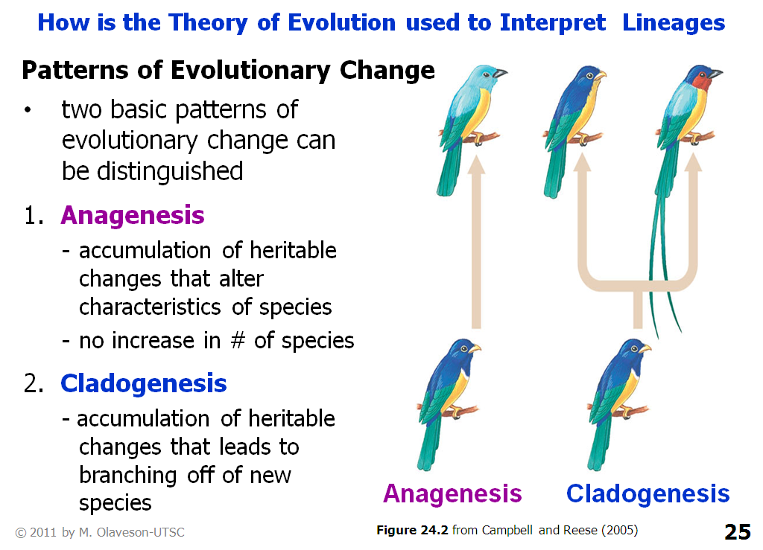
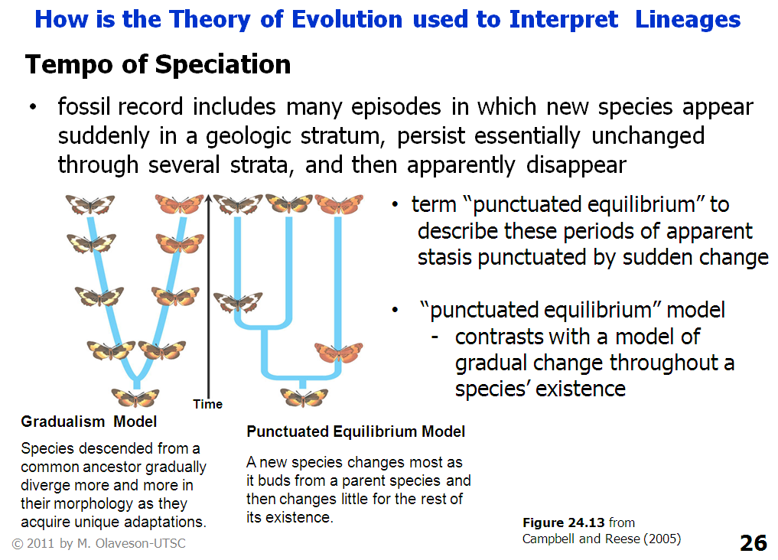

17.7 Macroevolutionary Trends in Morphology
- Macroevolution = cumulative change during thousands of small speciation episodes
- Cope’s Rule: organisms become larger over time
  - Some evolutionary lineages exhibit trends toward larger size and greater morphological complexity
  - Not true in all cases (i.e. insects)
- Evolution introduces novel and innovative features over long periods of time
- No underlying purpose or direction
- Novel morphological structures such as wings often appear suddenly in fossil record.
- How do they appear?
  - Preadaptation: occur when a trait that is adaptive in one context is also advantageous in another.
    - In such situation, trait may be enhanced by natural selection, modifying and enhancing the feature to enhance its new function
    - Lucky accidents, never evolve in anticipation of future evolutionary needs
    - Each step in evolutionary lineage was advantageous in particular environment
- Allometric Growth: changes in shape through differential growth
  - Occurs when different parts of the body grow at different rates
  - Can result in changes in the morphology of individuals over time
    - Occurs in humans
  - Example: skulls of chimpanzees and humans are similar in newborns but different in adults, as some regions of the chimp skull grow much more quickly than others
    - May simply reflect changes in one or a few genes that regulate the pattern of growth
- Heterochrony: Timing of Developmental Event and Larval Stages
  - Heterochrony: changes in the timing of developmental events
  - Can cause morphology of closely related species to differ
  - Two phenomena can be involved: neoteny and pedomorphosis
    - Neoteny: occurs when larvae acquire the ability to reproduce
    - Pedomorphosis: occurs when adults retain juvenile characters
  - Metamorphosis: change from a juvenile form to an adult form
    - Example: species of salamanders and frogs, the changes from aquatic (juvenile) to terrestrial (adult) forms
    - Can involve significant reorganization of internal organs
    - In amphibians, hormone thyroxine induces metamorphosis
    - Pedomorphosis could result from a mutation that either reduces thyroxine production or limits the responsiveness of some developmental processes to thryoxine concentration.

17.8 Evolutionary Developmental Biology
- “evo-devo” asks how evolutionary changes in genes regulating embryonic development can lead to changes in body shape and form
- Study of development helps advance the understanding of macroevolutionary trends because changes in genes that regulate development often promote evolution of morphological innovations
- Resulting changes in body plans have sometimes fostered adaptive radiations, increasing biodiversity over geologic time.
- In life cycle of multicellular organism, many diff body parts of the adult develop in a highly controlled sequence of steps specified by genetic instructions in the single cell of a fertilized egg
- Developmental biologists study how regulatory genes control the development of phenotypes and their variations
- In multicellular organisms - genes program development
  - control the rate, timing, and spatial pattern of changes in an organism’s form as it develops into an adult
Genetic tool-kits: Controlling growth and development
- Homeotic genes (the genes that are involved in embryologic development) are regulatory genes that code for transcription factors that bind regulatory sites on DNA, either activating or repressing the expression of other genes that contribute to an organisms’ form
  - Control transcription of development genes
  - Organisms have a set of several 100 homeotic genes that control their development
  - Control basic design of the body plan by controlling the activity of thousands of other genes
  - “genetic tool-kit”
  - Tool-kit genes do not differ much among the animals that have them and generally play the same role in development in all species
    - Hox-family control the overall body plan of animals
      - 180-nucleotide sequence (a homeobox) that codes for homeodomain, part of a protein that functions as a transcription factor
        - Transcription factor activates or represses a downstream gene involved in development
      - Specify where appendages such as wings in flies and legs in mice will develop on the animal’s body.
    - Pax-6 gene
      - Triggers formation of light-sensing organs as diverse as the eyespots in flatworms, compound eyes of insects and camera eyes of vertebrates
      - Also contains a homeobox indicating that the protein for which it codes either activates or represses gene transcription.
      - It triggers activity in genes that carry the specific instructions for making an eye typical of the spcies.
    - Hox and Pax-6 gene conserved for millions of years by evolution.

- Evolutionary Changes in Development Switches: Changes in Gene expression
  - Evo-devo researchers propose that morphological differences among species arise when mutations alter the effects of developmental regulatory genes.
    - Developmental programs involve complex networks of many interacting genes.
    - Continuously changing tool-kit genes may be expressed at diff times and in diff body regions.
    - Tool-kit genes encode proteins that either activate or repress a multitude of possible combinations
    - Thus, they can generate an unimaginably large number of diff gene expression patterns, each with the potential to alter morphology.
  - All cells in an animal contain exactly same set of genes, but the differential expression of genes in diff body regions and at diff times during embryonic development cause diff structures to be made.
    - Allmoetric growth can result from such evolutionary changes in developmental switches that cause certain body parts to grow larger or more quickly than others.
    - Heterochrony can be explained as an evolutionary change in the switches that either delays the development of adult characteristics or speeds up the development of reproductive maturity.
  - Mutations in developmental regulatory genes and their effects on morphology are subject to action of the same microevolutionary processes- natural selection, genetic drift and gene flow- that influences the frequencies of genotypes and phenotypes in a pop.
  - Thus every morphological change by a mutation in a homeotic gene or in a developmental gene is tested by success or failure of the individual that carries it.
- Changes in expression of homeotic genes can have dramatic effects on morphology
- Sean Carroll described the regulatory sites that transcription factors can bind as switches, like those that we use to turn lights on or off
- When a combination of transcription factors turns a regulatory switch on, they activate a gene farther downstream
- When they turn it off, their activity represses the gene
- Argues that changes in the genes that regulate development cause most morphological change, proponents of evo-devo recognize that mutations in developmental regulatory genes and their effects on morphology are subject to the action of the same microevolutionary processes – natural selection, genetic drift, and gene flow – that influence the frequencies of genotypes and phenotypes in populations
- Thus, every morphological change induced by a mutation in a homeotic gene or in a developmental switch is tested by the success or failure of the individual that carries it

