Chapter 18: Classification, Evolution, and Phylogeny

Clades
Systematics
Molecular comparisons
Morphology structures
Embryological patterns
Fossil record
Shared derived characters
Shared ancestral characters
Cladistics
Homologies
Phylogenetic trees
Evolutionary history = phylogeny
Hierarchical taxons (e.g. genus, family, order, etc.)
Identify and name species
Classification of biological diversity = taxonomy
- Classifications of organisms are usually based on evolutionary relationships using as board a set of evidence as possible
- Morphological, developmental, behavioural, genetic, and molecular data

18.1 The Significance of Similarities and Differences
- Determining evolutionary relationships between organisms and deciding if similar structures or similar-looking structures are grounds for grouping species together
- Convergent (or parallel) evolution: tendency among organisms living under the same conditions to develop similar body forms
  - Parallel or convergent depending on evolutionary relatedness of organisms involved
  - Convergent evolution refers to more distantly related organisms
  - Parallel evolution refers to more closely related ones
- Similarity(resemblance) in appearance does not always mean relatedness
- biologists classify (and name) organisms based on features
  - Morphological traits, chromosomal anatomy, gene sequences, physiological functioning, morphology of sub-cellular structures and behaviour patterns
Case 1:  -What was thought to be a flower was actually a leaf modified by a fungus  -Changed the appearance and odour | Case 2:  -Plants using flypaper, snap traps, and pitchers to capture insects | Case 3:  -Mammals with flat tails are not always beavers  -Example: platypus

18.2 Systematic Biology: An Overview
- Systematics: analytical approach for studying the diversity of life and evolutionary relationships
  - identify, describe, classify and name organisms based on evolutionary relationships
- Two goals of systematic: reconstruct phylogeny and taxonomy
- Phylogeny: evolutionary history of a group of organisms
  - Phylogenetic tree
    - Formal hypotheses identifying likely relationships among species
    - Allows us to distinguish similarities inherited from a common ancestor from those that evolved independently in response to similar environments
- Taxonomy: identification and naming of species and their placement in a classification
  - Ordered division of organisms into categories based on a set of characteristics used to assess similarities and differences
  - Uses binomial nomenclature
    - Two-part format of the scientific name of an organism
    - Developed by Carolus Linnaeus (mid-1700’s)
    - Binomial name of an organism or “scientific epithet”
      - is the genus and species
      - is Latinized
      - is italicized or underlined
  - Classification: arrangement of organisms into hierarchical groups that reflect their relatedness
  - Most Systematists want classifications to mirror Phylogenetic history and adaptive radiation (evolutionary history) of group of organisms
- Gynogenetic: the process whereby a sperm fertilizes an ovum, but does not contribute genetic material to the resultant zygote.
- Androgynous: Partly male and partly female in appearance; of indeterminate sex.
  - Having the physical characteristics of both sexes; hermaphrodite.

18.3 The Linnaean System of Classification
- Established by Carolus Linnaeus
- Taxonomic hierarchy: arranging organisms into ever more inclusive categories.
  - Species, genus, family, order, class, phylum, kingdom, domain
    - King Philip came over for great spaghetti.
  - Life on earth is classified into 3 domains.
  - Taxon: organisms included within any category of taxonomic hierarchy
- Next step is to determine which species are most closely related to one another.
  - Want to know which characteristics some species have in common and can be used to place the species in the same genus and family

18.4 From Classification to Phylogeny
- For at least 200 years (before Darwin), biologists relied on organismal traits (mainly morphology) when analyzing and classifying organisms - taxonomy
- After Linnaeus, they developed phylogenies based on chromosomal anatomy, details of physiological functioning, morphology of subcellular structures, cells, organ systems and whole organisms, and patterns of behavior
- Today systematists also use molecular sequences of nucleic acids and proteins as additional characters when deriving phylogenies

18.5 Evaluating Systematic Characters
- Systematics - provides essential information for all of the biological sciences
  - provides data for testing for homologous vs. analogous relationships
- Systematists study traits in which phenotypic variation reflects genetic differences.
  - Exclude diff caused by environmental conditions
- Systematists create phylogenetic hypotheses and classifications by analyzing the genetic caused speciation and differentiation
- Systematic characters:
  - Must be genetically independent, reflecting diff parts of organisms’ genomes
    - Necessary because diff organismal characters can have the same genetic basis.
    - Want to use each genetic variation only once in an analysis
    - Example: two foots, toes (pads on lizards). Both right and left toe coded by same genes, therefore choose only one as systematic character
- Homologous characters: sharing the same embryological history and they are useful in preparing phylogenies
  - Such phenotypic similarities between organisms reflect underlying genetic similarities
  - Emerge from comparable embryonic structures and grow in similar ways during development
    - Systematists have put great stock in embryological indications of homology on the assumption that evolution has conserved the pattern of embryonic development in related organisms.
  - Systematic analyses rely on the comparison of homologous characters as indicators of common ancestry and genetic relatedness
  - Homologous structures where their function has changed can differ considerably among species
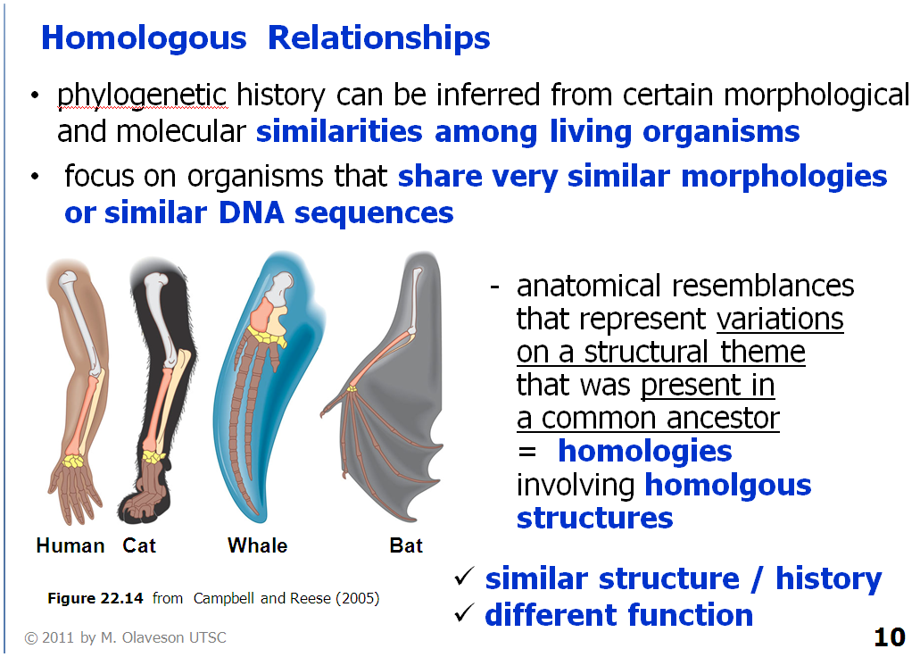
- Analogous characters: homoplasious (homoplasies): phenotypic similarities that evolved independently in different lineages
- i.e. the flattened tails of aquatic mammals
  - Similar function in different species
  - Systematists exclude homoplasies from their analyses because homoplasies provide no information about shared ancestry
- Mosaic evolution
  - Refers to reality that in all evolutionary lineages, some characteristics evolve slowly, whereas others evolve rapidly.
  - It is pervasive: (esp. of an unwelcome influence or physical effect) Spreading widely throughout an area or a group of people.
  - Every species displays a mixture of ancestral characters (old forms of traits) and derived characters (new forms of traits).
  - A "derived character" is a trait that arose in the most recent common ancestor of a particular lineage and was passed along to its descendants.
    - Among a given group of organisms, the shared derived characters are generally the less common characters.
    - The evolutionary interpretation is that these characters of organisms are more recently evolved. They are contrasted with primitive characters. Shared derived characters should have the same structure and function.
  - Derived characters provide the most useful information about evolutionary relationships because once a derived character becomes established; it is usually present in all of that species’ descendants.
    - Unless they are lost or replaced by newer characters over evolutionary time, derived characters can serve as markers for entire evolutionary lineages.
- Systematists score characters as either ancestral or derived only when comparing them among organisms
  - Any particular character is derived only in relation to what occurs in other organisms
    - Older version of same character or an entirely new trait, absence of it altogether
  - Example: most species of animals lack a vertebral column (backbone)
    - Systematists compare vertebrates with all animals lacking vertebral column
    - Absence of vertebral column = ancestral condition
    - Presence of vertebral column= derived
      - Fossils of earliest animals lack backbones.
  - Systematists distinguish between ancestral and derived characters to ascertain in which direction a character has evolved.
- Outgroup comparison: comparing the group under study with more distantly related species not otherwise included in the analysis
  - Used to identify ancestral and derived characters
  - Example: butterflies mostly have 6 walking legs, two families have 4 walking and 2 nonwalking legs
    - Outgroup comparison with other insects (most which have 6 walking legs as adults) show that 6 legs is the ancestral character and 4 walking legs and 2 non walking legs is a derived character.

18.6 Phylogenetic Inferences and Classification
- Phylogenetic trees portray the evolutionary diversification of lineages as a hierarchy that reflects the branching pattern of evolution
  - Each branch represent the descendants of a single ancestral species
- When converting Phylogenetic tree into a classification, Systematists use the principle of monophyly
- Monophyletic taxa: those derived from a single ancestral species
- Polyphyletic taxa: includes species from separate evolutionary lineages
- Paraphyletic taxon: includes an ancestor and some but not all of its descendants
  - E.g. class reptiles
- Most Systematists strive to create parsimonious Phylogenetic hypothesis.
  - Include fewest possible evolutionary changes to account for diversity within a lineage
- Assumption of parsimony: simplest explanation should be the most accurate.
  - Any particular evolutionary change is an unlikely event and presumably happened only once in any evolutionary lineage
  - Unlikely that same change evolved twice in one lineage
- Traditional evolutionary systematic: groups together species that share ancestral and derived characters
- Mammals are defined by their internal skeleton, vertebral column, and four limb
Cladistics: Classifications based on shared derived characters
- Cladistics produces Phylogenetic hypotheses and classifications that reflect only the branching pattern of evolution
  - Ignores morphological divergence
- Group together species that share derived characters.
  - Mammals form a monophyletic lineage, a clade since they have unique set of derived characters – hair, mammary glands, reduction of bones in lower jay and 4 chambered heart.
  - Ancestral characters such as internal skeleton and a vertebral column do not distinguish them from other tetrapod vertebrates (so these traits excluded from analysis)
- Cladograms: Phylogenetic trees produced by cladists.
  - Illustrate the hypothesized sequence of evolutionary branching, with a hypothetical ancestor at each branching point.
  - Strictly monophyletic groups and are constructed using principle of parsimony.
- PhyloCode: strictly cladistic system that identifies and names clades instead of placing organisms into familiar taxonomic groups
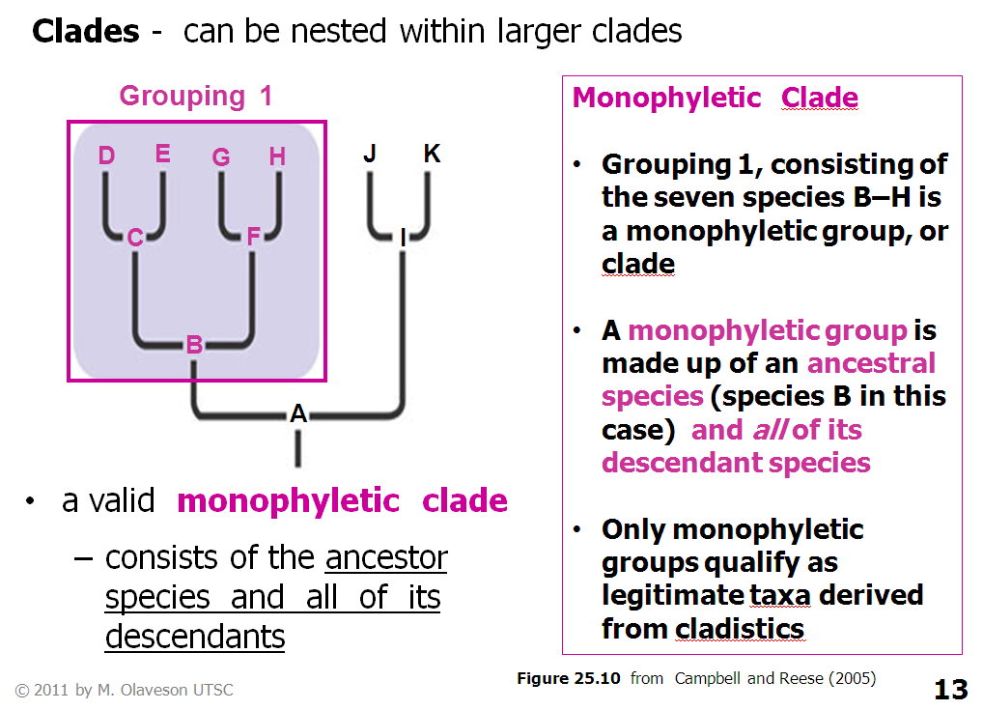
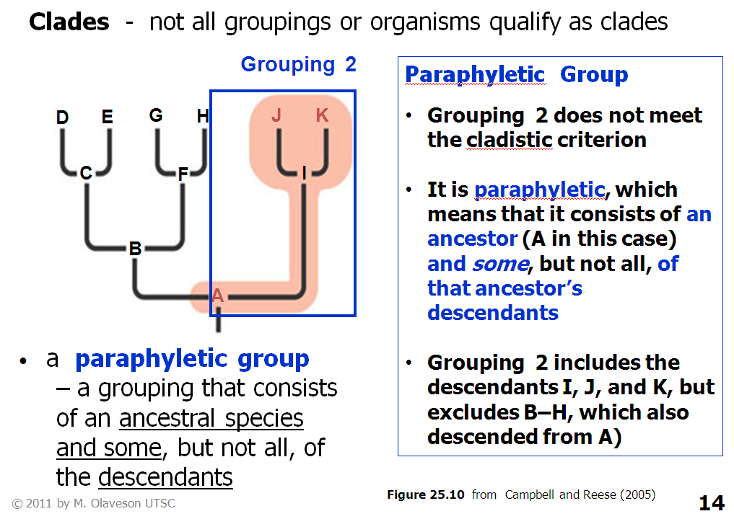
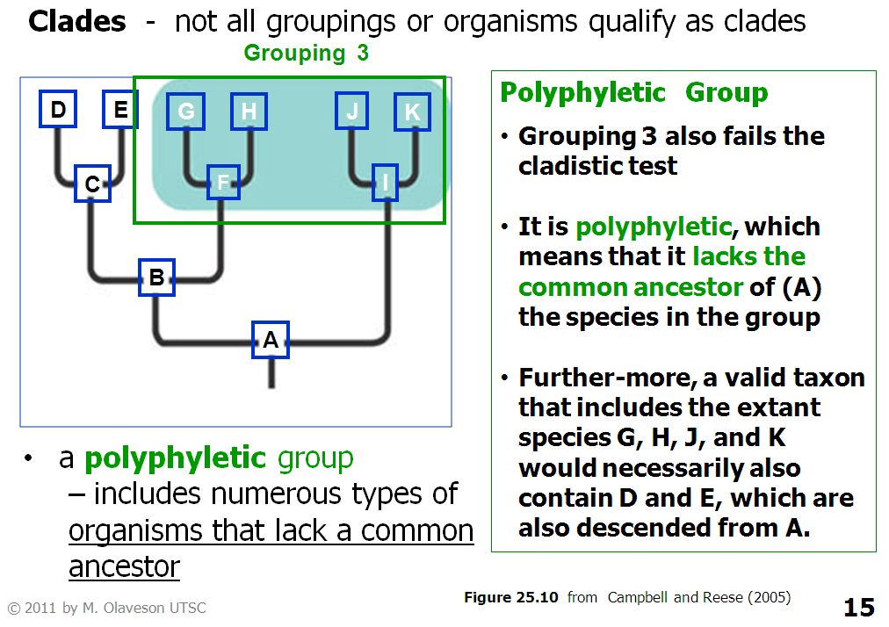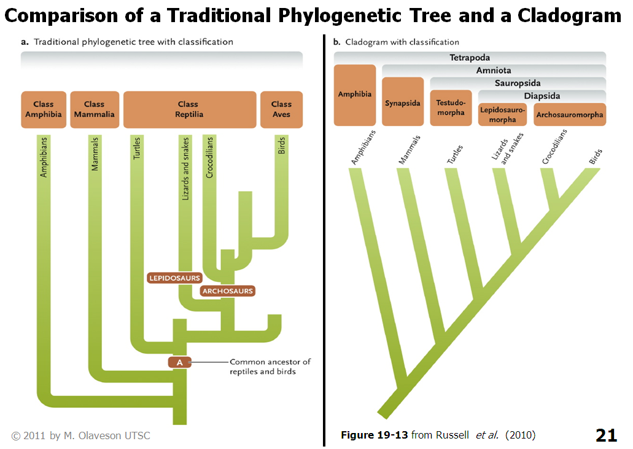
THIS IS IMPORTANT!!! READ
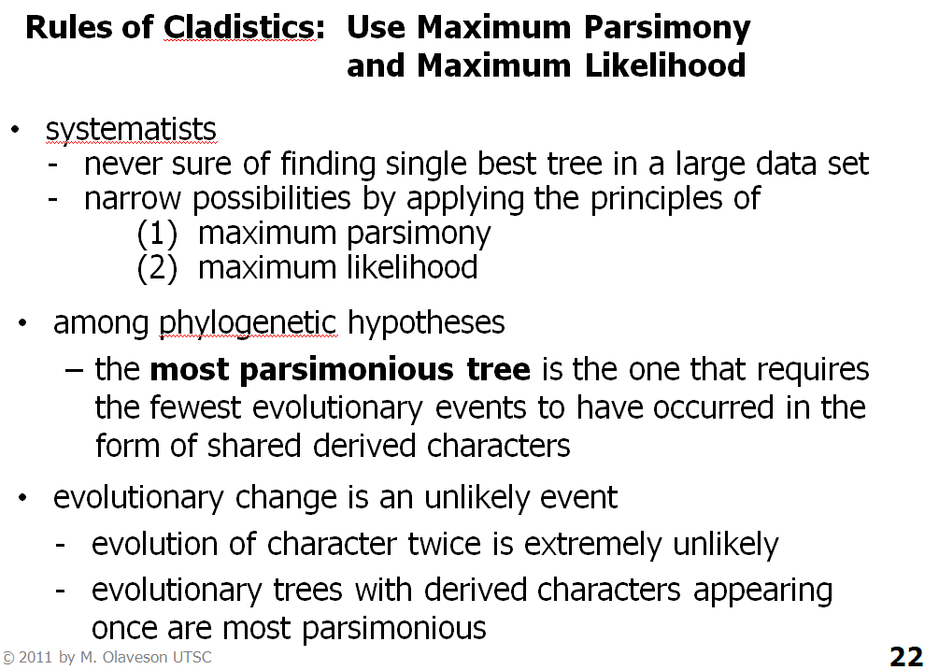

18.7 Molecular Data
- Use molecular characters as part of the data when conducting Phylogenetic analyses
- Molecular data include nucleotide base sequence of DNA and RNA or amino acid sequence of proteins for which they code
- Since DNA is inherited, shared changes in molecular sequences (insertions, deletions or substitutions) provide clues to evolutionary relationships of organisms
- Molecular sequences have some practical advantages over organismal characters
  - Provide abundant data
    - Every amino acid can serve as a separate independent character for analysis
    - Since many genes are conserved by evolution, molecular sequences can be compared btw distantly related organisms that share no organismal characteristics.
  - Many proteins and nucleic acids are not directly affected by developmental or environmental factors that cause non-genetic morphological variations.
- Problems:
  - Only 4 nucleotide bases at each position in a DNA or RNA sequence and only 20 amino acids at each position in a protein
    - If two species have the same nucleotide base substitution at a given position in a DNA segment, their similarity may have evolved independently.
    - Find it difficult to verify that molecular similarities were inherited from a common ancestor.
- Molecular Clocks: Using shared mutations to estimate times of divergences
  - Molecular phylogenetics is based on the observation that many molecules have been conserved by evolution.
  - But diff adaptive changes and neutral mutations accumulate in separate lineages from the moment they first diverge.
    - Mutations in some type of DNA appear to arise at a relatively constant rate.
  - Differences in the DNA sequences of two species can serve as a molecular clock
    - Indexing their time of divergence.
    - Large diff = divergence in distant past.
    - Small diff = more recent
  - Mosaic evolution occurs at the molecular level, so diff molecules exhibit individual rates of change, each molecule is an independent clock ticking at its own rate
    - Study diff molecules to track evolutionary divergences over diff time scales
    - mtDNA evolves quickly and useful for dating evolutionary divergences in last few million years
    - Chloroplast DNA (cpDNA) and genes that encode ribosomal RNA evolve slowly and provide info about divergences hundreds of millions of years old.
  - To synchronize molecular clocks, some researchers study DNA sequences that are not parts of protein-encoding genes.
    - Because they don’t affect protein structure, mutations in these sequences are not often eliminated by natural selection
    - Thus, sequence differences between species in non-coding areas probably result from mutation alone and therefore reflect the ticking of the molecular clock more directly
    - Some researchers also calibrate molecular clocks to the fossil record so that actual times of divergence can be estimated from molecular data with a fair degree of certainty
- Extracting Molecular Data: Using Segments of Nucleic Acid for Analysis
  - Species that diverged recently from a common ancestor should share many similarities in their molecular sequences than distantly related species.
  - Determine sequence of bases (If DNA or RNA) or amino acids (if protein)
  - When two species exhibit similar amino acid sequences for the same protein, Systematists infer their genetic similarity and evolutionary relationship
  - Use of cytochrome c to construct a phylogenetic tree
  - Most are now based on DNA sequencing data
    - Detailed view of the genetic material that is changed by evolutionary process
    - PCR makes it easy by amplifying DNA for comparison
- Aligning Molecular Sequences: Correcting for effects of insertions and deletions
  - Before comparing molecular sequences, must make sure that the homologous sequences are properly aligned.
  - Insertions or deletions can change relative location of specific DNA sequence
  - By determining where insertions or deletions of base pairs have occurred, Systematists match up (align) the positions of nucleotides for comparison.
  - Once aligned, systematists can compare the nucleotide base or amino acid sequences and determine whether mutations or other processes have produced evolutionary changes in the sequences.
    - Similarities and diff can be used to reconstruct a Phylogenetic tree.
    - Each tree is a hypothesis about evolutionary relationships
  - For DNA sequences, simplest approach is to count the number of similarities and diff btw each pair of organisms being compared
    - Use to estimate genetic distances btw species and construct the tree by grouping together organisms exhibiting smallest genetic distances
    - However, this approach can produce phylogenies based on both ancestral and derived characters.
  - Using cladistics and the principle of parsimony, molecular sequence data can be converted into a phylogenetic tree.
    - Requires identification of ancestral and derived character states
    - For each position in the sequence, determine which nucleotide bases are ancestral and which are derived.
    - As for organismal characters where analysis of homologous sequences in a designated outgroup can provide info that allows researchers to distinguish btw ancestral and derived conditions.
    - In the parsimony approach, a computer program is used to test all possible Phylogenetic trees and identify the one that accounts for the diversity of organisms in the group using fewest evolutionary changes in molecular sequences
    - Identical changes in nucleotides can arise independently.
      - Systematists use series of statistical techniques known as maximum likelihood methods.
      - Reconstructs Phylogenetic history from molecular sequence data by making assumptions about variations in the rate at which diff segments of DNA evolve.
        - Take into account variations in the rates of evolution between genes or between species as well as changes in evolutionary rates over time.
      - Maximum likelihood programs construct numerous alternative Phylogenetic trees and estimate how likely is that each tree represents the true evolutionary history.
        - Accept the one most likely to be true until more data is available

18.8 Clarifications from Molecular Phylogenetics
- Analyses of morphological data sometimes produced conflicting hypotheses about the origin and relationships of flowering plants.
- Molecular phylogenetics has been used to resolve these conflicts.
- Molecular phylogenetics has revolutionized our view of the entire tree of life
  - First efforts based on morphological analyses did not resolve branches of tree containing prokaryotes as they lack significant structural variability to allow the researchers to resolve their relationships to eukaryotes
- Phylogenetic tree based on rRNA sequences divides living organisms into three primary lineages called domains: Bacteria, Archaea and Eukarya
  - Bacteria and archaea include prokaryotic organisms
  - Eukarya include eukaryotes
    - Includes animals, plants, fungi protista

18.9 Phylogeny: Contributions from Bayesian, Bootstrap, and Parsimony Analysis
- Bayesian analysis uses an observed distribution of values to estimate the underlying distribution, which is assumed to be uniform
- Bootstrap analysis is used to obtain an estimate of error, a measure of the reliability of a set of data
- Randomly sampling the original data set provides pseudoreplicate sets
- Bayesian and bootstrap analysis are used to evaluate the reliability of phylogenetic trees
- Decisions about which phylogeny is most likely are informed by using parsimony, the simplest of explanations for a phenomenon
- Higher scores for a phylogeny reflect the numbers of changes inherent in its production
- Most parsimonious trees involve the fewest changes
- Neighbor-joining and UPGMA are two other statistical tools used in phylogenetic analysis
- Neighbor-joining involves successive clustering of lineages where branch lengths are set as lineages join
- In UPGMA, the tree is constructed by successive clustering as determined by average-linkage clustering

18.10 The Evolution of Humans
- Genetic analyses of living hominoids species indicate that African hominoids diverged into several lineages between 5 and 10 million years ago
- One lineage, the hominids, includes modern humans and our bipedal ancestors
- Upright posture and bipedal locomotion are adaptations that distinguish hominids from apes
- Bipedalism aided in developing other abilities tool-making
- Evolutionary refinements in grasping ability allow hominids to hold objects tightly with a power grip or manipulate them precisely with a precision grip
- Female hominids suffer at least one consequence of being bipedal, namely the shift in the body’s centre of mass during pregnancy
- Have derived curvature of the lumbar area and reinforcement of those vertebrae to compensate for additional load associated with pregnancy
- Adaptations in humans increase in number of lumbar vertebrae and the length of individual vertebra
- Marked posterior concavity of individual lumbar vertebrae (lordosis), which stabilizes the centre of mass of the upper body over the hips
- Evidence from Australopithecus fossils suggests that these adaptations to bipedalism preceded the evolution of species in the genus Homo
- Birth canals of Neanderthals suggest that this species also gave birth to relatively large young
- Bipedalism may have raised from arboreal setting
The Fossil Record Provides Evidence for Human Evolution
- O. tugenensis (“first man”), a species that lived about 6 million years ago in E. African forests
- Hominid fossils from 1.2 M to 4.2 Mya are known from many sites in East, Central, and South Africa
- Assigned to genera Australopithecus and Paranthropus
- Large faces, protruding jaws, and small skulls and brains, most are ape-like
- 1.95 Mya, hominids that lived in northern Kenya ate a variety of animals and plants
- Aquatic resources can be important because nutrients essential for growth of the brain are more abundant in fish and shellfish than in meat
Species | Description
Ardipithecus ramidus | - Lived about 4-6 Mya  - Bipedal reflected by the structure of its pelvis and feet  - Small canine teeth  - Reduced competition between males females in oestrus, concealed ovulation  - Bipedalism promotes exploiting land surfaces and trees for food and be more effective provisioners
Australopithecus afarensis | - Found in northern Ethiopia  - Lucy is bipedal, 40% of skeleton discovered  - Lived 3 to 3.5 Mya  - Moderately large and pointed canine teeth and a relatively small brain  - Males and females were 150 cm and 120 cm tall, respectively  - Bipedal species found footprints in a layer of volcanic ash  - “Big man” provided evidence of a pelvic girdle and sacrum, scapula
Other species of Australopithecus and Paranthropus | - Lived in E. Africa or S. Africa between 1 and 3.7 Mya  - Adult males ranged fro 40kg to 50kg and 130cm to 150cm  - Females were smaller  - Most had deep jaws and large molars  - Several had a crest of bone along the midline of the skull  - Ate hard food  - A. africanus found only in S. Africa had small jaws and teeth
Australopithecus sediba | - Fossil found in S. Africa  - Ankles and feet suggest a mix of climbing ability and bipedalism  - Shares features with Lucy and other australopithecines sacral and public areas  - Also similar to Homo species in the shape of its ilium  - Giving birth with large brains had not appeared  - Capacity for strong fexion climbing trees  - Long thumb and short fingers precision gripping  - Features of the brain suggest gradual reorganization of the brain that eventually appear in species of Homo
Homo habilis | - Handy man  - 1.7 to 2.3 Mya  - Occupied the woodlands and savannas of E. and S. Africa, sharing these habitats with Paranthropus  - Brains of H. habilis were at least 20% larger, larger incisors and smaller molars compared to hominids  - Ate hard-shelled nuts and soft fruits  - May also have hunted small prey or scavenged carcasses left by larger predators  - Oldest tools manufactured by H. habilis
Homo erectus | - 1.8 Mya  - “Upright man”  - E. Africa  - Larger brain, taller, thicker skull, and protruding brow ridges  - Made fairly sophisticated tools, including the handaxe, used to cut food and other materials, scrape meat from bones, and to dig for roots  - Probably ate both animals and plants  - May have hunted and scavenged animal prey  - Use of fire to process food and keep warm  - H. erectus and H. habilis lived together in the same habitats  - Adult males were much larger than adult females suggests polygynous lifestyle  - 1.5 Mya, groups left Africa and dispersed northward into northwestern Africa, Eurasia, some into Asia and as far as Java  - Occupied western Europe  - Produced several descendants, including H. sapiens (only survivor)  - Archaic humans first appeared 400kya  - Larger brains, rounder skulls, and smaller molars than H. erectus
Homo Neatherthalensis | - Lived in Europe and Western Asia from 28k to 150kya  - Best-known archaic humans  - Heavier build, pronounced brow ridges, and slightly larger brains  - Culturally and technologically sophisticated  - Made complex tools  - Built shelters  - Used fire  - Successful hunters  - Some groups buried their dead and may had rudimentary speech  - Some were cannibals  - Neanderthals and modern humans are different species that diverged from a common ancestor 550k to 690kya  - Species demised 28k to 40kys
Homo sapiens | - More prominent chin  - Earliest fossil found in Africa and Asia are 150k  - Those from middle east are 100k  - Fossils from Western Europe are 20k

Early Human Descendants Came From Africa
- 100k to 200k they arose in Africa
- Migrated to Europe and Asia
- Gene flow between them prevented reproductive isolation and maintained them as a single but variable species
- Fossilized child from 24kya had a mix of Neanderthal and modern human traits interbreed?
- Recent finds in the middle east indicate that Neanderthals and modern humans coexisted without interbreeding for 50k years
- African mtDNA varies the most
- Rest contain at least one African mtDNA

