Chapter 19 Species
What is a species?
Hybrid breakdown
Hybrid sterility
Hybrid inviability
Temporal
Ecological
Mechanical
Gametic
Behavioural
Postzygotic
Prezygotic
Reproductive isolating mechanisms
Phylogenetic Species Concept
Biological Species Concept
Ecological Species Concept
Morphological Species Concept

19.1 What’s in a Name?
- Communication affects both inter and intraspecific behavior
  - Like monkeys signaling for the different threats
- Names to distinguish between categories of objects
  - Each species has a scientific name
    - Latinized descriptions of the organism bearing the name

19.2 Definition of “Species”
- Biologists use names to precisely identify species, subspecies, or varieties
- Traditionally, morphological features were most important to identify species, but now behavioural and genetic features are more commonly used
- Molecular markers are also becoming important to identify and separate species
- Species = a Latin word meaning “kind” or “appearance”
- Species are the fundamental taxonomic units of biological classification.
- Biological species concept defines species as group of organisms that can successfully interbreed and produce fertile offspring but are unable to produce viable fertile offspring with members of other populations
  - Problems
    - Works with sexually reproducing species, does not work with those that reproduce asexually
    - Species that hybridize and produce fertile offspring
    - Hybridization: two species interbreed and produce fertile offspring
      - Many hybridize naturally in the wild
      - 10% of 8000 species of birds hybridize naturally and produce fertile offspring.
- Androdioecous organisms exist as natural populations of functional males and hermaphrodites but include no true females
- Gynogenetic species have only females
- Eggs require mechanical stimulation by sperm to initiate development
- Phylogenetic Species concept defines species as a group of organisms bound by a unique ancestry
- Ecological Species concept defines species as a group of organisms that share a distinct ecological niche
- No one definition of “species” in biology is uniformly used or subscribed to by all biologists!!

18.3 One Size Does Not Fit All
- Genetic cohesiveness of species
- Populations of same species are said to experience gene flow that mixes their genetic material and could be “glue” holding a species together
- Genetic distinctiveness of each species
- Populations of different species are reproductively isolated, they cannot exchange genetic information
- Process of speciation is frequently defined as the evolution of reproductive isolation between population
- Biologists often use similarities or differences in morphological traits as convenient markers of genetic similarity reproductive isolation
- Morphological Species Concept defines a species as all individuals that share measurable traits distinguishing them from individuals of other species
  - Characterizes a species in terms of its body shape, size, and other structural features

19.4 Gene Flow: Four examples
- Gene flow occurs within populations of single species
  - Species that reproduce sexually and whose geographic distributions are relatively continuous
- Four examples illustrate how ecology, habitat availability, and behaviour can affect distribution
- Distribution of species
- Widely spread out or clustered
- Ability to measure gene flow and relatedness among populations
- Genetic evidence combined with knowledge about bird migration made it easier to understand the distribution and diversity of the snails
- Behaviour
- Social structures in mouse populations limited genetic exchange
- i.e. a single barn lived groups of mice that did not interbreed social behaviour prevented gene flow
- Using female house mice to mate with males genetic markers moved rapidly through wild and captive populations
- Genetic markers provided a more representative view of mouse population genetics than variation in allozymes
- Habitat change
- i.e. changes in forest availability along the border between England and Scotland affected the distribution and genetic relatedness along populations of Eurasian red squirrels
- Reflected genetic changes
- Landscape and habitat can alter genetic patterns may cause problems to conserving biodiversity

18.5 Geographic Variation
- Subspecies: geographically separated populations of a species exhibit dramatic, easily recognized phenotypic variation
  - Local variants of a species
  - Individuals from diff subspecies usually interbreed where their geographic distributions meet
    - Offspring often exhibit intermediate phenotypes
  - “race”(zoologists) for subspecies or “variants”(botanists) or “cultivars” for domesticated stock.
- Ring species: geographic distribution that surrounds uninhabitable terrain
  - Adjacent populations can exchange genetic material directly
  - Gene flow between distant populations occurs only though intermediary populations
  - i.e. Ensatina eschscholtzi – lungless salamander from California
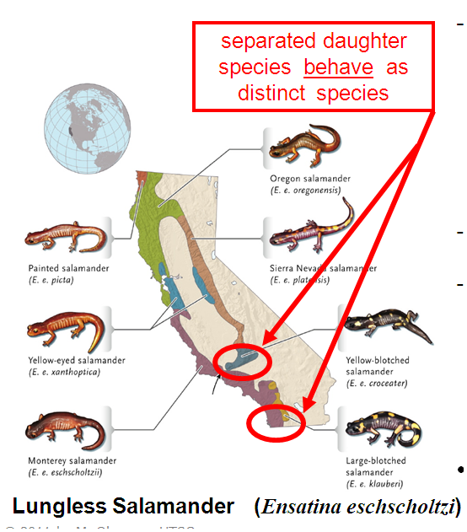
- Cline species: species distributed over a large environmentally diverse area exhibit pattern of smooth variation along the geographic gradient
  - Clinical variation results from gene flow btw adjacent pops that are each adapting to slightly diff conditions
- Most species are morphologically or behaviourally distinct from other species
  - Local and geographic variation can mask interspecific differences

19.6 Reproductive Isolation
- Reproductive isolating mechanism: biological characteristic that prevents the gene pools of two species from mixing even when they are sympatric (occupying the same spaces at the same time)
- Reproductive isolation can be achieved in two ways
  - Prezygotic isolating mechanisms
    - Exert their effects before the production of a zygote or fertilized egg
  - Postzygotic isolating mechanisms
    - Operate after zygote formation.
  - These are not mutually exclusive and two or more may operate simultaneously
Prezygotic Isolating mechanisms
There are 5 mechanisms that can prevent interspecific matings or fertilizations and the production of hybrid offspring.
- Ecological isolation
- Live in different habitats but same geographic region
- Temporal isolation
- Species in the same habitat but mate at different times of the day or diff times of the year
- Behavioural isolation
- Signals used by one species are not recognized by another
- Many animals rely on specific signals which often differ dramatically between species to identify the species of a potential mate – courtship displays
- Females that choose appropriate mates are likely to produce more surviving offspring than those that choose other species and hybridize
- Natural selection plays a role?
- Mate choice by females and sexual selection generally drive the evolution of mate recognition signals.
- Overtime, # of males with recognizable traits and # of females able to recognize the traits increase in the population
- Mechanical isolation
- Different in structure of copulatory (sexual) organs prevent successful mating between individuals of diff species
- Example: pollination of flowers in the same area by different birds
- Gametic isolation
- Incompatibility between the sperm of one species and the eggs of another prevent fertilization
- E.g. marine species – invertebrates
- Release gametes into environment for external fertilization.
- Sperm and egg of each species recognize another’s complementary surface proteins
- Different surface proteins on gametes of different species do not match
Postzygotic Isolating Mechanisms
- Despite prezygotic isolation, sperm from one species sometimes fertilizes egg of another
- The two species are reproductively isolated if their offspring called interspecific (btw species) hybrids have lower fitness than those produced by intraspecific (within species) matings
- Hybrid inviability
- Occur because many genes govern the complex processes that transform a zygote into a mature organism
- Hybrids have two sets of developmental instructions, which may not interact properly for the successful completion of embryonic development.
- So, it die as an embryo or at an early age
- i.e. offspring of a sheep and goat
- Hybrid Sterility
- Although some hybrids between closely related species develop into healthy and vigorous adults, they produce non-functional gametes
- Results when parent species diff in the number or structure of their chromosomes which cannot pair properly during meiosis
- Zero fitness no descendants
- Example mule: mating between female horse (2n = 64) and male donkey (2n = 62).
- Example zebroids: zebras and horses
- Hybrid breakdown
- Some F1 hybrids are healthy, vigorous and fully fertile and can breed with other hybrids and with both parental species
- Sometimes F2 gen, produced by mating btw F1 or btw F1 and parental species, they may exhibit reduced survival or fertility
- Reproductive isolation is maintained btw species because there is little long-term mixing of their gene pools

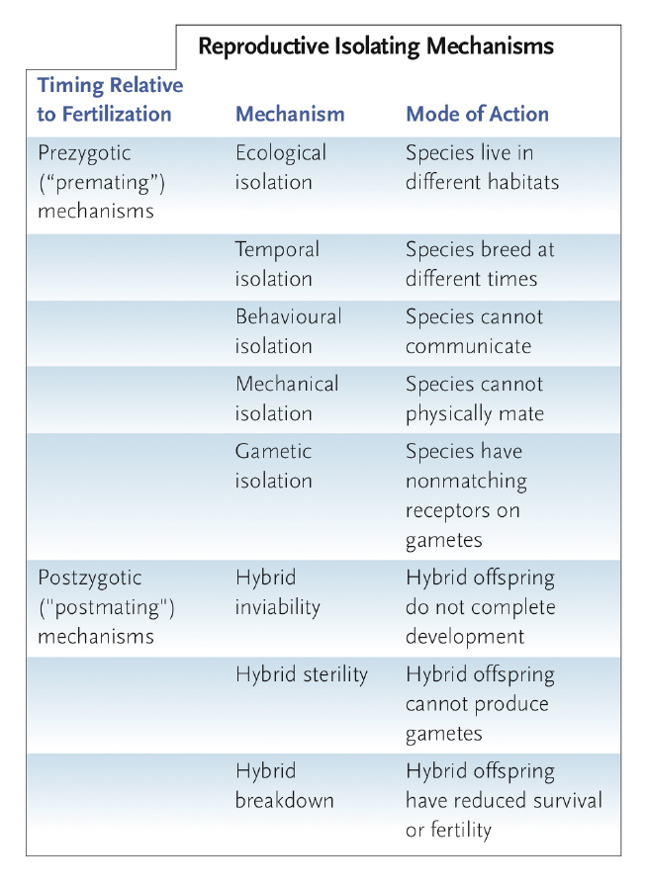

19.7 Geography of Speciation
- Geography has a huge impact on whether gene pools have the opportunity to mix
- Three modes of speciation based on geographic relationship of populations as they become reproductively isolated: allopatric speciation, parapatric speciation, and sympatric speciation
- Allopatric speciation
  - Occur when a physical barrier subdivide a large pop or when a small pop becomes separated from a species’ main geographic distribution
    - Hurricanes may create new channels that divide low coastal island and the populations inhabiting them
    - Uplifting mountains or landmasses, advancing glaciers can also produce barriers that subdivide populations
    - Small populations become isolated at the edge of a species’ geographic distribution
      - Peripheral populations diff genetically from central populations since they are adapted to somewhat different environments
  - Once geographic separation has occurred, one or both populations may undergo evolutionary change during the period of separation
  - Most common mode of speciation in large animals
  - 2 stages
    - 2 populations become geographically separated no gene flow between them
    - Then as the pop experience distinct mutations and diff patterns of natural selection and genetic drift, they accumulate genetic differences that isolate them reproductively
  - Once a small pop is isolated, genetic drift and natural selection as well as limited gene flow from parent pop foster further genetic differentiation
  - Accumulated genetic diff may lead to reproductive isolation
  - Populations on oceanic islands show extreme examples of this phenomenon
  - Founder effect make the populations genetically distinct
- i.e. Galapagos and Hawaiian islands
  - Species cluster: evolution of a bunch of species on the same geographic area
  - Allopatric pops may reestablish contact when a geographic barrier is eliminated or breached.
    - Secondary contact provides test of whether or not the pop have diverged into separate species
    - If their gene pools did not differentiate much during geographic separation, the populations will interbreed and merge
    - If the populations have differentiated enough to be reproductively isolated, they have become separate species
    - Morphological and gametic isolation could involve chemical or genetic factors as well as the timing of reproduction
    - During early stages of secondary contact, prezygotic reproductive isolation may be incomplete.
      - Some may mate with other pop, produce viable and fertile offspring in areas called hybrid zones
        - Generally narrow and ecological or geographic factors maintain the separation of the gene pools for majority of individuals in both species
      - If hybrids have lower fitness, natural selection will favour interbreeding pops. - Reinforcement
        - Reinforcement: enhances reproductive isolation that had begun to develop while the pops were geographically separated.
        - Thus natural selection may promote the evolution of prezygotic isolating mechanisms
- Parapatric Speciation
  - Isolation occurs in a situation where a single species is distributed across a discontinuity in environmental conditions- span a barrier
    - E.g. change in soil type
  - May develop due to temporal separation in reproductive processes
  - Although organisms from both sides of discontinuity can interbreed freely, natural selection may favour diff alleles on either side, limiting gene flow
  - Hybrid offspring have low relative fitness
- Sympatric Speciation
- Reproductive isolation evolves between distinct subgroups that arise within one population
- Do not require:
- Pop be either geographically or environmentally separated as their gene pools diverge
- Changes in diet, behavior or chromosomes could affect reproductive isolation
- Example: insects that feed on just one or two plant species are among the animals most likely to evolve by sympatric speciation.
- Generally carry out most important life cycle activities on or near their host plants
- Mate on the host plants, larvae feed on host plants and grow into adults and cycle continues
- Host plant choice is genetically determined or individuals associate with the host plant species they ate as larvae
- A genetic mutation could change some insects’ choice of host plant
- Mutant individuals would shift their life cycle activities to new host species and then interact primarily with others preferring the same new host
- Ecological isolation
- Host race: these individuals would collectively form a separate subpopulation
- Reproductive isolation could evolve between diff host races if individuals of each host race are more likely to mate with members of their own host race than with members of another

19.8 Genetic Mechanisms of Speciation
- Genetic mechanisms that can lead to reproductive isolation: genetic divergence between allopatric populations; polyploidy in sympatric populations; and chromosome alterations, which occur independently of the geographic distributions of populations

- Genetic divergence
- Absence of gene flow, geographically separated pops accumulate genetic differences
- Postzygotic isolating mechanisms probably develop as accidental byproducts of mutation, genetic drift and natural selection
  - Natural selection cannot directly promote evolution of reproductive isolating mechanisms between allopatric pops because individuals in allopatric pops do not encounter one another and therefore have no opportunity to produce hybrids
  - In absence of hybrids, natural selection cannot select against the matings that would have produced them
  - Natural selection may foster adaptive changes that create postzygotic reproductive isolation between pops after they reestablish contact
  - If postzygotic isolating mechanisms reduce fitness of hybrids, natural selection can reinforce the evolution of prezygotic isolating mechanisms
- For postzygotic reproductive isolation, mutations in a few gene loci may establish reproductive isolation.
- For prezygotic reproductive isolation, some mechanisms have a surprisingly simple genetic basis
  - Single mutation reverses the direction of coiling in the shells of some species of snails
  - Opposite direction or coiling = snails cannot approach each other to mate reproduction impossible
- Many traits that now function as prezygotic isolating mechanisms may have evolved in response to sexual selection
  - This process exaggerates showy structures and courtship behaviours in males
  - On secondary contact, these traits may prevent interspecific mating
- Polyploidy
- >2n sets of chromosomes – common among plants.
  - Plays an important role in diversification and speciation
  - May also have been an important factor in the evolution of some species of fishes, amphibians, and reptiles
  - Polyploidy individuals can arise from autopolyploidy or through allopolyploidy
- Autopolypoidy: Can arise from chromosome duplication within a single species
  - Diploid (2n) individual produce tetraploid (4n) offspring, each with four complete chromosome sets.
  - Occurs because of error in mitosis or meiosis – gametes receive the same number of chromosomes as a somatic cell
  - Tetraploids also arise when diploid pollen fertilizes diploid ovules of a self fertilizing individuals or when it fertilizes unreduced gametes of another plant.
    - Tetraploids can reproduce by self-pollination or by breeding with other tetraploid individuals
    - Cannot produce fertile offspring by hybridizing with its diploid parents

      - Diploid with a normal haploid produces triploid (3n) – usually sterile because of odd number of chromosome do not segregate properly during meiosis
  - Tetraploid reproductively isolated from original diploid pop.
- Allopolyploidy: two closely related species hybridize and subsequently form polyploidy offspring
- In plants, polyploids can maintain themselves for long periods of time without sexual reproduction because they reproduce vegetatively
  - Not in animals
- When two parent species have diverged sufficiently, their hybrid offspring are sterile because chromosomes from two parents do not pair properly during meiosis.
- However, if chromosome number double in the interspecific hybrid, chromosome complement of the gametes is also doubled producing homologous chromosomes that can pair during meiosis.
  - Hybrid establishes a pop of new polyploidy species if it can produce polyploidy gametes.
  - Thru self fertilization or fertilization with other doubled hybrids
  - Speciation by allopolyploidy is extremely rapid than speciation by genetic divergence causing a new species to arise in one generation without geographic isolation
  - Even sterile polyploids grow larger than parent species
    - Example: wheat used to make flour has 6 sets of chromosomes.
- Chromosome alterations
- Other changes in chromosome structure or number may also foster speciation
- Inversions, translocations, deletions and duplication
  - These diff may foster postzygotic isolation
- Banding patterns allow scientists to identify specific chromosome segments and compare their positions in the chromosomes of diff species
- They are constant and chromosome specific, making them useful in cytogenetic mapping and karyotype analysis
- Rearranged chromosome segments = proteins evolved >twice as quickly
- Chromosome rearrangements inhibit chromosome pairing and recombination during meiosis.
  - Preserving new genetic variation
  - Therefore, new genetic variation favoured by natural selection would be conserved within the rearranged segments
  - Accumulate over time; contribute to genetic divergence btw pop of ones with rearrangement and ones without
- Chromosome rearrangements can be a trigger for speciation
- Proteins change more than twice as quickly in rearranged chromosome segments
- Chromosome rearrangements inhibit chromosome pairing and recombination during meiosis
- Once chromosome rearrangement becomes established, that population will diverge more rapidly from pop lacking the rearrangement.
- Genetic divergence eventually causes reproductive isolation
- Humans 99% similar to chimps in genetic evidence
  - This similarity reflect base substitutions
- Differences in the genomes between species can inform us about genetic isolation, but they do not provide a quantitative measure of differences between species.

19.9 Back to the Species Concept in Biology
- Speciation can occur when one species splits into two or more
- Sympatric species share the same geographic range and are subject to similar pressures
- Genomic island models predicted extensive homogenization of most of the genomes of two populations
- Genomic regions involved in reproductive isolation must be considered in trying to understand sympatric speciation
- Speciation can also result from hybridization

