Ch 17 Microevolution: Genetic changes within populations

Sexual selection
Disruptive selection
Stabilizing selection
Directional selection
Natural Selection
Genetic drift
Mutation
Gene flow
Nonrandom mating
Genotypic/phenotypic variation
Genetics of population
Microevolution
Founder effect
Population bottleneck

17.1 Variation in Natural Populations (Pg 374)
- Microevolution: heritable change in the genetics of a population
  - change in the genetic makeup of a population from generation to generation due to natural Selection
  - leads to variation in genetic makeup of population over time
- Population: group of individuals belonging to the same species living at the same time and in the same area (individuals can interact)
- a new era of biology began in 1859 when Charles Darwin published On the Origin of Species by Means of Natural Selection
  - focused biologists’ attention on great diversity of organisms
  - Darwin made two major points:
    - Presented evidence that present-day species are descendants of ancestral species that were different
    - Proposed a mechanism for evolutionary processes = Natural Selection
- Differential Survival in Nature (= Natural Selection):
  - populations in nature do not grow exponentially indefinitely
  - reach a stable level (carrying capacity) determined by limiting resources
  - leads to struggle for existence
  - only a portion of offspring survive and reproduce
  - most offspring die (80% is typical in wild populations)
- Variation: differences between individuals in a population
- Heredity: - Some variations are passed on to offspring
  - Individuals with some variations survive better than others with none
  - traits that increase survival are passed on to offspring
- Result: - differential ability to survive and reproduce will lead to gradual change in population – with accumulation of favourable traits selected over generations (by nature)
- Favourable traits that survive lead to genetic variation among individuals in populations - contribute to evolution of species
- common misconception about evolution is that individual organisms evolve during their lifetimes
- Natural Selection acts on individuals, but populations evolve
- Phenotypic variation: differences in appearance or function that are passed from generation to generation
- evolutionary biologists describe and quantify phenotypic variation due to:
  - heritable variation in appearance and/or function
    - genetic cause - mutations, recombination through crossing over, independent assortment and random fertilization)
  - phenotypic plasticity (environmental cause): the ability of an organism to change its phenotype in response to changes in the environment
- Quantitative variation: individuals differ in small, incremental ways.
  - Characteristics with a range of variation
  - Controlled by multiple genes
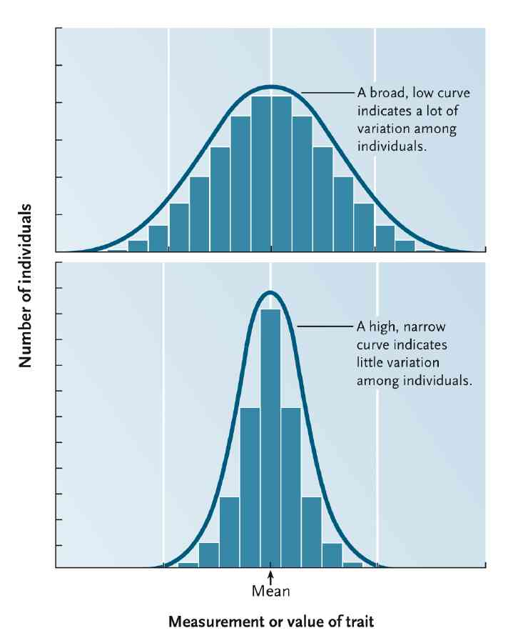
- Qualitative variation: they exist in two or more discrete states and intermediate forms are often absent
  - Characteristics with distinct states
  - Polymorphism: distinct variants of character
    - The occurrence of something in different forms, in particular.
  - Describe by percentage or frequency of each
- Causes of phenotypic variation
  - Genetic differences between individuals
  - Diff in env. Factors that individuals experience
  - Interaction between genetics and the environment
- Genetic and phenotypic variations may not be perfectly correlated.
- Diff genotypes can have the same phenotype
- Same genotype can have diff phenotype. Eg: acidity of soil changes flower color
- Only genetically based variation is subject to evolutionary change
- Phenotype is product of interaction btw genotype and its env.
  - Test for env cause of variation: same genotype, change one env variable and measure effects.
  - Breeding experiments can demonstrate the genetic basis of phenotypic variation
    - Traits that vary quantitatively will respond to artificial selection only if variation has genetic basis.
  - Genetic causes of variation can also be identified by analyzing genealogical pedigrees.
    - Genealogical: Of or relating to the study or tracing of lines of family descent
- What generates genetic variation
  - 2 potential sources
    - Production of new alleles
      - Arise from small scale mutations in DNA
    - Rearrangement of existing alleles
      - Arise from large scale changes in chromosome structure or number
      - several forms of genetic recombination
        - crossing over between homologous chromosomes during meiosis
        - independent assortment of nonhomologous chromosomes during meiosis
        - random fertilizations between genetically different sperm and eggs
  - More than 10⁶⁰⁰ combinations of alleles are possible in human gametes.
- 1960s, gel electrophoresis of proteins.
- Identification of protein polymorphism allows researchers to infer genetic variation at the locus coding for that protein.
  - Problems: same size but diff amino acids – can’t distinguish.
  - Every locus exhibits some variability in its nucleotide sequence.

17.2 Population Genetics (Pg 377)
- study of how populations change genetically over time
- reconciled ideas of Darwin and Mendel
- focuses on populations as units of evolution
- for a population to evolve, its members must have heritable genetic variation (= raw material on which agents of evolution act)
- Phenotype = the physical / physiological expressions of all of the genes of an individual organism
- Genotype = genetic make-up of all of the genes of an individual organism
- A population evolves when individuals with different genotypes survive or reproduce at different rates.
- heritable variation determined in genotype
- heritable variation studied by following changes in the phenotype of a population
- features of a phenotype = characters (e.g. ear attachment)
  - encoded in genotype as genes
- specific forms of a character = traits (e.g. attached / detached)
  - encoded by different versions of a gene = alleles
- A single individual has only some of the alleles found in the population to which it belongs.
- gene pool : sum of all alleles at all gene loci in all individuals
  - includes all of the alleles at all of the gene loci in all of the individuals in the population at any 1 time
  - contains all of the variation (= different alleles) that produces differing phenotypes on which the agents of evolution act
- 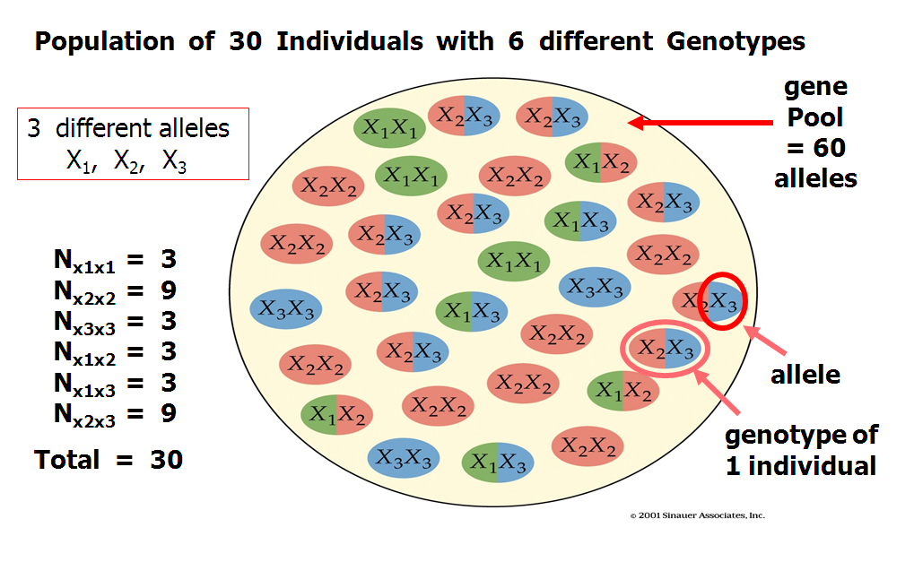
- Genotype frequency: percentages of individuals possessing each genotype
- Allele frequencies: measure genetic variation in the genotypes in a population by determining the relative proportions of all alleles in a population
- mmeasurements of allele frequencies range from 0 to 1
- sum of all allele frequencies at a given locus is 1 and sum of genotype frequency in a population is also equal to 1
- an allele’s frequency (p) is calculated by dividing the number of copies of the allele in a population by the total number of alleles
- if only two alleles (A and a) for a given locus - may form three different genotypes: AA, Aa, and aa
- total number of alleles in a population is 2N because each individual is diploid (e.g. 3 genotypes - AA, Aa or aa)
- p = the frequency of allele A
- q = the frequency of allele a
- allele frequency for each population: p + q = 1 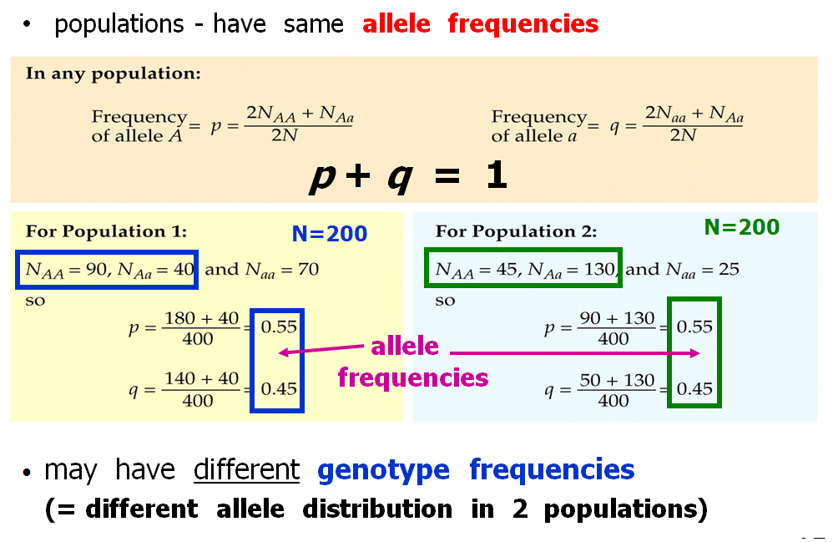
- 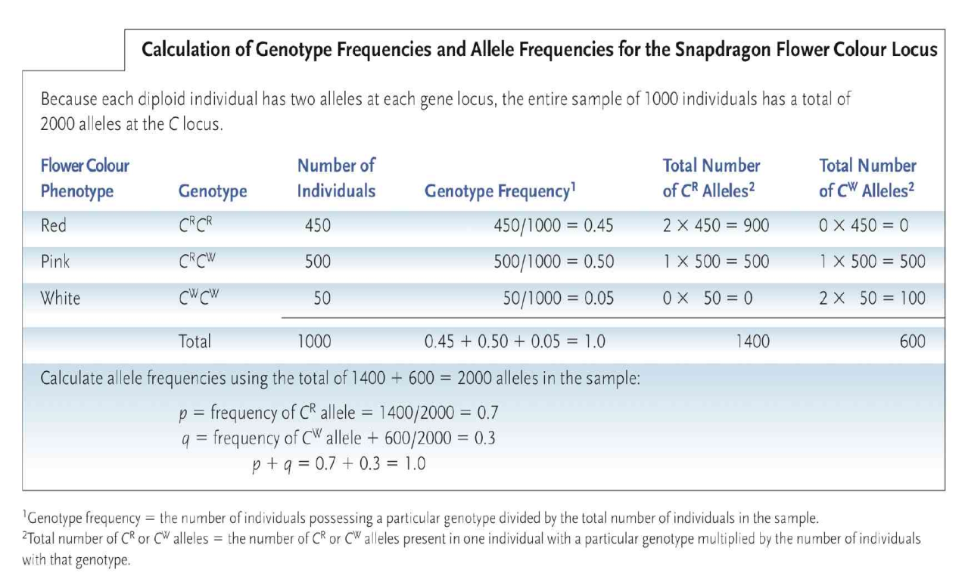
- Studying Population Genetics using Null Models
- conceptual models that serve as theoretical reference points to observations made on populations
- use Hardy-Weinburg Principle: a mathematical model that describes how genotype frequencies are established in sexually reproducing organisms.
  - It is a null model for evaluating the circumstances under which evolution may occur
- describes conditions where a population of diploid organisms show genetic equilibrium : point at which neither allele frequencies nor genotype frequencies change in succeeding generations
  - if conditions met, microevolution does not occur
  - if observations do not match null, microevolution occurring
- Their work showed that dominant alleles need not replace recessive ones and that the shuffling of genes in sexual reproduction does not in itself cause the gene pool to change.
- 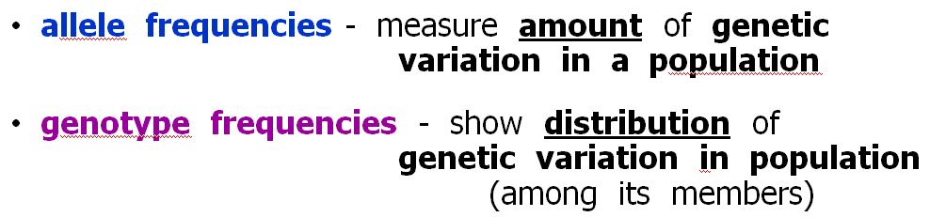
- population is in Hardy-Weinberg Equilibrium = no evolution
- 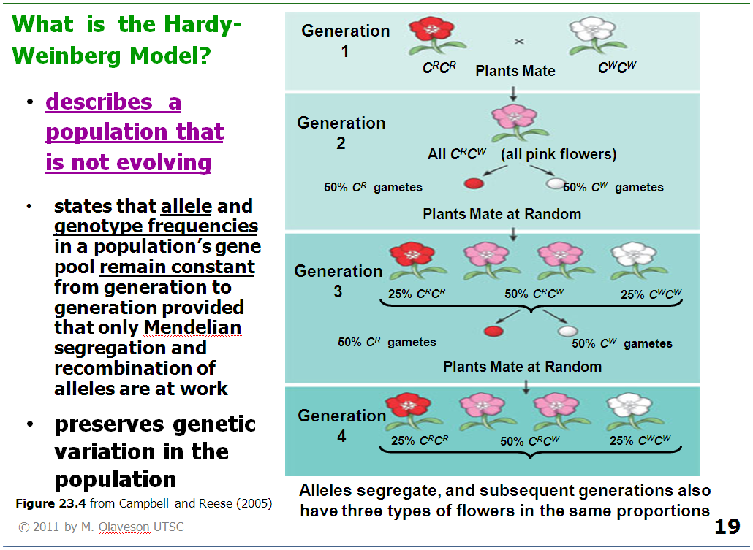
- p + q = 1 where p and q remain unchanged
- genotype frequencies remain in constant proportions
- p² + 2pq + q² = 1 where p + q = 1
- p² and q² represent frequencies of the homozygous genotypes
- and 2pq represents the frequency of the heterozygous genotype
- the Hardy-Weinberg Equilibrium Model describes a model situation in which allele frequencies do not change
- if the following conditions are met, genetic structure of a population does not change over time
  - no mutation (or mutations can be ignored)
  - no gene flow - no migration into or out of the population (population is closed)
  - population size is infinite - large populations are not affected by genetic drift
  - Mating is random
  - no selection - natural selection does not affect survival of any genotypes
    - - all genotypes in the population survive and reproduce equally well.
- most important message of the Hardy–Weinberg Equilibrium is that allele frequencies remain unchanged from generation to generation unless some agent acts to change them
- can determine whether an agent of evolution is acting on a population by comparing a population’s observed genotype frequencies with a population’s ‘expected’ genotype frequencies predicted from Hardy–Weinberg Equilibrium
- populations in nature never fit conditions for Hardy-Weinberg Equilibrium Model
- it is useful in predicting genotype frequencies from allele frequencies because Model describes conditions that would result if no evolution occurred
- any patterns of deviation from the Model help identify specific mechanisms of evolution

17.3 The Agents of Microevolution (Pg 379)
- Evolutionary Agents
  - mutation
  - gene flow
  - random genetic drift
  - non-random (assortative) mating
  - natural selection
- cause changes in allele / genotype frequencies in a population
- are observed as deviations from the expected frequencies predicted from Hardy–Weinberg Equilibrium Model
1)Mutation
- major source of genetic variation
- occurs at a low but variable rate
  - btw 1 gamete in 100,000 to 1 in 1M will include a new mutation at a particular gene locus
  - infrequent- exert little or no immediate effect on allele frequencies in most populations
  - but over evolutionary time scales, their numbers are significant
  - mutations accumulating in biological lineages for billions of years
- heritable change in DNA.
  - Mutations in the germ line (cell lineage that produces gametes) are heritable
  - Others have no direct effect on next generation
  - In plants, mutations may occur in meristem cells which eventually produce flowers as well as non reproductive structures- so mutations may be passed to the next generation and ultimately influence the gene pool
- Deleterious mutations: alter an individual’s structure, function or behavior in harmful ways.
- Lethal mutations: death of organisms carrying them
  - if death b4 reproduction, mutations eliminated from populations
- Neutral mutations : neither harmful nor helpful
  - Cuz of diff codons for same amino acids, some substitutions wont affect proteins
  - Mutations at third position persist longer in population than those in first two positions.
  - May be beneficial later if env changes
- Other mutations may change an organism’s phenotype without influencing its survival and reproduction
- Advantageous mutation: confers some benefit on an individual that carries it.
  - Natural selection may preserve the new allele and even inc its frequency over time.
  - Once the mutation is passed to new generation, other agent of microevolution determine its long term fate.
- an irreversible change in DNA or RNA (stable)
- random
- spontaneous
- types: gene (point) or chromosomal
- significant over long time scales
2) Gene flow
- Organisms or gametes sometimes move from one population to another.
- If reproduce, they introduce novel(new) alleles into the population: Gene flow
  - Violates hardy Weinberg requirement that populations must be closed to migration
- may add new alleles to the gene pool of the new population
- may change the frequencies of alleles already present
- Dispersal agents: most population: pollen-carrying wind or seed carrying animals
  - Enhance gene flow
- Hard to document; researchers can use phenotypic or genetic marks but must also show they reproduced and contributed to the gene pool
- Evolutionary importance depends on the degree of genetic differentiation btw population and rate of gene flow
  - If two gene pools are very different, little gene flow may inc genetic variability within population that receives immigrants and it will make the two populations more similar.
  - If two populations already similar, lot of gene flow will have little effect
- life history and behaviour may enhance gene flow
Genetic Drift
- def: Chance events sometimes cause allele frequencies in a population to change unpredictably
- alters allele frequencies in all populations
- overrides natural selection only in small populations
- dramatic effects on small populations

- chance deviations from expected results – which cause genetic drift- occur whenever organisms engage in sexual reproduction, simply because their population sizes are not infinitely large.
- More common in small populations since only a few individuals contribute to the gene pool and because any given allele is present in very few individuals
- Leads to loss of alleles and reduced genetic variability.
- Population bottlenecks and founder effects often foster genetic drift
- 1) Population bottlenecks
  - organisms of normally large populations may pass through periods when only a small number of individuals survive a random event - due to population reduction
    - On occasion, stressful factor such as disease, starvation or drought kills many individuals and eliminates some alleles from a population producing population bottleneck.
  - Reduces genetic variation even if population numbers later rebound
  - 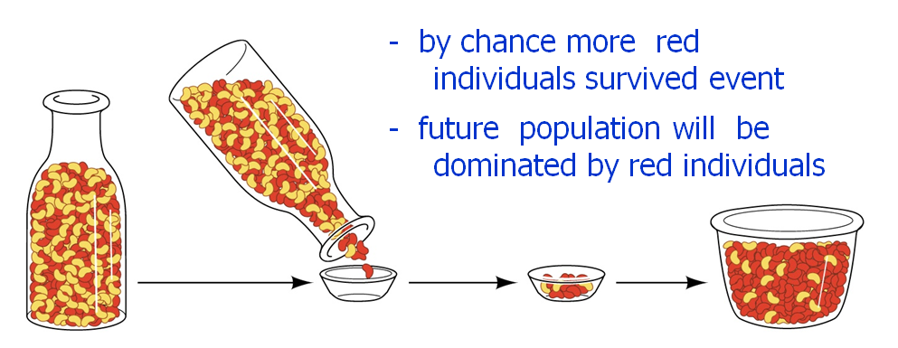
- 2) Founder effect
  - new populations established by a few founding individuals that have gene frequencies that differ from those in the parent population
  - Few individuals colonize distant locality and start a new population.
  - They carry only a small sample of parent population’s genetic variation.
  - By chance, some alleles may be missing from the new pop. and rare alleles might occur at relatively high frequencies.
- Conservation Implications
  - Genetic drift has important implications for conservation biology
  - Def: endangered species experience several pop bottlenecks, which result in loss of genetic variability.
  - Small # of individuals available for captive breeding programs may not fully represent a species’ genetic diversity.
  - Without such variation, no matter how large a pop may become in future, it will be less resistant to diseases or less able to cope with environmental change.
  - Example: bottle neck in African cheetah 10,000 years ago
    - Cheetahs are remarkably uniform in genetic makeup
    - Populations are highly susceptible to diseases; high proportion of sperm cell abnormalities and reduced reproductive capacity.
  - Thus limited genetic variation as well as small numbers threatens populations of endangered species

Natural Selection
- Requirements for hardy-weinberg eq. = all genotypes survive and reproduce equally well.
  - Not met in nature
  - Heritable traits enable some individuals to survive better and reproduce more than others
- Natural selection: process by which such traits become more common in subsequent generations
  - it is phenotype of an individual organism rather than any particular allele that is successful or not.
- When they reproduce, the alleles passed. If lethal-> organism dies b4 reproduction and alleles “die” too
- Relative fitness: # of surviving offspring that an individual produces compared with the number left by others in the pop
  - Thus a particular allele will inc in frequency in the next generation if individuals carrying that allele produce more offspring than individuals carrying other alleles.
  - Differences in relative success of individuals are the essence of natural selection
- Natural selection tests fitness diffs at nearly every stage of their life cycle.
- Natural selection exerts little or no effect on traits that appear after individuals reproductive life.
  - They reproduce n pass it to next generation – natural selection doesn’t affect it.
- Measure effects of natural selection on phenotypic variation by recording changes in the mean and variability of characters over time
- Directional selection
  - Traits undergo this selection when individuals near one end of the phenotypic spectrum have the highest relative fitness.
  - Directional selection shifts a trait away from the existing mean and toward the favoured extreme.
    - Traits mean value is higher or lower than before
  - Extremely common
- Stabilizing Selection
  - Individuals expressing intermediate phenotypes have the highest relative fitness.
  - Eliminating phenotypic extremes, this reduces genetic and phenotypic variation and increases frequency of intermediate phenotypes.
  - Most common mode of natural selection
- Disruptive Selection
  - Extreme phenotypes have higher relative fitness than intermediate phenotypes
  - Alleles producing extreme phenotypes become more common promoting polymorphism.
  - Much less common than directional selection and stabilizing selection
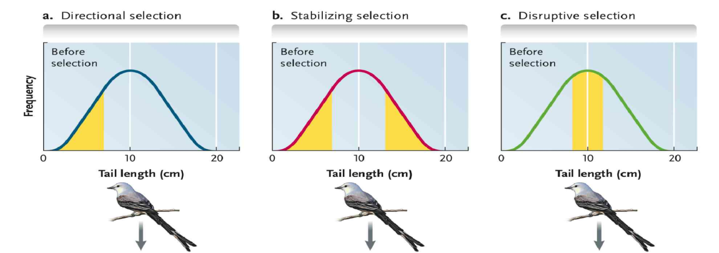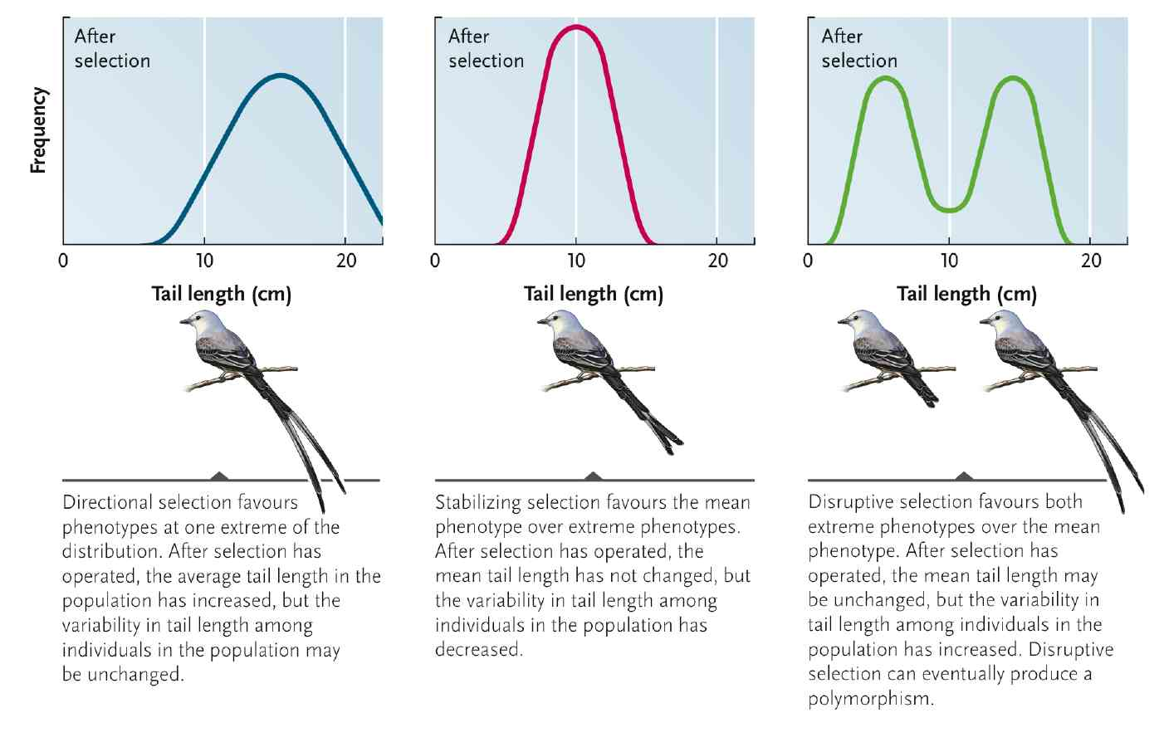
Non-random (assortative) mating
- if individuals mate more often with individuals having the same or different genotypes than would be expected on a random basis
- frequencies of homozygous and heterozygous genotypes will differ from Hardy–Weinberg Model expectations
- Sexual selection: fostered the evolution of showy structures and elaborate courtship beh (Behavior designed to persuade someone to marry one) in the males of many animal species
- Males produce otherwise useless structures just for looks since females find them attractive
- Intrasexual selection: selection btw same sex
  - Males user their large body size, antlers, tusks to intimidate, injure or kill rival males.
- intersexual selection (structures to lure mates)
- intrasexual selection (structures to combat same-sex rivals)

- In many species, sexual selection is the most probable cause of sexual dimorphism: def differences in the size or appearance of males and females
- Pushes phenotypes toward one extreme
  - Produces sometimes bizarre (like really long tails or something)
- Humans kinda mate randomly (don’t look for genes for better digestive enzymes or blood types)
- Many organisms mate nonrandomly, selecting a mate with a particular phenotype and underlying genotype.
- Inbreeding: special form of nonrandom mating in which individuals that are genetically related mate with each other.
  - Ex: self fertilization in plants and few animals because offsprings produced from gametes of a single parent.
  - Organisms in small closed pop often mate with related individuals.
  - Since relatives often carry same alleles, it increases the frequency of homozygous genotypes and dec frequency of heterozygotes
    - Recessive phenotypes often expressed
  - 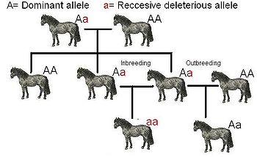
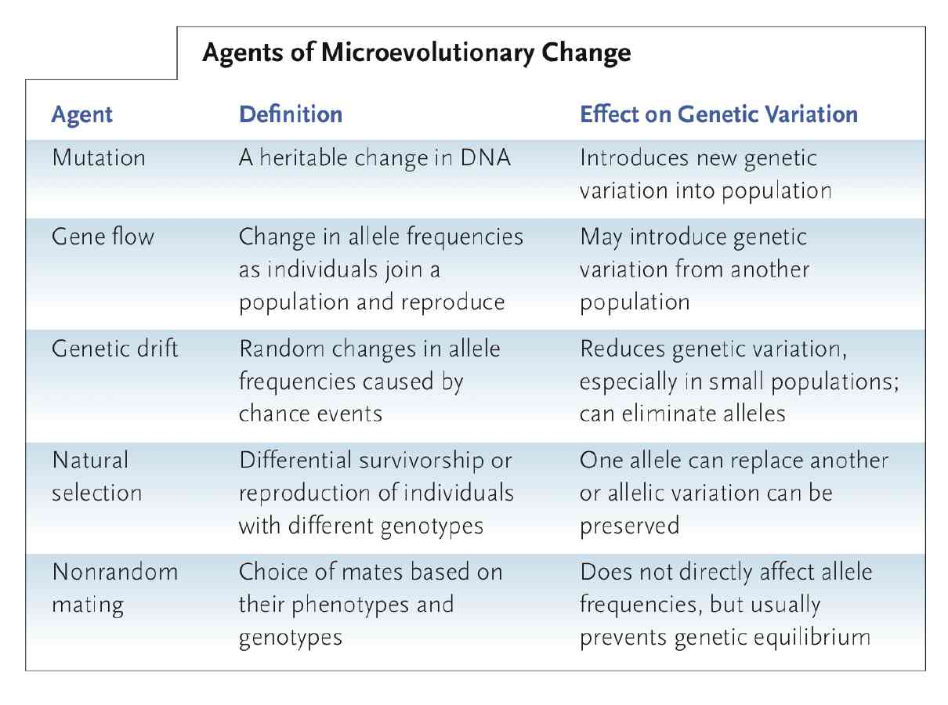

17.4 Maintaining Genetic and Phenotypic Variation (Pg 388)
- Diploid condition reduces effectiveness of natural selection in eliminating harmful recessive alleles from a population.
  - Although disadvantageous in homozygous state, have no effect on heterozygotes.
  - Masking of recessive alleles in heterozygotes, impossible to eliminate them completely through selective breeding
  - In large populations, heterozygotes preserve recessive alleles at low frequencies.
  - when recessive alleles are rare, most copies are in heterozygotes
- Balanced polymorphism: two or more phenotypes are maintained in fairly stable proportions over many generations.
  - Natural selection preserves balanced polymorphisms when heterozygotes have higher relative fitness, when different alleles are favoured in different env. And when the rarity of a phenotype provides an advantage
  - Heterozygote Advantage
    - A balanced polymorphism can be maintained by heterozygote advantage.
    - When heterozygote for a particular locus have higher relative fitness than either homozygotes.
  - Selection in varying environments
    - Genetic variability can also be maintained within a population when different alleles are favoured in different places or at different times.
    - Example: camouflage by snails.
      - Brown when dead leaves, green in grass
    - In populations that span several habitats, selection preserves different alleles in different places, thus maintaining variability in the population as a whole
    - Natural selection favours different alleles in different local populations, maintaining genetic variability in pops that span several vegetation types.
  - Frequency Dependant selection
    - Sometimes genetic variability is maintained because rare phenotypes have higher relative fitness than more common phenotypes.
    - Rare phenotype inc in frequency until it becomes so common that it loses its advantage.
    - Called frequency dependant selection because selective advantage enjoyed by a particular phenotype depends on its frequency in the population
    - Predator-prey interactions can establish frequency dependant selection because predators often focus their attention on most common types of prey
- Neutral variation hypothesis
  - many mutations do not affect function of resulting proteins
  - an allele that does not affect fitness is a neutral allele- tend to accumulate in a population.
  - Some of the genetic variation at loci coding for enzymes and other soluble proteins is selectively neutral.
  - Even if various alleles code for slightly different amino acid sequence, diff forms function equally well.
    - Natural selection does not favour one over other
  - Helps explain why we see diff levels of genetic variation in diff pops.
  - It proposes that genetic variation is directly proportional to a population’s size and the length of time over which variations have accumulated.
    - Small populations experience fewer mutations than a large population because they include fewer replicating genomes
    - Small populations also lose rare alleles more readily through genetic drift.
    - Thus small pops have less genetic variation than large pops.

17.5 Adaptation and Evolutionary Constraints (Pg 391)
- Although natural selection preserves alleles that confer high relative fitness on the individuals that carry them, researchers are cautious about interpreting the benefits that particular traits may provide
- Adaptive trait: any product of natural selection that increases the relative fitness of an organisms in its env.
- Adaptation: accumulation of adaptive traits over time
  - Adaptive explanation for traits that do not vary much can be done by comparing variations of a trait in closely related species living in different environments
- A trait that is observed today may have had a different function in the past.
  - Bird shoulder join example: the shoulder joint that allows wings to move and birds to flight might have evolved as an adaptation for capturing prey (like dinosaurs) and only later proved useful for flapping flight.
- Not all characteristics produced by evolution are adaptive
- some may be products of chance events or genetic drift
- others maybe produced by alleles that were selected for unrelated reasons
- some may results from action of basic physical laws
  - eg seed falling to the ground when they mature due to gravity
- Factors constrain Adaptive Evolution
  - Adaptive traits of most organisms are compromises produced by competing selection pressures
    - Sea turtles must lay eggs on beaches since embryos cannot acquire oxygen under water
    - Flipper allow females to crawl to nesting sites on beach but not suited for terrestrial locomotion
    - Their structure reflects their primary function in underwater locomotion
  - No organism can be perfectly adapted to its env since it keeps changing over time.
  - When selection occurs, it preserves alleles that are successful under the prevailing env conditions.
  - Each generation is adapted to the env conditions under which its parents lived
    - if the env changes from one generation to the next, adaptation will always lag behind
  - another constraint is historical
    - natural selection acts on new mutations and existing genetic variation.
    - Because new mutations are fairly rare, natural selection works primarily with alleles that have been present for many generation
    - Thus, adaptive changes in the morphology of an organism are almost inevitably based on small modifications of existing structures.
      - Eg bipedal( 2 foot) evolved from quadrupedal (4 foot) posture of ancestors.
      - Natural selection did not produce an entirely new skeletal design to accompany this radical behavioural shift
      - Instead existing characteristics of the spinal column and musculature of legs and back were modified for upright stance.

The agents of evolution cause microevolutionary changes in the gene pools of populations.

