Chapter 1

Corporate Finance and the Financial Manager

3 Questions for Financial Manager – What long-term investments should you take on? Where will you get the long-term financing to pay for your investment? How will you manage you every day financial activities?

Capital Budgeting – The process of planning and managing a firm’s investment in long-term assets

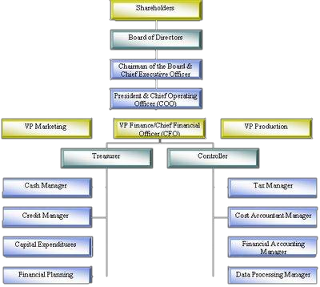

Capital Structure – The mix of debt and equity maintained by a firm

Working capital management – Planning and managing the firm’s current assets and liabilities

Forms of Business Organization

Sole Proprietorship – A business owned by a single individual

Partnership – A business formed by two or more co-owners

Corporation – A business created as a distinct legal entity owned by one or more individuals or entities

The Goal of Finance Management

Possible Goals

- Survive in Business
- Avoid financial distress and bankruptcy
- Beat the competition
- Maximize sales or market share
- Minimize costs
- Maximize profits
- Maintain steady earnings growth

- The Goal of financial management is to maximize the current value per share of existing stock

The Agency Problem and control of the Corporation

Agency Problem – The possibility of conflicts of interest between the shareholders and management of a firm

Corporate Governance – Rules for corporate organization and conduct

Stakeholder – Anyone who potentially has a claim on a firm

Financial Markets and the Corporation

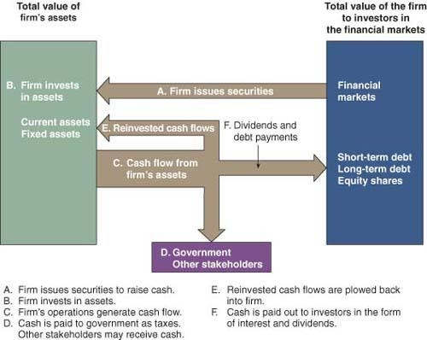

Money Markets – Financial markets where short-term debt securities are bought and sold

Thank you for using www.freepdfconvert.com service!

Only two pages are converted. Please Sign Up to convert all pages. https://www.freepdfconvert.com/membership

