Lecture 3: Functional Units of the Central Nervous System
What are the Units of Nervous System Function?
- Cells of the Nervous System
- Internal Structure of a Cell
- Genes, Cells, and Behavior

Cells of the Nervous System
Debate in the Early 1900s
- Golgi
  - The nervous system is composed of a network of interconnected fibers: a “nerve net”
- Cajal
  - Nervous system is made of discrete cells
  - Neuron Hypothesis
      - Neurons are the units of brain function
  - Used the Golgi stain to show that the nervous system was made up of discrete cells thereby supporting the Neuron Hypothesis
- Brainbow
  - Individual cells can be visualized offering a way to describe where each neuron sends its processes and how it interconnects with other neurons
Neurons: The Basis of Information Processing
- Human nervous system contains more than 100 billion neurons
- Examining how one cell works can be a source of insight that we can generalize to other cell types.
- As you learn to recognize some of their different types, you will also see how their specialized structures contribute to their functions in your body
- Most behaviors are produced by groups of hundreds or thousands of neurons
- Neurons continuously change their shape
  - Grow and shrink
- The production of new neurons does take place throughout life and some behavior depends on new neurons.
- Most CNS neurons are with you for life and are never replaced

Cells of the Nervous System: Neurons
- Neurons
  - Functional units
  - Enable us to receive information, process it, and act
- Glial Cells (“glue”)
  - Help neurons
  - Multiple functions; provide:
    - Structural support, nutrients, and protection
- 3 basic subdivisions
- Dendrites
- Gather information from other neurons
- Cell body or Soma
- Core region; contains the nucleus
- Integrates the information
- Axon
- Carries information to be passed on to other cells
- Different Types
- Sensory neurons
  - Bring information tot eh central nervous system
- Principal neurons (“interneurons”; association neurons)
  - Associate sensory and motor activity within the central nervous system
- Motor neurons
  - Send signals from the brain and spinal cord to muscles
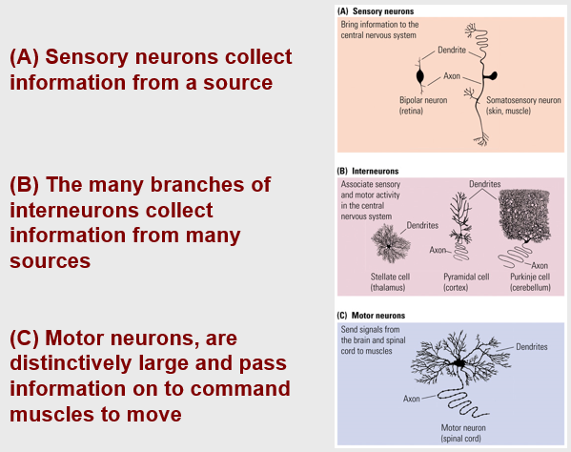

Neurons: The Basis of Information Processing
- The Language of Neurons: Excitation and Inhibition
  - Each neuron receives thousands of excitatory and inhibitory signals every second
  - Neurons “sum” these signals and respond accordingly: They become active or not
  - From the simple “yes-no” language of neurons emerges enormous possibilities for behavior
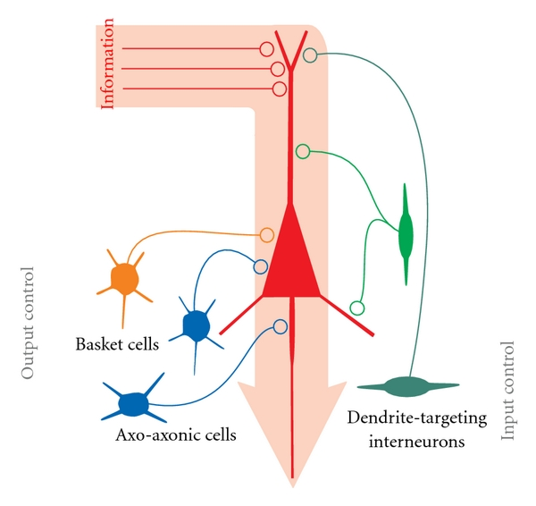
Neurons
- The dendrites
  - Receiving portion of the nerve cell
  - Information collecting
  - Info channeled to cell body
  - Surface area of dendrites is many times greater than that of cell body
- The dendritic spines
  - Expand the area of dendrites
  - Points where inputs from other cells are directed
    - Head region (point where connection to another cell is made)
    - Shaft or neck
- The cell body or soma
  - Contains the nucleus and the cytoplasm
    - Within cytoplasm
      - Mitochondria
      - Endoplasmic reticulum
      - Ribosomes
      - Golgi apparatus

Internal Structure of a Cell: Parts of a Cell
- Cell Membrane
  - Separates intracellular and extracellular fluid
  - Regulates movement of substances into and out of the cell: most cannot pass
    - Proteins embedded within membrane allow substances into and out of cell
  - Phospholipids
    - Hydrophilic head: phosphorous
    - Hydrophobic tail: lipids (fat molecules)
- Cell Membrane
  - Channel
    - Opening in a protein embedded in the cell membrane that allows the passage of ions
  - Gate
    - Protein embedded in a cell membrane that allows substances to pass through the membrane on some occasions but not others
  - Pump
    - Protein embedded in a cell membrane that actively transports a substance across the membrane
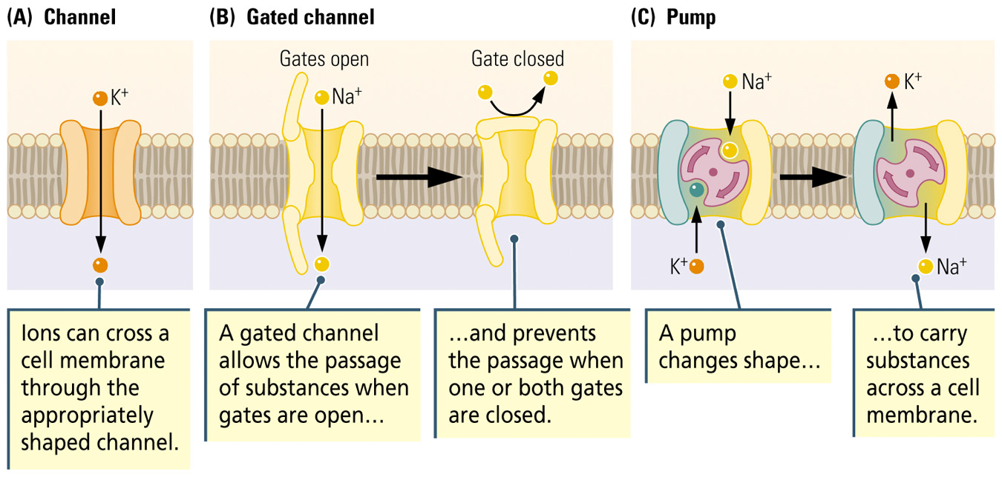
Nucleus
- The Nucleus
  - Gene
    - Contain segments of DNA
    - Blueprints for making proteins
    - Sequences of nucleotides determine which amino acids are to be joined to form the particular protein
  - Transcription
    - Early phase of protein synthesis in which the DNA strands unwind and a complementary strand of messenger RNA (ribonucleic acid) is created
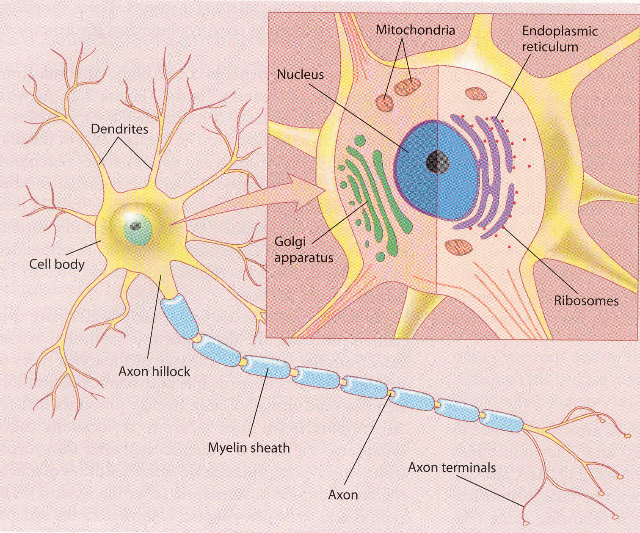

Cell body (soma)
- Mitochondria
- POWERHOUSE OF CELLS
  - organelles that convert energy to forms that cells can use for work
  - sites for cellular respiration, the catabolic process that generates ATP
  - Number of mitochondria is based upon the cells level of metabolic activity.

Internal Structure of a Cell: Parts of a Cell
- The Endoplasmic Reticulum (ER)
  - Ribosomes
    - Site of protein synthesis
  - Translation
    - Later phase of protein synthesis in which the messenger RNA (mRNA) travels from nucleus to the ER
    - mRNA is translated into a particular sequence of amino acids to form a protein

Cell body (soma)
- Endoplasmic reticulum (smooth and rough)
  - makes up more then half the membrane of the cell
  - two different kinds: smooth and rough.
  - Smooth lacks ribosomes on the cytoplasmic surface
  - rough because ribosomes stud the cytoplasmic surface.
- Ribosomes
- SITES OF PROTEIN SYNTHESIS
  - consist of two sub units and function as the site of protein synthesis in the cytoplasm
  - Free ribosomes function in the cytosol, while bound ribosomes generally make proteins that are for inclusion into the membrane, packaging, or for export from the cell.
- Golgi apparatus
- PROTEIN MOVERS
  - After leaving the endoplasmic reticulum, many transport vesicles travel to the Golgi apparatus
  - consists of flattened membranous sacs
  - center of manufacturing, warehousing, sorting and shipping
  - Here, products of the endoplasmic reticulum are modified and sorted then sent to their destination.
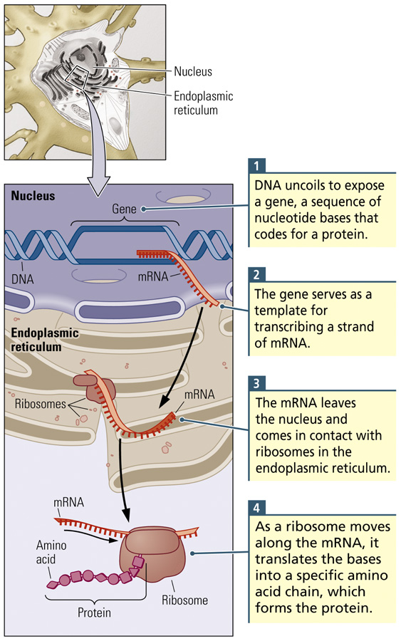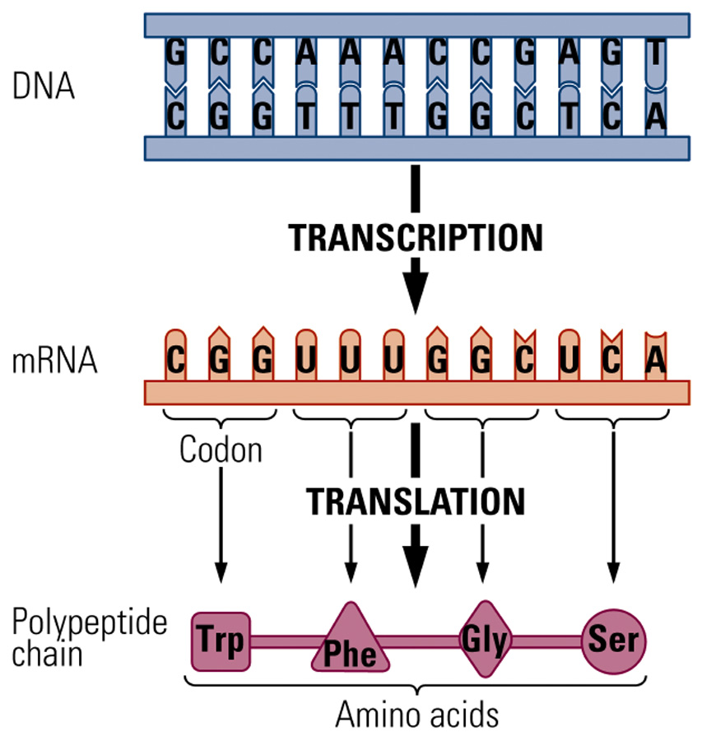

Soma to Axon
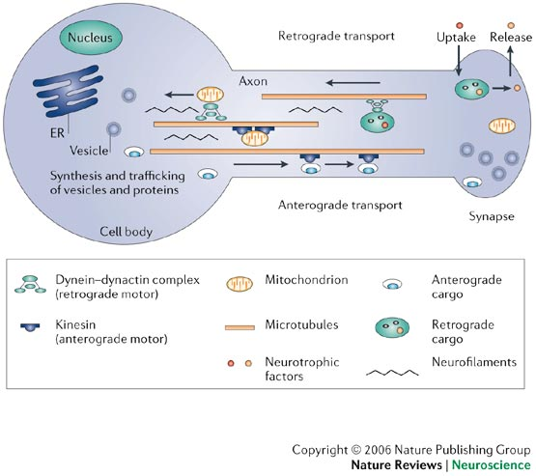

Cells of the Nervous System: Neurons
Basic Structure and Function
- Axon Hillock
  - Juncture of soma and axon where the action potential begins
- Axon collaterals
  - Brach of axon
- Teleodendria
  - Branch of an axon collateral
- End foot
  - Knob at the tip of an axon that conveys information to other neuron; also called a terminal button
- The axon
  - Only one axon emanates from a cell body
  - May branch to give off collaterals
  - Specialized to carry info away from cell body to other cells
  - 0.2-20um in diameter
  - May extend up to 1 meter
  - Propagates info in all-or-none fashion
    - Electrical signal called action potential
    - Initiated at axon hillock
- Organelles from soma travel along axon to terminals
- Large axons are covered in myelin: produced by glial cells
- Terminal region consists of specialized swellings (presynaptic terminals)
Basic Structure and Function
- Synapse
  - Gap between one neuron and another neuron
  - Usually between an end foot of the axon of one neuron and a dendritic spine of another neuron
- Information Flow in a Neuron
Dendrite
Cell Body
Axon
End Foot

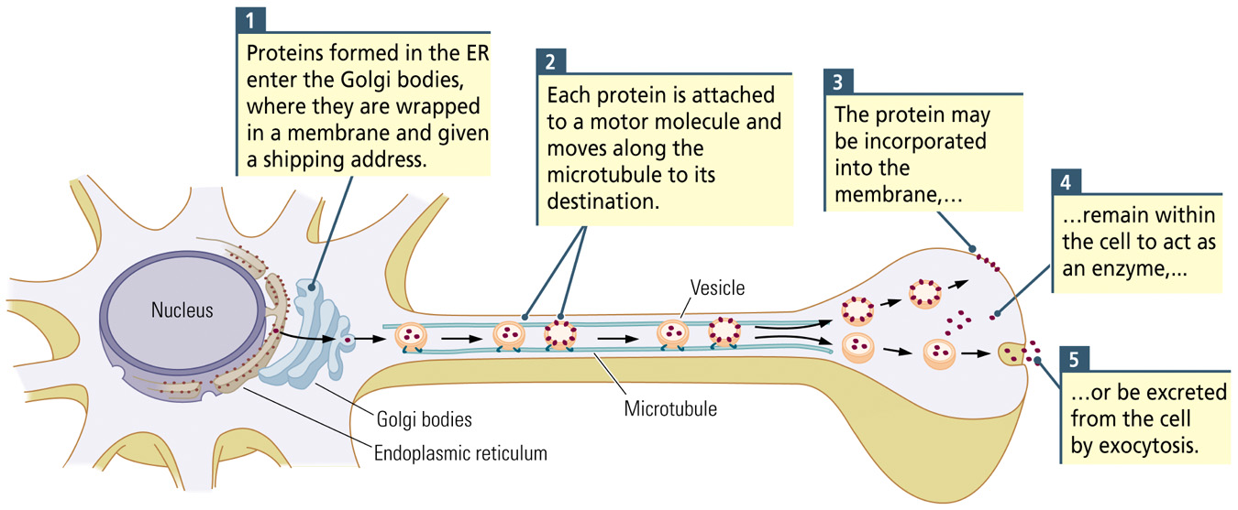
Synaptic Terminals
- By means of these terminals, one cell transmits info about its activity to the receptive surface (spine) of another cell
- Cajal: neuron doctrine
  - Neurons are the basic signaling unit of CNS

Oligodendrocytes
- Found in CNS
- Participate in myelination of white matter
- In grey matter, they surround the cell body
- Single oligodendrocyte forms myelin sheaths around many axons in CNS
- Myelin sheath insulates axons
- Myelin enhances conduction of electrical signals
- One oligodendrocyte can myelinate many axons in the CNS
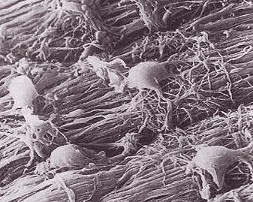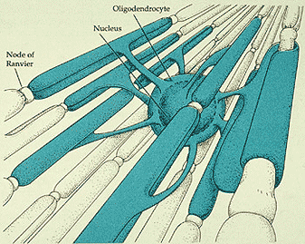
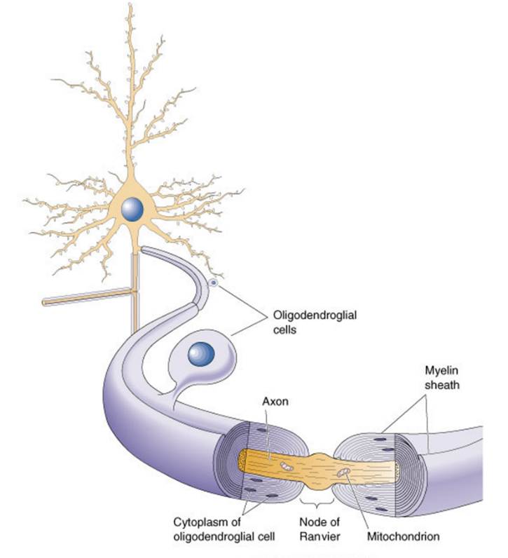

Schwann cells
- Found in the PNS
- Several Schwann cells line up along a single axon at regular intervals forming a myelin sheath
- Intervals between myelinated segments called nodes of Ranvier
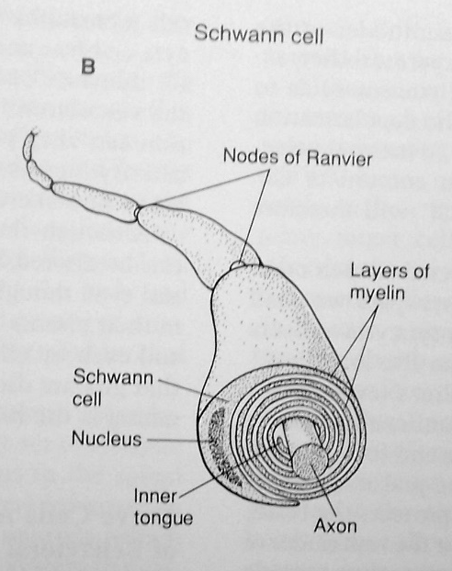
Astrocytes
- Polar sets of end feet
- One set of end feet contact capillaries
- One set of feet contact neurons
- May serve a nutritional role
- Participate in the induction of the blood brain barrier
- Remove neurotransmitters from synaptic cleft
- Remove neuronal debris and help seal off damaged brain tissue

Cells of the Nervous System: Glial Cells
- Astrocyte
  - Star shaped, symmetrical
  - Structural support for neurons
  - Transports substances between neurons and capillaries (blood-brain barrier)
  - Scar tissue formation

Conclusion
- The brain is a tissue. It is a complicated, intricately woven tissue, like nothing else we know of in the universe, but it is composed of cells, as any tissue is. They are, to be sure, highly specialized cells, but they function according to the laws that govern any other cells. Their electrical and chemical signals can be detected, recorded and interpreted and their chemicals can be identified; the connections that constitute the brain's woven feltwork can be mapped. In short, the brain can be studied, just as the kidney can.
  - David Hubel 1981 Nobel Prize Winner

