Leverage Research, Develop Measurement Plans
- Change must be data driven
- Uses of data in the change process for diversity competence:
  - How to use data to build a commitment to change
  - How to use data to enhance diversity education
  - How to diagnose the climate for diversity
  - How to measure progress
  - Caveats for using research to drive change

Using Data to Build Commitment
  - Any type of change encounters resistance – some types more than others
  - Majority of resistance comes from culture group members
    - They fear that change will produce a zero-sum game in which others gain and they will lose
  - In mergers & acquisitions, attention to diversity is sometimes viewed as taking control away from the more dominant partner in the merger in order to enfranchise members of the smaller partner
  - In organizations w/ labour unions, diversity work is sometimes viewed by managers as the power is in favour of the unions
  - This form of resistance is partly due to a misunderstanding of what diversity work is about
  - How to overcome this type of resistance:
    - Education & communication that is designed to show the LT benefits of diversity
  - Resistance can also occurs when ppl don’t see the need for intervention around diversity issues
    - Workers don’t see it as a problem that needs to be solved
  - Research can create a break through to help people see the opportunity of workforce diversity
    - Developing the business case
    - Getting execs focused on the need for change
    - Promoting a shared leadership with labour unions
Developing the Business Case
  - Example: Shell Oil
    - In 1995, Shell created a task force to develop an approach diversity that would benefit the org
    - 1st & highest priority: build a “business case”
      - Show why diversity is closely linked to the org’s financial success
    - They first developed their conceptual logic:
      - Diversity competence was critical for effective teamwork, would increase the quality of human inputs to the org, etc.
    - Result: the team was able to win support for virtually all of their recommendations
      - The well-articulated business base, using hard data, was an impt. Part of their success
  - Using relevant data to form the business case will work well for any type of org
Getting Executives Focused on the Need for Change
- Example: work at Alcoa
  - At a meeting, data was presented on the climate for diversity based on surveys & interviews at 4/5 locations of the company
  - Quotes were taken from interviews w/ EEs of all job grades
    - The leaders found out that the behaviours and conditions undermined the org’s core values & policies
  - The meeting helped build support for the change effort at Alcoa
Using Data to Promote Shared Leadership with Unions
- Example: Experience at Alcoa, involving union leadership
  - Participation by union leaders in the change work on diversity can make an enormous diff in the success of the work
  - Even if your org doesn’t have an union, there may still be resistance from members of the workforce in lower-level jobs bc they see this work as the responsibility of management NOT the total org
  - Using data to show issues involving behaviour at all levels can remove some of this resistance

Using Data to Enhance Education
- Second way of using research data to promote org change related to diversity:
  - Include it in education efforts
    - Use feedback from EEs about specific issues of the diversity climate
    - Create case scenarios for analysis in training courses on diversity
  - Advantages:
    - Responds to a widespread request among EEs working on diversity education to bring the learning down to the level of behavioural change
      - Cases allow learners to apply what they are hearing to solve a problem
    - Provides scenarios that are guaranteed to be relevant to the group being trained and thus avoids the learning obstacle of “that doesn’t happen here”
      - You’ll save training design costs bc the material is avail from another step of the change process that you already paid for
- Another way:
  - Use the results of work from one organization to show the value of the change process to other organizations
    - Example: Show data to give an idea of what the organization hopes to accomplish by using the process
- Another way:
  - Include some published research data to support points that you want to make
  - Example: In a training segment dealing w/ effects of group identity on performance appraisals, you might include research that shows that age & race identities often affect how ppl are rated. Also show that an EEs’ gender & race often affect assumptions their ERs make about the cause (or attribution) of performance achievements
    - Knowing this can help increase their motivation to learn about related topics such as stereotyping

Diagnosing the Climate for Diversity
- No change effort will get far w/o some form of org diagnosis
- A formal measurement of the current state is necessary
  - To guide action planning
  - Set a baseline for assessing progress
Measure the Right Things
- Measurement is only valuable if it focuses on true indicators of success
- To identify the right things, start with some kind of explicit, research-based, conceptualization of the components of work climate that determine an org’s capacity to welcome & use workforce diversity as a resource for better performance
- Example:
  - 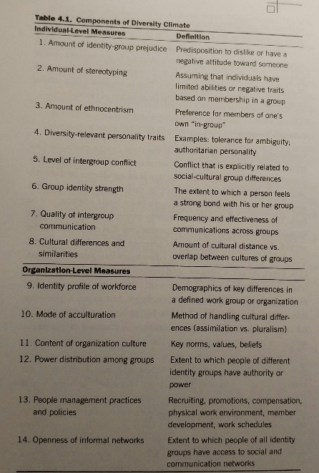
  - BUT: even though all items on the list is important, not all of them need to be included to diagnose the org’s climate bc unless you are v. thoughtful about the factors, you will miss some key components
- We must combine content expertise & collection savvy together to get the best results when diagnosing a work climate
Calibrate Carefully
- Gathering data is only helpful if the data can be calibrated as good/bad in terms that make sense to the decision maker
  - Bc calibration often requires comparisons
- 3 basic approaches
  - External benchmarking against orgs that are known to be world class on the dimension of interest
    - Cons: extremely difficult to find the full spectrum of data needed for orgs that are truly comparable to one’s own
    - Example: might be possible to get data on the gender breakdown of hires in a company, but what about gender climate factors such as levels of sexual harassment & stereotyping of women?
  - “internal benchmarking”
    - Involves generating a database for your own organization that is large enough to make cross-unit comparisons
    - Example: if there are 12 accounting groups in your org, you can get a good idea of performance levels by comparing each unit to the range & avg of the set of 12
      - This won’t avoid problems of external benchmarking entirely, but will sig. reduce them
  - Compare data for the same work unit at different time
    - Involves setting a measurement baseline & then evaluating performance based on changes over time
- All 3 methods can be combined
  - Example: you can compare the % increase over a baseline in the 1st year of work to what has been achieved in a similar organization that is ahead of you in the change process
Triangulate Methods
- Express the power of data drawn from multiple sources
- Recommended: use a combination of:
  - Interview data
  - Survey data
  - Data from the firm’s computer information system
  - Direct observations
- Adding interview data offers a # of impt. benefits for work in this area
  - Benefits:
    - Ability to clarify the meaning of the q’s being asked so all respondents have the same understanding of them
    - Ability to probe & get further depth of info
    - Provide an exchange of information

Measuring Progress
- Organizations need a formal plan of measurement for any major change effort
- Examples of metrics for measuring progress
  - EE turnover
  - EE absenteeism
  - Structured EE feedback (interview/survey data)
  - Levels of change in diversity profiles
  - Percent implementation of action plans
  - Positive job-offer-response ratio
  - Levels of identity-group-related complaints/litigation costs
  - Successful accommodations for persons w/ disabilities
- The different types of metrics must be selected to fit your organizational circumstances
  - Example: rates of harassment are often 2-3x higher for women in male-dominant organizations than they are for men
Lessons Learned About Measuring Progress
Communication
- V. important to have a consistently effective communications plan that keeps ppl on track to achieve results
- Helps make connections b/w the feedback & the action steps
Pay Attention to the Unit of Analysis
- Relationship b/w measurement options & the unit of analysis for measurement
- The relationship looks like:
  - 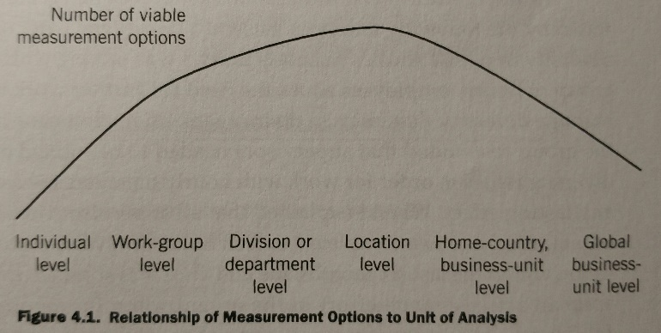
Set Appropriate Measurement Intervals
- Determining the right intervals for measuring progress
- The desire of change agents for ST feedback must be balanced against what is prudent, as certain realities in the nature of the work being measured
- What to keep in mind when setting measurement intervals:
  - Change doesn’t happen overnight
  - Measurement intervals must be keyed closely to rates of action implementation
  - Excessive frequency of measurement, esp where EE feedback is used can make people resistant to change
  - The appropriateness of some metrics for use at short intervals (<1 year) will depend on the org’s specific circumstances

Some Caveats on Using Research
- Research data can be a powerful tool in support of a change process focused on diversity
- BUT it can backfire if the consultant/internal sponsors of the change effort are damaged by missteps in the use of data
- Tips:
  - Don’t oversell the data
  - Make sure the ppl presenting the data have a deep understanding of the data & how they were collected
  - Make sure the presentation of the data is user-friendly
    - Good rule: if the avg high school student doesn’t understand a graphic, it needs to be revised
  - Help your audience by making clear what YOU think the data means
  - Take every precaution to ensure the accuracy of the data

Chapter Summary
- There’s great value in research & measurement and that they are fundamental to the process of change for managing diversity

MHR600 – Align Organizational Systems and Practices by T. Cox

- Change to welcome and leverage diversity must be done in a systems approach
- 3 main categories of work climate:
Time: way time is scheduled for performance of work
Space: concerns aspects of physical work environment
People: designed to manage acquisition of human talent and employment outcomes
- 5 elements of policies towards system alignment:
Time-off: specify the ability of employees to take paid/unpaid time from work
-If your organization has more liberal time-off policies, you will be able to attract, retain, and motivate the diverse workforce
-Policies, even if enforced the same for all employees, does not necessarily have the same impact on all members of social and cultural groups
Presence of class distinctions: tendency to organize or “rank” social groups into status hierarchies
-A work climate becomes more diversity friendly when it avoids or removes policies/practices that tend to reinforce existence of such hierarchies
-Examples: executive dining, reserved parking, office furnishing, job-type restrictions, differential vacation strategies
Recruiting practices: how to successfully target qualified people from underrepresented identity groups. Three areas need attention:
1. Reflecting diversity competency in selection tools: developing information for diversity competency, include diversity-related material in selection activities
2. Managing the composition of recruiting teams: proportional representation panel
3. Conducting new-hire orientation: assisting new hires with their socialization into the culture by assigning them “buddies” or mentors
Performance appraisal:
-Possibility that identity factors such as race, origin, and age are affecting ratings, first step is to investigate a variety of possible causes
-Need to develop a meaningful way to include diversity competency as a rated item in the formal performance evaluation process:
Planning: joint effort between employee and manager
1. Define individual roles based on business objectives
2. Determine annual objectives
3. Identify the critical success factors and business-technical knowledge required to excel in the identified role
Assessment: determination of what has been accomplished during the previous time period (rewards, development and staffing)
Career development: alignment with the goal of diversity competency requires giving attention to a variety of issues. Some of the most important include job posting, annual development planning, succession planning, and globalization of career paths.

Managing multicultural team

