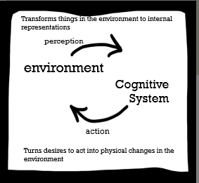
Learning, Memory, and Representation- Lecture 1
Cognitive Systems: Transforms things in the environment to internal representations

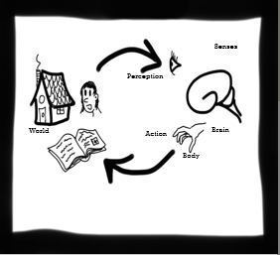
How the Animal Mind Works:
- Perception comes through the sense organs
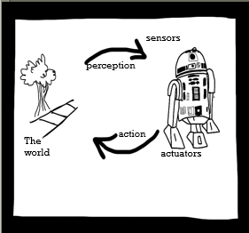
- Eyes send info to the brain
Robotics:
  - Perceptions/ organs are called sensors in a robot (ex. motion detector, automatic door)
  - Sensors for motion
  - Robot affects the environment with actuators
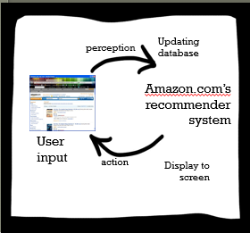

Disembodied Software:
  - Environment= Webpage
  - Actuator= Display to screen (how it changes environment)
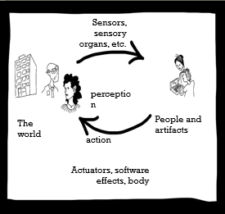
Distributed Cognition:
  - What is their environment?
  - Ex. Writing a paper w/ a friend- environment could be books or websites- action on the environment could be submitting the paper
  - Ex. Calculator- environment- is the problem trying to be solved, actuator- the answer or saying the answer out loud
How does a (cognitive system) act and how does it perceive?= Example of question on exam

Cognition is Manipulation of Representations:
Definition: Cognition involves the manipulation of representations
Ex. Number 3 in the environment
Representations Are Stored in Memory:
- Describing memory biologically= hippocampus
- Describing memory functionally= long term and short term
Animal | Software | Distributed System
- Brain  - Long Term Memory  - Short Term Memory- remembering something for a short time can go away if you don’t make an effort to remember it | - Databases  - Symbols | - Memory might be on...  - Paper  - Brain  - Disk  - Environment Manipulation  - Ex. Whiteboard

Human Memory of Fact and Perceptions (not skills):
- Sensory Memory- Sensory memory is like a scratch pad (for vision), or a bit of recording tape (for hearing), that can be overwritten with new things. It is re-written every few seconds by new perceptions
- Short Term Memory- Short term memory is a temporary store. Some things from it end up becoming long term memories.
  - Ability to recognize what something is
- Long Term Memory- Probably stored here forever, though we might have trouble with retrieval
  - Even if you are not able to remember something or have trouble remembering, it may still be there
  - ex. Keeping a diary

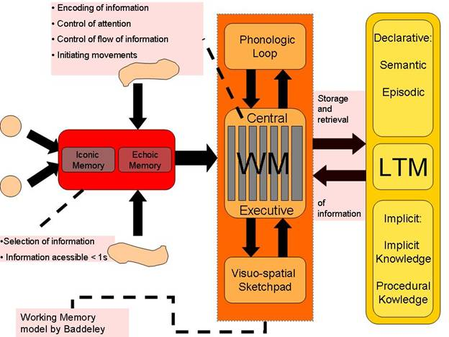
Human Memory:

Phonological Loop (sound)
Visuo-spatial sketchpad (visual)
Declarative Memory- Facts
Implicit Memory- procedural memories- how to do things (ex. Standing up)

Bio. Of Human Memory:
Hippocampus:
  - transforms short term into long term memory
  - If hippocampus is removed then you will have a tough time storing & creating long term memories
- We don’t know much about where declarative long term memories are stored
- Procedural memory appears to happen in the cerebellum, the basal ganglia, and the motor cortex
Computer Memory vs. Software memory
- Software Memory:
  - Hash Tables
  - Schemata
  - Frames
  - Scripts
  - Logical Sentences
  - Bitmaps
  - Activation patterns
  - Weights in links
- Computer Memory
  - Disk
  - Flash Memory
  - The brain is seen as a “hardware”
Memory in Distributed Systems:
Examples:
  - Books
  - Brains
  - Fingers
  - Notes
  - Arrows and sign
  - Etc.
Learning:
- Learning is changing memory with the purpose of preparing a mind for better action in the future
  - We remember things so that we can behave appropriately in the future (ex. Not eating a food that made you throw up in the past)
- Through learning we create memories
Habituation:
- Diminution of a behavioural response with repeated stimulation
  - Ex. The first time you hear a loud noise, you might be startled, but afterward you are not startled at all
Sensitization:
- Opposite of habituation
- When a behavioural response is amplified by repeated exposure to a stimulus
Classical Conditioning:
- Learning to associate two previously unrelated stimuli
- Typically this means that you learn to behave similarly to stimulus B as you do to stimulus A
Learning Classical Conditioning:
- Learning to associate two previously unrelated stimuli
- Typically this means that you learn to behave similarly to stimulus B as you do to stimulus A
- Ex. The dog learns that when you pick up the leash a walk is soon to follow
Operant Conditioning: Positive= Present, Negative=Remove, Reinforce= Make more likely, Punish= Make less likely
Positive Reinforcement (the strongest):
- An increased behaviour because of a reward
  - Ex. Someone smiles at you when you hold the door for him or her
Negative Reinforcement:
- Taking away a bad stimulus so that it can result in a positive stimulus
- Negative because you are taking something away, but still positive in its sense
  - Ex. A baby screams until you give them candy. Then she stops
Positive Punishment:
- Introducing an unpleasant stimulus
- Positive punishment discourages a behaviour and makes a behaviour less likely
  - Ex. Getting burned by touching then hood of a car in the sun
Practice:
- Practice uses classical conditioning
- Practice involves doing something over and over and learning how to do it better. It uses reinforcement and punishment to hone the skill
- Play is theorized to be a form of practice for future events (chasing, fighting, caretaking, manipulating objects, etc.)
- Motor skills (moving your body) gets easier because of automatization (automatization= doing without thinking)
  - Becomes “instinct”, fast, unconscious, and automatic (ex. Tying your shoes)
Imprinting:
- Common in animals
- A time sensitive learning in an animal that is insensitive to behavioural outcomes
- Ex. Geese imprints on whoever is around them when they are born
Common in animals
Ex. Geese imprints on whoever is around them when they are born
Observational Learning:
- Learning that happens by observing another individual to do something
  - Ex. Copying Michael Jackson dance moves on YouTube
  - Much of cultural learning (called “enculturation”) is observational, but some is explicitly taught.
Testimony:
- Learning because someone told you something (ex. Lecture, how to start a web browser...)
- It can be read or heard aloud
- A lot of what we’ve learned comes from testimony (Ex. People’s names…)
- We also get facts by figuring them out, but this is better described as “reasoning” or ‘inference” than “learning”
Learning over Human History:
Genetic:
- When environments change very slowly
- How genes in a species change to adapt to an environment

Cultural Learning (a.k.a Imitation)
- When environments change relatively quickly
  - Content Bias:
    - Imitating the best ideas (ex. Life hack on YouTube; How to Fold a Shirt)
  - Prestige Bias:
    - Imitating the most successful (ex. Imitating a celebrity)
  - Conformist Bias:
    - Imitating the most common ways of doing things
      - Ex. Even if someone of authority is wearing jeans while everyone else is wearing sweatpants, an individual would be more obliged to wear sweatpants because that is what the majority of people are wearing sweatpants
      - Culture changes because of individual learning
        - Ex. Cellphone usages
- Baldwin effect- predisposed to learning things (being afraid of a snake vs being afraid of a lamp)
- Individual learning (figuring out for yourself, perhaps influenced by the Baldwin effect)
  - When environments change very rapidly, there is reduced cultural transmission
- Of course, cultures are subject to natural selection as well. Evolution is substrate-neutral.

