MC Questions – Worth 20 marks ( 1/2Mark each)

- Scarcity exists when
a. | there is less than an infinite amount of a resource or good.
b. | society can meet the wants of every individual.
c. | there is less of a good or resource available than people wish to have.
d. | the government fails to produce goods.

- Which of the following is true?
a. | Efficiency refers to the size of the economic pie; equity refers to how the pie is divided.
b. | Fortunately, government policies are designed to promote both equity and efficiency.
c. | As long as the economic pie continually gets larger, no one will have to go hungry.
d. | Efficiency and equity can both be achieved if the economic pie is cut into equal pieces.

- Making decisions "at the margin" means that people
a. | make those decisions that do not impose a marginal cost.
b. | evaluate how easily a decision can be reversed if problems arise.
c. | compare the marginal costs and marginal benefits of each decision.
d. | always calculate the marginal dollar costs for each decision.

- Which is the best statement about the way economists study the economy?
a. | They study the past, but do not try to predict the future.
b. | They use a probabilistic approach based on correlations between economic events.
c. | They devise theories, collect data, then analyze the data to test the theories.
d. | They use controlled experiments much the same way a biologist or physicist does.

- A circular-flow diagram is a model that
a. | illustrates cost-benefit analysis.
b. | explains how the economy is organized.
c. | shows the flow of traffic in an economic region.
d. | explains how banks circulate money in the economy.

- For each good produced in a market economy, demand and supply determine
a. | the price of the good, but not the quantity.
b. | the quantity of the good, but not the price.
c. | both price and quantity.
d. | neither price nor quantity is determined by demand and supply, because prices are ultimately set by producers.
- In a market economy,
a. | demand is determined by supply.
b. | supply is determined by demand.
c. | price is determined by quantity.
d. | quantity is determined by price.
e. | Either a or b are correct, depending on the product.

- A competitive market is one in which
a. | there is only one seller of the product.
b. | each seller of the product is free to set the price of his product.
c. | each seller attempts to compete with other sellers, causing fewer sellers in the market.
d. | there are so many buyers and many sellers that each has a negligible impact on price.

- Which of the following would NOT be a determinant of demand?
a. | the price of related goods
b. | income
c. | tastes
d. | the prices of the inputs used to produce the good

- If a good is "normal," then an increase in income will result in
a. | no change in the demand for the good.
b. | an increase in the demand for the good.
c. | a decrease in the demand for the good.
d. | a lower market price.

- Suppose that a decrease in the price of X results in less of good Y sold. This would mean that X and Y are
a. | complementary goods.
b. | normal goods.
c. | inferior goods.
d. | substitute goods.

- If goods A and B are complements, an increase in the price of A will result in
a. | more of good A sold.
b. | more of good B sold.
c. | less of good B sold.
d. | no difference in the quantity sold of either good.

- You love peanut butter. You hear on the news that 50 % of the peanut crop in the South has been wiped out, which will cause the price to double by the end of the year. As a result,
a. | your demand for peanut butter will increase by the end of the year.
b. | your demand for peanut butter increases today.
c. | your demand for peanut butter falls as you look for a substitute good.
d. | you decide to give up peanut butter completely.

- Holding all else constant, a higher price for ski lift tickets would be expected to
a. | increase the number of skiers.
b. | decrease the supply of ski resorts.
c. | decrease the demand for other winter recreational activities.
d. | decrease ski sales.

- The concept of elasticity is used to
a. | analyze how much the economy is capable of expanding.
b. | determine the level of government invention in the economy.
c. | analyze supply and demand with greater precision.
d. | calculate consumer credit purchases.

- Demand is said to be inelastic if
a. | the quantity demanded changes only slightly when the price of the good changes.
b. | demand shifts only slightly when the price of the good changes.
c. | buyers respond substantially to changes in the price of the good.
d. | the price of the good responds only slightly to changes in demand.

- If a good is a necessity, demand for the good would tend to be
a. | elastic.
b. | horizontal.
c. | unit elastic.
d. | inelastic.

- If a good is a luxury, demand for the good would tend to be
a. | inelastic.
b. | elastic.
c. | unit elastic.
d. | horizontal.

- Demand for a good would tend to be more inelastic the
a. | fewer the available substitutes.
b. | longer the time period considered.
c. | more the good is considered a luxury good.
d. | more narrowly defined the market is.

- Chocolate Chip Cookie Dough ice cream would tend to have very elastic demand because
a. | it must be eaten quickly.
b. | the market is broadly defined.
c. | there are few substitutes.
d. | other flavors of ice cream are almost perfect substitutes.

- When the price of bubble gum is $0.50, the quantity demanded is 400 packs per day. When the price falls to $0.40, the quantity demanded increases to 600. Given this information and using the midpoint method, you know that the demand for bubble gum is
a. | inelastic.
b. | elastic.
c. | unit elastic.
d. | perfectly inelastic.

- Suppose the price of Twinkies is reduced from $1.45 to $1.25 and, as a result, the quantity of Twinkies demanded increases from 2,000 to 2,200. Using the midpoint method, the price elasticity of demand for Twinkies in the given price range is
a. | 2.00.
b. | 1.55.
c. | 1.00.
d. | .64.

- When the local used bookstore prices economics books at $15.00 each, they generally sell 70 per month. If they lower the price to $7.00 each they sell 90. Given this, we know that the elasticity of demand for economics books is
a. | 2.91, so this store should lower price to raise total revenue.
b. | 2.91, so this store should raise price to raise total revenue.
c. | 0.34, so this store should lower price to raise total revenue.
d. | 0.34, so this store should raise price to raise total revenue.

- Demand is said to be unit elastic if
a. | quantity demanded changes by the same percent as the price.
b. | quantity demanded changes by a larger percent than the price.
c. | the demand curve shifts by the same percentage amount as the price.
d. | quantity demanded does not respond to a change in price.

- Price controls are
a. | used to make markets more efficient.
b. | usually enacted when policymakers believe that the market price of a good or service is unfair to buyers or sellers.
c. | nearly always effective in eliminating inequities.
d. | established by firms with monopoly power.

- A government-imposed maximum price at which a good can be sold is called a price
a. | floor.
b. | ceiling.
c. | support.
d. | equilibrium.

- A legal minimum price at which a good can be sold is a price
a. | cut.
b. | stabilization.
c. | ceiling.
d. | floor.

- A binding price ceiling causes
a. | a shortage, which cannot be eliminated through market adjustment.
b. | a surplus, which cannot be eliminated through market adjustment.
c. | a shortage, which is temporary, since market adjustment will cause price to rise.
d. | a surplus, which is temporary, since market adjustment will cause price to rise.

Figure 6-2
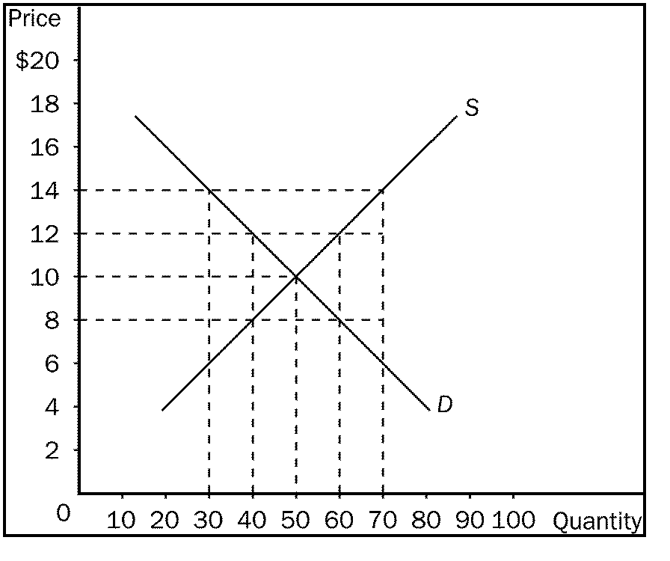
- Refer to Figure 6-2. A binding price ceiling would exist at a price of
a. | $14.00.
b. | $12.00.
c. | $10.00.
d. | $8.00.

- Refer to Figure 6-2. If the government imposes a binding price floor of $14.00 in this market, the result would be a
a. | surplus of 20.
b. | surplus of 40.
c. | shortage of 20.
d. | shortage of 40.

- Refer to Figure 6-2. If the government imposes a binding price ceiling of $8.00 in this market, the result would be a
a. | surplus of 20.
b. | surplus of 40.
c. | shortage of 20.
d. | shortage of 40.

- Refer to Figure 6-2. A binding price floor would exist at
a. | a price of $10.00.
b. | a price of $8.00.
c. | any price above $10.00.
d. | any price below $10.00.

- Economic profit is equal to
(i) | total revenue - (explicit costs + implicit costs).
(ii) | total revenue - opportunity costs.
(iii) | accounting profit + implicit costs.

a. | (i) only
b. | (i) and (ii)
c. | (ii) and (iii).
d. | All of the above are correct.

- One would expect to observe diminishing marginal product of labour when
a. | crowded office space reduces the productivity of new workers.
b. | workers are discouraged about the lack of help from other workers.
c. | only new workers are trained in using the most productive capital.
d. | union workers are told to reduce their work effort in preparation for a new round of collective bargaining talks.

- Let L represent the number of workers hired by a firm and let Q represent that firm's quantity of output. Assume two points on the firm's production function are (L = 12, Q = 122) and (L = 13, Q = 130). Then the marginal product of the 13th worker is
a. | 8 units of output.
b. | 10 units of output.
c. | 122 units of output.
d. | 130 units of output.

- One assumption that distinguishes short-run cost analysis from long-run cost analysis for a profit-maximizing firm is that in the short run,
a. | output is not variable.
b. | the number of workers used to produce the firm's product is fixed.
c. | the size of the factory is fixed.
d. | there are no fixed costs.

- The cost of producing the typical unit of output is the firm's
a. | average total cost.
b. | opportunity cost.
c. | variable cost.
d. | marginal cost.

- Marginal cost equals
(i) |  |  | change in total cost divided by change in quantity produced.
(ii) |  |  | change in variable cost divided by change in quantity produced.
(iii) |  |  | the average fixed cost of the current unit.
 | a. | (i) and (ii)
 | b. | (ii) and (iii)
 | c. | (ii) only
 | d. | All of the above are correct.

- Economic profit
a. | will never exceed accounting profit.
b. | is most often equal to accounting profit.
c. | is always at least as large as accounting profit.
d. | is a less complete measure of profitability than accounting profit.

- Which of the following would be categorized as an implicit cost?
(i) |  |  | wages of workers
(ii) |  |  | raw material costs
(iii) |  |  | forgone investment opportunities
 | a. | (i) and (iii)
 | b. | (iii) only
 | c. | (ii) and (iii)
 | d. | All of the above are correct.
Short Answer Questions – Worth 80 marks

- For your birthday, your friends have joined forces and offer you a choice among the following options (they will pay all expenses of your choice) (3 Marks):
A) A two-week trip to an exotic destination;
B) A new, high-tech mountain bike,
C) An annual pass to your preferred sports team games, and D) A dinner with your preferred movie star.
Suppose your subjective valuations of these options are as follows: A)$800, B)$700, C)$1500, and D)$1000. If you are a rational individual, you will obviously choose C, the annual pass, because it is the option of your highest valuation.
a) What is your opportunity cost of choosing option C? Explain.
b) Now, suppose your friends announce at the last minute a fifth option, E, a cheque of $1100. What is now your opportunity cost of choosing option C?
c) As you can see, the theory of opportunity cost implies that the cost of an action depends on other, seemingly unrelated facts. Why does this make sense?

- Suppose that there are 10 million workers in Canada and South Korea and each worker in Canada and South Korea can produce 4 cars per year. A Canadian worker can produce 10 tonnes of grain a year, whereas, a South Korean worker can produce 5 tonnes of grain a year. The following table shows the production of grain and cars for the two countries, Canada and South Korea.
(18 Marks)

1 Worker | Cars | Grain
Canada | 4 | 10
South Korea | 4 | 5

(a) Graph the production possibilities frontier of the Canadian and South Korean economies. (6 Mark)
(b) For Canada, what is the opportunity cost of a car? What is the opportunity cost for grain? For South Korea, what is the opportunity cost of a car? For grain? (8 Marks)
(c) Which country has an absolute advantage in producing cars? In producing grain.(2 Mark)
(d) Which country has a comparative advantage in producing cars? In producing grain. (2 Mark)

Demand and Supply Schedule

Price | Quantity Demanded/Month | Quantity Supplied/Month
$5 | 6,000 | 10,000
$4 | 8,000 | 8,000
$3 | 10,000 | 6,000
$2 | 12,000 | 4,000
$1 | 14,000 | 2,000

- (a) Given the above table, graph the demand and supply curves for flashlights. Make certain to label equilibrium price and equilibrium quantity.
(b) What is the equilibrium price and equilibrium quantity?
(c) Suppose the price is currently at $5. What problem would exist in the economy? What would you expect to happen to price? Show this on your graph.
(d) Suppose the price is currently $2. What problem exists in the economy? What would you expect to happen to price? Show this on your graph. (13 Marks)

- Fill in the accompanying table, showing whether equilibrium price and equilibrium quantity go up, down, stay the same or is ambiguous (9 Marks)

 | No Change in Supply | An Increase in Supply | A Decrease in Supply
No Change in Demand
An Increase in Demand
A Decrease in Demand

- (a) Using the graph shown, analyze the effect a $300 price ceiling would have on the market for ten-speed bicycles. Would this be a binding price ceiling? (9 Marks)
(b) Using the graph shown, analyze the effect a $700 price floor would have on this market. Would this be a binding price floor?
(c) Why would policymakers choose to impose a price ceiling or price floor?

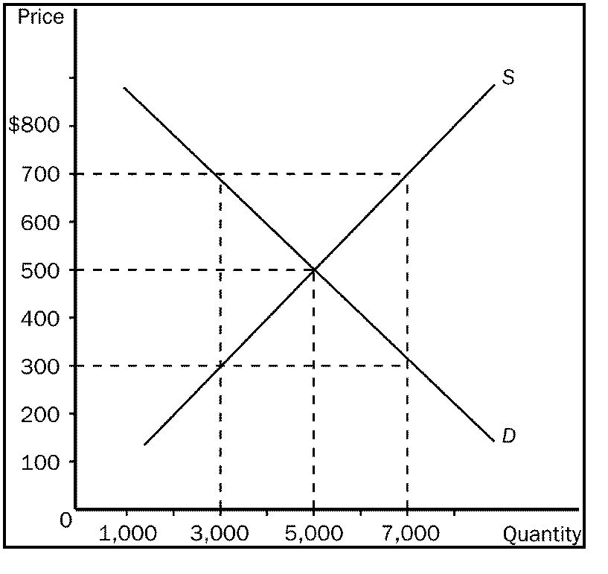

- Consider the following pairs of goods. Which would you expect to have the more elastic demand? Why? (5 Marks)
a. | water or diamonds
b. | insulin or nasal decongestant spray
c. | food in general or breakfast cereal
d. | gasoline over the course of a week or gasoline over the course of a year
e. | personal computers or IBM personal computers

- Using the midpoint method, compute the elasticity of demand between points A and B. Is this portion of the curve elastic or inelastic? Interpret your answer with regard to price and quantity demanded. Now compute the elasticity of demand between points B and C. Is this portion of the curve elastic or inelastic? (8 Marks)

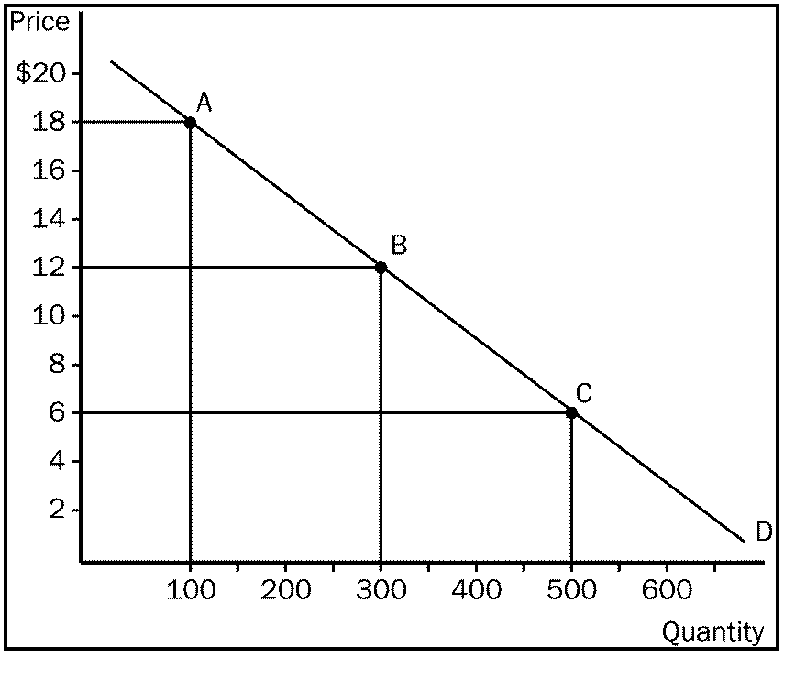

- You own a small town movie theatre. You currently charge $5 per ticket for everyone who comes to your movies. Your friend who took an economics course in college tells you that there may be a way to increase your total revenue. Given the demand curves shown, answer the following questions. (15 Marks)

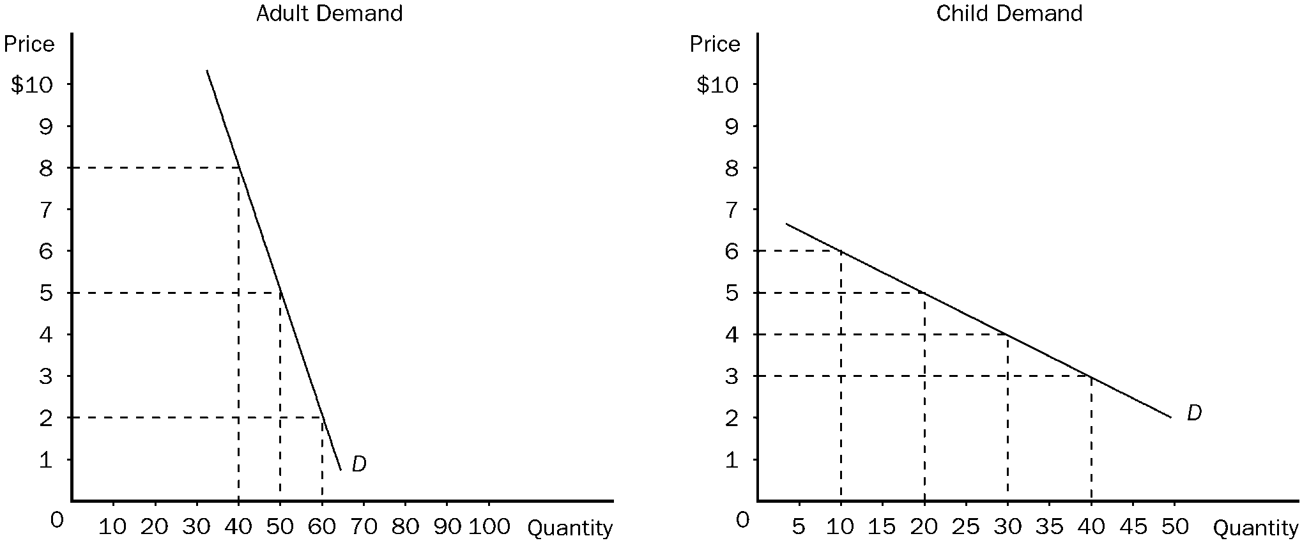

a. | What is your current total revenue for both groups? (1 Mark)
b. | The elasticity of demand is more elastic in which market? (1 Mark)
c. | Which market has the more inelastic demand? (1 Mark)
d. | What is the elasticity of demand between the prices of $5 and $2 in the adult market? Is this elastic or inelastic? (1 Mark)
e. | What is the elasticity of demand between $5 and $3 in the children's market? Is this elastic or inelastic? (1 Mark)
f. | Given the graphs and what your friend knows about economics, he recommends you increase the price of adult tickets to $8 each and lower the price of a child's ticket to $3. How much could you increase total revenue if you take his advice? (5 Marks)

