Review Questions in Preparation for Final Micro Exam
Wednesday, June 18, 2015

Chapter 14

- a. The following table shows a firm’s costs.

Q | FC=$9 | MC | VC | TC=FC+VC | ATC=TC/Q
1 | 9 | 2 | 2 | 11 | 11
2 | 9 | 4 | 6 | 15 | 7.5
3 | 9 | 6 | 12 | 21 | 7
4 | 9 | 8 | 20 | 29 | 7.25
5 | 9 | 10 | 30 | 39 | 7.8
6 | 9 | 12 | 42 | 51 | 8.5

b. The demand schedule shows 200 pies demanded at P = $11. The quantity of pies produced by a firm when the price is $11 is found where price equals marginal cost, which gives us Q* = 5 (for pie #5, the marginal cost is $10, but if the firm would produce one more pie it would lose $1). The profit to each firm is equal to P × Q − TC = 11 × 5 − 39 = $16.

c. This is not a long-run equilibrium; since entry is free and there are positive profits, more firms will enter, driving the price down.

d. Each firm makes zero profit in the long run. The price that maximizes profit and makes it zero is equal to the lowest value of ATC, P = Lowest ATC = $7. At this price the quantity demanded is 600 pies and each firm produces 3 pies. Thus, the number of firms in the market is 600/3 = 200.

10. Ball Bearings Inc.

- The following table shows the company’s costs:

Quantity | Total Fixed Costs | Total Variable Costs | Average Fixed Costs | Average Variable Costs | Average Total Costs | Marginal Costs
0 | $100 | $0 | − | − | − | −
1 | 100 | 50 | $100 | $50 | $150 | $50
2 | 100 | 70 | 50 | 35 | 85 | 20
3 | 100 | 90 | 33.33 | 30 | 63.33 | 20
4 | 100 | 140 | 25 | 35 | 60 | 50
5 | 100 | 200 | 20 | 40 | 60 | 60
6 | 100 | 360 | 16.67 | 60 | 76.67 | 160
- The firm must produce 4 units to maximize profit, because marginal cost is equal to the price at that production level. Profit is equal to 4 × $50 – 4 × $60 = −$40, which is a loss of $40. However, the firm should not shut down because if it does, it loses the fixed costs, which are equal to $100. By operating, the firm minimizes losses.

- If the firm produces 1 unit of output, the loss is $50 − $150 = $100, which is greater than the one corresponding to the loss-minimizing level of production of 4. However, it is still better to produce 1 unit than to produce nothing.

11. In a competitive market, marginal revenue is equal to average revenue and both are equal to the market price, which in our case is $10. Since total revenue is $500, the quantity sold must be 500/10 = 50 units.

12. The market price is $10, thus total revenue is $1000. Total cost is 100 × 8 = $800.

a. Profit = 1000 – 800 = $200

b. Marginal cost = price = $10.

c. Average variable cost = average total cost – average fixed cost = 8 − (200/100) = $6.

d. At a level of production of 100 units, marginal cost is greater than average total cost. Therefore, the efficient level of production (where average total cost is minimum) is less than 100 units.

Chapter 15

3. A monopolist’s marginal revenue is less than the price of its product because: (1) its demand curve is the market demand curve, so (2) to increase the amount sold, the monopolist must lower the price of its good for every unit it sells. (3) This cut in prices reduces revenue on the units it was already selling.

A monopolist’s marginal revenue can be negative because, to get purchasers to buy an additional unit of the good, the firm must reduce its price on all units of the good. The fact that it sells a greater quantity increases revenue, but the decline in price decreases revenue. The overall effect depends on the elasticity of the demand curve. If the demand curve is inelastic, marginal revenue will be negative.
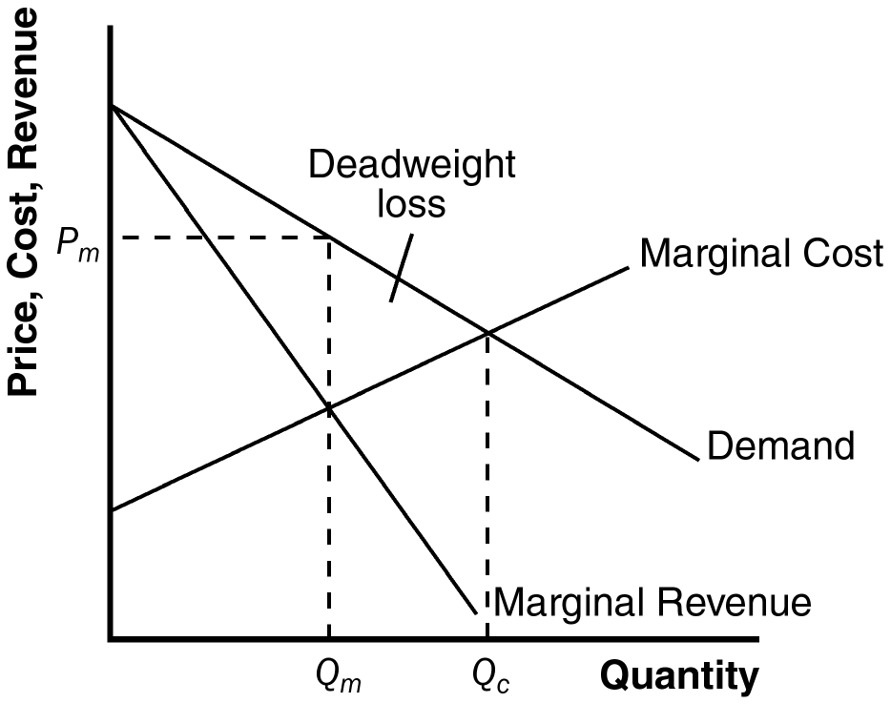
4. Figure 1 shows the demand, marginal-revenue, and marginal-cost curves for a monopolist. The intersection of the marginal-revenue and marginal-cost curves determines the profit-maximizing level of output, Q_{m}. The demand curve then shows the profit-maximizing price, P_{m}.

Figure 1
5. The level of output that maximizes total surplus in Figure 1 is where the demand curve intersects the marginal-cost curve, Q_{c}. The deadweight loss from monopoly is the triangular area between Q_{c} and Q_{m} that is above the marginal-cost curve and below the demand curve. It represents deadweight loss, since society loses total surplus because of monopoly, equal to the value of the good (measured by the height of the demand curve) less the cost of production (given by the height of the marginal-cost curve) for the quantities between Q_{m} and Q_{c}.

Chapter 16

3. a. Both.

- Both.

- Monopolistically competitive firm.

- Monopoly.

- Both.

- Neither.

4. a. Figure 4 illustrates the market for Sparkle toothpaste in long-run equilibrium. The profit-maximizing level of output is Q_{M} and the price is P_{M}.

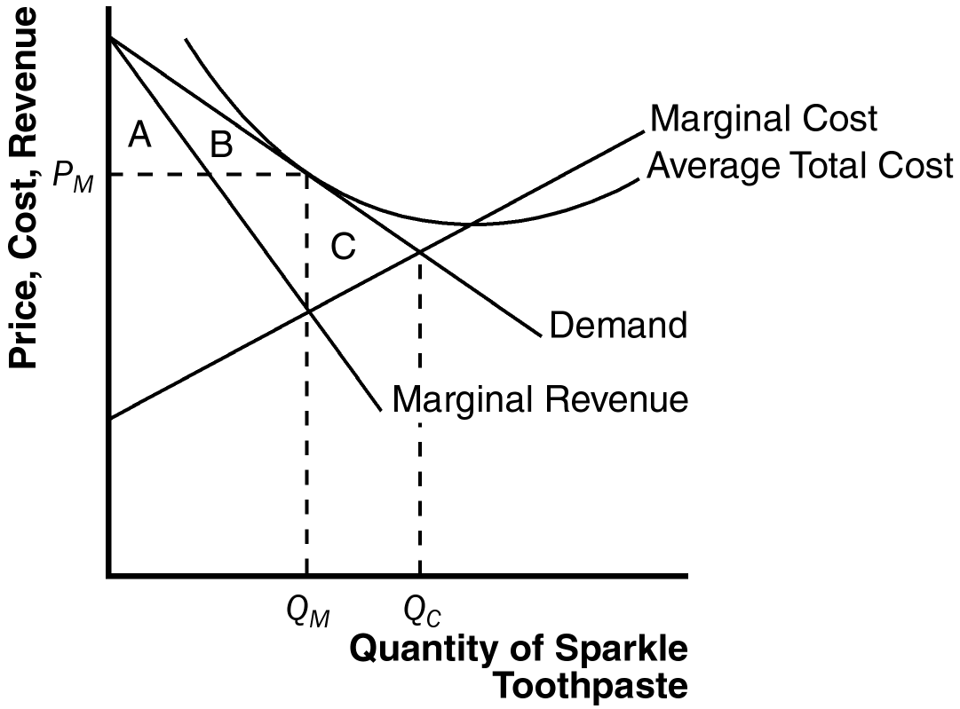

Figure 4

b. Sparkle’s profit is zero, since at quantity Q_{M}, price equals average total cost.

c. The consumer surplus from the purchase of Sparkle toothpaste is area A + B. The efficient level of output occurs where the demand curve intersects the marginal-cost curve, at Q_{C}. So the deadweight loss is area C, the area above marginal cost and below demand, from Q_{M} to Q_{C}.

d. If the government forced Sparkle to produce the efficient level of output, the firm would lose money because average cost would exceed price, so the firm would shut down. If that happened, Sparkle’s customers would earn no consumer surplus.

