Statistics: The science of collecting, organising, presenting, analysing and interpreting a set of data
  - Descriptive statistics focuses on collecting, summarising, presenting and analysing a set of data
  - Inferential statistics uses data that have been collected from a small group to draw conclusions about a larger group
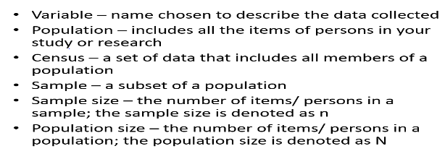
- A parameter is a numerical measure that describes a characteristic of a population
- Numeric data is quantitative
- Non-numeric data is qualitative
- Primary data is collected directly from respondents (participants)
- Secondary data is collected by another party or source
- * Interval - “0” is only an arbitary reference point, “0” does not mean “nothin g”, it actually represents a point of measure // Examples. Temperature, Personality measure, SAT score, IQ score // 0 C does not mean “no heat”
- * Ratio - Does mean “0”, “0” means the absence of the characteristic being measured, “0” means nothing. // Examples - # of DVD’s owned, Distance travelled, income, height, weight, volume
- * Discrete Data: COUNTING : distinct values, no fractions // “How many TV’s you buy?” = 1, 2, 3 - you can’t buy 1&half TV’s, only full values
- * Continuous Data: can assume any value within a range // “How long have you waited?” = 1m20s, 3min40s - You can have a decimal value // Money is continuous
- Nominal - No specific order of data, can be put in any way // Ex. Gender, ethnicity, bar code, religion, martial status
- Ordinal - Natural order to the catergories, one category higher than other // Ex. Movie rating, ranking, edu. level
- Pareto charts are combinations of bar graphs and an ogive
  - An ogive is a line representing the cumulative frequency
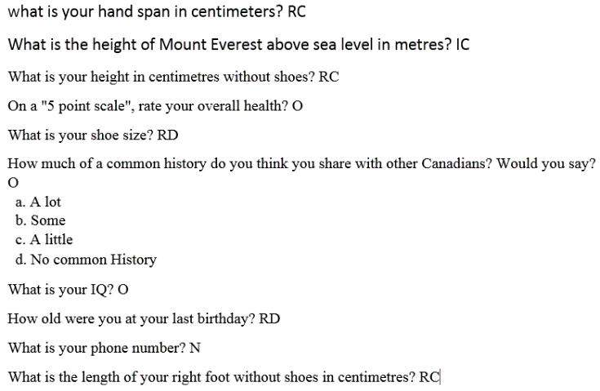
- Pareto principle is the 80/20 rule – 80% of problems arise from 20% of problem sources
Stem and Leaf
6-13 Stems only
We can either split the leaves associated with a stem into two (0 – 4 & 5 – 9)
groups or five (0&1, 2 &3, 4&5, 6&7, 8&9) groups
Negative is opposite
- How do we sort data using the calculator?
In STAT mode enter 16, 19, 22, 17, 19, 25, 17, 20, 27 being sure to press EXE after every
number
- Press F6 to go to the next screen so you see the option TOOL above F1
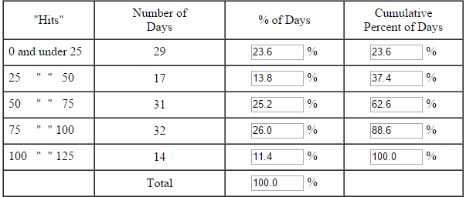
- Press F1 to select tool and then press F1 again to select SRT-A or SORT
- Input 1 when it asks how many lists and input the list number when it asks you which list?
- Press EXE to get 16 17 17 19 19 20 22 25 27
- NEGATIVE 0.0, -3.12, -1.12, -2.51, -1.76, -1.36, 1.38, -0.71, -0.3, 1.65
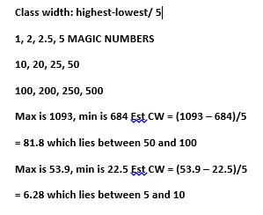
-3 1
-2 5
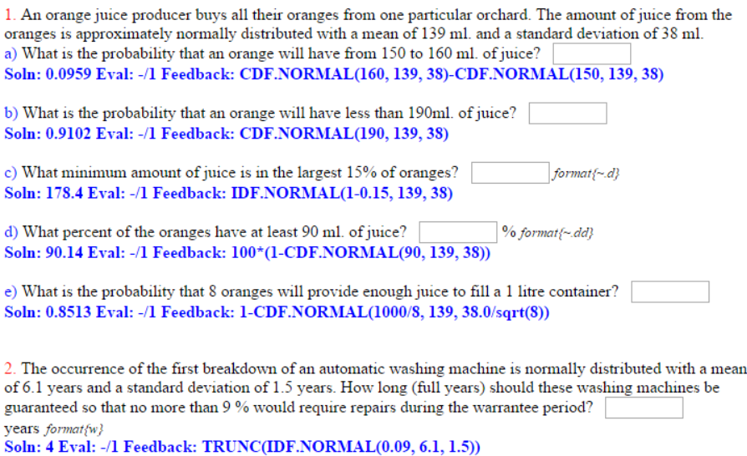
-1 7 3 1
-0 7 3
0 0
1 3 6
Percentiles
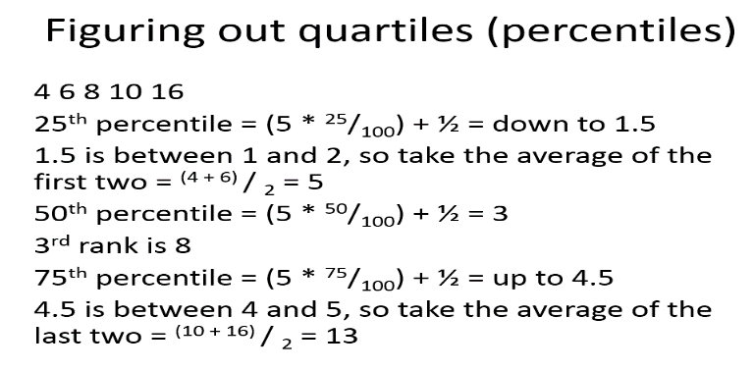
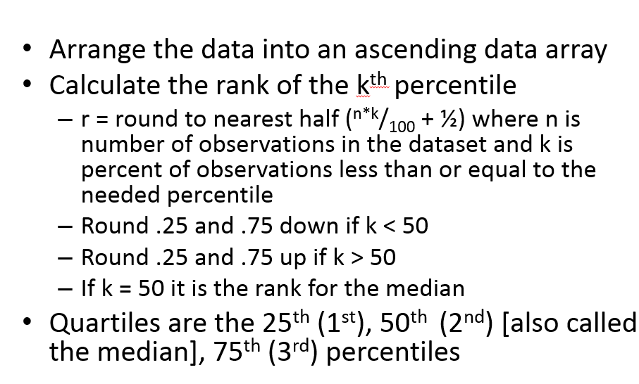
FIND MEAN CALC
Enter the frequencies under List 2 making sure that each frequency is on the same line as the relevant number in List 1
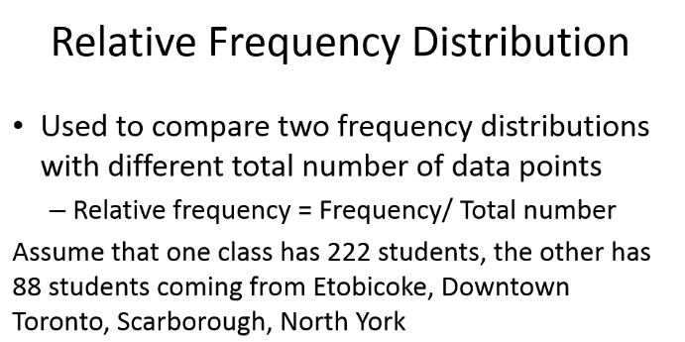
Press the button under the word CALC
Press the button under the word SET
Press the button under the word LIST
Specify that 1Var Xlist is 1
Specify that 1Var Freq is 2
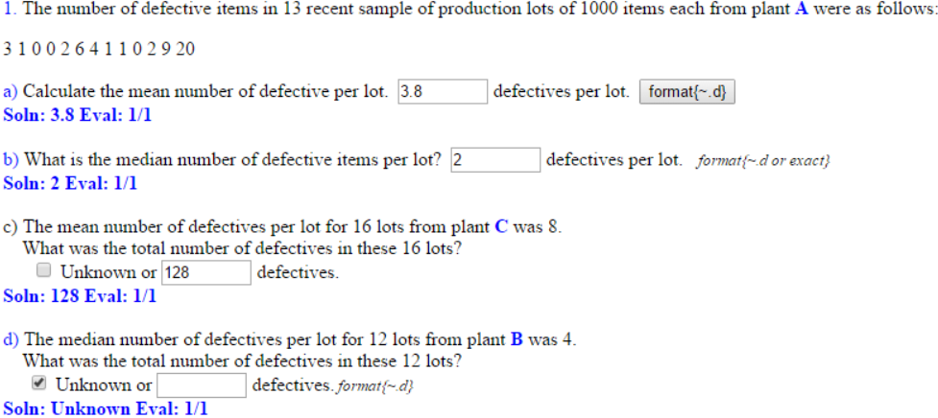
Press EXIT and then press the button under 1VAR to get the grouped data mean


