Why and How Managers Control
- Controlling
  - The process of measuring performance and taking action to ensure desired results.
  - Has a positive and necessary role in the management process.
  - Ensures that the right things happen, in the right way, at the right time.
  - Organizational learning and after-action review.
Figure 16.1 The role of controlling in the management process.
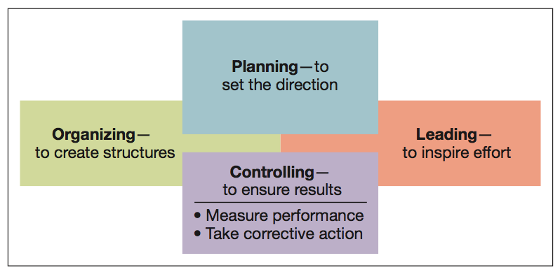

- Feedforward controls
  - Employed before a work activity begins.
  - Ensures that:
    - Objectives are clear.
    - Proper directions are established.
    - Right resources are available.
  - Focuses on quality of resources

Concurrent controls
- Focus on what happens during work process.
- Monitor ongoing operations to make sure they are being done according to plan.
- Can reduce waste in unacceptable finished products or services.
Feedback controls
- Take place after work is completed.
- Focus on quality of end results.
- Provide useful information for improving future operations.

Figure 16.2 The role of feedforward, concurrent, and feedback controls in organizations.
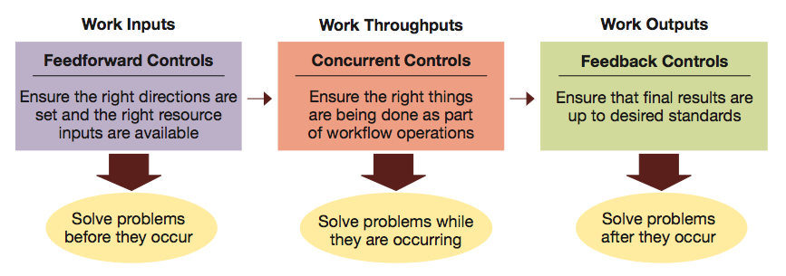

Internal and external control
- Internal control or Self-control
  - Allows motivated individuals and groups to exercise self-discipline in fulfilling job expectations.
- External control
  - Occurs through personal supervision and the use of formal administrative systems.
Bureaucratic control
- influences behaviour through authority, policies, procedures, job descriptions, budgets, and day-to-day supervision
Clan control
- influences behaviour through norms and expectations set by the organizational culture.
Market control
- influences behaviour through market competition.
Steps in the control process:
Step 1 — establish objectives and standards.
Step 2 — measure actual performance.
Step 3 — compare results with objectives and standards.
Step 4 — take corrective action as needed.
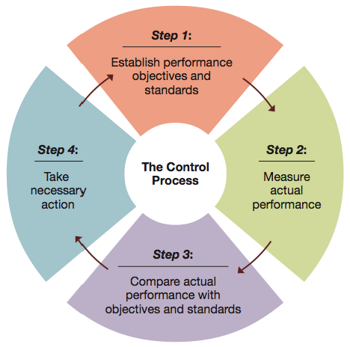
Figure 16.3 Four steps in the control process.

Step 1 — establishing objectives and standards
- Output standards
  - Measure performance results in terms of quantity, quality, cost, or time.
- Input standards
  - Measure effort in terms of amount of work expended in task performance.
Step 2 — measuring actual performance
- Goal is accurate measurement of actual performance results and/or performance efforts.
- Must identify significant differences between actual results and original plan.
- Effective control requires measurement.
Step 3 — comparing results with objectives and standards
- Need for action reflects the difference between desired performance and actual performance
- Comparison methods:
  - Historical comparison
  - Relative comparison
  - Engineering comparison
Step 4 — taking corrective action
- Taking action when a discrepancy exists between desired and actual performance.
- Management by exception
  - Giving attention to situations showing the greatest need for action.
  - Types of exceptions
    - Problem situation
    - Opportunity situation
Employee discipline systems
- Discipline is the act of influencing behaviour through reprimand.
- Discipline that is applied fairly, consistently, and systematically provides useful control.
- Progressive discipline ties reprimands to the severity and frequency of the employee’s infractions.
- Progressive discipline seeks to achieve compliance with the least extreme reprimand possible.
To be effective, reprimands should
- Be immediate.
- Be directed toward actions, not personality.
- Be consistently applied.
- Be informative.
- Occur in a supportive setting.
- Support realistic rules.
Project Management
- Overall planning, supervision, and control of projects.
  - Projects – unique one-time events that occur within a defined time period
  - Gantt chart – graphic display of scheduled tasks required to complete a project
  - CPM/PERT – combination of the critical path method and program evaluation and review technique

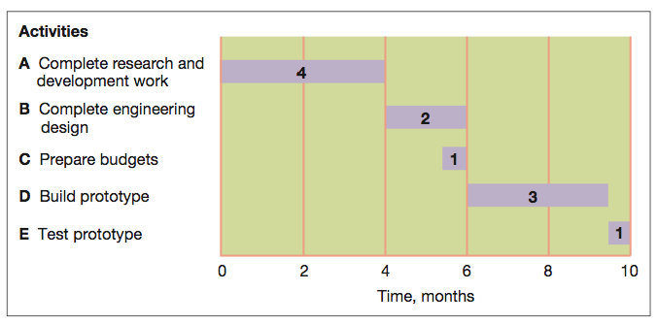
Figure 16.4 Simplified Gantt chart for a new cell phone

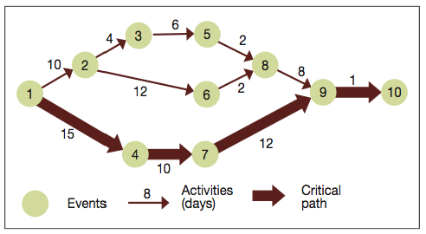
Figure 16.5 Sample CPM/PERT

Economic Value Added
- a performance measure of economic value created in respect to profits being higher than the cost of capital
Market Value Added
- a performance measure of stock market value relative to the cost of capital

Basic Financial Ratios
- Liquidity
  - The ability to generate cash to pay bills.
- Leverage
  - The ability to earn more in returns than the cost of debt.
- Asset management
  - The ability to use resources efficiently and operate at minimum cost.
- Profitability
  - The ability to earn revenues greater than costs.
Balanced Scorecard
- Factors used to develop scorecard goals and measures:
  - Financial performance
  - Customer Satisfaction
  - Internal process improvement
  - Innovation and learning

