Organizing as a Management Function
- Organizing and organization structure
- Organizing
  - The process of arranging people and other resources to work together to accomplish a goal.
- Organization structure
  - The system of tasks, workflows, reporting relationships, and communication channels that link together diverse individuals and groups.
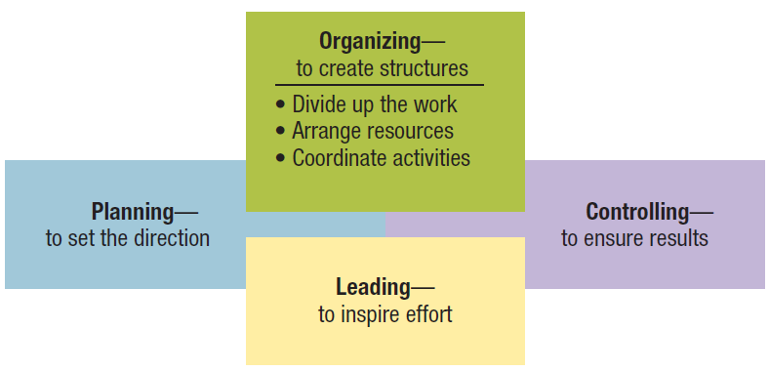
Figure 8.1 Organizing viewed in relationship with the other management functions.

- Formal structures
- The structure of the organization in its official state.
- An organization chart is a diagram describing reporting relationships and the formal arrangement of work positions within an organization.
- An organization chart identifies the following aspects of formal structure:
  - The division of work.
  - Supervisory relationships.
  - Communication channels.
  - Major subunits.
  - Levels of management.
- Informal structures
- A “shadow” organization made up of the unofficial, but often critical, working relationships between organization members.
- Potential advantages of informal structures:
  - Helping people accomplish their work.
  - Overcoming limits of formal structure.
  - Gaining access to interpersonal networks.
  - Informal learning.

- Potential disadvantages of informal structures:
  - May work against best interests of entire organization.
  - Susceptibility to rumor.
  - May carry inaccurate information.
  - May breed resistance to change.
  - Diversion of work efforts from important objectives.
  - Feeling of alienation by outsiders.
Traditional Organization Structures
- Functional structures
- People with similar skills and performing similar tasks are grouped together into formal work units.
- Members work in their functional areas of expertise.
- Are not limited to businesses.
- Work well for small organizations producing few products or services.

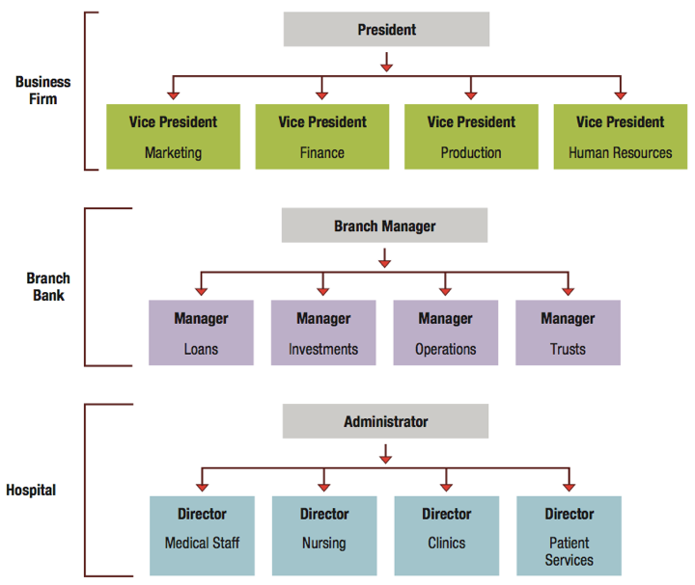
Figure 8.3 Functional structures in a business, branch bank, and community hospital.

- Potential advantages of functional structures:
- Economies of scale.
- Task assignments consistent with expertise and training.
- High-quality technical problem solving,
- In-depth training and skill development.
- Clear career paths within functions.
- Potential disadvantages of functional structures:
- Difficulties in pinpointing responsibilities.
- Functional chimneys problem.
- Sense of cooperation and common purpose break down.
- Narrow view of performance objectives.
- Excessive upward referral of decisions.
- Divisional structures
- Group together people who work on the same product or process, serve similar customers, and/or are located in the same area or geographical region.
- Common in complex organizations.
- Avoid problems associated with functional structures.
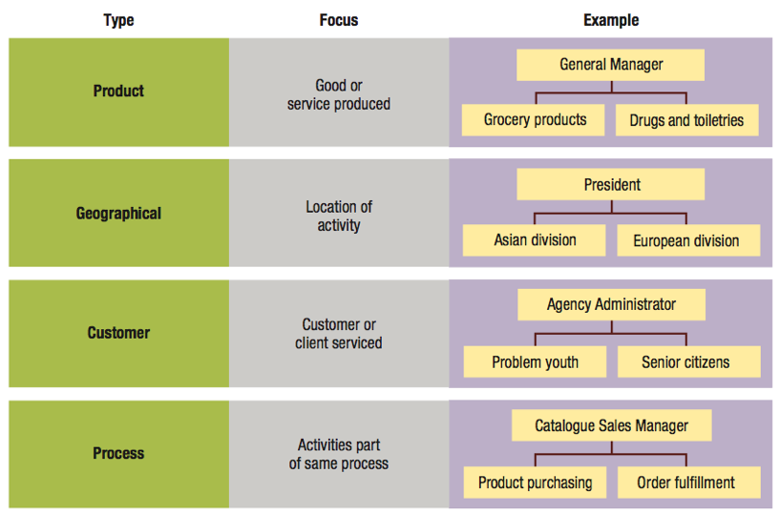
Figure 8.4 Divisional structures based on product, geography, customer, and process.

- Types of divisional structures and how they group job and activities:
- Product structures focus on a single product or service.
- Geographical structures focus on the same location or geographical region.
- Customer structures focus on the same customers or clients.
- Process structures focus on the same processes.
- Potential advantages of divisional structures:
- More flexibility in responding to environmental changes.
- Improved coordination.
- Clear points of responsibility.
- Expertise focused on specific customers, products, and regions.
- Greater ease in restructuring.
- Potential disadvantages of divisional structures:
- Duplication of resources and efforts across divisions.
- Competition and poor coordination across divisions.
- Emphasis on divisional goals at expense of organizational goals.

- Matrix structure
- Combines functional and divisional structures to gain advantages and minimize disadvantages of each.
- Used in:
  - Manufacturing
  - Service industries
  - Professional fields
  - Non-profit sector
  - Multi-national corporations
Figure 8.5 Matrix structure in a small multi-project business firm.
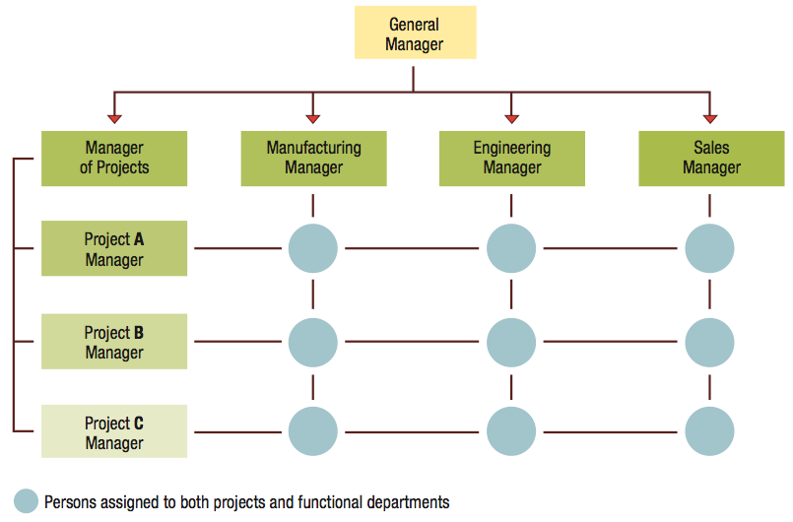

- Potential advantages of matrix structures:
- Better cooperation across functions.
- Improved decision making.
- Increased flexibility in restructuring.
- Better customer service.
- Better performance accountability.
- Improved strategic management.
- Potential disadvantages of matrix structures:
- Two-boss system is susceptible to power struggles.
- Two-boss system can create task confusion and conflict in work priorities.
- Team meetings are time consuming.
- Team may develop “groupitis.”
- Increased costs due to adding team leers to structure.

Horizontal Organization Structures
- Team structures
- Extensively use permanent and temporary teams to solve problems, complete special projects, and accomplish day-to-day tasks.
- Often use cross-functional teams composed of members from different functional departments.
- Project teams are convened for a specific task or project and disbanded once completed.
Figure 8.6 How a team structure uses cross-functional teams for improved lateral relations.
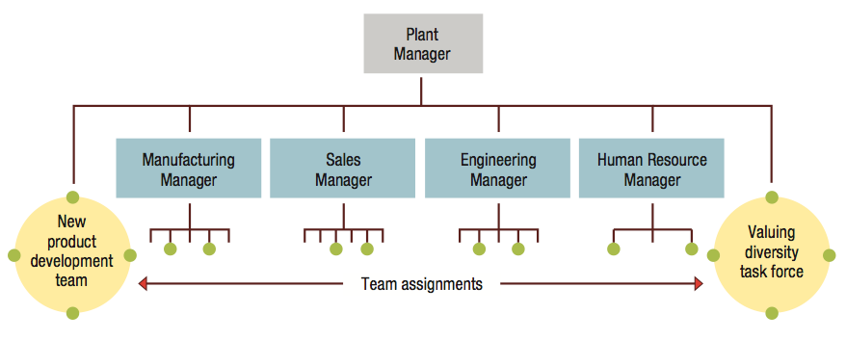

- Potential advantages of team structures:
- Eliminates difficulties with communication and decision making.
- Eliminates barriers between operating departments.
- Improved morale.
- Greater sense of involvement and identification.
- Increased enthusiasm for work.
- Improved quality and speed of decision making.
- Potential disadvantages of team structures:
- Conflicting loyalties among members.
- Excessive time spent in meetings.
- Effective use of time depends on quality of interpersonal relations, group dynamics, and team management.
- Network structures
- A central core that is linked through networks of relationships with outside contractors and suppliers of essential services.
- Own only core components and use strategic alliances or outsourcing to provideother components.

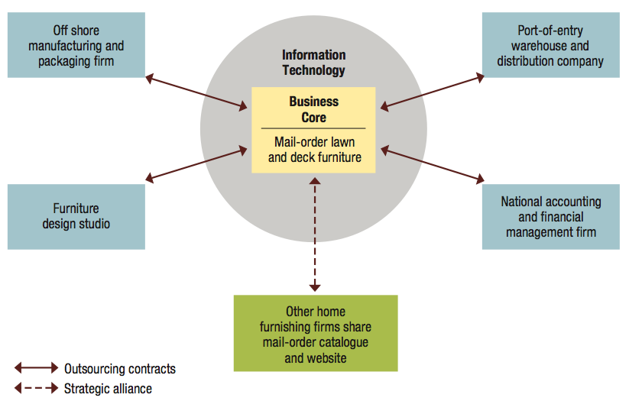
Figure 8.7 A network structure for a Web-based retail business.

- Potential advantages of network structures:
- Firms can operate with fewer full-time employees and less complex internal systems.
- Reduced overhead costs and increased operating efficiency.
- Permits operations across great distances.

- Potential disadvantages of network structures:
- Control and coordination problems may arise from network complexity.
- Potential loss of control over outsourced activities.
- Potential lack of loyalty among infrequently used contractors.
- Excessively aggressive outsourcing can be dangerous.
- Boundaryless organizations
- Eliminate internal boundaries among subsystems and external boundaries with the external environment.
- A combination of team and network structures, with the addition of “temporariness.”
- Key requirements:
  - Absence of hierarchy.
  - Empowerment of team members.
  - Technology utilization.
  - Acceptance of impermanence.
- Encourage creativity, quality, timeliness, flexibility, and efficiency.
- Knowledge sharing is both a goal and essential component.

- Virtual organization.
  - A special form of boundaryless organization.
  - Operates in a shifting network of external alliances that are engaged as needed, using IT and the Internet.
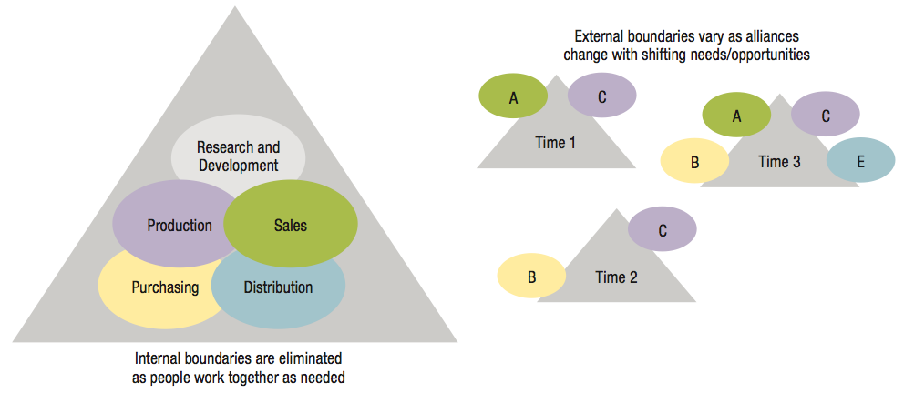
Figure 8.8 The boundaryless organization eliminates internal and external barriers.

Organizational Designs
- Organizational design
- Choosing and implementing structures that best arrange resources to serve the organization’s mission and objectives.
- A problem-solving activity that should be approached from a contingency perspective.

- Bureaucracy
- A form of organization based on logic, order, and the legitimate use of formal authority.
- Bureaucratic designs feature …
  - Clear-cut division of labour.
  - Strict hierarchy of authority.
  - Formal rules and procedures.
  - Promotion based on competency.
- Contingency perspective on bureaucracy asks the questions:
- When is a bureaucratic form a good choice for an organization?
- What alternatives exist when it is not a good choice?
- Environment determines the answers to these questions.
- A mechanistic design works in a stable environment
- An organic design works in a rapidly changing and uncertain environment.

- Mechanistic Designs
- Predictable goals
- Centralized authority
- Many rules and procedures
- Narrow spans of control
- Specialized tasks
- Few teams and task forces
- Formal and impersonal means of coordination
- Organic Designs
- Adaptable goals
- Decentralized authority
- Few rules and procedures
- Wide spans of control
- Shared tasks
- Many teams and task forces
- Informal and personal means of coordination

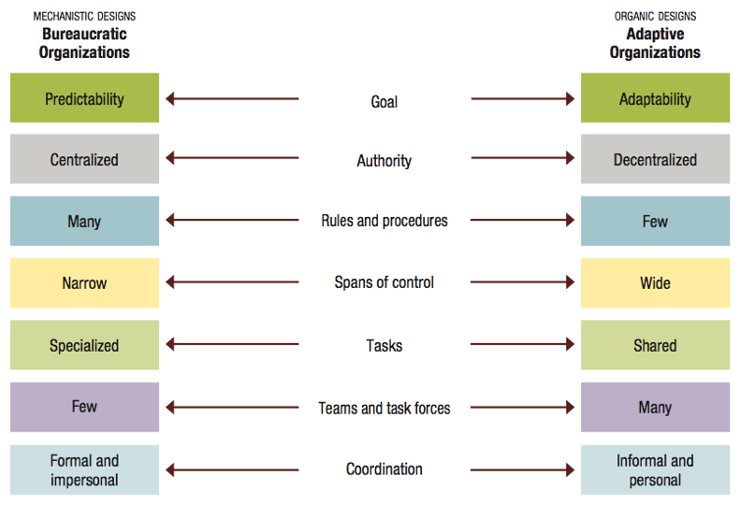
Figure 8.9 A continuum of organizational design alternatives: from bureaucratic to adaptive organizations.

- Basics of subsystem design
- Subsystem
  - A department or work unit headed by a manager.
  - Operates as a smaller part of the larger organization.
- Ideally, each subsystem supports other subsystems, working toward interests of entire organization.

- Lawrence and Lorsch’s findings on subsystems design …
- The total system structures of successful firms match the challenges of their environments.
- The subsystems structures of successful firms match the challenges of their respective sub-environments.
- Subsystems in successful firms worked well with each other.
- Managing subsystem differentiation:
- Differentiation is the degree of difference that exists among the internal components of an organization.
- Common sources of subsystems differentiation:
  - Time orientation
  - Objectives
  - Interpersonal orientation
  - Formal structure
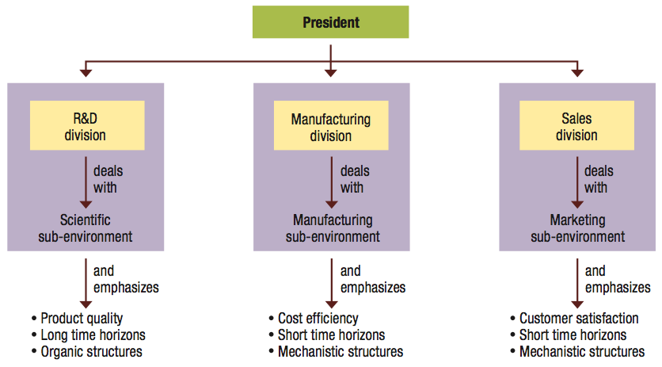
Figure 8.10: Subsystems differentiation among research and development, manufacturing, and sales

- Managing subsystem integration:
- Integration is the level of coordination achieved among an organization’s internal components.
- Organization design paradox —
  - Increased differentiation creates the need for greater integration.
  - Integration is more difficult to achieve as differentiation increases.
- Mechanisms for achieving subsystem integration:
- Rules and procedures
- Hierarchical referral
- Planning
- Direct contact
- Liaison role
- Task forces
- Teams
- Matrix organizations

- Contemporary organizing trends include:
- Fewer levels of management
  - Shorter chains of command.
  - Less unity of command.
- Wider spans of control.
- More delegation and empowerment.
- Decentralization with centralization.
- Reduced use of staff.
- Shorter chains of command
- The line of authority that vertically links all persons with successively higher levels of management.
- Organizing trend:
  - Organizations are being “streamlined” by cutting unnecessary levels of management.
  - Flatter structures are viewed as a competitive advantage.
- Less unity of command
- Each person in an organization should report to one and only one supervisor.

- Organizing trend:
  - Organizations are using more cross-functional teams, task forces, and horizontal structures.
  - Organizations are becoming more customer conscious.
  - Employees often find themselves working for more than one boss.
- Wider spans of control
- The number of persons directly reporting to a manager.
- Organizing trend:
  - Many organizations are shifting to wider spans of control as levels of management are eliminated.
  - Managers have responsibility for a larger number of subordinates who operate with less direct supervision.
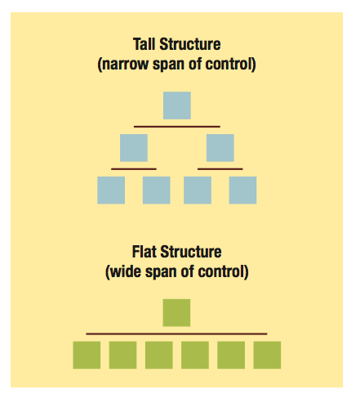
Figure 8.11: Organizations with fewer levels of management have wider spans of control

- More delegation and empowerment
- Delegation is the process of entrusting work to others by giving them the right to make decisions and take action.
- The manager assigns responsibility, grants authority to act, and creates accountability.
- Authority should be commensurate with responsibility.
- Three Steps in Delegation:
- Assign responsibility – explain task and expectations
- Grant authority – allow others to make decisions and act
- Create accountability – require others to report back on results
- More delegation and empowerment
- A common management failure is unwillingness to delegate.
- Delegation leads to empowerment.
- Organizing trend:
  - Managers are delegating more and finding more ways to empower people at all levels.

- Decentralization with centralization
- Centralization is the concentration of authority for making most decisions at the top levels of the organization.
- Decentralization is the dispersion of authority to make decisions throughout all levels of the organization.
- Decentralization with centralization
- Centralization and decentralization not an “either/or” choice.
- Organizing trend:
  - Delegation, empowerment, and horizontal structures contribute to more decentralization in organizations.
  - Advances in information technology allow for the retention of centralized control.
- Reduced use of staff
- Specialized staff
  - People who perform a technical service or provide special problem-solving expertise to other parts of the organization.
- Personal staff
  - People working in “assistant-to” positions that provide special support to higher-level managers.

- Line and staff managers may disagree over staff authority.
  - Advisory Authority.
  - Functional authority.
- No one best solution for dividing line-staff responsibilities.
- Organizing trend:
  - Organizations are reducing staff size.
  - Organizations are seeking increased operating efficiency by employing fewer staff personnel and smaller staff units.

