The Nature of Leadership
- Leadership
  - The process of inspiring others to work hard to accomplish important tasks.
- Contemporary leadership challenges:
  - Shorter time frames for accomplishing things.
  - Expectations for success on the first attempt.
  - Complex, ambiguous, and multidimensional problems.
  - Taking a long-term view while meeting short-term demands.
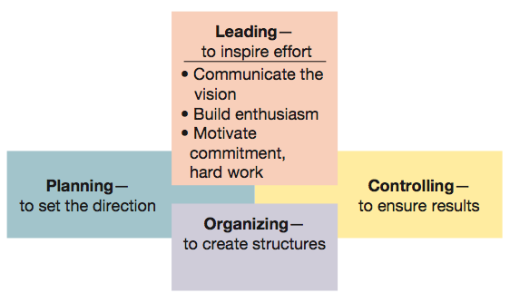
Figure 11.1 Leading viewed in relationship to the other management functions.

- Power
  - Ability to get someone else to do something you want done or make things happen the way you want.
- Power should be used to influence and control others for the common good rather seeking to exercise control for personal satisfaction.
- Two sources of managerial power:
  - Position power
  - Personal power
- Position power
  - Based on a manager’s official status in the organization’s hierarchy of authority.
- Sources of position power:
  - Reward power
    - Capability to offer something of value.
- Coercive power
  - Capability to punish or withhold positive outcomes.
- Legitimate power
  - Organizational position or status confers the right to control those in subordinate positions.

- Personal power
  - Based on the unique personal qualities that a person brings to the leadership situation.
- Sources of personal power:
  - Expert power
    - Capacity to influence others because of one’s knowledge and skills.
- Referent power
  - Capacity to influence others because they admire you and want to identify positively with you.
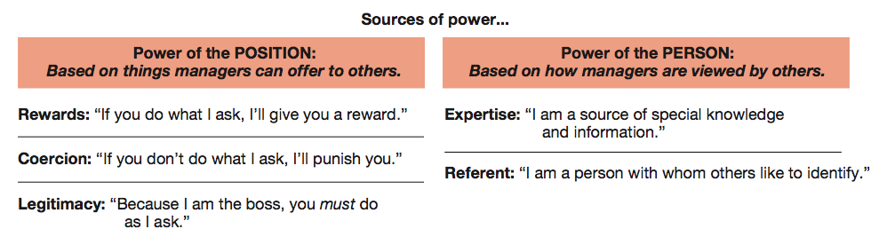
Figure 11.2 Sources of position power and personal power used by managers.

- Visionary leadership.
  - Vision
    - A future that one hopes to create or achieve in order to improve upon the present state of affairs.
  - Visionary leadership
    - A leader who brings to the situation a clear and compelling sense of the future as well as an understanding of the actions needed to get there successfully.
- Meeting the challenges of visionary leadership:
  - Challenge the process.
  - Show enthusiasm.
  - Help others to act.
  - Set the example.
  - Celebrate achievements.
- Servant leadership
  - Commitment to serving others.
  - Followers more important than leader.
  - “Other centered” not “self-centered”.
  - Power not a “zero-sum” quantity.
  - Focuses on empowerment, not power.
- Servant leadership and empowerment
  - Empowerment
    - The process through which managers enable and help others to gain power and achieve influence.
  - Effective leaders empower others by providing them with:
    - Information
    - Responsibility
    - Authority
    - Trust
Leadership Traits and Behaviours
- Traits that are important for leadership success:
  - Drive
  - Self-confidence
  - Creativity
  - Cognitive ability
  - Job-relevant knowledge
  - Motivation
  - Flexibility
  - Honesty and integrity

- Leadership behaviour
  - Leadership behaviour theories focus on how leaders behave when working with followers.
  - Leadership styles are recurring patterns of behaviours exhibited by leaders.
  - Basic dimensions of leadership behaviours:
    - Concern for the task to be accomplished.
    - Concern for the people doing the work.
- Task concerns
  - Plans and defines work to be done.
  - Assigns task responsibilities.
  - Sets clear work standards.
  - Urges task completion.
  - Monitors performance results.
- People Concerns
  - Acts warm and supportive toward followers
  - Develops social rapport with followers
  - Respect the feeling of followers
  - Is sensitive to followers’ needs
  - Shows trust in followers
- Blake and Mouton Leadership Grid
  - Team management.
    - High task concern; high people concern.
  - Authority-obedience management.
    - High task concern; low people concern.
  - Country club management.
    - High people concern; low task concern.
  - Impoverished management.
    - Low task concern; low people concern.
  - Middle of the road management.
    - Non-committal for both task concern and people concern.
Figure 11.3 Managerial styles in Blake and Mouton’s Leadership Grid.
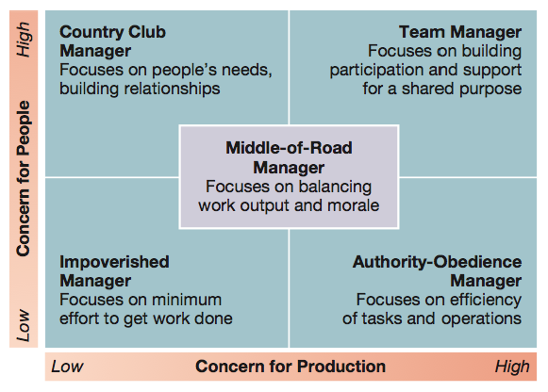

- Classic leadership styles:
  - Autocratic style.
    - Emphasizes task over people, keeps authority and information within the leader’s tight control, and acts in a unilateral command-and-control fashion.
  - Human relations style
    - Emphasizes people over work
- Classic leadership styles (cont’d):
  - Laissez-faire style.
    - Shows little concern for task, lets the group make decisions, and acts with a “do the best you can and don’t bother me” attitude.
- Democratic style.
  - Committed to task and people, getting things done while sharing information, encouraging participation in decision making, and helping people develop skills and competencies.

Contingency Approaches to Leadership
- Fiedler’s Contingency Model
  - Good leadership depends on a match between leadership and situational demands.
  - Determining leadership style:
    - Low LPC ⎯ task-motivated leaders.
    - High LPC ⎯ relationship-motivated leaders.
  - Leadership is part of one’s personality, and therefore relatively enduring and difficult to change.
  - Leadership style must be fit to the situation.
  - Diagnosing Situational Control:
    - Quality of leader-member relations (good or poor).
    - Degree of task structure (high or low).
    - Amount of position power (strong or weak).
  - Task oriented leaders are most successful in:
    - Very favourable (high control) situations.
    - Very unfavourable (low control) situations.
  - Relationship-oriented leaders are most successful in:
    - Situations of moderate control.
Figure 11.5 Matching leadership style and situation: summary predictions from Fiedler’s contingency theory.
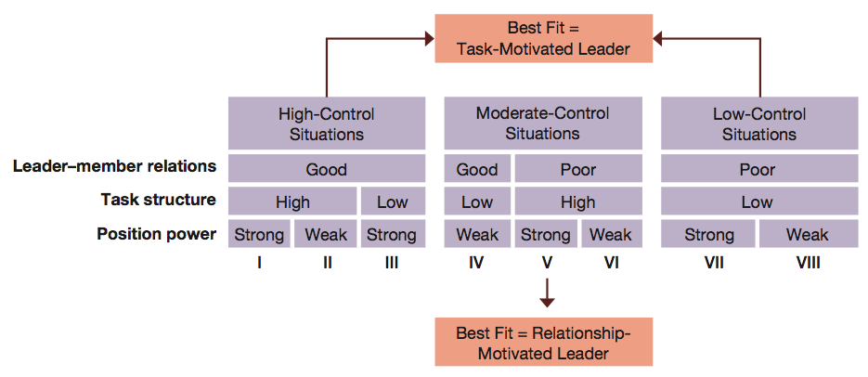

- Hersey-Blanchard situational leadership model
  - Leaders adjust their styles depending on the readiness of their followers to perform in a given situation.
    - Readiness — how able, willing and confident followers are in performing tasks.
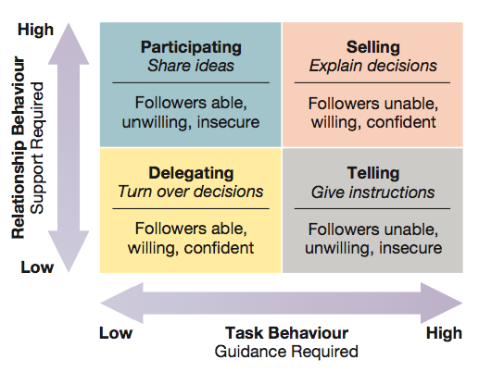
Figure 11.6 Leadership implications of the Hersey-Blanchard situational leadership model.

- Hersey-Blanchard leadership styles:
  - Delegating.
    - Low-task, low-relationship style.
    - Works best in high readiness-situations
  - Participating.
    - Low-task, high-relationship style.
    - Works best in low- to moderate-readiness situations.
- Hersey-Blanchard leadership styles:
  - Selling.
    - High-task, high-relationship style.
    - Work best in moderate- to high-readiness situations.
  - Telling.
    - High-task, low-relationship style.
    - Work best in low-readiness situations.

- House’s path-goal leadership theory.
  - Effective leadership deals with the paths through which followers can achieve goals.
  - Leadership styles for dealing with path-goal relationships:
    - Directive leadership.
    - Supportive leadership.
    - Achievement-oriented leadership.
    - Participative leadership.
Figure 11.7 Contingency relationships in the path-goal leadership theory.
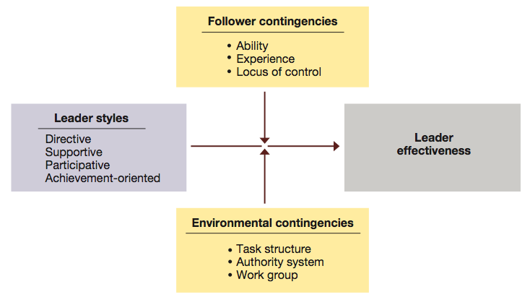

- House’s leadership styles:
  - Directive leadership.
    - Communicate expectations.
    - Give directions.
    - Schedule work.
    - Maintain performance standards.
    - Clarify leader’s role.
  - Supportive leadership.
    - Make work pleasant.
    - Treat group members as equals.
    - Be friendly and approachable.
    - Show concern for subordinates’ well-being.

- House’s leadership styles:
  - Achievement-oriented leadership.
    - Set challenging goals.
    - Expect high performance levels.
    - Emphasize continuous improvement.
    - Display confidence in meeting high standards.
  - Participative leadership.
    - Involve subordinates in decision making.
    - Consult with subordinates.
    - Ask for subordinates’ suggestions.
    - Use subordinates’ suggestions.
- When to use House’s leadership styles:
  - Use directive leadership when job assignments are ambiguous.
  - Use supportive leadership when worker self-confidence is low.
  - Use participative leadership when performance incentives are poor.
  - Use achievement-oriented leadership when task challenge is insufficient.

- Leader-Member Exchange Theory (LMX)
  - Not all people are treated the same by leaders in leadership situations
    - “In groups”
      - High LMX
    - “Out groups”
      - Low LMX
- Leader-Member Exchange Theory (LMX)
  - Nature of the exchange is based on presumed characteristics by the leader
  - High LMX relationship:
    - favourable personality
    - competency
    - compatibility
  - Low LMX relationship:
    - low competency
    - unfavourable personality
    - low compatibility

Figure 11.8 Elements of leader-member exchange theory.
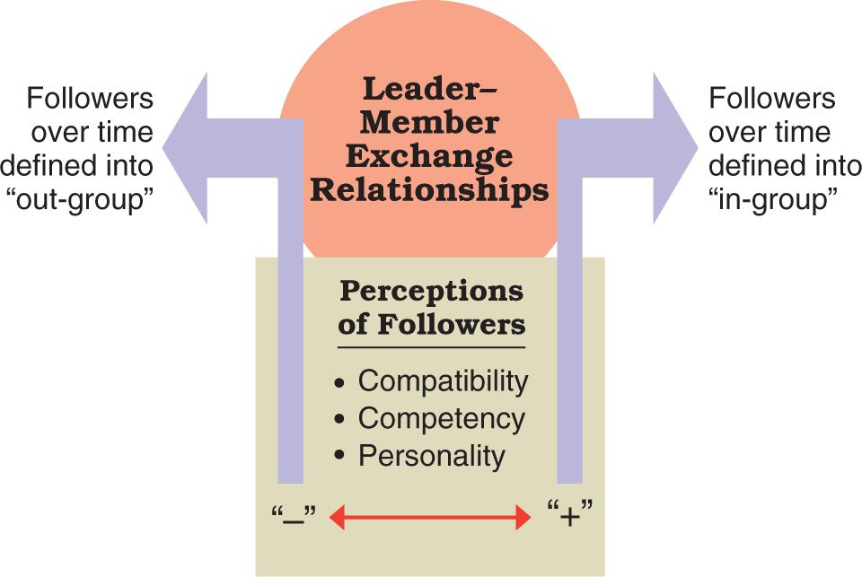

- Vroom-Jago leader-participation theory
  - Helps leaders choose the method of decision making that best fits the nature of the problem situation.
  - Basic decision-making choices:
    - Authority decision.
    - Consultative decision.
    - Group decision.

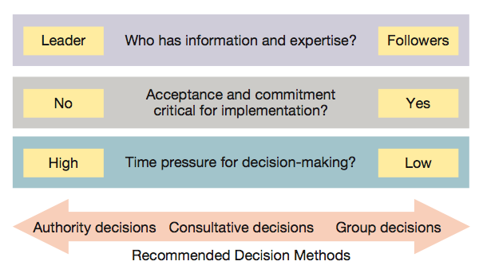
Figure 11.9 Leadership implications of Vroom-Jago leader-participation model.

- Decision-making options in the Vroom-Jago leader-participation theory:
  - Decide alone.
  - Consult individually.
  - Consult with group.
  - Facilitate.
  - Delegate.

- Contingency factors in the Vroom-Jago leader-participation theory:
  - Decision quality.
    - Who has the information needed for problem solving.
  - Decision acceptance.
    - Importance of subordinate acceptance to eventual implementation.
  - Decision time.
    - Time available to make and implement the decision.
- According to Vroom-Jago leader-participation theory, a leader should use authority-oriented decision methods when
  - The leader has greater expertise to solve a problem.
  - The leader is confident and capable of acting alone.
  - Others are likely to accept and implement the decision.
  - Little or no time is available for discussion.

- According to Vroom-Jago leader-participation theory, a leader should use group-oriented and participative decision methods when:
  - the leader lacks sufficient information to solve a problem by himself/herself.
  - the problem is unclear and help is needed to clarify the situation.
  - acceptance of the decision and commitment by others is necessary for implementation.
  - adequate time is available for true participation.
- Benefits of participative decision methods:
  - Help improve decision quality.
  - Help improve decision acceptance.
  - Helps develop leadership potential.
- Potential disadvantages of participative decision methods:
  - Lost efficiency.
  - Not particularly useful when problems must be solved immediately.

Personal Leadership Development
- Superleaders
  - Persons whose vision and strength of personality have an extraordinary impact on others.
- Charismatic leaders
  - Develop special leader-follower relationships and inspire others in extraordinary ways.
- Transactional leadership
  - Someone who directs the efforts of others through tasks, rewards, and structures
- Transformational leadership
  - Someone who is truly inspirational as a leader and who arouses others to seek extraordinary performance accomplishments.
- Characteristics of transformational leaders:
  - Vision.
  - Charisma.
  - Symbolism.
  - Empowerment.
  - Intellectual stimulation.
  - Integrity.
- Emotional intelligence
  - The ability of people to manage themselves and their relationships effectively.
  - Components of emotional intelligence:
    - Self-awareness
    - Self-regulation
    - Motivation
    - Empathy
    - Social skill
- Gender and leadership
  - Both women and men can be effective leaders.
  - Women tend to use interactive leadership.
    - A style that shares qualities with transformational leadership.
  - Men tend to use transactional leadership.
  - Interactive leadership provides a good fit with the demands of a diverse workforce and the new workplace.

- Gender and leadership
  - Future leadership success will depend on a person’s capacity to lead through:
    - Openness
    - Positive relationships
    - Support
    - Empowerment
- Moral leadership
  - Ethical leadership adheres to moral standards meeting the test of “good” rather than “bad” and “right” rather than “wrong.”
  - All leaders are expected to maintain high ethical standards.
  - Long-term, sustainable success requires ethical behaviour.
  - Integrity involves the leader’s honesty, credibility, and consistency in putting values into action.
  - Leaders with integrity earn the trust of their followers
  - Leaders have a moral obligation to build performance capacities by awakening people’s potential.
  - Authentic leadership activates performance through the positive psychological states of confidence, hope, optimism, and resilience.
  - Authentic leadership helps in clearly framing and responding to moral dilemmas, and serving as ethical role models.
- Drucker’s “old-fashioned” leadership
  - Leadership is more than charisma; it is “good old-fashioned” hard work.
  - Essentials of “old-fashioned” leadership:
    - Defining and establishing a sense of mission.
    - Accepting leadership as a “responsibility” rather than a rank.
    - Earning and keeping the trust of others.
The Communication Process
- Communication
  - An interpersonal process of sending and receiving symbols with messages attached to them.
- Key elements of the communication process:
  - Sender
  - Message
  - Communication channel
  - Receiver
  - Interpreted meaning
  - Feedback
Figure 11.13 The interactive two-way process of interpersonal communication.
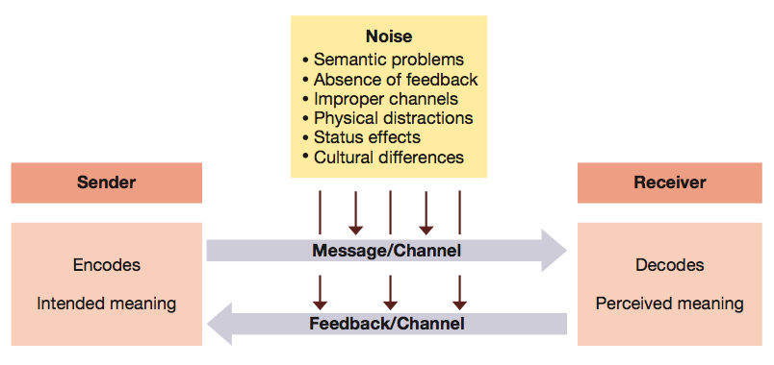

- Effective and efficient communication:
  - Effective communication
    - Occurs when the intended meaning of the sender is identical to the interpreted meaning of the receiver.
  - Efficient communication
    - Occurs at a minimum resource cost.
  - Potential trade-offs between effectiveness and efficiency must be recognized.

- Persuasion and credibility in communication
  - Communication is used for sharing information and influencing other people.
  - Persuasion is getting someone else to support the message being presented.
  - Horizontal structures and empowerment are important contexts for persuasion.
  - Expert power and referent power are essential for persuasion.
  - Credibility involves trust, respect, and integrity in the eyes of others.
  - Credibility can be built through expertise and relationships.
- Communication Barriers:
  - Poor choice of channels.
  - Poor written or oral expression.
  - Failure to recognize nonverbal signals.
  - Physical distractions.
  - Status effects.

- Poor choice of channels
  - Choose the channel that works best.
  - Written channels work for messages that:
    - Are simple and easy to convey.
    - Require extensive dissemination quickly.
    - Convey formal policy or authoritative directives.
  - Spoken channels work best for messages that:
    - Are complex or difficult to convey where immediate feedback is needed.
    - Attempt to create a supportive, even inspirational, climate.
- Guidelines for making oral presentations:
  - Be prepared.
  - Set the right tone.
  - Sequence points.
  - Support your points.
  - Accent the presentation.
  - Add the right amount of polish.
  - Check your technology.
  - Don’t bet on the Internet.
  - Be professional.
- Failure to recognize nonverbal signals
  - Nonverbal communication takes place through gestures, facial expressions, body posture, eye contact, and use of interpersonal space.
  - Mixed messages occur when a person’s words and nonverbal signals communicate different things.
  - The growing use of communication technologies causes important nonverbal communication to be lost.
- Physical distractions
  - Include interruptions from telephone calls, drop-in visitors, a lack of privacy, etc.
  - Can interfere with the effectiveness of a communication attempt.
  - Can be avoided or at least minimized through proper planning.
- Status effects
  - Occur when an organization’s hierarchy of authority creates a barrier to effective communication.
  - Status effects include:
    - Filtering — the intentional distortion of information to make it appear favourable to the recipient.
    - Subordinates acting as “yes men.”

Improving Communication
- Active listening
  - The process of taking action to help someone say exactly what he or she really means.
- Rules for active listening:
  - Listen for message content.
  - Listen for feelings.
  - Respond to feelings.
  - Note all cues, verbal and nonverbal.
  - Paraphrase and restate.
- Five rules for good listening:
  - Listen for message content.
  - Listen for feelings.
  - Respond to feelings.
  - Note all cues.
  - Paraphrase and restate.

- Feedback
  - The process of telling others how you feel about something they did or said, or about the situation in general.
- Constructive feedback guidelines:
  - Give it directly.
  - Make it specific.
  - Give it when the receiver is willing/able to accept it.
  - Make sure it is valid.
  - Give it in small doses.
- Proxemics and space design
  - Proxemics is the use of interpersonal space.
  - Interpersonal space is an important nonverbal cue.
  - Workspace layout is often overlooked as a form of nonverbal communication but is being increasingly recognized for its impact on communication and behaviour.

- Use of communication channels
  - Channel richness is the capacity of a communication channel to carry information in an effective manner.
    - Low channel richness is impersonal, one-way, and fast.
    - High channel richness is personal, two-way, and slow.
  - Managers need to choose a channel with the appropriate richness for the communication.
- Ways to keep communication channels open through interactive management.
  - Management by wandering around (MBWA)
  - Open office hours
  - Regular employee group meetings
  - Computer-mediated meetings and video conferences
  - Employee advisory councils
  - Communication consultants
  - 360-degree feedback

- Tips on managing email
  - Read items once
  - Take action immediately.
  - Purge folders of useless messages.
  - Send group mail/reply to all only when necessary.
  - Remove yourself from distribution lists that don’t add value.
  - Send short messages in the subject line.
  - Put large files on websites.
  - Use instant messaging as an alternative
  - Don’t forget the basic rule of email privacy – there isn’t any.
Figure 11.15 Channel richness and the use of communication media.
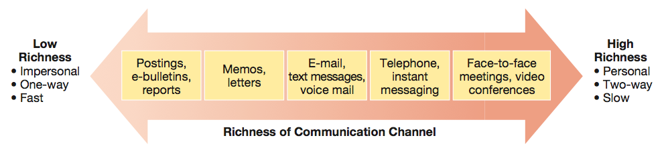

- Technology utilization
  - Information technologies facilitate communication.
  - The electronic grapevine speeds messages and information from person to person.
    - Functional if information is accurate and useful.
    - Dysfunctional if information is false, distorted, or based on rumor.
  - E-mail privacy.
  - Employer’s policy on personal e-mail.
  - Don’t assume that e-mail privacy exists at work..
Valuing culture and diversity
- Ethnocentrism is the tendency to consider one’s culture superior to any and all others.
- Ethnocentrism can cause people to:
  - Not listen to others.
  - Address or speak to others in ways that alienate them.
  - Use inappropriate stereotypes in dealing with someone from another culture.

