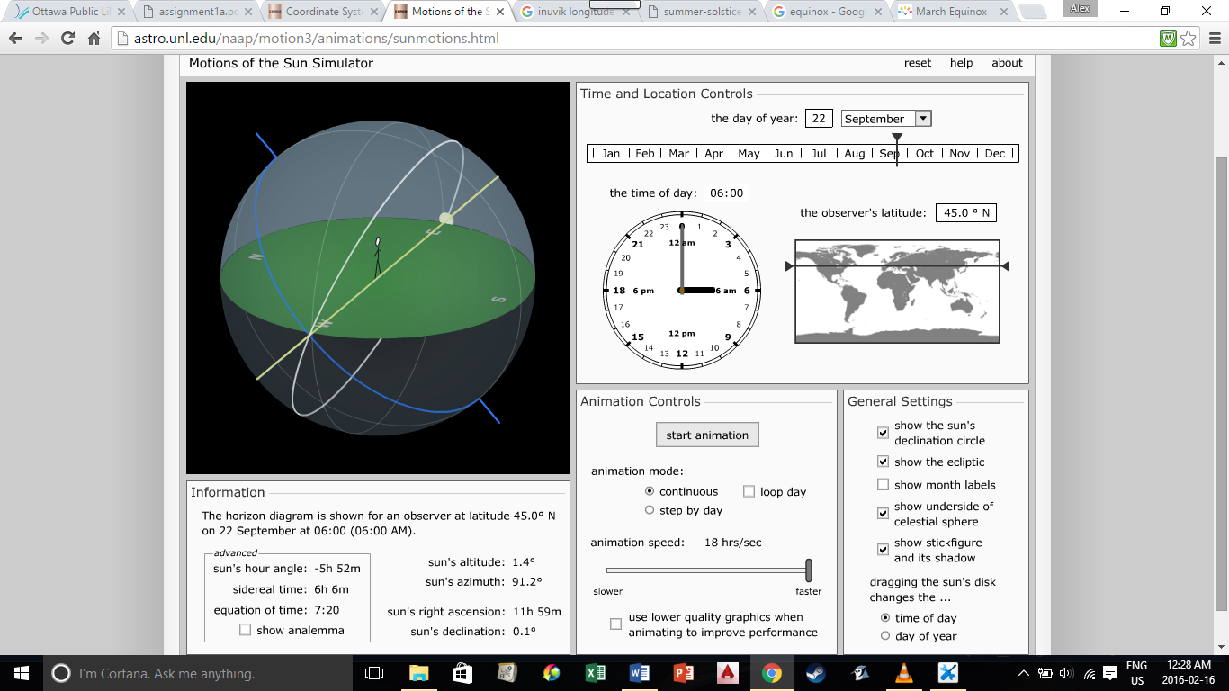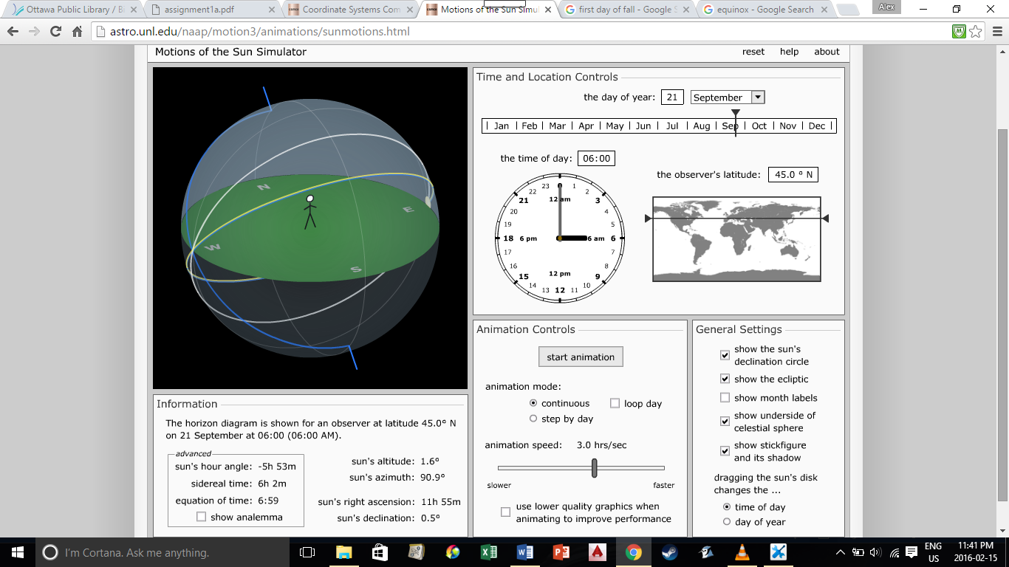

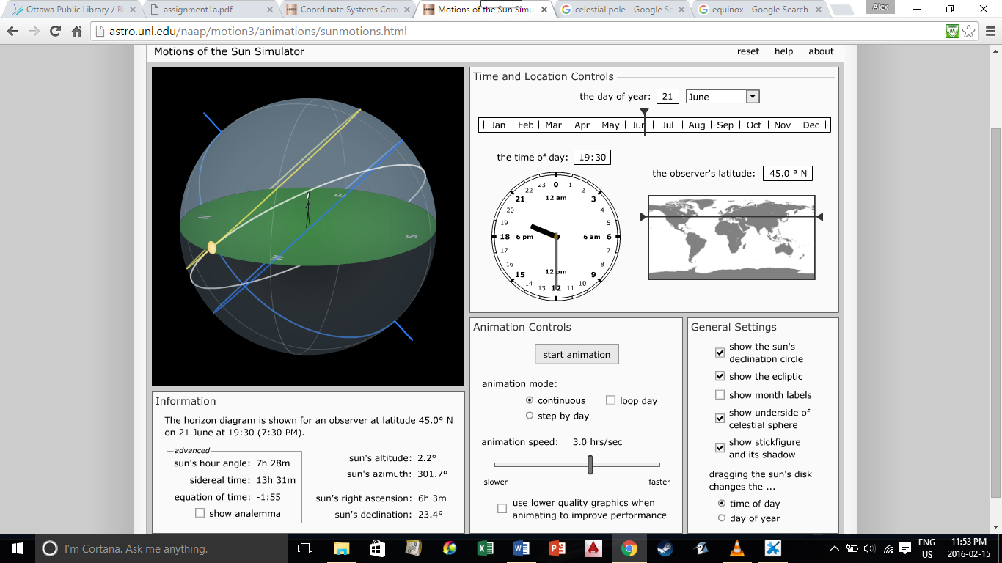

1a) In Litterman’s article, he postulates that carbon taxing rates are risk dependent. Currently, these rates are modeled off of an averaging of a risk-free interest rate. Litterman states that the appropriate price to account for carbon emissions is based on the unknown. On the one hand, if the worst case outcomes from the climate change were known to be manageable by our economy, then the price would be lower. On the other hand, if it was known that worst case outcomes could be detrimental to the economy, then the price would be higher. Ultimately, no one knows with certainty the gravity and magnitude that future climate change may have on the economy. Since unmanageable and unimaginable scenarios are plausible, Litterman believes a weighted average, taking into account likelihoods of different outcomes is a justified course of action and that the price of carbon emissions should be higher if anything.

Litterman explains that the pricing of carbon emissions is based on the average of potential future damages. On the one hand, if it was known with certainty that our economy could manage the damages caused by climate change in the distant future, then pricing now would be lower relative to the average, and could gradually increase as the damages increase. On the other hand, if it was known that the damages caused by climate change would be detrimental to the economy in the distant future, then the pricing for carbon emissions now would be higher than the average cost of damages. One way or the other, it is unknown as to how big of an impact climate change could have on the economy. Litterman also states that non greenhouse gas related catastrophes should also be taken into consideration.

1a) In Litterman’s article, he postulates that carbon taxing rates are risk dependent. Litterman explains that the pricing of carbon emissions is based on the average of potential future damages. There exists two scenarios that help predict what will happen to the economy depending on the severity of the climate change future damages. The first case is if it was known with certainty that our economy could manage the damages caused by climate change in the distant future, then the cost now for climate change could be set lower than the average. The idea is that less cost will allow economy to grow faster so as future damages start to build up, the cost can increase since people have more money. The other case suggests that if it was known that the damages caused by climate change would be detrimental to the economy in the distant future, then the pricing for carbon emissions now would be higher than the average cost of damages. The idea here is that higher prices would deter production of carbon emissions right away, slightly stalling the economy’s growth, but trying to ensure an economy for the future. One way or the other, it is unknown as to how big of an impact climate change could have on the economy, and with this uncertainty there is a trade-off between economic growth and preparation for worse off climate change outcome.
Litterman also states that non greenhouse gas related catastrophes should also be taken into consideration. The above scenarios are only climate related, but other non-climate related catastrophic scenarios are also plausible such as terrorist attacks and epidemics. Litterman also adds that the likelihood of a non-climate related catastrophe is also unknown. Litterman concludes that pricing carbon emissions correctly depends on the unknowable. That is, pricing no lower and potentially higher than the determined average cost of future damages puts the economy in better shape to deal with unknown future threats. Also higher pricing can be lowered as time goes by depending on any new information that comes to light, i.e., climate related scientific inquiries and costs of near future damages.
b) For starters, scientific method will be required to correctly adjust policies as information about climate change damages is updated as time passes. For example, if climate related damages increases at a particular and predictable rate and the carbon emission prices are insufficient, a potential increase in prices may be justifiable. In addition, similar to how the pricing of carbon emissions was discussed in the article, the ability to predict cause and effect relations is a must to effective policies. Therefore, the scientific method will play a crucial role in future government endeavors to counter climate change and other non-climate related scenarios.

