Chapter 4 (Consumer Behaviour)

The Consumer Decision Process

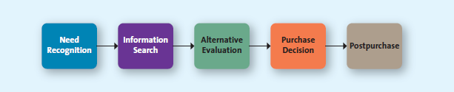

Step One: Need Recognition

- You realize that there is something that you want or need (food when you are hungry)

Functional Needs – pertain to the performance of a product or service (a jacket keeps you warm)

Psychological Needs – pertain to the personal gratification consumers associate with a product and/or service

(Shoes serve the function of keeping feet clean and nice expensive high end shoes are wanted by women simply to please their satisfaction of looking good)

Step Two: Information Search

- The next thing consumers like to recognize is the different options available to them that will help to satisfy that need

Internal Search for information – Use your own general knowledge from past events to make decisions

External Search for Information – The buyer seeks information outside his or her personal knowledge base to help make the buying decision

Factors affecting Consumer Processes

- The perceived benefits versus perceived costs of search - Is it worth the time and effort to search for information about a product or service?
- External locus of control - consumers believe that fate or other external factors control all outcomes. In that case, they believe it doesn't matter how much information they gather; if they make a wise decision, it isn't to their credit, and if they make a poor one, it isn't their fault
- Actual or perceived - Five types of risk associated with purchase decisions can delay or discourage a purchase: performance, financial, social, physiological, and psychological. The higher the risk, the more likely the consumer is to engage in an extended search.
- Performance risk - involves the perceived danger inherent in a poorly performing product or service. An example of performance risk might be the possibility that Brad's sports car does not start or breaks down on the day he is supposed to take his girlfriend out for a drive to show off his new car
- Financial Risk - risk associated with a monetary outlay and includes the initial cost of the purchase, as well as the costs of using the item or service. Car manufacturers, for instance, recognize that extended warranties help alleviate financial risk because consumers fear extensive post-purchase repair costs
- Social Risk - involves the fears that consumers suffer when they worry others might not regard their purchases positively
- Physiological risk - could also be called safety risk. Whereas performance risk involves what might happen if a product does not perform as expected, physiological (or safety) risk refers to the fear of actual harm should the product not perform properly
- Psychological risk - risks associated with the way people will feel if the product or service does not convey the right image

Step Three: Alternative Evaluation

- Take their information and evaluate it the results

Evaluative criteria consist of a set of salient, or important, attributes about a particular product that are used to compare alternative products (price, quality, etc.)

Determinant attributes are product or service features that are important to the buyer and on which competing brands or stores are perceived to differ

Consumer decision rules are the set of criteria that consumers use consciously or subconsciously to quickly and efficiently select from among several alternatives. These rules take several different forms: compensatory, noncompensatory, or decision heuristics.

- Compensatory - assumes that the consumer, when evaluating
alternatives, trades off one characteristic against another, such that good characteristics compensate for bad characteristics (if the car is priced high, it makes up for it with the low mileage)

- Noncompensatory decision rule - in which they choose a product or
service on the basis of a subset of its characteristics, regardless of the values of its other attributes

- Decision Heuristics - in which they choose a product or service on the
basis of a subset of its characteristics, regardless of the values of its other attributes (price, brand, product)

Step Four: Purchase Decision

After the decision for which product will be bought is made, the consumer goes through with the purchase.

After obtaining the product or service, they might put it to the test through a ritual consumption.

Ritual consumption – a special test that refers to a pattern of behaviors tied to life events that affect what and how we consume

Step Five: Postpurchase

There are three possible purchase outcomes…

Exhibit 4.3 – Purchase outcomes

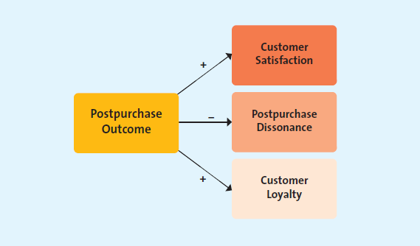

Customer Satisfaction

Setting unrealistically high consumer expectations of the product through advertising, personal selling, or other types of promotion may lead to higher initial sales, but eventually it will result in dissatisfaction when the product fails to achieve these high performance expectations (lead to dissatisfied customers)

Customer Satisfaction

Setting unrealistically high consumer expectations of the product through advertising, personal selling, or other types of promotion may lead to higher initial sales, but eventually it will result in dissatisfaction when the product fails to achieve these high performance expectations

Customer Loyalty

Customer loyalty develops over time with multiple repeat purchases of the product or brand from the same marketer. In the postpurchase stage of the decision-making process, marketers attempt to build and nurture a loyal relationship with their customers from the very first purchase and with each subsequent purchase

Undesirable Consumer Behavior

Failure to purchase the product again due to dissatisfaction

Negative Word of mouth – when consumers spread negative information about a product or service to others

Factors Influencing Consumer Buying Decisions

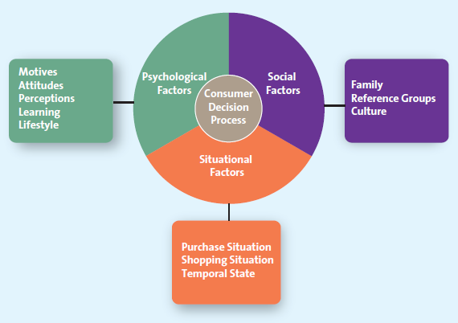

Psychological Factors

- There are many factors that affect how an individual perceives a marketers message

Motive - is a need or want that is strong enough to cause the person to seek satisfaction

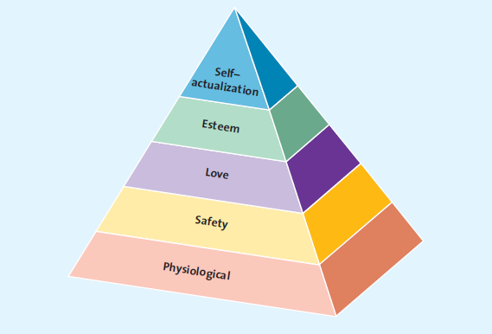
Maslow’s hierarchy of needs

Physiological needs deal with the basic biological necessities of life: food, drink, rest, and shelter

Safety needs pertain to protection and physical well-being. The marketplace is full of products and services that are designed to make you safer, such as airbags in cars and burglar alarms in homes, or healthier, such as vitamins and organic meats and vegetables

Love (social) needs relate to our interactions with others. Haircuts and makeup make you look more attractive, and deodorants prevent odour

Esteem needs allow people to satisfy their inner desires. Yoga, meditation, health clubs, and many books appeal to people's desires to grow or maintain a happy, satisfied outlook on life

Self-actualization occurs when you feel completely satisfied with your life and how you live

- An attitude is a person's enduring evaluation of his or her feelings about and behavioural tendencies toward an object or idea

It has three components:

- Cognitive component – reflects what we believe to be true
- Affective component – involves what we feel about the issue at hand
- Behavioral component – Comprises the action we take based on what we know and feel

Perception - is the process by which we select, organize, and interpret information to form a meaningful picture of the world. Perception influences our acquisition and consumption of goods and services through our tendency to assign meaning to things such as color, symbols, taste, and packaging

Learning refers to a change in a person's thought process or behavior that arises from experience and takes place throughout the consumer decision process (you learn things that you didn’t before when you do research)

Lifestyle refers to the way consumers spend their time and money to live. For many consumers, the question of whether the product or service fits with their actual lifestyle, which may be fairly sedentary, or their perceived lifestyle, which might be outdoorsy, is an important one

Social Factors

Lifestyle refers to the way consumers spend their time and money to live. For many consumers, the question of whether the product or service fits with their actual lifestyle, which may be fairly sedentary, or their perceived lifestyle, which might be outdoorsy, is an important one

Reference group - is one or more persons an individual uses as a basis for comparison regarding beliefs, feelings, and behaviors. A consumer might have various reference groups, including family, friends, coworkers, or famous people the consumer would like to emulate. These reference groups affect buying decisions by (1) offering information (2) providing rewards for specific purchasing behaviors, and (3) enhancing a consumer's self-image

Culture

The shared meanings, beliefs, morals, values, and customs of a group of people. Your cultural group might be as small as your reference group at school or as large as the country in which you live or the religion in which you participate

Situational Factors

- Factors affecting the consumer decision process ; factors specific to the situation, override, or at least influence, psychological and social issues

Purchase Situation

Customers may be predisposed to purchase certain products or services because of some underlying psychological trait or social factor, but these factors may change in certain purchase situations (if you are buying a silver tray for someone at a wedding you would go somewhere classy, if it were for you, you would’ve gone somewhere cheap)

Shopping Situation

Consumers might be ready to purchase a product or service but for a variety of reasons be completely derailed once they arrive in the store. Marketers use different strategies to make the store more appealing…

- Store atmosphere. Some retailers and service providers have developed unique images that are based at least in part on their internal environment, also known as their atmospherics
- Salespeople. Well-trained sales personnel can influence the sale at the point of purchase by pointing out the advantages of one item over another and by encouraging multiple purchases
- Crowding. Customers can feel crowded because there are too many people, too much merchandise, or lines that are too long
- In-store demonstrations. The taste and smell of new food items may attract people to try something they normally wouldn't
- Promotions. Retailers employ various promotional vehicles to influence customers once they have arrived in the store
- Packaging. It is difficult to make a product stand out in the crowd when it competes for shelf space with several other brands (make packaging appealing)

Temporal State

Our state of mind at any particular time can alter our preconceived notions of what we are going to purchase. For instance, some people are “morning people,” whereas others function better at night. In turn, a purchase situation may have different appeal levels depending on the time of day and the type of person the consumer is.

Involvement and Consumer Buying Decisions

Involvement is the consumer's degree of interest or concern in the product or service

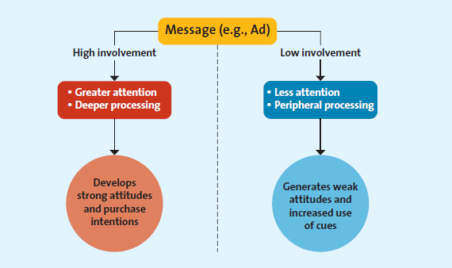

If both types of consumers viewed ads for hybrids produced by Toyota and Ford, the high-involvement consumer (e.g., Katie who is researching hybrids) will scrutinize all the information provided (e.g., gas savings, eco-friendly) and process the key elements of the message deeply.

As a consequence, Katie, an involved consumer, is likely to either end up judging the ad to be truthful and forming a favourable impression of the product or alternatively viewing the message as superficial and developing negative product impressions (i.e., her research suggests the product is not as good as it is being portrayed).

In contrast, a low-involvement consumer will likely process the same advertisement in a less thorough manner. Such a consumer might pay less attention to the key elements of the message (e.g., gas savings, eco-friendly) and focus on heuristic elements such as brand name (Toyota), price, and the presence of a celebrity endorser. The impressions of the low-involvement consumer are likely to be more superficial

Extended Problem Solving - A purchase decision process during which the consumer devotes considerable time and effort to analyzing alternatives; often occurs when the consumer perceives that the

Limited problem solving - occurs during a purchase decision that calls for, at most, a moderate amount of effort and time

impulse buying, a buying decision made by customers on the spot when they see the merchandise (spending without considering other options)

Habitual decision making describes a purchase decision process in which consumers engage with little conscious effort (got a donut from Tim Horton’s on the way home)

