Chapter 3 (Analyzing the Marketing Environment)

A Marketing Environment Analysis Framework

- Companies analyze their marketing environment using a framework

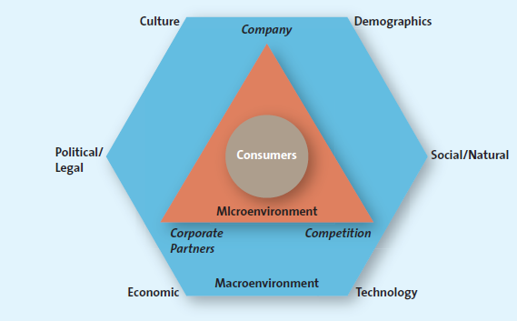

(Exhibit 3.1 – Understanding the Marketing Environment)

- Value-based marketing is to provide greater value to consumers than competitors offer
- This requires that the marketing firm looks at the entire business process from a consumer’s point of view (needs and wants, ability to purchase, etc.)
- For example, Pharmaceutical companies have done an excellent job of monitoring market trends and consumers. Based on the baby boomer generation, they have marketed drugs to lower cholesterol, improve sexual performance, slow aging, and stem hair loss

Micro-environmental Factors

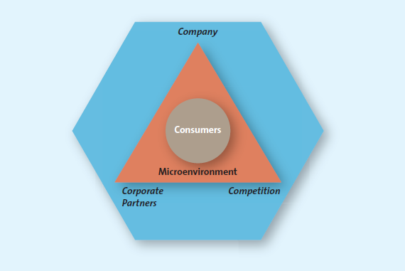

(Exhibit 3.2 – Understanding the Microenvironment)

Company Capabilities

- The first factor that affects the consumer is the firm itself. Successful firms focus their efforts on satisfying customer needs that match their core competencies
- Apple originally rested in the design of the Macintosh, but used its core competency to create the iPod, iPhone, iPad, etc.

Competition

- Firms use competitive intelligence (CI) to collect and synthesize information about their position with respect to their rivals
- CI strategies can include sending an employee to a competitors store to observe the environment to
  - reviewing public materials, including websites, press releases, industry journals, annual reports, subscription databases, permit applications, patent applications, and trade shows
  - interviewing customers, suppliers, partners, or former employees
  - analyzing a rival's marketing tactics, distribution practices, pricing, and hiring needs

Corporate Partners

- Very few firms operate in isolation, automobile manufacturers collaborate with suppliers of sheet metal, tire manufacturers, unions, etc. Just to complete one product
- It takes multiple organizations to create a product

Macro-environmental Factors

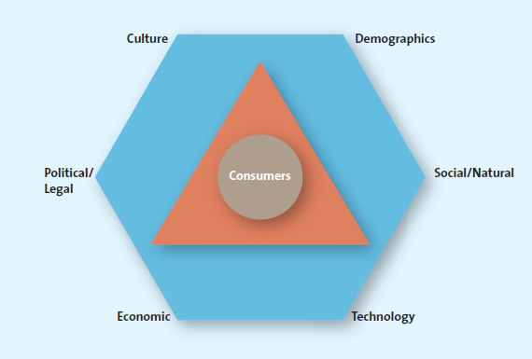

Marketers must understand the macro-environment…

Exhibit 3.3 – The Macro-environment

- Aspects of the external environment—culture, demographics, social trends, technological advances, economic situation, and political/legal environment (CDSTEP)—that affect companies.

Culture

We broadly define culture as the shared meanings, beliefs, morals, values, and customs of a group of people. Transmitted by words, literature, and institutions, culture is passed down from generation to generation and learned over time

Country Culture

The visible nuances of a country's culture, such as artifacts, behavior, dress, symbols, physical settings, ceremonies, language differences, colors and tastes, and food preferences, are easy to spot.

Country’s culture - Easy-to-spot visible nuances that are particular to a country, such as dress, symbols, ceremonies, language, colors, and food preferences, and more subtle aspects, which are trickier to identify

Regional Subcultures

The region in which people live in a particular country affects the way they react to different cultural rituals, or even how they refer to a particular product category. A resident of Quebec is 25 percent less likely to buy a hot prepared meal or re-heatable meal than a resident of Ontario

Demographics - Characteristics of human populations and segments, especially those used to identify consumer markets, such as age, gender, income, race, ethnicity, and education.

*How do firms use demographics to assess their customers needs and position themselves to deliver better value for those customers

- Generational Cohorts - A group of people of the same generation who typically have similar purchase behaviours because they have shared experiences and are in the same stage of life
- Tweens – Not quite teenagers but not youngins either. They mainly spend their money on food, drinks, and cellphones, and clothing
- Generation Y or Millennial (born between 1972 and 1992) – They are hard to market to and use electronics for person reasons. Grew up in a media intensive era and use technology a lot more than their parents
- Generation X (Born between 1966 and 1971) – First generation to grow up in homes where both parents worked.
- Baby Boomers (1946 to 1965)
- Seniors

Income

The median income of Canadian families in 2010 was approximately $72,240.⁴¹ Canadians may be classified into distinct groups based on their income and other factors such as background, education, and occupation: upper class, middle class, working class (or low-income earners), and underclass (at or below poverty).

Education Studies show that higher levels of education lead to better jobs and higher incomes.⁴⁵ Moreover, average annual earnings are higher for those with degrees than for those without. For example, in 2008, the median earnings for Canadians with a bachelor's degree were $44,100, a master's degree $60,000, and a doctorate $65,000.

Those with a college diploma earned on average $38,000, and those with less than a high school education earned considerably less at $30,900.⁴⁶ The median income for immigrants with a university degree was $36,451, and without a university degree $27,698.

Gender

Years ago, gender roles appeared clear, but those male/female roles have been blurred. This shift in attitude and behaviour affects the way many firms design and promote their products and services. For example, more firms are careful about gender neutrality in positioning their products and, furthermore, attempt to transcend gender boundaries whenever they can.

Ethnicity

Statistics Canada data shows that the ethnic composition of Canada has changed over the last two decades and will continue to change in the next decade. Current research shows that 1 out of every 5 Canadians was not born here, accounting for nearly 70 percent of Canada's population growth. If this trend continues, Canada's population growth will be attributed almost exclusively to immigration by 2030

Technological Advances - Technological changes that have contributed to the improvement of the value of both products and services in the past few decades.

Economic situation - Economic changes that affect the way consumers buy merchandise and spend money; see inflation, foreign currency fluctuations, interest rates, and recession

Inflation - Refers to the persistent increase in the prices of goods and services.

Foreign currency fluctuations - Changes in the value of a country’s currency relative to the currency of another country; can influence consumer spending

Interest rates – represent the cost of borrowing money

Recession - A period of economic downturn when the economic growth of the country is negative for at least two consecutive quarters

Political/Legal environment - Comprises political parties, government organizations, and legislation and laws that promote or inhibit trade and marketing activities

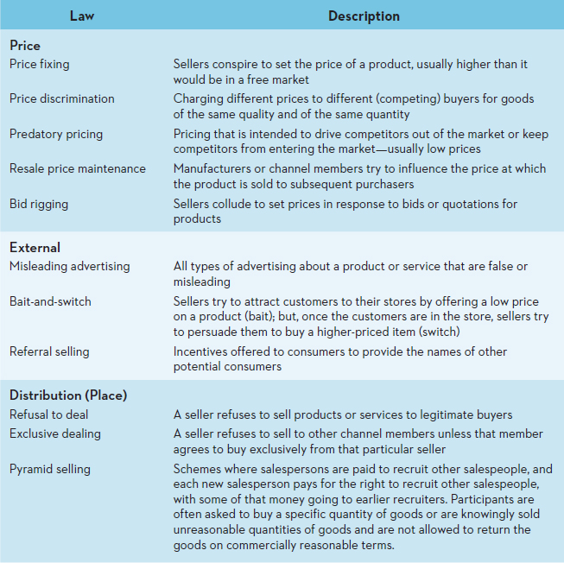

Social and Natural Trends

Greener Consumers

Green marketing - involves a strategic effort by firms to supply customers with environmentally friendly merchandise. Although this “green” trend is not new, it is growing. Many consumers, concerned about everything from the purity of air and water to the safety of beef and salmon, believe that each person can make a difference in the environment

Marketing to Children

In the past 20 years, child obesity has doubled in Canada, leading to skyrocketing rates of high blood pressure, high cholesterol, early signs of heart disease, and Type 2 diabetes among children. In response, the Center for Science and the Public Interest (CSPI) has proposed Guidelines for Responsible Food Marketing to Children, which outlines a variety of changes to advertising directed at children.

Privacy Concerns

More and more consumers worldwide sense a loss of privacy. At the same time that the Internet has created an erupting volcano of accessibility to consumer information, improvements in computer storage facilities and the manipulation of information have led to more and better credit-check services. In addition, consumers are constantly reminded that their identity may not be their own, as in the humorous series of Citibank commercials that depict unsuspecting credit card users who have had their identities stolen.

The Time-Poor Society Reaching a target market has always been a major challenge, but it is made even more complicated by several trends that increase the difficulty of grabbing those markets' attention. First, in the majority of families, both parents work, and the kids are busier than ever. For example, on average, Canadians worked 8.9 hours during a typical workday, but 25 percent said they devote more than 10 hours a day to their work. That means Canadians have less time for leisure and to spend with family.

Health and Wellness Concerns Health concerns, especially those pertaining to children, are prevalent, critical, and widespread. In Canada, 60.1 percent of adult men and 44.2 percent of adult women are categorized as obese or overweight

