Chapter Two (Developing Marketing Strategies and a Marketing Plan)

What is a Marketing Strategy?

A marketing strategy identifies (1) a firm's target market(s), (2) a related marketing mix—the four Ps, and (3) the bases upon which the firm plans to build a sustainable competitive advantage

A sustainable competitive advantage is an advantage over the competition that is not easily copied and thus can be maintained over a long period of time

Example: For Nike, its thickest wall is its strong brand name. Consumers often think of them first when the need running, basketball, or even casual running shoes

Four strategies that develop a competitive advantage:

Customer excellence: Focuses on retaining loyal customers and excellent customer service
Operational excellence: Achieved through efficient operations and excellent supply chain and human resource management
Product excellence: Having products with high perceived value and effective branding and positioning
Locational excellence: Having a good physical location and Internet presence

Customer Excellence

- achieved when a firm develops value-based strategies for retaining loyal customers and provides outstanding customer service

Customer Service

- Marketers may also build sustainable competitive advantage by offering excellent customer service, though consistently offering excellent service can prove difficult.

Operational excellence

- Firms achieve operational excellence, the second way to achieve a sustainable competitive advantage, through their efficient operations, excellent supply chain management, and strong relationships with their suppliers.

(Netflix users can receive videos instantly using their tablet, TV, or computer)

Product Excellence

- The third way to achieve a sustainable competitive advantage, occurs by having products with high perceived value and effective branding and positioning

(Apple – overtook the mobile music industry with its iPod and iTunes combination)

Locational Excellence

- Location is very important in retail

(Most people do not want to walk or drive to far when going to get coffee)

Multiple Sources of Advantage

- It takes more than just low prices and good service to maintain a competitive advantage

(WestJet has achieved success by providing customers with good value that satisfies their expectations… customers get to their destination in a timely manner at a fair price.

The Marketing Plan

Marketing plan - is a written document composed of an analysis of the current marketing situation, opportunities and threats for the firm, marketing objectives and strategy specified in terms of the four Ps, action programs, and projected or pro forma income (and other financial) statements

The three major phases of marketing are:
- Planning
- Implementation
- Control

A Marketing Plan entails 5 steps:

(Step One) Planning phase - marketing executives, in conjunction with other top managers, define the mission and objectives of the business. For the second step, they evaluate the situation by assessing how various players, both inside and outside the organization, affect the firm's potential for success

(Step Two) – Evaluate situation by assessing how various players, both inside and outside the organization, affect the firm’s potential for success

(Step Three) Implementation phase: In the implementation phase, marketing managers identify and evaluate different opportunities by engaging in a process known as segmentation, targeting, and positioning

(Step Four) 4 Ps - They then are responsible for implementing the marketing mix by using the four Ps

(Step Five) Control Phase – entails evaluating the performance of the marketing strategy by using marketing metric and take any necessary corrective actions

Developing a Marketing Plan

Step One: Define the Business Mission and Objectives

The mission statement, a broad description of a firm's objectives and the scope of activities it plans to undertake, attempts to answer two main questions: What type of business are we? and What do we need to do to accomplish our goals and objectives?

Step Two: Conduct a situation analysis

- Use SWOT

Step Three: Identify and Evaluate Opportunities by Using STP (Segmentation, Targeting, and Positioning)

- First it must understand the wants of consumers so it can divide them into SEGMENTS, determine which of those segments it should pursue or target, and how it should position those products or services to best meet the needs of those chosen targets

Market Segment – group of consumers who respond similarly to a firms marketing efforts

Market Segmentation - The process of dividing the market into distinct groups of customers—where each individual group has similar needs, wants, or characteristics—who therefore might appreciate products or services geared especially for them in similar ways

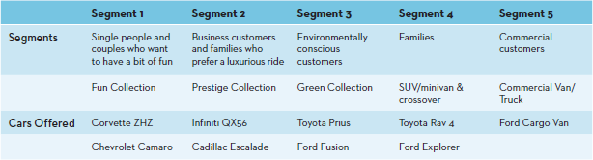

Targeting – After a firm has identified the various market segments it might pursue, it evaluates each segments attractiveness and decides which to pursue by using a process known as target marketing or targeting

Target Marketing or TARGETING - The process of evaluating the attractiveness of various segments and then deciding which to pursue as a market

(If the minivan appeals more to young families, they would direct their marketing resources there)

Positioning – Finally when the firm decides which segments to pursue, it must determine how it wants to be positioned within those segments

Market Positioning - The process of evaluating the attractiveness of various segments and then deciding which to pursue as a market

Step Four: Implement Marketing Mix and Allocate Resources (4Ps)

- Product and Value Creation
- Price and Value for Money
- Place and Value Delivery
- Promotion and Value Communication

Step Five: Evaluate Performance by Using Marketing Metrics

- A metric is a measuring system that quantifies a trend, dynamic, or characteristic. Metrics are used to explain why things happened and to project the future

Who Is Accountable for Performance?

At each level of an organization, the business unit and its manager should be held accountable only for the revenues, expenses, and profits that they can control. Expenses that affect several levels of the organization, such as the labour and capital expenses associated with operating a corporate headquarters, shouldn't be arbitrarily assigned to lower levels

Performance Objectives and Metrics

Many factors contribute to a firm's overall performance, which make it hard to find a single metric to evaluate performance. One approach is to compare a firm's performance over time or to competing firms, using common financial metrics such as sales and profits

Financial Performance Metrics

Some commonly used metrics to assess performance include revenues, or sales, and profits. For instance, sales are a global measure of a firm's activity level. However, a manager could easily increase sales by lowering prices, but the profit realized on that merchandise (gross margin) would suffer as a result.

(Company may compare its sales or profits to other competitors in the industry… Adidas/Nike)

Social Responsibility Performance Metrics As Canadian companies become more convinced of the importance of social responsibility, we will likely see an increasing number of companies report corporate social responsibility metrics, such as their impact on the environment, their ability to diversify their workforce, their energy conservation initiatives, and their policies on protecting the human rights of their employees and the employees of their suppliers

Portfolio Analysis

In portfolio analysis, for example, management evaluates the firm's various products and businesses—its “portfolio”—and allocates resources according to which products are expected to be the most profitable for the firm in the future

Strategic Business Unit (SBU) - A division of the company that can be managed somewhat independently from other divisions since it markets a specific set of products to a clearly defined group of customers

(Loblaw’s… General merchandise, drugstores, etc.) – each of these is an SBU, a product line that customers may use together or perceive as similar in some way.

Relative Market Share - A measure of the product’s strength in a particular market, defined as the sales of the focal product divided by the sales achieved by the largest firm in the industry.

Market Growth Rate - The annual rate of growth of the specific market in which the product competes

Growth Strategies

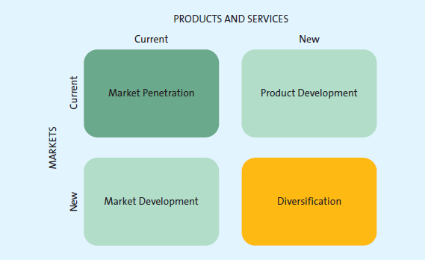

Market Penetration - A growth strategy that employs the existing marketing mix and focuses the firm’s efforts on existing customers

- Usually requires greater marketing efforts such as increased advertising, additional sales and promotions, or intensified distribution efforts in which the product/service is already sold

Market Development Strategy - A growth strategy that employs the existing marketing offering to reach new market segments, whether domestic or international or segments not currently served by the firm

(MTV has expended its network to 565 million households, 161 countries, and 33 languages)

Product Development - A growth strategy that offers a new product or service to a firm’s current target market

- MTV constantly develops new TV shows in effort to retain current viewers

Diversification - A growth strategy whereby a firm introduces a new product or service to a market segment that it does not currently serve.

Downsizing - Exiting markets, reducing product portfolios, or closing certain businesses or store or plant locations

