Chapter One continued…

How do firms become more value driven?

- They focus on four activities…
- (1) Share information about their customers and competitors across their own organization and other firms involved with the product or service
- (2) strive to balance their customers' benefits and costs
- (3) they concentrate on building relationships with customers
- (4) They need to take advantage of new technologies and connect with their customers using social and mobile media.

- Sharing Information

- In a value based, market oriented firm, marketers share information about customers and competitors that has been collected through customer relationship management, and they integrate it across the firm’s various departments

Example: The fashion designers for Zara, the Spain-based fashion retailer, for instance, collect purchase information and research customer trends to determine what their customers will want to wear

- Balancing benefits with costs

- Value-oriented marketers constantly measure the benefits that customers perceive against the cost of their offering

- Build relationships with customers

Relational orientation - A method of building a relationship with customers based on the philosophy that buyers and sellers should develop a long-term relationship.

During the past decade or so, marketers have begun to develop a relational orientation as they have realized the need to think about customers in terms of relationships rather than transactions

Example: Apple makes sure its old features are compatible with new products so older customers can maintain a long term relationship with their electronic needs

- It uses a customer relationship management approach (CRM)

CRM - A business philosophy and set of strategies, programs, and systems that focus on identifying and building loyalty among the firm’s most valued customers.

- Connecting with customers using social and mobile media

Why is Marketing Important?

Understands the importance of marketing both within and outside the firm

- Marketing advises production about how much of the company's product to make and then tells logistics when to ship it. It creates mutually valuable relationships between the company and the firms from which it buys. It identifies those elements that local customers value and makes it possible for the firm to expand globally.
- Marketing has had a significant impact on consumers as well. Without marketing, it would be difficult for any of us to learn about new products and services. Understanding marketing can even help you find a job after you graduate.

Marketing Expands Firms Global Presence

- It is easier to get access to products like Coca-Cola, Levis jeans, Parasuco, and other brands that would’ve otherwise only been accessible in certain geographic regions
- Without understanding the needs of customers in each environment in which the location presides in, it would be difficult to expand globally

Marketing is Pervasive Across Marketing Channel Members

- Firms do not typically work in isolation, Manufacturers buy raw materials and components from suppliers, which they sell to retailers after they have turned it into a product
- Whenever materials are bought or sold, they are transported to a different location, and they are stored in a warehouse operated by yet another organization

Supply Chain – A group of firms and a set of techniques and approaches firms use to make and deliver a set of given goods or services

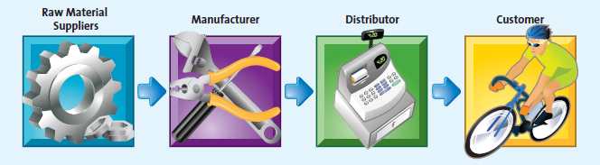

Marketing Enriches Society

- Marketing focuses on more than just financial profitability… they must act socially responsible in how they conduct their business processes

Example: HP donated equipment packages to two First Nations communities to increase literacy and technology skills

Marketing can be Entrepreneurial

- Tim Horton and Ron Joyce opened Tim Horton’s
- Lululemon (Chip Wilson)

