CHAPTER 8- International Trade
Comparative Advantage and International Trade
- Goods and services purchased from other countries are imports; goods and services sold to other countries are exports.
- Globalization is the phenomenon of growing economic linkages among countries.
- To understand why international trade occurs and why economists believe it is beneficial to the economy, we will first review the concept of comparative advantage.
Production Possibilities and Comparative Advantage, Revisited
- Let’s repeat the definition of comparative advantage from earlier: A country has a comparative advantage in producing a good or service if the opportunity cost of producing the good or service is lower for that country than for other countries.
- The Ricardian model of international trade analyzes international trade under the assumption that opportunity costs are constant.

- Autarky is a situation in which a country cannot trade with other countries, it is self-sufficient.
- The following figure shows hypothetical production possibility frontiers for Canada and Mexico.
We assume that:
(1) there are only two goods and
(2) the production possibility frontiers are straight lines.
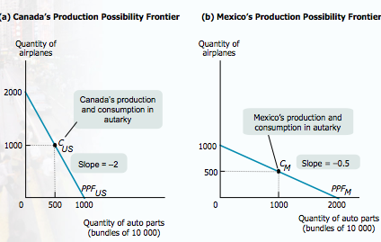

The Gains from International Trade
- The Ricardian model of international trade shows that trade between two countries makes both countries better off than they would be in autarky—that is, there are gains from trade.
- The following tables and figures illustrate that specialization has the effect of increasing total world production of both goods and that each country can consume more of both goods than it did under autarky.

Comparative versus Absolute Advantage
- Gains from trade depend on comparative advantage, not absolute advantage
- In countries where labour is highly productive, employers are willing to pay high wages to attract workers, so competition leads to an overall high wage rate.
- In countries with less productive labour, there is lower competition and wages.
- Just because workers abroad make much lower wages than Canadian workers does not mean that these workers are worse off with trade
- Absolute advantage: country is able to produce more of a good/service with the same amount of resources

Sources of Comparative Advantage
The main sources of comparative advantage are:
- Differences in climate
  - For example: winter deliveries of Chilean grapes and to the North American and European supermarkets
- Differences in technology
- Differences in factor endowments
  - The relationship between comparative advantage and factor availability is found in an influential model of international trade: the Heckscher–Ohlin model.

Heckscher-Ohlin Model
- According to the Heckscher-Ohlin model, a country has a comparative advantage in a good whose production is intensive in the factors that are abundantly available in that country.
- A key concept in the model is factor intensity.
- The factor intensity of production of a good is a measure of which factor is used in relatively greater quantities than other factors in production.
  - Oil refining is capital-intensive compared with clothing manufacture, because oil refiners use a higher ratio of capital to labour than clothing producers.
- The Heckscher–Ohlin model shows how comparative advantage can arise from differences in factor endowments:
  - goods differ in their factor intensity, and countries tend to export goods that are intensive in the factors they have in abundance.
- Trade in manufactured goods amongst developed countries is best explained by increasing returns to production.

Supply, Demand, and International Trade
The Effects of Imports.
- The domestic demand curve shows how the quantity of a good demanded by domestic consumers depends on the price of that good.
- The domestic supply curve shows how the quantity of a good supplied by domestic producers depends on the price of that good.
- The world price of a good is the price at which that good can be bought or sold abroad.

The Effects of Imports
- When a market is opened to trade, competition among importers or exporters drives the domestic price to equality with the world price.
- If the world price is lower than the autarky price, trade leads to imports and a fall in the domestic price compared with the world price.
- There are overall gains from trade because consumer gains exceed the producer losses.
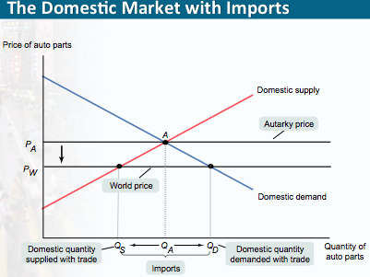
Price drops from PA to PW, domestic quantity demanded goes from QA to QD domestic quantity supplied goes from QA to QS, and the difference between quantity demanded and supplied are imports. When price falls, producer surplus gets smaller while consumer surplus increases. There are overall gains from trade because consumer gains exceed the producer losses.

The Effects of Exports
- If the world price is higher than the autarky price, trade leads to exports and a rise in the domestic price compared with the world price.
- There are overall gains from trade because producer gains exceed the consumer losses.
- The graph that follows shows the domestic market with exports.
- Producer surplus decreases while consumer surplus increases
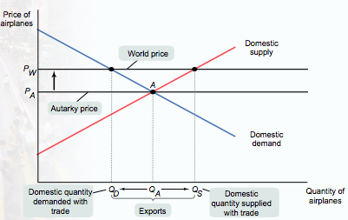
International Trade and Wages
- Exporting industries produce goods and services that are sold abroad.
- Import-competing industries produce goods and services that are also imported from abroad.
- International trade tends to increase the demand for factors that are abundant in our country compared with other countries, and to decrease the demand for factors that are scarce in our country compared with other countries.
- As a result, the prices of abundant factors tend to rise, and the prices of scarce factors tend to fall as international trade grows.

Effects of Trade Protection
- An economy has free trade when the government does not attempt either to reduce or to increase the levels of exports and imports that occur naturally as a result of supply and demand.
  - Policies that limit imports are known as trade protection or simply as protection.
- Most economists advocate free trade, although many governments engage in trade protection of import-competing industries.
  - The two most common protectionist policies are tariffs and import quotas. In rare instances, governments subsidize export industries.

Effects of a Tariff
- A tariff is a tax levied on imports.
- It raises the domestic price above the world price, leading to a fall in trade and total consumption and a rise in domestic production.
- Domestic producers and the government gain, but consumer losses more than offset this gain, leading to deadweight loss in total surplus.

Effects of an Import Quota
- An import quota is a legal limit on the quantity of a good that can be imported.
- Its effect is like that of a tariff, except that revenues—the quota rents—accrue to the licence-holder, not to the government.
- Now, let’s move on to the political economy of trade protection.

Environmental and Health Restrictions
- Sometimes imports are restricted on the grounds that foreign producers don’t meet our environmental and health standards.
- Concern: sometimes these restrictions seem high-minded, but are really just protectionist.
- But not always.

The Political Economy of Trade Protection
Arguments for Trade Protection
- Advocates of tariffs and import quotas offer a variety of arguments. Three common arguments are:
  - national security
  - job creation
  - the infant industry argument
- Despite the deadweight losses, import protections are often imposed because groups representing import-competing industries are smaller and more cohesive than groups of consumers.

International Trade Agreements and the World Trade Organization
- To further trade liberalization, countries engage in international trade agreements.
- International trade agreements are treaties in which a country promises to engage in less trade protection against the exports of other countries in return for a promise by other countries to do the same for its own exports.
- Some agreements are for only a small number of countries, such as the North American Free Trade Agreement, which is among the United States, Canada, and Mexico.
- The World Trade Organization (WTO) is a multinational organization that seeks to negotiate global trade agreements as well as adjudicate trade disputes between member countries.
- The European Union, or EU, is a customs union among 27 European nations: tariffs are levied at the same rate on goods from outside the EU entering the union.

Chapter 11
The Production Function
- A production function is the relationship between the quantity of inputs a firm uses and the quantity of output it produces.

Inputs and Outputs
- A fixed input is an input whose quantity is fixed for a particular period and cannot be varied.
- A variable input is an input whose quantity the firm can vary at any time.
- The long run is the period in which all inputs can be varied. Given that a long enough period of time has elapsed, firms can adjust the quantity of any input
- The short run is the period in which at least one input is fixed.
- The total product curve shows how the quantity of output depends on the quantity of the variable input, for a given quantity of the fixed input.
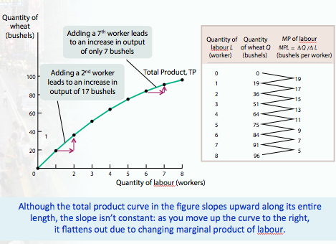
- To understand why the slope changes, look at the 3rd column of the table in adding one ore worker. This is called the marginal product of labor MPL. The additional quantity of output from using one more unit of labour, holding other inputs and the production technology fixed. The marginal product of an input is the additional quantity of output that is produced by using one more unit of that input.

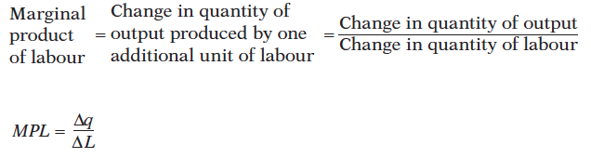
- There are diminishing returns to an input when an increase in the quantity of that input, holding the levels of all other inputs fixed, leads to a decline in the marginal product of that input.
To grasp why diminishing returns can occur, think about what happens as Alec and Janet add more and more workers without increasing the amount of land or improving their farming techniques. As the number of workers increases, the land is farmed more intensively and the number of bushels produced increases, but each additional worker is working with a smaller share of the 1 hectare than the previous worker, so the additional worker cannot produce as much output as the previous worker.
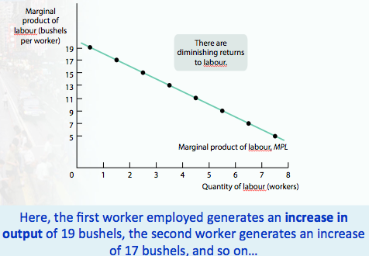

What happens if the levels of other inputs were allowed to change?

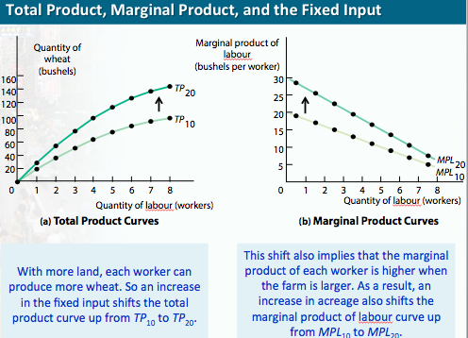
if you change the quantity of the other inputs, both the total product curve and the marginal product curve of the remaining input will shift.

- Janet and Alec may also be interested in knowing how much wheat is harvested per worker. The average product of labor is the amount of output produced per unit of labor.
- The average product of an inout is the amount of output produced per unit of that input
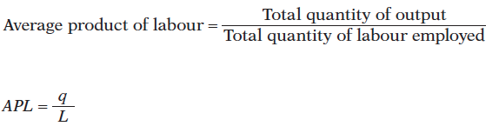

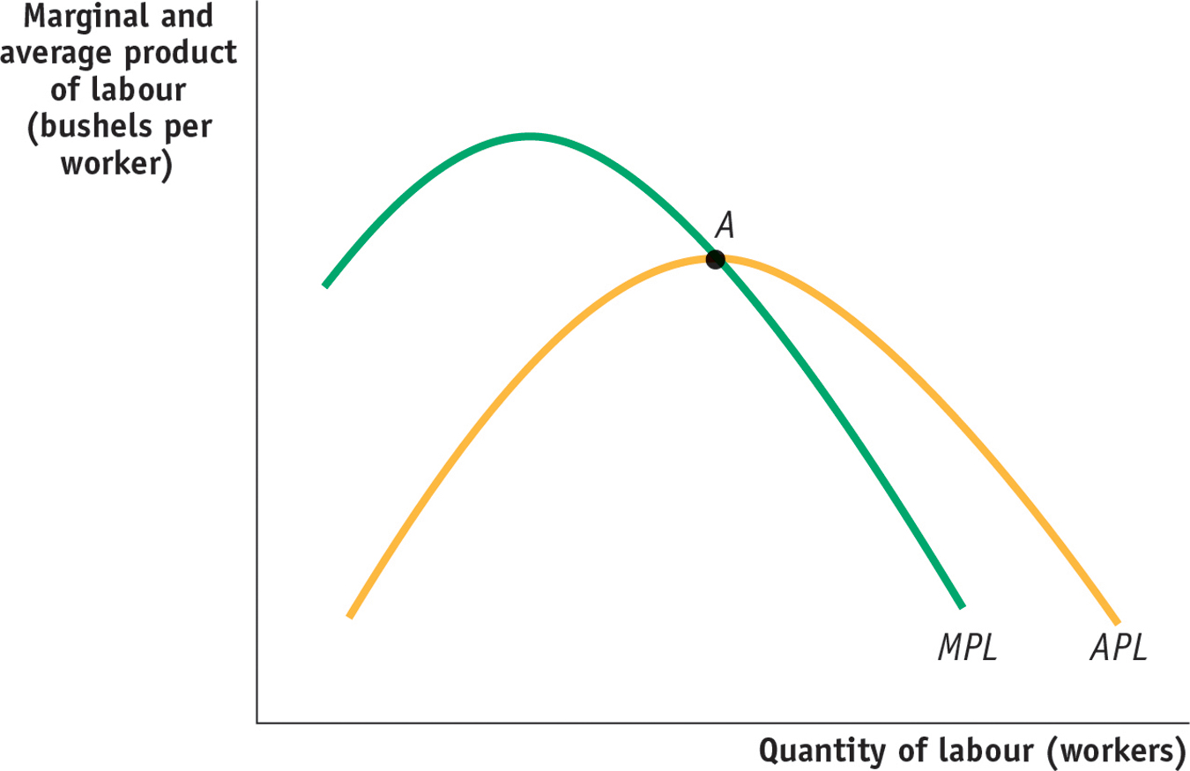
- When marginal product is greater than average product, AP rises
- When MP is less than AP, AP falls
- When MP is the same as AP, AP remains unchanged. AP is maximized when the MP is equal to the AP

From the Production Function to Cost Curves
- A fixed cost is a cost that does not depend on the quantity of output produced. It is the cost of the fixed input. Ex: Janet and Alec pay $400 for the use of the land
- A variable cost is a cost that depends on the quantity of output produced. It is the cost of the variable input. Ex: Janet and Alec pay each worker $200, but the amount of workers they hire depends on the amount of wheat produced
- The total cost of producing a given quantity of output is the sum of the fixed cost and the variable cost of producing that quantity of output.
- The total cost curve becomes steeper as more output is produced due to diminishing returns. The slope of the total cost curve is greater as the amount of output produced increases

Two Key Concepts: Marginal Cost and Average Cost

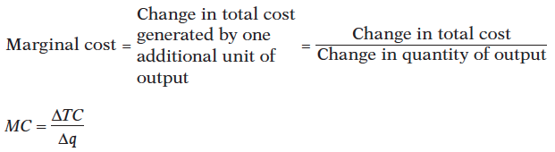
As in the case of marginal product, marginal cost is equal to rise (the increase in total cost) divided by run (the increase in the quantity of output). So just as the marginal product is equal to the slope of the total product curve, marginal cost is equal to the slope of the total cost curve

- The marginal cost curve is upward sloping because there are diminishing returns to inputs in this example. As output increases, the marginal product of the variable input declines.
- This implies that more and more of the variable input must be used to produce each additional unit of output as the amount of output already produced rises.
- And since each unit of the variable input must be paid for, the cost per additional unit of output also rises.

Average Cost
- Average total cost, often referred to simply as average cost, is total cost divided by quantity of output produced.
ATC = TC/q = (Total Cost) / (Quantity of Output)
- Tells producer how much the average or typical unit of output costs to produce. Marginal cost tells the producer how much one more unit of output costs to produce
- A U-shaped average total cost curve falls at low levels of output, then rises at higher levels. ATC first falls then rises as output increases
- Average fixed cost is the fixed cost per unit of output.
AFC = FC/q = (Fixed Cost) / (Quantity of Output)
- Average variable cost is the variable cost per unit of output.
AVC = VC/q= (Variable Cost) / (Quantity of Output)

Average total cost is the sum of AFC and AVC. It has a U shape because these components move in opposite directions as input rises

Average Total Cost Curve
- Increasing output, therefore, has two opposing effects on average total cost—the spreading effect and the diminishing returns effect:
  - The spreading effect: the larger the output, the greater the quantity of output over which fixed cost is spread, leading to lower the average fixed cost
  - The diminishing returns effect: the larger the output, the greater the amount of variable input required to produce additional units leading to higher average variable cost
  - At low levels of output, the spreading effects dominates the diminishing returns effect and causes the average total cost curve to slope downward, but when output is large, average fixed cost is already quite small, so increasing output further has a small spreading effect. Diminishing returns however usually grow increasingly important as output rises. When output is large, diminishing returns effect dominates the spreading effect, causing the ATC curve to slope upward.

Putting the Four Cost Curves Together
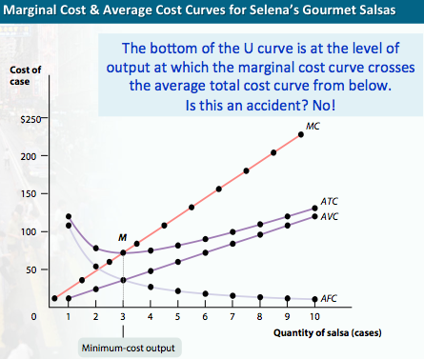
Note that:
- Marginal cost is upward sloping due to diminishing returns.
- Average variable cost also is upward sloping, but is flatter than the marginal cost curve.
- Average fixed cost is downward sloping because of the spreading effect.
- The marginal cost curve intersects the average total cost curve from below, crossing it at its lowest point. This last feature is our next subject of study.

General Principles that Are Always True About a Firm’s Marginal and Average Total Cost Curves
- The minimum-cost output is the quantity of output at which average total cost is lowest—the bottom of the U-shaped average total cost curve.
  - At the minimum-cost output, average total cost is equal to marginal cost.
  - At output less than the minimum-cost output, marginal cost is less than average total cost and average total cost is falling.
  - And at output greater than the minimum-cost output, marginal cost is greater than average total cost and average total cost is rising.
  - Think of how your grade in one course, a 3.0 in physics, affects your overall grade point average. If your GPA before that grade is higher, the new grade lowers your average. Similarly, if marginal cost, the cost of producing one more unit is less than the average total cost, producing that extra unit lowers average total cost so any quantity of output where marginal cost is less than average total cost must be on the downward sloping segment of the U. if MC is greater than ATC, producing that extra unit raises ATC where the movement is on the upward sloping segment of the U. when MC equals ATC we must be at the bottom of the U because at this point TC isn’t falling or rising.

Does the Marginal Cost Curve Always Slope Upward?
- In practice, marginal cost curves often slope downward as a firm increases its production from zero up to some low level, sloping upward only at higher levels of production.
- This initial downward slope occurs because a firm that employs only a few workers often cannot reap the benefits of specialization of labour.
- This specialization can lead to increasing returns at first, and so to a downward-sloping marginal cost curve.
- Once there are enough workers to permit specialization, however, diminishing returns set in.

Short-Run versus Long-Run Costs
- In the short run, fixed cost is completely outside the control of a firm. But all inputs are variable in the long run: This means that in the long run fixed cost may also be varied.
- In the long run, in other words, a firm’s fixed cost becomes a variable it can choose.
- The firm will choose its fixed cost in the long run based on the level of output it expects to produce.

Returns to Scale
- There are increasing returns to scale (economies of scale) when long-run average total cost declines as output increases.
- There are decreasing returns to scale (diseconomies of scale) when long-run average total cost increases as output increases.
- There are constant returns to scale when long-run average total cost is constant as output increases.

CHAPTER 12
Perfect Competition
- A price-taking producer is a producer whose actions have no effect on the market price of the good it sells.
- A price-taking consumer is a consumer whose actions have no effect on the market price of the good he or she buys.
- A perfectly competitive market is a market in which all market participants are price-takers. Neither consumption decisions by individual consumers nor production decisions by individual producers affect the market price of the good
- A perfectly competitive industry is an industry in which producers are price-takers.
Two Necessary Conditions for Perfect Competition
- For an industry to be perfectly competitive, it must contain many producers, none of whom have a large market share.
  - A producer’s market share is the fraction of the total industry output accounted for by that producer’s output.
- An industry can be perfectly competitive only if consumers regard the products of all producers as equivalent.
  - A good is a standardized product, also known as a commodity, when consumers regard the products of different producers as the same good.

Free Entry and Exit
- There is free entry and exit into and from an industry when new producers can easily enter into or leave that industry.
- Free entry and exit ensure:
  - the number of producers in an industry can adjust to changing market conditions; and
  - producers in an industry cannot artificially keep other firms out.

Production and Profits
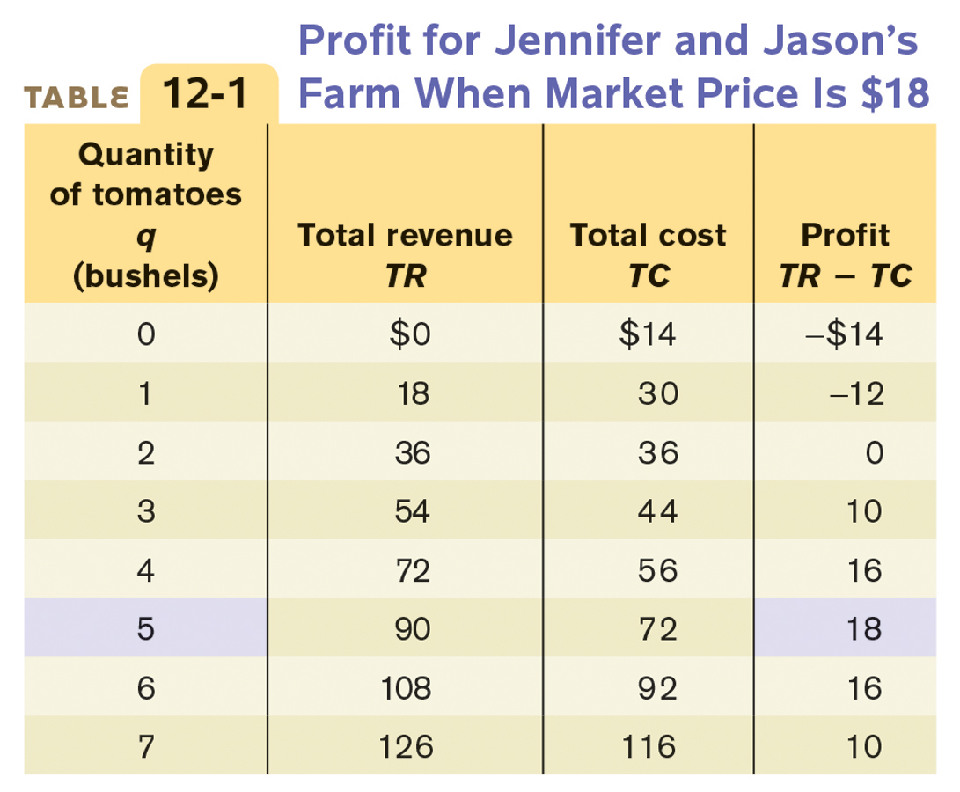
- Total Revenue is equal to the market price times the quantity sold
TR = P x Q
- Profits equal total revenue minus total costs
Profit = TR - TC

Using Marginal Analysis to Choose the Profit-Maximizing Quantity of Output
- Marginal revenue is the change in total revenue generated by an additional unit of output.
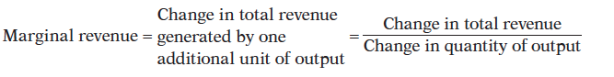
- The optimal output rule says that profit is maximized by producing the quantity of output at which the marginal cost of the last unit produced is equal to its marginal revenue. MR=MC at the optimal quantity of output.
- The price-taking firm’s optimal output rule says that a price-taking firm’s profit is maximized by producing the quantity of output at which the marginal cost of the last unit produced is equal to the market price.
MR = P = MC
- The marginal revenue curve shows how marginal revenue varies as output varies.
- Whenever s firm is a price-taker, its marginal revenue curve is a horizontal line at the market price: it can sell as much as it likes at the market price

When Is Production Profitable?
- If TR > TC, the firm is profitable.
- If TR = TC, the firm breaks even.
- If TR < TC, the firm incurs a loss.

- If P > ATC, the firm is profitable.
- If P = ATC, the firm breaks even.
- If P < ATC, the firm incurs a loss.

Profit, Break Even, or Loss
- Profit = TR – TC = (P – ATC) x q
- The break-even price of a price-taking firm is the market price at which it earns zero profits.
- Whenever market price exceeds minimum average total cost, the producer is profitable.
- Whenever the market price equals minimum average total cost, the producer breaks even.
- Whenever market price is less than minimum average total cost, the producer is unprofitable.

The Short Run Production Decision
- Fixed costs are irrelevant to decisions about whether to produce or shut down in the short run, because fixed costs must be paid regardless of whether or not they produce
- Variable costs do matter
- The vertical distance between the ATC and AVC curves represents average fixed costs
- A firm will cease production in the short run if the market price falls below the shut-down price, which is equal to minimum average variable cost.
The Perfectly Competitive Firm’s Profitability and Production Conditions
PG. 391

Industry Supply Curve
- The industry supply curve shows the relationship between the price of a good and the total output of the industry as a whole.
- The short-run industry supply curve shows how the quantity supplied by an industry depends on the market price given a fixed number of producers.
- There is a short-run market equilibrium when the quantity supplied equals the quantity demanded, taking the number of producers as given. In the long run this may change since new firms may enter or exit the industry.

The Long-Run Industry Supply Curve
- A market is in long-run market equilibrium when the quantity supplied equals the quantity demanded, given that sufficient time has elapsed for entry into and exit from the industry to occur.
- Additional producers will enter the industry when existing producers are making a profit (whenever the market price is above the break-even price)
- What will happen?
- Short run supple curve will shift to the right
- This will alter the market equilibrium and result in a lower market price

The LRS shows how the quantity supplied responds to the price once producers have had time to enter or exit the industry.

D↑ P↑ non-zero profits entry S↑ P↓ back to zero profit (on LRS curve)

Comparing the Short-Run and Long-Run Industry Supply Curves
-LRS may slope upward, but it is always flatter—more elastic—than the short-run industry supply curve.
-This is because of entry and exit:
a higher price attracts new entrants in the long run, resulting in a rise in industry output and lower price;
a fall in price induces existing producer to exit in the long run, generating a fall in industry output and a rise in price.

- The long run elasticity of supply is higher than the short run elasticity of supply whenever there’s free entry or exit

The cost of production and efficiency in the long-run equilibrium
- Three conclusions about the cost of production and efficiency in the long-run equilibrium of a perfectly competitive industry:
  - In a perfectly competitive industry in equilibrium, the value of marginal cost is the same for all firms.
  - In a perfectly competitive industry with free entry and exit, each firm will have zero economic profits in long-run equilibrium.
  - The long-run market equilibrium of a perfectly competitive industry is efficient: no mutually beneficial transactions go unexploited.

CHAPTER 13- Monopoly
Types of Market Structure
- In order to develop principles and make predictions about markets and how producers will behave in them, economists have developed four principal models of market structure:
  - perfect competition
  - monopoly
  - oligopoly
  - monopolistic competition

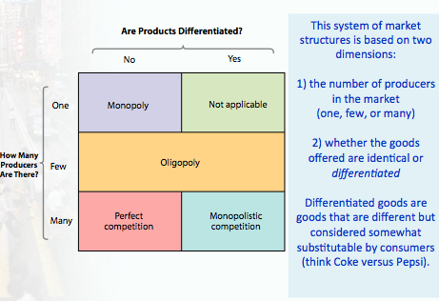

The Meaning of Monopoly
Our first departure from perfect competition…

- A monopolist is a firm that is the only producer of a good that has no close substitutes. An industry controlled by a monopolist is known as a monopoly, e.g. De Beers.
- The ability of a monopolist to raise its price above the competitive level by reducing output is known as market power.
- What do monopolists do with this market power? Let’s take a look at the following graph.

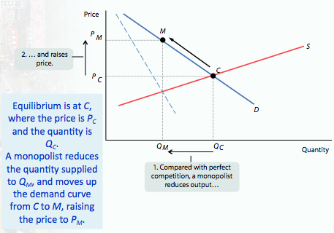

Why Do Monopolies Exist?
- A monopolist has market power, and as a result will charge higher prices and produce less output than a competitive industry.
  - This generates profit for the monopolist in the short run and long run.
- For a profitable monopoly to persist, something must keep others from going into the same business. This something is known as barrier to entry
- Profits will not persist in the long run unless there is a barrier to entry. There are 5 principle types of barriers to entry:
  - control of scarce resources or inputs
  - increasing returns to scale
  - technological superiority
  - government-created barriers including patents and
copyrights

Control of a Scarce Resource or Input
- a monopolist that controls a resource or input crucial to an industry can prevent other firms from entering its market

Increasing Returns to Scale
- local gas supply is an industry in which average total cost falls as output increases, in industries like these, larger companies are more profitable and drive out smaller companies
- a monopoly created and sustained by increasing returns to scale is called a natural monopoly
- A natural monopoly exists when increasing returns to scale provide a large cost advantage to a single firm that produces all of an industry’s output.
- Under such circumstances, average total cost is declining over the output range relevant for the industry.
- This creates a barrier to entry because an established monopolist has lower average total cost than any smaller firm.

Technical Superiority
- A firm that maintains a consistent technological advantage over potential competitors can establish itself a monopolist
- Technological superiority is typically not a barrier to entry over the long term
- In certain high tech industries technological superiority is not a guarantee of success against competitors due to network externalities

Network Externality
- When the value of a good or service to an individual is greater when many other people use the good or service as well

Government Created Barrier
- Patents
- Copyrights
- Trademarks
- Industrial designs

How a Monopolist Maximizes Profit
- Demand curve for a perfectly competitive producer is perfectly elastic and horizontal. Demand curve for a monopolist slopes downward
- The price-taking firm’s optimal output rule is to produce the output level at which the marginal cost of the last unit produced is equal to the market price.
- A monopolist, in contrast, is the sole supplier of its good. So its demand curve is simply the market demand curve, which is downward sloping.
- This downward slope creates a “wedge” between the price of the good and the marginal revenue of the good—the change in revenue generated by producing one more unit

- An increase in production by a monopolist has two opposing effects on revenue:
  - A quantity effect: one more unit is sold, increasing total revenue by the price at which the unit is sold.
  - A price effect: in order to sell the last unit, the monopolist must cut the market price on all units sold. This decreases total revenue.

- Due to the price effect of an increase in output, the marginal revenue curve of a firm with market power always lies below its demand curve.
- That’s because of the price effect: a monopolist’s marginal revenue from selling an additional unit is always less than the price the monopolist receives for the previous unit
- The price effect creates a wedge between the monopolist’s marginal revenue curve and the demand curve
- So, a profit-maximizing monopolist chooses the output level at which marginal cost is equal to marginal revenue—not equal to price.
- As a result, the monopolist produces less and sells its output at a higher price than a perfectly competitive industry would. It earns a profit in the short run and the long run.
- At low levels of output, the quantity effect is stronger than the price effect
- At high level of output, the price effect is stronger than the quantity effect (as it sells more, it now has to lower the price on many units of output)

The Monopolist’s Profit-Maximizing Output and Price
- To maximize profit, the monopolist compares marginal cost with marginal revenue.
- If marginal revenue exceeds marginal cost, De Beers increases profit by producing more; if marginal revenue is less than marginal cost, De Beers increases profit by producing less.
- So the monopolist maximizes its profit by using the optimal output rule:
  - At the monopolist’s profit-maximizing quantity of output:
MR = MC

Monopoly Versus Perfect Competition
- P = MC at the perfectly competitive firm’s profit-maximizing quantity of output
- P > MR = MC at the monopolist’s profit-maximizing quantity of output
- Compared with a competitive industry, a monopolist does the following:
  - Produces a smaller quantity: Q_{M} < Q_{C}
  - Charges a higher price: P_{M} > P_{C}
  - Earns a profit

The Monopolist’s Profit
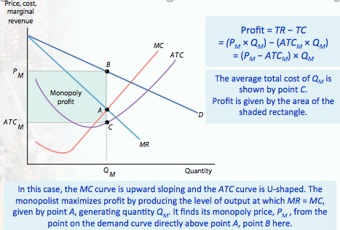

PG 419

Monopoly and Public Policy
- By reducing output and raising price above marginal cost, a monopolist captures some of the consumer surplus as profit and causes deadweight loss.
  - To avoid deadweight loss, government policy attempts to prevent monopoly behavior.
- When monopolies are “created” rather than natural, governments should act to prevent them from forming and should break up existing ones.
- The government policies used to prevent or eliminate monopolies are known as competition or antitrust policies.
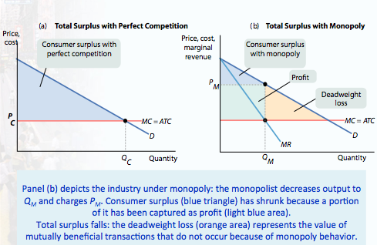
The monopolist produces output at higher price, and reduces quantity. The industry now earns profit which is the producer surplus. This profit is surplus that has been captured from customers as consumer surplus shrinks to the area of the blue triangle. The sum of total surplus is also smaller under monopoly because of the deadweight loss.

Preventing Monopoly
- Policy towards monopoly depends crucially on whether or not the industry in question is a natural monopoly, one in which increasing returns to scale ensure that a bigger producer has lower average total cost

Dealing with Natural Monopoly
- Breaking up a monopoly that isn’t natural is clearly a good idea, but it’s not so clear whether a natural monopoly, one in which large producers have lower average total costs than small producers, should be broken up, because this would raise average total cost.
- Yet even in the case of a natural monopoly, a profit-maximizing monopolist acts in a way that causes inefficiency—it charges consumers a price that is higher than marginal cost, and therefore prevents some potentially beneficial transactions.
- What can public policy do about this? There are two common answers (aside from doing nothing)
  - One answer is public ownership, but publicly owned companies are often poorly run. In public ownership of a monopoly, the good is supplied by the government or by a firm owned by the government.
  - A common alternative to public ownership is price regulation. A price ceiling imposed on a monopolist does not create shortages as long as it is not set too low.
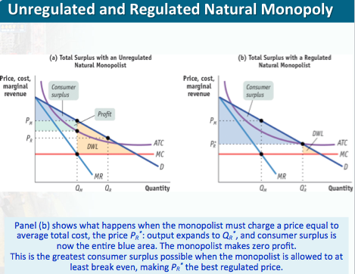
Average cost pricing: a form of price regulation that forces a monopoly to set its price equal to its average total cost

Marginal cost pricing: a form of price regulation that forces a monopoly to set its price equal to its marginal cost

CHAPTER 14
The Prevalence of Oligopoly
- In addition to perfect competition and monopoly, oligopoly and monopolistic competition are also important types of market structure.
  - They are forms of imperfect competition.
- The most important source of oligopoly is the existence of increasing returns to scale which gives bigger producers a cost advantage over smaller ones
- Oligopoly is a common market structure.
  - It arises from the same forces that lead to monopoly, except in a weaker form.
  - It is an industry with only a small number of producers.
  - A producer in such an industry is known as an oligopolist.
- When no one firm has a monopoly, but producers nonetheless realize that they can affect market prices, an industry is characterized by imperfect competition.

Understanding Oligopoly
- Some of the key issues in oligopoly can be understood by looking at the simplest case, a duopoly.
- An oligopoly consisting of only two firms is a duopoly. Each firm is a duopolist.
- With only two firms in the industry, each would realize that by producing more, it would drive down the market price.
  - So each firm would, like a monopolist, realize that profits would be higher if it limited its production.
- So how much will the two firms produce?
- One possibility is that the two companies will engage in collusion. Sellers engage in collusion when they cooperate to raise each others’ profits.
- The strongest form of collusion is a cartel, an agreement by producers that determines how much each is allowed to produce
- By acting as if they were a single monopolist, oligopolists can maximize their combined profits.
  - So, there is an incentive to form a cartel.
- However, each firm has an incentive to cheat—to produce more than it is supposed to under the cartel agreement.
  - So, there are two principal outcomes: successful collusion or behaving noncooperatively by cheating.
- When firms ignore the effects of their actions on each others’ profits, they engage in noncooperative behaviour.
  - It is likely to be easier to achieve informal collusion when firms in an industry face capacity constraints.
- Firms may decide to engage in quantity competition or price competition.
- The basic insight of the quantity competition (or the Cournot model) is that when firms are restricted in how much they can produce, it is easier for them to avoid excessive competition and to “divvy up” the market, thereby pricing above marginal cost and earning profits.
- It is easier for them to achieve an outcome that looks like collusion without a formal agreement.
- The logic behind the price competition (or the Bertrand model) is that when firms produce perfect substitutes and have sufficient capacity to satisfy demand when price is equal to marginal cost, then each firm will be compelled to engage in competition by undercutting its rival’s price until the price reaches marginal cost—that is, perfect competition.

The Kinked Demand Curve
- An oligopolist who believes she will lose a substantial number of sales if she reduces output and increases her price, but will gain only a few additional sales if she increases output and lowers her price away from the tacit collusion outcome, faces a kinked demand curve—very flat above the kink and very steep below the kink.
- It illustrates how tacit collusion can make an oligopolist unresponsive to changes in marginal cost within a certain range when those changes are unique to her.
- Tacit collusion: when firms limit production and raise prices in a way that raises one other’s profits, even though they have not made any formal cooperative agreement
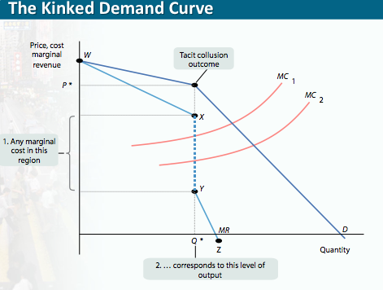
Oligopoly in Practice
- Oligopolies operate under legal restrictions in the form of antitrust policy.
- Competition or Antitrust policies are efforts undertaken by the government to prevent oligopolistic industries from becoming or behaving like monopolies.
  - But many succeed in achieving tacit collusion.
- Tacit collusion is limited by a number of factors, including:
  - large numbers of firms
  - complex products and pricing scheme
  - bargaining power of buyers
  - conflicts of interest among firms (elaborate)

Product Differentiation and Price Leadership
- When collusion breaks down, there is a price war.
- To limit competition, oligopolists often engage in product differentiation, which is an attempt by a firm to convince buyers that its product is different from the products of other firms in the industry.
- When products are differentiated, it is sometimes possible for an industry to achieve tacit collusion through price leadership, where one firm sets its price and the others follow
- Oligopolists often avoid competing directly on price, engaging in nonprice competition through advertising and other means instead.
- When tacit collusion breaks down, there is a price war. Oligopolists try to avoid price wars in various ways, such as through product differentiation and through price leadership, in which one firm sets prices for the industry. Another is through nonprice competition, like advertising.

CHAPTER 15- Monopolistic Competition and Product Differentiation

The Meaning of Monopolistic Competition
Monopolistic competition is a market structure in which
  - there are many competing producers in an industry
  - each producer sells a differentiated product (but are still close substitutes)
  - there is free entry into and exit from the industry in the long run
  - each producer has some ability to set the price of her differentiated product

Product Differentiation
- Product differentiation plays an even more crucial role in monopolistically competitive industries.
- Why?
  - Tacit collusion is virtually impossible when there are many producers.
  - Hence, product differentiation is the only way monopolistically competitive firms can acquire some market power.
- How do firms in the same industry—such as fast-food vendors, gas stations, or chocolate companies—differentiate their products?
- Is the difference mainly in the minds of consumers or in the products themselves?

There are three important forms of product differentiation:

  - Differentiation by style or type – sedans vs. SUVs
2) Differentiation by location – dry cleaner near home vs. cheaper dry cleaner far away
3) Differentiation by quality – ordinary chocolate ($) vs. gourmet chocolate ($$$)

Whatever form product differentiation it takes, however, there are two important features of industries with differentiated products:
  - Competition among sellers: even though sellers aren’t offering identical goods, producers compete for the same market, so entry by more producers reduces the quantity each existing producer sells at any given price.

  - Value in diversity: In addition, consumers gain from the increased diversity of products, a food court with lots of vendors make customers happier than a food court with only 2.

Understanding Monopolistic Competition
Suppose an industry is monopolistically competitive: it consists of many producers, all competing for the same consumers but offering differentiated products. How does such an industry behave

As the term monopolistic competition suggests, this market structure combines some features typical of monopoly with others typical of perfect competition:
  - Because each firm is offering a distinct product, it is in a way like a monopolist: it faces a downward-sloping demand curve and has some market power—the ability within limits to determine the price of its product.
  - However, unlike a pure monopolist, a monopolistically competitive firm does face competition: the amount of product it can sell depends on the prices and products offered by other firms in the industry.
  - In a MC industry there are many producers as opposed to an oligopoly.
The MC Firm in the Short Run
The following figure shows two possible situations that a typical firm in a monopolistically competitive industry might face in the short run.
  - In each case, the firm looks like any monopolist: it faces a downward-sloping demand curve, which implies a downward-sloping marginal revenue curve.
  - We assume that every firm has an upward-sloping marginal cost curve, but that it also faces some fixed costs, so that its average total cost curve is U-shaped.

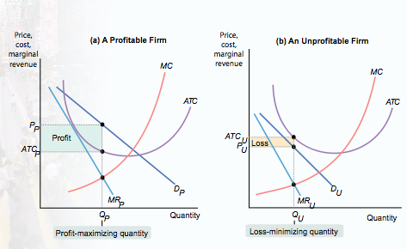
pg 473

Monopolistic Competition in the Long Run
- If the typical firm earns positive profits, new firms will enter the industry in the long run, shifting each existing firm’s demand curve to the left.
- If the typical firm incurs losses, some existing firms will exit the industry in the long run, shifting the demand curve of each remaining firm to the right.
- In the long run, equilibrium of a monopolistically competitive industry, the zero-profit-equilibrium, firms just break even.
- The typical firm’s demand curve is just tangent to its average total cost curve at its profit-maximizing output.
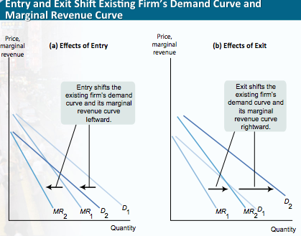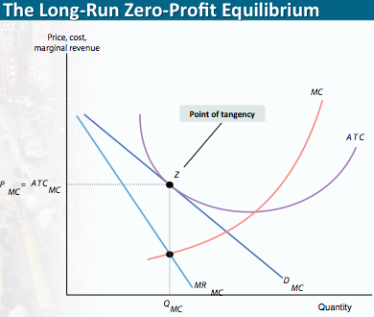

Monopolistic Competition versus Perfect Competition
In a way long run equilibrium of a typical firm in a perfectly competitive industry looks a lot like long run equilibrium in a perfectly competitive industry. In both cases there are many firms, in both cases profits have been competed away, in both cases the price the price received by every firm is equal to the ATC of production

However the 2 versions of long run equilibrium are different:

Price, Marginal Cost, and ATC
- In the long-run equilibrium of a monopolistically competitive industry, there are many firms, all earning zero profit.
- Price exceeds marginal cost, so some mutually beneficial trades are unexploited.
- The following figure compares the long-run equilibrium of a typical firm in a perfectly competitive industry with that of a typical firm in a monopolistically competitive industry.
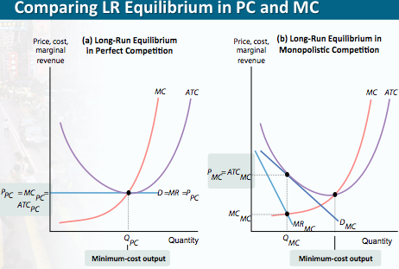

Is Monopolistic Competition Inefficient?
- Firms in a monopolistically competitive industry have excess capacity: they produce less than the output at which average total cost is minimized.
- Price exceeds marginal cost, so some mutually beneficial trades are unexploited.
- The higher price consumers pay because of excess capacity is offset to some extent by the value they receive from greater diversity.
- Hence, it is not clear that this is actually a source of inefficiency.

Controversies About Product Differentiation
No discussion of product differentiation is complete without spending at least a bit of time on the two related issues of advertising and brand names.

The Role of Advertising
- In industries with product differentiation, firms advertise to increase the demand for their products.
- Advertising is not a waste of resources when it gives consumers useful information about products.
- Advertising that simply touts a product is harder to explain.
- Either consumers are irrational, or expensive advertising communicates that the firm's products are of high quality.

Brand Names
- Some firms create brand names.
- A brand name is a name owned by a particular firm that distinguishes its products from those of other firms.
- As with advertising, the social value of brand names can be ambiguous.
- The names convey real information when they assure consumers of the quality of a product.

CHAPTER 16- Externalities
The Economics of Pollution
- Pollution is a bad thing.
  - Yet most pollution is a side effect of activities that provide us with good things.
  - Our air is polluted by power plants that generate the electricity that lights our cities, and our rivers are damaged by fertilizer runoff from farms that grow our food.
- Pollution is a side effect of useful activities, so the optimal quantity of pollution isn’t zero.
- Then, how much pollution should a society have? What are the costs and benefits of pollution?

Costs and Benefits of Pollution
How much pollution should we allow? How much decisions include comparing the marginal benefit with the marginal cost
- The marginal social cost of pollution (MSC) is the additional cost imposed on society as a whole by an additional unit of pollution.
  - MSC = MPC + MEC
  - The marginal private cost of pollution (MPC) is the additional cost imposed on the polluter if the polluter creates another unit of pollution
  - The marginal external cost (MEC) is the additional cost imposed on others when the polluter creates another unit of pollution
  - How do we measure the MSC of pollution?
  - It is the sum of the willingness to pay among all members of society to avoid that unit of pollution
  - Hard to estimate accurately

- The marginal social benefit of pollution (MSB) is the additional gain to society as a whole from an additional unit of pollution.
  - MSB = MPB + MEB
  - The marginal private benefit (MPB) is the additional benefit the polluter receives from producing another unit of pollution
  - The marginal external benefit (MEB) it the additional benefit others receive if the polluter creates another unit of pollution
  - How do we measure the MSB of pollution?
  - It is the highest willingness to pay for the right to emit that unit measured across all polluters

- MSC = MPC + MEC
- But typically the Marginal Private Cost of pollution is zero, so, with pollution:
- MSC = MEC
- MSB = MPB + MEB
- But typically the Marginal External Benefit of pollution is zero, so, with pollution:
- MSB = MPB
So the benefit is private but the cost is imposed on others

- The socially optimal quantity of pollution is the quantity of pollution that society would choose if all the costs and benefits of pollution were fully accounted for.
- Where MSC and MSB intersect
- In the presence of external costs, the free market cannot accomplish this.

Pollution: An External Cost
- Pollution is an example of an external cost, or negative externality; in contrast, some activities can give rise to external benefits, or positive externalities.
- External costs and benefits are jointly known as externalities.
- Left to itself, a market economy will typically generate too much pollution because polluters have no incentive to take into account the costs they impose on others.

Another Perspective: Production of Goods
- Above we looked directly at the production of pollution.
- Now we change perspective, and look at the production of goods, production that has the side effect, or external cost, of pollution.
Externalities and the Competitive Market
- Pollution is the by-product of either the manufacture or consumption of goods and services
- In order to study the social welfare impact of pollution we can look at the social costs and benefits in the market for a good or service that causes pollution by its manufacture or consumption

Private Solutions to Externalities
Coase’s Theorem (internalize the externality)
- The implication of Coase’s analysis is that externalities need not lead to inefficiency because individuals have an incentive to find a way to make mutually beneficial deals that lead them to take externalities into account when making decisions.
- When individuals do take externalities into account, economists say that they internalize the externality. If externalities are fully internalized, the outcome is efficient even without government intervention
- Why can’t individuals always internalize externalities? Because in the backyard music example the transaction costs are low enough for mick and Christina to be able to make a deal, but this isn’t always the case
- Transaction costs prevent individuals from making efficient deals.
- Examples of transaction costs include the following:
- The costs of communication among the interested parties- such costs may be high if a lot of people are involved
- The costs of making legally binding agreements- such costs may be high if expensive legal services are required
- Costly delays involved in bargaining- even if there is a potentially beneficial deal, both sides may hold out an effort to extract more favourable terms, leading to increased effort and forgone benefit
- When transaction costs are such that the private market does not internalize the externalities, then governments sometimes intervene, to promote the public interest.

Policies Toward Pollution
- Environmental standards are rules that protect the environment by specifying actions by producers and consumers. Generally such standards are inefficient because they are inflexible.
- An emissions tax is a tax that depends on the amount of pollution a firm produces.
- Taxes designed to reduce external costs are known as Pigouvian taxes.
- Tradable emissions permits are licenses to emit limited quantities of pollutants that can be bought and sold by polluters.
- An emissions tax is an efficient way to reduce pollution because the marginal benefit of pollution is equal across producers whereas an environmental standard is not efficient.
- An emissions tax is a form of Pigouvian tax, a tax designed to reduce external costs.
- The optimal Pigouvian tax is equal to the marginal social cost of pollution at the socially optimal quantity of pollution
- Tradable emissions permits are licences to emit limited amounts of pollution that can be bought and sold by producers.
- Emissions taxes and tradable emissions permits can have the exact same outcome
- That is they can both lead to efficient outcomes

Positive Externalities
- Positive externalities occur when there is an external benefit associated with the production or consumption of a good or service
- Left to its own, the market will produce too little of the good or service that confers external benefits on others
- Society as a whole is better off when policies are enacted that increase the supply of such a good or service
- Pigouvian subsidy: a payment designed to encourage activities that yield external benefits
- Technology spillover: an external benefit that results when knowledge spreads among individuals and firms

Network Externalities
- A good is subject to a network externality when the value of the good to an individual is greater when a large number of other people also use the good.
- Have no effect on society, what they share is the existence of an external effect from one person’s actions
- Examples include:
    - communication systems: the internet, telephones, telegraphs, fax machines, etc.
    - railway systems
    - air travel: hub and spoke
- Any way in which other people’s consumption of a good increases your own marginal benefit from consumption of that good can give rise to network effects.
  - Example: computer operating systems like Windows
- Windows is used widely so it attracts more attention from software developers.
  - As a result, there are more programs that run on Windows than on any other operating system.
- A good is subject to positive feedback when success breeds greater success and failure breeds failure. When a good or service is subject to a network externality, it exhibits positive feedback: if large numbers of people buy the good or service, others become likely to buy it too. If people don’t buy it, others become less likely to buy it. So both success and failure tend to be reinforcing

CHAPTER 17- Public Goods and Common Resources
Private Goods—and Others
- What’s the difference between installing a new bathroom in a house and building a municipal sewage system?
- What’s the difference between growing wheat and fishing in the open ocean?
- In each case there is a basic difference in the characteristics of the goods involved.
  - Bathroom appliances and wheat have the characteristics needed to allow markets to work efficiently; sewage systems and fish in the sea do not.
- Let’s look at these crucial characteristics and why they matter.
Characteristics of Goods
- Goods can be classified according to two attributes:
  - whether they are excludable
  - whether they are rival in consumption
- A good is excludable if the supplier of that good can prevent people who do not pay from consuming it.
- A good is rival in consumption if the same unit of the good cannot be consumed by more than one person at the same time.
- A good that is both excludable and rival in consumption is a private good.
- When a good is nonexcludable, the supplier cannot prevent consumption by people who do not pay for it (firefighters).
- A good is nonrival in consumption if more than one person can consume the same unit of the good at the same time. (tv shows)

There are four types of goods:
  - Private goods, which are excludable and rival in consumption, like wheat
  - Public goods, which are nonexcludable and nonrival in consumption, like a public sewer system
  - Common resources, which are nonexcludable but rival in consumption, like clean water in a river
  - Artificially scarce goods, which are excludable but nonrival in consumption, like pay-per-view movies on cable TV

Why Markets Can Supply Only Private Goods Efficiently
- Goods that are both excludable and rival in consumption are private goods.
- Private goods can be efficiently produced and consumed in a competitive market.
- Goods that are nonexcludable suffer from the free-rider problem: individuals have no incentive to pay for their own consumption and instead will take a “free ride” on anyone who does pay. (group projects)
- When goods are nonrival in consumption, the efficient price for consumption is zero.
- If a positive price is charged to compensate producers for the cost of production, the result is inefficiently low consumption.

Public Goods
- A public good is the exact opposite of a private good: it is a good that is both nonexcludable and nonrival in consumption.
- Here are some other examples of public goods:
  - Disease prevention: When doctors act to stamp out the beginnings of an epidemic before it can spread, they protect people around the world.
  - National defence: A strong military protects all citizens.
  - Scientific research: More knowledge benefits everyone.
  - Because these goods are nonexcludable they suffer from the free rider problem so no private firm would be willing to produce them
Providing Public Goods
- Because most forms of public good provision by the private sector have serious defects, they must be provided by the government and paid for with taxes.
- The marginal social benefit of an additional unit of a public good is equal to the sum of each consumer’s individual marginal benefit from that unit.
- At the efficient quantity, the marginal social benefit equals the marginal cost.
- The following graph illustrates the efficient provision of a public good.
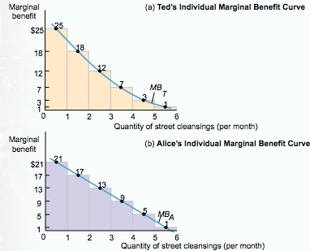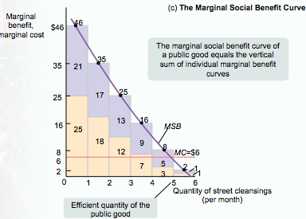
- No individual has an incentive to pay for providing the efficient quantity of a public good because each individual’s marginal benefit is less than the marginal social benefit.
- Hence each individual’s marginal benefit is less than the marginal cost.
- This is a primary justification for the existence of government: to provide public goods.
Cost-Benefit Analysis
- Governments engage in cost-benefit analysis when they estimate the social costs and social benefits of providing a public good.
- Although governments should rely on cost-benefit analysis to determine how much of a public good to supply, doing so is problematic because individuals tend to overstate the good’s value to them.
Common Resources
- A common resource is nonexcludable and rival in consumption: you can’t stop me from consuming the good, and more consumption by me means less of the good available for you.
- Some examples of common resources are clean air and water as well as the diversity of animal and plant species on the planet (biodiversity).
- In each of these cases, the fact that the good, though rival in consumption, is nonexcludable poses a serious problem.
The Problem of Overuse
- Common resources left to the free market suffer from overuse.
- Overuse occurs when a user depletes the amount of the common resource available to others but does not take this cost into account when deciding how much to use the common resource.
- In the case of a common resource, the marginal social cost of my use of that resource is higher than my individual marginal cost or the cost to me of using an additional unit of the good.
- The following figure illustrates this point.
The Efficient Use and Maintenance of a Common Resource
- To ensure efficient use of a common resource, society must find a way of getting individual users of the resource to take into account the costs they impose on other users.
- Like negative externalities, a common resource can be efficiently managed by:
  - a tax or a regulation imposed on the use of the common resource.
  - making it excludable and assigning property rights to it (assigning property rights to someone means it now belongs to someone who values it).
  - creating a system of tradable licenses for the right to use the common resource.

Artificially Scarce Goods
- An artificially scarce good is excludable but nonrival in consumption.
- Because the good is nonrival in consumption, the efficient price to consumers is zero.
- However, because it is excludable, sellers charge a positive price, which leads to inefficiently low consumption.
- A good is made artificially scarce because producers charge a positive price.
- The marginal cost of allowing one more person to consume the good is zero (for ex one persons viewing of a movie doesn’t interfere with other people’s viewing, yet movie theatres still don’t allow people who don’t pay to view it).
- The problems of artificially scarce goods are similar to those posed by a natural monopoly.

CHAPTER 18- The Economics of the Welfare State

Poverty, Inequality, and Public Policy
- The welfare state is the collection of government programs designed to alleviate economic hardship.
- A government transfer is a government payment to an individual or to families that provides financial aid to the poor, assistance to unemployed workers, guaranteed income for the elderly, and assistance in paying medical bills for those with large health care expenses.

The Logic of the Welfare State
There are 3 major rationales for the creation of the welfare state
- One major rationale for the welfare state is alleviating income inequality.
  - Because a marginal dollar is worth more to a poor person than a rich one, modest transfers from the rich to the poor will do the rich little harm but benefit the poor a lot. So this argument takes from the rich and gives to the poor, which does more good than harm
  - A social welfare program is a government program designed to provide payments based on need.
- A second major rationale for the welfare state is alleviating economic insecurity.
  - A social insurance program is a government program designed to provide protection against unpredictable financial distress.
- These two rationales for the welfare state are closely related to the ability-to-pay principle (see Chapter 7).
- The ability-to-pay principle was used to justify progressive taxation.
- The ability-to-pay principle says that people with low incomes (for whom an additional dollar makes a big difference to their economic well-being) should pay a smaller fraction of their income in taxes than people with higher incomes (for whom an additional dollar makes much less difference).
- The same principle suggests that those with very low incomes should actually get money back from the tax system.
- The third major rationale for the welfare state involves the benefits of poverty reduction and access to healthcare
- Children from economically disadvantaged backgrounds are more likely to be unemployed, commit crimes, and suffer from long-term health problems—all of which impose significant social costs (think back to chapter 16)
- Therefore programs to alleviate poverty and provide healthcare generate external benefits to society

The Problem of Poverty
- While LICOs are the most common measure, the low-income measure (or LIM) is also used for international comparisons
  - The LIM is defined as 50% of median adjusted household income in which household size is taken into account
  - Since this measure compares a household’s income to the median household income it is another relative measure of poverty
- The market basket measure (MBM) is a measure of low income based on the cost of a specific basket of goods and services for a family with two adults and two children
  - Since it is based on the amount of income a family needs, this is an absolute measure of poverty

Trends in Poverty
- Seniors in poverty declined over years
- Under 18 only dropped slightly
- Between 18-64 the poverty rate moved from below overall poverty rate to above in recent years

Who Are the Poor?
- In 2011, about 3 million Canadians were in poverty—about 8% of the population, or about one in eleven persons.
      - Poverty is roughly equally split between males and females.
- About 1.39 million unattached individuals were considered poor in 2011, and 85% of those were below age 65.
- Poverty is correlated with family makeup
- About 56% of the poor were families with female breadwinners
- Married couples with children were much less likely to be poor with a poverty rate of 5.1%, but about 21% of the poor were in families with children and both parents present
- Poverty rates among First Nations are much higher than any other ethnic group in Canada with half of the status First Nations children living in poverty (compared to a 15% poverty rate for all other children)
- Families considered visible minorities were three times as likely to live under the poverty line than those families that did not consider themselves visible minorities

What Causes Poverty?
- Lack of education
  - 45% “college premium” for males and 60% for females (2005)
  - Lack of proficiency in English or French
- Racial and gender discrimination
- Bad luck

Does Capitalism Require Poverty?
- Disagreement:
- Yes, poverty is needed to discipline the labour force, keep wages in check so that profits can be high.
- No, the poorer people are the fewer goods and services they can buy, and the less profitable firms are.

Consequences of Poverty
The consequences of poverty include:
- Lack of access to a nutritious diet
- Behavioural problems
- Lower educational attainment
- Higher risk of health problems
- Developmental Delays
- Learning disabilities
  - Children raised in severe poverty tend to suffer from lifelong learning disabilities.
  - Poverty is self-perpetuating.
  - The children of the poor start at such a disadvantage relative to other Canadians that it’s very hard for them to achieve a better life.
  - The problems of child poverty do not hit the country evenly (more in some cities than others)

Economic Inequality
Mean versus Median Household Income
- Mean household income is the average income across all households.
- Median household income is the income of the household lying at the exact middle of the income distribution.
- The mean household income is strongly affected by the incomes of a relatively small number of high-income people, who don’t represent the population as a whole. This is why median income is a better guide to the economic status of typical families
- The Gini coefficient is a number that summarizes a country’s level of income inequality based on how unequally income is distributed across quintiles.

The Canadian Welfare State
Consists of 3 major programs (health care, social security/old age security, and child care benefits) and other smaller ones
- A means-tested program is a program available only to individuals or families whose incomes fall below a certain level (e.g. social assistance, workers’ compensation, National Child Benefit Supplement). They’re basically social welfare programs designed to help only those in low-income groups. Non means tested programs provide their benefits to everyone.
- Some programs prove money transfers that beneficiaries can spend as they choose and those that provide in-kind benefits. An in-kind benefit is a benefit given in the form of goods or services (e.g. spending on health care or affordable housing).
- A negative income tax is a program that supplements the income of low-income working families.
  - Not used in Canada
  - Example: Earned Income Tax Credit (EITC) in the U.S.
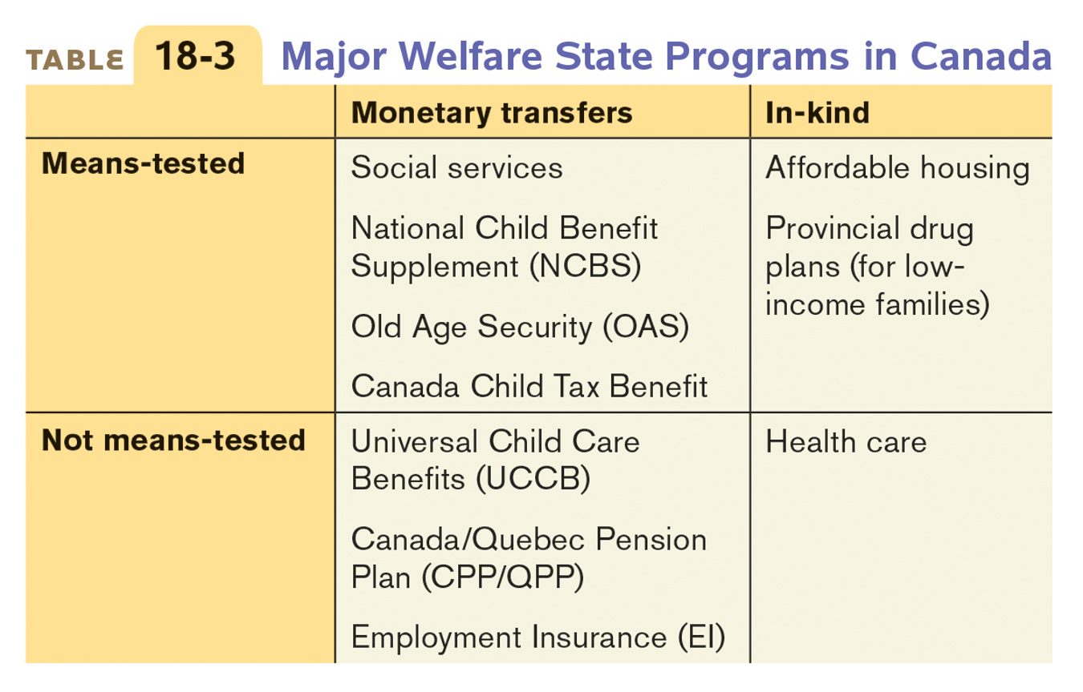

The Effects of the Welfare State on Poverty and Inequality
- The Canadian welfare state is redistributive.
- The poorest three quintiles receive more from the government than they pay in taxes, while the top two quintiles tend to pay much more in taxes than they reap in government transfers.

The Economics of Health Care
- Health insurance satisfies an important need because expensive medical treatment is unaffordable for most families.
- Under private health insurance, each member of a large pool of individuals pays a fixed amount to a private company that agrees to pay most of the medical expenses of the pool’s members.
  - Most working Canadians have some private insurance to supplement the public health coverage
- Each member of a large pool of individuals agrees to pay a fixed amount annually (a premium) into a common fund (or pool) that’s managed by a private company which then pays most of the medical expenses of the pool’s members. Although members must pay fees even in years they don’t have large medical expenses, they benefit from the reduction in risk

Adverse Selection in the Provision of Healthcare
- Adverse Selection is the phenomenon whereby healthy people choose not to purchase insurance which raises the average cost of insuring a population
- To avoid the problem of adverse selection:
  - Health insurance can be provided publicly
  - Private insurance providers can have a carefully screen applicants
  - Private insurance can by provided via a person’s employer
  - Employment based health insurance

Government Health Insurance in Canada
- Canada’s health system is a single-payer system in which the government is the principal payer of medical bills funded through taxes
  - Administered by each province and territory
  - The federal government provides transfer payments to help cover health costs
  - Five Principles in the Canada Health Act of 1984
    - Universality, meaning the public health care insurance must be provided to all Canadians
    - Comprehensiveness, meaning that all medically necessary hospital and doctor services are covered by public health insurance
    - Accessibility, meaning that financial or other barriers to the provision of publicly funded health services are discouraged, so that health services are available to all Canadians when they need them
    - Portability, meaning that all Canadians are covered under public health care insurance, even when they travel internationally or move within canada
    - Public Administration, which requires provincial and territorial health care insurance plans be managed by a public agency on a not for profit basis
  - There are 2 objectives of federal health care policy: to ensure that every Canadian has timely access to all medically necessary health services regardless of their ability to pay for those services, and to ensure that no Canadian suffers undue financial hardship as a result of having to pay health care bills

Health Care in Other Countries
- Healthcare is one area in which Canada is very different from the United States
- Compared with other wealthy countries, U.S. health care is different in three distinct ways
  - Heavy reliance on private insurance
  - Highest spending on healthcare per person
  - They are the only wealthy nation where a large fraction of the population lacks health insurance

The Debate Over the Welfare State
The goals of the welfare state are to help the poor, to protect against severe economic hardship, and to ensure access to essential health care

The debates over the welfare state include the
following questions and concerns:
- about how large the welfare state should be
- philosophical concerns about government involvement
- about the trade-off between efficiency and equity
- that high marginal tax rates to finance an extensive welfare state can reduce the incentive to work
- that means-testing programs to reduce the cost of the welfare state also reduce the incentive to work
- Morality: self sufficiency vs. caring for others

Notch- feature of means tested benefits which makes a family worse off if it earns more

- Debates over the size of the welfare state are based on philosophical and equity-versus-efficiency considerations.
- Politicians on the left tend to favour a bigger welfare state and those on the right oppose it. This left-right distinction is central to today’s politics. Canada’s three major federal political parties have become more polarized in recent decades, with a much clearer distinction than in the past about where their members stand on the left-right spectrum

Writers on the Welfare State
- There is a huge academic, political, popular literature on this topic.
- Next we review a few of the most influential authors.
Michael Harrington, The Other America, 1962
- Poverty became a pressing political and social issue only in the early 1960s.
- Harrington’s book had a huge impact.
- Why? Because for the first time in the history of the rich countries, poverty was “invisible,” and therefore forgotten by the non-poor.
- But Harrington showed that one third of Americans were poor.
- Impact on President Kennedy, Robert Kennedy
- Lyndon Johnson’s “War on Poverty.”
Rawls’ “Difference Principle”
- Differences in income are morally justified only to the extent that they are to the benefit of the worst off.
- People disagree as to whether this is a call for radical equalization, or a cynical defense of the inequalities inherent in the capitalist system
The Parable of Wilt Chamberlain
- Nozick’s case against any pattern of income distribution.
Musgrave, The Theory of Public Finance
- Three Departments (Branches) of the Government
- Department Criterion
- Allocation Efficiency
- Distribution Equity (Fairness)
- Stabilization Stability
- A policy may originate in one department, but will likely affect the others.
Musgrave’s Government Departments
- The policies of the welfare state originate in the Department of Distribution.
- They involve the Department of Allocation, because they may have effects on incentives.
- They involve the Department of Stabilization, because they may be counter-cyclical.
Example: Raising the Minimum Wage
- Policy originates in the Department of Distribution, because its intent is to increase the incomes of the poor.
- Department of Allocation: Does it give employers an incentive to cut back their work force? See Ben Carson, David Card.
If it has both effects, we have a classic conflict between equity and efficiency.

CHAPTER 19- Factor Markets and the Distribution of Income
The Economy’s Factors of Production
- A factor of production is any resource that is used by firms to produce goods and services, items that are consumed by households.
- Factors of production are bought and sold in factor markets, and the prices in factor markets are known as factor prices.
- What are these factors of production, and why do factor prices matter?
- Economists divide factors of production into four principal classes:
- 1) Land: a resource provided by nature
- 2) Labour: the work done by human beings
- 3) Physical capital: which consists of manufactured resources such as buildings, equipment, tools, and machines
- 4) Human capital: the improvement in labour created by education and knowledge that is embodied in the workforce

The Allocation of Resources
Factor prices play a key role in the allocation of resources among producers because of two features that make these markets special:
  - Demand for the factor (aka derived demand), which is derived from the firm’s output choice
  - Factor markets are where most of us get the largest shares of our income

Factor Incomes and the Distribution of Income
- Most families get most of their income in the form of wages and salaries, which means they get their income by selling labour. Some people get most of their income however from physical capital (renting land, owning stock in company)
- The factor distribution of income is the division of total income among labour, land, and capital.
- Factor prices, which are set in factor markets, determine the factor distribution of income.
- Labour receives the bulk—almost 60%—of the income in the modern Canadian economy.
- Although the exact share is not directly measurable, much of what is called compensation of employees is a return to human capital.

Marginal Productivity and Factor Demand
- All economic decisions are about comparing costs and benefits. For a producer, it could be deciding whether to hire an additional worker.
- But what is the marginal benefit of that worker?
- We will use the production function, which relates inputs to output to answer that question.
- We will assume throughout this chapter that all producers are price-takers—they operate in a perfectly competitive industry.
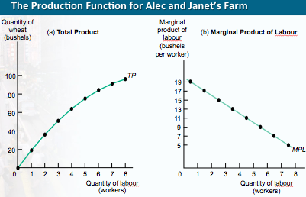
Value of the Marginal Product
- What is Alec and Janet’s optimal number of workers? That is, how many workers should they employ to maximize profit?
  - As we know from earlier chapters, a price-taking firm’s profit is maximized by producing the quantity of output at which the marginal cost of the last unit produced is equal to the market price.
  - Once we determine the optimal quantity of output, we can go back to the production function and find the optimal number of workers.
  - There is also an alternative approach based on the value of the marginal product.
- The value of the marginal product of a factor is the extra value of output generated by employing one more unit of that factor.
- Value of the marginal product of labour =
VMPL = P × MPL
- The general rule is that a profit-maximizing, price-taking producer employs each factor of production up to the point at which the value of the marginal product of the last unit of the factor employed is equal to that factor’s price.
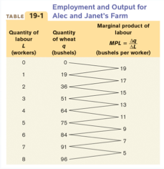
To maximize profit, Alec and Janet will employ workers up to the point at which VMPL = W for the last worker employed

The Value of the Marginal Product Curve
- The value of the marginal product curve of a factor shows how the value of the marginal product of that factor depends on the quantity of the factor employed.
- This curve like the marginal product of labour curve slopes downward because of diminishing returns to labor in production. The value of the marginal product of each worker is less than that of the preceding worker.

The demand curve for labour
- In other words, the demand curve for labour is: The value of the marginal product of labour, or VMPL
What causes factor demand curves to shift?
- There are three main causes:
- Changes in prices of goods
- Changes in supply of other factors
- Changes in production technology

Changes in Prices of goods
- if P changes, VMPL=P x MPL will change at any given level of employment
- when an increase in price occurs, it shifts the value of the MPL curve up
- when a decrease in price occurs, this shifts the MPL curve down

Changes in Supply of Other Factors
- the value of the MPL curve shifts upward when supply increases or when MPL rises
- the value of the MPL curve shifts downward when supply decreases or when MPL falls

Changes in Production Technology
- Effect of technological progress on demand for a given factor can go either way: improved technology can either increase or decrease the demand for a given factor of production

The Marginal Productivity Theory of Income Distribution
- We have learned that when the markets for goods and services and the factor markets are perfectly competitive, factors of production will be employed up to the point at which the value of the marginal product is equal to their price.
- What does this say about the factor distribution of income?

Equilibrium in the Labour Market
- Each firm will hire labour up to the point at which the value of the marginal product of labour is equal to the equilibrium wage rate.
- This means that, in equilibrium, the marginal product of labour will be the same for all employers.
- So, the equilibrium (or market) wage rate is equal to the equilibrium value of the marginal product of labour—the additional value produced by the last unit of labour employed in the labour market as a whole.
- It doesn’t matter where that additional unit is employed, since the value of the marginal product of labour (VMPL) is the same for all producers.
- According to the marginal productivity theory of income distribution, every factor of production is paid its equilibrium value of the marginal product.

Is the Marginal Productivity Theory of Income Distribution Really True?
- There are some issues open to debate about the marginal productivity theory of income distribution:
  - Do the wage differences really reflect differences in marginal productivity, or is something else going on? Like the wage differences between wem and women and amongst different ethnic cultures
  - What factors might account for these disparities, and are any of these explanations consistent with the marginal productivity theory of income distribution?
How to Explain those Differences?
- Could it be simply discrimination?
- Could it be differences in human capital? But if so, could the differences in human capital be explained by discrimination?

Marginal Productivity and Wage Inequality
3 sources of wage differences:
- Compensating differentials are wage differences across jobs that reflect the fact that some jobs are less pleasant than others.
- Second theory is difference in talent
- Difference in quantity of human capital (education and training)
- Compensating differentials—as well as differences in the values of the marginal products of workers that arise from differences in talent, job experience, and human capital—account for some wage disparities.
- It is clear from the following graph that, regardless of gender or ethnicity, education pays.
- Those with a high school diploma earn more than those without one, and those with a post-secondary education earn substantially more than those with only a high school diploma.
- Market power, in the form of unions or collective action by employers, as well as the efficiency-wage model, also explain how some wage disparities arise.
- Unions are organizations of workers that try to raise wages and improve working conditions for their members by bargaining collectively.
- According to the efficiency-wage model, some employers pay an above equilibrium wage as an incentive for better performance.
- Discrimination has historically been a major factor in wage disparities.
- Market competition tends to work against discrimination.

So Does Marginal Productivity Theory Work?
- The main conclusion you should draw from this discussion is that the marginal productivity theory of income distribution is not a perfect description of how factor incomes are determined, but that it works pretty well.
- It’s important to emphasize that this does not mean that the factor distribution of income is morally justified.
- Remember the difference between marginal and average productivity. The marginal product of labour is strongly influenced by supply

The Supply of Labour
- Decisions about labour supply result from decisions about time allocation: how many hours to spend on different activities.
- Leisure is time available for purposes other than earning money to buy marketed goods.
- In the upcoming graph, the individual labour supply curve shows how the quantity of labour supplied by an individual depends on that individual’s wage rate.
- A rise in the wage rate causes both an income and a substitution effect on an individual’s labour supply.
  - The substitution effect of a higher wage rate induces longer work hours, other things equal.
  - This is countered by the income effect: higher income leads to a higher demand for leisure, a normal good.
  - If the income effect dominates, a rise in the wage rate can actually cause the individual labour supply curve to slope the “wrong” way: downward.

Shifts of the Labour Supply Curve
- The market labour supply curve is the horizontal sum of the individual supply curves of all workers in that market.
- It shifts for four main reasons:
  - changes in preferences and social norms- changes in preferences and social norms can lead workers to increase or decrease their willingness to work at any given wage
  - changes in population- as population increases more workers are available at any given wage and vice wersa
  - changes in opportunities- when superior alternatives arise for workers in another labour market, the supply curve in the original labour market shifts leftward as workers move to the new opportunities
  - changes in wealth- a person whose wealth increases will buy more normal goods including leisure. More wealth shifts supply curve to the left

