Linguistics Midterm Study Guide
- Introduction and Animal communication

- Components of language:
  - Lexicon-
    - Elements of language that you must memorize, they are not systematic
  - Phonology
    - Combines sounds into larger units like words
  - Syntax
    - Combines words into larger units like phrases and sentences
    - Chimps did not succeed at this. Words were strung together without proper structure
  - Semantics
    - Relates the meaning of larger expressions to the meaning of their parts
- Design features of human language:
  - Discreteness
    - Discrete means it is a finite number
    - Human Language is a Discrete Combinatorial system
      - A small number of units (phonemes) from old messages can be combined to form new messages
      - Body language is not combinatorial
      - Loudness communicating anger is not considered discrete
  - Productivity
    - aka ‘Creativity
    - Existing patterns can be extended to create new expressions
    - “Discrete Infinity”: There is no finite limit on the number of messages that can be encoded in human language
  - Recursion
    - ability of categories to contain other categories of the same type
  - Duality of patterning
    - the difference between morphology and syntax
    - Every human language possesses these two structures
  - Arbitrariness of the sign
    - Connection between sound and meaning is unpredictable.
    - Some evidence:
      - languages are different
      - new things don’t have obvious names (unless the name is derived from existing words) new words don’t refer to obvious objects
  - Onomatopoeia, sound symbolism
    - have sounds in the that communicate the meaning
    - called iconic or iconicity
    - An exception to ‘Arbitrariness of the sign’
    - sound symbolism
      - Bouba/ Kiki Test
      - K sounds sharp
      - B sounds rounded
      - 
  - Displacement
    - ability to communicate about things not immediately present
  - Reflexiveness
    - ability to use language to talk about language
    - Also referred to as Metalinguistic
    - Exclusive to humans
  - Cultural Learning
    - Acquisition of language from the community.
      - Learn English from English Family.
- Relationship between language learning and language diversity; (?)
- poverty of the stimulus
  - language learners possess some prior/innate knowledge
  - The mind is not a blank slate.
- Universal grammar
  - the knowledge that a human learner (baby) brings to the language acquisition process
  - Human Languages Never:
    - 1. Form questions by reversing the order of words in a sentence
      - English preforms auxiliary fronting (the auxiliary is ‘is’)
    - 2. Have no vowels at all
    - 3. Allow words with only an odd number of sounds
    - 4. Have separate verb forms depending on the current time of day
    - 5. Always arrange words in a sentence in the order of increasing length
    - 6. Lack a noun/verb distinction Have a finite sentence length limit
- Sign languages
  - Possess their own distinct grammar
    - Cannot use signed words with English grammar
    - ASL has a freer word order (SVO)
  - Also demonstrate ‘Arbitrariness of sign’
  - Also have Duality of Patterning (phonology and syntax)
- Vocal tract anatomy in apes vs. humans
  - Humans evolved a vocal tract shape that maximizes distinctions between speech sounds.
  - Humans have a shorter tongue, lower larynx and a larger pharynx.
    - This allows the human tongue more freedom to move and grants them a greater ability to shape the oral cavity.
  - The epiglottis of the ape touches the soft pallet so it can chew without risk of choking
- Design feature differences between animal and human languages
  - Modality
    - Sound
    - Visual Cues: posture, facial expressions, colour
    - Touch
    - Chemicals: pheromones
    - Electrical signals
  - Mostly innate Knowledge
    - Cultural learning seen in whale and bird songs
  - No productivity
  - Usually no recursion
  - Some limited discreteness, but they still do not have a true finite combinatorial system
    - Cannot consistently form new messages based on the rearrangement of parts
  - Whole unit messages. (EX. Vervet monkeys predatory alarm calls)
  - Continuous scales (infinite)
    - Body language, volume
  - What animal’s language is a Closed, Simultaneous, Continuous scale?
    - Bees’
  - Physiology: Birds
    - Possess no larynx, rather a syrinx
      - The part of the vocal tract where the trachea branches into the lungs
      - Resonance due to vibration of the membranes in the walls of the trachea
      - Pitch and volume controlled by tension of the membranes and rate of airflow
      - *Possibly review song structure*

- Phonetics and phonology

- The vocal tract; the speech production mechanism
  - 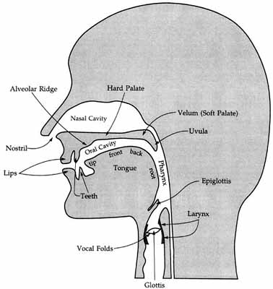
  - Vocal folds are spread and let the air pass through in voiceless sounds Downstream from the larynx, the behavior of the articulators modifies the sound
- Places and manners of articulation: bilabial, labiodental, dental, alveolar, palatal, velar; stop, fricative, affricate, nasal
  - Bilabial: closure two lips (in m and p)
  - Labiodental: lower teeth, upper lip (v and f)
  - Dental: tongue and upper teeth (th)
  - Alveolar: tongue and alveolar ridge (ridge right behind the teeth) (d and t)
  - Post-alveolar: tongue just in front of the hard palate
  - Palatal: tongue and hard palate (sh, j)
  - Velar: tongue and soft palate (velum) (k, g, ing)
  - Glottal: focal folds (in the larynx) (consonants produced with only vocal chords)
    - I-this, uh-oh
- Manner of Articulation: How closely or far apart the two articulators come together
  - Stop- Articulators are completely together
  - Fricative-Articulators are closely together, but not completely.
  - Affricative- Stop followed by a fricative. (jury, church)
  - Nasal-Does the sound stop when you plug your nose?
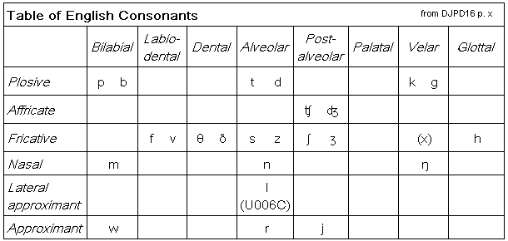

- Larynx and voicing
  - If your vocal chords vibrate, the sound is voiced
- Phonemes and allophones
  - Phoneme
    - The smallest unit of sound that distinguishes meaning
    - Speakers are good at telling phonemes apart
  - Allophones
    - The different pronunciations of a phoneme.
    - Does not change the meaning of the word.
    - Speakers are not usually good at telling allophones apart
- Contrastive vs. complementary distribution
  - Complementary distribution-same phoneme
    - The two sounds cannot occur in the same environment
    - Minimal pairs are impossible
    - [p] ∼ [ph] in English; [l] ∼ [R] in Korean
  - Contrastive distribution-Minimal pairs-different phonemes
    - Sound location and meaning is unpredictable + must be learned
    - Switching the sounds changes the meaning
      - Cannot be used interchangeably
    - [p] ∼ [ph] in Hindi; [l] ∼ [R] in English
- English consonant phonemes, and their IPA transcription
- The Great Canadian Shift
  - We pushed our vowels back more.
    - Therefore Cot and caught sound the same but are different in the US
- The Northern Cities Shift
  - People in Detroit push their vowels forward
- Grimm’s Law-wide sound shift
  - Initial Voiceless stops p, t and k became the fricatives f, th and h
- The Great English Vowel Shift
  - Occurred with Early Modern English
  - Long Vowels were raised one spot
  - Already high vowels became diphthong
  - Meat: Mate (sound)meat (sound)
    - Break and steak remained the same

- Language change, varieties, and attitudes

- Language families
  - Languages are related if they can be shown to have descended from a common ancestor speech community, called a ‘proto-language’
  - Related languages have Cognates: words that share a common origin
- Comparative method
  - allows us to make hypotheses about specific properties of proto-languages even when they left no direct evidence in the written record
- Regularity of sound change
  - Key point: sound change is regular
  - In other words, if b changes into v in some words, it changes into v in all words
  - Regularity of sound change is what makes it possible to reconstruct unattested proto-languages, using the so-called comparative method
  - Languages change, and related languages become less similar over time
    - Words are replaced
    - Sounds change into other sounds
    - Morphology is lost or added
    - The syntax changes
  - Reductive
    - Assimilation
    - Loss (silent letters)
    - Vowel Reduction in unstressed positions
    - Fusion
  - Addition
  - Dissimilation
  - Metathesis
- Morphological Change
  - Inflection like the accusative and nomative distinction has been lost in nouns
  - Levelling of Analogy: Irregular morphology is lost
    - The past tense of dive became dove by analogy with ride/rode, write/rode
  - Morphology can be gained
    - Example: future tense in Romance languages
  - Going to gonna
    - Cannot be the verb of motion.
    - Simply replaces the future tense
- Semantic change
  - Widening
    - Sometimes acquired through metaphorical extension
  - Narrowing
    - E.g. Meat: food animal muscle
  - Reinterpretation
    - Want used to mean lack
    - Bead: Prayer ball on a string
    - Antonymic Change
      - Wicked really good
  - Weakening
    - Dreadful: full of dread very bad
    - Terribly: full of terror very
  - Phrase Abbreviation
    - Wife used to mean woman
      - Wife wifmanwoman
    - I am engaged to be married I am engaged
  - Displacement: only referring to something by the modifier
    - Ex. Contact lenses contacts
  - Pejoration: a neutral word acquires a negative meaning
    - EX. Mister/Mistress are not an equal pair.
  - Amelioration: a word acquires a positive meanings
    - Ex. ‘Praetig’ (crafty, sly) Pretty
  - Taboo replacement: Euphemism
  - Hyperbole
  - Evidence for semantic change
    - Written records from earlier stages in the history of the language
      - Matthew 3.4: [John the Baptist’s] meat was locusts and wild honey
        - meat ‘food’ > ‘muscles of animals’
    - Fixed expressions, proverbs, compound words, etc.
      - Time and tide wait for no man
      - midwife
        - wife ‘woman’ > ‘female spouse’
        - mid used to mean ‘with’
        - cf. fishwife, old wives’ tales
- Dialect maps;
  - Isoglosses: lines that separate varieties from each other
- Tree and wave diagrams of language families
  - Tree: Highlights common descent
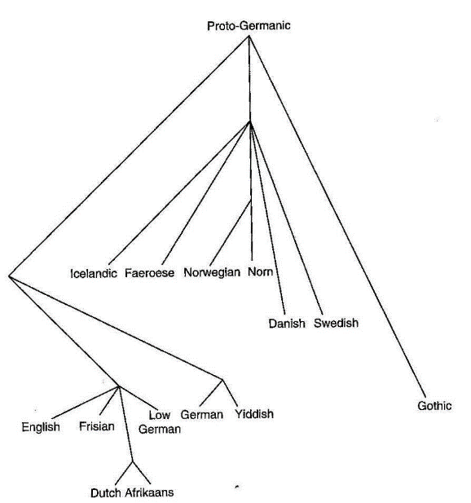

  - Wave: Highlights degrees of similarity
- Connection between change and variation
  - Changes originate and spread across a language, but don’t necessarily cover the entire area
  - Changes often have social conditioning (stratification) (more on that next week)
  - As a result, after a few changes have taken place, the language possesses variation, both geographically and socially
- Variation and social meaning
  - A phonetic variant signals an attitude and/or identity
  - Language (grammar), as a result of change, makes available variant pronunciations to speakers, which are coopted for social purposes
  - Which variant has which meaning is an accident of history
  - In many cases variants may be associated with social class, and stigmatized as “incorrect” or “careless” language
  - The association is just as arbitrary!
- Features of AAVE:
  - AAVE phonology
    - Cluster reduction
      - pas’ the house vs. pas’ a house
    - Non-rhotic
    - [θ, ð] > [t̯ , d̯]/[f,v]
    - Copula absence
    - ‘bin’ a long time ago
    - ‘be’ habitual
    - ‘be done’ will have

- Morphology & syntax

- Parts of speech: nouns, verbs, determiners, adjectives, pronouns, prepositions, conjunctions, adverbs

- open vs. closed class;
  - Open classes (new items can be easily added):
    - Noun
    - Verb
    - Adjective
    - Adverb
  - Closed classes (new items are rarely, if ever, added):
    - Preposition
    - Conjunction
    - Pronoun
- lexical vs. function words
  - Lexical words have meaning on their own
    - How to define lexical categories?
    - Bad idea: meaning (noun = ‘object’, verb = ‘action’. . .)
    - Better: by their morphological and syntactic behavior
      - Nouns take plural -s, can be preceded by determiners
      - Verbs take progressive -ing, can be preceded by auxiliaries
  - Function words aid the interpretation of other words
- Morpheme: Smallest constituent in a word
  - Affixes: suffixes and prefixes need a stem. They are bound morphemes.
    - Derivational: Derive new words/change the meaning of the root.
    - Inflectional Suffixes: Modify the root. Creates plurality or modifies tense.
    - Diminutive Suffix: makes a word mean small. (book booklet)
    - Combining forms: no roots, only suffixes. (sui-cide)
    - Infix: bind inside another morpheme. Ex. Abso-bloody-lutely
  - Portmanteau Root: No distinction between root and tense. i.e. ‘took’.
  - Stem: an extended root that is sometimes needed for the addition of bound morphemes
- word formation processes:
  - back formation
    - Removing letters that look like bound morphemes to create new roots
  - compounding
    - Strong Stress on the first word
    - Created often using rhymes of alliteration
    - Not Common in other languages
    - Some compound origins are forgotten
    - Loan translation: Where another language copies a compound word but replaces the roots with the equivalent forms in their own language.
  - zero derivation
    - No affix is used to change a word’s class
  - Blending: combing parts of words to make a new word
  - Shortening: Shortens a word to make a new word
    - (public house pub)
    - Clipped Compound: situation Comedy sitcom
  - Reduplication: Doubling single word to give it a new meaning
    - Partial reduplication
    - English has vowel alternation/oscillation (Criss-cross)
  - Proper names to common noun: naming an object after an inventor
  - Borrowing: used to describe new objects
- predicates, arguments
  - Predicate: expresses a property of an entity or a relationship between entities
    - Can be verbs, prepositions adjectives or nouns.
    - One-place Predicates: have only one argument
      - E.g. sleep, yawn, cough
    - Two-place predicates: have 2 arguments
      - E.g. see, like, bite, kidnap
    - Three-place predicate: Give
  - Argument: the entity of the predicate
  - A sentence must have a predicate and (if no predicate) a finite verb
    - Finite verbs: write/wrote but not writing/written
    - If the predicate is not a verb then a finite form of ‘to be’ must be in the sentence. Here ‘to be’ is referred to as a copula when linking the subject and the predicate.
    - Phrases can be used as predicates without verbs when they are not the main predicate and relate to a direct object
      - E.g. They elected her (to be) party whip.
- head, modifier, constituent
- grammatical relations
  - Subject: argument before the verb
  - Complement: argument after the verb
  - Adjunct: a constituent that does not express the argument
  - Indirect Object: the recipient of the object
- Inflection on Nominals
  - Case
    - When nouns and pronouns are ‘inflected’ to show their relation to the sentence. (Object, subject, etc.)
      - Nominative Case: the subject of a sentence
      - Accusative Case: the object
      - Genitive case: show’s possession. English ‘-‘s’ meaning this noun has possession of the next noun.
      - Dative Case: expresses ‘to’ or ‘for’ (to benefit of)
      - Ablative Case: expresses from
      - Locative case: expresses location. ‘on’, ‘in’ or ‘at’
    - Case systems are usually supplemented with prepositions and postpositions
    - Most case markings are lost in English
    - Case tenses allow word order to be more free as
    - For English personal pronouns, there is a 2-way case distinction.
      - Nominative: I (subject)
      - Accusative: me (object)
    - Ergative case: marks “the subject of a transitive verb”.
  - Number
    - Denotes singularity, duality or plurality.
    - English has lost the inflection for duality. (‘wit’ was used as ‘we’ for only two people)
    - In other languages the plural marker is put before the case marker in a word
      - ‘adam-lar-a’ (for the men). ‘Lar’ is the plural marker and ‘a’ is the case marker
    - In English we simply add ‘s’ or ‘es’ to denote plurality in nouns
      - Demonstrative words like ‘this’ must change to ‘these’
    - In old English, the plural marker fused with the case marker to make a portmanteau morph
  - Gender
    - Grammatical gender: arbitrary
    - Natural gender: reflect true gender
    - In English gender is natural. French has grammatical and natural gender forms. Italian has a portmanteau of
  - Inflection on Verbs
    - Verb tenses
    - Aspect
- Syntax
  - Compositionality: Meaning of larger expressions depends on the meanings of their parts
  - Constituents are smaller expressions out of which larger ones are constructed
    - Each constituent has one and only one head: the central, obligatory part
    - Non-head parts of the constituent are modifiers
      - In noun-noun compounds, heads are the initial elements

