Ch20 Bacteria and Archaea
20.1 The full extent of the diversity of Bacteria and Archaea is unknown
-Only 6000 of bacteria and archaea have been identified which is only 1% of the total number.
-we know a few about prokaryotic organisms as they cannot be grown in culture(they require extreme physiochemical conditions) like bacteria and archaea to be classified by external features and physiological differences.
-Metagenomics: the isolation and cloning of DNA from and environment and to analyze gene sequences.
-Metagenomics helps to investigate the diversity of prokaryotic organisms in a wide range of environments.
-20.1a:Prokaryotic organisms make up two of the three domains of life
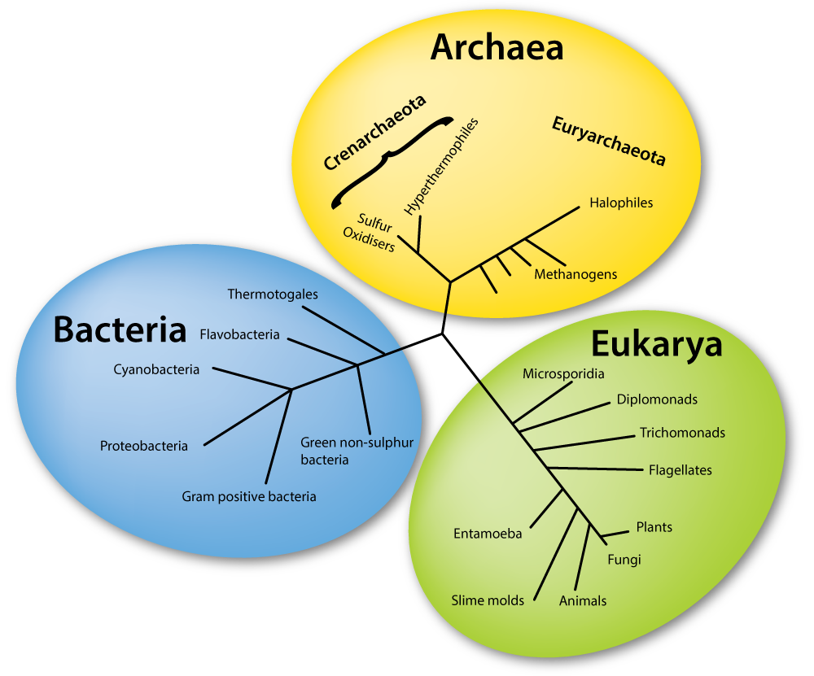
- Archaea and Bacteria consist of prokaryotic organisms and Eukarya includes all eukaryotes.
- Bacteria are most familiar to us,unlike archaea as they were only discovered 40 years ago.
- Archaea share some cellular features with eukaryotes and some with bacteria,but have some features that make them unique.

20.2 Prokaryotic Structure and Function
- prokaryotic organisms are the smallest in the world. (less than a micrometer)
- despite their size,they dominate life on earth(billions of species with biomass exceeds that of animals).
-bacteria cells in our bodies outnumber all other cells in our body

20.2a Prokaryotic cells appear simple in structure compared with eukaryotic cells
-Three cell shapes are common among prokaryotes:spiral,spherical(or coccoid;occus=berry), and cylindrical(known as rods), but some archaea even have square cells.
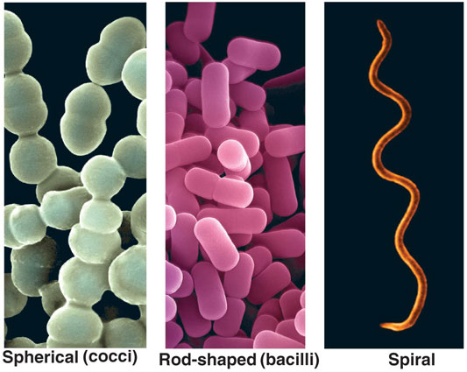
-Microscopic images of prokaryotes reveal a cell wall and plasma membrane surrounding cytoplasm with DNA concentrated in one region and ribosomes scattered throughout. Chromosome is not contained in membrance-bound nucleus but is packed in a nucleoid.
- They have no cytoplasmic organelles equivalent to endoplasmic reticulum or golgi complex like eukaryotes
-Chemical reactions are carried out by plasma membrane and cytoplasmic solution(macromolecules like proteins tend to concentrate in cytoplasm,thus they tend to be viscous.
-Recent researchers found that prokaryotes have an organelle which is surrounded by a membrane that generates ATP.
Internal structures:
- Their genome consists of a single,circular DNA molecule,some have a linear chromosome.
- Many contain small circles of DNA called plasmids which contain genes for nonessential but beneficial functions such as antibiotic resistance.
- Genes are shared by (horizontal gene transfer;also occurs when bacterial cells take up DNA from the environment)among cells since plasmids replicate indep. Of cell’s chromosome and can be transferred from one cell to another.
- They contain ribosomes , they are smaller than eukaryotic ribosomes,but carry out protein synthesis
- Archaeal ribosomes resemble those of bacteria in size but differ in structure;protein synthesis in archaea is a comb. Of both bacterial and eukaryotic processes.
- They have a cell wall which lies outside their plasma membrane and protectes the cell from lysing if exposed to hypertonic conditions.
- The cell wall’s primamry component is peptidoglycan,a polymer of sugars and a.a’s that forms linear chains.
- Bacteria can be divided into two groups,gram-positive and gram-negative cells based on their reaction to the Gram stain procedure:
1)cells stained with crystal violet and then treated with iodine, which forms a complex with crystal violet
2)cells then rinsed with ethanol and stained with safranin
3)gram positive cells retain the crystal-violet iodine complex and thus appear purple
4)gram negative cells, the ethanol washes the crystal violet-iodine complex out of the cells which are colourless, until counterstained with safranin and thus appear pink
- Gram-positive bacterial cell walls: consist of a single, thick peptidoglycan layer
- Gram-negative bacterial cell walls:consist of thin peptidoglycan sheath surrounded by an outer lipopolysaccharide(LPS) membrane.
- Cell wall of many prok. Cells is surrounded by a layer of saccharides known as a capsule; they are sticky and protect cells in difference environments.

Flagella and Pili: see figure 2
- Prok. Cells can move actively through liquids via flagella(sing. Flagellum=whip) extending from the cell wall
- Prok. Flagella are made up of rigid shafts of protein called Pili(sing. Pilus=hair) extending from their cell walls which enables them to adhere or move along a surface.
- One type of Pili,sex pilus, helps in the transfer of plasmids from one cell to another. Others help bacteria to bind to animal cells. Also,some Pili conduct electricity to transfer electrons.

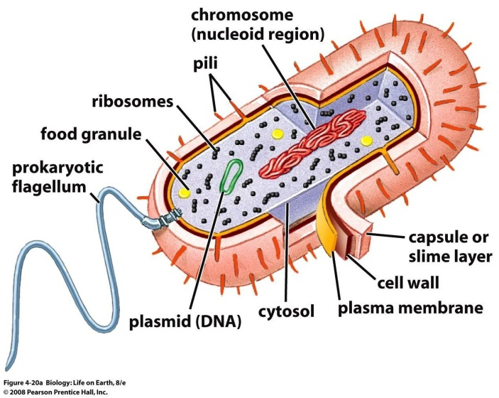
Figure2: structure of a bacterial cell

20.2b Prokaryotic Organisms Have the Greatest Metabolic Diversity of All organisms
Energy source | Oxidation of molecules | Light
Carbon source CO2  Organic  molecules | Chemoautotroph  Some bacteria and archaea;no eukaryotes | Photoautotroph  Some bacteria,some protists, and most plants
Carbon source CO2  Organic  molecules | Chemoheterotroph  Some bacteria,archaea, and protists; also fungi, animals, and even some plants | Photohetrotroph  Some bacteria

-organisms can be grouped into four modes of nutrition
1)Autotrophs (auto=self, trophs=nourishment):organisms such as plants that can synthesize organic carbon molecules using inorganic carbon(CO2)
2)Heterotrophs: organisms that obtain carbon from organic molecules, either from living hosts or from organic molecules in the products, wastes or remains of dead organisms. All animals are heterotrophs

Division according to the source of energy used to drive biological activities:
Chemotrohps: organisms which obtain energy by oxidizing inorganic or organic substances
Phototrophs: organisms which obtain energy from light.

Prokaryotic organisms(bacteria and archaea) are the only representitives of two of the following categories:
3)photoheterotrophs: organisms that use light as an energy source and obtain carbon from organic molecules rather than from CO2
4) Chemoautotrophs: organisms that obtain energy by oxidizing inorganic substances such as hydrogen, iron, sulfur, ammonia and nitrites and use CO2 as their carbon source. These organisms live in habitats such as deep-sea hydrothermal vents where reduced inorganic compounds are abundant.

-Aerobic organisms or aerobes: organisms which use oxygen as their final electron acceptor. Some of them are prokaryotes. Aerobes may obligate; they cannot survive without oxygen.
-Anaerobic respiration: some prok. Organisms ‘breathe’ metals as their final e acceptor, it may also involve nitrate or sulfate. Only prok. Are capable of this kind of respiration
-Obligate anaerobes: organisms which are poisoned by oxygen, and survive either by fermentation or anaerobic respiration.
-Facultative anaerobes: use oxygen when its present, but when its absent they use fermentation or anaerobic respiration.

20.2C Bacteria and Archaea Play Key Roles in Biogeochemical Cycles.
- Biogeochemical cycle: pathway by which an element moves through an ecosystem
-Nitrogen fixation: The breakage of nitrogen usin the enzyme nitrogenase into other forms which can be used by other organisms. (only some bacteria and archaea can break the bonds of nitrogen) 1)N2 is reduced to ammonia(NH3)
2) ammonia is ionized to ammonium(NH4+), which prok. Use to produce nitrogen containing molecules such as a.a and nucleic acids
-Nitrofication: oxidation of ammonium(NH4+) to nitrate(NO3-). It makes nitrogen available for many organisms like plants,animals and bacteria that cannot metabolize ammonia.

20.2d Asexual Reproduction Can result in Rapid Population Growth
-prok. Organisms reproduce by asexual reproduction
- a parent cell divides by binary fission into two daughter cells that are exact genetic copies of their parent.
-rapid reproduction by binary fission in favourable conditions can cause the population to double in 20 min.
-This means that prok. Have higher mutation rates than do euko. organisms.
- The rapid reproduction also contributes to a larger genetic variability in bacteria and archaea.

20.2e Pathogenetic Bacteria Cause Diseases by Different Mechanisms
- Exotoxins: toxic proteins produced by some bactiera which are leaked from or secreted from the bacterium.
-Endotoxins: lipid A protein of the LPS molecule of the outer membrane of all Gram-negative bacteria

20.2f Pathogenic Bacteria Commonly Develop Resistance to Antibiotics
-Antibiotic: a natural synthetic substance that kills or inhibits the growth of bacteria and other microorganisms
-prok. And fungi produce these sub. As defensive molecules.
-Bacteria can resist antibiotics by pumping antibiotics out of the cell using membrane-bound pumps. They can also produce molcules that bind to the antibiotic or enzymes that break down the antibiotic. A simple mutation can also causes to change shape which inhibits it from binding.

20.2g In Nature, Prokaryotic Organisms May Live in Communitites Attached to a surface
- bacteria and archaea live in communites where they interact. One important type of community is a biofilm; which consists of complex aggregation of microoganisms attached to a surface and surrounded by a film of polymers. Benefits are:
1) organisms can adhere to hospitable surfaces,
2) can live on the products of other cells.
3)conditions within the biofilm promote gene transfer between species
4)biofilm protects cells from harmful environmental conditions

-dental plaque is a biofilm which are harmful and must be removed by brushing and flossing
- biofilms of bacteria and archaea are found in human gastrointestinal tract,they are benefical as they protect against pathogenic bacteria and maintain a healthy immune system
-prok. Organisms in a biofilm communicate via quorum sensing; it allows cells to start secreting extracellular polymeric substances (EPS) when a high enough cell density is reached

Formation of a biofilm:
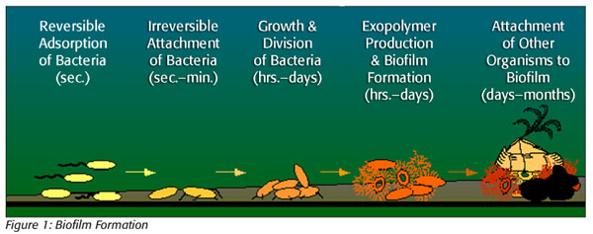

20.3 The Domain Bacteria
- rRNA sequences are used in evolutionary studies of prok. Organisms. Several branches are identified:
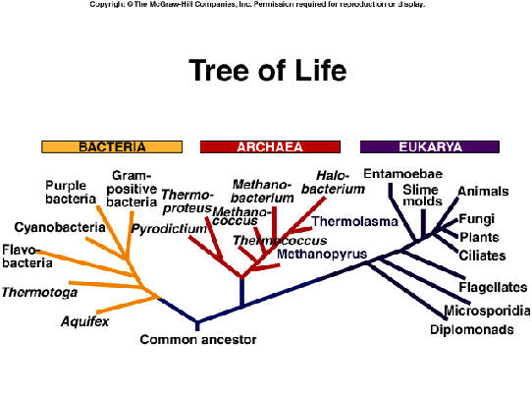
20.3a Molecular Studies Reveal Numerous Evolutionary Branches in the Bacteria
-6 important groups of bacteria:
1 )Proteobactieria:The Purple Bacteria and Their Relatives
-Gram-negative bacteria which evolved from a purple,photosynthetic ancestor
. e.g.E.coli;plant pathogenic bacteria and bacteria that caise human diseases.
2) Green Bacteria
-gram negative bactiera with chlorophyll pigment that gives their green colour
3)Cyanobacteria
-gram-negative photoautotrophs which are blue-green in colour
4) Gram-positive bacteria
-some cause human diseases and some are benficial to humans

5)Spirochetes
-have helically spiraled flagella in their cytoplasm
6)Chlamydias
-gram-negative bacteria but lack peptidoglycan

20.4 The Domain Archaea
-were firstly found in extreme environments(thus were called extremophiles)but later found in less extreme environments

20.4a Archaea Have Some Unique Characterstics
-unique plasma membrane;some lipids have polar head groups at both ends
-their unique lipids make them more resistant to disruption,making the membrane more suited to extreme environments
-many are chemoautotrophs,and others are chemoheterotrophs. No pathogenic members.

20.4b Molecular Studies Reveal Three Evolutionary Branches in the Archaea
1) Euryarchaeota
-methanogens,extreme halophiles and some extreme thermophiles
2)Grenarchaeota
-most of the extreme thermophiles, as well as psychrophiles and mesophiles
3)Korarchaeota
-known only from DNA samples

NOTE:CHECK Pg.481 FOR CHARACTERSTICS OF BACTERIA,ARCHAEA AND EUKARYA

Chapter 21- Viruses Viroids & Prions

21.1 What Is a Virus? Characteristics of Viruses
- Structure of a virus is reduced to the minimum necessary to transmit its genome from one host cell to another.
- Virus is one or more nucleic acid molecules surrounded by a protein coat or capsid
- Some capsids are enclosed within a membrane or envelope derived from their host cell’s membrane
- Not a cell, does not have cytoplasm enclosed by plasma membrane
- Lack metabolic system to provide energy for their life cycles and cannot reproduce on their own, depended on host cells they infect for their functions
- Referred to as infectious biological particles
- Nucleic acid genome of a virus may be DNA or RNA and can be composed of either a single strand or a double strand of RNA or DNA
- All viruses have genes that encode at least their coat proteins and the enzymes required for nucleic acid replication
- Many viruses have genes that encode recognition proteins that become implanted in the coat surface
  - Coat proteins recognize and bind to the host cell, promoting entry of the virus particle or its nucleic acid core into that cell
- Viruses are in 2 basic structural forms, helical or polyhedral
  - Helical viruses, the protein subunits assemble in a rodlike spiral around the genome
    - Infect plant cells
  - In polyhedral viruses, coat proteins form triangular units that fit together like the parts of a geodesic sphere
    - Include forms that infect animals, plants and bacteria
    - In some polyhedral viruses, protein spikes that provide host cell recognition extend from the corners, where the facets fit together
  - Both helical and polyhedral circuses can be enveloped in a membrane derived from the host’s membrane

- Viruses are classified into orders, families, genera and species using several criteria, including virus size and structure, genome structure (RNA or DNA, single stranded or double stranded) and how their nucleic acid is replicated
- Coronaviridae, familie which influenza virus belongs, is named for the “crown” of protein spikes on the capsid, corona=crown
- 80 viral families described to date, 21 include viruses that cause human diseases
  - Cause diseases of wild and domestic animals
  - Plant viruses cause annual losses of millions of tonnes of crops including potatoes, sugar beets, cereal and sugar cane

- Not all viruses are harmful to people
- Bacteria is destroyed in huge number by bacteriophages, or phases for short
- Viruses also provide a natural means to control some insect pests, such as spruce budworm

21.2 Viruses Infect Bacterial, Animal, and Plant Cells by Similar Pathways
- Virulent bacteriophages, kill host cells during each cycle of infection, whereas others are temperate
- Temperature bacteriophages enter an inactive phase inside the host cell and can be passed on to several generations of daughter cells before becoming active and killing their host

Virulent Bacteriophages
- E. Coli, the T-even bacteriophages T2, T4, and T6 have been the most valuable in genetic studies
- Coats of these phages are divided into a head and a tail
- Double stranded linear molecule of DNA is packed into the head
- Tail, assembled from several different proteins, has recognition proteins at its tip that can bind to the surface of the host cell
- Once tail is attached, it functions as assort of syrinage that injects the DNA genome into the cell

- Infection begins when a T-even phage collides randomly with the surface of an E. Coli cell and the tail attaches to the host cell wall
- Phage injects its DNA into the host cell. Expression of phage genes produces an enzyme that breaks down bacterial chromosome
- The phage DNA is replicated inside the host cell
- Viral head and tail units are synthesized
- Phage DNA, head and tail units assemble into complete phage particles
- Cell ruptures, releasing the new phage particles

- Series of events, from infection of a cell through to the release of progeny phages from the ruptured (for lysed) cell, is called the lytic cycle
- Transfer of bacterial genes from one bacterium to another via a virus is known as transduction
- Bacterial genes from essentially any DNA fragment can be randomly incorporated into phage particles; thus, gene transfer by this mechanism is termed generalized transduction
- Specialized transduction: transfer of bacterial genes between bacteria using temperate phages that have incorporated fragments of the bacterial genome as they make the transition from the lysogenic cycle to the lytic cycle

Infection of Animal Cells
- Viral coat and genome enter a host cell
  - Removal of the coat to release the genome occurs during or after cell entry; the envelope does not enter the cell
- Majority of animal virus infections are asymptomatic because causing disease is of no benefit to the virus
- Number of pathogenic viruses cause diseases in a variety of ways
  - Some viruses cause cell death when progeny viruses are released from the cell
    - Destroys vital tissues such as nervous tissue or white or red blood cells, or causing lesions in skin and mucous membranes
- Other viruses release cellular molecules when infected cells break down, which can induce fever and inflammation (influence virus)
- Some animal viruses enter a latent phase, similar to the lysogenic cycle for bacteriophages, in which the virus remains in the cell in an inactive form

Plant Viruses
- May be rodlike or polyhedral
- Most include RNA as their nucleic acid, some contain DNA
- Enter cells through mechanical injuries to leaves and stems they can also be transmitted from one plant to another during pollination or via herbivorous animals such as leadhoppers, aphids, and nematodes
- Plant viruses can be transmitted from one generation to the next in seeds

21.3 Viral Infections Are Typically Difficult to Treat
- Viral infections are unaffected by antibiotics and other treatment methods used for bacterial infections
  - Allowed to run their course, with treatment limited to relieving the symptoms while the natural immune defences of the patient attack the virus
  - Some viruses cause serious and sometimes deadly symptoms on infection
  - This is why viral infections are difficult to treat
- Drugs fight virus directly by targeting a stage of the viral life cycle; drug zanamivir inhibits release of influence virus particles from cells

21.4 Viruses May Have Evolved from Fragments of Cellular DNA or RNA
There are several hypotheses about the origin of viruses. Viruses may have evolved after cells did and may have descended from nucleic acid fragments that “escaped” from a cell. Evidence for this hypothesis comes from the fact that viruses can duplicate only by infecting a host cell. On the other hand, a competing hypothesis suggests that viruses evolved before the first cells, with the first virus-like particles originating from the pool of RNA that was the first genetic material.

21.5 Viroids and Prions Are Infective Agents Even Simpler in Structure than Viruses
Viroids, which infect crop plants, consist of only a very small, single-stranded RNA molecule. Prions, which cause brain diseases in some animals, are infectious proteins with no associated nucleic acid. Prions are misfolded versions of normal cellular proteins, which can induce other normal proteins to misfold

Ch22 Protists:
-traditionally,protists are grouped together into the kingdom Protista
22.1The Evolution of Protists Involved Endosymbiosis:
-Protists evolved 1.5-2 million years ago
-they contain mitochondria and chloroplasts which are descendants of free-living prok. that,over evolutionary time, became organelles.
-all mitochondria are thought to have arisen from a single endosymbiotic event

22.2Characterstics of Protists:
-have a membrane-bound nucleus with multiple linear chromosomes, mitochondria and chloroplasts, microtubules and microfilaments.
-all of the organisms in the eukaryotic lineages consists of protists except for three groups, the animals, land plants and fungi which arose from protest ancestors
-most protists are motile and their cell walls are made of cellulose.
-protists don’t retain developing embryos in parental tissue, as plants do, nor do they have roots, stems or leaves
-protists are unicellular, lack nerve cells, collagen and internal digestive tract
-was found recently that most protists don’t share a common ancestor and that many protists grouped together in a phylum are no more closely related to each other than they are to fungi,plants or animals

Figure: phylogenetic relationship between Protista and other eukaryotes
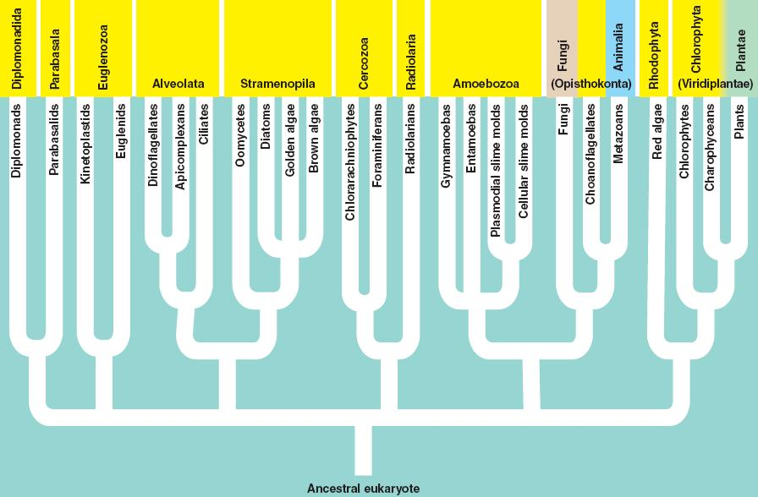

22.3 Protists’ Diversity Is Reflected in Their Metabolism, Reproduction, Structure, and Habitat
1) Habitat:
-protists live in aqueous habitats
-phytoplankton;small photosynthetic protists which capture the energy of sunlight
-protists that live in host organisms are parasites, obtaining nutrients from the host
2)Structure:
-some are single cells, some live as colonies
-some are large multicellular organisms
-some have a cytoplasmic organelle, the contractile vacuole which fills with fluid and then expels the fluid outside through a pore in the membrane
-instead of a cell wall, some have pellicle; a layer of supportive protein
-almost all protists move at some point by ambeoid motion by extending pseudopodia (false feet)
3)Metabolis:
- Protists are aerobic organisms that live as heterotrophs (obtaining carbon from organic molecules produced by other organisms) or as photoautotrophs(producing organic molecules by themselves by photosynthesis , some live as a comb. Or both
4)Reproduction:
-may be asexual, by mitosis, or sexual, through meiotic call division and formation of gametes

22.4 The Protist Group
22.4a Excavates Lack ’’Typical’’ Mitochondria
-all excavates are single-celled animal parasites that lack mitochondria and move by means of flagella.
-most ancient line of protists;now appears that the ancestor of this group did have mitochondria
-may have lost their mitochondria as an adaption of parasites’ life as oxygen is in short supply.
1) Dimplomonadida
-cells with two functional nuclei and multiple flagella
- e.g.Giardia
2)Parabasala
-move through viscous fluids using both freely beating flagella and a flagellum buried in a fold of cytoplasm and cause STD
e.g STD Trichomonas

22.4b Discicristates Include the Euglenoids and Kinetoplastids:Highly Motile Protists
-protists in this group are reffered to as protozoa because they are similar to animals in that they ingest food and move by themselves
-disk shaped mitochondrial cristae
-single celled and highly motile cells that swim by flagella
-most are photosynthetic but some can live as heterotrophs. Some are parasitic
1)Euglenoids
2)Kinetoplastids

22.4c Alveolates Have Complex Cytoplasmic Structures and Move via Flagella or Cilia
-small, membrane-bound vesicles called alveoli in a layer under the plasma membrane
-many are photosynthetic
-include two motile, primarly free-living groups
1)Ciliophora:The Ciliates
-large group, nearly 10 000 known species
-some live individually,some in colonies
-some are animal parasites; others live and reproduce in their hosts as mutually beneficial symbionts
-swim using cilia and have complex cytoplasmic structures, micronuclei and macronuclei
2)Dinoflagellata:The Dinoflagellates
-more than 4000 species are known
-some are bioluminescent (release light when disturbed)
-have two flagella that propel them in a ‘whirling’ motion and are primarily marine organisms
…and a nonmotile, parasitic group
-live as heterotrophs or autotrophs or both
3)Apicomplexa
-can attach and invade host cell by an organelle
-absorb nutrients through plasma membrane and lack food vacuoles
-plasmodium species is responsible for malaria
LIFE CYCLE OF PLASMODIUM:
- mosquito infected with malaria parasite bites human, passing cells called sporozoites into human’s bloodstream.
- sporozoites travel to liver. Each sporozoite undergoes asexual reproduction forms two new cells, called merozoites.
- merozoites enter bloodstream and infect red blood cells.
- merozoites grow and divide producing more merozoites eventually causing red blood cells to rupture.
- some of newly released merozoites infect other red blood cells.
- some merozoites develop into sex cells known as male and female gametocytes.
- another mosquito bites infected human, ingesting the gametocytes.
- in mosquito’s stomach, gametocytes mature. Male and female gametocytes undergo sexual reproduction, uniting to form a zygote.
- zygote matures into motile cell (ookinete) migrates to gut wall where develops into oocyst. Inside oocyst, cell division occurs each producing a new sporozoite.
- sporozoites rupture from oocyst travel to the mosquito’s salivary glands. If this mosquito bites another human, the cycle begins again.

22.4d Heterokonts Have Two Dissimilar Flagella at Some Stage of Their Life Cycles
-different flagella;one smooth one covered with hair
1)Bacillariophyta:diatoms: photosynthetic single-celled organisms covered by a glassy silica shell
-have flagella on reproductive cells
2)Oomycota:Water Moulds and Downy Mildews
-fungus -like, often grow as masses of microscopic filaments and live as saprophytes or parasites, secreting enzymes that digest organic matter
3)Chrysophyta: Golden Algae
-autotrophs and photosynthesize
-can live as hetetrophs if no sufficient light
4)Phaeophyta:Brown Algae
-photoautotrophs, large as kelps
-1500 known species which inhabit temperate or cool coastal marine waters
Brown algae – phylum Phaeophyta
- multicellular
- found in marine environments
- larger know as kelp – grow along coasts and provide food and shelter for many different organisms
- among the largest organisms on Earth

22.4e Cercozoa Are Amoebas with Filamentous Pseudopods
-single celled protists with amoebic motion(extending pseudopia)
-hetetrophic
-produce hard outer shells
-both groups engulf prey that adhere to their cells
1)Radiolaria
-marine organisms that secrete a glassy internal skeleton
2)Foraminifera: Forams
-marine organisms that form chambered,spiral shells containing calcium

22.4f Amoebozoa Includes Slima Moulds and Most Amoebas
-include most amoebas with amoebic motion(extending pseudopia) and are hetetrophs which are found in marine and freshwater environments and in the soil
-include two types of slime moulds: cellular(which move as individual cells)
And plasmodial (which move as large masses of nuclei sharing a common cytoplasm)

22.4g Archaeplastida Include the Red and Green Algae and Land Plants
-The three groups share a common ancestor
Green algae – phylum Chlorophyta
- freshwater unicellular
- some are large, multicellular marine organisms
- major part of microscopic marine plankton
- live in damp soil or thrive within the cells of other organisms – symbiosis
- contain the same pigments found in chloroplasts of plants
- have both sexual and asexual reproductive stages

Red algae – phylum Rhodophyta
- multicellular
- found in warm ocean water
- red pigments can absorb the light that penetrates deep waters
- some have calcium carbonate in their cell walls
- others are used to make agar and carrageenan – ice cream
- complex life cycle, usually involving alternation of generations

22.4h Opisthokonts Include the Choanoflagellates, Which May Be the Ancestors of Animals
-named for single posterior flagella found at some stage of their life
-live in either marine or freshwater
-why are they thought to be ancestors of animals?
There are many morphological and molecular similarities compared with sponges

22.5 Some Protist Groups Arose from Primary Endosymbiosis and Others from Secondary Endosymbiosis
-endosymbiosis involving photoautotrophs happened more than once, resulting in a wide range of photosynthetic eukaryotes like the ones studied before
-In primary endosymbiosis, a eukaryotic cell engulfed a cyanobacterium, which became an organelle, the chloroplast. Then, evolutionary changed produced red algae, green algae and land plants
-In secondary endosymbiosis, nonphotosynthetic eukaryote engulfed photosynthetic eukaryotes to produce photosynthetic protists

Chapter 23: Fungi
23.1:
What makes fungi unique? General Characteristics
- Heterotrophic eukaryote, obtain Carbon by breaking down organic molecules synthesized by other organisms. Divided based on how they get carbon:
- non-living saprotroph (decomposers): from dead animals or plants
- living symbiont (parasitism mutualism): ranges from parasitism to mutalism

- either way, feed by absorptive nutrition:
  - secrete enzymes into environment,
  - break down large molecules into smaller soluble molecules,
  - absorb smaller molecules

how can fungus polifrate quickly?
Fungus has Hyphae.

Hyphae: filaments that spread through whatever substrate the fungus is growing in(soil).
The cell walls of hyphae are made of chitin.

- Nuetients are absorbed at the tips of hyphae.
- This leads to epical growth: outward growing of the entire mycelium.
- Fungus only thrives in moist environments where it can absorb water, simple sugars and dissolved ions.
- Septum: separate hayphae into compartments.
- Even if theyre separated, they’re also interconnected by cytoplasmic streaming: Flowing of cytoplasm and organelles in the mycelium. By cytoplasmic streaming, the nutrients that are absorbed by on part of mycelium can be transported to the other parts that are nonabsorptive.
- Defence mechanism of fungus: producing toxins and antimicrobials that inhibit the growth of copetitors. These toxins are secondary metabolites

- Sexual reproduction:
- Plasmogamy fusion two haploid cells, nuclei remain distinct (dikaryotic cell) within common cytoplasm,
Dikaryotic cell grows dikaryotic mycelium; when favourable conditions occur develop dikaryotic fruiting bodies (basidiocarp),
- Karyogamy underneath, fusion of nuclei on basidia,
- Meiosis formation haploid spores each genetically independent

23.2: (….mycota)
- The discovery of chitin and comparisons of DNA and RNA indicates that fungi and animals are ore related to each other than to plants.
- The biologists divide fungi into 5 phylums based on the distinctive structures produced in sexual reproduction.
Basidiomycota

fungi :
Chytridiomycota:
- primitive fungi,
- retain characteristics of aquatic lifestyle. They live in soil and freshwater habitats.
- flagellated, motile spores requiring minimally film of water.

- These spores are chemotaxis : they move based on chemical gradient.

- Most of them are saprotrphs, some symbionts in the guts of cattle and some are parasites in plants fungi or animals.

- Can cause disease ( Chytridiomytocis): disease that caused the decline in amphibian species. This type of fungus colonizes the skin of amphibians which interfere with the balance and functioning of the organelles because amphibians use their skin in exchanging gases. This disease has wiped out an estimated 2/3 Harlequin frogs species Coast Rica alone.

- The asexual reproduction produces sporangium in which motile spores are formed.

Zygomycota
- This includes the moulds on bread and fruits (el 3afan).
- The structure formed in sexual reproduction is zygospore. And lack of regular septa.
- Zygometes are also used in production of fermented foods.
- The sexual reproduction occurs when mycelium of different mating types produce specialised hyphae that grow toward each other and form sex organs at their tips.
- Sexual reproduction
1) Plasmogamy
2) Dikaryotic cell
3) Zygospore
4) Karyogamy
5) Meiosis haploid Spores
Or produce by a sexual: when sporangia gives rise to haloid sopres that look genetically alike.

Glomeromycota
- sexual reproduction unknown and lack of septa.
- symbiotic associations with most plant roots,
- Ecological importance as they make up half of the fungi in soil and form mycorrhizes (linking) with many plants.
- Hyphae penetrate cell walls they colonize in the roots of plants forming arbuscules creating large surface area through which nutrients are exchanged.
- And sometimes glomeromycota form vesicles in the roots to store nutrients and can also act as spores.
- C ↔ dissolved minerals

Ascomycota
- Is the phylum with the largest number of species (has more than 30000 species).
- Yeasts that reproduce sexually by budding or binary fission.
- It is the most useful in genetic research
- Also common in symbiotic associations by forming mycorrhizae and lichens.
- It can cause disease for beetles and humans (AIDS). Causes also infections such as athlete’s foot.
- Produces spores that are called conidia. The conidia are produced and released faster than zygomycete spores.

Basidiomycota:
- Include mushroom forming species. Mushroom: reproductive structures only formed by basidiomycetes.
- Produce enzymes to breakdown cellulose and lignin. Important decomposers of woody plants and some pollutants. It can also trap and consume small animals by secreting paralyzing toxins that immobilize the prey.
- Basidiomycetes such as rusts and smuts are parasites that cause diseases to wheat.
- Basidiocraps are formed in favourable conditions.
- They are fungal pathogens that cause diseases to humans.

23.3

Fungi as saprotrophs:
- Fungus that decompose or digst the dead tissues of organisms. This is beneficial to the ecosystem because it helps return key nutrients such as N and P. This activity recycles carbon to most plants on earth.

- However, some of the fungus has allergens spores that cause serious health problems to humans. Also, when building becomes wet cause of fluiding of water this will cause weakening to the building cz the fungus are feeding on the wood of the building (el 3afan ele bekoon bl sa2ef ta3 el 3’orfe).

Fungi can be symbiont:

- Lichens: association between a fungus and one or more photosynthetic organisms. The lichen is formed between:
- Fungus (ascomycete or basidiamycete) X green alga and/or cyanobacteria.
- Lichens live in harsh, dry environments on rocks and trees.

- Lichens are important o environment because they absorb airbone pollutants and concentrate these in their tissues.

- The fungus mycobiont makes up most of the body (thalus) of the lichen with the photosynthetic partner (photobiont) that is found in the thin layer of thalus. The photobionts that are found in the thalus are:
- Cyanobacteria/ green alga.
- Sometimes mycobiont absorb 80% of carbohydates that are made by the photobionts to make secondary metabolites.

Mycorrhizas: (they are mutalisms).
- Symbiotic associations between fungus and plants roots.
- Mycorrhizal fungi extend in the soil to uptake nutrients such as N and P.

- 2 types of mycorhizas:
Arbuscular mycorrhiza: formed by glomeromycetes fungi.
Ectomycorrhiza: involve ascomycetes and basideomycetes.

- The benefit that plants get from this association is obtaining carbon in the form of sugar.

- Endophytes: fungi living in the above-ground tissues of plants.

From his slides:

X-section = thallus
Cortex outer layer, tightly woven
Photobionts green algae/ cyanobacteria
Medulla loosely woven hyphae
Cortex concentrated hyphae (site of attachment to rocks).

Chapter 25.1- 25.4:
All animals share certain structural and behavioural traits:
Traits of all animals:
- multicellular (Metazoans),
- division of labour,
- eukaryotic heterotroph,
- chaonocyte ancestral cell type
- decentralized nerve net

- All animals are:
Heterotrophs: they depend on other life forms to get their food, either by eating them or living in hosts.
Motile: ability to move from one place to another. Sessile is unability to move. Most animals are motile in their adult sage.

- Amnimals produce sexually or asexually.
Sexually reproduction: produces gametes (egg and sperm) that fertilizes into a zygote.
Polymorphic development: when development of an adult requires one or more larval forms. (this strategy is important for invertebrates with parasitic lifestyle).

- Biologists indicated that animal lineage probably aroused from a colonial choanoflagellate ancestor that lived at least 700 mya.
- Metazoans: more developed animals.

25.2: key innovation in animal evolution:
- Germ layers:
Endoderm layer: forms the lining of the gut and respitory organs.
Ectoderm: forms the external coverings and nervous system.
Mesoderm layer: the layer between these two and forms muscles o the body wall.
Diploblastic: Have ectoderm and endoderm layers. Triblastic: have all 3 layers.

Animals exhibit either radical or symmetrical shapes:
- Most animals are symmetrical: bodies that can be divided by a plane into mirror halves.

- Radially symmetrical: their bodies are arranged regularly around a central axis. The two phylum that are radially symmetrical:
Cnidaria: jellyfishes.
Ctenophora: comb jellies.

- Bilateral symmetry: on either sides of the body’s midline they have left and right sides mirror of each other.
Bilateral symmetrical animals favour cephalization: the development of anterior (front)head where sensory organs and nerve tissue are concentrated.

Many animals have cavities that surround their internal organs:
- The body cavity separates the gut from the muscles of the body wall.
- Acoelomate: animals that do not have cavities but instead they have mass of cells from the layers of mesoderm that packs the region between the gut and muscles of body wall. This includes flatworms.
- Psuedocoelomate: fluid-filled space between gut and muscles of body wall. Includes roundworms. Coelomate: fluid-filled body cavity completely lined by mesoderm.

Development patterns mark a major divergence in animal ancestry:
- Animals are divided into 2 lineages: Protostomes and dueterostomes.
- Cleavage: series of divisions. Spiral cleavage is trait of protostomes. Radical cleavage is a trait of dueterostomes.
- Determinate cleavage: each cell’s developmental path is determined as the cell is produced (prostosomes).
- Indeterminate cleavage: the cell’s fates are determined later. (dueterostomes).

The development of protostomes includes a larval stage. This polymorphic development allows sessile animals to be distributed and permits parasites to be formed in different environments and prevent competition between adults and the young.

25.3: overview of animal phylogeny and classification:

- Molecular analysis of animal relationships is based on nucleotides sequences in small subunit ribosomal RNA and mitochondrial DNA.

- Sponges lack of true tissues unlike metazoans. Sponges have been placed in the parazoa kingdom. Sponges are distinct from other metazoans because they don’t form nervous tissues and they are asymmetrical. However, molecular data shows that metazoans and sponges have a common ancestor.

- Radial animals: have radial symmetry with 2 tissue layers. Bilateral animals: bilateral symmetry with 3 tissue layers.

- The molecular phylogeny indicates that ancestral protostomes had coelom and that acoelomate and pseudocoelomate conditions were derived from the coelomate.

- The segmentation arose in 3 lineages:
- Annelids
- Arthropoda
- Chordata

25.4: phylum porifera
Sponges:
- Have no particular symmetry (asymmetrical). No true tissues, no nerves.
- Sessile s adults.
- Most of them are monocious: produce both eggs and sperms.
- Obtain their food by filtrating it from water.
- The opening of the sponge to the environment is called osculum.
There are 2 layers of organised cells:
- Pinacoderm layer: consists of cells of outside of the sponge.
pinacoderm (very leaky skin),
- cells not always in contact with each other,
- lack inter-cellular connections,
- lack underlying basal lamina,
- can transmit weak electrical signals nerve net

- Choanocytes: layer that is lining the cavity each with a flagellum surrounded by a microvilli.

- The two layers are separated by mesohyl ( non-living sponging fibers and spicules) with amoeboid cells called archaecytes: archaeocytes (amoeboid):
- mobile
- scanvange contaminants
- produce spongin & spicules
- totipotent (like stem cells) also into eggs/sperm
- sponges are suspension feeders: water gets in through porocytes (ostim) and leaves via the osculum.
- Some archaeocytes specialised to form spicule (extracellular rigid supporting structure that gives the shape of sponge).
- Gemmules: clusters of cells that allow them to survive unfavourable conditions.

25.5:

Phylum Cnidaria (hydrozoans, jellyfish, corals, sea anemones):

- Radial symmetry and with nerves.
- Include gastrovascular cavity with a single opening, the mouth. The nutrient exchange is done by diffusion.

- Have diploblastic body plan: gastrodermis (endoderm) and epidermis (ectoderm) and have mesoglea (glue structure) between the 2 layers.

- Cidarians may be vase shaped, upwad-pointing polyps, bell shaped, and downward-pointing medusae. Polyps attached to aboral and medusa floats and is not attached.

- The epidermis includes unique cells, cnidocytes each armed with a stinging nematocyst.

- Nematocyst: it has thread that is fired at pry or predators and sometimes releasing toxin by its tip. The toxin can paralyse small prey by disrupting nerve cell membranes

- Sexual reproduction results in a ciliated, nonfeeding larval stage, the panula, that eventually settles and undergoes metamorphosis into the polyp form. The 4 classes of cnidaria differ in the form that predominates in the life cycle.

- The 4 classes are :

Class Hydrozoa
marine polyp & medusa stage (jellyfish)
fresh water medusa
reproduce by budding under favourable conditions. Under adverse conditions they produce eggs and sperms. There is no larval stage.

Class Scyphozoa
male or female – gametes released in water and fertilization takes place.
passive swimmers

Class Cubozoan
“box jellyfish”
male or female – gametes released in water
active swimmers
Nematocyst rich tentacles (to kill preys and sometimes humans), eyes with lenses and retina.

- Class Anthozoa
Class anthoza
corals secrete calcium carbonate skeletons. They are sessile and colonial.
sea anemones soft bodied,
reproduction by budding or fission. And most reproduce sexually by producing eggs.
exist only as polyps

phylum ctenophora :
composed of : anal pore, stomach, muscular
- They have radial symmetry, mesoglea and feeding tentacles.
- Lack of nematocyst, they expel waste through anal pores.
- They move by beating cilia arranged on eight longitudinal plates that resemble combs.
- Gravity –sensing statocyst: helps maintain an upright position.
- Food-laden tentacles (to entrap small animals floating in sea) are drawn across the mouth.
Retractable tentacles
- colloblasts (glue cells)

25.6 Lophotrochozoan Protosomes
-share a bilateral symmetry
-most have a coelom or pseudocoelom

25.6a Two Lophophorate Phyla share a distinctive feeding structure
-double tentacle, ciliated, suspension feeding(filter feeding)
-larger cilia generate incurrent from each side expel water through central stream,
-no gills
-incurrent siphon, & excurrent siphon,
-suspension filter feeding using gills,
-fine cilia on gills generate water flow,
-phylum Brachiopoda large individuals
-phylum Ectoprocta tiny colonial

25.6b Phylum Platyhelminthes
-include a large number of flatworm species which live in aquatic and moist terrestrial habitats
-some are parasitic
-can swim or float in water, but they are also able to crawl over surfaces
-range from 1mm to 25m in length
- adult tapeworm within human(definitive host) up to 25m length-maintain position by scolex
- shed gravid proglottids(One of the segments of a tapeworm, containing both male and female reproductive organs.) (each up to 100 000 eggs),
- passed in feces or actively migrate out anus (~6/day - individual proglottids muscular, crawl in a worm-like fashion).
- proglottids dry up eggs released in environment survive months,
- cattle (intermediate host) become infected ingesting vegetation contaminated with eggs.
- eggs hatch in intestine migrate to striated muscle where develop into cysticerci
- consumed by humans bile salts trigger to evaginate,
- scolex attach to intestinal wall, worms mature several weeks

25.6c Phylum Rotifera(Syndermata) (no characters mentioned in class)
- live in fresh water and a few are marine
- very short in length
- exhibit eutely;cell division ceases early and growth is by cell enlargement

25.6d Phylum Nemertea(not mentioned in class)
25.6e Phylum Mollusca
- soft bodied, mantle cavity
- body includes a head-foot, a visceral mass, and a mantle
- include snails, clams and octopuses which are marine
- vary in length 1mm-18m
- Class Polyplacophora = chitons
- Class Gastropoda = snails, limpets,slugs
- Class Cephalopoda = squid, octopus, nautilus(closed circulatory system)
- Class Bivalvia= clams,scallops and muscles

25.6f Phylum Annelida
- Segmented worms
25.7a Ecdysozoan Protosomes
25.7a Phylum Nematoda round worms (no appendages)
- Feed on decaying organic matter
- Muscle contracting for locomotion
- adult worms live in lumen of small intestine.
- female produce up to 240,000 eggs per day passed with feces
- eggs become infective after several days
- after eggs swallowed the larvae hatch
- invade intestinal mucosa carried via portal, then systemic circulation to lungs
- larvae mature further in lungs (two weeks)
- penetrate alveolar walls ascend bronchial tree to throat, where swallowed
- reach small intestine develop into adult worms
- Humans definitive host alone
25.7b Phylum Onychophora
- velvet worms, flexible cuticle, segmented bodies and unjointed appendages

25.7c Phylum Arthropoda
- most diverse
- segmented bodies differentiated into distinct regions
- rigid exoskeleton, jointed appendages(which are specialized for feeding,locomotion or reproduction)
- open circulatory system

Question from slides:what's the difference between a brachiopod, a bivalve, & a barnacle?

Chapter 26- Deuterostomes: Vertebrates and Their Closest Relatives

26.1 Deuterostomes
- Anus develops from the blastopore and the mouth from a second opening

26.2 Phylum Echinodermata
- Echinodermata are slow-moving or sessile, bottom-dwelling animals. They are important herbivores and predators that occur from shallow coastal waters to the ocean’s depths. Adult echinoderms develop from bilaterally symmetrical, free-swimming larvae. Developing larvae assume a secondary radial symmetry, often organized around five rays or “arms”. The table provides a comparison of echinoderms and humans.

System | Echinoderms | Humans
Digestive | Complete system | Complete system
Excretory | Not present | Complete system
Respiratory | Not present | Complete system
Circulatory | Minimal system | Closed, complete system
Nervous system | No head or central | Cephalized system

- Water enters the fluid-filled canals of the water vascular system through the madreporite (a sievelike plate) on the aboral surface. A tube connects the madreporite to the ring canal, which surrounds the esophagus. The ring canal branches into radial canals that extend into each arm and is connected to numerous mucus-covered tube feet. When ampullae, small muscular bulbs in each tube foot, contract, they force water into the tube foot, causing it to lengthen and attach to a substrate. The tube foot contracts, pulling the animal along and pushing water back into the ampulla; this causes the tube foot to release the substrate. Echinoderms reproduce either sexually or asecually. Sexual reproduction is usually achieved by releasing gametes into the water. Asexual reproduction involves clonal budding and may be stimulated by the odour of a predator.

- Asteroidean (sea stars) consist of a central disk surrounded to 20 radiating “arms”. Small princers at the abse of pedicellariae (short spines) are used to remove debris that falls onto the animal’s surface. The ossicles of their endoskeleton are not fused, permitting flexibility of the arms and disk. Most sea stars eat invertebrates and small fish

- Ophiuroidea (brittle stars and basket stars) have a well-defined central disk and slender, elongated arms that are sometimes branhes. They crawl swiftly across substrates by moving their arms in a coordinated fashion. They feed on small prey, suspended plankton, or detritus extracted from muddy deposits

- Echinoidea (sea urchins and sand dollars) lack arms. Their ossicles are fused into tests that provide excellent protection but restrict flexibility. Echinoids use test tube feet in locomotion. They grace on algae and other organisms that cling to marine surfaces

- Holothuroidea (sea cucumbers) have a reduced endoskeleton consisting of widely separated microscopic plates. They have five rows of tube feet and a soft body elongated along the oral-aboral axis. Modified tube feet form a ring of tentacles around the mouth. Some species secrete a mucus net that traps plankton or other food particles. The net and tentacles are inserted into the mouth, where the food is ingested. Other species extract food from bottom sediments.

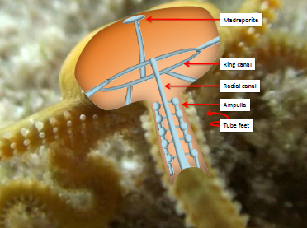

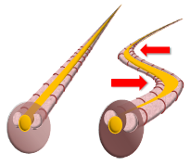
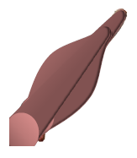

Derived characteristics:
- Notochord
- Segmented muscles

26.4 Phylum Chordata
- Dorsal hollow nerve chord
  - A notochord, a dorsal hollow nerve cord, adn hill slits distinguish chordates from all other deuterosomes. Hill slits are sets of paired openings in the pharync. Water is drawn into the mouth, food is filtered out, and the water passes through the pharync, where gas exchange takes place, and then out through the gill slits
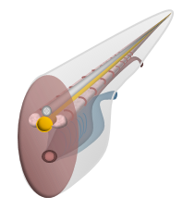
- Pharangeal gill slits
- Muscular postanal tail

Subphylum Urochordata: Sea Squirts and Tunicates

- Tunicates (sea squirts) float in surface waters or attach to substrates in shallow waters. Many are sessile as adults and secrete a gelatinous or leathery “tunic” around their bodies. They squirt water through a siphon when disturbed. Some urochodrates have larvae that resemble cephalochordates (or lacelets), and in a few species, these larvae are neotenous.

Subphylum Cephalochordata: Lancelets
- 28 species of cephalochordate (cephalo = head)
- Adult lancelets are mainly sedentary, lying partly buried in sand of shallow marine waters. They have well-developed body wall muscles and a prominent notochord. Adults have light receptors on the head and chemical sense organs on tentacles
- Lancelet bodies, 5 to 10 cm long, are pointed at both ends like the double edged surgical tools for which they are named
Subphylum Vertebrata
- Crainite distinct head
- Neural crest cells (teeth, cranial nerves)
- Backbone , spine made up of individual bony vertebrae
  - The internal skeleton of vertebrates provides structural support for muscles and protects the nervous system and other internal organs. The backbone surrounds and protects the dorsal nerve cord, and a bony cranium provides protection for the brain. The backbone acts as a place for muscle attachments, which allows quick movement
- Vertebrates have a bone, a connective tissue in which cells secrete the mineralized matric that surrounds them
  - Mostly sharks and rays, have skeletons of cartilage
- Vertebrates have 4 characteristic morphological innovations: cranium, vertebrae, bone, and neural crest cells

26.6 Agnathans: Hagfish and Lampreys, Conodonts, and Ostracoderms

Myxinoidea Hagfish
- Have skull
- Dorsal nerve chord exposed (no vertebrae)
- Teeth composed of keratin
- Copious quantities of slime

Petromyzontoidea lampreys
- Dorsal nerve chord partially protected by cartilage

Conodonts
- Dentine teeth

Ostracoderms
- Brain divided into fore, mid, and hind brain

- Agnatha are primitive vertebrates that use a mucular pharynx to suck water containing food particles into their mouths and gills to filter the food and perform gas exchange. Hagfishes and lampreys have a well-developed notochord but lack true vertebrae and paired fins. The hagfish skeleton is a cranium and a notochord. These marine scavengers feed on invertebrate prey and dead fish. They lack a larval stage. Lampreys have a more deried axial skeleton than hagfishes. Their notochord is surrounded by cartilage that partially covers the nerve cord, whereas hagfish have no specialized structures surrounding the nerve cord. Some species of lampreys are parasitic as adults, attaching to a host. Ammocoetes, the larval stage of lampreys, resemble ephalohordates and may develop for up to seven years before metamorphosing into adults

26.7 Jawed Fishes: Jaws Expanded the Feeding Opportunities for Vertebrates
- Paired limbs

Class Actinopterygii Ray-finned fish (fins supported by thin flexible bony rays)
Sarcopterygii Fleshy-finned fish (fins supported by muscles & internal bony structure
  - Pectoral & pelvic girdles
- Jaws meant that fishes could feed on larger items of food with higher energy content. Jaws also function to defend against predators, groom, transport young, and grasp, kill and shred food items
- Flexible fins, lightweight skeletons, streamlined bodies, and an absence of heavy body armour allow sharks to pursue prey rapidly. Sharks and their relatives have squalene, an oily substance contained within the liver. Squalene is lighter than water and increases the animals’ buoyancy
- The lateral line system of elasmobranchs and other fishes consists of a row of tiny sensors in canals along both sides of the body. This system allow detection of vibrations in water, which can be used when hunting
- In many bony fishes, a gas-filled swim bladder serves as a hydrostatic organ to increase buoyancy. Bony fish also have small, smooth, lightweight sales, and bodies that are covered with a protective coat of mucus that retards bacterial growth and smooths the flow of water past the body

26.8 Early Tetrapods and Modern Amphibians
- Neck, ribs, flat head, ankle bone, ear notches
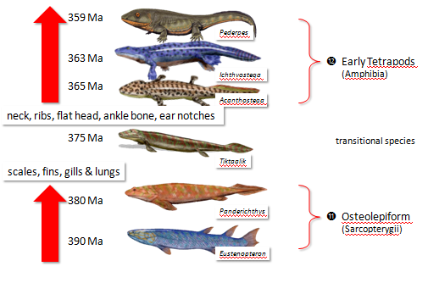

- Osteolepiforms (fleshy-finned fishes) and tetrapods had infoldings of their tooth surfaces. The shapes and positions of bones on the dorsum and side of their crania and in their appendages were similar. Osteolepiforms had strong fins enabling them to crawl on mud (making their movee onto land) and possessed vertebral columns with crescent-shaped bones for support. Osteolepiforms had lungs allowing them to breathe atmospheric oxygen. They could excrete urea or uric acid rather than ammonium
- The body wall of fish picks up sound vibrations and directly transfers them to sensory receptors. Sound waves are harder to detect in air. The development of a tympanum, or eardrum, allowed tetrapods to detect airborne vibrations and transfer them to the sensory cells of their inner ear
- Amphibians have thin, scaleless skin, well supplied with blood vessels. Since some oxygen and carbon dioxide enter the body across a thin layer of water, most amphibians need moist skin restricting them to aquatic or wet terrestrial habitats. Many amphibians need access to free-standing water to reproduce.

Class Amphibian
- Naked eggs, aquatic larval
- Thin scaleless skin kept necessarily moist for gas exchange tied to water

Amniotes
- Water proof skin (keratin & lipids)
- Amniotic eggs (resistant to desiccation)
- Urea and/or uric acid vs., ammonia
- “Free” from water

26.9 The Origin and Mesozoic Radiations of Amniotes
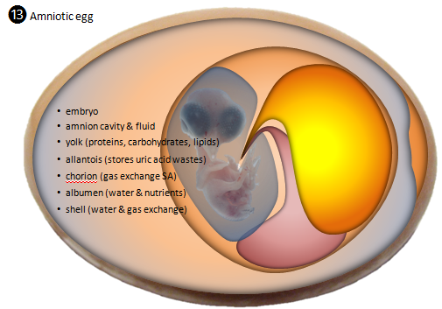
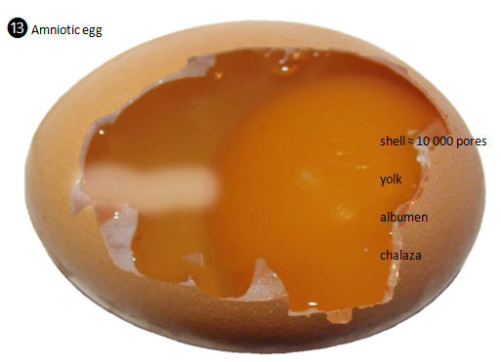

- Amniotes get their name from the amnion, a fluid-filled sac surrounding the embryo during development. Amniote eggs are resistant to desiccation because the developing embryos excrete uric acid that is stores in the allantois
- Amniotic eggs have 4 specialized membranes that protect the embryo and facilitate gas exchange and excretion. They also have a hard or leathery shell perforated by microscopic pores that mediates the exchange of air and water between the egg and its environment. Keratin and lipids are partly responsible for making the skin waterproof

26.10 Subclass Testudinata: Turtles and Tortoises

There have been three major radiations of amniotes: anapsids, synapsids, and diapsids, distinguishable by the numbers of bony arches in the temporal region of the skill. The bony arches allow space for contraction (and expansion) or large and powerful jaw muscles. Anapsids lacked temporal arches, synapsids have two pairs of arches

Surviving anapsids are tutles and tortoises. A turtle’s body is defined by a bony, boxlike shell, which includes a dorsal carapace and a ventral plastron. Its ribs are fused to the inside of the carapace, and the pectoral and pelvic girdles lie within the rub cage. Large keratinized scales cover the bony plates that form the shell.

Amniota

- Anapsida
- Diapsids
- Synapsids
26.13 Mammalia: Monotremes, Marsipials, and Placentals

What makes a mammal, a mammal?
- Furry
- Diaphragm
- Left aortic arch leaving the heart, and two occipital condyles
- Endothermic
- Well developed cortex
- Secondary palate
  - Separates the nose cavity from the mouth cavity
- Milk
  - Milk teeth to suck properly (LOL Fatima)
- Diphyodant
  - Two generations of teeth, milk or deciduous teeth and adult teeth
- Bear live young
- Heterodant
  - Different types of teeth specialized for different jobs
  - Make mammals more efficient at mechanically dealing with their food (chewing), reducing the lagtime between consumption of food and availability of the food’s energy

Mammals
Monotremata
- Prototheria (first Monotremata)
  - Lay leathery egg shells
  - When newborns hatch, they lap up milk secreted by the mammary glands located on the mother;s belly modified sweat glands mother’s belly
  - Platypus

Marsupialia
- Metatheria (between Marsupials)
  - Short gestation periods of as few as 8-10 days
  - Young are born at an early stage of development and complete their development attached to a teat in the abdominal pouch (the marsupium) of their mother
  - Drag selves to abdominal pouch
  - Rats?

- Primates
Eutheria (good Placental)
- Placental mammals complete embryonic development in the mother’s uterus, nourished through a placenta until they reach a fairly advanced stage of development
  - Viviparous advanced stage development before borne
  - Altricial helpless
  - Precocial ready to go

