Civil Engineering Materials

LAB 1: MATERIAL TESTING BEST PRACTICE

XXXXXXXX
XXXXXXXX
XXXXXXXX
XXXXXXX

Lab Date: September ## & October ##, 2015
Report Date: October ##, 2015
T.A.: ###########
Lab Group: ##

ABSTRACT

Tension tests were performed on two steel coupons to determine certain mechanical properties of the steel. These properties include modulus of elasticity, proportional limit, yield stress and strain, percentage of elongation, percentage of area reduction, and Poisson’s ratio. The first portion of the lab was training on the measuring instrumentation. The second portion of the lab applied the knowledge from the first portion to find the mechanical properties of steel.
From the tensions tests, steel has a ductile failure since necking was observed after the coupons reached their ultimate stress and strain. The strain gauges failed before the ultimate stress and strain, and for the first coupon, before the yield stress and strain could be recorded.
Table of Contents

List of Tables 3
List of Figures 4
Objectives 5
Theoretical Background 5
Materials and Equipment 7
Experimental Procedure 7
Analysis of Data 8
Discussion of Results 13
References 15
Appendix A – Results of Calibration Test 16
Appendix B – Results of Tension Tests 17
Appendix C – Sample Calculations 23

LIST OF TABLES

Table 1: Percent Elongation and Percent Area Reduction of Samples  Table 2: Initial Dimensions of Samples  Table 3: Final Dimensions of Samples  Table 4: Initial and Final Cross Sectional Areas of Samples  Table 5: Poisson’s Ratio for Samples  Table 6: Load Cell Calibration Test  Table 7: Edited Data Points for Sample 1  Table 8: Edited Data Points for Sample 2 | 10  10  10  10  16  17  20  24

LIST OF FIGURES

Figure 1: Steel Tension Coupon  Figure 2: Load Cell Test for Calibration  Figure 3: Sample 1 Fracture Surface  Figure 4: Sample 2 Fracture Surface  Figure 5: Stress-Strain Curve for first steel coupon  Figure 6: Stress-Strain Curve for second steel coupon  Figure 7: Stress-Strain Curve for elastic portion of the first steel coupon  Figure 8: Stress-Strain Curve for elastic portion of the second steel coupon  Figure 9: 2D Simulation Model of a Strain Gauge  Figure 10: Screenshot of Excel Calculations | 7  8  9  9  11  11  12  12  13  24

OBJECTIVES

The objectives of this laboratory experiment are to learn the application process of the instrumentation technology for materials so that their mechanical properties can be measured; “to learn the concepts of stress, strain, modulus of elasticity, yield, and failure of materials; to understand the stress-strain characteristics of steel.” (Laboratory Manual)

THEORETICAL BACKGROUND

The American Iron & Steel Institute (AISI) categorizes steel into 4 major types: Carbon steel, Alloy steel, Stainless steel and Tool steel. [1] Steel excels in tension and that is its most common application. Throughout this application, many technical concepts will be observed and measured. The theory behind these notions will be discussed in the following paragraphs.

The textbook recommended for this class defines stress as “the force per unit area” [2] (Mamlouk & Zaniewski, pg. 5). When load is applied to an object, its cross-sectional area will change as it deforms. True stress considers the continuous change in area while engineering stress only takes into account the initial area. Therefore, true stress is more accurate, however more difficult to determine. For this experiment, engineering stress will be calculated using the formula below.
$σ =\frac{P}{A_{o}}$ (1)

Where σ represents stress, P is the applied load and
A_{o} the initial cross sectional area.

The measure of deformation in a material due to a force applied is a good description of strain. As noted above, true strain is more complex because it entails the sum of a series of small elongations. The simpler solution would be to use only the initial and final lengths, also known as the engineering strain. This principle will be determined according to equation (2).

$ε=\frac{(L_{f}- L_{o})}{L_{o}}= \frac{∆L}{L_{o}}$ (2)

Where ε is the strain, L is the change in elongation
divided by L_{o}, the original length.

Young’s Modulus of elasticity is a measurement of a material’s resistance to being deformed elastically. Different elastic materials have different proportional constants between stress and strain. Formula (3) expresses this relationship.

$E= \frac{σ}{ε}$ (3)

Where E is Young’s Modulus of Elasticity.

When a material withstands a certain stress, it tends to expand in one direction and decrease in the other. Poisson’s ratio is a proportion between the lateral strain and longitudinal strain. For solid materials such as steel, its theoretical value is generally in the range of 0.2 to 0.5. Thus, we can write:
$Υ= \frac{-ε_{y}}{ε_{z}}$ (4)

Where Υ is Poisson`s Ratio, ε_{y} is the lateral strain and
ε_{z} is the longitudinal strain.

Afterwards, the percentage of elongation and area reduction at the point of fracture will be analysed. The percentage of elongation is simply the strain multiplied by 100. (Refer to equation (5)
$\% Elongation= ε*100\%$ (5)

The percentage of area reduction will be calculated using the formula below.

$\% Area Reduction=\frac{\left(A_{o}- A_{failure} \right)}{A_{o}}*100\%$ (6)

Where A₀ is the original area and A_{failure} is the cross-sectional area at the specimen’s failure point.

Finally, ductility is a material’s ability to stretch. A ductile material will deform and go through the process of “necking” before failing. Typically, this can be seen with the human eye and is used as a type of warning.
A material’s yield strength can be explained as the point when it stops behaving elastically. This value can be estimated by evaluating a stress-strain curve. The slope of the linear elastic region is copied and offset at 0.5% of the original line for steel bars. The yield strength is where the two lines cross paths. From there, the yield point can be estimated using the graph or for more accurate results, the point of intersection could be calculated.

MATERIALS AND EQUIPMENT

For the calibration testing of a load cell, the following materials are needed (as listed in lab manual):
- Load cell
- Testing machine (MTS), load and stroke control, programmable

For the tension test of steel, the following materials and equipment are needed (as listed in lab manual):
- Steel Tension coupon (as shown)
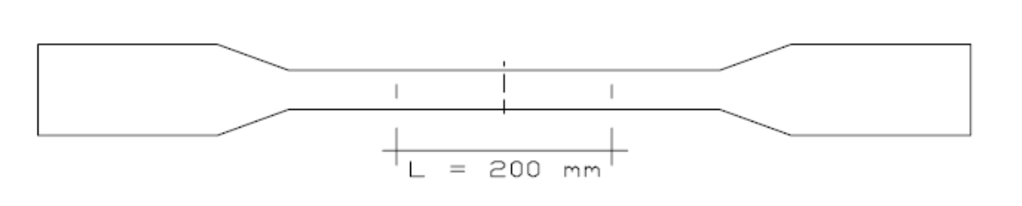
Figure 1: Steel Tension coupon
- 2 strain gauges per specimen
- Testing machine (MTS), load and stroke control, programmable
- Thermocouple (to measure heat of specimen after fracture)
- Measuring Callipers

EXPERIMENTAL PROCEDURE

Instrumentation:
This experiment partially follows the procedure outlined in the lab manual.
First, the surface of the samples was polished to prepare them for the application of the strain gauges. Then the strain gauges were applied, one in the lateral direction and one in the longitudinal direction, in the centre of the necked down portion of the coupon and at mid-height. Then the voltages of the strain gauges were tested to ensure that they will produce accurate measurements. The load cell was placed in the testing machine and then connected to the data acquisition system. While recording the voltage each time, the force was applied to the load cell at 10 KN intervals. The load was applied up to 50 KN, then unloaded at 10 KN intervals while continuing to record the voltage each time. A calibration curve was created by estimating a load versus voltage best fit line. This was programmed to allow a load cell to be used with confidence.

Tension Test:
This procedure partially follows the lab manual procedure and the ASTM A307 standard or the CSA G40.20M.
First, the samples were measured and the dimensions for width, thickness and gauge length were obtained using calipers. Then the sample was aligned in the testing machine and the gages were connected to the data acquisition system. The instruments were zeroed. The specimen was continuously loaded using the load control method as the data acquisition system recorded the load, extension and strain at specific time intervals. The strain gauges fell off at some point, but loading was continued until failure. After failure, the final load, final elongation, necked down area, type and location of failure and also the temperature of the fracture surface were recorded.

ANALYSIS OF DATA

- Load Cell Calibration

The results for the load cell calibration obtained from the machine are in Table 6 in Appendix A. Figure 2 shows the plotted load against voltage curve.

Figure 2: Load Cell Calibration Test with Calibration Line (Line of Best Fit)

- Tension Test

The values of the strain from the four gauges of each measurement recorded by the machine throughout the experiment can be found in Tables 7 and 8 in Appendix B, for the first and second steel coupon respectively. A sample calculation for converting the load to stress has been included in Appendix C, and Tables 7 and 8 contain the calculated stress values. Figure 3 and 4 are the plotted stress-strain curves for the first and second steel coupon, with the four strain gauges displayed. The proportional limit, the yield stress and the yield strain are labelled on each curve, when possible.
Some of the collected data has been omitted from the tables after the strain gauges unbounded. This was observed when the strain data for each individual strain gauge started behaving differently than the expected behavior. The data that remained did not include the ultimate stress and strain. Strain gauges 1 and 3 were positioned longitudinally on the coupons and strain gauges 2 and 4 were positioned transversely.
The readings taken with the strain gauges while the specimens were behaving elastically appear in the above mentioned tables. The data was selected for the linear part of the graph. Figures 5 and 6 show the plotted curves for these values. The equations of best fit on the charts give the modulus of elasticity.
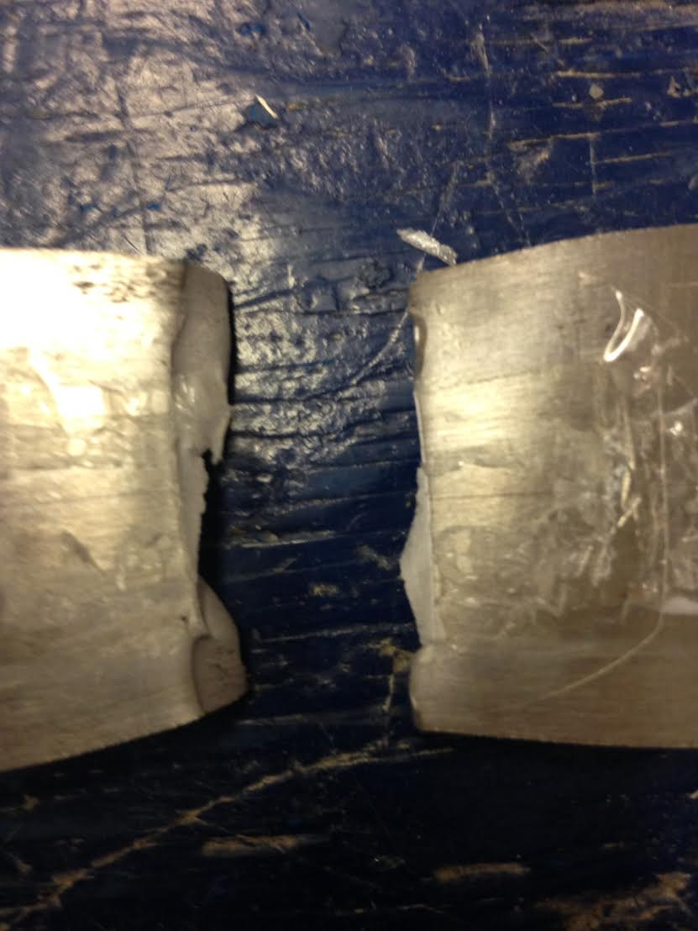
The temperature recorded on the fracture surface immediately after failure was 49.6°C for the first specimen, and 49.7°C for the second. Hence the average temperature is 49.65°C
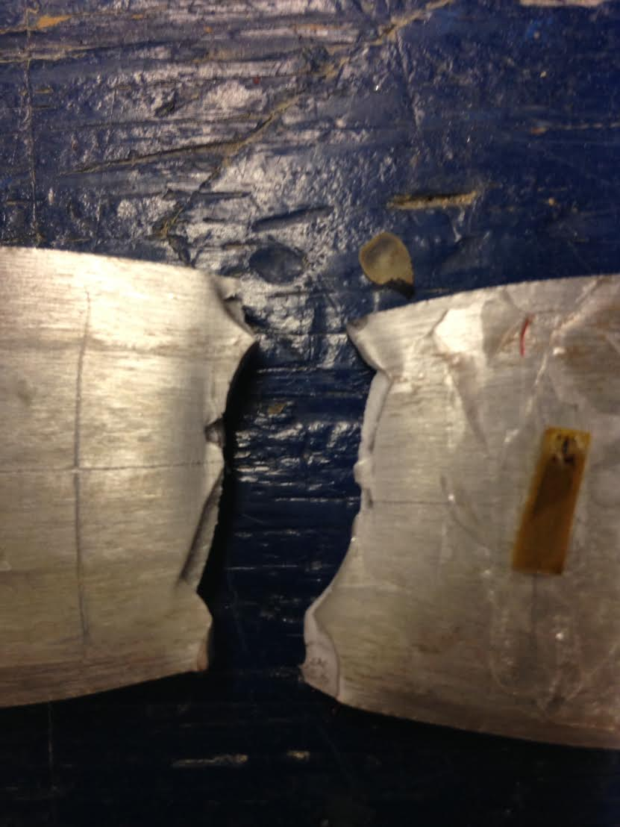
Figure 3 : Sample 1 Fracture Surface Figure 4 : Sample 2 Fracture Surface
Above are the fracture surfaces of Sample 1 (left) and Sample 2 (right).

Table 1: Percent Elongation and Percent Area Reduction of Samples
Sample | Percent Elongation at Failure | Percent Area Reduction at Failure
Sample #1 | 20.8% | 47.6%
Sample #2 | 20.2% | 44.2%

The sample calculations for percent elongation and percent area reduction can be found in Appendix C. The data used to calculate these values can be found in tables 2, 3, and 4. The sample calculations for cross sectional area can be found in Appendix C.
Table 2: Initial Dimensions of Samples
Sample | Initial Length (mm) | Initial Width (mm) | Initial Thickness (mm)
Sample #1 | 199.5 | 40.5 | 6.15
Sample #2 | 200.25 | 40.3 | 6.20

Table 3: Final Dimensions of Samples
Sample | Final Length (mm) | Final Width (mm) | Final Thickness (mm)
Sample #1 | 240.95 | 30.7 | 4.25
Sample #2 | 240.7 | 32.4 | 4.30

Table 4: Initial and Final Cross Sectional Areas of Samples
Sample | Initial Cross Sectional Area (mm²) | Final Cross Sectional Area (mm²)
Sample #1 | 249.075 | 130.475
Sample #2 | 249.86 | 139.32

A sample calculation for cross sectional area can be found in Appendix C.
Table 5: Poisson’s Ratio for Samples
Sample | Poisson’s Ratio
Sample #1 | 0.25
Sample #2 | 0.26

The calculation procedure for Poisson’s Ratio can be found in Appendix C.
Figure 5: Stress-Strain curves for the first steel coupon
Proportional limit
Yield point
Proportional limit
Yield Stress
Yield Strain

Figure 6: Stress-Strain curves for the second steel coupon

Figure 7: Stress-Strain curves for the elastic portion of the first steel coupon
Figure 8: Stress-Strain curves for the elastic portion of the second steel coupon
DISCUSSION OF RESULTS

From Figures 5 and 6, it can be observed that both steel coupons behaved similarly. However, the second steel coupon has a lower modulus of elasticity than the first steel coupon. This could be caused by the different rolling directions of the steel. The modulus of elasticity for the longitudinal strains are observed to be close to the published value of 200 GPa, or 200 000 MPa, for ASTM-A36 steel. The proportional limit for both coupons is near 400 MPa. The ultimate stress and strain values were not obtained because the strain gauges failed before that point, as well as the yield stress and strain of first steel coupon. The second steel coupon had a yield strain of around 0.003 mm/mm and a yield stress of around 440 MPa. The percentage of elongation for the first coupon was 20.8% and for the second coupon 20.2%. The percentage of area reduction at failure for the first coupon was 47.6% and for the second coupon 44.2%. Poisson’s ratio was 0.25 and 0.26, respectively, which is smaller than the published value of 0.32.
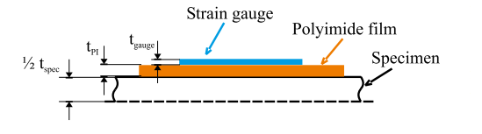
The strain gauge is constructed of thin metallic foil and plastic film. The foil is usually made of a copper nickel alloy and has a very small sensor element inside. When the gauge is properly adhered to a certain object or material, the metallic foil elongates or contracts, depending on the reaction of the object. For instance, if the steel has a tensile load applied to it, the resistive foil will also stretch. The rate of resistance change in the alloy foil that with a certain constant, is proportional to strain. Hence, this is how the strain is measured.
Figure 9: 2D simulation model of a strain gauge [3]
There are many important steps to follow while applying a strain gauge. First, carefully remove it from the package, making sure not to damage the wires. After, using a sand cloth, lightly buff the piece of steel in the area where the strain gauge will be applied. This technique removes any unwanted paint or rust. Next, determine the measuring site in the strain direction and gently mark it with a pencil. Afterwards, use an acetone dipped disinfectant tissue paper to clean the specified area. Note, only one strong wipe in a single direction is required, as back and forth cleaning does not ensure a proper surface. Now apply a dab of adhesive to both sides of the strain gauge, do not spread the glue (this accelerates curing time and lowers strength). Finally, place the strain gauge on the measuring surface and cover it with a piece of polyethylene sheet. Firmly press on the sheet with a thumb for about a minute. For accurate results, measurements should be taken after the adhesive has cured for 1 hour.
In this lab the strain gauges on both specimens adequately measured the elastic range. Nevertheless, after this region the gauge had a tendency to unbind from the steel. For instance, it was noted that one of the gauges on specimen #1 unbounded after approximately 120 kN of load. The piece of metal failed shortly after that, at 120.5 kN.
Alternatively, there are a variety of different methods available to measure the strain. For example, extensometers, optical measurement, or even laser measurement. Although this one is only an emerging technology. Optical measurement uses image correlation to measure strain.
Another very similar technology to the strain gauge is the load cell. It is essentially a small compartment containing multiple strain gauges inside of it. It uses the same concept and technology as the strain gauge. The major difference between these two instruments, is that a load cell has a higher life expectancy. It can last up to 20 years. This is because the adhesive is never exposed to the environment air or moisture.
In the experiment, both steel coupons experienced changes in their cross-sectional area and length. The data for these changes can be found in Tables 2, 3, and 4. The first coupon had bigger changes in its dimensions compared to the second coupon. From this, it can be determined that the grain of the first coupon was closer to parallel to the applied load while the grain of the second coupon was closer to perpendicular.
The fracture surfaces of the two samples have some variation. Samples 1’s fracture surface was more jagged while Sample 2’s fracture surface had a slightly more uniform break. The different fracture surfaces are due to how the samples were cut out of the sheet of steel they were made from. They were cut perpendicular to each other on the sheet. The specimens got immediately “hot” after fracture because as the material is loaded, plastic strain develops in the form of small dislocations throughout the specimen. Once the material is loaded until failure, the accumulation of energy of these plastic strains is released in the form of heat.
During this lab, there were certain areas where results could have been skewed due to the nature of lab experiments. The first source of error that could have a large impact is the application of the strain gauges. If the strain gauges were not applied properly, there’s a chance that they only measured the strain in the glue instead of the strain thus giving false results.
Another source of error that could affect final calculations was the measurement of the fracture area. Since the failure area did not have even surfaces, it was difficult to get a precise reading which could give very different results depending on where the measurements were taken.

CONCLUSIONS

Steel experiences ductile failures that are shown by necking that occurs past the ultimate stress and strain. The two steel coupons were observed to have values similar to the published values for ASTM-A36 steel. From the lack of usable data, not all experimental values could be compared to the published values.

REFERENCES

[1] 'The Four Types of Steel | Metal Supermarkets', 2015. [Online]. Available: http://metalsupermarkets.com/blog/types-of-steel/. [Accessed: 05- Oct- 2015].

[2] M. Mamlouk and J. Zaniewski, Materials for civil and construction engineers, 3rd ed. Pearson, 2011.

[3] S. Zike and L. Mikkelsen, 'Correction of Gauge Factor for Strain Gauges Used in Polymer Composite Testing', Exp Mech, vol. 54, no. 3, p. 394, 2014. Scholars Portal Carleton Library Database [Online].
Available: http://journals2.scholarsportal.info.proxy.library.carleton.ca/details/00144851/v54i0003/393_cogffsguipct.xml?q=strain+gauges&search_in=anywhere&date_from=2010&date_to=2016&sort=relevance&sub= [Accessed: 08- Oct- 2015].
[4] Laboratory Manual

APPENDIX A: RESULTS OF CALIBRATION TEST

Table 6 - Load Cell Calibration Test

Voltage (mV) | Load (kN)
0 | 0
0.93 | 51.51
1.68 | 100.77
2.47 | 150.2
3.33 | 200.48
4.21 | 250.16
5.11 | 300.61
4.28 | 250.04
3.39 | 201.24
2.51 | 149.6
1.62 | 100
0.74 | 50.9
0 | 0

APPENDIX B: RESULTS OF TENSION TESTS

Table 7 - Edited Data Points for Sample 1
Stress (MPa) | Strain | Strain | Strain | Strain
1.019773161 | 0.000001245 | -0.000000502 | 0.000008093 | -0.000002058
2.22422965 | 0.000004405 | -0.000001745 | 0.000016765 | -0.000003422
3.272106795 | 0.000009465 | -0.000003082 | 0.00002076 | -0.000004067
4.006825253 | 0.000015662 | -0.000004537 | 0.000020966 | -0.000004581
4.773662551 | 0.000024091 | -0.000006756 | 0.000020669 | -0.000005121
5.685034628 | 0.000032142 | -0.000008753 | 0.000021276 | -0.000005407
6.821238583 | 0.000041323 | -0.000011196 | 0.000023144 | -0.000005977
7.796848339 | 0.000048774 | -0.000013178 | 0.000025495 | -0.000006424
8.668071866 | 0.000055063 | -0.000014752 | 0.000027529 | -0.000006592
10.12546422 | 0.000064963 | -0.000017535 | 0.000031351 | -0.000008039
11.26568303 | 0.000072841 | -0.000019667 | 0.000034426 | -0.000008454
12.77526849 | 0.000083158 | -0.000022429 | 0.000038965 | -0.000009832
14.86299307 | 0.000096411 | -0.000026304 | 0.000045516 | -0.000011555
16.77406404 | 0.000107948 | -0.000029225 | 0.000052078 | -0.000012904
19.09465021 | 0.000121638 | -0.000033175 | 0.000060877 | -0.000015011
21.19441935 | 0.000133354 | -0.000036447 | 0.000069644 | -0.000016895
22.62772257 | 0.000143638 | -0.000039085 | 0.000072347 | -0.000017859
25.69105691 | 0.000161172 | -0.000043788 | 0.000084095 | -0.000020497
29.13981732 | 0.000180236 | -0.000049068 | 0.00009877 | -0.000024112
32.22724079 | 0.000196897 | -0.000053528 | 0.000111344 | -0.000026899
35.99317475 | 0.00021648 | -0.000059524 | 0.000127796 | -0.000030686
39.67479675 | 0.000235954 | -0.000065075 | 0.000144068 | -0.000034473
44.24771655 | 0.000259378 | -0.000071697 | 0.000164474 | -0.000039204
49.03743852 | 0.000282191 | -0.000078321 | 0.000188093 | -0.000044821
55.58566697 | 0.000312681 | -0.000087699 | 0.000221036 | -0.00005219
60.77285958 | 0.000337136 | -0.000095189 | 0.000246902 | -0.000057495
65.33774967 | 0.000358719 | -0.000101535 | 0.000270478 | -0.000062544
70.25996186 | 0.000381894 | -0.000108849 | 0.00029524 | -0.000068257
75.10990665 | 0.000406087 | -0.000115588 | 0.000319371 | -0.000073595
76.37458597 | 0.000413334 | -0.000117863 | 0.000325717 | -0.000075993
78.69115728 | 0.000424368 | -0.000121098 | 0.000337268 | -0.000078603
86.49603533 | 0.000461119 | -0.000131917 | 0.000375176 | -0.00008714
89.68784503 | 0.000478711 | -0.000137011 | 0.000392934 | -0.00009047
94.96336445 | 0.000504659 | -0.000144432 | 0.000420194 | -0.000096051
99.07457593 | 0.000526381 | -0.000150897 | 0.000442968 | -0.00010085
103.197832 | 0.000549964 | -0.000157687 | 0.000467721 | -0.000105992
112.1589883 | 0.000600222 | -0.000172305 | 0.000520385 | -0.000117851
123.9225133 | 0.000658702 | -0.000189417 | 0.000581102 | -0.000131958
137.8380006 | 0.000726381 | -0.000209025 | 0.000651 | -0.000148578
147.7225735 | 0.000773788 | -0.000222851 | 0.000700613 | -0.000160546
162.4611061 | 0.00084523 | -0.000243343 | 0.000773537 | -0.000177492
171.8960153 | 0.000891446 | -0.000256325 | 0.000820581 | -0.000188385
187.3933554 | 0.000965953 | -0.000277614 | 0.000896837 | -0.000206588
189.119743 | 0.000974653 | -0.000280782 | 0.000905606 | -0.00020884
195.6559269 | 0.001007513 | -0.000290708 | 0.000939241 | -0.00021671
215.4210579 | 0.001101204 | -0.000317292 | 0.001034438 | -0.000238947
223.141624 | 0.001135522 | -0.000327358 | 0.001069381 | -0.000247236
224.8198334 | 0.001142254 | -0.000329715 | 0.001075685 | -0.00024868
243.2279434 | 0.001228488 | -0.000354031 | 0.001162326 | -0.000268906
237.2538392 | 0.00119774 | -0.000345825 | 0.001132062 | -0.000262004
254.726488 | 0.001280086 | -0.000369327 | 0.001215075 | -0.000280821
264.3500954 | 0.001325348 | -0.000382894 | 0.001260012 | -0.000291619
269.6015256 | 0.001347886 | -0.000389206 | 0.001283349 | -0.000297139
269.3285155 | 0.001348034 | -0.000389491 | 0.001282961 | -0.000296731
278.2414935 | 0.001390015 | -0.000401429 | 0.001325561 | -0.000306825
285.9058517 | 0.001426123 | -0.000412196 | 0.001361262 | -0.000315601
289.2381813 | 0.001441911 | -0.000417336 | 0.001377048 | -0.000319593
284.4444444 | 0.001419726 | -0.000411367 | 0.001354852 | -0.000314311
294.007829 | 0.001465458 | -0.000424382 | 0.001400737 | -0.000325082
304.1694269 | 0.00151296 | -0.000438434 | 0.001447891 | -0.000335857
311.0789923 | 0.001545039 | -0.000447757 | 0.001479096 | -0.000343227
311.8137107 | 0.001548191 | -0.000448906 | 0.001482799 | -0.000343998
305.0205761 | 0.001515498 | -0.000440119 | 0.001450157 | -0.000336721
320.7989561 | 0.001588426 | -0.000461082 | 0.001522559 | -0.000353277
327.391348 | 0.001617897 | -0.00046999 | 0.00155211 | -0.000359981
333.6625514 | 0.001646392 | -0.000478706 | 0.001579765 | -0.000366134
339.2552444 | 0.001670412 | -0.000486083 | 0.001603653 | -0.000372119
340.2268393 | 0.001674604 | -0.000487416 | 0.00160763 | -0.000372892
332.1569808 | 0.001637339 | -0.000477595 | 0.00157046 | -0.000364641
348.2846532 | 0.001710793 | -0.000498267 | 0.001642967 | -0.000381282
354.5598715 | 0.001739235 | -0.000506983 | 0.00167117 | -0.00038777
361.0077286 | 0.001768456 | -0.000516556 | 0.001699986 | -0.00039451
366.616481 | 0.001793943 | -0.000524181 | 0.001724727 | -0.000400387
360.497842 | 0.001768772 | -0.00051816 | 0.001699653 | -0.000394619
364.1955234 | 0.001792761 | -0.00052536 | 0.001723039 | -0.000399647
369.2783298 | 0.001809229 | -0.00053021 | 0.001739671 | -0.000404015
381.1904045 | 0.001863462 | -0.000546548 | 0.001792989 | -0.000416147
387.6302319 | 0.001893545 | -0.000555975 | 0.001822427 | -0.000423269
384.5147044 | 0.001881928 | -0.00055373 | 0.001811215 | -0.000420659
396.2782294 | 0.001935427 | -0.000569266 | 0.001863713 | -0.000432944
395.8928034 | 0.001936391 | -0.000570402 | 0.001864239 | -0.000433186
398.8156178 | 0.001951463 | -0.000575258 | 0.001878742 | -0.000436521
410.3864298 | 0.002005389 | -0.000591879 | 0.001931267 | -0.000448672
415.8305731 | 0.002031994 | -0.000600721 | 0.001957119 | -0.000454865
420.8652012 | 0.002056148 | -0.000609174 | 0.001981021 | -0.000460718
424.8479374 | 0.002075947 | -0.000615815 | 0.002000307 | -0.000465155
426.9396768 | 0.002089693 | -0.00062014 | 0.002014467 | -0.00046836
417.7055104 | 0.00205336 | -0.000611044 | 0.001977839 | -0.000459884
434.9774164 | 0.00213376 | -0.000634762 | 0.002057207 | -0.000478331
438.8397069 | 0.002154005 | -0.000641498 | 0.002077029 | -0.000483179
446.616481 | 0.002193326 | -0.000654906 | 0.002114895 | -0.0004923
451.5667971 | 0.002219406 | -0.000664371 | 0.002139967 | -0.000497868
456.1919101 | 0.002244132 | -0.000673223 | 0.002164598 | -0.000503685
447.8410117 | 0.002214764 | -0.000666037 | 0.002135072 | -0.00049713
462.6879454 | 0.00228396 | -0.000686715 | 0.00220392 | -0.00051347
459.8293687 | 0.002276735 | -0.000685363 | 0.002196856 | -0.000511844
470.8180267 | 0.002331596 | -0.000703531 | 0.002251623 | -0.000525234
475.792432 | 0.002359546 | -0.000713622 | 0.002278982 | -0.000531507
472.2673893 | 0.002351814 | -0.000712979 | 0.002271455 | -0.00053012
482.878651 | 0.002404441 | -0.000729248 | 0.002322496 | -0.000542437
487.33514 | 0.002430293 | -0.000738849 | 0.002350145 | -0.000549063
489.5673994 | 0.002443563 | -0.000744562 | 0.00236911 | -0.000553633
488.4231657 | 0.002442926 | -0.000745512 | 0.002371521 | -0.000554034

Table 8 - Edited Data points for Sample 2
Stress (MPa) | Strain | Strain | Strain | Strain
0.984551 | 4.248 | -1.152 | 5.839 | -1.081
3.109741 | 12.725 | -3.682 | 18.102 | -4.01
4.514528 | 17.542 | -5.195 | 26.571 | -6.316
6.495638 | 24.138 | -7.418 | 38.848 | -8.969
8.112543 | 28.856 | -9.059 | 48.673 | -11.48
8.900985 | 32.166 | -10.077 | 53.983 | -12.577
9.645401 | 35.963 | -10.868 | 57.386 | -13.229
10.70199 | 42.166 | -12.491 | 61.012 | -14.415
11.84263 | 50.429 | -14.369 | 63.478 | -15.886
13.27543 | 60.066 | -16.519 | 67.096 | -16.557
14.98039 | 70.812 | -19.538 | 72.787 | -18.251
16.52525 | 80.522 | -21.775 | 78.542 | -19.799
18.63844 | 93.3 | -25.154 | 86.176 | -21.932
20.92772 | 107.187 | -28.736 | 94.875 | -24.071
23.64524 | 123.171 | -32.513 | 106.089 | -27.171
26.22268 | 137.769 | -36.622 | 117.025 | -30.122
29.4565 | 156.545 | -41.336 | 131.042 | -33.72
31.92988 | 170.305 | -44.401 | 141.447 | -36.359
35.44385 | 189.546 | -49.67 | 156.965 | -40.253
38.9298 | 207.924 | -54.449 | 172.878 | -44.665
43.18018 | 230.518 | -60.332 | 192.736 | -49.589
46.98231 | 250.45 | -65.681 | 210.498 | -54.279
51.67294 | 274.855 | -71.755 | 232.86 | -60.507
55.77924 | 296.64 | -77.452 | 252.706 | -65.309
59.88554 | 317.711 | -83.165 | 272.63 | -70.336
63.5716 | 336.771 | -88.382 | 291.004 | -75.097
68.08213 | 359.88 | -94.403 | 313.806 | -80.811
70.11526 | 370.587 | -97.589 | 325.285 | -83.722
77.34331 | 408.078 | -106.948 | 361.483 | -92.961
82.89042 | 436.666 | -114.904 | 390.893 | -100.666
82.87841 | 436.833 | -114.967 | 390.846 | -100.676
83.25462 | 439.505 | -115.44 | 393.642 | -100.814
88.64164 | 465.645 | -122.16 | 420.547 | -108.367
92.09157 | 483.999 | -126.624 | 439.18 | -113.344
96.52605 | 506.924 | -132.379 | 462.941 | -119.997
98.08693 | 517.285 | -135.04 | 472.102 | -122.648
106.2635 | 560.115 | -145.875 | 516.132 | -134.336
117.6819 | 622.521 | -161.872 | 577.463 | -149.995
129.8327 | 689.281 | -178.933 | 644.941 | -167.137
142.2116 | 756.015 | -195.828 | 711.896 | -184.34
152.3533 | 813.082 | -209.855 | 768.626 | -198.711
163.8678 | 875.479 | -226.118 | 831.722 | -214.92
175.8505 | 941.856 | -242.624 | 896.441 | -231.803
182.0019 | 978.553 | -251.699 | 931.725 | -240.908
193.4363 | 1042.453 | -267.375 | 993.463 | -257.257
196.7182 | 1066.551 | -273.254 | 1016.991 | -263.479
211.3824 | 1143.249 | -292.621 | 1092.287 | -283.722
216.9055 | 1174.686 | -299.976 | 1123.109 | -291.374
226.8911 | 1231.137 | -314.056 | 1178.383 | -306.055
230.8173 | 1255.032 | -319.903 | 1201.25 | -312.245
238.7377 | 1302.696 | -331.322 | 1247.592 | -324.431
242.904 | 1326.097 | -337.399 | 1269.96 | -330.525
252.5975 | 1381.277 | -350.941 | 1324.337 | -344.46
255.9834 | 1408.867 | -357.914 | 1350.452 | -351.47
253.1458 | 1394.773 | -353.891 | 1336.195 | -347.7
261.0942 | 1438.907 | -364.794 | 1379.749 | -359.343
274.6218 | 1514.137 | -383.707 | 1452.298 | -378.602
280.373 | 1550.518 | -392.597 | 1487.66 | -387.994
266.121 | 1490.73 | -376.814 | 1428.155 | -372.581
285.4839 | 1583.181 | -400.662 | 1519.648 | -396.457
292.1756 | 1624.483 | -410.818 | 1559.85 | -407.163
299.1115 | 1670.178 | -421.833 | 1603.082 | -419.017
296.0658 | 1670.615 | -421.219 | 1603.303 | -419.041
297.2945 | 1682.678 | -424.407 | 1614.85 | -422.126
308.921 | 1738.503 | -438.509 | 1668.71 | -436.398
313.4635 | 1769.808 | -445.985 | 1699.264 | -444.669
322.1924 | 1829.349 | -460.472 | 1756.243 | -459.92
326.815 | 1864.946 | -469.011 | 1790.332 | -469.22
327.5674 | 1877.408 | -472.205 | 1802.891 | -472.321
320.4314 | 1849.691 | -465.248 | 1774.336 | -465.302
337.6171 | 1945.478 | -488.482 | 1867.6 | -489.692
343.9006 | 1994.902 | -500.56 | 1915.392 | -502.155
342.3277 | 2002.94 | -502.466 | 1923.109 | -504.418
337.517 | 1998.709 | -501.621 | 1917.962 | -502.636
354.6426 | 2085.61 | -523.056 | 2002.665 | -525.13
358.2726 | 2117.917 | -531.182 | 2034.814 | -533.168
366.6333 | 2190.147 | -549.027 | 2103.905 | -550.862
371.7482 | 2241.457 | -561.887 | 2153.079 | -562.591
370.4475 | 2266.575 | -568.578 | 2176.937 | -568.228
378.8522 | 2316.71 | -580.763 | 2225.247 | -580.825
376.6109 | 2317.957 | -580.789 | 2225.618 | -579.932
386.3684 | 2397.985 | -600.782 | 2302.568 | -599.022
392.7439 | 2478.261 | -620.489 | 2377.416 | -616.756
395.6256 | 2538.144 | -635.01 | 2432.352 | -629.001
400.6243 | 2589.801 | -647.672 | 2480.437 | -640.82
398.283 | 2599.518 | -649.758 | 2487.922 | -641.516
400.6484 | 2665.797 | -665.711 | 2547.862 | -655.657
412.3229 | 2780.41 | -693.214 | 2653.119 | -679.917
417.862 | 2906.939 | -721.44 | 2763.398 | -702.489
421.9963 | 3012.583 | -745.764 | 2854.906 | -720.693
426.2867 | 3136.845 | -774.192 | 2961.772 | -741.697
429.8687 | 3252.805 | -801.737 | 3062.016 | -761.645
431.1534 | 3333.133 | -821.037 | 3129.92 | -776.205
418.1342 | 3369.828 | -828.457 | 3151.909 | -776.203
437.9172 | 3581.872 | -876.963 | 3345.129 | -819.313
441.7154 | 3850.071 | -932.869 | 3572.721 | -861.601
444.8091 | 4193.644 | -1000.264 | 3859.624 | -916.91
446.8062 | 4537.692 | -1062.609 | 4148.475 | -969.764
448.4791 | 5017.79 | -1162 | 4528.395 | -1053.135
449.1835 | 5508.04 | -1271.629 | 4917.869 | -1142.655
447.7547 | 6036.438 | -1411.73 | 5376.527 | -1256.488
438.9538 | 6165.229 | -1449.379 | 5490.024 | -1286.484
441.4352 | 7265.268 | -1478.689 | 6381.355 | -1321.361

APPENDIX C: SAMPLE CALCULATIONS

Stress of Sample 1:
$$Stress=\frac{Load}{Area}$$
= (0.254 kN * 1000 N / 1 kN) / (249.08 mm²)
= 1.0198 MPa

Modulus of Elasticity of Sample 1:

$$Modulus of Elasticity=\frac{Stress}{Strain}$$
= (482.88 MPa) / (0.002404 mm/mm)
= 200 865 MPa

% Elongation of Sample 1:
$\% Elongation=\frac{(L_{f}- L_{o})}{L_{o}}* 100$
= $\frac{(240.95mm- 199.5mm)}{199.5mm}*100$
= 20.7769%
= 20.8%
% Area Reduction of Sample 1:
$$\% Area Reduction=\frac{\left(A_{o}- A_{failure} \right)}{A_{o}}*100\%$$
= $\frac{\left(249.075{mm}^{2}-200.25{mm}^{2}\right)}{200.25{mm}^{2}}*100\%$
= 47.6161%
= 47.6%
Poisson’s Ratio Calculation:
$Υ= \frac{-ε_{y}}{ε_{z}}$ [4]
Where Υ is Poisson`s Ratio, ε_{y} is the lateral strain and
ε_{z} is the longitudinal strain.
The values for Poisson’s Ratio were calculated using Excel. The average of the lateral and longitudinal strains were calculated, then the formula was applied and Poisson’s Ratio was obtained.
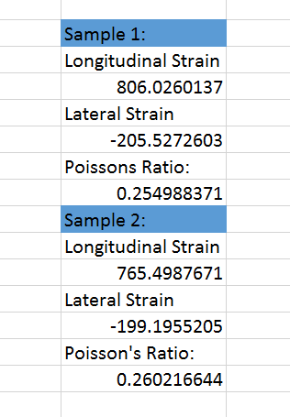
Figure 11: Screenshot of Excel calculations.

Sample Calculation of Cross Sectional Area (Sample 1):
$${Area}_{0}=thickness*width$$
= (6.15mm)(40.5mm)
= 249.075 mm²

