ARCC Test4 – Questions
- Imagine 2 identical beams (A and B). A is simply supported at the ends and B is fixed with rigid connections at the ends. Identify 2 distinctions (differences) between the beam action occurring.

- What are 2 advantages of a skew grid structure such as the one shown below?
- More economical than one way beam systems because of the cost of connections
- Better structural efficiency
- An additional saving in floor depths may at times be achieved

- As illustrated bellow, why does the behaviour of the circular plate with a simply supported boundary not differ substantially from that of the circumscribed square plate?
Because the corners of the square plate are rigid and only it’s central portion present sizable deflections.

- True or False: As illustrated below, the behaviour of a circular plate with fixed boundary is very different from that of the inscribed square plate.

- Why do the columns in the illustration below have capitals shaped as shown?
Tetrahedral space frame element? (Page 290)

- Briefly provide the definition of a membrane.
A sheet of material, so thin that for all practical purposes it can only develop tension. (ex: sheet of rubber) Also the smoothest surface connecting the points of a given boundary.

- Provide 2 examples of membrane structures with locked-in stresses.
- Umbrella
- Circular net that firefighters use to catch people jumping from burning buildings

- What are, or describe, for-resistant structures?
FOLDED PAPER. A structure that is formed to absorb the load it is subjected to.

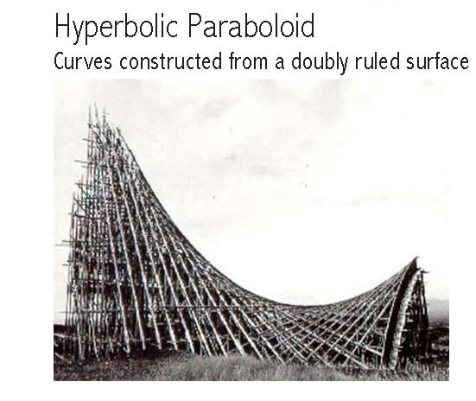
- What kind of roof shape (name) is being constructed in the illustration below and what is its highly efficient construction characteristics? (pictures)

Directions are the same at all points. So the vertical sections parallel to these directions are all straight lines and that the hyperbolic paraboloid has a double set of lines lying on its surface.
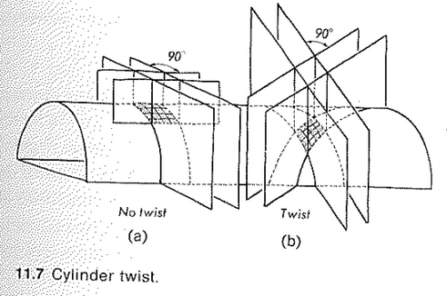
- On the barrel vault illustration below, draw 2 small separate squares that would indicate where or how the vault curvature would have no twist and where it would. Disregard the loads indicated. (picture)

- Illustrated below is a rectangular beam, 6 inches wide and 18 inches deep. To the right of the illustration, sketch an equivalent folded plate beam (clearly indicate the dimensions and their orientation).
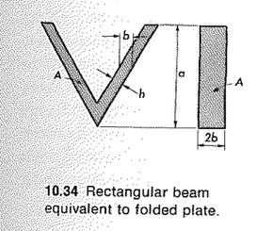

- Illustrated below are 2 alternative ways of structurally ribbing, for example concrete floor slabs. Briefly identify name both and describe the rationale behind the method shown at the bottom.
- Waffle Slab: ribbed with 2 identical sets of ribs at right angles
- Plate ribbed along isostatics: detailed and difficult but more aesthetically pleasing. (enhanced appearance) The curved ribbed lines are where the principle stress lines are.

- Regarding question 12 above, which method is more efficient from a purely structural perspective point of view? Why?
Bottom, because the curved ribbed lines are where the principle stress lines are so it supports better.

- Regarding question 12 above, which method is more efficient from a purely construction point of view? Why?
Top, because it’s cheaper and easier to make. It doesn’t take as much ime to make and saving time saves money.

- True or False: Load carrying by twisting action characterizes plates and differentiates them from beams and grids. In this connection, it is interesting to notice that the plate twist is responsible for a good percentage of its load-carrying capacity.

- Illustrated below is a plate with a concentrated load in its center. Briefly provide a sketch that would easily assist in visualizing the role of bending, shear, and torsional stresses in the transmission of the concentrated load by plate action. Indicate only where twist would occur and where shear would occur.
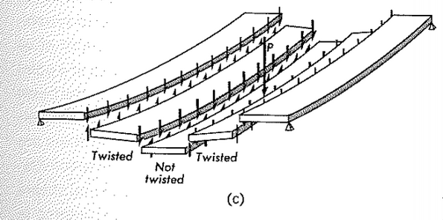
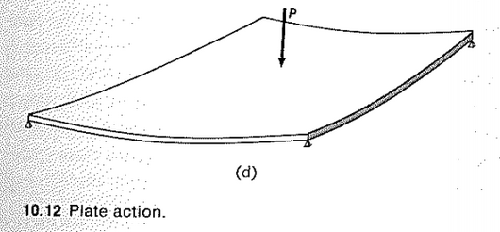
Vertical shear

- True or False: Since a plate may be considered as a grid of beams, the load transfers mechanism takes place not in one but in 2 directions and plate action is equivalent to beam action in 2 directions plus twisting action.

- Membranes must change shape under varying loads because they can develop only tensile stresses. Identify 2 primary sources of varying loads on such membrane structures.
- Concentrated load
- Normal load
- Uniform load??

- Relative to the neutral axis of plates, briefly explain how or why the structural efficiency is increased by folding the plate.
There is more material located away from the neutral axis creating greater structural efficiency since the load is distributed away from the axis.

- Regarding the roof shown below (Felix Candela project) identify the shape and indicate, directly on the image, the 2 curves that generate the surface of this thin shell roof (note that it is generated twice).
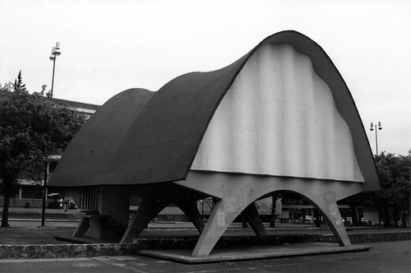
2
1
Hyperbolic Paraboloids (2)

- On the image below, indicate the 2 directions of beam action of the roof.
- Transcending
- Longitudinal?

- Identify the type of structure illustrated below. What is the structural advantage of the indented (dimpled) surface?
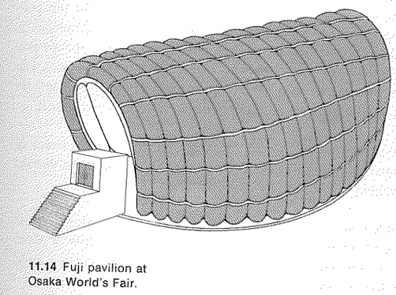
Curved roof obtained by means of inflated curved tubes of plastic material. It is advantageous because the internal pressure can be controlled to increase stability of the structure with increasing wind velocity.

- What is translational surface?
A translational surface is obtained by sliding a plane curve on another plane curve, usually at right angle to the first, while maintaining it vertical.

- True or False: The meridional sections and the sections at right angles to the meridians are the principle curvature and principle stress sections of a spherical dome.

- What is a synclastic surface?
When the normal to the curvature will always be pointing up or down, but never both at any point along the surface. Such as a dome always points down and a dish always points up.

