ELEC 1908

Matlab Assignment 1

Performed: January 20/2016
Submitted: January 27/2016

Performed By:

TA: S D

Introduction
Purpose
The purpose of this lab was to familiarize the student with using Matlab, a “high-level technical computing language and interactive environment” [1]. This will be achieved by: learning to plot graphs by modelling sinusoidal functions, completing Matlab tutorials and training and also creating a program to approximate the value of pi (π).

Results
Section 1: Matlab Tutorials
The tutorials that were completed are as follows: Getting Started with Matlab, Basic Matrix Operations, Matrix Manipulation, Controlling Random Number Generation and Graphs and Matrices.
Also an introductory course called Matlab Onramp was completed and certificate obtained (see Appendix D). These aided in understanding the syntax of Matlab and the power of the program.

Section 2: Graphing Sinusoidal functions
Using the knowledge of Matlab obtained from completing the tutorials and Matlab Onramp, Plots were created to show interference caused by two waves of equal amplitude and frequency but opposite direction. The types of interference can be found in Appendix B.
Also Plotted was two functions with different wavelength and amplitude and there interference which script and plot can be found in Appendix E.

Section 3: Approximating Pi (π)
To approximate pi using Matlab, a script was created.
Using the relationship between the area of a circle and the area of a square, it was determined that the area of a circle divided by the area of a square is pi / 4. $p=\frac{πr^{2}}{4r^{2}}=\frac{π}{4}$ . Where p is the ratio between area of a circle and square. Solving for pi and we obtain$π=p*4$. This is what we will use to approximate pi. Using a random number generator, generating random values for x and y components between 0 and 1, if the radius is smaller or equal to 1, the number falls into the circle. If it is greater than 1 it falls outside the circle into the square. Also since we are using 0 to 1 and only positive x and y values, we are only using one quarter of the circle.
Therefore the value of pi is the total amount of times the random numbers fall inside the circle / the total amount of times the numbers fall inside the circle and square times by 4. (See Appendix C).
The total number of iterations was set to 1 billion iterations. This was to insure an accurate value. To run the entire program it took approximately 26 hours to complete.
The calculated value for pi was: 3.141664552. After calculating the percentage error ( the amount a number is greater or smaller than the accepted value, it was found that the accuracy was 500 times less that 1% off ( calculated value of 2x10^-2 %). This shows that this approximation was very accurate.

$$Percent error=\frac{\left|calculated-accepted value\right|}{accepted value}*100\%$$

$=\left|3.141664552-3.14159265) \right|÷3.14159265$ * 100%
$$= 2 x 10^{-3} \%$$

Conclusion
The goal of this lab was to become familiar with Matlab. This goal was achieved. Tutorials were completed and also an introductory course (See appendix D).
Pi was approximated at 3.1416 which is only + 2% off of the actual value (using percentage error).
Appendix A
This appendix contains the graphs of sinusoidal functions. The scripts that created these graphs can be found in Appendix B.
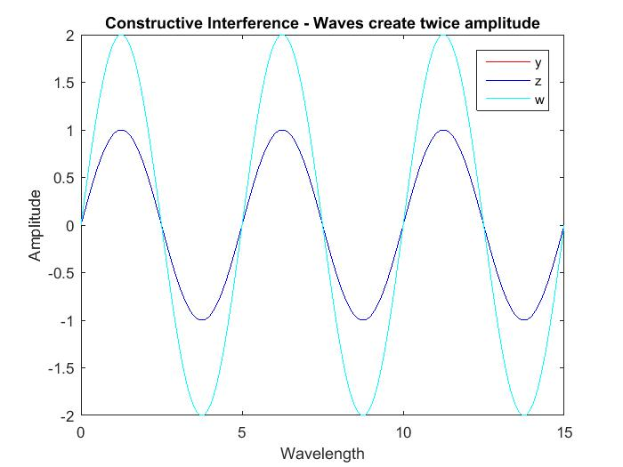
Figure 1
Figure 1: This figure demonstrates the effect of constructive interference of two waves. The blue wave ‘w’ is the result of the addition of ‘y’ and ‘z’ which have the same frequency. At this point in time they add uniformly and produce a wave with an amplitude equal to the amplitudes of each wave combined. Amplitude ‘w’ = amplitude ‘y’ + amplitude ‘z’.

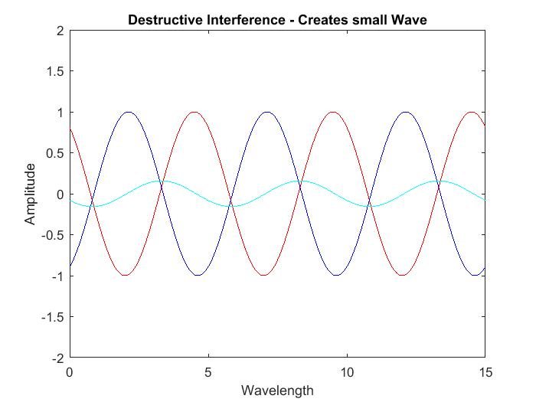
Figure 2
Figure 2: This figure demonstrates the interference of two waves ‘y’ and ‘z’ creating the wave ‘w’. This is an example of destructive interference, but it is not completely destructive. The two waves partly cancel out to create the resulting wave with a smaller amplitude.
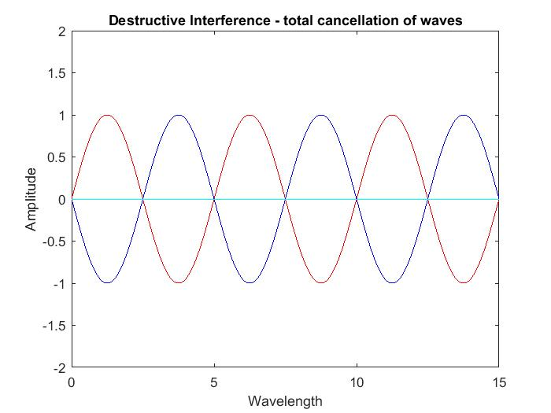
Figure 3
Figure 3: This figure demonstrates complete destructive interference. The two waves ‘y’ and ‘z’ cancel each other out completely resulting in a flat line for the wave ‘w’.

Appendix B
This appendix contains the script for plotting the graphs of two sinusoidal functions ‘y’ and ‘z’ and there interference ‘w’. This was used to create the graphs in Appendix A.

x = linspace (0,15,1000); %Create an array

for i = 0:1000 % 1000 iterations
t = 0.1*i; %Manipulating the time interval every iteration
y = sin((2*pi/5)*x - (2*pi*0.5)*t);%calculate and initialize 'y' to the sin curve
z = sin((2*pi/5)*x + (2*pi*0.25)*t);%calculate the sin curve in the opposite direction
w = y + z; % sum of y and z

plot(x,y,'r'); %plot the 'y' curve

xlabel ('Wavelength') % creating x axis label
ylabel ('Amplitude') % creating y axis label

axis([0 15 -2 2]);%axis manipulation
hold on % keep the current data on plot
plot(x,z,'b');%plot the 'z' curve

plot(x,w,'c');%plot the 'w' curve, 'y' + 'z'
pause(0.1);
hold off

end

Appendix C
This appendix contains the script for approximating the value of pi (π).
% declaring variables
c = 0; %
d = 0; %
N = 1; % number of trials
for N = 1: 1000000000 % using 1 billion random numbers
x = rand(); % generating random x
y = rand(); % generating random y

if (sqrt(x^2 + y^2) <= 1) % if r is <= 1, inside circle
c = c + 1;
else
d = d + 1;

end
N = N + 1 % to increase N by 1 to repeat the iterations

end
format long % using format long for more significant figures
p = (c / 1000000000)*4 % variable p is calculated pi

Appendix D
This appendix contains the certificate (figure 4) obtained for completing the Matlab ‘Onramp’ Introductory training course. This is included to show that proficient knowledge of use of the programming language has been achieved.

Figure 4

Appendix E
This appendix contains the script and plot for the interference of two different functions ‘y’ and ‘z’ that have different amplitudes and wavelengths.

x = linspace (0,15,1000); %Create an array

for i = 0:1000 % 1000 iterations
t = 0.1*i; %Manipulating the time interval every iteration
y = sin((2*pi/5)*x - (2*pi*0.5)*t);%calculate and initialize 'y' to the sin curve
z = sin((2*pi)*x + (2*pi)*t);%calculate the sin curve in the opposite direction
w = y + z; % sum of y and z

plot(x,y,'r'); %plot the 'y' curve
xlabel ('Wavelength') % creating x axis label
ylabel ('Amplitude') % creating y axis label
title ('Interference for waves of different Amplitude and Wavelength')
axis([0 15 -2 2]);%axis manipulation
hold on
plot(x,z,'b');%plot the 'z' curve

plot(x,w,'c');%plot the 'w' curve, 'y' + 'z'
pause(0.1);
hold off
end
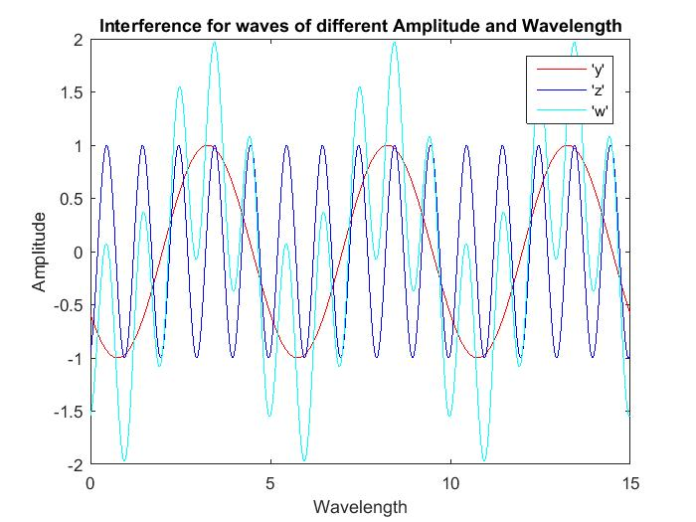
Figure 5
Figure 5: This plot contains the function ‘y’ and ‘z’ and their interference ‘w’. Interference from different amplitude and wavelength waves is ununiformed.

References

[1] | MathWorks, "Matlab," MathWorks, 1994-2016. [Online]. Available: http://www.mathworks.com/products/matlab/?refresh=true. [Accessed 26 January 2016].

