MAAE 2202 Study Guide
Chapter 1
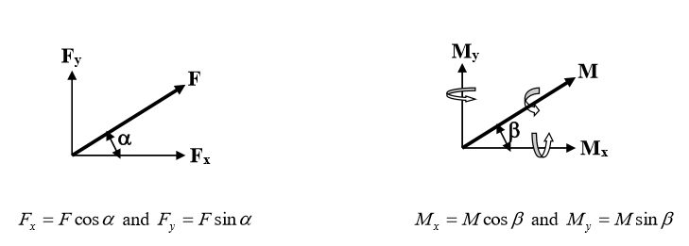 F_{r} = µ·N
Case I: If p is constant, then
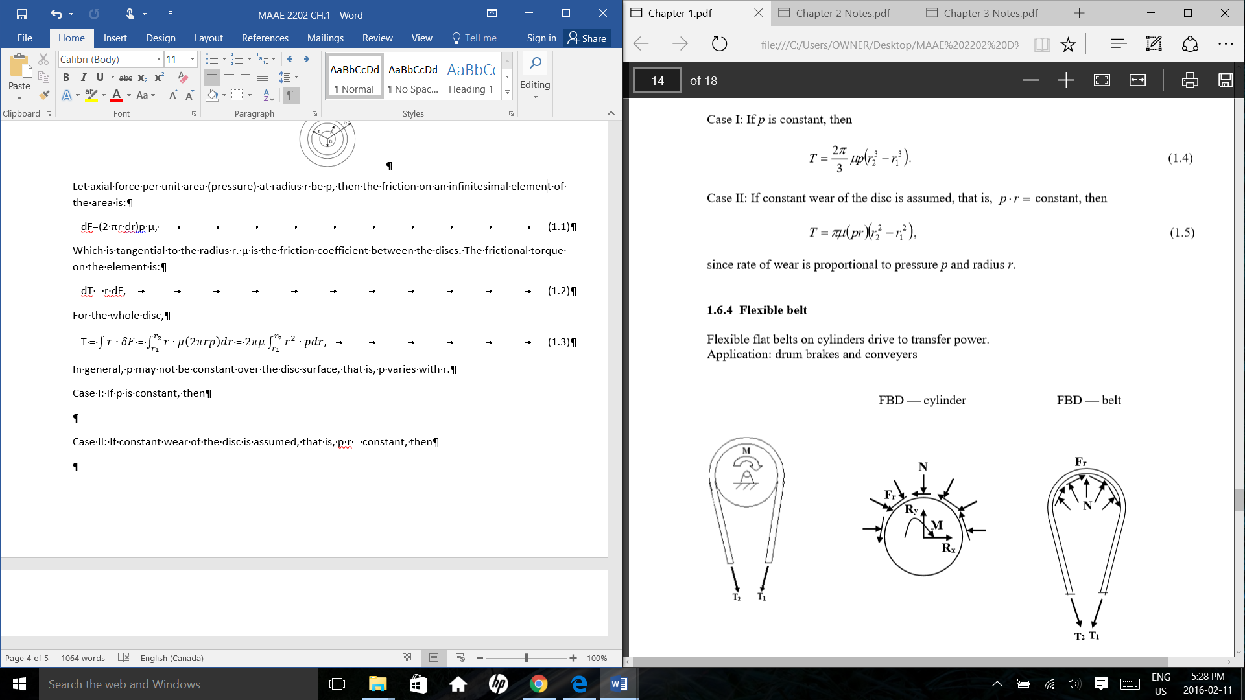
Case II: If constant wear of the disc is assumed, that is, p·r = constant, then
since rate of wear is proportional to pressure p and radius r.
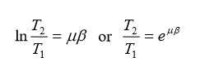
Note:
- β can be greater or less than π.
- T₂/T₁ depends on µ and β only.
- T₂ is greater than T₁.
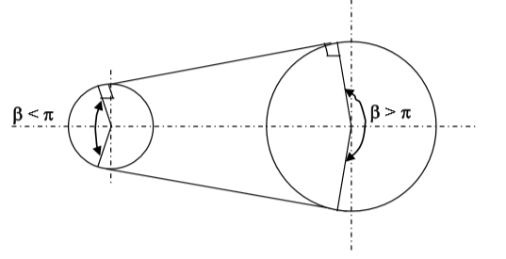

Chapter 2
Units of stress: N/mm2 (MPa), N/m2 (Pa), lb/in2 (psi), lb/ft2
1 MPa = 1 N/mm2 = 1 MN/m2
1 GPa = 1 GN/m2 = 10³ MPa
1 lb/in2 = 1 psi
1 ksi = 103 psi
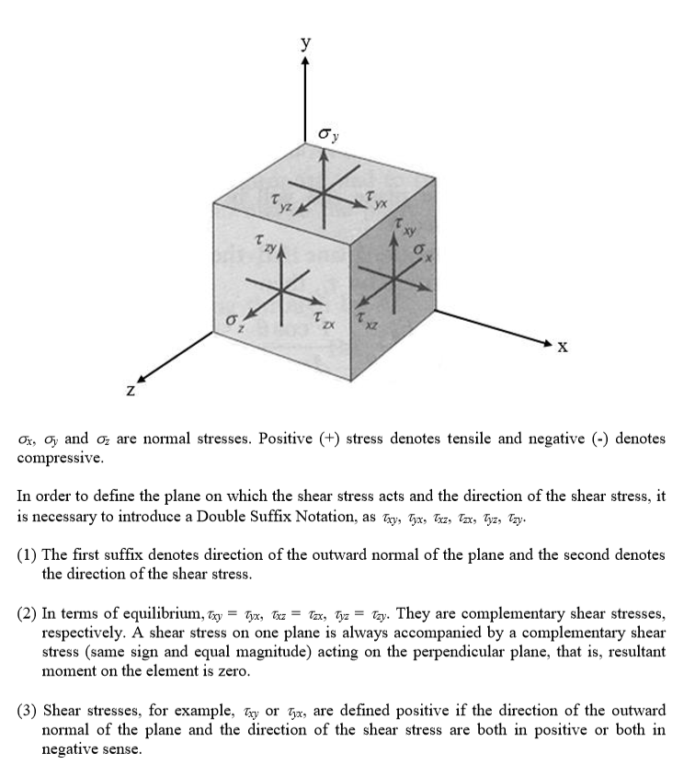
1 ft = 12 in
$σ= \frac{P}{A}$ $τ=\frac{P}{A}$

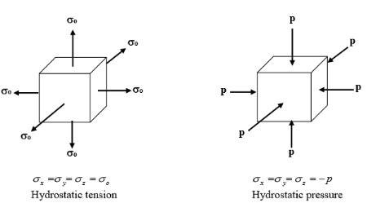
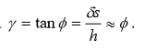
$$ε=\frac{∆l}{l_{o}}$$

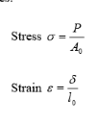

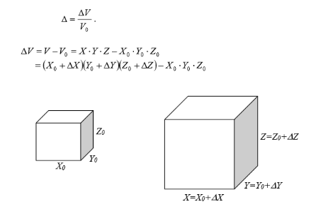

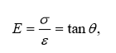
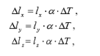
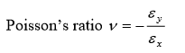
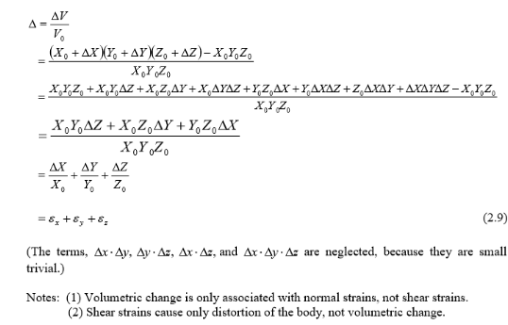

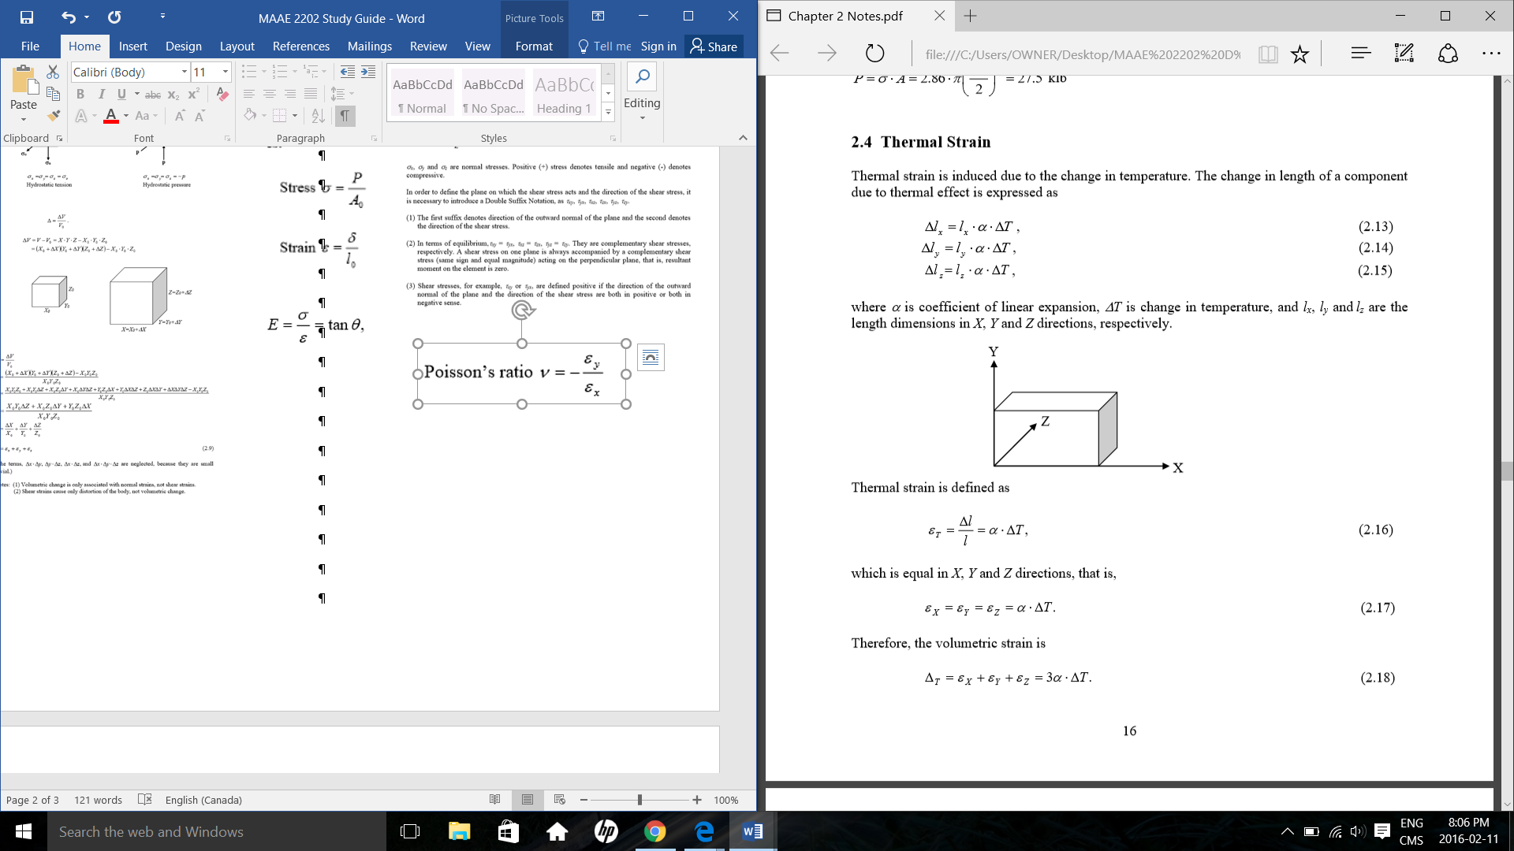
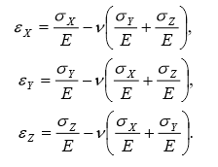

$$G= \frac{τ}{γ}$$
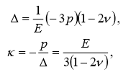
$G= \frac{E}{2(1+v)}$
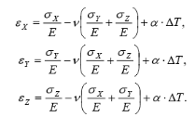

Chapter 3
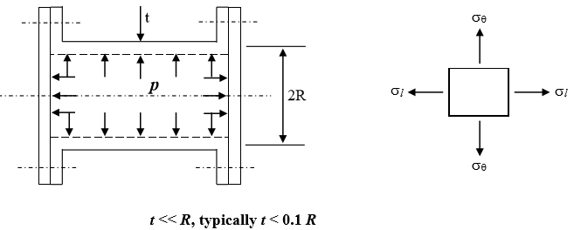
A statically determinate system is one that can be solved by force equilibrium only, that is, the number of unknowns in the system, e.g., reactions and internal forces, equals the number of equations available from force equilibrium.
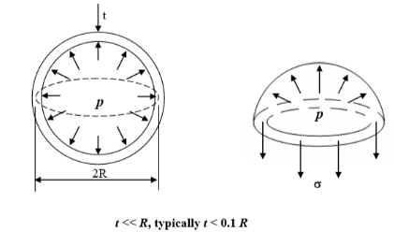
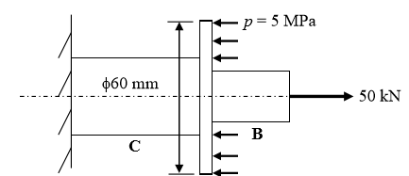

A statically indeterminate system is one that cannot be solved by force equilibrium only, that is, the number of unknowns in the system, e.g., reactions and internal forces, is greater than the number of equations available from force equilibrium. In this case, deformation of geometry has to be involved.
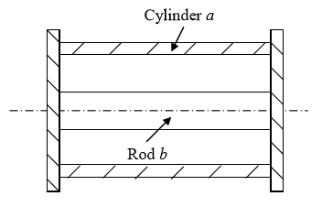
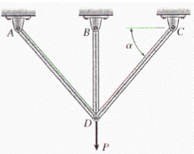
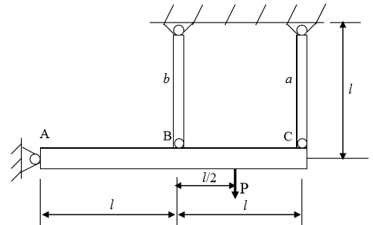
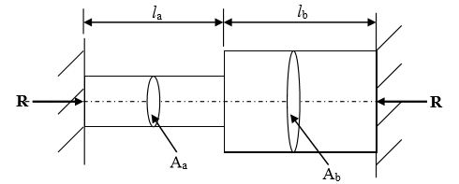

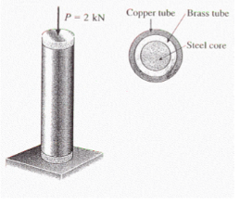

Mid-term Feb. 12th, 2016

