Chapter 2 (Management Learning: Past to Present)

Classical Management Approaches

- Scientific Management (Frederick Taylor)
- Administrative Principles (Henri Fayol)
- Bureaucratic Organization (Max Weber)

Figure 2.1 - Major branches in the classical approach to management

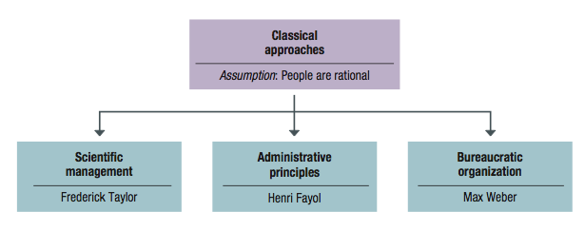

Scientific Management – emphasizes careful selection and training of workers and supervisory support

- Develop for every job a “science” that involves making standard procedures, standardized work, and proper working conditions
- Carefully select workers with the right abilities for the job
- Train workers and provide proper incentives
- Support workers by carefully planning their work and smoothing the way as they accomplish each task

Motion study – The science of reducing a task to its basic physical motions

Administrative Principles (Henri Fayol)

1. Division of labor – Specialized in a certain division
2. Authority – Managers have the right to give orders
3. Discipline – No slacking or bending rules
4. Unity of command – Each employee should have only one manager
5. Unity of direction – Manager makes a plan, everyone plays a part
6. Subordination of individual interests – At work, problems should only be related to work
7. Remuneration – All should receive fair pay, employees are valuable
8. Centralization – Decisions are primarily made at the top
9. Scalar chain – Clear, formal chains of command running from the top to bottom
10. Order – There is a place for everything
11. Equity – Managers must be kind and fair
12. Personnel tenure – Unnecessary turnover is to be avoided, and lifetime employment for good workers
13. Initiative – Do work with energy and enthusiasm
14. Espirit de corps – Build an environment with harmony and cohesion among personnel

Fayol identified FIVE rules or duties…

- Foresight – complete a plan of action for the future
- Organization – provide and mobilize resources to implement the plan
- Command – lead, select, and evaluate workers to get the best work toward the plan
- Coordination – fit diverse efforts together and to ensure info is shared and problems solved
- Control – make sure things happen according to plan and to take necessary corrective action

Bureaucratic Organization (Max Weber)

Bureaucracy – is a rational and efficient form of organization founded on logic, order, and legitimate authority

- Clear division of labour – jobs are well defined, and workers become highly skilled as performing them
- Clear hierarchy of authority – Authority and responsibility are well defined for each position, and each position reports to a higher level one
- Formal rules and procedures – Written guidelines direct behaviour and decisions in jobs, and written files are kept for historical record
- Impersonality – Rules and procedures are impartially and uniformly applied, with no on receiving preferential treatment
- Careers based on merit – Workers are selected and promoted on ability, competency, and performance, and managers are career employees of the organization

Behavioural Management Approaches

Figure 2.3 – Foundations in the behavioural or human resource approaches to management

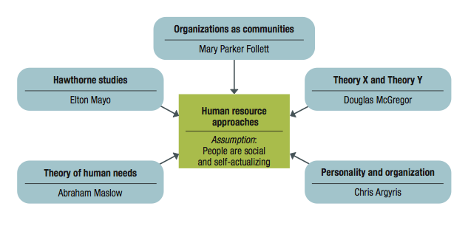

Administrative principles (Mary Parker Follett)
- Groups and human cooperation:
- Groups are mechanisms through which individuals can combine their talents for a greater good.
- Organizations are cooperating “communities” of managers and workers.
- Manager’s job is to help people in the organization cooperate and achieve an integration of interests.

Forward-looking management insights: Administrative principles
- Making every employee an owner creates a sense of collective responsibility (precursor of employee ownership, profit sharing, and gain-sharing)
- Business problems involve a variety of inter-related factors (precursor of systems thinking)
- Private profits relative to public good (precursor of managerial ethics and social responsibility)
Hawthorne studies
- Initial study examined how economic incentives and physical conditions affected worker output.
- No consistent relationship found.
- “Psychological factors” influenced results.

Relay assembly test-room studies (Hawthorne Studies)
- Manipulated physical work conditions to assess impact on output.
- Designed to minimize the “psychological factors” of previous experiment.
- Factors that accounted for increased productivity:
  - Group atmosphere
  - Participative supervision

- Employee attitudes, interpersonal relations and group processes.
    - Some things satisfied some workers but not others.
    - People restricted output to adhere to group norms.
- Lessons from the Hawthorne Studies:
    - Social and human concerns are keys to productivity.

*Hawthorne effect — people who are singled out for special attention perform as expected

Human relations movement – suggested that managers using good human relations will achieve productivity

Organizational behavior – is the study of individuals and groups in organizations

Maslow’s Theory of Human Needs

Need – a physiological or psychological deficiency that a person wants to satisfy

Based on two principles…

Deficit principle – a satisfied need is not a motivator of behavior

Progression principle – the five needs of Maslow… a need at any level is activated only when the next lower-level need is satisfied

Figure 2.4 – Maslow’s hierarchy of human needs

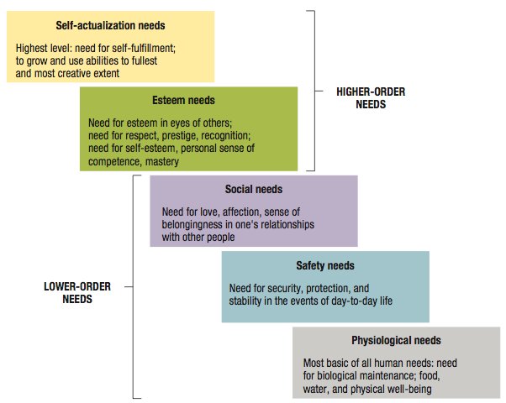

McGregor’s Theory X and Theory Y

Theory X – assumes people dislike work, lack ambition, act irresponsibly, and prefer to be led

Theory Y – assumes people are willing to work, like responsibility, and are self directed and creative

Self-fulfilling prophecy – occurs when a person acts in ways that confirm another’s expectations

Argyris’s theory of adult personality

- Classical management principles and practices inhibit worker maturation and are inconsistent with the mature adult personality.
- Management practices should accommodate the mature personality by:
  - Increasing task responsibility
  - Increasing task variety
  - Using participative decision making
Modern Management Foundations

Quantitative Analysis and Tools

Management science and operations research – use quantitative analysis and applied mathematics to solve problems

Examples…

Problem: An oil exploration company is worried about future petroleum reserves in various parts of the world

Quantitative approach: Mathematical forecasting – helps make future projections for reserve sizes and depletion rates that are useful in the planning process

The scientific applications of mathematical techniques to management problems:
- Mathematical forecasting makes future projections useful for planning
- Inventory modeling controls inventories mathematically
- Linear programming calculates how to allocate scarce resources among competing uses

Operations management: study of how organizations produce goods and services

Organizations as Systems

System – collection of interrelated parts working together for a purpose

Subsystem – smaller component of a larger system

Open System – interacts with its environment and transforms resource inputs into outputs

2.6 – Organizations as complex networks of interacting subsystems

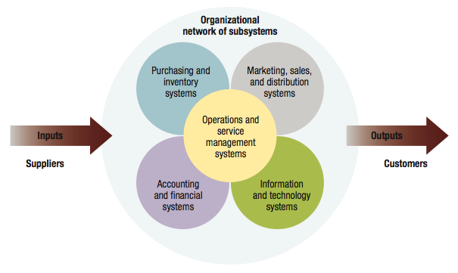

Contingency thinking – tries to match management practices with situational demands
- Especially individual or environmental differences.
- No “one best way” to manage.
- Appropriate way to manage depends on the situation.

Total Quality Management (TQM) – is managing with an organization-wide commitment to continuous improvement, product quality, and customer needs

Continuous improvement – involves always searching for new ways to improve work quality and performance

ISO (International Organization of Standardization) certification - Global quality benchmark of a organization. Refine and upgrade quality to meet ISO standards

Knowledge Management and Organizational Learning

- Knowledge management: is the process of using information technology to achieve performance success
- Portfolio of intellectual assets include patents, intellectual property rights, trade secrets, and accumulated knowledge of the entire workforce.

Learning organization: continuously changes and improves, using the lessons of experience

Key ingredients include…

- Mental models – everyone sets aside old ways of thinking
- Personal mastery – everyone becomes self-aware and open to others
- Systems thinking – everyone learns how the whole organization works
- Shared vision – everyone understands and agrees to a plan of action
- Team learning – everyone works together to accomplish the plan

High Performance Organizations

Organizations that consistently achieve excellence while creating a high quality work environment.

Common characteristics of high performance organizations include:
- People oriented – value people as human assets
- Team oriented – achieve synergy through teamwork
- Information oriented – mobilizes the latest information technology
- Achievement oriented – focuses on the needs of customers and stakeholders
- Learning oriented – operates with internal culture that respects and facilitates learning

Evidence-Based Management

- Making management decisions on “hard facts” about what really works

Evidence-Based Positive Human Resource Management Practices
  - Employment security
  - Selective hiring
  - Self-managing teams
  - High pay based on merit
  - Training and development
  - Reduced status distinctions
  - Shared information

21st Century Manager
  - Managers have to excel as never before to meet the expectations held of them and of the organization they lead.

Attributes of a 21st Century Manager
  - Global strategist – understanding the interconnections among nations, cultures and economies
  - Master of technology – comfortable with information technology
  - Inspiring leader – attracting and motivating workers to achieve high-performance culture
  - Model of ethical behavior – acting ethically in all ways

