Started from the bottom now we here, u ready to die? u gonna fail it’s okay tho I feel you

Chapter 1: Information Systems in Business Today

How Information Systems are Transforming Business
- Increased e-commerce (online shopping flexxx is tooo real)
- Emerging mobile digital platform
- Growing business use of “big data” like really, really, really big
- Growth in cloud computing (apple music, Netflix & chill dunknoe)
- New Government regulations affect business responsibilities
- Shifts in Media: more news delivered online
Globalization challenges and opportunities
- The internet has “flattened” the world
  - When Thomas Friedman wrote that the world was now "flat" (2005), he meant that:
- The internet has drastically reduced costs of operating on global scale
The Emerging Digital Firm
- Significant business relationships are digitally enabled and mediated
- Core business processes are accomplished through digital networks
- Key corporate assets are managed digitally
- Digital firms offer greater flexibility in organization and management
  - Time shifting, space shifting
Strategic Business Objectives of Information Systems
- Operational Excellence
- New products, services, and business models
- Customer and supplier intimacy
- Improved decision making (like choosing to study this)
- Competitive advantage
- Survival (like this course)

The Role of Information Systems in Business Today
- Operational Excellence
  - Improvement of efficiency to attain higher profitability
  - Information systems, technology and important tool in achieving greater efficiency and productivity
  - Walmart’s retail link system links suppliers to stores for superior replenishment system

- New Products, services, and business models:
  - Business model: describes how company produces, delivers, and sells product or service to create wealth
  - Information systems and technology a major enabling tool for new products, services, business models
    - Examples: iPad, Android OS, Netflix n shit

- Customer and supplier intimacy:
  - Serving customers well leads to customers returning, which raises revenues and profits
    - Example: High-end hotels that use computers to track customer preferences and used to monitor and customize environment
  - Intimacy with suppliers allows them to provide vital inputs, which lower costs.
    - Example: Nygrad’s information system which link sales records to contract manufacturer. I can’t make this funny cuz Idk what any of this means.

- Improved decision making
  - Without accurate information:
    - Managers must use forecasts, best guesses, luck
    - Results In:
      - Overproduction, underproduction
      - Misallocation of resources
      - Poor response times
    - Poor outcomes raise costs, lose customers

- Competitive advantage
  - Delivering better performance
  - Charging less of superior products
  - Responding to customers and suppliers In real time
  - Examples: Apple, Walmart, UPS

- Survival
  - Information technologies as necessity of business
  - Industry-level changes
    - Example: Citibank’s introduction of ATMs
  - Governmental regulations requiring record-keeping
    - Example: Canadian Sarbanes-Oxley Act
Perspectives on Information Systems

- Information Technology
  - The hardware and software that a firm needs to achieve business objectives

- Information System
  - Set of interrelated components that
  - Collect, process, store, and distribute information
  - Support decision, making, coordination, and control
- Information vs. Data
  - Data are streams of raw facts
  - Information is data shaped into meaningful form
Four activities of information systems:
- Input: Captures raw data from organization or external environment
- Processing: Converts raw data into meaningful form
- Output: Transfers processed information to people or activist that use it
- Feedback: Output returned to members of the organization to help them evaluate or correct the input and/or processing
Computer/Computer program vs. Information System
- Computers and software are technical foundation and tools, similar to the material and tools used to build a house.
Information Systems are an intergral part of organizations
- Key elements of organizations include
  - People
  - Structure
  - Business processes
  - Politics
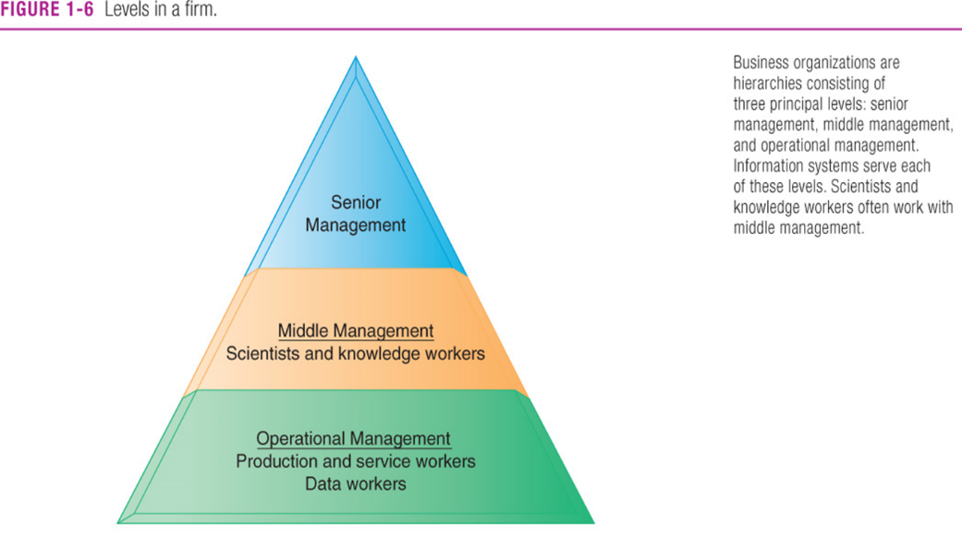
  - Culture
Hierarchy of authority, responsibility
- Senior Management
- Middle Management
- Operational Management
- Knowledge workers
- Data workers
- Production or service workers

Organizational Dimension of Information Systems
Separation of Business Functions
- Sales and marketing
- Human Resources (Mhr next sem nooooooooooooooo!!)
- Finance and Accounting
- Manufacturing and Production
Unique business processes
Unique business culture
Organizational Politics
Management
Management dimension of information systems
- Managers set organizational strategy for responding to business challenges
- In addition, managers must act creatively:
  - Creation of new products and services
  - Occasionally re-creating the organization
Information Technology Nigga
Technology dimension of Information Systems
- Computer Hardware and Software
- Data Management Technology
- Networking and telecommunications technology
  - Networks, the internet, intranets and extranets, World Wide Web
- IT infrastructure: provides platform that system I built on
A Business Perspective on Information Systems
Information system is instrument for creating value
Investments in information technology will result in superior returns:
- Productivity increases (Adderall?)
- Revenue Increases
- Superior long-term strategic positioning
That Business Information Value Chain Dawg
- Raw data acquired and transformed through stages that add value to that information
- Value of information system determine in part by extent to which it leads to better decisions greater efficiency and higher profits.
Business Perspective:
- Calls attention to organizational and managerial nature of information systems.
Cute Complementary Assets
- Assets Required to derive value from a primary investment
- Firms supporting technology investments with investment in complementary assets receive superior returns
- Example: invest in technology and the people to make it work properly

  - Complementary Assets Include:
    - Organizational Assets, for example:
      - Appropriate business model
      - Efficient business processes
  - Managerial assets, for example:
    - Incentives for management innovation
    - Teamwork and collaborative work environments
  - Social assets, for example:
    - The internet and telecommunications infrastructure
    - Technology Standards

Contemporary Approaches to Information Systems
- Technical Approach
  - Emphasizes mathematically based models
  - Computer Science, management science, operations research
- Behavioral Approach
  - Behavioral issues (strategic business integration, implementation, etc.)
  - Phycology, economics, sociology
- Management Information Systems
  - Combines computer science, management science, operations research and practical orientation with behavioral issues
- Four Main Actors
  - Suppliers of hardware and software
  - Business firms
  - Managers and employees
  - Firm’s environment (legal, social, cultural context)

Chapter 2: How Businesses Use Information Systems

Business Processes and Information System
Business Processes
- The manner in which work is organized, coordinated, and focused to produce a valuable product or service
- Every business is a collection of business processes
Information technology enhances business processes
- Increases efficiency of existing processes
- Enables new processes that can transform the business
How information Technology Improves Business Processes
Business Processes
- Workflows of material, information, knowledge
- Sets of activities, steps
- May be tied to functional area or be cross-functional
Businesses: Can be seen as collection of business processes
Business processes may be assets or liabilities
Examples of functional business processes
- Manufacturing and production
  - Assembling the product
- Sales and marketing
  - Identifying customers
- Finance and accounting
  - Creating financial statements
- Human resources
  - Hiring employees
1 . Increasing efficiency of existing processes
- Automating steps that were manual
2. Enabling entirely new processes that are capable of transforming the business
- Change flow of information
- Replace Sequential steps with parallel steps
- Eliminate delays in decision making

Transaction Processing Systems
- Perform and record daily routine transactions necessary to conduct business
  - Examples: Sales order entry, payroll, shipping
- Allow managers to monitor status of operations and relations with external environment dunknoe
- Serve operational levels
- Serve predefined, structured goals and decision making ohhhh yeaaaaa
Systems for Business Intelligence
- Business Intelligence Systems for Decision Support
  - Business intelligence: data and software tools for organizing, analyzing, and providing access to data to help managers and other enterprise users make more informed decisions.
  - Management Information Systems (MIS)
  - Decision Support Systems (DSS)
  - Executive Support Systems (ESS)
Management Information Systems (MIS)
- Serve middle management
- Provide reports on firms current performance, based on data from TPS
- Provide answers to routine questions with predefined procedure for answer them
- Typically have little analytic capability
Decision Support Systems (DSS)
- Serve middle management
- Support noneroutine decision making
  - Example: What is impact on production schedule if December sales doubled? Idfk
- Often use external information as well as information from TPS and MIS
- Model Driven DSS
  - E.g., Voyage-estimating systems... dun ask questions jus memorize
- Data Driven DSS
  - E.g., Intrawest’s marketing analysis system
Executive Support Systems (ESS)
- Support senior management
- Address non-routine decisions requiring judgement, evaluation, and insight
- Incorporate data about external events (e.g. new tax laws or competitors) as well as summarized information from internal MIS and DSS
  - Example: ESS that provides minute-to-minute view of firms financial performance as measured by working capital, accounts receivable, accounts payable, cash flow, and inventory .

Systems for Linking the Enterprise
- Enterprise applications
  - Enterprise Systems (ERP)
  - Supply Chain Management Systems (SCM)
  - Customer Relationship Management Systems (CRM)
  - Knowledge Management Systems (KMS)
  - Intranets and Extranets
Enterprise Systems
- Also known as enterprise resource planning (ERP)
- Collect data from different functions and store data in single central data repository
- Resolve problem of fragmented, redundant data
- Enable:
  - Coordination of daily activities
  - Efficient response to customer orders
  - Use of valuable information for improved management decision making
Supply Chain Management (SCM) Systems
- Manage firms relationship with suppliers
- Inter-organizational systems
- Share information about
  - Orders, production, inventory levels, delivery of products and services
- Goal: Right amount of products to destination with least amount of time and lowest cost
Customer Relationship Management (CRM) Systems
Provide information to coordinate all of the business processes that deal with customer in sales, marketing, and service to optimize revenue, customer satisfaction, and customer retention
Integrates firm’s customer-related processes and consolidate customer information from multiple communication channels
Knowledge Management Systems (KMS)
Support processes for acquiring, creating, storing, distributing, applying, integrating knowledge
Collect Internal Knowledge and link to external knowledge
Include enterprise-wide systems for:
- Managing documents, graphics and other digital knowledge objects
- Directories of employees with expertise

Intranets and Extranets
Internal networks built with same tools and standards as internet
Used for internal distribution of information to employees
Typically utilize private portal providing single point of access to several systems
May connect to company’s transaction systems
E-Business, E-Commerce, and E-Government
E-business
- Use of digital technology and internet to drive major business processes
E-Commerce
- Subset of e-business
- Buying and selling goods and services through the internet
E-Government
- Using internet technology to deliver information and services to citizens, employees and businesses.
Systems for Collaboration and Social Business
“Interaction” jobs a major part of global economy
Methods Include
- Internet-based collaboration environments
- Email and instant messaging ;)
- You used to call me on my CELLPHONEEE
- Social Networking
- Wikis
- Virtual Worlds
What is collaboration thooooooooooo???
Well collaboration be that thing where u work with others n shit to achieve shared and explicit goals. Collaboration focuses on task or mission accomplishment and usually takes place in a business or other organization and between businesses
Teams have a specific mission that someone in the business assigned to them. P.S don’t pick shitty partners.
- Changing nature of work
- Growth of professional work
- Changing organization of the firm
- Changing scope of the firm
- Emphasis on innovation & Changing culture of work and business
What is Social Business?
- The goal of social business is to deepen interactions with groups inside and outside the firm
- To expedite and enhance information-sharing innovation, and decision making.
Business Benefits
Investments in collaboration technology can produce organizational improvements returning high ROI
- Productivity
- Quality
- Innovation
- Customer Service
- Financial Performance
  - Profitability, sales, sales growth
Tools and Technologies for Collaboration and Social Business
- Email and instant messaging
- Wikis
- Virtual worlds
- Collaboration and Social Business Platforms
- Virtual Meetings
- Google Apps/ Google Sites and Cloud Collaboration Services
- Microsoft SharePoint
- Lotus Notes
- Enterprise Social Networking Tools
- Collaborative writing

Chapter 3: Information Systems, Organizations, and Strategy

Information Technology and Organizations Influence Each Other
Relationship influenced by organizations:
- Structure
- Business processes
- Politics
- Culture
- Environment
- Management decisions

What is an Organization?
Technical definition:
- Stable, formal social structure that takes resources from environment and processes them to produce outputs
- A formal legal entity with internal rules and procedures, as well as a social structure
Behavioral definition:
- A collection of rights, privileges, obligations, and responsibilities that is delicately balanced over a period of time through conflict and conflict resolution
Features of Organizations:
- Routines and business processes
  - Precise rules, procedures, and practices developed to cope with virtually all expected situations
  - Business processes: Collections of routines
  - Business firm: Collection of business processes

- Organizational politics
  - Divergent viewpoints lead to political struggle, competition, and conflict
  - Political resistance greatly hampers organizational change

- Organizational culture
  - Encompasses set of assumptions that define goal and product
    - What products the organization should produce
    - How and where it should be produced
    - For whom the products should be produced

- Organizational environments
  - Organizations and environments have a reciprocal relationship
  - Organizations are open to, and dependent on, the social and physical environment
  - Organizations can influence their environments
  - Environments generally change faster than organizations
  - Information systems can be instrument of environmental scanning, act as a lens

Disruptive Technologies: Riding the Wave
Technology that brings about sweeping change to businesses, industries, markets
- Examples: personal computers, word processing software, the internet, the PageRank algorithm
First movers and fast followers
- First Movers -> Inventors of disruptive technologies
- Fast Followers -> firms with the size and resources to capitalize on that technology
Organizational Structure
- Five basic kinds of organizational structure
- The kinds of information systems often reflects the type of organizational structure
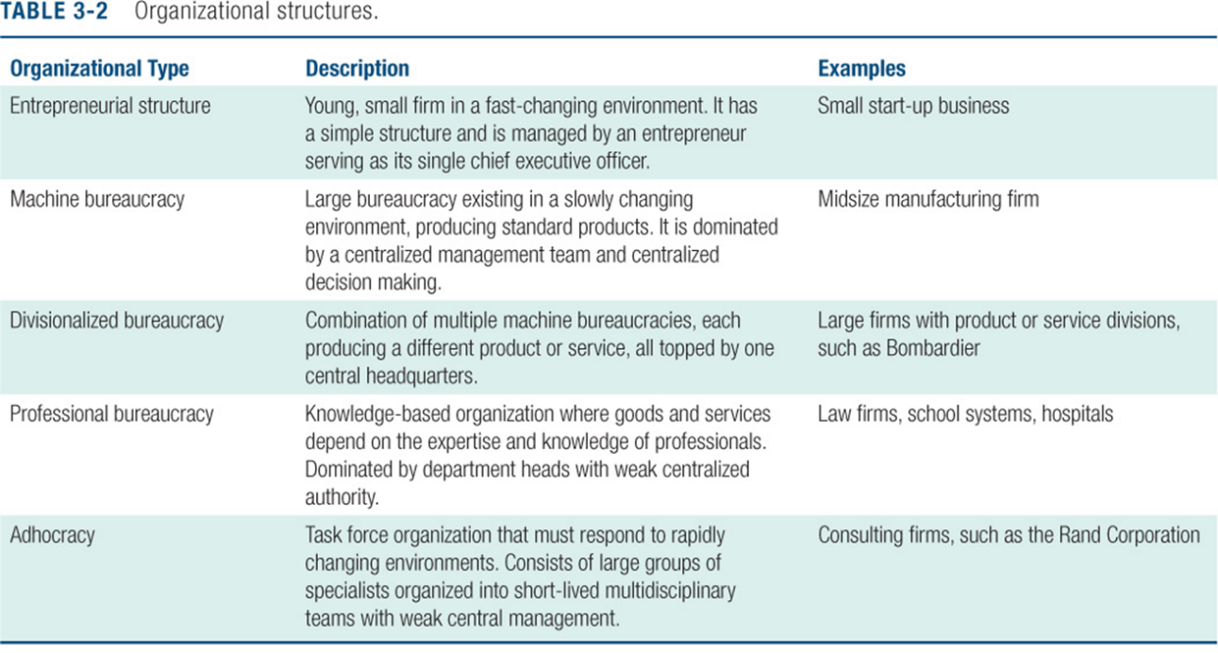
^ Good luck reading that lol ^

How Information Systems Impact Organizations
- Economic impacts
- Organizational and behavioral impacts
  - IT Flattens organizations
  - Post-industrial organizations
  - Understanding organizational resistance to change
- The internet and organizations
- The implications for the design and understanding of information systems
Other Organizational Features
Goals
- Coercive, utilitarian, normative, etc.
Constituencies
Leadership Styles
Tasks
Surrounding Environments

Economic Impacts
- IT changes relative costs of capital and the costs of information
- Information systems technology is a factor of production, like capital and labour
- IT affects the cost and quality of information and changes economics of information
  - IT helps firms contract in size because it can reduce transaction cost (the cost of participating in markets)
Transaction Cost Theory
- Firms seek to economize on cost of participating in market (Transaction costs)
- IT lowers market transaction costs for firm, making it worthwhile for firms to transact with other firms rather than grow the number of employees
Agency Theory
- Firms is nexus of contracts among self-interested parties requiring supervision
- Firms experience agency costs (the cost of managing and supervising) which rise as firm grows
- IT can reduce agency costs, making it possible for firms to grow without adding to the costs of supervising, and without adding employees
Organizational & Behavioural Impacts
IT flattens organizations
- Decision making pushed to lower levels
- Fewer mangers needed (IT enables faster decision making and increases span of control)
Post-industrial organizations
- Organizations flatten because in post-industrial societies, authority increasingly relies on knowledge and competence rather than formal positions
Understanding Organizational Resistance to Change
Information systems become bound up in organizational politics because they influence access to a key resource
Information systems potentially change an organizations structure, culture, politics, and work
Most common reason for failure of large projects is due to organizational and political resistance to change LIKE BLOCKBUSTER REMEMBER THAT SHIT BACKKK IN DAA DAYYY???
The Internet and Organizations
- The internet increases the accessibility, storage and distribution of information and knowledge for organizations
- The internet can greatly lower transaction and agency cost
  - Example: Large firm delivers internal manuals to employees via corporate Web site, saving millions of dollars in distribution costs

Implications for the Design and Understanding of Information Systems
- Information systems must be developed with an understanding of the organization in which they will be used
- These must be considered: The organizations culture, structure, environment, the groups who will use the IS, and the kinds of tasks, process and decisions the information system is meant to assist
Porter’s Competitive Force Model
Five Competitive Forces
- Traditional Competitors
- New Market Entrants
- Substitute Products and Services
- Customers
- Suppliers
Using Information Systems to Achieve Competitive Advantage
Traditional Competitors
- All firms share market space with competitors who are continuously devising new products, services, efficiencies, switching costs
New Market Entrants
- Some industries have high barriers to entry, e.g. computer chip business
- New companies have new equipment, younger workers, but little brand recognition
Substitute products and services
- Substitutes customers might use if your prices become too high: e.g. iTunes substitutes for CDs
Customers
- Can customers easily switch to competitor’s products? Can they force businesses to compete on price alone in transparent marketplace?
Suppliers
- Market power of suppliers when firm cannot raise prices as fast as suppliers

Information System Strategies for Dealing with Competitive Forces
- Low-cost leadership
  - Produce products and services at a lower price than competitors while enhancing quality and level of service
  - Example: Walmart’s continuous replenishment system

- Product differentiation
  - Enable new products or services, greatly change customer convenience and experience
  - Example: Walmart’s continuous replenishment system

- Focus on market niche
  - Use information systems to enable a focused strategy on a single market niche; specialize
  - Example: Hilton Hotels

- Strengthen customer and supplier intimacy
  - Use information systems to develop strong ties and loyalty with customers and suppliers; increase switching costs
  - Example: Chrysler, Amazon
Business Value Chain Model
Firm is viewed as a series of activities that add value to products or services
Highlights activities where competitive strategies can best be applied
- Primary activities vs. support activities
At each stage, determine how information systems can improve operational efficiency and improve customer and supplier intimacy
Utilize benchmarking, industry best practices
The Value Web
A firm’s value chain is linked to the value chain of its suppliers, distributers, and customers
Amazon.com uses systems that
- Make it easy for suppliers to display goods and open stores on the Amazon site
- Make it easy for customers to pay for goods
- Coordinate the shipment of goods to customers
- Track shipment for customers

Synergies, Core Competencies, and Network-Based Strategies
- Network-based Strategies
- Take advantage of firm’s abilities to network with each other
- Include use of:
- Network economics

- Virtual company model
  - Virtual company uses networks to ally with other companies to create and distribute products without being limited by traditional organizational boundaries or physical locations

- Business ecosystems
  - Industry sets of firms providing related services and products
    - Microsoft platform used by thousands of firms for their own products
    - Walmart’s order entry and inventory management system
  - Keystone firms: Dominate ecosystem and create platform used by other firms
  - Niche firms: Rely on platform developed by keystone firm
  - Individual firms can consider how IT will enable them to become profitable niche players in larger ecosystems

Chapter 4: Social, Ethical, and Legal Issues in the Digital Firm

Behavioural Targeting: Your Privacy is the Target
- Online activity is tracked and ads are displayed depending on your activity
- Behavioural targeting allows businesses and organizations to more precisely target desired demographics.
- Google uses tracking files to monitor user activity on thousands of sites; businesses monitor activity on their own sites to better understand customers.
- Demonstrates IT’s role in organizing and distributing information.
- Illustrates the ethical questions inherent in online information gathering.
- Increased use of behavioural targeting has drawn attention of Parliament and the Office of the Privacy Commissioner.
- In the U.S. the National Security Agency keeps phone and email logs, and uses FaceBook to create maps of social connections.
- The ethical and moral question is understanding what rights individuals have in their own personally identifiable Internet profiles.
- How much privacy are we willing to give up in order to receive more relevant ads?

Five Moral Dimensions of the Information Age
Information rights and obligations
Property rights and obligations
Accountability and control
System quality
Quality of life
Ethics in an Information Society
Basic concepts:
- Responsibility:
  - Accepting the potential costs, duties, and obligations for your decisions
- Accountability:
  - Mechanisms for identifying responsible parties
- Liability:
  - Permits individuals to recover damages done to them
Ethical Analysis
- Identify and describe the facts clearly
- Define the conflict or dilemma, and identify the higher-order values involved
- Identify the stakeholders
- Identify the options that you can reasonably take
- Identify the potential consequences of your options
Candidate Ethical Principles
- Golden Rule:
  - Do unto others as you would have them do unto you
- Immanuel Kant’s Categorical Imperative:
  - If an action is not right for everyone to take, then it is not right for anyone
- Descartes’ rule of change:
  - If an action cannot be taken repeatedly, then it is not right to be taken at any time
- Utilitarian Principle:
  - Take the action that achieves the greatest value for all concerned
- Risk Aversion Principle:
  - Take the action that produces the least harm or the least potential cost
- Ethical “no free lunch” rule:
  - Assume that all tangible and intangible objects are owned by someone else, unless there is a specific declaration otherwise

Professional Codes of Conduct
Promises by professionals to regulate themselves in the general interest of society
Promulgated by associations such as the
- Canadian Medical Association (CMA),
- Canadian Bar Association (CBA),
- Canadian Information Processing Society (CIPS), and
- Association of Computing Machinery (ACM)
Real-World Ethical Dilemmas
- Using technology to reduce workforce
- Selling subscriber information to advertisers
- Employees using corporate IT for personal use
- Using IT to monitor employees
The Moral Dimensions of Information Systems
Information rights: Privacy and Freedom in the Internet Age
- Privacy:
  - Claim of individuals to be left alone, free from surveillance or interference from other individuals, organizations, or the state.
- Personal Information Protection and Electronic Documents Act (PIPEDA) establishes principles for collection, use, and disclosure of personal information
- Provinces have parallel legislation
Ten Principles of the Canadian Standards Association’s Privacy Code
- Accountability
- Identifying Purpose
- Consent
- Limiting Collection
- Limiting Use, Disclosure and Retention
- Accuracy
- Safeguards
- Openness
- Individual Access
- Challenging Compliance
The European Directive on Data Protection
In Europe, privacy protection is much more stringent than in North America: European countries do not allow businesses to use personally identifiable information without consumers’ prior consent

Informed Consent
Consent given with knowledge of all the facts needed to make a rational decision.
EU member nations must translate these principles into their own laws and cannot transfer personal data to countries, such as the United States, that do not have similar privacy protection regulations.
Canada’s privacy legislation meets the standards of the European Directive on Data Protection.
Safe Harbour
- A private, self-regulating policy and enforcement mechanism that meets the objectives of government regulators and legislation but does not involve government regulation or enforcement.
- Businesses would be allowed to use personal data from EU countries if they develop privacy protection policies that meet EU standards. Enforcement would occur in the United States (or Canada) using self-policing, regulation, and government enforcement of fair trade statutes
Internet Challenges to Privacy
- Cookies
  - Identify browser and track visits to site
  - Super cookies (Flash cookies)
- Web beacons (Web bugs)
  - Tiny graphics embedded in emails and web pages
  - Monitor who is reading email message or visiting site
- Spyware
  - Surreptitiously installed on users computers
  - May transmit a user’s keystrokes or display unwanted ads
- Google services and behavioural targeting
Copyright
Statutory grant protecting intellectual property from being copied for at least 50 years
Canadian copyright law protects original literary, musical, artistic, and dramatic works. It also includes software, and prohibits copying of entire programs or their parts.
Patents
A grant to the creator of an invention granting the owner an exclusive monopoly on the ideas behind an invention for between 17 and 20 years
Patent law grants a monopoly on underlying concepts and ideas of software
Originality, novelty, and invention are key concepts

Challenges to Intellectual Property Rights
- Perfect digital copies cost almost nothing
- Sharing of digital content over the Internet costs almost nothing
- Sites, software, and services for file trading are not easily regulated.
- A web page may present data from many sources, and incorporate framing
Accountability, Liability, and Control
- Computer-related liability problems
- Difficult to hold software producers liable for their software products
- Given the centrality of software to everyday life, the chances are excellent that liability law will extend its reach to include software
System Quality
Data Quality and System Errors
- Three principal sources of poor system performance
  - Software bugs and errors
  - Hardware or facility failures
  - Poor input data quality
Quality of Life: Equity, Access, and Boundaries
- Balancing power: Centre versus periphery
- Rapidity of change: Reduced response time to competition
- Maintaining boundaries: Family, work and leisure
- Dependence and vulnerability
- Computer crime and abuse, including spam
- Employment: Trickle-down technology and reengineering job loss
- Equity and access: Increasing racial and social class cleavages
- Health risks: RSI, CVS and Technostress
We all gonna fail <3

Chapter 5: Information Systems in Business Today

IT Infrastructure
The shared technology resources that provide the platform for the firm’s specific information system applications.
Includes investment in hardware, software, and services, such as consulting, education, and training

Defining IT Infrastructure
- Set of physical devices and software required to operate enterprise
- Set of firm wide services including:
  - Computing platforms providing computing services
  - Telecommunications services
  - Data management services
  - Application software services
  - Physical facilities management services
  - IT management, standards, education, research and development services
Evolution of IT Infrastructure
- General-purpose mainframe and minicomputer era: 1959 to present
- Personal computer era: 1981 to present
- Client/server era: 1983 to present
- Enterprise computing era: 1992 to present
- Cloud Computing and Mobile Computing era: 2000 to present
Technology Drivers of Infrastructure Evolution
- Moore’s Law and microprocessing power
- The Law of Mass Digital Storage
- Metcalfe’s Law and network economics
- Declining communications costs and the Internet
- Standards and network effects
Moore’s Law and Microprocessing Power
Has been interpreted as:
- The power of microprocessors doubles every 18 months
- Computing power doubles every 18 months
- The price of computing falls by half every 18 months
Nanotechnology uses individual atoms and molecules to create computer chips and other devices
The Law of Mass Digital Storage
The amount of digital information is roughly doubling every year
The cost of storage is falling at an exponential rate of 100 percent per year
Metcalfe’s Law and Network Economics
The value of a network grows exponentially as a function of the number of network members

Computer Hardware Platforms
- Client machines (desktops, laptops, and PDAs)
- Server machines
  - Blade servers
  - Server Farms
- Mainframes systems used as giant servers for enterprise networks and corporate Web sites
Operating System Platforms
- Microsoft Windows dominates the market of client machine software
- Unix or Linux widely used as server software
  - Linux available as open-source software
- Google’s Chrome
- Android is an open-source operating system for mobile devices
- iOS is Apple’s Operating System for its mobile devices
Enterprise Software Applications
Largest suppliers of enterprise software are
- SAP
- Oracle
  - PeopleSoft was acquired by Oracle
Data Management and Storage
Database software: IBM (DB2), Oracle, Microsoft (SQL Server), Sybase (Adaptive Server Enterprise), MySQL
Physical data storage: EMC Corp (large-scale systems), Seagate, Maxtor, Western Digital
Storage area networks (SANs): connect multiple storage devices on dedicated network
Lol pce
Networking/Telecommunications Platforms
Leading network hardware providers are Cisco, Lucent, Nortel, and Juniper
Software leaders are Microsoft, Novell, Linux, and Unix
Service vendors include Bell Canada, Primus, and regional carriers
Growth of wireless and Voice over IP (VoIP)

Internet Platforms
Hardware, software, management services to support company Web sites, (including Web hosting services) intranets, extranets
Internet hardware server market: Dell, HP/Compaq, IBM
Web development tools/suites: Microsoft (FrontPage, .NET) IBM (WebSphere) Sun (Java), independent software developers: Macromedia/Adobe, RealMedia
Basically gg
Consulting and System Integration Services
- Even large firms do not have resources for full range of support for new, complex infrastructure
- Software integration: ensuring new infrastructure works with legacy systems
- Legacy systems: older TPS created for mainframes that would be too costly to replace or redesign
- Accenture, IBM Global Services, EDS, Infosys, Wipro
Eight Hardware Trends
- The mobile digital platform
- Consumerization of IT and BYOD
- Grid computing
- Virtualization
- Cloud computing
- Green computing
- High-performance and Power-saving processors
- Autonomic Computing
The Mobile Digital Platform
Cell phones, smartphones (BlackBerry, iPhone) have assumed data transmission, Web surfing, e-mail and IM duties
Smartphones and Tablets are increasingly used for business
Consumerization of IT and BYOD
Technology emerges in the consumer market and then spreads into business organizations
BYOD: Bring Your Own Device
New challenges for the IT department: security, software availability, ownership
Grid Computing
Involves connecting geographically remote computers into a single network capable of working in parallel on business problems that require short-term access to large computational capacity
Rather than purchase huge mainframes or super computers, firms can chain together thousands of smaller desktop clients into a single computing grid
Virtualization
Virtualization: presents computing resources so that they can be accessed in ways that are not restricted by configuration
Allows multiple operating systems to run on one machine; increases server utilization rates from 10-15 to 70 percent of capacity
Cloud Computing
- Firms off-load peak demand for computing power to remote, large-scale data processing centres
- Firms pay only for the computing power they use, as with an electrical utility
- Excellent for firms with spiked demand curves caused by seasonal variations in consumer demand, e.g. holiday shopping
- Saves firms from purchasing excessive levels of infrastructure
- Data permanently stored in remote servers, accessed and updated over the Internet by users
Cloud Infrastructure as a service
- Customers use processing, storage, networking resources to run their information systems
- They pay for only the computing capacity they use
Cloud Platform as a service
- Customers use infrastructure and programming tools to develop their own applications
Cloud Software as a service
- Customers use software hosted on a vendor’s cloud
A cloud can be private or public
- A public cloud is owned and maintained by a service provider
- A private cloud is operated only for an organization
Concerns include:
- Security
- Availability
- Users become dependent on the cloud provider
Autonomic Computing
Industry-wide effort to develop systems that can configure, heal themselves when broken, and protect themselves from outside intruders
Similar to self-updating antivirus software; Apple and Microsoft both use automatic updates

Contemporary Software Platform Trends
- Linux and open-source software
  - Open-source software is free and can be modified by users
  - Developed and maintained by a worldwide network of programmers and designers under the management of user communities
  - Linux is the most widely used open-source software program. Linux is an operating system derived from Unix

- Java, HTML, and HTML5
  - Java
    - Object-oriented programming language (Sun Microsystems)
    - Operating system, processor-independent (Java Virtual Machine)
    - Leading programming environment for Web
  - HTML
    - Hypertext Markup Language describes how text, graphics, video and sound are placed on a web page
  - HTML5
    - Images, audio, video can be embedded directly into a document without processor add-ons

- Web services and service-oriented architecture
  - Web Services: software components that exchange information using Web standards and languages
    - More powerful and flexible than HTML
    - Tagging allows computers to process data automatically
  - Service-Oriented Architecture (SOA): Set of self-contained services that communicate with each other to create a working software application
    - Software developers reuse these services in other combinations to assemble other applications as needed

- Software outsourcing and cloud services
  - Three external sources for software:
    - Software packages and enterprise software
    - Software outsourcing (domestic or offshore)
    - Cloud-based Software Services and Tools

Mashups and Apps
Mashups
- Combinations of two or more online applications, such as combining mapping software (Google Maps) with local content
Apps
- Small pieces of software that run on the Internet, on your computer, or on your cell phone
  - iPhone, BlackBerry, Android
Generally delivered over the Internet
Management Issues
- Dealing with platform and infrastructure change
- Management and governance
- Making wise infrastructure investments
  - Competitive forces model for IT infrastructure
  - Total cost of ownership of technology assets
Dealing with Platform and Infrastructure Change
- As firms shrink or grow, IT needs to be flexible and scalable
- Scalability: Ability to expand to serve larger number of users
- Firms using mobile computing and cloud computing require new policies and procedures for managing these new platforms
  - Contractual agreements with firms running clouds and distributing software required
Management and Governance
- Who controls IT infrastructure
- Centralized/decentralized
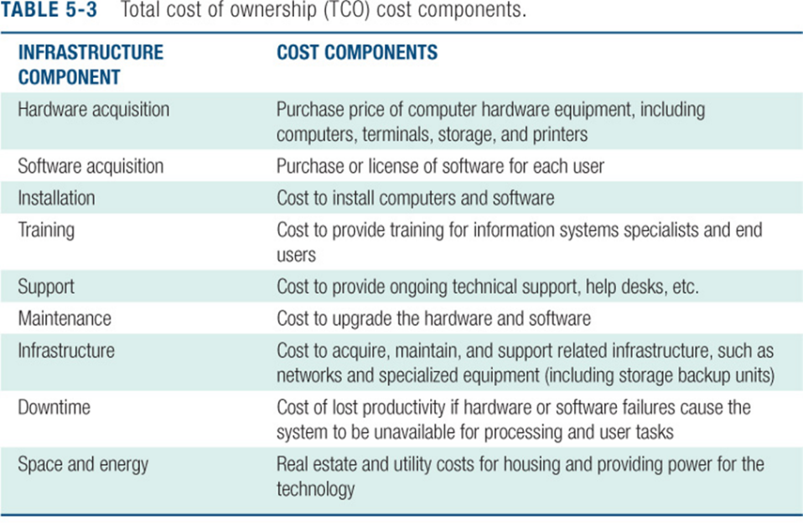
- How are costs allocated between divisions, departments?
Making Wise Infrastructure Investments
How much to spend on IT is complex question
- Rent vs. buy, outsourcing
Total Cost of Ownership (TCO) of Technology Assets
Competitive Forces Model for IT Infrastructure

Fuck you ITM .

