Punishment
Oct 1, 2015
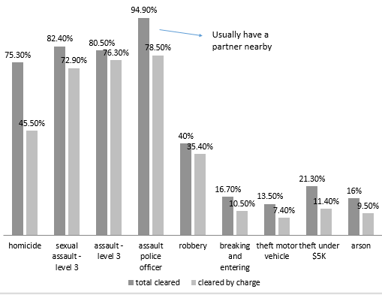
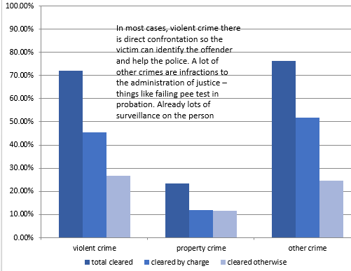
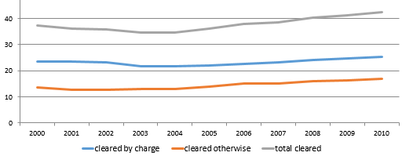
Continuing with clearance rates. Percentages.
V. Court Statistics – Adults
- Most cases – assault level 1, impaired driving, theft, failing to comply with an order of court
- ~3/4 cases completed are non-violent offences
- ~ 4/5 of accused are males
  - Women charged increased since 1970’s – now more acceptable to charge women. ~20-25% of charged are women
- More younger people than older
  - 18-24 year olds make up 12% of population and 30% of those charged
  - 55+ make up about 1/3 of the population and are 5% of the accused
- ~ 2/3 cases outcome is finding of guilt
- ~ 1/3 of sentences result in incarceration
- Most incarcerations managed by provincial system (4% 2+ years in federal)
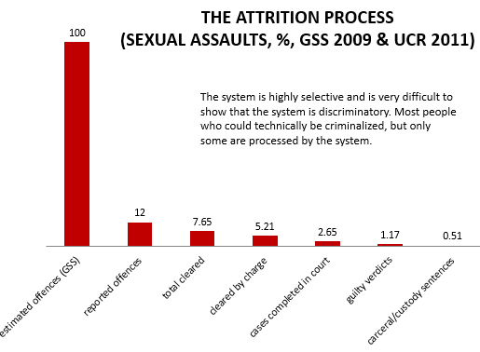
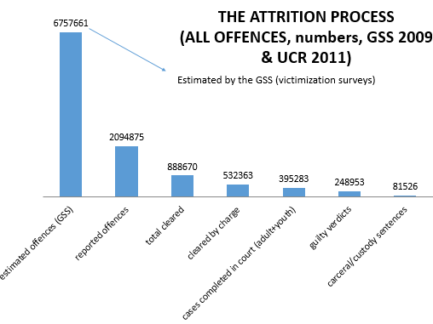
- Most common sentence is probation

VI. Self-Report Surveys
- Targets particular groups or good sample population
- 86% report behaviour that could be criminal
- Began with Poterfield (1943)
  - 1950’s Nye & Short
- Explosion in research in 1980’s
- Most using broad ideas of sociality – maybe not good representation of criminology
- Risk factor of criminality. Younger reported, more likely can predict if people are going to be criminals
- Peaks of criminality: Yong adulthood (ages 18-24)
  - Benaliy of perpetration
  - Impact of “early onset”
- Moffitt (1993)
  - Adolescence-limited / Life-course-persistent: Two types of criminals
    - People who limit criminal activity to adolescence
    - People who are criminals their entire lives
- This is best way to study how criminal involvement varies through life on individual and to study factors
- Problems:
  - Telescoping
  - Forgetting
  - Lying
PUNISHMENT!!
- Socio-historical Introduction
- Penological Rationales
- Penal Measures
- Conditional Release
I. Socio-Historical Introduction
- Variations in punishment does not necessarily reflect variations in crime
14th and 15th Centuries
- Rise in use of death penalty
  - Rusche and Kircheimer
    - Punishment and Social Structure (1939)
    - Relation between punishment and availability of labour
    - Economy and body’s value on the labour market
    - Death penalty rose because there was no need for the bodies
    - Punishment and Social Structure Thesis: Severity of punishment is subject to the labour force and economy
      - First application of Marxist conceptual framework within criminology
  - Melossi
    - Thesis that politics were connected to the severity of punishment
    - When there is perception of the economy going bad, then there is a likelihood that political figures are going to increase severity to show that society is still under control
- Refinement in ways to inflict pain
  - Punishment and torture
- Punishment a demonstration of sovereign’s power and might
- Very public
16th and 18th Centuries
- Death penalty recedes
  - Penal transportation instead
    - Sent to be slaves in the time of empirical expansion
    - Slave trade was cheaper than to send convicts away
    - Crisis where there was nowhere to ship people, so convicts would be sitting in the boats awaiting transportation
    - Shipped to Australia instead of States
    - Also used on Military vessels
- John Howard (1726-1790)
  - The State of the Prison (1777)
  - Established idea that everyone should have their own cell instead of being stuck together in one place tied to the ground
End of 18th Century – The birth of the Prison
- Before 19th century, prison was a place for prisoners awaiting to be killed, sent off, or used on military boats
- States discovered that incarceration itself could be form of punishment – can rehabilitate people
- Two competing models in States in beginning
  - Pennsylvania Model (Eastern State Penitentiary)
    - Idea that people are isolated in cells with limited contact with other people – idea that they could reconcile with God
    - Developed mental health issues
  - Auburn Model (Auburn Prison)
    - Notion that criminals must be disciplined to get good habits
    - Put to work in silence and rigid schedule
    - Became more popular and was basis of modern model
- Alexis de Tocqueville (1805-1859)
  - Studied US penitentiary systems to teach Europe to develop the systems
- Michel Foucault (1926-1984)
  - Discipline and Punishment (1975)
  - Thesis that prison testified to making disciplined society and one that is more invested in producing normal people through education and reform.
  - Believed society was form of prison. Everyone is a case and is under surveillance and follows schedules.
  - Disciplinary society: we are obsessed with the norm and with deviancy and we want to correct the deviants and make them docile
    - No longer about the law, but about the norm
II. Penological Rationales – Trying to explain why we punish
- Two competing ideas
Retributivism – Punishment as an end in itself
- Immanuel Kant
- Backward-looking
- Looking at the past. Was the crime committed and is the individual guilty?
- Only interested in justice while punishing
- Disrespecting autonomy of individual if you think that they want to be rehabilitated. They chose to commit crime, and now they suffer
- Retribution

- Denunciation
  - Punishing to denounce and say that something is wrong
  - Trans-historical rational
    - Always there
  - Implies you cannot denounce something without inflicting pain in the form of punishment
  - Can be associated with a project of education
  - Expressive penality – moral communication
    - About clarifying values of a given political entity
    - Particular Bonds
    - Showing and communicating values whether or not this produces results
  - Stable penological rational
  - More moral

- Retribution
  - Lex Talionis – eye for an eye, tooth for a tooth, life for a life
  - Cannot distinguish punishment from vengeance
  - Code of Hammurabi (~2250 BC) had three types of individuals, depending on who you were there was a system of retribution
  - Retribution dominated pre-modern penality. Dominant penological rational before rehabilitation
  - Rehabilitation concerns made this system fall away

- Just Deserts
  - “Nothing Works”
  - Proportionality, predictability, consistency
  - Saying rehabilitation is too gentle with offenders
  - Reason of justifying punishment
    - Aimed toward making system more predictable
  - Ordinal and cardinal proportionality
    - Ordinal: ranking severity of infractions
    - Cardinal: The overall scale of punishments
    - Mixing creates a table to determine punishment. Severity of the crime x the offender’s crime history
    - Difficult to explain how this is just
      - Following rules – no discretion
      - Ignorant of context of infraction
      - Trying to find what is proportionate
        - Murder = dying
        - Tax fraud = ??
Consequentialism – Punishment as a means to an end
- Jeremy Bentham
- Forward-looking
- What can we achieve through punishment?
- Concerns for utility
- Punishment that maximizes happiness for the greatest number of people

- Deterrence
General Deterrence – Deterring public  - “Classical Criminology” – punishment geared toward utility  - Late 18th century  - Certainty of punishment more likely to reduce crime than the severity  - Beccaria – people to connect crime with punishment when calculating risk and reward  - How quick punishment happens after the fact  - Problem of measurement  - Want to measure the impact of crime  - Aims to dispose people to obedience to show that people committing crimes are punished  - Costs/benefits unlikely to have impact on crimes of passion | Individual Deterrence – Deterring re-offense  - Focus on recidivism  - Examples:  - Boot camps  - “Sock incarceration”  - Started with adults went to youth. Military form of punishment meant to instill respect for authority and scare individual.  - No sure statistics whether this worked  - 2 & 3 strike laws  - Repeat offences – severity of punishment increases

- Rehabilitation
  - Opportunity to make offender better person
  - People commit crime because of something – rehabilitate in accordance
    - Cause of crime is a result of something in their life
    - In extreme – individual not seen as responsible
      - Puppet of society – inequality, poverty, lack of education
        - Want to rehabilitate in accordance
  - Indeterminate sentences
    - Lock people up until we can decide when they are ready to be released – undetermined at the beginning
  - Positivist tradition
    - Identify causes of crime – solve causes of crime
    - Generated horizon of crime-free society
  - Is rehabilitation helping the offender or controlling them?

- Incapacitation
  - Containment so individual cannot harm others
  - Death, lobotomy, castration
    - Cannot reoffend based on what they did
  - “Dangerous few” – false positives
  - Dangerous offender designation
    - Tackling violent crime act (2008)
    - Form of three-strike law
    - At third offence, if previous offences violent or sexual in nature at the federal level, you are automatically designated a dangerous offender and are stuck with that title.
  - 1997 – Long-term offender designation
    - Watered down dangerous offender
    - Targeting sexual offenders
    - Continue the surveillance of individual after sentence served
Time Line
- Pre-modern penality – Up to 18th century
  - Focus on retribution
- Modern Penality
  - Classic – Late 18th century
    - General deterrence
  - Positivist – Early 19th century
    - Rehabilitation
- Late Modern Penality
  - From late 20th century
    - Retribution and Incapacitation
Multiplicity of Penological Rationales
- Can combine penological approaches
  - Ex. Mandatory Minimum sentences (about 60 different infractions have them
    - Deterrence + incapacitation + denunciation + retribution
  - Problems with MMS’s
    - No judge’s discretion
    - Deterrent effect far from obvious
    - Punishment may be disproportionate
III. Penal Measures (For adults)
Incarceration – most severe form of punishment to sovereign power
- Imposed in ~ 1/3 sentences
- Typically national rate – but incarceration for different offences can vary per province
- More property crimes that go to jail than violent crimes
  - Lvl. 1 assault so common – jail rare
- Intermittent sentences
  - Go to jail on weekends so that you can still work and provide
- Stock vs. flow
  - Stock: picture at any given time who is in the walls
    - Roughly 37,000 persons detained on a given day
    - Steady increase of about 10% in last 10 years in federal
      - Rate is the same, but people are being sentences to bigger sentences
      - ~1/4 men in custody serving life sentence in federal
  - Flow: Flow of admittance. How many people are put in prison in the year?
    - Stable from 1950’s to early 2000’s, slight increase after that.
    - 2014: 118/100,000 people were in prison
- Mass incarceration of First Nation’s people
  - Aboriginals about 3% of Canadian population
  - 20% of the people in remand (awaiting finding)
  - 25% of the prison population
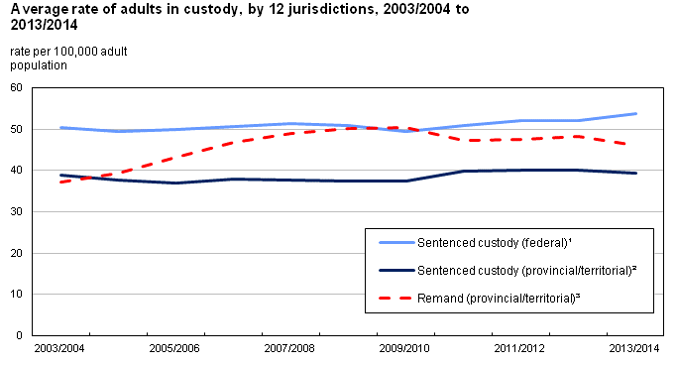
Remand
- System doesn’t want to grant bail – reduce chance of reoffending
- Truth in Sentencing Act (2009)
  - Judges used to give a 2-1 time in jail for time spent in remand. One day in remand was 2 days in jail. This act made it so it’s about a 1.5 ratio
Conditional Sentences “house arrest”
- Considered sentence of incarceration (except for in the CSI)
- 2nd most serious punishment
- Introduced in 1996 – way to reduce use of incarceration
- Moving away from idea of prison
- Now, people who would not have gotten incarceration are getting house arrest – increase site of penal capture
- If asked to go through program (ie. Anger management) you have no choice
- Conditions to receive:
- Must promise:
  - To keep peace
  - Report to supervisor
  - Remain in specific area

  - Cannot if terrorist
  - Not if sentences >2y
  - If you are risk to community
  - Drug
  - Motor vehicle theft – Bill C-10
  - Theft over 5 years
Suspended Sentences
- Form of Probation – if done correctly, no jail
- Delaying jail time to serve probation
- Individual deterrence
- Not considered incarceration
- Accompanied by probation officer
Probation
- Imposed in almost half of sentences – standalone probation or probation with something else
- Maximum term of three years
- Can be asked to do a program but must consent
Fine
- Imposed in roughly 30% of sentences
- Failure to pay can lead to prison
- Average pay is about $1000
- One day in prison ~$25 of fine
(Un)conditional Discharge
- Require admission of guilt
- No criminal record
- If receive unconditional – nothing is imposed and you are free person
Drug Treatment Courts
- Specialised courts
- Started 1998
- Require admission of guilt
- Non-violent offences

