Counting Crime
Sept 24, 2015
Six parts:
- Victimization surveys
- The construction of official statistics
- Police-reported crimes
- Clearance rates
- Court Statistics
- Self-report surveys
I. Victimization surveys
- Estimating the “dark figure” of crime (all the crime that exists unknown to the police)
- Typically view victimization surveys as more accurate than official statistics
  - Doesn’t depend on what the police find important to report
  - Independent from police gaze
- Started in 1988 in Canada with the GSS (General Social Survey), done every 5 years
- Variations with the official crime rate
- International comparisons
- Problems
  - Limited set of offences
    - Doesn’t cover the entire criminal code (things like terrorism or victimless crimes are not covered)
  - Underreporting
    - Might not report the crime (ashamed etc)
  - Ignorance
    - Only asks one person 15y/o or older in each household – person may not be aware of what has happened to everyone in the household
  - Forgetting
  - Telescoping
    - Say a crime happened in the 12 months they ask about when it happened outside of that time
  - Survey conditions
    - Relationship between interviewer, interviewee, time of day, current situation
  - Experience vs. incidents
  - May not call all kinds of people (prisoners)
  - Some people may not be able to count all the times they have been victimized because of constant abuse
General Social Survey
- Eight crimes (in order, biggest to smallest on pie) (GSS 2009)
  - Theft personal property
  - Theft household property
  - Vandalism
  - Break-ins
  - Theft motor vehicle/parts
  - Physical Assault
  - Sexual Assault
  - Robbery
- Overall rates stable 1999-2004-2009
- 1 in 4 Canadians (15y+) are victimized per year
- ~70% is non violent crime
Census Metropolitan Areas (GSS)

2.1-2.4% pop. Sexually assaulted each year.
1/5 are forced sexual activity.
Perp is friend/acquaintance – 51%

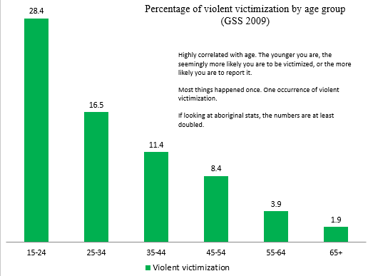
II. The Construction of Official Statistics
- Despite limits in victimization surveys, this is the data used to find reporting rates
- Attrition process (or penal funnel)
  - Removes some crimes from consideration
  - From events that can be criminalized – a very small amount of incident lead to the finding of guilt and the actual infliction of pain in the form of punishment
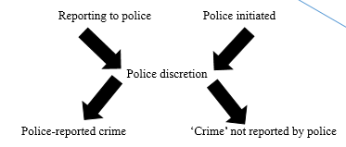
- Reporting to the police:
  - Citizen initiating the criminalization by reporting to the police
  - May not report because they feel ashamed or don’t want to waste time etc.
- Police initiated
  - Usually goes further as the police know how to frame things for the system
- Police discretion
  - The police decide what to report and what not to.
- Police-reported crime
  - Crime that the police have determined can end up in the crime statistics
- ‘Crime’ not reported by police
Reporting Rates
- Extremely low – zero: Consensual infractions
  - Eg. Prostitution
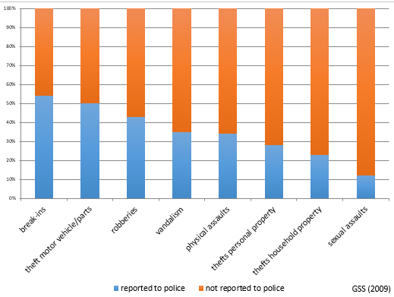
  - Moralistic and paternalistic are generally not reported
- Low – medium: Assaults, thefts
  - Depends on the value of the thing that was lost or stolen
- Higher: Break-ins, theft motor vehicle
  - Mostly for insurance purposes to get some money back
- Roughly 30-31% of crimes in Canada are reported
Police Discretion
- Two levels – factors that play in the decision whether or not to report because it influences the crime rate
Institutional Discretion  - Policies (eg. Zero tolerance)  - Tough to distinguish from political needs. Might want to react to a concern expressed by citizens.  - Distribution patrols  - What do we send where – strategic and discretionary  - Changes how crime is seen in a particular city  - Financial needs  - Political needs | Operational Discretion  - Most of patrol work is unsupervised  - Conceptions police work  - How police think of their job “catch people or help people”  - Views on the crime  - Van. Police not going to convict drug users  - Factors related to the suspect  - Social/economic class  - Race  - Gender  - Mental state  - “Relational distance” – do cops think that the person is similar to them? (socially)  - Situational factors  - Are they aggressive  - Behaviour of the suspect  - Attitude  - Systemic factors  - What do police think will happen when the crime is reported  - What is the amount of work needed  - New framework – are the routines established  - Characteristics of city or neighbourhood
III. Police-Reported Crimes
Uniform Crime Report – UCR (1962)
- Incident-based
- Expressed as rates/100,000
  - To allow international comparison
- Hard thing is when there is one incident involving multiple crimes – only one is recorded in the crime stats
  - Most serious offence is recorded
- Function in high volume/low severity crimes
Crime Severity Index – CSI (2009)
- Weight = incarceration rate x duration sentence
- 2006 as base year (value = 100)
  - Arbitrary but gives a point of reference
- Result of the lobby of some police organizations who felt that each year the publication of the crime rate was not reflecting how good the police were in terms of what mattered
- Not volume, but severity
- Drug offences included here but not in the UCR
- Wanted a tool connecting the number of crimes relating to the max penalty
  - Instead is the first point
- Some limits**
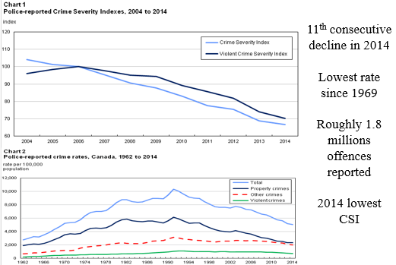
  - Doesn’t take into account if people are or are not recidivist (the risk of committing a crime again)
  - In the eyes of the law – house arrest is a sentence of incarceration – not considered as such in the CSI
  - Other examples in the text
- Change the formula every 5 years

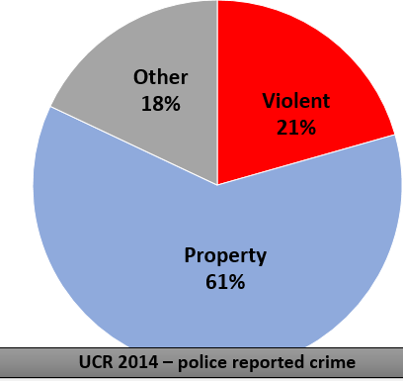
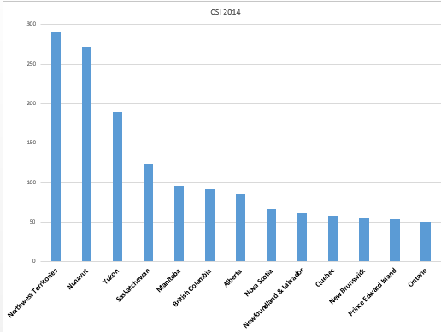
80% of crime according to police is non-violent
Most of these infractions are violations of the administration of justice

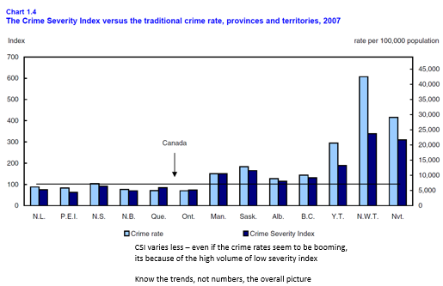

- Official stats show that most crime is less violent
- Homicide generally solid stats in the UCR – general decline but can be tripped with suicide
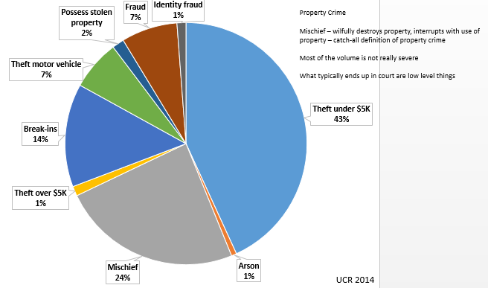
- Can use reporting rate of GSS to estimate the actual number of sexual assaults in Canada.

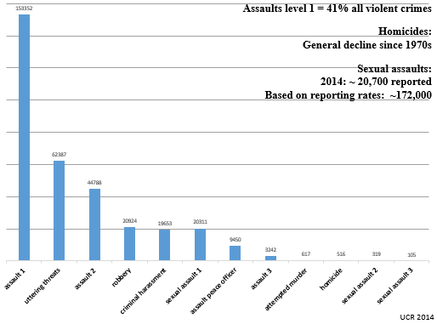
IV. Clearance Rates: A measure of the quality of police work
- Police reported crimes are either cleared or not cleared. If cleared, it is by charge or otherwise.
  - Not cleared: cases that remain unsolved
    - Include all cases where there is not enough evidence to charge anyone
  - Cleared: cases that are regarded as being solved and something has been done (or there has been a decision to do nothing)
  - By charge: someone has been charged of the offence
  - Otherwise
    - Pre-charge diversion programs: individual to recognize guilt and be rehabilitated by criminologists and psychologists after an intervention. Used a lot with youth
    - Suspect is below 12
    - Suspect has diplomatic immunity
    - Suspect is dead
    - Suspect already incarcerated for something else
    - Suspect is in a psychiatric facility

