CLASS 4 Negligence

Negligence
- The careless causing of harm
Purpose:
- To compensate for harmful, risky actions conducted carelessly, but to allow for careful risk taking
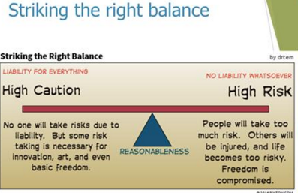

Elements of Negligence
Duty of Care
- Why should the defendant care? (relational analysis)
Standard of Care
- How should the defendant care? (Analyze the act or omission)
Causation
- Who should care? (is there a connection between what the defendant has done and the injury suffered by the plantiff?)

All 3 elements must be met to impose liability for the tort of negligence

Duty of Care: Elements
- For there to be a Duty of Care, there must be:
- Reasonable foreseeability (the one who didn’t put the horeshoe on is the one liable for the kingdom being lost) and
- Proximity
- But even if there is a duty of care, a court might not enforce it due to :
- Public policy

Reasonable Foreseeability
Objective test
- Would reasonable person have foreseen risk that harm would occur?
- Slip and fall on icy sidewalk in front of the store
- In Florida?
Not Subjective
- Opinion of either plaintiff or defendant does not matter
- Not perfect-Average

Proximity
Proximity means close and direct
Physical
- Contractor and tools
- Careless driver hits a bridge
Social
- Parent and child
Commercial
    - Bar and drunk driver
    - Manufacturer and consumer (Donoghue)
Asks should there be a general duty for the relationship?
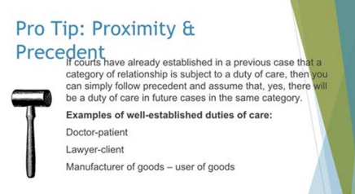
Public Policy
What effect would a duty care have on society and legal system?
- Open the floodgates for litigation
- Stock market loss
- Interfere with political decisions
- Professional regulatory
- Hurt a valuable type of relationship
- Mother and unborn child

Special Case: Duty of Care for statements

Legal Tests
- Reasonable Foreseeability
- Communicated on a serious occasion
- Made in response to an inquiry
- Defendant was paid for the statement
- Statement of fact v. statement of opinion
- Disclaimer

Proximity
- Defendant knew that the plaintiff, either as an individual or a member of a group might rely on the statement; AND
- The plaintiff relied on the statement for its intended purpose

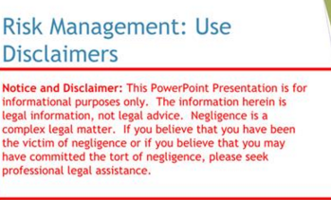

Standard of Care
- Focuses on the defendant’s actions or omissions
- Defines how much care a person with a duty of care must exercise

Standard of Care: Legal Test
- Reasonable Person Test: What would a reasonable person in the position of the defendant have one?
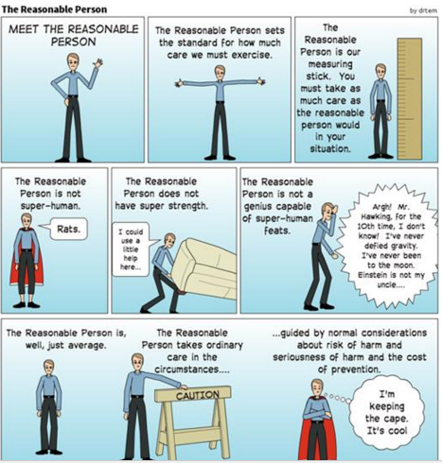

Ethical consideration: who is this “reasonable person”?
- The reasonable person plays a big role in negligence law setting the standard for our behaviour. Whether or not a defendant is liable depends in a part on whether or not the defendant acted like this reasonable person.
- The reasonable person was once called “the reasonable man” . To what extent might this standard have been influenced by a particular group of power-holders in society? Who were those power- holders?
- Might this standard still represent what is “reasonable” for a certain group of people? It is ethical to use this type of standard, given this risk?
- Is it ethical to use an objective rather than a subjective standard? What are the ethical arguments in favour of an objective standard? What about the ethical arguments in favour of a subjective standard?
The Reasonable Person Weighs
Severity of the Harm
- (Magnitude)
Likelihood of its occurrence
- (Probability)
Cost of avoiding the harm

Social Utility
Fire truck

Sudden Peril

Standard of Care for Professionals
- Professionals must act as a reasonable professional would under similar circumstances

Standard of Care for Professionals
- Standard is higher than a reasonable person in general
- Must act as reasonable professional
    - No allowance for inexperience
    - No allowance for exaggerated credentials
- Standard may be higher still for specialist or expert
- Must act as a reasonable expert would act

Limits to Professional Standard
- Remember hindsight cannot be used: focus on information reasonably available to defendant at the time
- DNA evidence
- “Errors of Judgment” are different than carelessness
- Choice of medical procedure
Compliance with approved or statutory standard
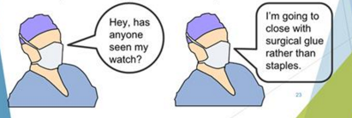

Standard of Care for Products
Product Liability
  - Harm caused by manufactured products
  - Strict liability in the US
- Manufacturer liable for any defects

Negligence in Canada
  - Manufacturer liable only for careless defects in design
  - Manufacturer usually strictly liable for manufacturing defects

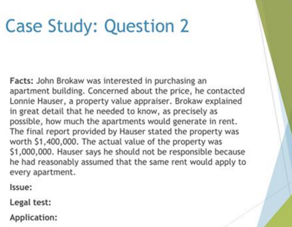

Duty of Care: Appraisal man does have special knowledge because he had the contract. Report convinced 1.4 million. No disclaimer but was paid for his services in the contract.
Legal test of elements. : Duty of care foreseeability , proximity
Application
Negligence… calculated it wrong

Causation
Third Element: Who caused the harm?
The but-for test
  - Would the plaintiff still have suffered harm, “but for” the defendant?
  - What happens if you take the defendant “out of the picture”?
- If nothing changes, plaintiff still suffers:
- Defendant did not cause loss
- If the plaintiff does not suffer then:
- Defendant IS cause of loss
- Defendant must be cause in fact and in law of the plaintiff’s injury.
- Factual causation: the “but for” test.
Legal causation: Remoteness

Factual Causation: but –for test
- Would the plaintiff still have suffered harm, “but for” the defendant?
- If the defendant have not been careless, would the plaintiff still have suffered the same injury?

Applying the But-For Test
- What happens if we take the defendant out of the picture?
- If nothing changes ie. the plaintiff still suffers the same injury, then the defendant did not cause the loss. It would have happened anyway.

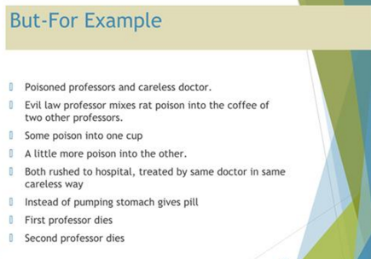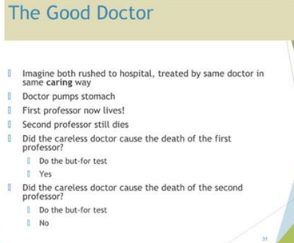

WHAT HAPPENS HAS NOTHING TO DO WITH CARELESSNESS
- No liability no negligence
- Broken leg and doctor sets the cast wrong. The man with broken legs dies of aneurism. Doctor is not liable.
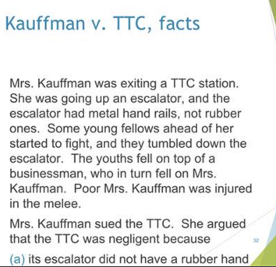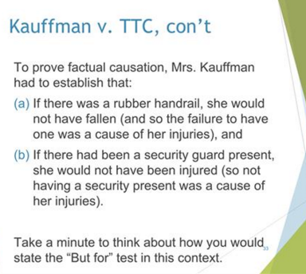

Not having security is the cause of the injury
But For test – if there was a security guard would the outcome be different/ if there was a hand rail
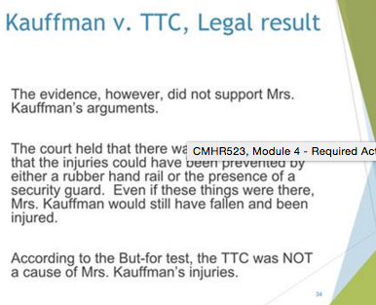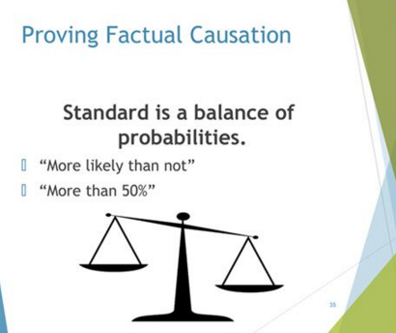

Legal Causation: Remoteness
Rule: No liability if the loss is too remote
- Something happens and harms someone but you cannot envision it
- Car takes to long to merge into another lane and person in ambulance behind dies. The car is not liable for the death of the person in the ambulance.
Test: was the type of harm suffered reasonably foreseeable
(even if how it happened was not)?

Remoteness
Duty of Care: The scope of the people to whom you might be liable
Remoteness: The type if injury for which you might be liable.
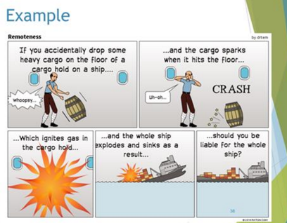

Exceptions to Remoteness
- Thin Skull -
- Thin wallet
- Intervening Act

Defences
- Contributory negligence
- Voluntary assumption of risk (“volenti”)
- Illegality-see book

Contributory Negligence
Definition
- Occurs when the plaintiff partially responsible for injusry that defendant toriously caused: the plaintiff’s own careless was a cause or added to the injury he or she suffered.
Damages reduced to reflect plaintiff’s contribution to harm

Apply the same tort analysis focusing on the plaintiff’s action:
- Did the plaintiff breach the standard of care?
- Was the plaintiff’s carelessness a cause of the plaintiff’s loss?

Impact of Liability
- The plaintiff’s damages will be reduced to reflect the plaintiff’s own contribution to his/her injury
- The judge will apportion liability ie. will decide what percentage of the loss would fall on the plaintiff.

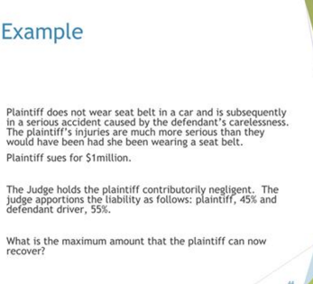

Voluntary Assumption of Risk
- Definition:Plaintiff freely accepted both physical and legal risk of injury (gave up right to sue)
- Volenti is a complete defence: if the defendant can prove that the plaintiff freely accepted both the physical and legal risk of harm, then there is no liability.
- Because of the harsh result( ie. the plaintiff recovers nothing) the courts have adopted a narrow approach.

Establishing Volenti
- The plaintiff must clearly accept the physical risk (“I accept that I might be harmed”) and the legal risk (“I agree that I won’t sue you as a result”)
- To be valid, the defendant must have drawn the plaintiff’s attention to the exclusion clause or waiver
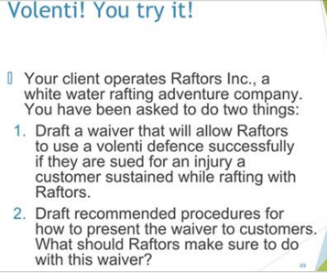

Ethical reasoning
Fact straights- paragraph on what the story is
State the law

