Jan 11/15 – How did Photography go Digital
Computational Thinking
- Formulate problems for computing
- Know how to appl technology
- Generalize & Communicate problems
- Systematically address problems
- Decomposition: Have a complex task and you want to break it down in order to better explain or organize it, using sub sections
- Pattern Recognition: making shortcuts, figuring out ways to avoid doing repetitive tasks
- Pattern Generalization – Abstraction: complex system and make it into easier terms
- Algorithm Design: step by step solution in order to solve a solution
Part 1: Photography intro, pixels, digital encoding of images
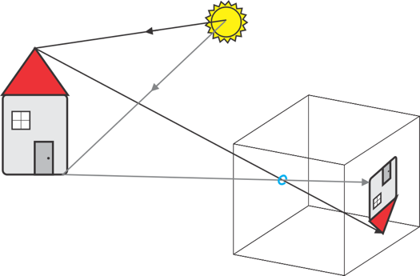
- Pin hole camera
- Black and white picture: how can we put an imageonto a computer via numbers
- Computers can only store information in the form of numbers
- House: take the boxes and put them on a grid
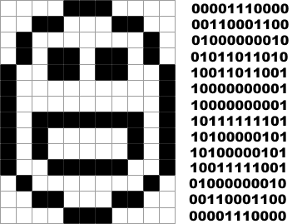
- Pixels: smallest part of a picture recorded by a computer – each box is a different shade that makes up a picture
Photography Basics
- Black and White Images
  - How to record a picture into numbers?
  - Can use numbers ->
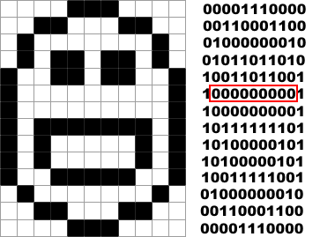
  - These numbers can be stored into a computer in addition to the size of the pic and what the numbers mean
  - One number per pixel encoding
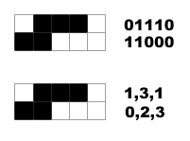
  - In efficient way to use computers memory (nine 0’s in a row)
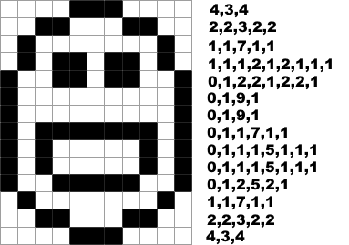
  - 1 white pixel, 3 black, 1 white
  - 0 white, 2 black, 3 white
    - Always start with white pixels
  - WOW so much more efficient
    - Simple run length encoding
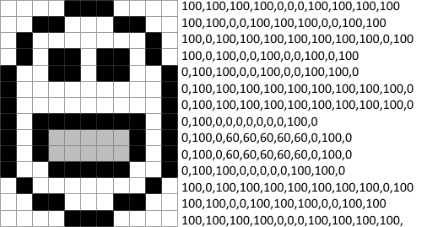
  - Run length encoding: missing one value fucks you over
  - One number encoding: loosing one value isn’t that bad
- Greyscale Images
  - 0 is black, 100 is white
  - One-pixel encoding ->
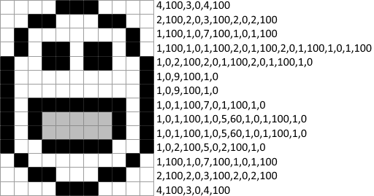
  - Run length (below)
    - The next 4 pixels are 100, the next 3 are 0…

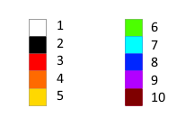
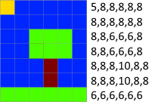
- Colour
  - One bad idea…
  - If you loose the legend no one would understand
  - Could use tree primary colors ( red, green, blue for computers)

  - With this you can make many colors
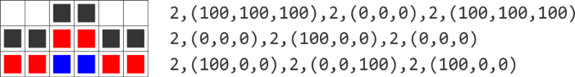
  - 2 pixels 100% each colour, 2 pixels 0% each colour…
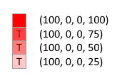
    - RGB encoding
  - 4th(last) number = transparency (Alpha) ->
    - RGBA encoding
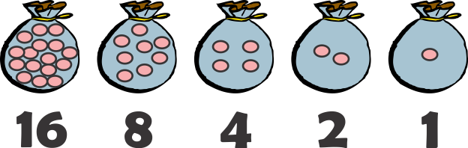
Part 2: Binary and Hexadecimal numbers
- The number system is a decimal system
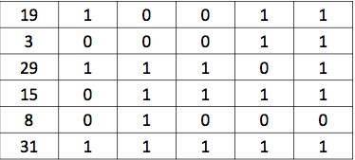
- Find the bags we need to break to make certain numbers
- Add bags that are twice the number of the last one
- Is there more than one way to choose the bags to break in order to get the exact number of stones we want?
  - No
- “X” is the number we want
  - While X is not zero:
  - Open the largest bag we can
  - Subtract its number of pebbles from X
  - x = 16
  - 19-16 = 3
  - 3-2 = 1
  - 1-1 = 0
  - fuck bitches get money, flip a desk
Decimal: each column is ten times its neighbour, 1’s, 10’s, 100’s, etc. (0-9)
Binary: each column is double its neighbour, 1’s, 2’s, 4’s, 8’s, 16’s (0-1)
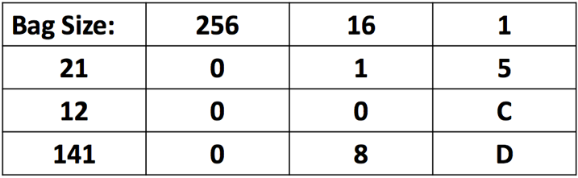
Hexadecimal: each column is sixteen(base sixteen) times its neighbour (0-9, A-F)
- A=10 B=11 C=12 D=13 E=14 F=15
Algorithmic Approach
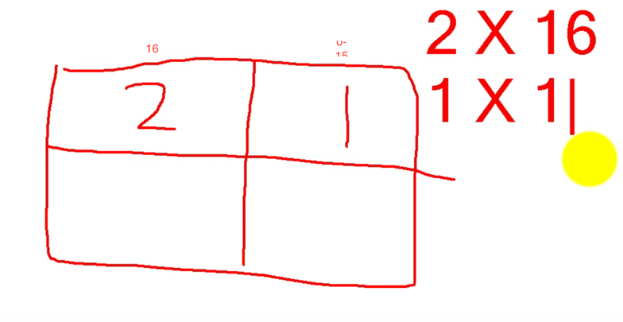
- “X” is the number we want to convert
- While X is not zero:
  - Choose the largest column we can
  - Divide x by its value, ignoring fraction
  - The value in that column is the result
  - Set X to be the remainder
- “X” is 717
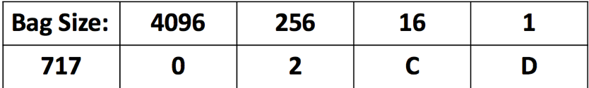
- We can use the bags of 256
- 717/256=2.80
- 717 –(256*2)=205
- 205 / 16 = 12.81
- 205 – (16*12) = 13
- 13 / 1 = 13 13 -13=0
Converting Hexadecimal to Decimal
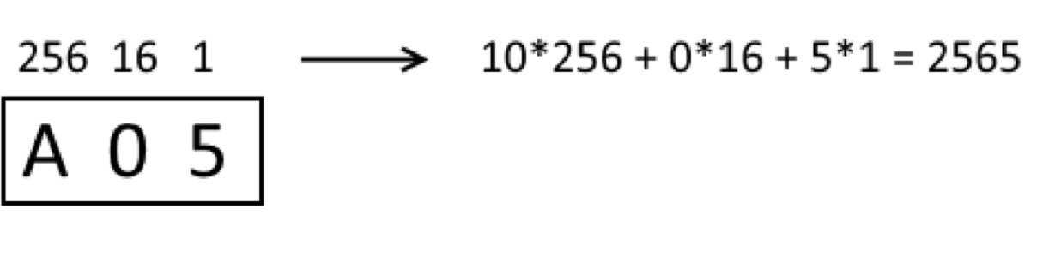
- multiply each column by it value
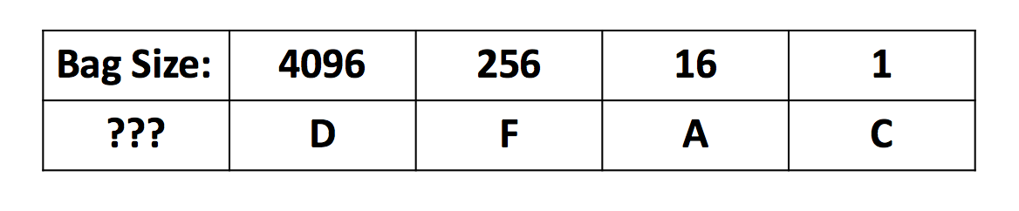
0X2CD = (4096*0)+(256*2)
(16*2) + (1*13)
0X2CD = 57260
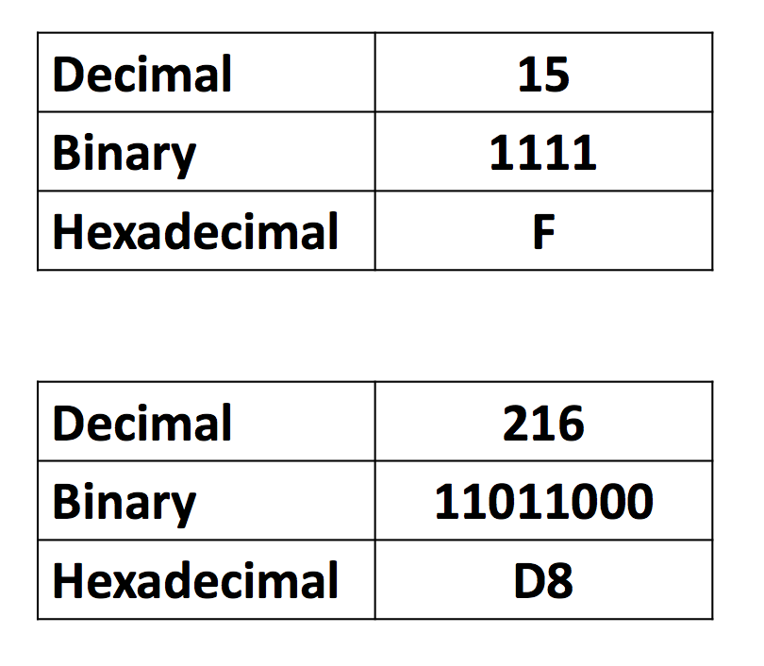
- one hexadecimal digit will correspond will 4 binary digits

Part 3: Data in memory, vector and raster images

Binary digit Bit (single 1 or 0, single memory location)
- for large numbers can combine two separate numbers to create a large number

Negative numbers
- Signed We read the first bit as a sign – 0 for positive, 1 for negative, not part of the number
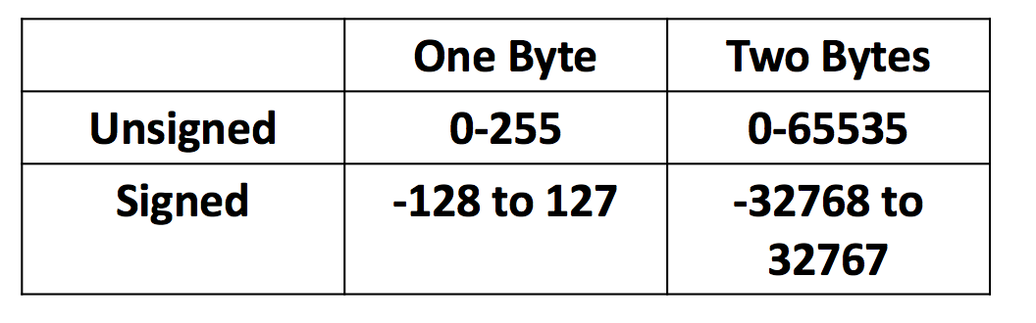
- Unsigned But 10000000 would then be wasted space! So we interpret it as -1…
- First bit = 1 = negative = 00001101 = +13
- First bit = 0 = positive = 100000111 = -8

Floating point numbers
- the decimal place is not fixed in memory
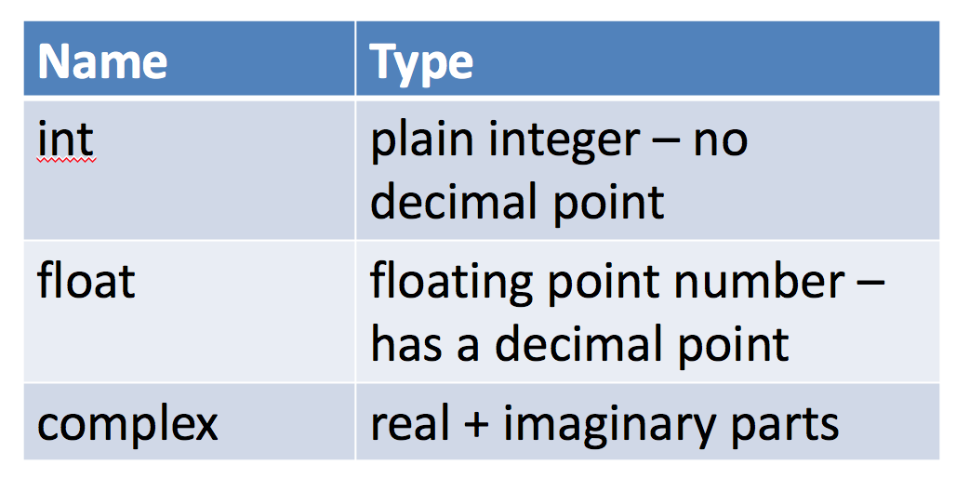
- we only have a finite number of bits
- therefore, need to approximate fractions
- rounding errors are therefore common
- floating point bytes are complex

Storing Text in memory
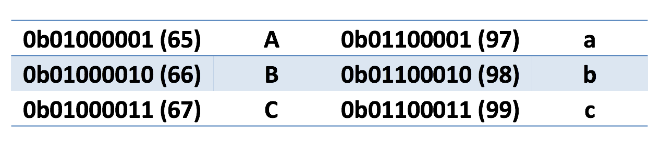
- coding scheme like a code: binary to character (number that represents a letter

- separate codes for upper and lower case
- includes punctuation and special codes
- but only 255 available characters
- ASCII only used for Latin-based languages
- UTF-8 is the standard for internet
- 3 byte pre character
- backwards compatible with ASCII
- Enough room for all foreseeable characters

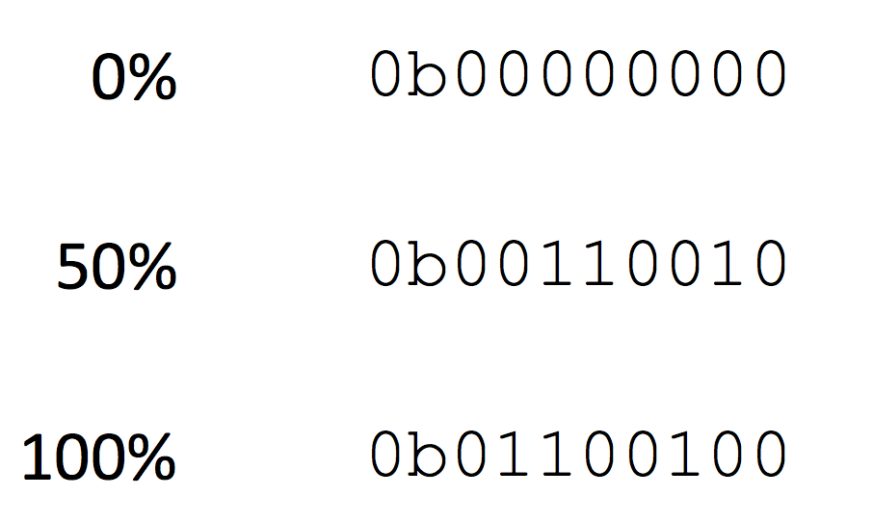
Sorting grayscale images in Bytes
- Storing each image in a single byte
- 100% is not a full byte
- instead want to store as:
- 0% = 0 0b00000000
- 50% = 127 = 0b01111111
- 100% = 255 = 0b1111111

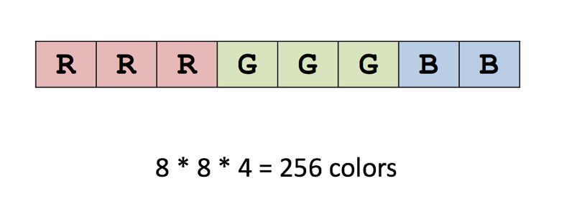
8-bit Color
- Red can be between 0 and 7 (8 choices)
- Green is the same,
- Blue can be between 0 and 3 (4 choices).
- To get all the combinations of these colors we multiply 8*8*4 and get 256.
- Thus, 8-bit color allows for 256 colors.
- All equal 1 bit

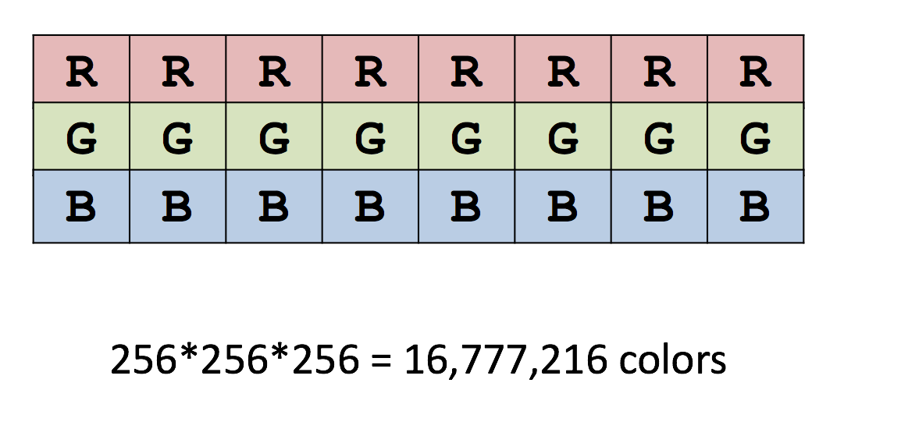
24-bit Color
- True color
- What a camera stores the pictures as
- Each pixel is 3 bites
- When you download a photo this is the system it will be encoded in

Hexadecimal and Bytes
- Byte = 8 bits = 8 binary digit
- Byte has a max of 255
- The third column in hex is 256
- Therefore, one byte is two hex characters
- FF = 1111 1111
- Hexadecimal is thus used to efficiently write byte values

Lossy Compression
- Losing pixels for a photo
- Makes them blurry
- Uncompressed is not blurry, compressed is blurry

Vector Graphics
- Instead of storing pixels, it stores a mathematical description of the image (eg. Lines, circles, shapes)
- Can zoom in and will not be blurry

3D Graphics
- Look at it from different angles
- Described by its mathematical description
- Can preform different actions (Eg. Translation, rotation, resizing(scaling))
- Texturing – when you have the wireframe and paint the portion of your image with raster graphics

