How Do Robots Find Their Way?
Comp 1001 – Jan 25 –

Learning Objectives
- Learn basic programming concepts (variables, if statements, loops, and functions) and write programs using these concepts

Robots are “dumb”
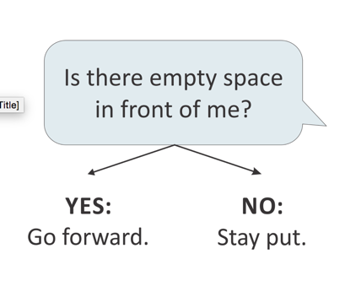
- Program can not react unless we tell them exactly what to do
- What does a robot need to have to pass a maze?
  - Is there empty space in front of me?
    - If Yes – move forward
    - If No – stay put
  - Both decisions are conditionals
  - If empty space, move forward

Conditionals
- If it is Raining… Then wear a rain coat
- If grade is least 50… Then pas the class
- True or false, aka Boolean value
- Also called a proposition more formally

Logic
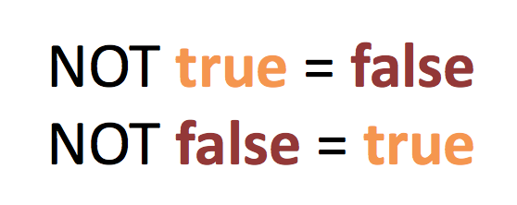
- NOT – the proposition takes the opposite value

- AND – Everything has to be true
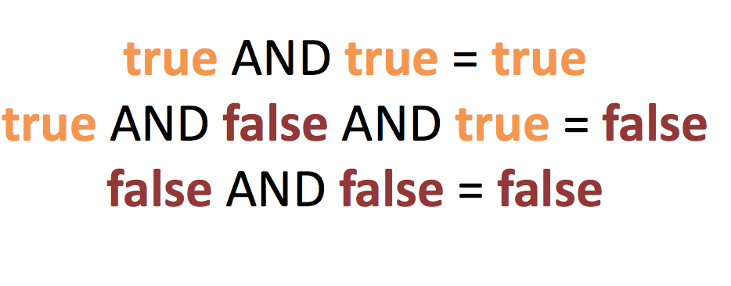
- Joins two or more conditionals

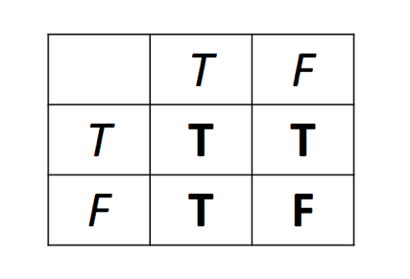

- OR – only one thing has to be true
- Joins two or more conditionals

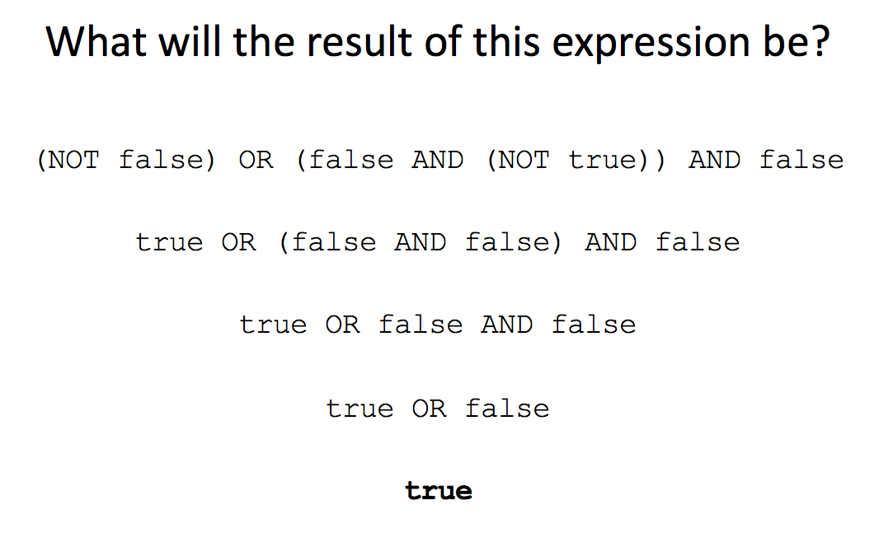

- ** Remember order of operations

Simplifying Logical Expressions
- WHILE we have more than two terms
- IF there are innermost brackets
- THEN resolve this first
- ELSE apply operations in order (NOT AND OR)

Boolean Expressions in Python
- 5 == 5 equal to
- 5 != 4 does not equal
- 5 > 4 greater than
- 5 < 4 less than
- 4 >= 4 greater than or equal to

Syntax for if statements
if <a Boolean expression>:
<code to run if the Boolean expression is true>
- everything with the same indentation will run when the Boolean expression is true

Nested If statement:

if <a Boolean expression>:
if <another Boolean expression>:
<run if both are true>
else:
<run if first is true, but not second>
else:
<code to run if the Boolean expression is false>
if <another Boolean expression>:
<run if second is true, but not first>
else:
<run if neither Boolean is true>

Else If statement:

if <a Boolean expression>:
<code to run if Boolean expression is true>
elif <another Boolean expression>:
<run if second Boolean is true, first is false>
elif <a third Boolean expression>:
<run if third is true, others false>
else:
<run if all Boolean expressions are false>
Maze Solving
How to find your way out of a maze?
- Right hand rule – hold your right hand to a wall and follow it all the way out
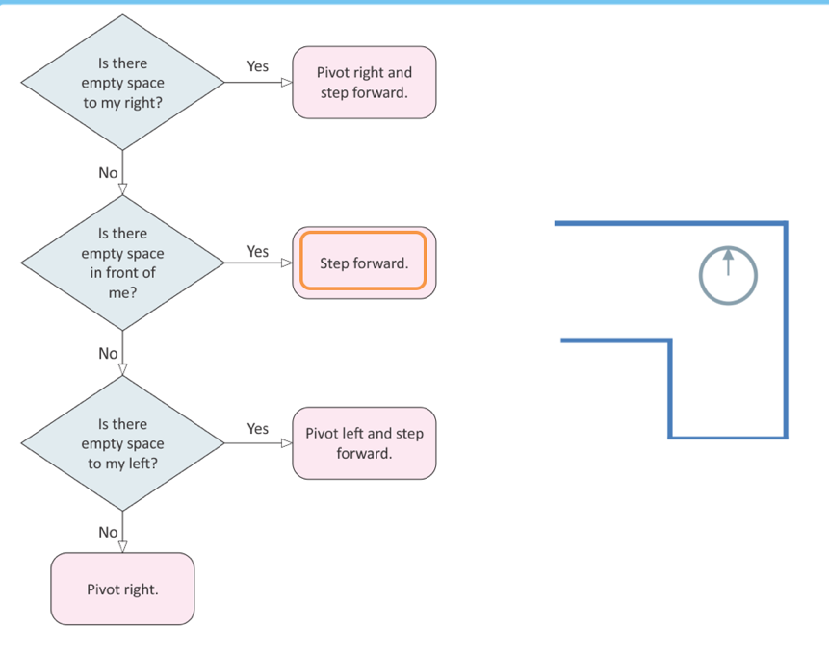
Way to move using the right hand rule
- If there is empty space to my right, then pivot right and step forward
- Otherwise, if there is empty space in front of me, then step forward
- Otherwise, if there is empty space to my left, then pivot left and step forward
- Otherwise pivot right without stepping forward

Loops
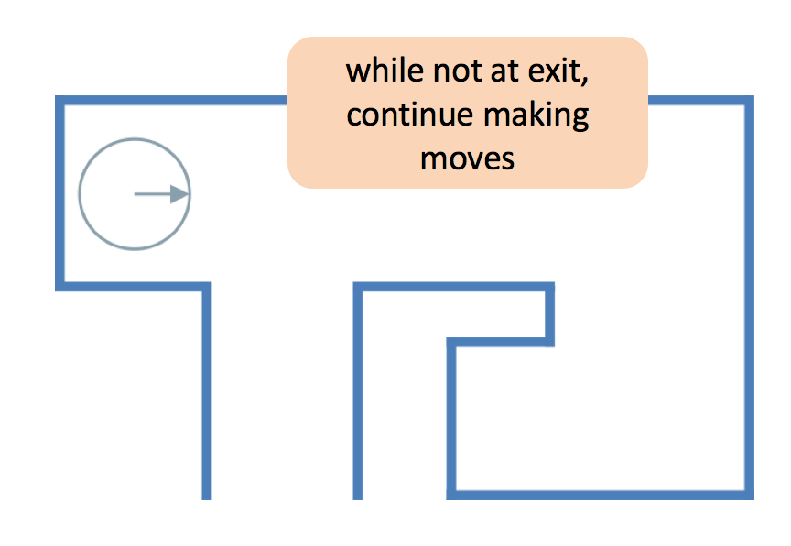
- Driving around the same track multiple times: each lap is exactly the same
- WHILE LOOP – while x != 0 keep doing binary number conversion

While Loops
While<Boolean value>:
<loop body>

Example:
x=0
While x < 2:
x = x +1
print(x)
- While x is less than 2 add 1 to x

Write a program that asks a user to enter an integer, then prints the number of digits in the number (eg 1234 = 4 digits).

number = input(“Enter a number: “)

number = int(number)

counter = 0
while number > 0:
number = number // 10 will divide and ignore the remainder
counter = counter + 1
print(counter)

counter = 1
while counter < X:
<loop body>
counter += 1

For loops
for counter in range (0,X):
<loop body>
- Excludes the last one in the range

Functions
- Eg. Bin(127), range(0,4), turtle.forward(90)
- Calling the function is anything in the brackets, called arguments
- Can have more than one argument
- May return values: eg. Age = input(“please enter your name”)

Writing Functions:
def <function name>(<arguments>):
<function body> code is run when the function is called

<function name> (<arguments>) example of a function call

Example:
def my_function():
print(“This is a function”)

print(“This prints first!”)
my_function()

What is the output?

def fun(x):
return (x*2)
for y in range(0,4): Return values: 0,2,2,3
if y < 2:
print(fun(y))
else:
print(y)

