Lecture 1,2 and 3

Ebbinghaus:
- Investigated the properties of the human memory
- Assumed that the process of committing something to memory involved the formation of new association and that these associations would be strengthened through repetition
- To observe that, he devised a set of items to be committed to memory that would have no previous associations, the “nonsense syllables” (consist of sequence of consonant, vowel and consonant CVC that does not spell anything in one’s language
- He would read them, say it to himself, go on to the next item, repeat it to himself and so on, spending same time one ach item
- Would do it till he reaches his criteria (one complete run through the list is a constituted a single repetition)
- Created table for his results

Wundt:
- Established the first psychology lab (1879) first instructor to actually have student and teach student to do their own research
- Interested in the properties of the mind
- He was skeptic
- Introspection examination of ones own conscious thoughts and feelings (relies on observation of ones mental state), while in spiritual context it may refer to examination of one’s soul

Slade:

Titchener:
- Student of Wundt, he was having students of his own spreading idea of research
- Structuralism: sensations, images, and feelings were the very elements of the mind’s structure
- Believed that they were the central idea of the structure of the mind
- Set up himself as authority as interpretation of introspection, therefore, he could not be wrong. Problem: work not independently verified
- Whole idea of introspection was not flying

James:
- American philosopher
- Functionalism: opposite to structuralism, why are things working the way they are
- Never implemented the study idea (informal observations)
- Memory is a number of different types of memory, it is more complicated
- He was influential and far-reaching

Watson:
- Behaviorism: we do not know what is going on in your head, is it mysterious zone that I am not entitled to go into, instead of looking at what’s going on in someone’s brain, you can watch/measure their behavior
- Believed in nurture and believed that a person can do anything if he is trained to do so
- Nature vs. nurture
- Anti-mentalistic: get away from studying mental processes because we do not have the tools, but we can objectively measure peoples responses, manipulate the stimuli, learning procedures

Skinner:
- Followed Watson
- Baby box (he was ridiculed, but now every hospital has them)
- Animal research, we do not know what goes on in animal brain but I can manipulate stimuli
- Worked with pigeons and rodents why? Inexpensive
- Pigeon guided bomb that would bring a bomb from the plane to a ship
- Pigeon would look at the screen and peck the right direction, for some reason American military passed his offered
- WWII: friction

D.O. Hebb:
- Cognitive science
- Hebb thought that where the science of the brain was, was inefficient
- In his book, “The Organization of Behavior”, he talked about thinking perception and learning in terms of events within the CNS
- Interdisciplinary approach to brain and behavior
- Because finally science was looking at the brain and that new information was informing
- Did not shy away from thought the importance of internal mental processes
- Four Interlocking Themes:
- Interdisciplinary approach
- Reigning theories had insufficient breadth and were characterized by physiological naiveté
- Emphasized internal mental processes, such as attention, imagery, expectancy and hypotheses
- Neuropsychological theory with concrete predictions about real-world variables
- Hebb’s Neuropsychological Theory:
- Hebb synapse
- Connections between neurons increase in efficacy in proportion to the degree of correlation between pre- and post-synaptic activity
- Neurons that fire together wire together
- Groups of neurons can form a cell assembly (a circuit)
- Phase sequence
- Thinking is the sequential activation of sets of cell assemblies

Verbal Learning 1
- The branch of experimental psychology that dealt with human subjects as they learned verbal material, stimuli composed of letters or sometimes words
- Problem: it is all technique
  - Empirical research with reference to introspection
  - A-theoretical
  - Eventually, underlying associations became the focus of research, rather than something to be avoided
Verbal Learning 2
- Existing memory associations led to the reorganization of the words during recall
- Obvious evidence of processes occurring between stimulus and response
- Development of standard paradigms that are still in use today
- They established protocols (advantageous)

Linguistics
- Skinner: language use followed the same laws of learning that other guides other behavior
- Wrote a book about language stating that the principles of behavior could explain all of language

Chomsky
- Applying behaviorism to language is only a metaphor, and only creates the illusion of scientific analysis
- Language is interested precisely because of what Skinner was trying to eliminate (mental events)
- Challenged skinner, thought that skinner language could be explained by some type of reinforcement mechanism was Ludacris

Cognitive Psychology
- Assumptions
- Mental process exist and are implemented in the brain
- Humans and all animals are active information processors (vs. passive)
- Mental processes can be studied scientifically

From History to 20th:
- Cognition
- Cognitive Science
- Memory
- Analytic Approach
- Worries
  - Ecological validity

Information Processing:
- Computers can give us new information
- The mission statement or metatheory
- The general framework
- Cognition = the four assumptions

IP Approach:

- Every processes needs to finish for the next one to happen

Themes:
- Attention
- Automaticity versus conscious control
- Data-driven (bottom-up) versus conceptual processing (top-down)
- Representation
- Implicit vs. explicit memory
- Metacognition – thinking about thinking
- Brain

Miller:
- George A. Miller (7+/- 2)
- “The magical number seven, plus or minus two”
- Absolute Judgments
- Uni-dimensional stimuli
- Memory tasks

A single dimension
- Sound
  - Pitch – could a person remember a pitch
  - Volume
  - Timbre
  - Tempo
  - Speed
  - Found out that memory is limited in the one dimensional

From seven to massive
- Each dimension provides information
- Adding dimensions
- How do we remember so many melodies?

Chunking
- 1 6 1 3 5 2 0 2 6 0 0
- Note phrases and relationships

Metrics
- How accurate are the responses?
- How fast are the responses?
  - Reaction time (RT)
  - Response time (RT)
- Verbal reports (Verbal protocol)
  - How did you figure that problem out?
- Neuropsychological evidence
  - fMRI, PET, EEG

Example:
- Spatial Numerical Association of Response Codes
- Parity task
- Number set {1 2 3 4 5 6 7 8 9}
- Left hand faster than right for 1 – 4
- Right hand faster than left for 6 – 9
- Right hand time – Left hand time

Difference in Response Times (ms) (look at graph lecture 1: slide 49)

Example:
- Learn a list of names
  - E.g., 15 words
- Recall the names in the correct order
- What was the accuracy of each recall?

Serial position curve (look at graph lecture 1: slide 51)

Speed vs. Accuracy:
- Tradeoff
  - As speed increases accuracy drops
  - If we focus on accuracy speed drops
- This can be altered by
  - Instruction
  - Consequence
  - Time limits

Information Processing (Old vs. New):
- Original approach
  - Narrow definition
  - Serial
- Current approach
  - Broader definition
  - Parallel
  - Cognitive Science

Model of Human Memory:
- Atkinson and Shiffrin (1968, 1971)
  - Three memory components: sensory memory, short-term memory, and long-term memory
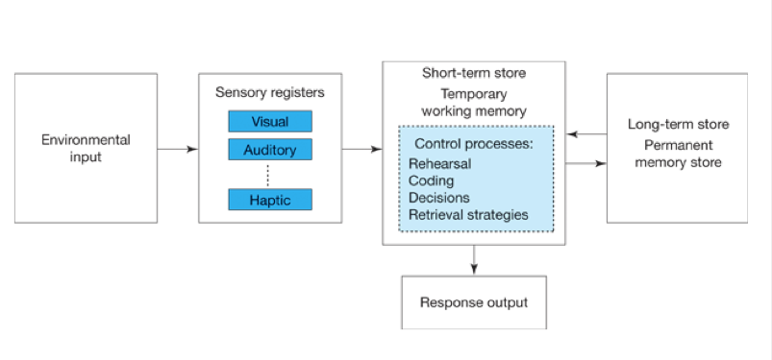
Model of Memory
Vocabulary:
- Haptic (touch)
- Sensory Memory
  - Initial mental storage system for sensory stimuli
- Short-term Memory
  - Information held for up to 20 seconds
  - Current and recently attended information
- Long-term memory
  - Information storage that can be retrieved
- Encoding
  - Translating or converting into a useable mental form
- Note the repetition and emphasis on the term mental ... in our brain

A Process Model
- Process Model
  - A hypothesis about the specific mental processes that take place when a specific task is performed
  - Tends to be focused and simpler
- Word Frequency Effect
  - It takes significantly longer to judge words of lower frequency than it does to judge high-frequency words
- Count the frequency of words in daily use
  - Newspapers
  - Online

Lexical Decision Task
- A timed task
- People decide whether letter strings are or are not English words
- Real words and words that look real
- Collect information on RT and Accuracy
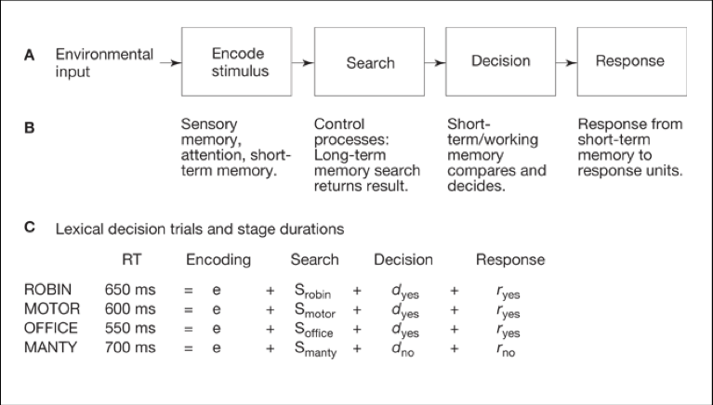
Breaking it down
- Almost by the numbers
- It is a cascade of processes in the brain
- From the model we draw conclusions
- Manty took more time (700 ms)
  - Searching?
  - Deciding?
  - Responding?

Narrow or strict IP
- Sequential Stages of Processing
  - An assumption in most process models that the separate stages of processing occur in a fixed sequence, with no overlap of the stages
- Independent and Non-overlapping Stages
  - The assumption in the strict information processing approach that the stages of processing are independent of one another in their functioning, and that they do not overlap in time

Christmas Lights
- Used to be serial
  - One bulb out, all are out
- Advantages of parallel
  - All bulbs work independently
- Evidence suggested that states of processing could happen at the same time
  - We are more efficient than the strict model allows

Difficulties with Serial
- Context effects
- Tough to generalize beyond RT measure
- Verbal Protocol Procedure
  - In studies of problem solving, a word-for-word transcription of what the subject said aloud during the problem-solving attempt

Cognitive Approach Now
- Cognitive Science
  - The study of human thought, using all available scientific techniques and including all relevant scientific disciplines for exploring and investigating cognition
- Cognition Psychology is one component within Cognitive Science

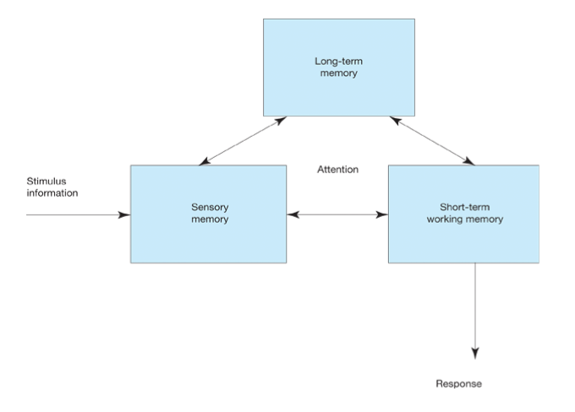
Parallel, interactive (note arrows)
The current direction
- Parallel Processing
  - Inclusion of neuro-scientific evidence
- Context
  - Top-down processing (conceptually driven processing)
- Guided and assisted by the knowledge already stored in memory
- Fixing the Narrowness
  - Open to results based on a variety of research techniques

The Brain and Cognition
- Neuropsychology
  - Deficits due to brain damage, and what the can tell us about neural and cognitive functioning
- Dissociation
  - A disruption in one component of mental functioning but no impairment of another
The Brain
- Learning from problems
- Neuron
- Cell that is specialized for receiving and transmitting a neural impulse

Basic Neurology
- Synapse
  - The region where the axon terminals of one neuron and the dendrites of another come together
- Divergence vs. convergence
- Neurons
  - Type I (excitatory) & Type II (inhibitory)
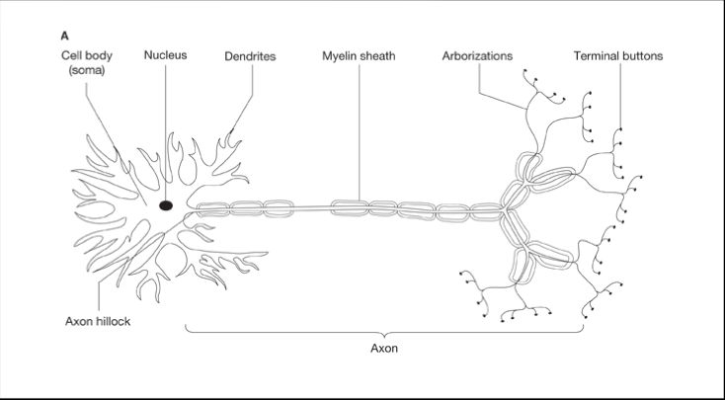

Principles of Functioning
- Contralaterality
- Control of one side of the body is localized in the opposite-side cerebral hemisphere
- In the eye, contra laterality acts via the side of the retina transmitting the signal
- Hemispheric Specialization
- Each hemisphere tends to specialize in different abilities and tends to process different kinds of information
- Cerebral Lateralization
- Different functions or action within the brain tend to be localized in one or the other hemisphere

Hemispheric Specialization*

Function | Left Hemisphere | Right Hemisphere
Visual  Auditory  Memory  Language | Letters, words  Language related sounds  Verbal memory  Speech  * Right handers | Faces  Music  Nonverbal memory  Prosody

Connectionism
- A computer-based model
- Uses an algorithm
- Called
  - Neural net models
  - Parallel distributed processing (PDP)
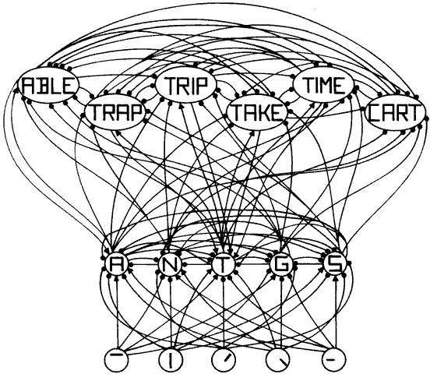
Trees in the brain
- Neurons
  - Dendrites
  - Arboration
- This model
  - The multiplicity of connections
  - A veritable tangle
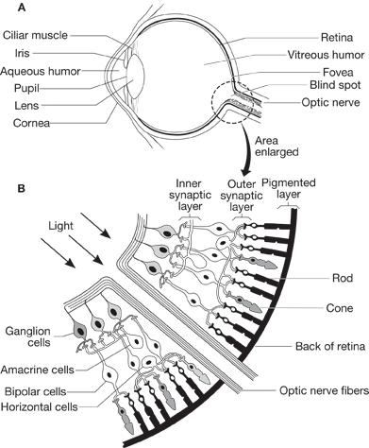

Eye

Retina

The light gets in
Why this blindness?
- Saccades
- Failure to store complete visual information in our short-term memory
- not in your slides for today
- I will update them after the class

Visual Path
- Dots – fixations
- Lines – eye movements,
paths, saccades
- Compare to picture

What eye tracking shows us?
- We only see a small prop
-ortion of the scene
- Fixations are for brief
amounts of time
- Saccades take more time
- We miss a lot

In-attentional Blindness
- An experiment by
  - Daniel Simons and Daniel Levin (1998)
- In the first example pay attention to
  - Hair of young man
  - Jacket he is wearing
  - The map he is using

Continuity
- Visual Persistence
  - Seeing an object for a brief time even after it has been removed from sight
- Iconic Memory
  - Or visual sensory memory
  - Very short duration
  - No more than 250 – 500 ms

Amount and Duration of Storage
- Tachistoscope
  - a device that presents visuals very quickly
  - Time measured in milliseconds
- Span of Apprehension
  - The number of individual items recallable after any short display
  - Aka span of attention, or span of immediate memory

- Light
- Scattered
- Retina
  - Rods (many) and cones (few)
- Fovea
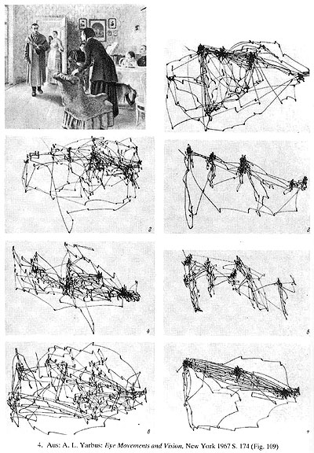
  - HD area
  - Dense in cones

The layers – simplified
- Rods and cones
  - 120 M and 7 M
- Bipolar cells
  - Rods and cones
  - Ganglion cells
- Ganglion cells
  - 1 M
  - Axons are the optic nerve fibers

Compression
- 120 M rods + 7 M cones
- 1 M ganglion cells
- ~ 130 : 1 compression

Picture Perfect?
- Light scattered on entering
- Fovea a small percentage of the retina
- Compression

Seeing, Hearing...
- Sensation
  - Stimulus and encoding
- Perception
  - Interpreting and understanding the sensation
  - Act of sensing and interpreting the sensation

Eye at work
- Fixation point
  - The focus of the eye
  - No movement during this time
- Saccade
  - The quick movements from one fixation to another
- Change Blindness
  - No vision processed during saccade

Change Blindness
- Also refers to the inability to recognize large visual changes between images.
- Here is an example of an easy visual difference

Amount and Duration of Storage
- Whole Report Condition
  - Report the entire visual display
  - Span of Apprehension ~ 4.5 items
  - Report the entire visual display
- Partial Report Condition
  - The participant reports a selected portion of the display
- Icon
  - The visual image that resides in the iconic memory

Sperling
- Investigated Iconic memory
  - (Visual sensory memory)
- Controlled the image projection
  - Onto the Fovea (not in this experiment)
- Varied the conditions
  - Blank field
  - Contrast
  - Duration

Big difference
- The original experiments
  - Direct presentation onto fovea
  - This room, people to the right and left of screen
  - Other objects in sight
  - Timing not as tightly controlled
    - PPT is not a tachistoscope

Averbach and Coriell
- Used a visual cue
- Backward masking
  - If the new stimulus occurs immediately after the target stimulus, the new stimulus can interfere with remembering the earlier
- Erasure
  - The loss of one set of information in visual sensory memory by another image
  - A form of over writing

Erasure and interference
- Erasure and Interference
  - the original research on information loss suggested that forgetting was a passive process like fading or decay
  - in real life, there is no blank screen following visual input
- Interference
  - forgetting caused by the effects of intervening stimulation or mental processing

Iconic Memory?
- Ecological Validity
  - The methods and tasks of the experiment should resemble the tasks within the real world
  - The stimuli of information processing experiments contained poor information in comparison to the stimuli in the real world (Gibson, 1950)
- External Validity
  - Whether the results of a study can be generalized to other situations
- We extract information within 50 ms of fixation (Rayner et al.)
- Tachistoscopic study
  - Showed participants an image (50 ms)
  - Filled in the next 175 ms with something else
  - People reported the image
  - Many people did not see the replacement

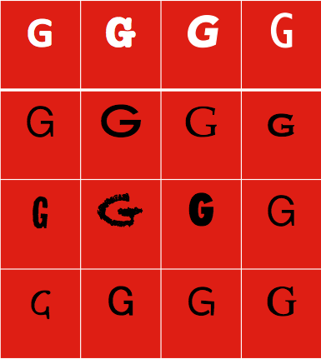
Pattern Recognition
- How do we recognize the variations in font?

Templates
- Stored models of all categorizable patterns
- But seriously flawed
  - Enormous variability in patterns
  - Time necessary to learn infinite possibilities
  - Limited capacity in the brain

Prototypes
- Experiences are merged, averaged
- Chapter 7

Visual Feature Detection
- A theoretical approach, most commonly in pattern recognition, in which stimuli (patterns) are identified by breaking them up into their constituent features
  - Pandemonium
  - In Selfridge’s description, Pandemonium reigns in the process of the mental mechanisms that process a visual stimulus

An imaginary model
Beyond Features: Top – Down
- Data-driven processing system
  - Processing is driven by the stimulus pattern, the incoming data
- Conceptually-driven processing effects
  - Context and higher-level knowledge influence lower-level processes
Top-down
- Free recall task
  - Related words remembered together
  - Car
  - Truth
  - Happy
  - School
  - Paper
  - Truck
  - Book

- Pandemonium
  - Selfridge (1959)
  - Little demons
  - Lots of shouting
  - Feature detection
  - Parallel processing
  - For this example, we will only use letters

Comparison
- Neuron vs Pandemonium
  - Loud demon = fast firing neuron
  - Listening demon = first past the post
  - Each neuron has a firing threshold
    - Above which a signal is sent down the axon
    - Divergence (sends signals to many neurons)
    - The neurons all “shout” together
    - Think Hebb’s cell assembly

Selfridge’s Model
- Future detecting
- Parallel processing

Beyond Features
- Pattern recognition starts by processing the incoming pattern, a bottom-up process
- This bottom-up emphasis slights the contribution made by the cognitive system
  - It misses the effect of context, the influence of surrounding information and your own knowledge
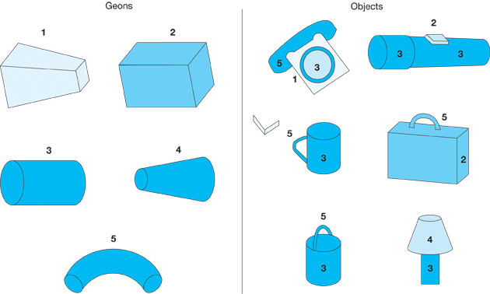
Object Recognition
- From Features to Components
- Recognition through basic shapes
- The geon
  - Recognition by components model (RBC)
- Problem with Recognition by Component
  - Relies too much on bottom-up
  - Does not account for expertise
- Probably a team effort
  - Two mental processes and two regions of brain
  - One responsible for features and components
  - Another for overall shape and global patterns

Evidence for RBC
- In partial pictures
  - It matters where a picture is degraded
  - Non-recoverable if junctions are deleted
  - Recoverable if part of the continuous edges are deleted

Agnosia
- A failure or deficit in recognizing objects
  - Prosopagnosia: A disruption in face recognition
  - Apperceptive Agnosia: individual features cannot be integrated into a whole percept or pattern
  - Associative Agnosia: A form of agnosia in which the individual can combine perceived features into a whole pattern but cannot associate the pattern with meaning
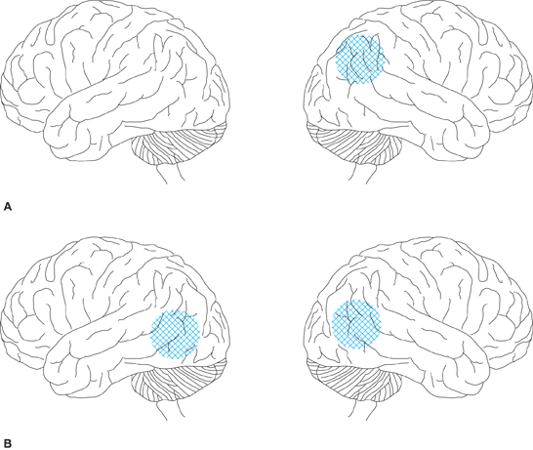
Damage
Apperceptive agnosia

Associative agnosia

Dissociation
- Double Dissociation
  - Complete separability of process A and B
- Simple Dissociation
  - Process A is damaged while process B remains intact, no reciprocal pattern (may not be possible)
- Complete Association
  - If process A is damaged, process B is also damaged

Implications for Cognitive Science
- The varieties of agnosia tell us at least three important things about the perception and identification of patterns and objects
  - Detecting the features in a visual stimulus is separate from the sensory steps that encode a stimulus
  - Detecting the visual features is critical in constructing a perceived pattern
  - There is a separate step involved in hooking up the pattern with its meaning and name

Auditory Perception
- Our sense of hearing
  - Brought to us by sound waves that reach our ears
  - Sound waves can travel through other material than air, but usually not heard, rather felt
  - The deaf have parties with music
The Human Ear

ITD
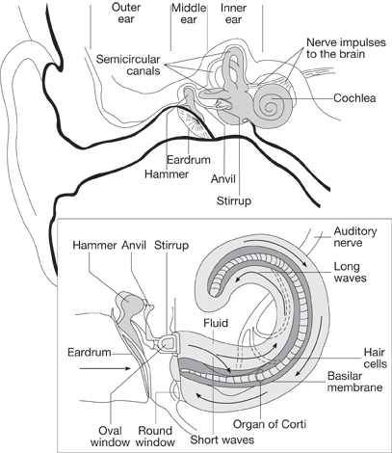
- Humans use Interaural time difference
- Able to detect location of sound
- Unless hearing damage

Auditory Sensory Memory
- Also Echoic Memory
  - A brief memory system that receives sound and preserves it for a small amount of time
- Think about ways in which Visual memory is comparable
  - However duration is different

Persistence and Erasure
- The best-known evidence on auditory persistence was presented by Crowder and Morton (1969)
  - Presented 9 digits visual, 2/second
  - Silent vocalization, Active vocalization, or Passive vocalization

Auditory Pattern Recognition
- Problem of Invariance: The sounds of speech (phonemes) are influenced by the sounds before and after it
  - Different speakers
  - Different words
Expectation
  - Even same person
Top-down processing
“It was found that the *eel was on the axle”
“It was found that the *eel was on the shoe”
“It was found that the *eel was on the orange”

Attention
- What is it?
- James (1890)
  - Both the focusing on one idea, or item, while inhibiting competing objects, or trains of thought
- Attention is a mental process
  - It directs our senses
  - Is not unlimited
  - Try listening to news while crunching an apple
- Four aspects
- When we are startled
- Looking for something
- Focusing during distractions
- The brain, and our thinking

Aspects of attention
- Too much information being presented
- Our brain has limitations as to processing
- Some tasks dealt with without thought
- Practice can make us faster at judging

Arousal
- Physiological
- Nervous system
  - Reticular activating system
    - Lower brain stem system
    - Voluntary: warning signal
- Tonic
  - State of arousal that is long-lasting and changes slowly over time
    - E.g., Sleep-wake cycle
- Phasic
  - Change in the state of arousal that is sudden and transient
    - Involuntary: loud noise
    - Voluntary: warning signal

Processing
- Explicit
  - Conscious control, aware
  - Learn a recipe
- Implicit
  - Person is not necessarily aware that the processing is occurring
  - Learning balance when riding a bike

Bonebakker et al. (1996)
- Before surgery During surgery
- Awake Anesthetic
- Tape recorded words Tape recorded words

- 24 hours later
- Word stem completion task
- Told not to use words they remember hearing
- Able to exclude before surgery words
- Reported words heard in surgery
Orienting
- Survival
  - Orienting towards sudden unexpected stimuli
  - Orienting towards sought out target

Reflexive Orienting
- Sudden sound or motion
  - Without thinking we react by a quick change of attention to the source
  - This is a reflexive orientation
  - Survival
  - Metaphor:
    - Think of it as an operator who can cut in on a telephone call

Overt-Covert
- Overt reflexive orienting
  - Hear a bang, turn my head towards the sound
  - See a flash of light, move my eyes towards the flash
  - Covert reflexive orienting
  - Hear a bang, but I do not move, and I reassign my mental processes to attending to the sound

Habituation
- A gradual reduction of the orienting response back to normal (baseline)

Voluntary Orienting
Presentation rates (reflexive)
- Valid trials = 40%
- Invalid trials = 40%
- Neutral trials = 20%

Posner et al. (1980, 1984)
- Second experiment for voluntary orienting
- A brief arrow
  - It is predictive (80% of arrows valid)
- Participant presses bar on seeing star
  - Does not press on catch trial (no star, 20%)
Presentation rates (reflexive)
- Valid trials = 64% of total trials*
- Invalid trials = 16%*
- Neutral trials = 20%
- (64%, 16%)

Interpretation
- The experiments investigated covert orienting of attention
  - Both reflexive and voluntary control
- When the cue agreed with the location of the target, the response was faster than neutral
- When the cue was contrary to the location of the target, need to disengage, move attention, and engage on correct target

- This is under our conscious control
- Hence, top-down process

The Spotlight paradigm
- We shine the light of our attention on a target
- We pay attention to that stimulus, and not another

Posner et al. (1980, 1984)
- Covert orientation of visual attention
- First the experiment for reflexive
- A brief light
  - It is not predictive
  - An equal chance to brighten in either box
- Participant presses bar on seeing star
  - Does not press on catch trial (no star)

Research Question
- Can the participant overcome the light?
- Or will it influence the visual orienting?
- If the focus is drawn to the light
  - And the star appears ... Fastest response
  - The star is at the opposite box ... Slowest response
- If the focus is not drawn to the light
  - Equal time to travel left or right
  - This is also the neutral condition

Interpretation
- The procedure was covert. There was no noticeable head or eye movement
- A cognitive phenomenon
- The attention shift was done internally
- Spotlight attention:
  - Covert focusing of attention that prepares you to encode stimulus information (p. 131)

The Spotlights?
- Reflexive orienting
Voluntary Attention
- Controlled Attention
  - Forms of processing that are deliberate, controlled, focused
- Selective Attention
  - The ability to select one source of information, while ignoring other sources
  - Inhibition of competing stimuli

Selective attention
- Filtering
  - The mental process of eliminating, or ignoring distractions
- In vision
  - Move head or eyes
- In hearing
  - Must be done cognitively, cannot avoid hearing
- Limited resource

Investigations
- Dual Task Procedure
  - Vary work load of each message or task
  - Measure accuracy
  - Attentional capacity used up by first task
  - Vary the messages and observe the effect
- Shadowing Experiments
  - Repeat what you hear as you hear it
  - One message in each ear
  - Vary aspects of the ignored stream
  - Accurate about physical characteristics, but not meaning
  - Bottom-up
  - Data driven
- Voluntary orienting
  - Top-down
  - Conceptual, knowledge
- Reflexive faster than Voluntary

Visual Search
- You search for an object
- It has a variety of features (toothbrush)
  - Colour
  - Shape
  - Size
  - Texture
- Using bottom-up (features) and top-down control of attention (knowing the scene)

Visual Search (O)
- This was an example of a distinctive feature
  - A pop-out effect
Visual Search (F)
Conjunction Search
- Two features
  - Colour red
  - Letter G
- Find the colour red and the letter G
  - i.e., a red G

Implications
- Disjunction search
  - A fast, automatic attentional process
  - a pop-out effect
- Conjunction search
  - A slower, serial, deliberate search
  - Requires the “spotlight” to be scanned across the search area

Reflexive vs Voluntary
- Both modes of searching utilize both reflexive and voluntary components
- The first component to find the target ends the search

Selection Models
- Broadbent’s Filter Theory
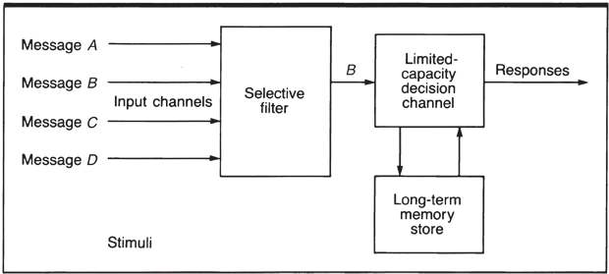
- A problem for Broadbent’s filter theory
- We often notice information from a message we are not attending to
    - e.g. your name

- Treisman’s Attenuation Theory

- Treisman performed a number of experiments to examine the slippage
- Message 1 & Message 2 = same speaker
  - Prediction: Stage 1 selection should not be possible
  - BUT! Ss had no trouble
  - Selection based on message content (Stage 2)
- Switch semantic content half-way through
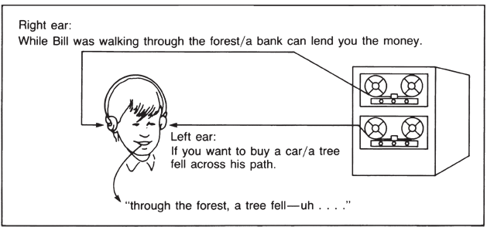
- All incoming messages received some low-level analysis
- When unattended yields no useful information, it is attenuated
- Middle-selection theory

- Norman’s Pertinence Model

- Norman’s model specifically included a mechanism for top-down processing
  - At any instant in time, attention to some piece of information is determined by two factors, sensory activation and pertinence.
- Pertinence
  - The momentary importance of information, whether caused by permanent or transitory factors.

- Multimode Model of Attention
- Selective attention can occur very early in the processing sequence, based on very low-level, physical characteristics
- It can be influenced by both permanent and temporary factors
  - Permanent factors include highly important information such as your name and highly overlearned and personally important factors
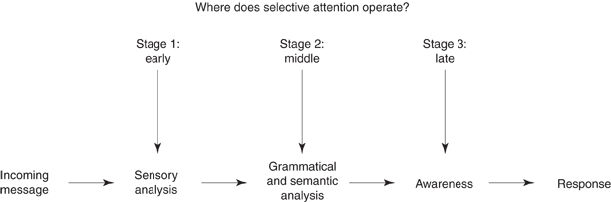
Johnston & Heinz
Conceptual
- Conscious processing also involves top-down processing
- In a shadowing task, with two sound files
  - Focus on the priority file
  - Interference
  - The context helps identify the words
Priming
- A top-down effect
- In a shadowing task
  - Talk about a bakery
    - Hear part of a word *un, or *ake
    - We are likely to say bun or cake
  - Talk about a beach
    - We are more likely to say sun or lake

Attention and Automaticity
- Attention
  - Conscious mental capacity
  - We can only focus on one difficult task at a time
- Automaticity
  - Achieve through practice and memory (experience)
  - Releases mental resources
- A matter of repetitive practice and memory
- Can lead to certain types of problem
  - Missing mistakes
  - Or inability to change a behavior as in the Stroop effect

McGinnies (1949)
- Perceptual defense
- The experiment
  - Five letter word
  - T-scope

Why models?
- Models are built on observations
- But if that were all, they would be of no use
- Provides us with simple explanations
- Allows for predictions in new situations
- Allows us to compare models

Automatic Processing
- Happens without intention
- Does not reveal itself to conscious awareness
  - We cannot describe how it happened
- Consumes very few mental resources
  - Highly efficient

Conscious Processing
- Contrast to Automatic
- Occurs with intent
- We are often aware of what is happening mentally
- Uses up mental resources

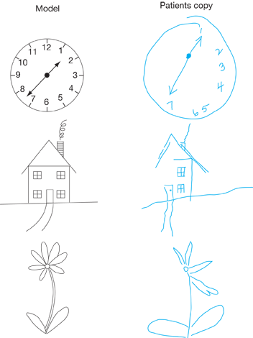
Hemineglect
- Hemi = half
- Hemineglect
  - A disorder of attention
  - Half of the visual field is unattended
  - Damage to the brain is contralateral
  - A neurological disorder
  - The attended field captures all the attention
    - Unless there is no competing stimulus
- Not deliberate
- The patient is copying what they see

Music Cognition
- An overview
- Relative vs absolute pitch
- Walter Murch
- (film editor and sound designer)
  - Godfather (1972)
Music – qualities
- Pitch
  - Scales made up of discrete steps
  - A moderate number of discrete steps
  - From the 12 tone scale the octave
  - Octave equivalence
  - Intervals
  - C D E F G A B C
  - Tone, tone, semi-tone, tone, tone, tone, semi-tone
- Duration
  - Length of each note
- Loudness
  - Quiet up to shouting
- Timbre
  - The difference in sound quality between instruments
- Consonant
  - Transient sounds
  - Pa, ba, ga, ka
- Vowel
  - Steady-state
  - Ah, oo, ih
- Steady-state variation
  - Supposed that the same auditory mechanisms are at play that capture and interpret vowel timbres
  - flute
- Transient sounds
  - Onset rapidity
    - Trumpet (fast) versus the violin (slower)

  - Apocalypse Now (1979)
  - The English Patient (1996)
  - Cold Mountain (2003)

Listening
- Walter Murch
  - Summer job cataloguing vinyl
  - Teach himself music history
  - Three weeks, up to 15th century
  - Heard discordant sounds
  - J. S. Bach (a 300 year leap)

Patterns & Expectations
- We grow up with a soundscape
  - We learn to interpret and expect
- Language is not a series of discrete sounds
  - They blend together
- Learning music = learning a language
  - Same problems

Top-down processing
- Our expectations drive the interpretations
  - Music from a different era
  - Or from a different type of instrument
  - Or from a different culture

Music – Cognition
- Thinking ahead
- Listening
- Remembering
- Action
- Emotion

Language and Music
- Shared areas of the brain
  - Determine timing, pitch
- Language
  - Questions end in a rise in pitch
- Music
  - Pitch shifts as part of the phrasing of the music

Relative Pitch
- Ability to recognize intervals
  - Intervals in Western music
    - Tone, tone, semi-tone, tone, tone, tone, semi-tone
- The original note does not have to be locked at one frequency
  - A = 440 Hz (but we could reduce to 400 Hz)
- Transposition
  - Songs can be shifted as long as intervals constant
- There is a developmental aspect
- Children begin by using absolute pitch when making judgments about sound
- Too much memory and processing load
- Develop relative pitch to identify voices, sounds

Attention and Memory
- Schemata
  - Knowledge structures developed through experience
  - Guide our attention
    - What will we pay attention to, and remember
    - Attention
  - Grabbed by salient features of the music
    - What are we not habituated to?

Absolute Pitch
- Able to identify the note by name when hearing the note in isolation
- May be connected to a particular instrument
- For example
  - The piano at home
  - Some older pianos are tuned down
  - For more information lookup: Isabelle Peretz

Degree of Absolute
- Some people remember the full range of notes
- Some remember the notes on their instrument
  - Perfect piano
    - Even if the piano is tuned down
- Some people remember only one note
  - The rest of the notes are tuned relatively
Mixed Blessing
- No tuner? No problem
  - Yes, having absolute pitch means the instrument can be tuned
- Transposers go home
  - In a band setting, the musician with AP needs to use sheet music, or learn the “new” music
- Off key is painful
  - AP knows each note, RP knows the intervals
Amusia
- Reduced ability to recognize pitch Why?
    - Able to tell tones apart
    - But not semi-tones
- Reduced perception of pitch shift
- Same imitation of pitch shift

Summary of Music
- A snapshot of Music cognition
  - Four qualities that make up music
  - Culture dependent scales
  - Intervals make up the building blocks

