Eco 100 Study Package
Kevin Wu
1. Thinking as an Economist:
Scarcity: Limited Resources, Unlimited Demand
Opportunity Cost = Direct Cost + Indirect Cost (What could I be doing instead?)
Key Word: What do I have to give up? “Should I do x for y if y is the most highly valued alternative to x”

Note: OC (opportunity cost) is the way to calculate MC (marginal cost)
↓ ↓ ↓
Marginal Cost: Cost of THE SINGLE ADDITIONAL unit (only the next unit)
Marginal Benefit: Benefit of THE ADDITIONAL unit (means only the next unit)
Decision Making: Marginal Benefit vs Marginal Cost
YES when Marginal Benefit is greater than the Marginal Cost - > NO when MB < MC
Sunk Cost: COST PAID REGARDLESS (i.e. A Bicycle purchased for $100, can now only be sold for $85, thus the sunk cost is $15)
Conclusion: The implication of behavior rule:

Will get more of an activity if:

1. Increase its benefits
2. Decrease its Opportunity Cost
3. Increase the direct cost of next best alternative

2. Gains from Trade (Application of Opportunity Cost)

This section explains why trading can make everyone better off

- Absolute advantage. (Fewer inputs/costs per unit production)

- Comparative advantage (Less opportunity cost(less given up))

Acceptable Trade: OC x < Trade < OC y

Part 3: Demand and Supply and market price

Competitive Market: Many buyers and sellers, each of whom has no influence on market price coffee.

So that the market price is defined by demand and supply, what buyers pay is buyers’ MC (Price) and Firm’s MC (Price)

Distinguish between “Change in Demand” and “Change in QUANTITY demanded”
Demand curve and Supply curve are studying the relationship between Quantity and price

- Demand Curve:

- Distinguish between

Demand curve (p= F(Q)) and Demand function (q=F(p))

- Law of Demand: decreasing marginal benefit

- What can change demand?
1. Related good,
2. Expected future price
3. Income
4. Size of market
5. Preference

Change in Demand = Demand Curve Shift
Movement Along Demand Curve: No shift, different point on same curve (When only the price of the good is changing)

- Complement and Substitutes.
Price of substitute go up, how demand change?
How about complement?
- Income: Inferior Good vs. Normal good.

- Supply Curve:

- The higher the price of a good, the higher is the quantity supplied source,
firms seeking to maximize profits. (# of firm and production)

2. Similarly, Behavioral and market assumptions work. MB(q)=P=MC(Q)

3. Law of Supply increasing MC. (Diminishing return)

- Market supply curve is combination of firm supply curve,

- Distinguish between

“Shift in supply” and “Change in quantity supplied”

6. What change supply?
1. Input price
2. Technology
3. Expectation
4. # of sellers.

Allocative Efficiency

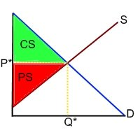

Consumer Surplus： WTP - the price actually paid
Producer Surplus: Price a producer received- MC

Allocative Efficiency: Any quantity where the Social Benefit > Social Cost need to be produced (and sold)
The Allocation Efficient Condition can be expressed as :
P= MC

Part 4: Elasticity:
Elasticity: How does Quantity demanded react to a Change in Price?
Implication: Change in Quantity/ Change in Something Else
Results of a decrease in price

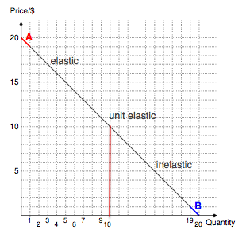
Elastic : TR increase
Inelastic: TR decrease
Vice-versa for an increase in P
What determines Price Elasticity?

      - Availability of Substitutes (milk vs soy milk (more elastic))
      - Time: longer = more elastic, since people have more time to search for substitute ( oil fuel for example) (Long Run supply curve ALWAYS PERFECTLY ELASTIC)

- Income Elasticity of Demand:

- Normal Good (Buy more as your income increases)

- Inferior (Buy less as your income increase (e.g TTC, junk food))

- Cross price elasticity of demand
- Substitute (Price of Coca-cola Increase, Demand for Pepsi increase)

- Complement (Price of Cars Increase, Demand for car tire decrease)

- Price Elasticity of supply

Part 5: Government Intervention
Price Floor & Price Ceiling:
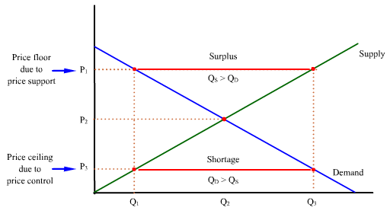
Price Floor:
- Excess Supply (Minimum Wage)
- ABOVE equilibrium
- *Problem with minimum wage (price floor): surplus, hire more skilled worker and unemployment of unskilled worker go up
Price Ceiling:
- Excess Demand
- BELOW equilibrium
- Problem with price celling: buy at low and resell with higher price in black market.

Quota: Limit Quantity
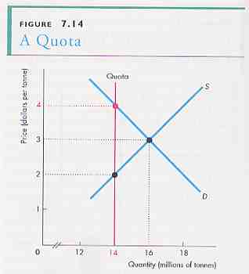
Exercise Tax
Exercise tax is the tax that is added on the price of each unit you buy (or sell).
Tax levied on the seller: seller pays the government
Tax levied on the buyer: buyer sends tax.
If government impose a tax of $10 on buyer,
Does that mean buyers’ payments will increase by $10?
How about impose a tax of $10 on seller? What is the determinant? = (elasticity)
If no tax: Price paid by buyer = price received by seller (assume $50)
Now consider a scenario, government impose a tax of $10 on seller.
The price received by seller will = price paid by buyer - $10. Since sellers’ cost structure is not changed
Where is the new market equilibrium? What do you observe?
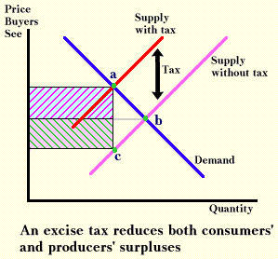
Tax burden is divided between seller and buyer.
Now let’s go back to our previous question. What determines the division of the tax burden?

Answer: elasticity of Demand and Supply.

The rule: the relatively inelastic party will burden more of the tax

Part 6: Short Run Cost
- Economic profit vs. Accounting profit (economic profit = accounting profit –implicit cost)

- Short run vs. Long run: not measured by time: 1) Short run = at least one factor of production is fixed (usually capital); 2) Long run = all factors of production are variable.

- Marginal product of labour (MPL): the additional units can be produced by adding 1 labor.
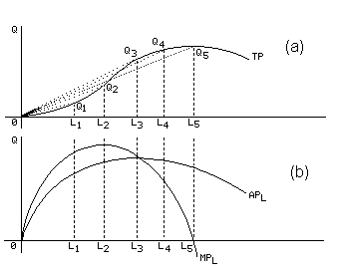
- Marginal Cost: the additional cost of producing 1 more unit.

- The relationship between MPL and MC: when MPL increase = MC decrease; When MPL decrease = MC increase.

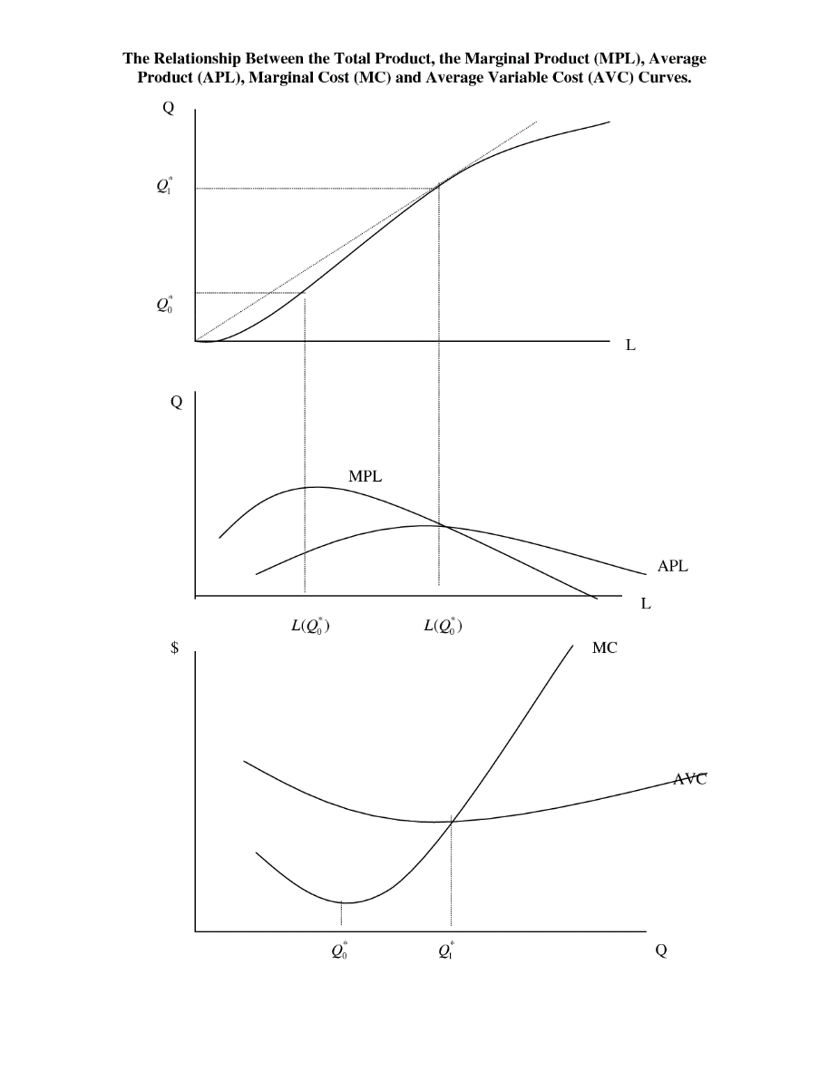
- Variable cost: variable cost is the cost that changes as Q changes, including labor cost, material cost, etc.

- Fixed cost: cost that not varies due to the change of Q. Rent, R&D,etc.

- Average fixed cost and average total cost and AVC

Marginal cost is the change of Variable cost due to 1 unit increase in Q. Distinguish between average Variable cost and marginal cost.

For example: your average mark and the mark you get on your next cost

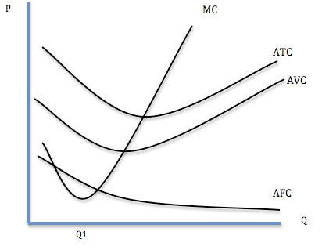

PART 7 Perfect Competitive Market

1. perfect competitive market :

- Many firms

- Goods are identical, homogenous

- Low enter barrier

- Many buyers

- Firm’s optimal production: MR = MC

Profit maximizing condition: MC = MR which means P = TR-TC

Max P when d(TR-TC)/dQ=0

so dTR/dQ-dTC/dQ=0 mr = mc.

3.Short run shut down condition : P<AVC why? shut down price is the minimum point of AVC
Firm shut down condition:P<AVC , Short run equilibrium 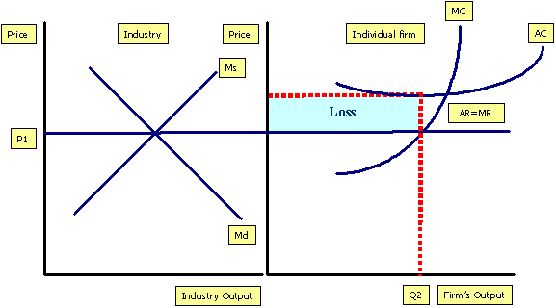

In test: there might be questions asking what if there is a change in fixed cost and v ariable cost, let’s see what happens.

Long run perfect competitive market
If you are making a economic profit in the SR what will happen in the LR?
If you are making an economic loss in the SR what will happen in the LR?
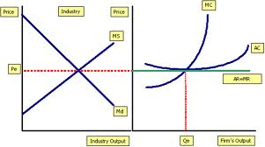
long run supply curve :

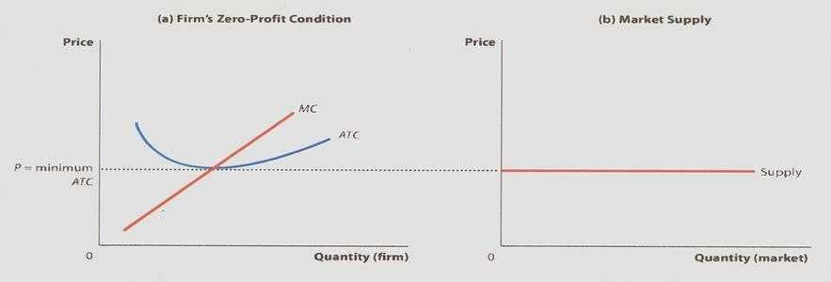

Perfectly Competitive Market: Price TAKER
1. P=MC, If not, adjust to the point where P=MC
2. P>ATC? If P > ATC, then Economic profit; P=ATC, Break Even; If P<ATC, step 3,
3. P> AVC? If P> AVC, continue to operate; P=AVC, indifferent between shut down and operate; P<AVC, Shutdown.
Firm only change output if MC changes, doesn't change output if FC change.
Profit/Loss= (P-ATC) * Q
SR Profit ==> Zero Profit in Long Run as more firms enter
SR Loss ==> Exit market in Long Run
Part 8 Introduction of Monopoly
- What is Monopoly？ （single seller， product no close substitutes）（there is barriers to entry ：ex legal or natural）
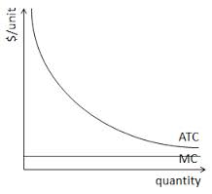graph for natural monopoly
- The relationship between MR and Demand curve
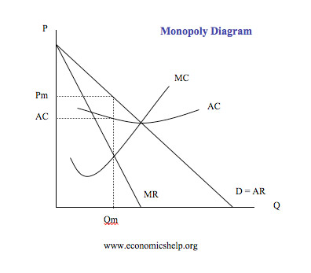
Why MR lies below D？ Let’s compare with Perfect competitive market.
The monopolist must reduce price to sell more units, thus the MR curve lies below the demand curve.
Observation: there is no supply curve in monopoly diagram
Profit maximizing firm produce at MC = MR.
There is only one price at Qm

A frequent question: what happens to price and output if a competitive industry becomes a monopoly?

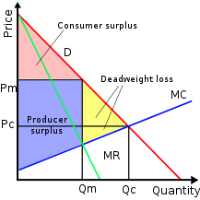
Natural monopoly: application:
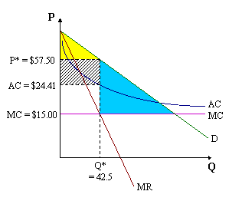 natural monopoly is not efficient
Government want to regulate the natural monopoly, how?
- Set price equal to AC :what is the outcome? Earn zero economic profit, but still not efficient.
- Set price equal to MC： earn negative economic profit， but achieve efficiency
1. 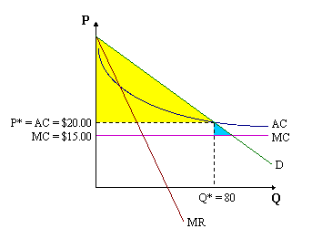
2. 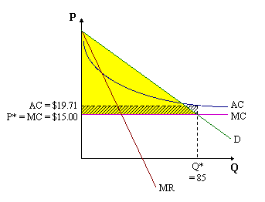
Monopoly Only operates on the elastic portion of the Demand Curve.
Part 9 Externality
Market failure:
1. monopoly 2. externality :social cost differ from private cost.
An impact of one’s action on the well being of another.
What is externality ？
It is the cost or benefit that affects a party who did not choose to incur that cost or benefit.
Have positive or negative, can be incurred from supplier or from buyer.
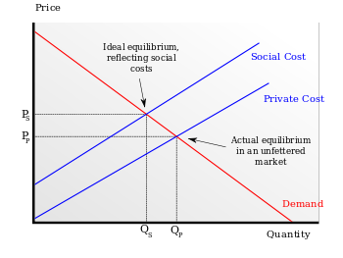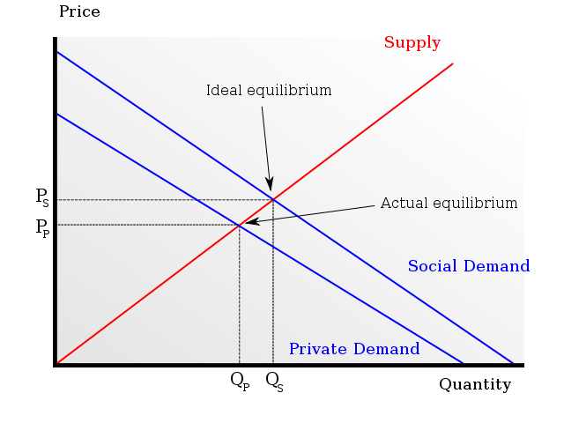
First one : negative from seller, second one: positive from buy side.
Recall that when considering efficiency, we are from a perspective of society, thus if externality does exists, private market would be INEFFICIENT

Generally:
MSC = MPC+MEC MSB=MPB+MEB
Or MSB = MPB – MEC MSC = MPC - MEB
How to find DWL in the graph?
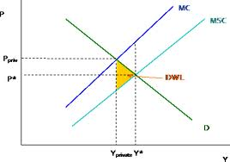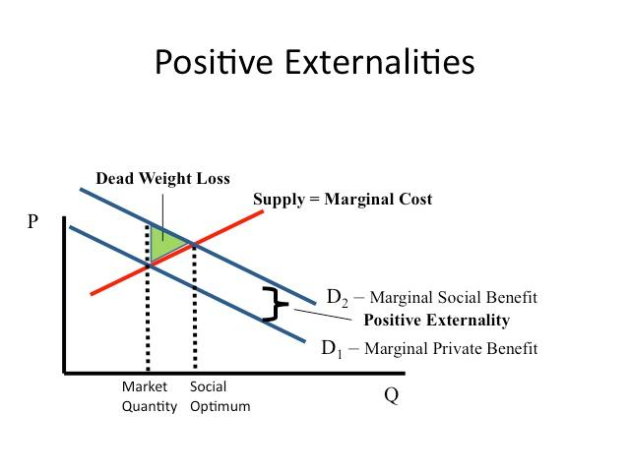
KEY , the DWL must be the area between MSC and MSB
Government intervention? Tax, subsidy or regulation.
Move MPB OR MPS TO MSB OR MSC and thus achieve efficient point

Part 10 public good

Characteristic of good:
1. Excludable: if I have it ，then I have the right to prevent you to use it.
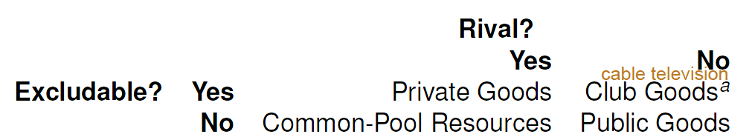
2. Rival: one person’s use diminishes other people’s use
Private goods: food, clothing, cars, personal electronics
Common goods (Common-pool resources): fish stocks, timber, coal
Club goods: cinemas, private parks, satellite television
Public goods: free-to-air television, air, national defense
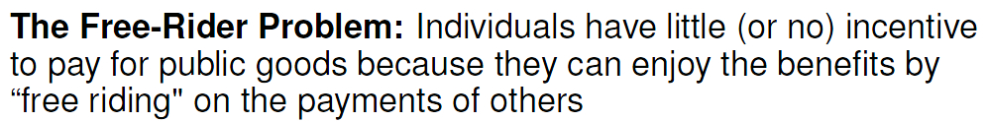

Macro Economics

Part 1 Introduction of Macro Economics:

What is GDP ?
Gross Domestic Product. Measurement of OUTPUT
VALUES CREATED

- GDP is a measuring output
One very important concept is that GDP only include FINAL GOOD and used good are not counted.

Difference between GDP and GNP?

what is the problem with GDP measure?
1.does not include unorganized market. 2.Black market not measured. 3.Value of leisure is not measured. 4. Can not measure externality. 5. informal market is not measured.

Calculate GDP:
1. Expenditure Approach: C+I+G+X-M
Consumption + Investment + Government Spending + Exports - Imports
2. Income Approach:
GNP = GDP + income earned abrod by nationals – income earned domestically by foreigners = GDP – NET investment income of foreigners)

NDY (net domestic income)= wage ,salarie and commission + coporate profits+ profit of unincorporated businesses (farm) (+ rent) + interest and other investment income.

NDY= GDP – CCA (capital consumption allowance which is depreciation) – indirect tax less subsidies.

C + I + G + NX = NDY + CCA + indirect taxes less subsidies.
(may not equal in reality since not easy to measure , the difference is statistical discrepancy)

3. Value Added:
E.g. $50 worth of rubber were used to make Tire and the Tire is sold for 300$, $250 of GDP was created in the transaction.
Notes: GDP is only counted with in the country( geographically), what American produced does not count toward Canadian GDP.
Part 3 Unemployment

Unemployment rate = unemployment/ labour force
Unemployment rate= ppl looking for job/ ppl looking for job + ppl who already have a job
Implication: If # of ppl that have a job decreased doesn't mean unemployment rate goes up, because there could be a change in the # of ppl looking for jobs.
TFU : Unemployment describes all the people in the population that don’t have a job.
Categories of unemployment
- frictional unemployment : is the time period between jobs when a worker is searching for, or transitioning from one job to another. It is sometimes called search unemployment and can be voluntary based on the circumstances of the unemployed individual.
- structural unemployment : is a form of unemployment where, at a given wage, the quantity of labor supplied exceeds the quantity of labor demanded, because there is a fundamental mismatch between the number of people who want to work and the number of jobs that are available. The unemployed workers may lack the skills needed for the jobs, or they may not live in the part of the country or world where the jobs are available.
- cyclical unemployment : unemployment due to actual GDP below Potential GDP (relate ,to aggregate demand topic that will be introduced later) , when AD is low, actual GDP is below potential GDP, caused high cyclical unemployment. When AD is high , when actual GDP is higher than potential, then there will be excess employment.
- seasonal unemployment: seasonal natures, unavoidable.

Frictional + structural + seasonal （all unavoidable） = Nnatural unemployment
Natural unemployment also called Full employment
when natural unemployment or full employment， The GDP is called potential GDP
When actural GDP < Potential there is a Recessionary Gap
Actual GDP ＞ Potential GDP ， there is an inflationary Gap
Part 4: Inflation/Deflation
Inflation and deflation:
Inflation rise in price, nominal GDP increase more than real GDP.
Deflation decrease in price.

CPI (Consumer price index)
Inflation rate = x 100
CPI =( Pcurrent * Q base) / ( P base * Qbase)

Core Inflation ：some good are subject to frequently price change such as food and fuel， core Price index exclude these goods in the calculation of price Index ， the inflation rate calculated using core price index is called core inflation.

- GDP deflator (another way to calculate price level change)
GDP deflator = (Nominal GDP/ Real GDP ) times 100

Calculating the real value
Real value= nominal value/ price index *100

Calculate real GDP = nominal GDP / GDP deflator
Implication:
- Real Interest Rate= Nominal Interest Rate - Inflation
- When inflation occurs: Borrowers are better off (Real Interest Rate go down), Lenders are worse off and vice versa.
- Q current wouldn't need to be considered in most calculations.

Part 5 the equilibrium model
Assumption ：price level is fixed , interst is fixed , no depreciation , no indirect tax
Income (Y) = GDP
AE represent desired expenditure (not actual )
Recall AE = C+ I + G + NX (now represent desired level)

Equilibrium GDP= AE (autonomous) * multiplier
Multiplier= 1/1-slope= 1/1-(c(1-t)-m)
Slope= c( 1-t) - m
c= marginal propensity to spend; t= tax rate; m=marginal propensity to import
Why they are in the multiplier: Autonomous Expenditure would not be changed regardless of how the economy is changing (you still buy food everyday etc), however, c,t &m would change depends on how the economy is doing, as tax rate decrease, the amount people can spend would increase therefore affect total consumption.
Therefore: Total change in GDP= change in AE (autonomous) * multiplier
CAN ONLY USE THIS MODEL IF PRICE IS FIXED

Part 6 Money and Banking

1.What is money ?
Is a kind of asset to serve as 1. Medium of Exchange 2.Store of Value 3.Unit of Account Commodity Precious Metal Fiat money (paper and coin) electronic

2. Ms = Currency in circulation + Deposit

Currency is the amount of cash in cash flow, definition is the thing that is acceptable for payment of debt.
Deposit is the bank liability , your checking account

3. Banking : Borrow and Lend .
Fractional Reserve Banking : Bank Reserves are a fraction of Bank Deposit .

4.What is reserve?
Currency in Vault (no interest) or deposits at Certral bank(may have interest) to pay out deposit withdrawals .
Reserve Ratio = R/D ( actual reserve / deposit )
Required Reserve Ratio (legal minimum ) = Minimum Reserve / Deposit.
Target Reserve Ratio ( Bank’s own target, here we assume it equals to RR) (Canada eliminate RR in 1990s)

5. Money Multiplier
Assume bank does not have excess Reserve (lend all excess) (Excess reserve = Actual Reserve- RR )
Cash Drain ratio = 0 , everything deposited .

Now let’s look at the Money Creation Process :
Please copy the note on Blackboard .
Money or Deposit Multiplier (base on the assumptions ) = 1/ RR
Deposit = Reserves/ RR

The following Equalities result form the discussion :
- Currency in Circulation + Currency in Banks = Legal Tender issue ( of CB)
- Legal tender Issue + Bank Deposit at Central Bank = Liabilities of Central Bank
The determinants of Money Supply Change are there fore
- change in CB liabilites,
- Change in public’s decision to hold money as currency
- Change in the Target Reserve Ratio.

6.Bank of Canada
Established in 1935 , 1. issue legal tender, 2. Hold official exchanges reserves
B/S
Asset :
- Government Securities purchased (1) directly from government , (2) from public and bank (open market operation)
- Foreign Exchange (and gold)
- Loans (Advances) to Private Banks
Liabilities:
1.Legal Tender (think that the money must have value to back it up, ex. Gold)
2. Deposit of 1. federal Government 2. Private Banks.

How BoC control Ms ?
- open market operations
Purchase or sale the Government securities or Foreign exchange from or to Public or private bank.
Purchase, Money outflow, Ms go up
Sale, Money inflow, Ms go down.
- Switching Deposit (switch government deposit from CB to private bank or vice versa)
- Change Bank rate ( the rate bank borrow from central bank, if go down, reserve go up, if go up, reserve go down) (Canadian bank rate was set at 1/4% above the T bill rate )
*T bill is a financial asset that buys on discount and payback at full amount , the difference is the interest rate .

Interest rate is the price of money , we assume there is no excess reserves, and no excess currency in circulation, Money Supply does not change with real interest rate perfectly inelastic Money supply with r

Money Demand
Money Market Equilibrium

Shift of Md : if Y (Real gdp) increase, demand curve shift to right ， if price level increase, the money demend curve shift to the right summary an increase in nominal Gdp will shift the demand curve to the right and vice versa .
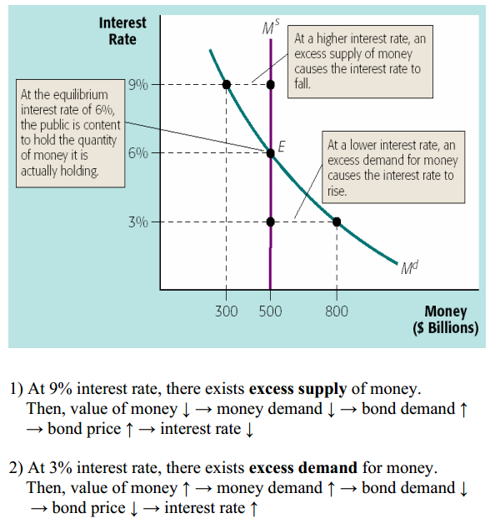

Part 7 AD-AS Model

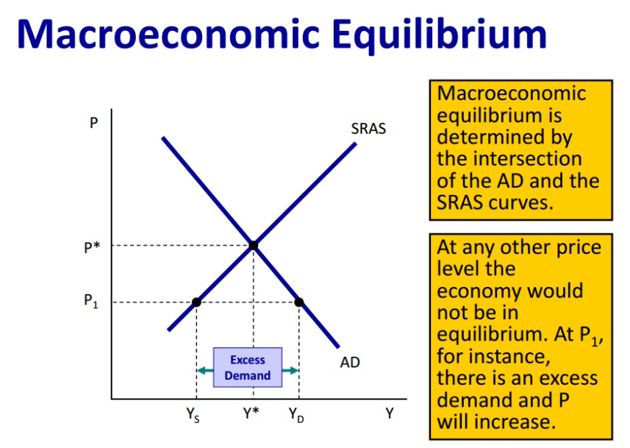
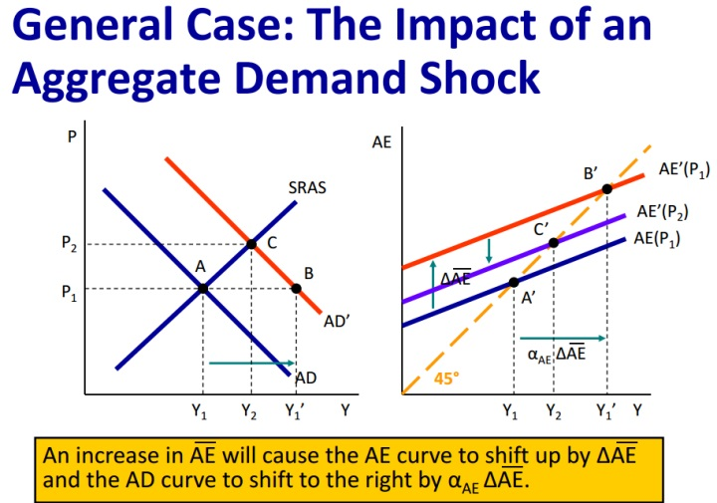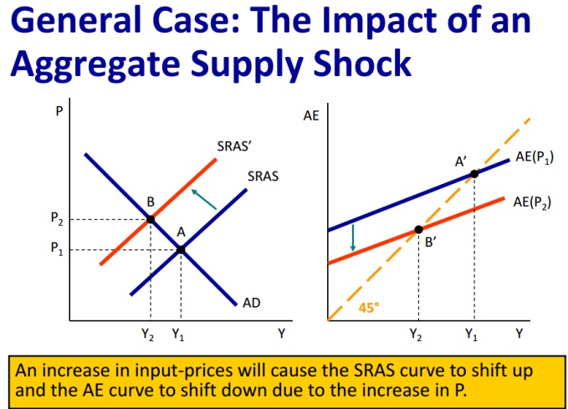

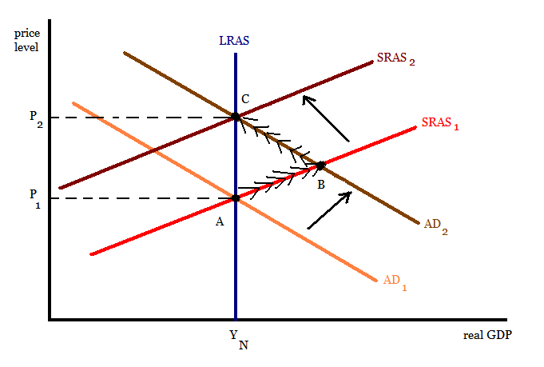
Long Run adjustment process
An increase in AD due to, say, a tax cut, shifts the AD curve up to the right. Equilibrium moves from point A to B in the short run. The higher price level means that firms will expect costs to eventually rise as well. So, the SRAS curve will shift up to the left. Long-run equilibrium is always on the LRAS curve at the natural level of real output. Changes in aggregate demand do not have a permanent effect on GDP, only on the price level. Temporarily, real GDP and the level of employment can be above their natural levels.
A decrease in aggregate demand results in a recession.
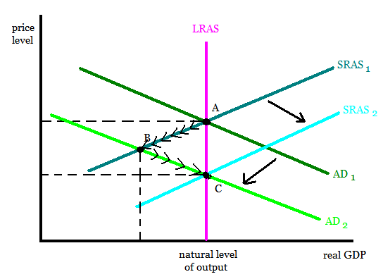
A decrease in aggregate demand, say, due to a decrease in consumer confidence shifts the AD curve down to the left. The economy moves to a short run equilibrium at point B. Real GDP falls below its natural level; the economy is in a recession and is experiencing cyclical unemployment. The price level falls, leading firms to expect input prices to fall. So, the SRAS curve will shift down to the right. The economy returns to a long run equilibrium at point C at the natural level of real output. Market forces will eventually end the recession. Much of the debate among economists over economic policy concerns how quickly recessions will end on their own.
A recession can also be caused by a supply shock: an event, such as an increase in the price of imported oil or a crop failure, that raises input prices for all or most firms.
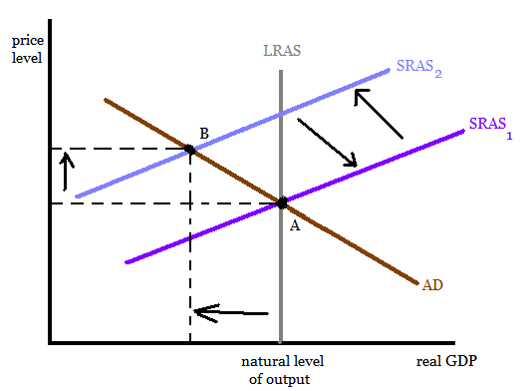
A supply shock causes the SRAS to shift up to the left. The economy enters a recession as GDP falls below its natural level. At the same time, the rise in the price level means that the economy is also experiencing inflation. Once the supply shock reverses itself, the economy returns to its long run equilibrium at point A.

Flexible Exchange rate :
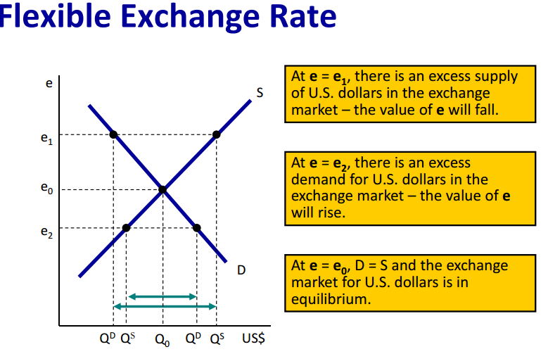
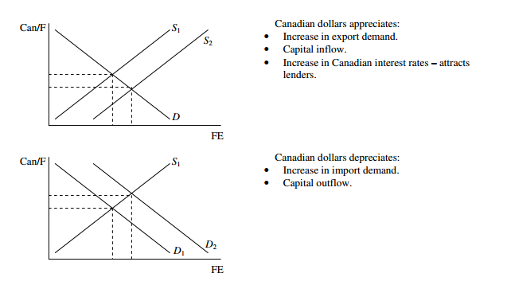
Fixed Exchange rate:


