CHAPTER 1
TEN PRINCIPLES OF ECONOMICS

- The work economy comes from the greek word for "one who manages a household."
- The management of society's resources (people, land, buildings, machinery) is important because resources are scarce (limited nature of society's resources)
Economics - the study of how society manages its scarce resources
- How people decided what to buy, how to work, save and spend
- How firms decide how much to produce, how many workers to hire
- How society decides how to divide its resources between national defence, consumer goods, protecting the environment, and other needs
- The social science that studies the choices that individuals, businesses, governments, and entire societies make as they cope with scarcity
- MICROeconomics focuses on the individual parts of the economy; how households and firms make decisions and how they interact in specific markets
- MACROeconomics looks at economy as a whole; economy wide phenomena, including inflation, unemployment, and economic growth
Basic Principles of Economics
- A household and an economy face many decisions:
  - Who will work?
  - What goods and how much will be produced?
  - What resources should be used in production?
  - At what price should goods be sold? 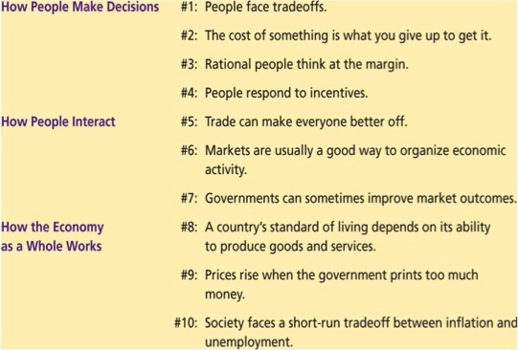
- Every economic issue involves individual choice
The Principles of HOW PEOPLE MAKE DECISIONS
Principle #1: People Face Tradeoffs
- To get one thing we usually have to give up something else
- Full-time schooling vs. full-time employment
- Food vs. clothing
- Leisure time vs. work
- Making decisions requires trading off one goal against another
- ALL decisions involve tradeoffs. Examples:
  - Going to a party the night before your midterm leaves less time for studying
  - Having more money to buy stuff requires working longer hours, which leaves less time for leisure
  - Protecting the environment requires resources that could otherwise be used to produce consumer goods
- Society faces an important tradeoff: efficiency vs. equality
  - Efficiency: when society gets the most from it scarce resources
  - Equity: when prosperity is distributed uniformyl among society's members
  - Tradeoff: to achieve greater equality, could redistribute income from wealthy to poor. But this reduces incentive to work and produce, shrinks the size of the economic "pie."
Opportunity Costs
- The opportunity cost of something is what you have to give up tp get it.
- It's the cost of the best forgone alternative
Marginal Thinking
- Marginal changes are small, incremental adjustments to an existing plan of action
- For example, a firm will wonder "what will happen to my profit if I decide to produce one more good?"
- People make decisions by comparing marginal benefits to marginal costs

Principle #2: The Cost of Something is What You Give Up to Get It
- Making decisions requires comparing the costs and benefits of alternative choices
- The opportunity cost of any item is whatever must be given up to obtain it
- It is the relevant cost for decision making

Principle #3: Rational People Think at the Margin
- Systematically and purposefully do the best they can to achieve their objectives
- Make decisions by evaluating costs and benefits of marginal changes - incremental adjustments to an existing plan

Principle #4: People Respond to Incentives
- Incentive: something induces a person to act,mi.e.e prospect of reward or punishment
- Rational people respond to incentives (when cigarette taxes increase, teen smoking falls)

Principle #5: Trade Can Make Everyone Better Off
- Rather than being self-sufficient, people can specialize in producing one good or service and exchange it for other goods
- Countries also benefit from trade & specialization:
  - Get a better price abroad for goods they produce
  - Buy other goods more cheaply from abroad than could be produced at home
Principle #6 Markets Are Usually a Good Way to Organize Economic Activity
- Market: a group of buyers and sellers (need not be in a single location)
- "Organize economic activity" means determining
  - What goods to produce
  - How to produce them
  - How much of each to produce
  - Who gets them
- A market economy allocates resources through the decentralized decisions of many households and firms as they interact in markets
- Famous insight by Adam Smith in The Wealth of Nations (1776):
Each of these households and firms acts as if "led by an invisible hand" to promote general economic well-being.
- The invisible hand works through the price system:
  - The interaction of buyers and sellers determines prices
  - Each price reflects the good's value to buyers and the cost of producing the good
  - Prices guide self-interested households and firms to make decisions that, in many cases, maximize society's economic well-being
Principle #7: Governments Can Sometimes Improve Market Outcomes
- Important role for gov't: enforce property rights (with police, courts)
- People are less inclined to work, produce, invest, or purchase if large risk of their property being stolen
- Market failure: when the market fails to allocate society's resources efficiently
- Causes:
  - Externalities, when the production or consumption of a good affects bystanders (e.g. pollution)
  - Market power, a single buyer or seller has substantial influence on market price (e.g. monopoly)
- In such cases, public policy may promote efficiency
- Gov't may alter market outcome to promote equity
- If the market's distribution of economic well-being is not desirable, tax or welfare policies can change how the economic "pie" is divided

Principle #8: A country's standard of living depends on its ability to produce goods & services
- Huge variation in living standards across countries and over time:
  - Average income in rich countries is more than ten times average income in poor countries
  - The Canadian standard of living today is about eight times larger than 100 years ago
- The most important determinant of living standards: productivity, the amount of goods and services produced from each hour of a worker's time
- Productivity depends on the equipment, skills, and technology available to workers
- Other factors (e.g., labour unions, competition from abroad) have far less impact on living standards

Principle #9: Prices rise when the government prints too much money
- Inflation: increases in the general level of prices
- In the long run, inflation is almost always caused by excessive growth in the quantity of money, which causes the value to fall
- The faster the gov't creates money, the greater the inflation rate
Principle #10: Society faces a short-run tradeoff between inflation and unemployment
- In the short-run (1-2 years), many economic policies push inflation and unemployment in opposite directions
- Other factors can make this tradeoff more of less favourable, but the tradeoff is always present
The Economist's Roles
- When economists are trying to explain the world, they are scientists
- When economists are trying to change the world, they are policy advisors
Positive vs. Normative Statements
- Positive statements are statements that attempt to describe the world as it is.
- Called descriptive analysis
- Normative statements are statements about how the world should be.
- Called prescriptive analysis
SUMMARY
- The principles of decision making are:
  - People face tradeoffs
  - The cost of any action is measured in terms of foregone opportunities
  - Rational people make decisions by comparing marginal costs/benefits
  - People respond to incentives
- The principles of interactions among people are:
  - Trade can be mutually beneficial
  - Markets are usually a good way of coordinating trade
  - Gov't can potentially improve market outcomes if there is a market failure or if the market outcome is inequitable
- The principles of the economy as a whole are:
  - Productivity is the ultimate source of living standards
  - Money growth is the ultimate source of inflation
  - Society faces a short-run tradeoff between inflation and unemployment
CHAPTER 2

- A market economy is one that allocates resources through the decentralized decisions of firms and households
- Housesholds decided what to buy and who to work for
- Firms decide who to hire and how much to produce
- A command or centrally planned economy is one where all production and distribution decisions are made by a central authority, like a government
- Most economies are mixed economies - a combination of both. Canada is a mixed economy.
The Economist as Scientist
- Economists play two roles:
  - Scientists: try explain the world
  - Policy advisors: try to improve it
- In the first, economists employ the scientific method, the dispassionate development and testing of theories about hoe the world works

Assumptions & Models
- Assumptions simplify the complex world, make it easier to understand
- Example: to study international trade assume two countries and two goods Unrealistic, but simple to learn and gives useful insights about the real world
- Model: a highly simplified representation of a more complicated reality. Economists use models to study economic issues

Our First Model: The Circular-Flow Diagram
- The Circular-Flow Diagram: a visual model of the economy, shows how dollars flow through a markets among households and firms
- Two types of "actors":
  - Households
    - own the factors of production, sell/rent them to firms for income
    - Buy and consume goods & services
  - Firms
    - Buy/hire factors of production, use them to produce goods and services
    - Sell goods & services
- Two markets:
  - The market for goods and services
  - The market for "factors of production"

Factors of Production
- Factors of production: the resources the economy uses to produce goods & services, including
  - Labour
  - Land
  - Capital (buildings & machines used in production)
  - entrepreneur

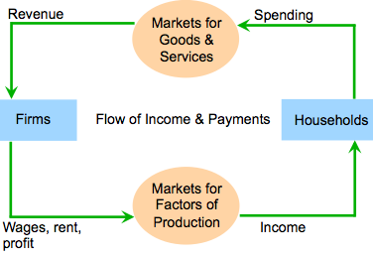

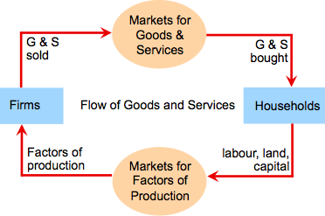
Our Second Model: The Production Possibilities Frontier
- The production possibilities frontier is a graph that shows the combinations of output that the economy can possibly produce given the available factors of production and the available technology
- It shows the best an economy can do if it uses all its resources efficiently, given the current technology
- It has two axis: X axis and Y axis
- E.g. consider an economy. It produces only 2 goods: Computers and Cars
- We assume that technology is given
- Its resources are fixed
- The following table shows combinations Computers and Cars. The Economy can produce if it uses all its resources, given the current technology

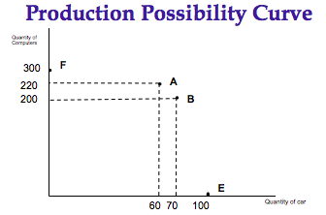

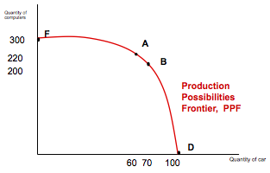

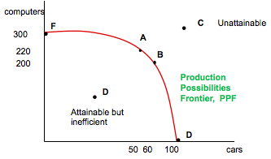
- Points F, A, B and E on the diagram are productively efficient - to produce these combos all resources are used, give the technology
- Points C lies outside the PPF - it is unattainable. There are not enough resources to produce that combo of goods, or the technology is not good enough or possibly both
- Point D lies inside and its already attained
- Every choice along the PPF involves a trade-off
- We have to give up some computers to get more cars and vice versa
- The PPF illustrates opportunity costs - how much we have to give up of one good to get more of the other
- Opportunity Costs tells us about the trade off between two goods
- We use Production Possibilities Curves to show this trade off
- Notice that as we move down the PPF, the opportunity cost of a good increases
- This explains why the PPF is bowed out - increasing opportunity costs

Concepts Illustrated by Production Possibility curves
- Concepts illustrated by the production possibilities frontier
- Efficiency
- Trade-offs
- Opportunity cost
- Economic growth

Constant Opportunity Costs
- It is also possible that opportunity costs are constant
- An economy always gives up the same amount of one good for more of another at the same rate
- If the goods are perfect substitutes
- If opportunity costs are constant, the PPF will be linear
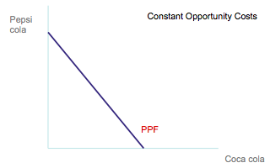
Shifts in the PPF
- Any changes to the amount of available resources, their productivity or changes to the available technology will shift the PPF
- Economic growth shifts the PPF to the right
- E.g. an improved technology only for computers becomes available:

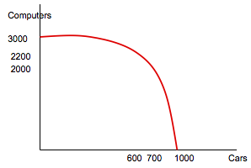

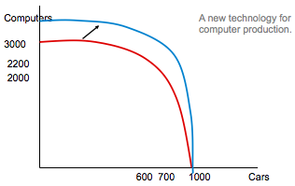
Another example: the labour force increases in both sectors and is equally productive: shifts the entire PPF out (right)
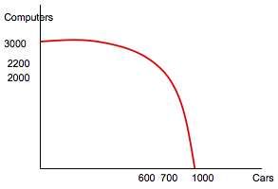

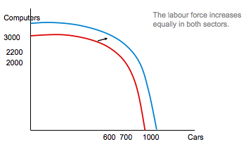
- A rubber shortage that doesn't affect computers means fewer tires and other rubber car parts which means fewer cars can be produced: rotates the PPF in (towards the origin) so that fewer cars can be produced, but no change in the quantity of computers
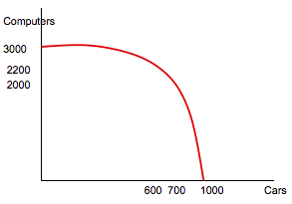

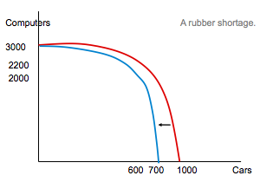
The PPF: A Summary
- The PPF shows all combinations of two goods that an economy can possibly produce, given its resources and technology
- The PPF illustrates the concepts of trade-off and opportunity cost, efficiency and inefficiency, unemployment, and economic growth
- A bow-shaped PPF illustrates the concept of increasing opportunity cost

Microeconomics and Macroeconomics
- Microeconomics is the study of how households and firms make decisions and interact in markets
- Macroeconomics is the study of economy-wide phenomena, including inflation, unemployment, and economic growth
- These two branches of economics are closely intertwined, yet distinct - they address different questions

The Economist as Policy Advisor
- As scientists, economists make positive statements, which attempt to describe the world as it is
- As policy advisors, economists make normative statements, which attempt to prescribe how the world should be
- Positive statements can be confirmed or refuted, normative statements cannot.
- The Gov't of Canada, like other governments, relies on the advice of economists. Many government agencies and departments, including the Bank of Canada employ economists

Chapter Summary
- As scientists, economists try to explain the world using models with appropriate assumptions
- Two simple models are the Circular-Flow Diagram and the Production Possibilities Frontier
- Microeconomics studies the behaviour of consumers and firms, and their interactions in markets. Macroeconomics studies the economy as a whole
- As policy advisers, economists offer advice on how to improve the world
- In this model, the economy is simplified to include only two types of decision makers—households and firms. Firms produce goods and services using inputs, such as labour, land (natural resources), and capital (buildings and machines). These inputs are called the factors of production. Households own the factors of production and consume all the goods and services that the firms produce.
- Essentially this is how the world works
- Households and firms interact in two types of markets. In the markets for goods and services, households are buyers and firms are sellers. In particular, households buy the output of goods and services that firms produce.
- In the markets for the factors of production, households are sellers and firms are buyers. In these markets, households provide the inputs that the firms use to produce goods and services. The circularflow diagram offers a simple way of organizing all the economic transactions that occur between households and firms in the economy.
- The two loops of the circularflow diagram are distinct but related. The inner loop of the circularflow diagram represents the flows of inputs and outputs. The households sell the use of their labour, land, and capital to the firms in the markets for the factors of production. The firms then use these factors to produce goods and services, which in turn are sold to households in the markets for goods and services. The outer loop of the diagram represents the corresponding flow of dollars. The households spend money to buy goods and services from the firms. The firms use some of the revenue from these sales to pay for the factors of production, such as the wages of their workers. What’s left is the profit of the firm owners, who themselves are members of households.

CHAPTER 4

Consumer Income
- As income increases, the demand for a normal good will increase - curve shifts to the right
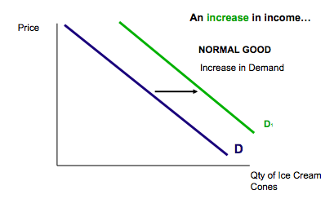

- As income increases, the demand for an inferior good will decrease - curve shifts to the left
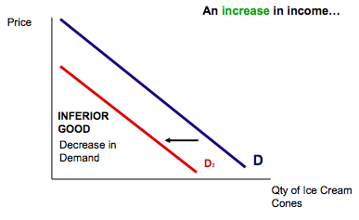

Price of Related Goods
- When a fall in the price of one good reduces the demand for its substitute, the demand for the substitute shifts to the left.
- When a fall in the price of one good increases the demand for its complement, the demand for the complement shifts to the right
Increase in the Price of a Substitute
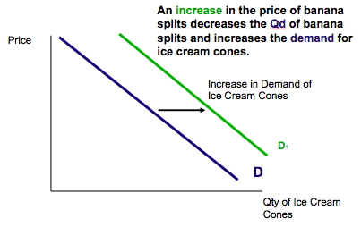
- Changes in expectations and tastes will shift demand accordingly
- Increases in population will shift demand to the right
Supply
- Quantity supplied, Qs, is the amount of a good that sellers are willing and able to sell
- When the price of a good increases, ceteris paribus (other things being equal), selling that good becomes more profitable and firms will want to offer more for sale
- Price and Qs are positively related
- As P , Qs 
- The Law of Supply - other things being equal (ceteris paribus), the quantity supplied of a good rises

Other Determinants of Supply
- Input Prices
  - When the price of an input into production (also called a factor of production) like labour costs, raw materials, machinery, energy, etc. increases, producing the good becomes less profitable and firms will offer fewer goods for sale at any price (and vice versa)
- Technology
  - Advances in technology which reduce production costs will increase supply
- Expectations
  - If a firm expects selling P to increase in the future, it will hold off selling now and current supply will decrease
- Number of Firms
  - More firms in the market means more supply
- The supply schedule is a table that shows the relationship between the price of the good and the quantity supplied
- The supply curve is a graph of the supply schedule
Let’s look at the supply schedule for Paul and John, the only 2 firms that sell ice cream cones in our market:
Price Terry’s Qs Tena’s Qs Market S
$.00 0 0 0
.50 0 0 0
1.00 1 0 1
1.50 2 2 4
2.00 3 4 7
2.50 4 6 10
3.00 5 8 13
Let’s graph market supply (of ice cream cones):
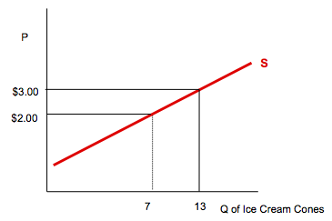

CHAPTER 6
6.1 law of diminishing marginal utility
- Gains in satisfaction decline as additional units are consumed
- Terms
  - Utility: is want – satisfying power – utility and usefulness not necessarily the same thing
- Total utility and Marginal Utility
  - TOTAL UTILITY: Total amount of satisfaction
  - MARGINAL UTILITY: Extra satisfaction from HEREHEHREHH
6.1
- You can keep novelty and that can decrease the marginal utility
Marginal Utility and Demand
- Diminishing marginal utility provides a simple rationale for the law of demand
  - Since successive units of a good yield smaller and smaller amounts of marginal utility, the consumer will buy additional units of a product only if its price falls
  - If marginal utility falls rapidly for each successive unit….it will take a considerable drop in price to cause an increase in quantity demanded
  - SO DEMAND IS FAIRLY INELASTIC
Consider this…Vending machines and marginal utility
- Newspaper vending machines normally allow one to take multiple papers: publishers allow this because they believe that people rarely take more than one paper because the marginal uility of the second paper is often zerio, and it has little shelf life
6.2 the theory of consumer choice
- A typical consumer
  - Exhbits rational behaviour – tries to get the most for the least of $. Maximizes satisfaction
  - Has clear cut preferences – knows how much satisfaction he/she will get from additional unit
  - Is subject to a budge constraint
  - Responds to price changes – as each tries to max satisfaction
Utility Maximizing Rule
- The consumers money income should be allocated so that the last dollar spent on each product purchased yields the same amount of extra marginal utility
MU of product A MU of product B
Price of A = Price of B
- At each step, spend where mY is highest
- In general, if MU/$ is unequal, spending will be allocated
  - Away form the good where MU/$ is low
  - And Toward the good where MU/$ is high
Utility maximization and the Demand Curve
- Deriving the demand curve
- What if the price of oranges falls to 1$
- TABLE 6.3
- When the orange was 2$ the quantity demanded was 4. But when it was 1, the demand was 4
- Demand curve is always downward sloping
- Substitution effect
  - When the price of oranges fall, there is a substitution of now cheaper oranges
- Income effect
  - Increase in real income (due to the fall in the price of oranges) increases consumption of both apples and oranges
6.4 Applications and Extensions
- New products
  - iPod consumers have concluded that ipods have higher MU than CD players
- Diamond water paradox – why are diamonds more expensive than water?
  - Water has higher total utility, but lower marginal utility because diamonds are scarce compared to water
- Opportunity cost and time – time to consumer must be included in the rpice of product or service
- Cash and Noncash gifts – do you prefer a gift or cash?
  - ALWAYS CHOOSE CASH
APPENDIX
- Indifference curves
- - an indifference curve shows all combinations of two products that will yield the same total utility to a consumer
- indifference curves are downward slopping
- convex to origin
- marginal rate of substitution is the slope of the indifference curve at any point
- Indifference map shows a series of indifference curves, for different levels of utility
Equilibrium at tangency
- Represents the optimal attainable combination of products A and B
The measurement of Utility
- Marginal utility theory assumes utility is numerically measurable
- Indifference curve approach requires only that a consumer specifies if a particular combination of products yield more or less utility than another
- At equilibrium. MRS=Pb/Pa
- Equivalent to marginal utility approach
MUa = MUb > Pb = MUb > MRS = MUb
Pa Pb Pa MUa MUa
- New budget line reflects the price change
- The indifference curve approach to consumer behaviour is based on the consumer’s budget line and indifference curves
- The budge line shows all combinations of two products that the consumer can purchase given product prices and money income
- An indifference curve shows all combinations of two products that will yield the same total utility to a consumer. Indifference curves are downward sloping and convex from the origin
- The consumer is in equilibrium at the point on the budge line that lies on the highest attainable indifference curve. At that point the budget line and indifference curve are tangent
- Changing the price of one products shifts the budget line and determines a new equilibrium point
- A price change causes a change in the quantity demanded. The change in the CHECK APPENDIX

