Class 2
LAWS 2501 A & T– Law, State and Constitution
Dr. Zoran Oklopcic
Fall 2015

Lecture 2 - Hobbes, Locke and Rousseau
What are the rhetorical functions of social contract and popular sovereignty? Compare Hobbes, Locke and Rousseau in their views of the social contract? More specifically: what is the difference between the state of war and the state of nature? Who concludes the social contract: the individuals amongst themselves, the individuals amongst themselves and the sovereign, the people with the sovereign, or something else? Who is absent from the social contract? Is the idea of the social contract necessary today? Are you, like Graeber, an anarchist?

Social contract: In moral and political philosophy, the social contract or political contract is a theory or model, originating during the Age of Enlightenment, that typically addresses the questions of the origin of society and the legitimacy of the authority of the state over the individual.
Popular sovereignty: Popular sovereignty or the sovereignty of the people is the principle that the authority of the government is created and sustained by the consent of its people, through their elected representatives (Rule by the People), who are the source of all political power.

How do these institutions come about?

Citizens of a country set out a constitution to limit their government’s powers. Actions and interactions between people.

These institutions are ultimately based on our political imagination. They are mental constructs.

Are you an anarchist? (If you are, this course won’t make sense.)

The idea that we ought to live in a society which is governed by a single locus of political authority to which we submit doesn’t make sense, to some groups of people.

How we are amongst each other - the assumption that people are naturally good, and humans can organize on their own without political authority. The idea that people are good: we can engage in conflict and solve our problems without overarching authority.

What would need to happen for this to become a realistic project? Anarchism could only happen with the downfall of our current political institutions.

David Graeber - Occupy movement

Hobbes (STATE OF WAR) (STATE OF NATURE)

Commonwealth = state

Wrote Leviathan after the bloodshed of the Civil War, so he believed he saw anarchism in practice. Why isn’t he an anarchist? Hobbes is a cynic - in a state of nature, humans would be in a constant state of war. What are we like, as humans? Competition, jealousy, willingness to do bad is what makes the state of nature so precarious. Diffidence = safety, or being preoccupied with safety. Glory = to protect reputation or pride. Face-saving obsessed teenagers in the state of nature.

Two-levels: vain-glorious and fearful about security, and knowing that everyone else is like that so you may as well strike first.

Commonwealth by institution, or Sovereignty by acquisition: submit your personal liberty to me. Why? I’m stronger than you. The other option is death. Under obligation to submit to a sovereign.

Life is nasty, brutish, and short. - appeals to our fear.
- he pleads to our reason
- pleading that we not live in a perpetual state of nature
- a) leave the state of nature
- b) submit to an omnipotent sovereign (sovereign can be a monarchy, or an aristocracy)
- power stems from the people

Authority stems from God.

Authority stems from reason.

How did the institution take place? General society.

Alienate our freedom in the expectation that others will do the same. The legal and political implications of this are dramatic.

Is the sovereign limited?

Social contract

Why?
Where?
Sovereign
The people
Constitution

?

Hobbesian social contract institutes virtually a police state. All power is condensed in one locus. That locus is authorized to do whatever it wants - arresting those without a warrant; censorship of books; etc. in the name of peace and security. The sovereign can do whatever it takes to ensure this.
No separation of powers, no limits on the kind of laws, and no right to rebellion.

- Unlimited legislative executive and judicial power
- No right to rebellion
- Jurisdiction over the entire scope of social life and interaction

Why can’t we exercise our judgement in the state of war? Does it make sense to talk about justice outside of a commonwealth?

Order and then, justice and rights? Or, justice and rights, and then, order?

There is no justice for Hobbes.

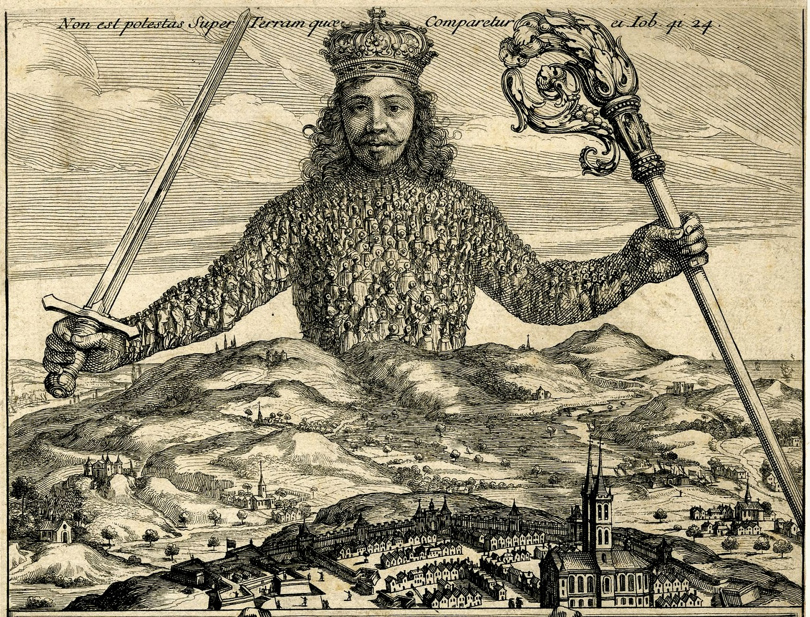

Locke (STATE OF NATURE)

We are not simply narcissistic and vain and “sociopathic”, the picture for Locke is different.
Why do we still need to leave the state of nature? The state of war is inconvenient - Locke agrees with Hobbes in that much. Why can’t we sit down and talk it through like normal people? There is an assumption about human nature that prevents it from being realistic. “I am right and you are wrong.” Always more partial to our own case over other people’s cases.

Create a political society - umpire. The impartial third, a judge that adjudicates.

Does he postulate a unanimous political body?

Unanimous social contract
- this body has options
  - creating a monarchy
  - majority has a right to make authoritative decisions
  - “The body moves in the direction of the stronger force.”
- the ultimate sovereign is the people; the political community

Can this legislature act in the same way as Hobbes’ sovereign acts?
- it can’t; fundamentally different
- Locke says more than this, however! - implications
- implications: political community CAN exist independently of a sovereign
- the exercise of that sovereign authority is different
- Hobbes can do what he pleases - does this exist in true form?
  - not in today’s world - in theory, the power is unlimited
- Locke: not unlimited when it passes laws; what kind of laws can it pass?
- the legislative cannot extend further of the common good; the object is the common good - laws to be enacted for the common good, not for a select few

Tacit consent:
- true ground of political obligation and political authority
- what about people who didn’t consent? Political communities are multi-generational patterns of interactions.
  - Lockean consent: immigrants sign a piece of paper

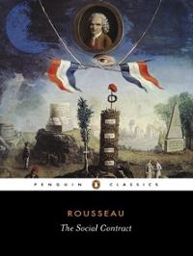

Rousseau (STATE OF NATURE)
- most politically impactful; popular sovereignty resonated most significantly in the way political events were shaped by social and economic forces, but political ideas itself
- ‘together we are stronger’; image of the supreme being

Small-city state - citizen ruled, similar to the way ancient Greek city states. Individuals coming together and making political decisions in common.

Who is the sovereign for Rousseau?
- What does the social contract institute for Rousseau, unlike for Hobbes?
- How does Rousseau call that political body? The people.
- Ideas of consent are similar between Rousseau and Locke. FORMULA: All come together to form a political society of which we are then members.
  - Critical difference between Rousseau and Locke:
    - Social contract is between the general population, according to Rousseau.
  - Who is exercising sovereignty (for Rousseau)? The collective.
  - The social contract for Hobbes is a device. Imaginative; a theory. It’s purpose is to persuade us is any form of political government is better than the state of nature. It justifies a political order, any political order. For Hobbes, the purpose of the social contract is (a) also explain to us and persuade us that a political order is superior to remaining in the state of nature but (b) providing us with a political criteria of what kind of a political order is superior to the state of nature. Promotes common good, protects private property, and whose laws have a certain quality.
  - Rousseau: legitimate political order is the one in which we can imagine ourselves, individually, to be part of a larger self-government whole

Are we self-governing?
If one has an addiction, is one self-governing, for example?

The individual does not have sufficient control; the people do, so they can be self-governing.

Who guarantees the people won't go crazy? Rousseau doesn’t guarantee anything.

in theory we can decide whatever the hell we want, democratically
Rousseau’s idea of popular sovereignty goes against constitutionalism

