The Strategic Role of Change:

- Today’s organizations must poise themselves to innovate and change

  - Innovate or perish

- Powerful forces

  - Technology
  - International economic integration
  - Maturing domestic markets
  - Globalization

Two types of changes:

- Incremental change: represents a series of continual progressions that maintain the organization's general equilibrium often affect only on organizational part.

- Radical change: breaks the frame of reference for the organization, often transforming the entire organizations.

Incremental vs. Radical Change

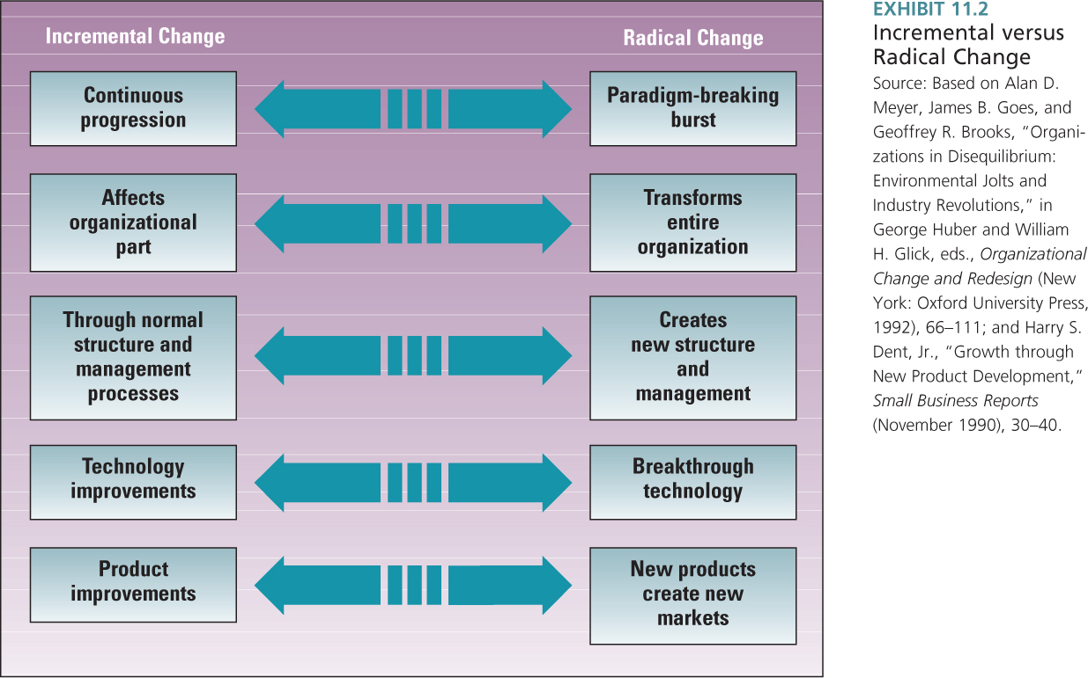

Four Types of Change:

- Technology
- Product and Service
- Strategy and Structure
- Culture

- Technology Change

- Technology changes are changes in an organization’s production process including tis knowledge and skill base that enable distinctive competence.

- Product and Service Change

- Product and service changes pertain to the product or services outputs of an organization.

- New products include small adaptations or existing products or entirely new product lines.

- Strategy and Structure

- Strategy and structure changes pertain to the administrative domain in an organization.

- The administration domain involves the supervision and Management of the organization.

- Culture Change

- Culture change refers to changes in the values, attitudes, expectation, beliefs, abilities and behavior of employees.

- Cultures changes pertain to changes in how employees think; these are changes in mind set rather than technology, structure or products.

Sequence of Elements for Successful Change

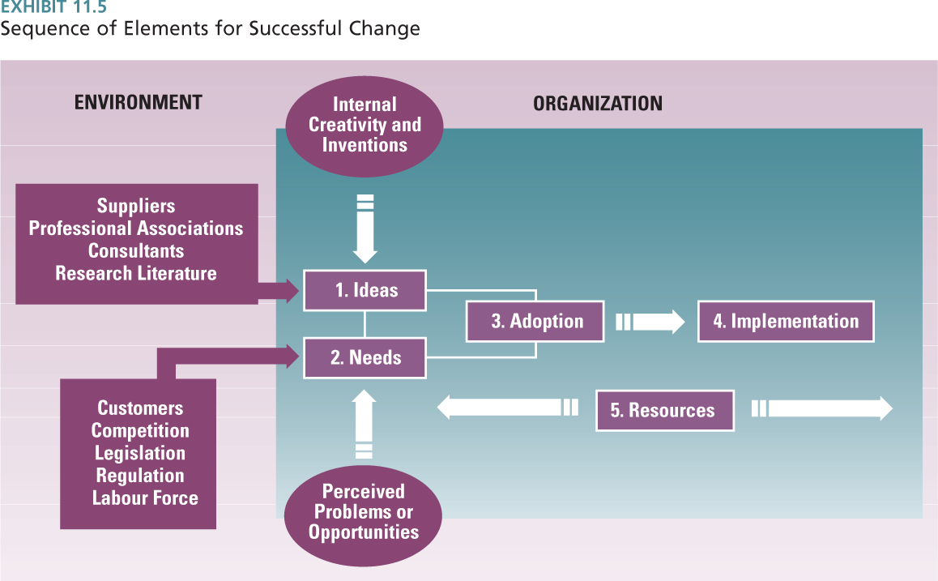

Technical Change:

- Ambidextrous Approach: To be both an organic and mechanistic, managers implement an ambidextrous approach

  - Structures and management processes that push innovation

Techniques for Encouraging Technology Change:

- Switching Structures
  - Create an organic structure

- Creative Departments
  - Department for innovation

- Venture Teams
  - A small company within the organization

- Corporate Entrepreneurship
  - Promote entrepreneurial spirit

- Collaborative Teams
  - Collaboration for innovation

Change related to New Products and Services:

- Reasons for success
  - Innovating companies understand customers
  - Innovating companies successfully use technology
  - Top management supports innovation

- Horizontal Coordination Model
  - Specialization
  - Boundary spanning
  - Horizontal Coordination

Horizontal Coordination for New Product Innovation

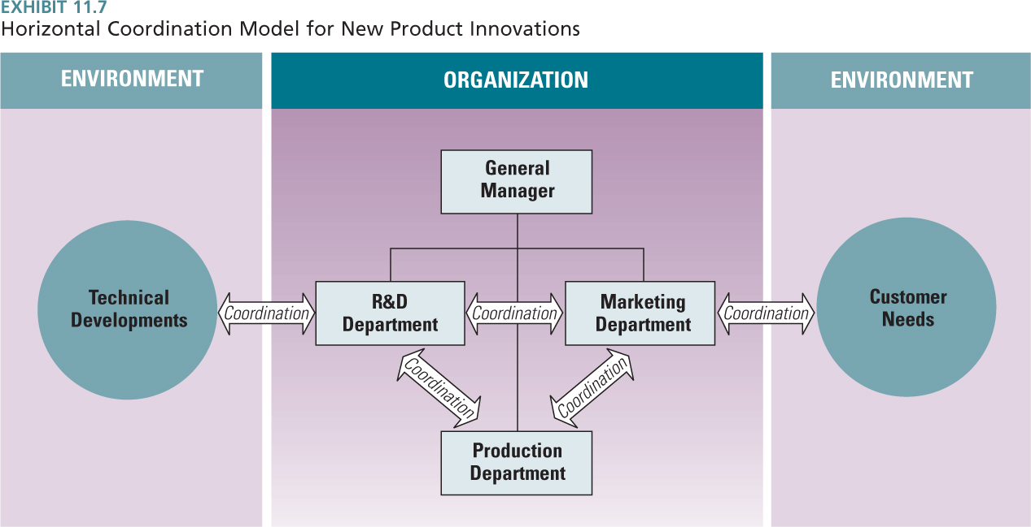

How Businesses Unwittingly Stifle New Ideas (Video Notes):

Reliability: Tendency to produce consistent outcomes (predictable).

- To get reliability measure narrower things that can be measured very simply and objectively. (IQ Tests)

Validity: Trying to produce an outcome that you actually want.

- To get valid results you have to take more factors into consideration that are often harder to measure to get the outcome you want. (Emotional Intelligence Tests)

Trade-off between consistent results and valid results:

- Companies say they want innovative and create new ideas but focus on using data from the past as projections for what will succeed. Unless they can prove from past data that the project will succeed then they won’t do it. This is because they are looking for reliable results, something that is consistent with the past.

- To get something that is valid they will only get proof from the unfolding of future events. Therefore, if the standard of proof is proving something using the past then they will never get a new idea or something that is valid.

- It is hard for organizations to take the risk to get valid results.

- Entrepreneurs are good at seeking validity but as a business grows and succeeds it often shifts towards reliability and use methods they know succeeded for them in the past.

- One example of a large organization that continually sought valid results was Apple. They continually came out with products very different then what was traditionally used with no past data to indicate whether or not it would succeed. Because of this Apple is considered a minority when compared to other large organizations.

Challenge for a CEO: Get as close to validity as they can. Be the “Chief Validity Officer” in the sense that over time as a corporation gets bigger the forces of reliability will tend to overwhelm the forces of validity and it is the job of the CEO to guard against that and protect validity. They must push the organization to try new thing that cannot be proven absolutely in advance. If the CEO fails to do this no one else will and reliability will win and eventually the organization will fade.

Strategy and Structural change:

- The Dual – Core Approach: To organizational change compares administrative and technical changes. Administrative changes pertain to the design and structure of organization itself, including restructuring, downsizing, team, control systems, information systems and departmental grouping.

The Dual – Core Approach:

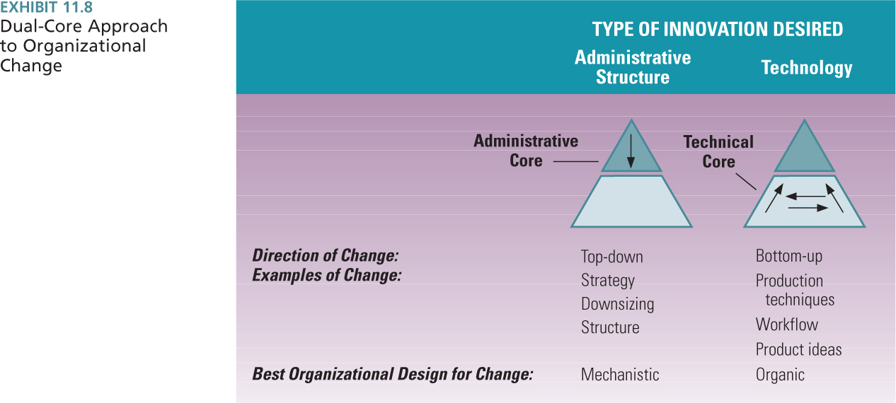

Culture Change:

- Forces for Cultural Change

  - Re-engineering and horizontal organizing
  - Diversity
  - Learning organization

- Example: WestJet sees itself as part of the hospitality industry, not the airline industry

OD Culture Change Interventions:

- Large Group Interventions
  - E.g., GE’s “Work Out” program
- Team Building
  - E.g., to address conflicts
- Interdepartmental Activities
  - E.g., increasing cultural fluency and valuing diversity

Stages of Commitment to Change:

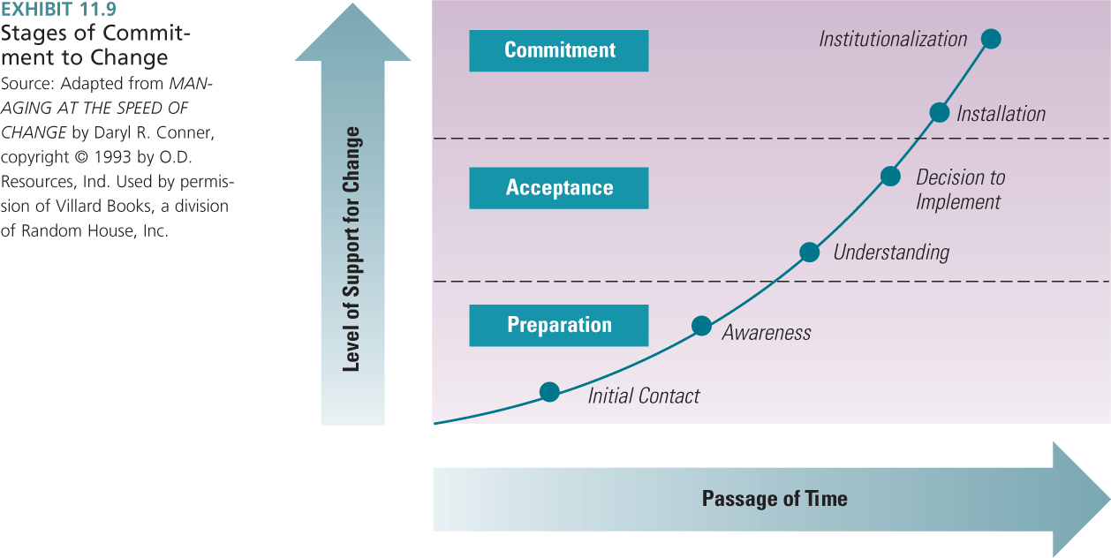

Barriers to Change:

- Excessive focus on costs
- Failure to perceive benefits
- Lack of coordination and cooperation
- Uncertainty avoidance
- Fear of loss

Leadership for Change: 80% of successful innovative companies have top leaders who reinforce the value and importance of innovation.

Kotter’s Seven Steps to Implementing Change:

- Establish urgency
- Establish a coalition
- Create vision and strategy for change
- Find an idea that fits the need
- Develop plans to address resistance
- Create change team
- Foster idea champions

