Organizational Culture:

- Unwritten feeling part of the organization

- Goes unnoticed until an organization tries to change

- Seen as visible behaviors, artifacts, symbols and stories reflect underlying values of culture

- Values, norms, guiding beliefs and understanding

- Shared by members of an organization

- Taught to new members

Levels of Organizational Culture:

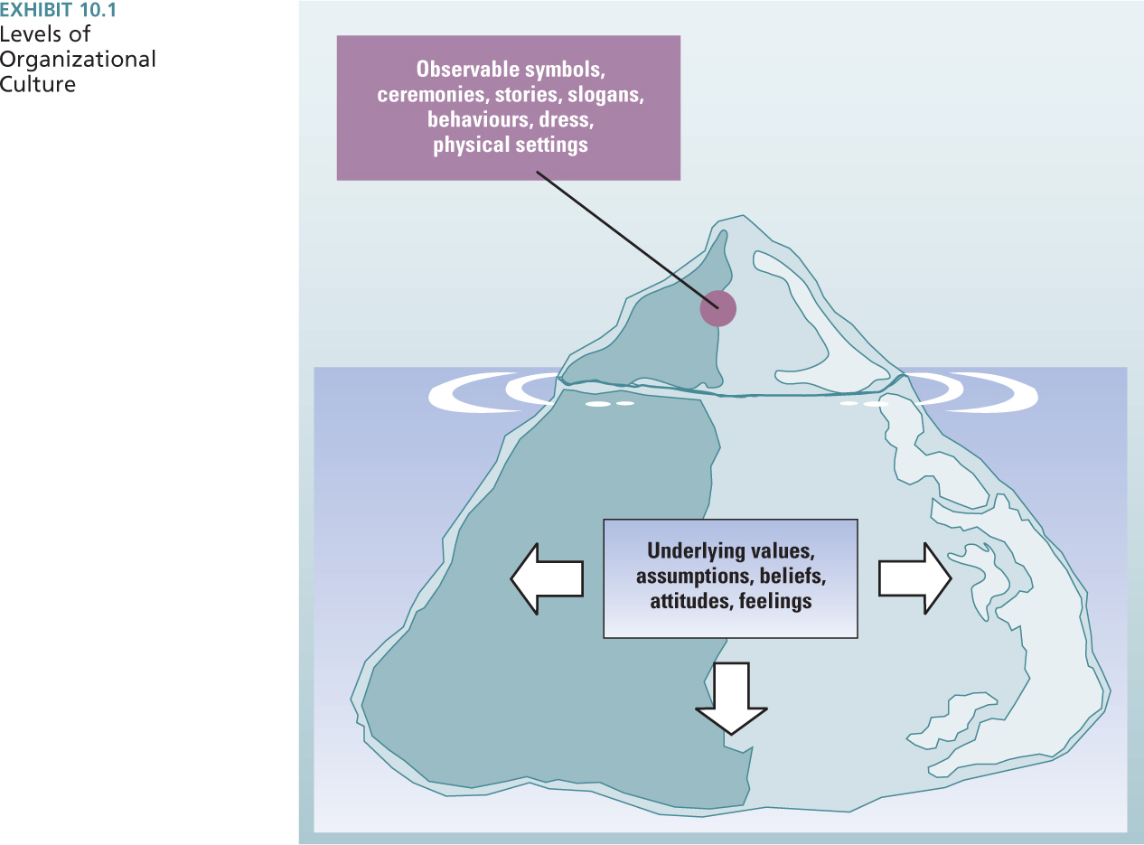

Purpose of Organizational Culture

- Internal Integration
  - Collective identity and know how to work together

- External Integration
  - How the organization meets goals and deals with outsiders

Origin of Organizational Culture

- Begins with the founder
- Can be influenced by any part of the organization
- Impacted by culture in industry

Elements of Organizational Culture:

- Rites and Ceremonies: Dramatic examples of company values – increase value of members orientation

- Stories: Told to new employees to inform them about the organization.
(E.g. president dealing with protestors)

- Symbols: Represents something else. (E.g. statues)

- Language: Slogans, metaphors, sayings – mean something to employees
(E.g. ROI or strat man)

Organizational Rites and their Purpose Harrison and Beyer (1984):

- Passage: Transition into new roles/status. (E.g. Graduation)

- Rites of passage facilitate the transition of employees into new social roles

- Enhancement: Enhance social identities and increase employee status.
(E.g. Awards ceremony)

- Rites of enhancement create stronger social identities and increase the status of employees

- Renewal: Refurbish social structure and improve organizational functioning (E.g. Training activity or retreat)

- Rite of renewal reflect training and development activities that improve organizational functioning

- Integration: Encourage and revive common feelings, bind together
(E.g. Office holiday party)

- Rite of integration creates common bonds and good feeling among employee and increase commitment to the organization.

Organizational Design and Culture:

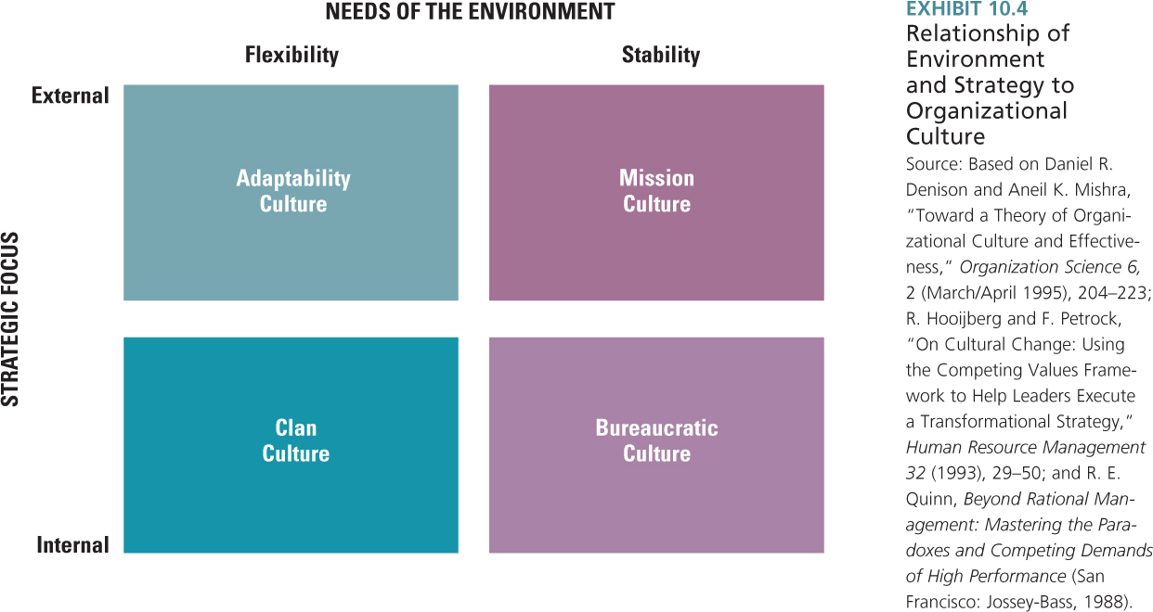

Adaptability Culture:

- Flexibility and change to meet customer needs
- Encourages entrepreneurial values, norms and beliefs
- Support organization’s ability to detect signals from the external environment
- Responsive behaviour
- Innovative, creative and risk taking

Mission Culture:

- Without the need for rapid change
- Focus on the achievement of goals (e.g. profits or market share)
- Stability needs by environment (E.g. Magna International)

Clan Culture:

- Rapidly changing external environment
- Internal strategic focus
- E.g. MEC

Bureaucratic Culture:

- Internal focus in a stable environment
- Methodical approach to doing business
- Follow SOP to reach goals
- Personal involvement is lower outweighed by focus on consistency and conformity
- Ministry of the Environment

A Culture of Discipline - Jim Collins:

- What does it takes to make company successful
- Great companies have a culture of discipline
- How is this culture of discipline created?

- Level 5 leadership:
- No personal ego, selfishness, greed, arrogance.
- Strong will/ambition for success of company.

- The right values:
- Values of individual freedom and responsibility.
- Values within framework of organizational purpose and goals.

- The right people in the right jobs:
- Self-discipline people that embody values that fit culture

- Knowing where to go:

- What company is good at, passionate about and what makes economic sense
Organizational Subcultures:

- Cultures are not uniform across organization
- Subcultures reflect a smaller group within the organization
- Typically include basic values of dominate culture
- Can lead to conflict across organizational subcultures
- E.g. manufacturing – emphasis order and efficiency
- E.g. R&D emphasis innovation, employee empowerment

Organizational Cultural Strength:

- Refers to the degree of agreement among members of an organization about specific values

- If widespread consensus exists it is cohesive and strong
- If there is little agreement it is weak
- In a strong culture there are many demonstrations of the culture
- Ceremonies increase dedication of cultures

Study by Kotter and Haskett On Strong Organizational Cultures:

- Strong organizational cultures not necessarily good
- May take organization in wrong direction until too late
- Company fails to adapt because they cling to outmoded values and beliefs
- Organizational cultures that take into consideration their stakeholders not just shareholders outperform those that just focus on their shareholders

Strong Adaptive Cultures:

- Healthy organizations adapt to the external environment. They are learning organizations,

- They value internal and external customers.
- They value inclusion.
- The whole is more important than the parts – systems
- They value equality and trust.
- Treating others with care and respect = safety and trust
- They allow experimentation.
- The culture encourages risk taking, change and improvement, and rewards failure
- They promote honest and open communication.

Maladaptive Cultures:

- Managers more concerned about themselves and their immediate work group
- They value process that can reduce risk
- Short-term gains are valued.
- Organization marches in the wrong direction
- May discourage good risk
- May encourage excessive risk

Sources of Individual Ethical Principles and Actions:

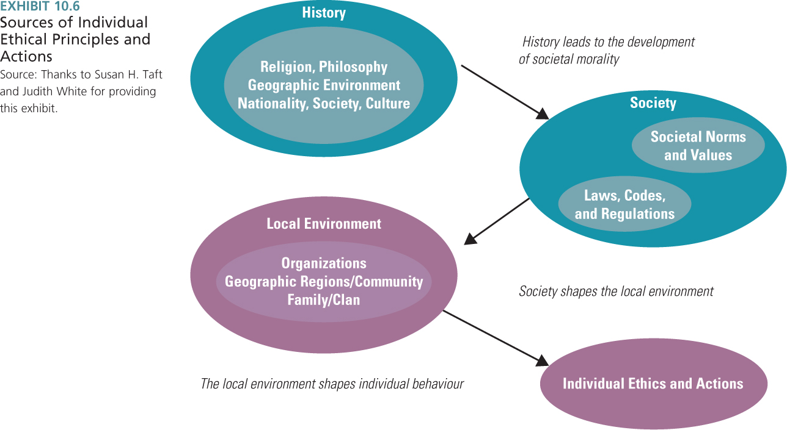

- Rule of law
- Ethical standards
- Not all moral standards are codified or can be codified

Managerial Ethics:

- Guide decisions and behaviors of managers
- Social responsibilities – actions and choices that respect stakeholders

Forces that Shape Managerial Ethics:

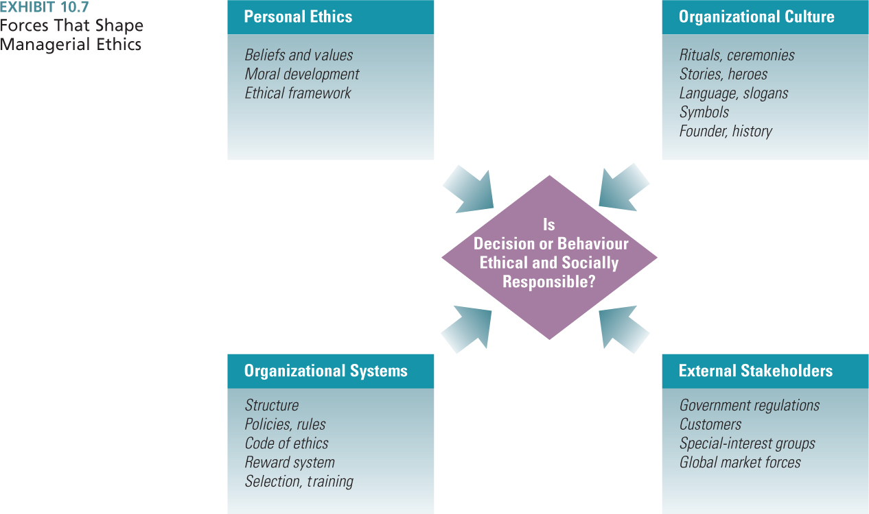

Facing an Ethical Dilemma:

- Situation concerning right and wrong
- Values are in conflict

- Does it pay to be good?
- Walker Research: If price and quality are equal, 2/3 of customers will switch to an ethical brand

How leaders shape culture and ethics:

- Value-based leadership:
- Values advocated and acted upon by leader
- Engender a high level of trust and respect from employees
- Encourage determination
- Motivate high-level performance

- Ethics officer:
- High-level company executive

How formal structure and systems shape culture and ethics:

- Ethics hotlines
- Employee can call to seek guidance

- Whistle-blower policy and hotline

- Code of ethics
- Formal statement of company values and guidelines,
- Workplace safety,
- Security of proprietary information,
- Employee privacy,
- Product safety,
- Environmental responsibility

- Training programs

