Pressures to Grow:

- Mega Corporations:
  - Toyota, GE, Proctor and Gamble
  - Few players in one industry
    - E.g. the accounting industry in Canada

- Serve other large corporations:
- Corporations going global - so are suppliers
- E.g. Magna International to service the auto industry
- Need quality, consistency, large orders

- Increase power in the market place:
- Distribution channels, resources more accessible with large demand
- Economies of scale
- Keep good employees

Reasons to Stay Small:

Focus on More Satisfying Business Goals:

- Being great at what they do
- Creating a great place to work
- Providing great customer service
- Making great contributions to their communities
- Finding great ways to lead their lives.

Pressure & Dilemmas of Growth:

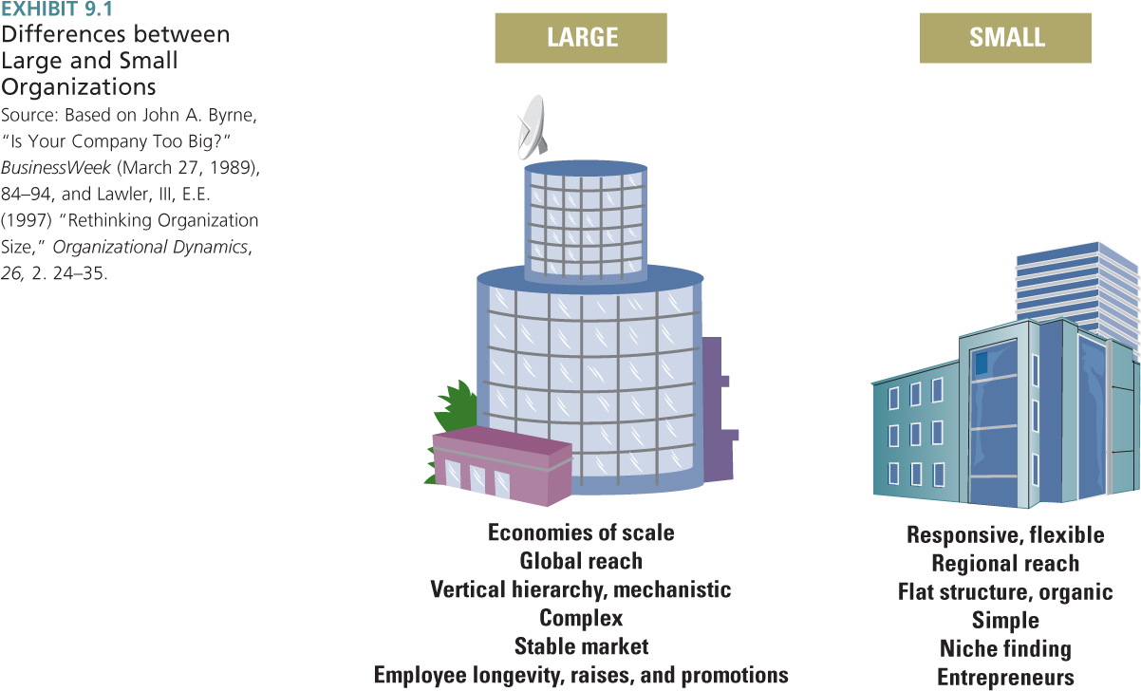
Large Organization:

- Standardized – work to reduce variance
- Mechanistic
  - Formalized – Standard operating procedures
- Complex
  - Offering many different products
  - Many functional specialties
- Career stability
  - Longevity, raises and promotions
- Big and Bigger – through mergers and acquisitions

Small Organizations:

- Quick reaction to changing customer needs
- Quick response to changing market
- Employees more committed
- Increase in global trade means increase in small firms
- Growth in jobs – small business sector
  - Most people today will be or are working in small companies
- Technology has made small companies more competitive and efficient

Successful Companies:

- Separate new from established
- Allow for different processes, structures and cultures at the same time
- Maintain tight links across units at senior management level

Types of Innovation:

- Incremental innovation – small improvements in existing products/operations, deliver greater value, operate more efficiently

- Discontinuous innovation - radical advances that will render other products obsolete

Organizational Life Cycle:

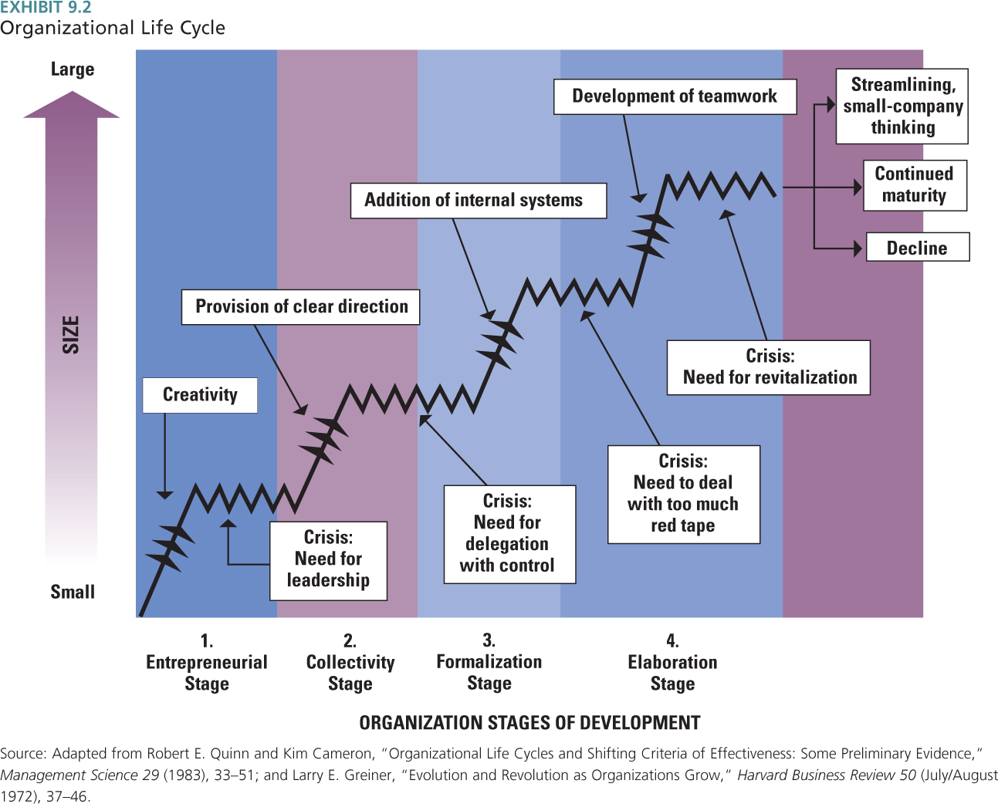

Organization Characteristics in the Four Life-Cycle Stages:

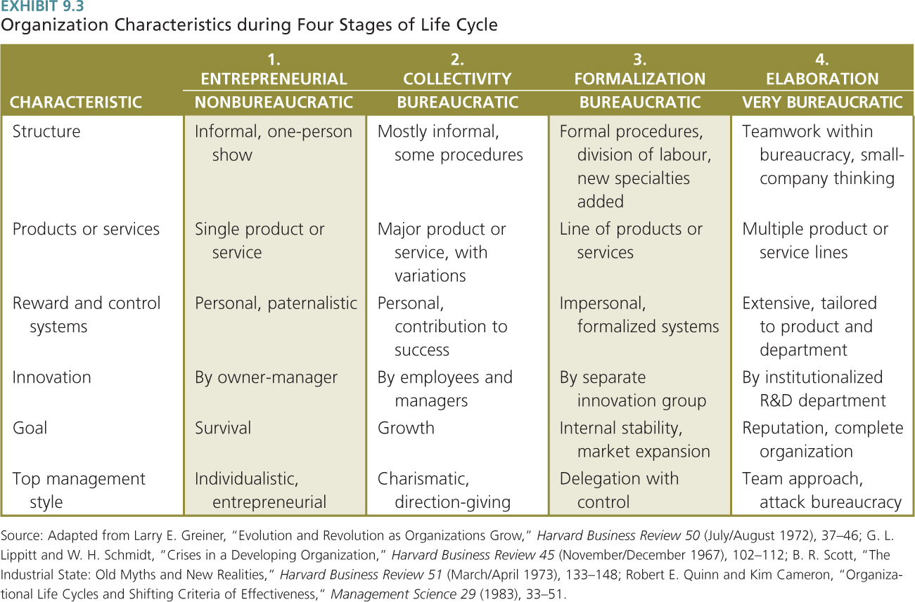

Apple as an Example of Organizational Life Cycle:

- Entrepreneur Stage
- Start up
- Steve Jobs and Steven Wozniak start company

- Crisis: need for leadership
- Markkula brought in as leader
- Neither jobs nor Wozniak wanted to run company
- Neither had the leadership skills

- Collectivity Stage
- Org grows and develops larger design
- Org develops clear goals and design

- 1978-1981
- Employees intensely involved
- Developing product line
- Signing up dealers for products

- Crisis: need for delegation
- Lower level managers have gained experience
- They want more discretion

- Formalization Stage:
- Become more bureaucratic
- Install rules, controls, procedures
- Apple 1980s

- Crisis: dealing with red tape
- Jobs resigns and new CEO takes over
- New CEO ready to deal with management issues

- Elaboration Stage:
- Organization becomes more flexible in its design
- Bureaucracy has reached its limit
    - Teamwork and collaboration help to deal with bureaucracy

- Crisis: need for revitalization
- At Apple successive CEOs replaced
- Steve jobs returns mid 1997
- Jobs had gained management skills

- All organizations need to revitalize or will not renew and change as needed
Weber’s Dimensions of Bureaucracy:

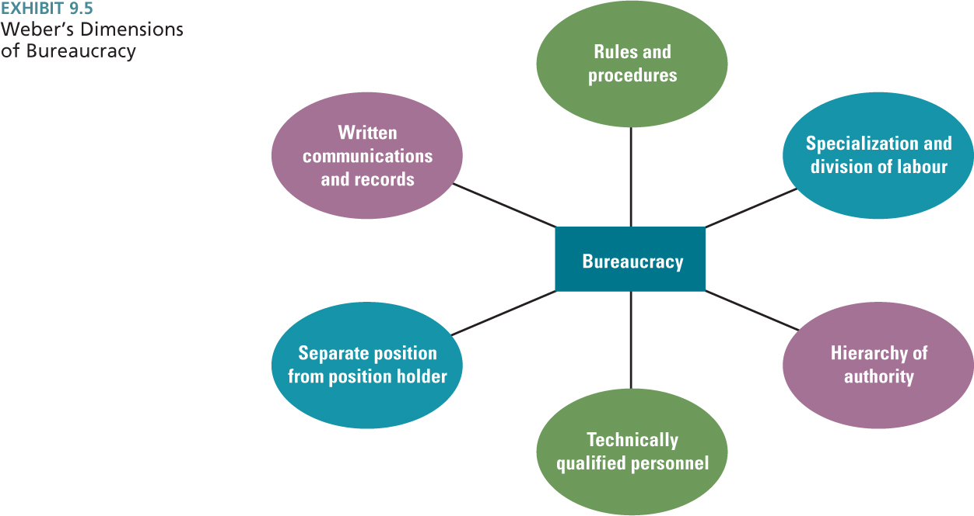

Bureaucracy:

- Rules and standard procedures enable organizational activities to be performed in a predictable, routine manner
- Each employee has a clear task to perform

Size and Structural Control:

- Formalization and Centralization:
  - Rules, procedures, and written documents
  - Rights and duties of employees
  - Centralization

- Personal Ratios:
  - Measurements and efficiency are followed
  - E.g. administrative ratios
  - Ratio of top # of employees to regular employees
    - # At the top small
    - # Of direct works reduces as a percentage of the organization

Organizing Temporary Systems for flexibility and Innovation:

- Incident Command System (ICS) is commonly used by organizations.
- E.g. Police, fire department or other emergency management agencies
- An Incident Commander is ultimately responsible for all activities that occur and everyone knows clearly who is in charge of what aspect of the situation.

Three Organizational Control Strategies:

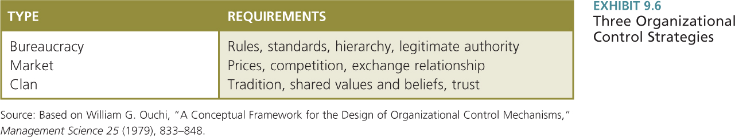

1) Bureaucratic control:

- Rational legal authority:
- Based on employees’ belief in the legality of rules and the right of those elevated to positions of authority to issue commands.

- Traditional authority:
- Belief in traditions and in the legitimacy of the status of people exercising authority through tradition.

- Charismatic authority:
- Based on devotion to the exemplary character or heroism of an individual person and the order he or she defines

2) Market control:

- Market control uses price-cost comparisons to evaluate performance. Market control requires price competition so that the price reflects the true value of outputs and is a measure of internal efficiency.

3) Clan control:

- Clan control is the use of corporate culture, shared values, commitment, traditions, trust, and beliefs to control behaviour.

- People behave the way the culture expects because they are part of the group and want to belong. It is used in organizations with a strong culture, because of personal involvement in and commitment to the organization's purpose.

Organizational Decline and Downsizing:

- Definition:
- Organizational decline is a condition in which a substantial, absolute decrease in an organization’s resource base occurs over a period of time.

- Three causes:

- Organizational atrophy
- Vulnerability
- Environmental decline or competition.

- Organizational atrophy:
- Atrophy occurs when organizations grow older and become inefficient and overly bureaucratized.

- Vulnerability:
- Vulnerability reflects an organizations strategic inability to prosper in its environment.

- Environmental decline or competition:
- Environmental decline refers to reduced energy and resource available to support an organization. When the environment has less capacity to support organizations, the organization has to either scale down operation or shift to another domain.

A Model of Decline Stages:

- The five stages of organizational decline are:

- Blinded Stage: This is the internal and external change that threatens long-term survival and might require the organization to tighten up.

- Inaction Stage: Denial occurs despite signs of deteriorating performance.

- Faulty Action Stage: During this stage the company tries to take action, but it is not the correct action.

- Crisis Stage: The organization experiences chaos and may go back to basics and experiences panic and anger.

- Dissolution stage: The organization is forced to close down in an orderly fashion.

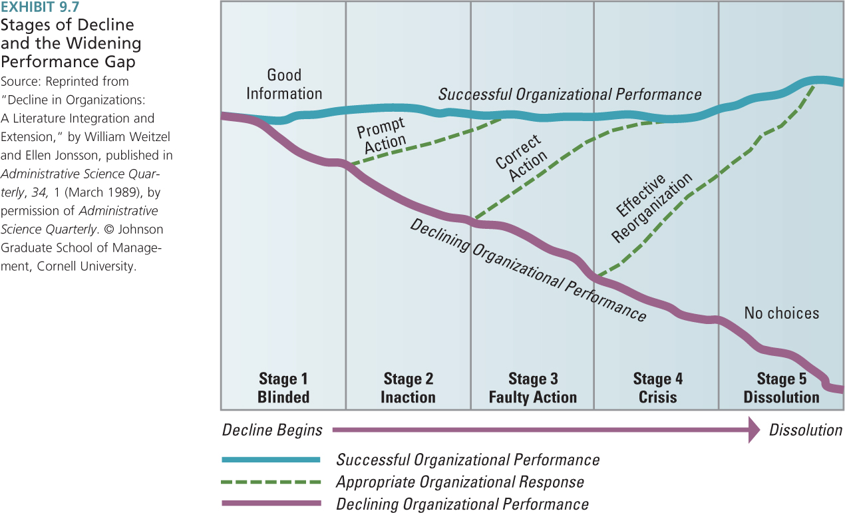

Downsizing Guidelines:

- Communicate more, not less
- Provide support to displaced workers such as training, severance, and outplacement activities
- Help the survivors deal with survivor guilt

