Technology:

- An organizations production process and includes work and procedures as well as machinery
- It is not the same as electronic tech

Core vs. Noncore work:

Core:
- Work process that is directly related to organizational mission
- E.g. teaching at university

Noncore:
- A department work process that is important to the organization but is not directly related to its primary mission
- E.g. HR

Core Transformation process for manufacturing:
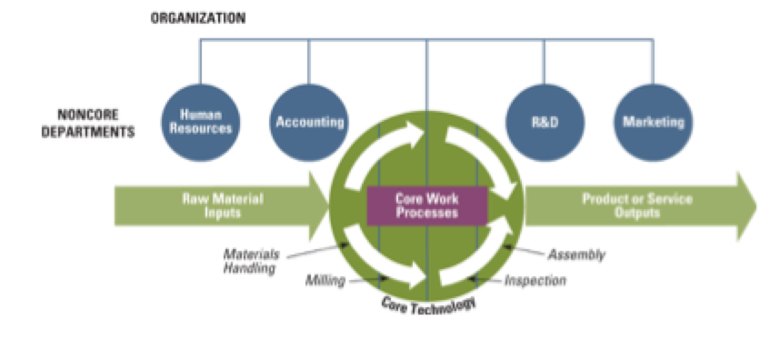
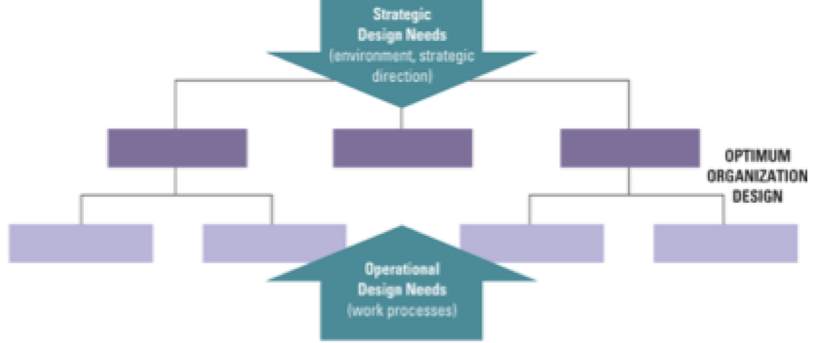
Joan Woodward:
- Published a book “industrial organization: behaviour and control”
- Research in org structure
- Longitudinal study of 100 organisations
  - 1950-59

Her Theory:

- 1950 Taylorism was big and very common
- The only best way
- Woodward surveyed 100 manufacturing firms
  - Looked at how they were organized
  - Interviewed managers
  - Looked at relative success of organization
- Woodward developed a scale organizing firms according to technological complexity
  - High complexity – many machines involved
  - Low complexity – many workers involved

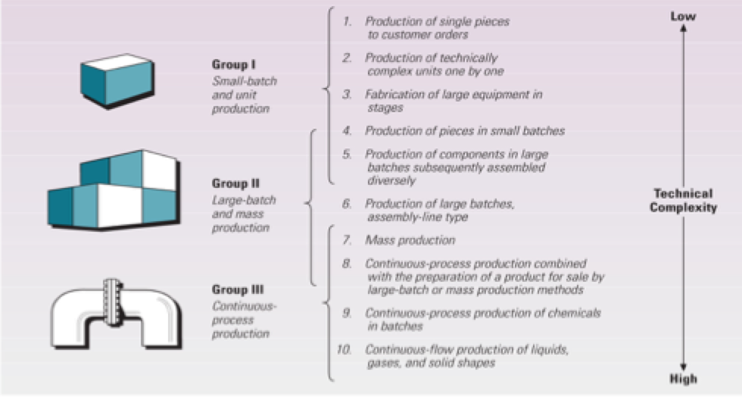

Contemporary Applications: 2 Flexible and Lean manufacturing systems

- Flexible Manufacturing Systems
  - Shop floor has been revolutionized **** all three will be on exam
    - Computer-aided design (CAD)
    - Computer-aided manufacturing (CAM)
    - Integrated information network (IIN)
  - FMS means that new products can be designed and prototypes without human hands

CAD:
- Use of computer systems to assist in the creation, modification, analysis or optimization of a design
- CAD software available
  - Increases the productivity of the designer
  - Improves the quality of design
  - Improves communications through documentation
  - Creates a database for manufacturing
- Allows for images of prototypes

CAM:
- Use of computer software to control machine tools and related machinery in manufacturing
- Refer to the use of a computer to assist in all operations of a manufacturing plant, including planning, management, transportation and storage.
- Its primary purpose is to create a faster production process
- Aims to use components and tooling with more precise dimensions and material consistency
- Uses only the required amount of raw material (thus minimizing waste)
- Reduces energy consumption

IIM:
- Computerized system links all aspects of the firm
- Accounting, purchasing, marketing, inventory control, design production.

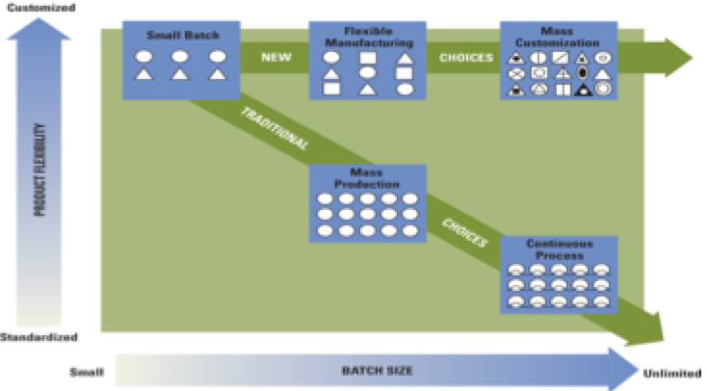

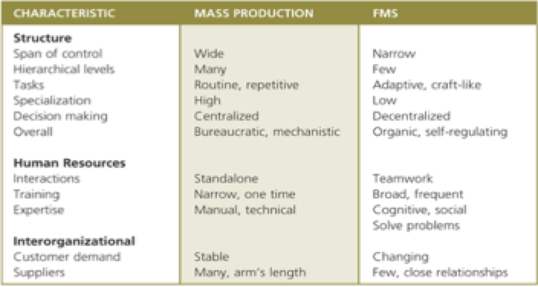

Mass customization:
- Mass customization refers to using mass production technologies to quickly and cost effectively assemble goods that are uniquely designed to fit the demands of individual customers
- JIT system, with all technology work in process system

Lean in Manufacturing:
- Incorporates technological elements
- Paved the way for mass customization
  - Using mass production technology to quickly and cost-effectively assemble individual goods for customers

- Implementing Lean:
  - Highly trained employees at every stage of production
  - Cut waste and improve quality
  - Requires observation and continuous improvement
  - Most difficult challenge is seeing the waste

Core organization service technologies: 8 elements
- Intangible output means that a service is abstract, such as information or knowledge
- Simultaneous production and consumption means that clients of services consume the output of the organization at the same time it is produced and that the intangible product does not exist until it is requested by the customer.
- Labour and knowledge intensive
- Interaction between customer and employee
- Human element is extremely important
- Quality of service is perceived and cannot be directly measured
- Rapid response time affects satisfaction and perception of quality
- Site selection is often much more important than with manufacturing
- All organizations can be classified along a continuum that includes both manufacturing and service characteristics:

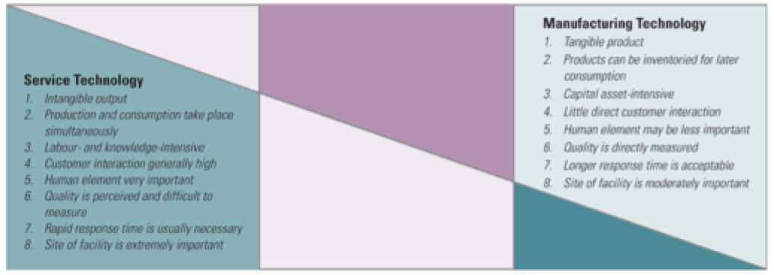

Noncore Departmental Technologies:

- Now, we shift to the department level of analysis for department within the noncore departmental technologies
- Charles Perrow framework has been used to understand a broad range of technologies

Routine vs. Non Routine: Charles Perrow

- Task Variety:
  - Number of exceptions in the work
    - High variety many exceptions
    - Low variety few exceptions
  - Is work performed the same every time

- Task Analyzability:
  - High analyzable
    - Work can be reduced to mechanical steps
    - Participants can follow an objective or procedure to solve problems
  - Low analyzable
    - No procedures to rely upon
    - Employees rely on accumulated knowledge, institution or judgement
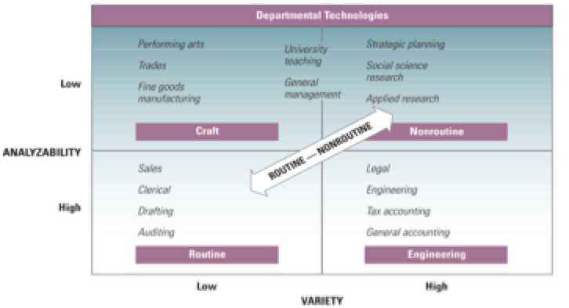

Mechanistic structure vs. Organic Structure:

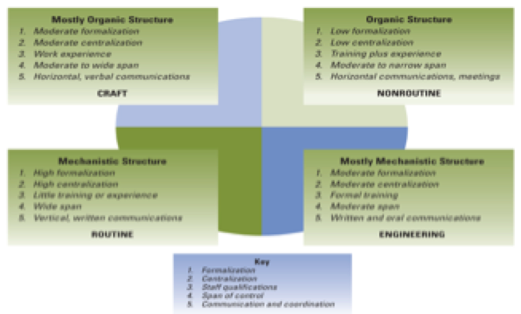

Workflow interdependence Thompson’s typology:

- The final characteristics of technology that influences structure is called interdependence
- Interdependence means that extent to which departments depend on each other for resource or material to accomplish their tasks.

Workflow interdependence:

- Pooled:
  - Each department works independently

- Sequential:

  - Outputs of one department are the inputs to another
  - E.g. opening case GE 100 steps

- Reciprocal:
  - Output of A is the input to B and the output of B is input back to A

Interdependence and Management Implications:

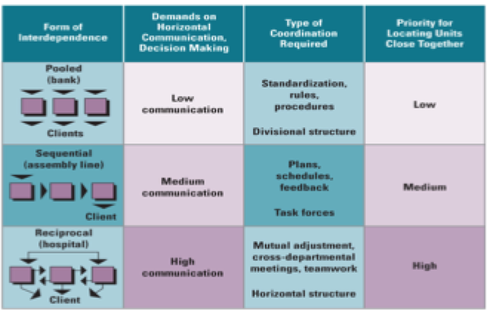

Impact of technology on Job Design:

- Job rotation:
  - Moving employees from job to job to give them more variety

- Job simplification:
  - Variety and difficulty of a task completed by an employee are reduced

- Job enrichment:
  - Job provides greater responsibility, recognition, opportunity for growth and development

- Job enlargement:
  - Expansion of the number of tasks performed by an employee

